APIs project By ghaida alharthi

Swagger screen

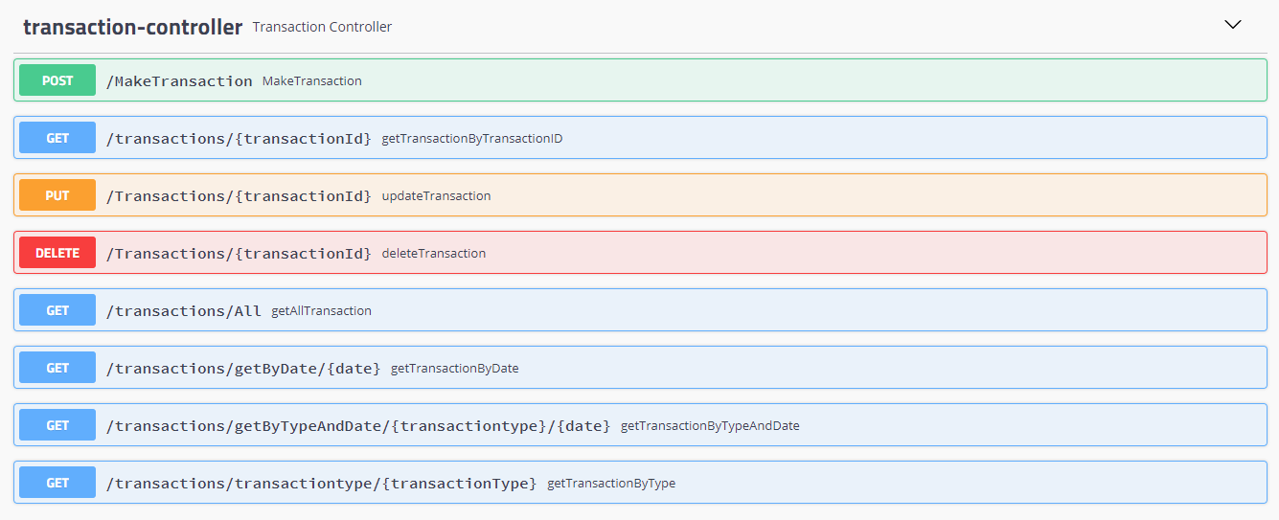

Pgadmin screen first I create transaction table

And 12 columns 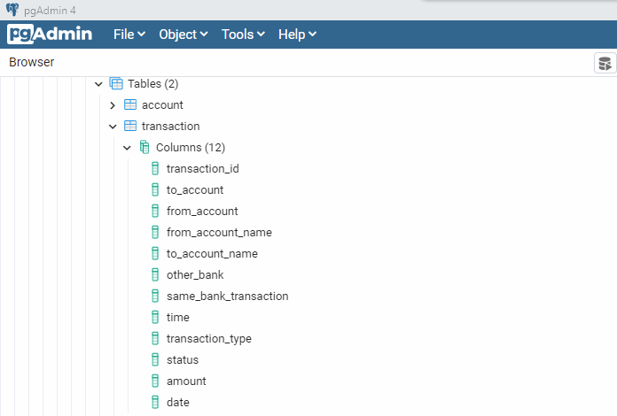

This is my database 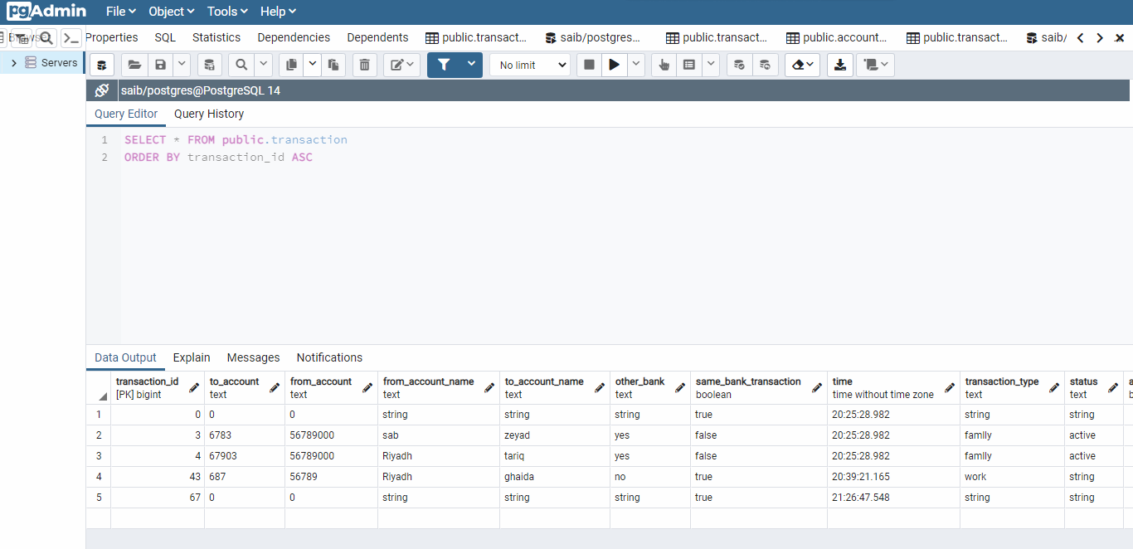

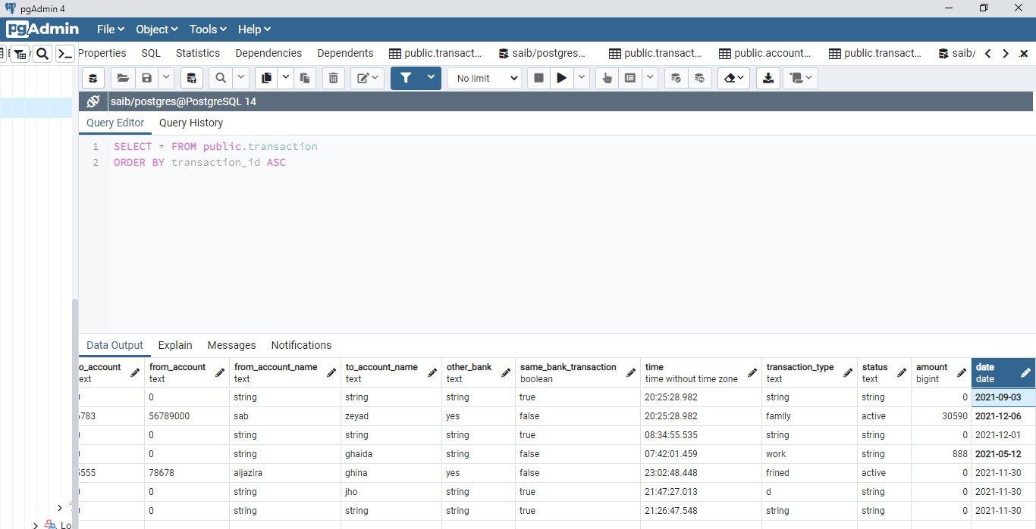

I insert data by using “make transaction “function

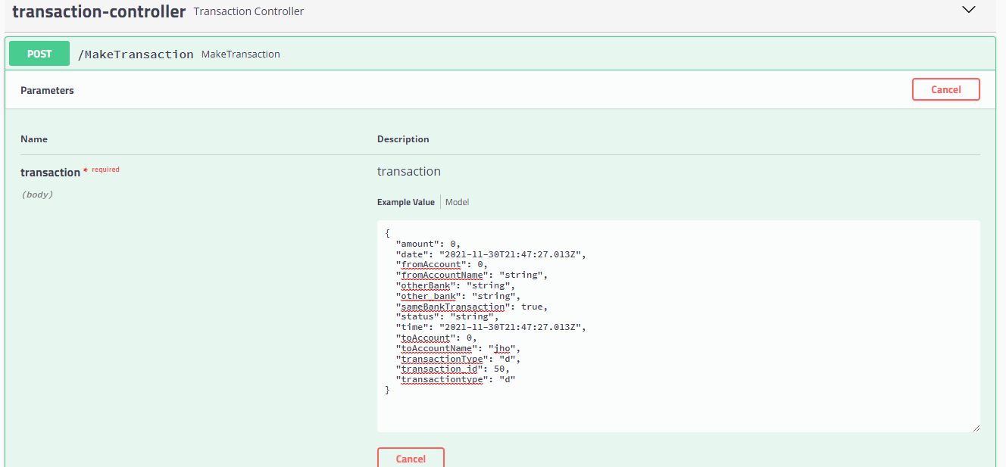

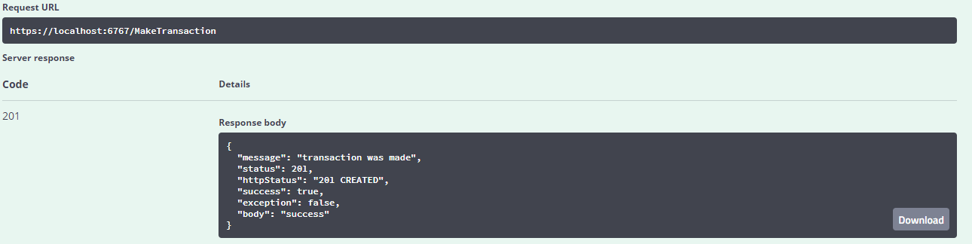

There I am trying to get transaction by ID and I choose ID “67” from database

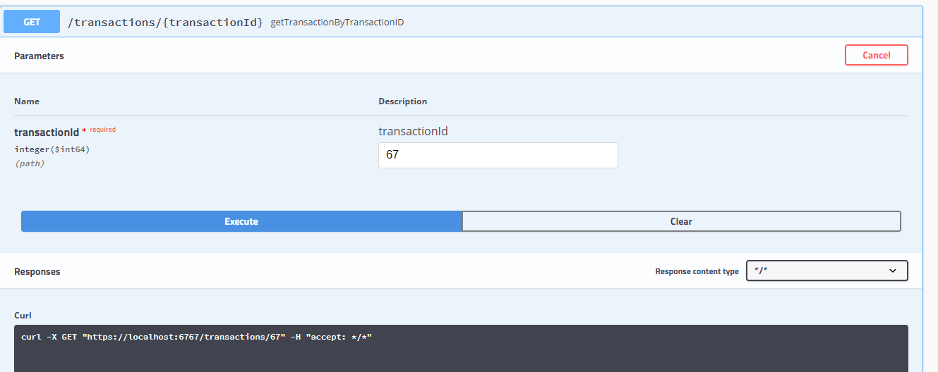

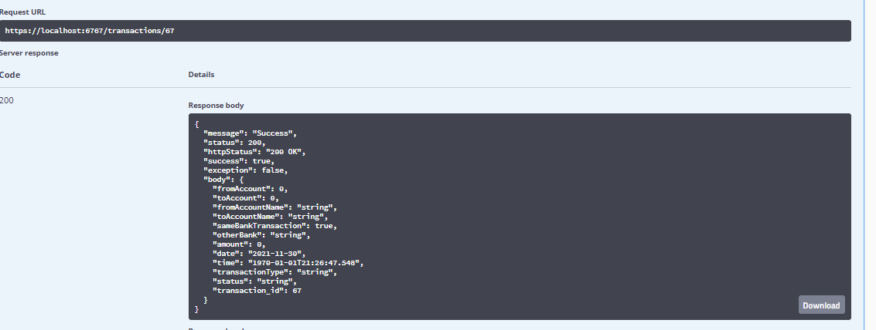

There I am trying to update my data by using” updateTransaction “function by ID and I choose what ID I want update it

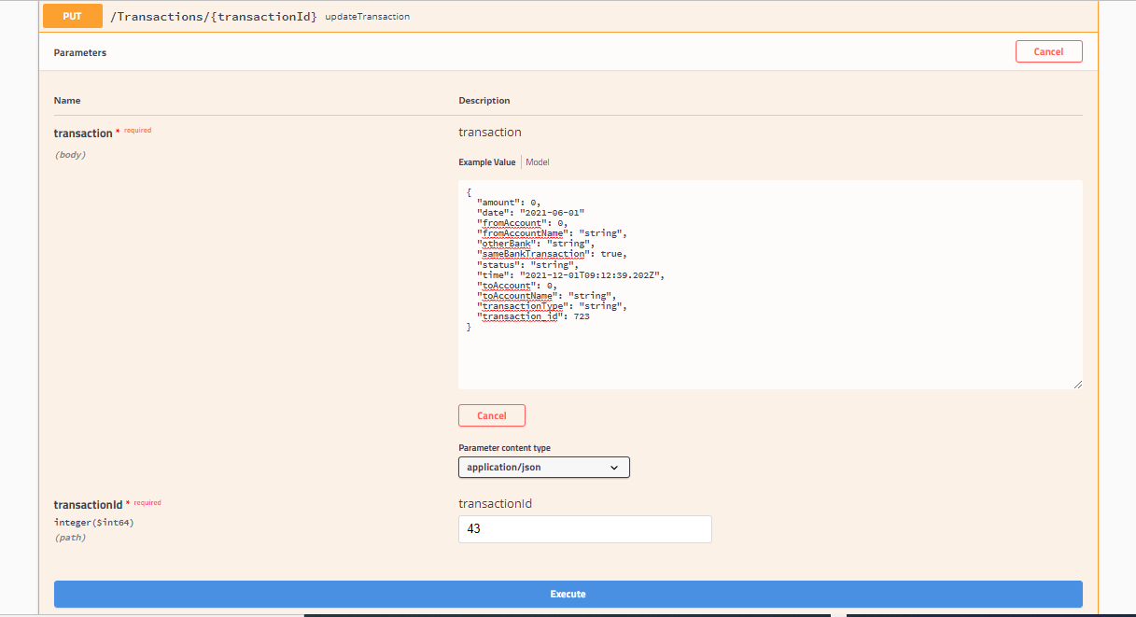

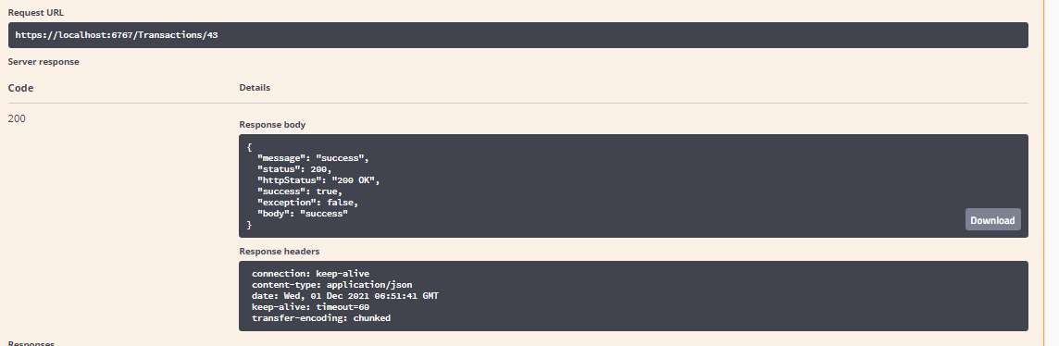

And here my “delet” function by ID and I choose ID (4)

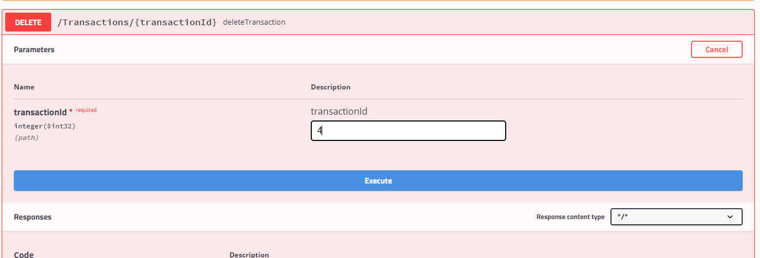

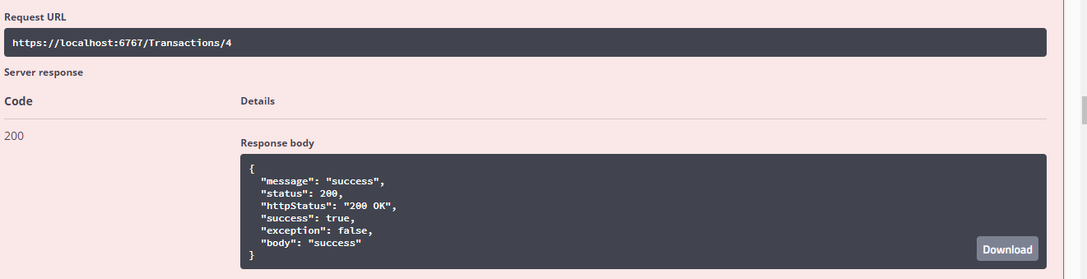

Database before execute

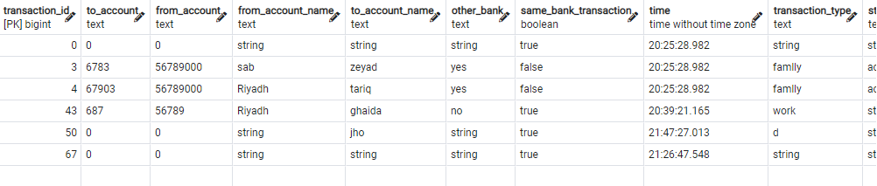

Database after execute

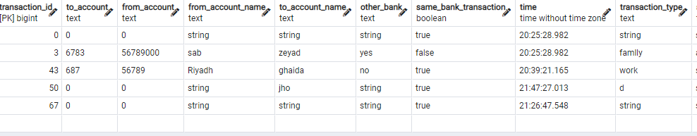

Filtering database by Date

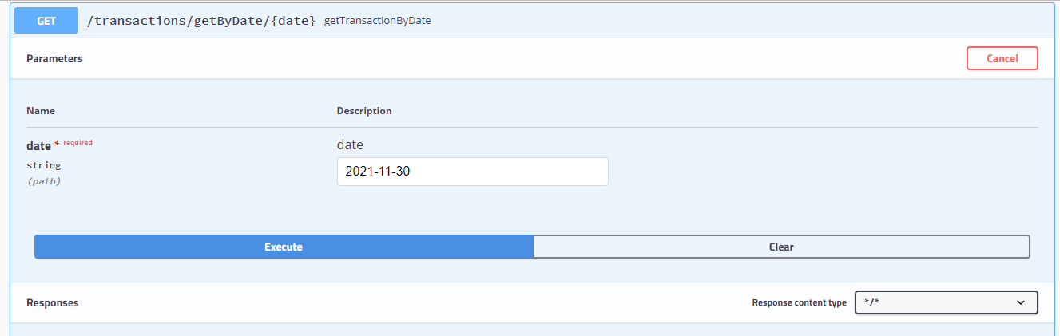

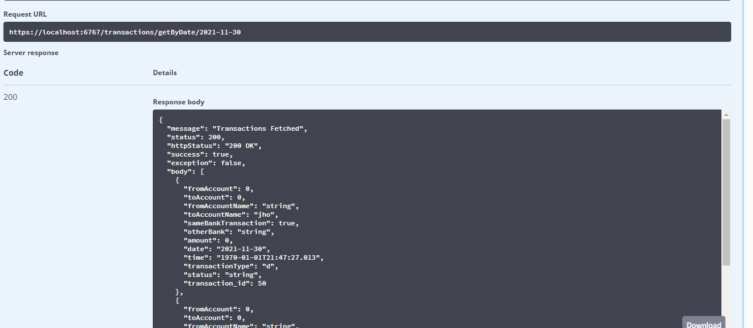

Flirting database by date and type

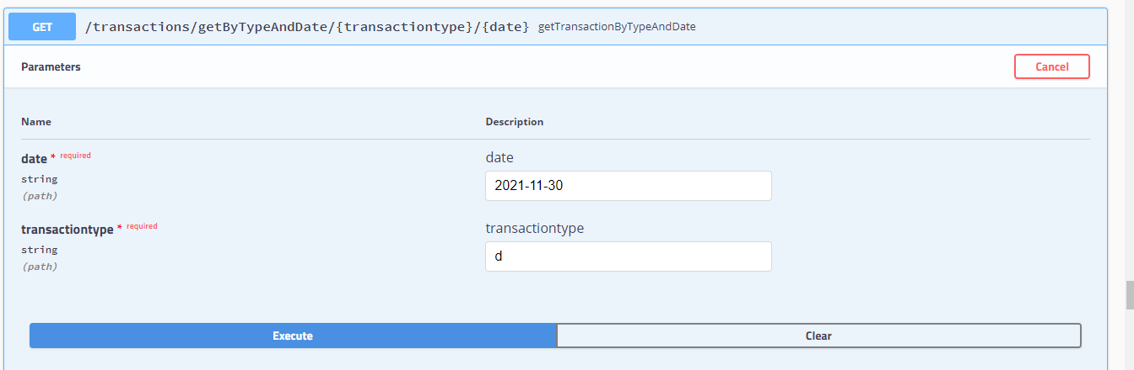 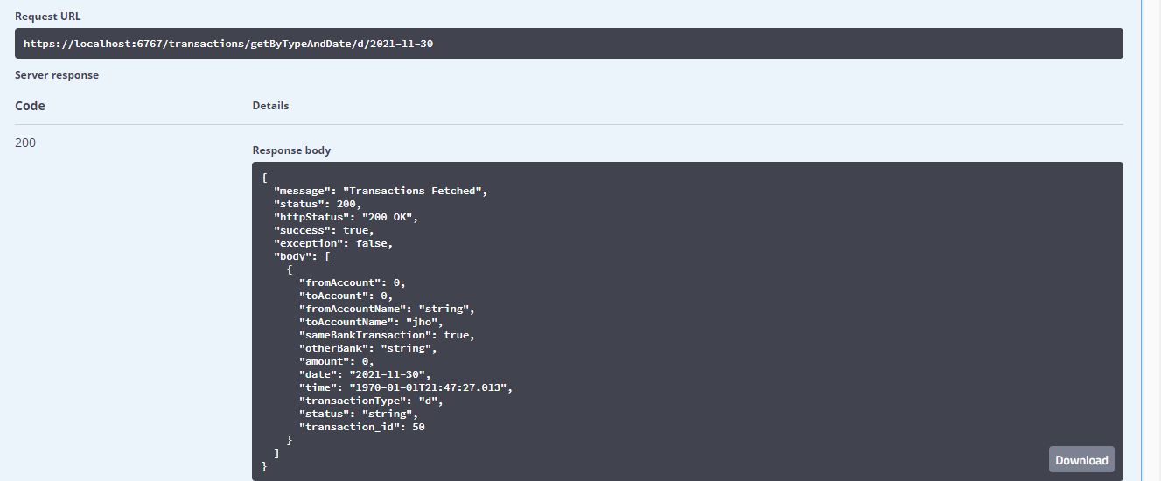

Filiting by type

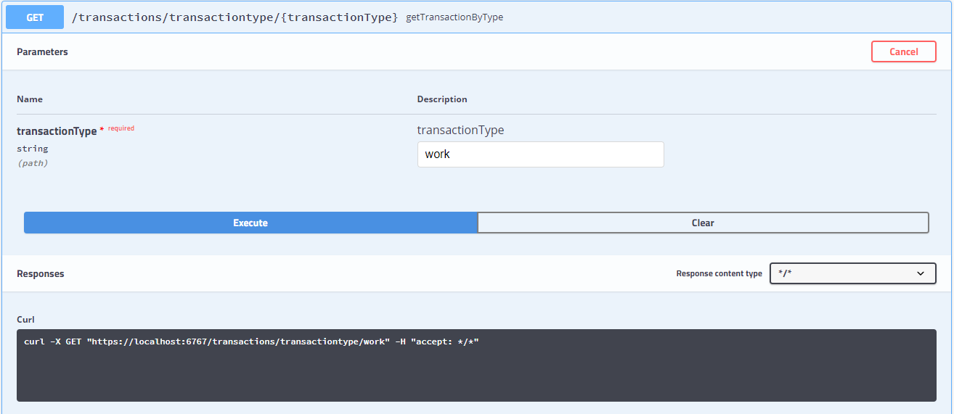

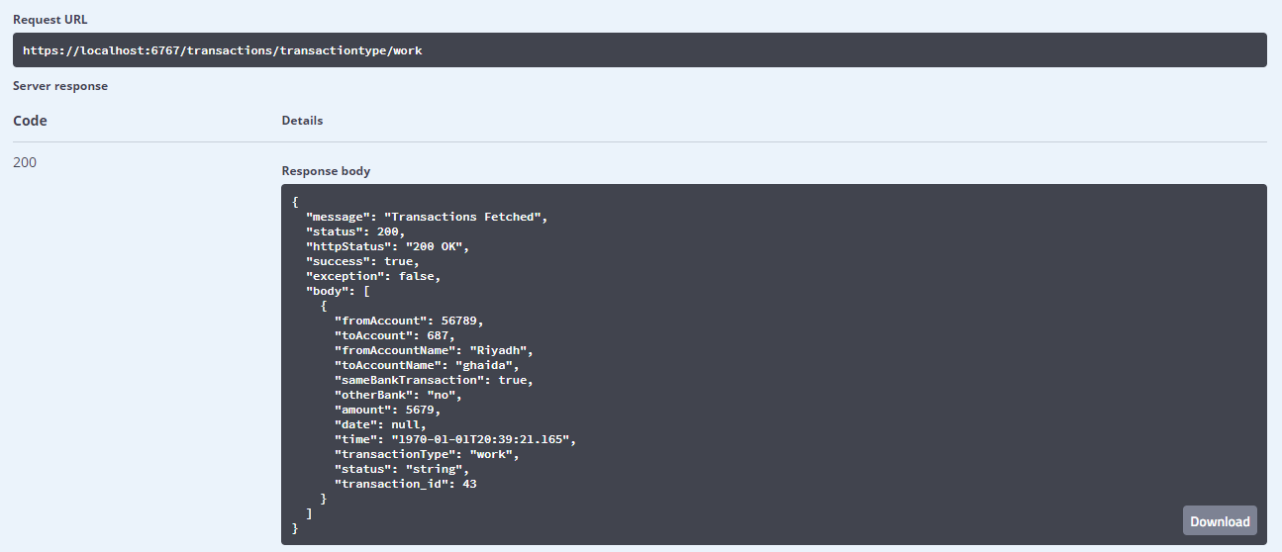

Get all transaction

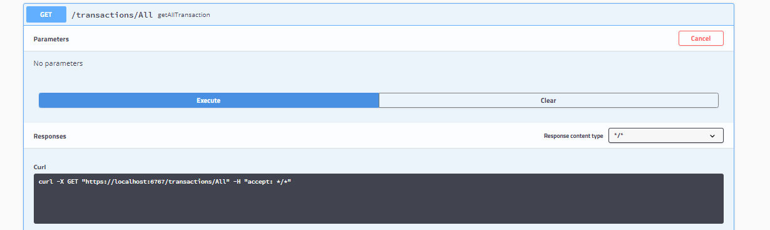

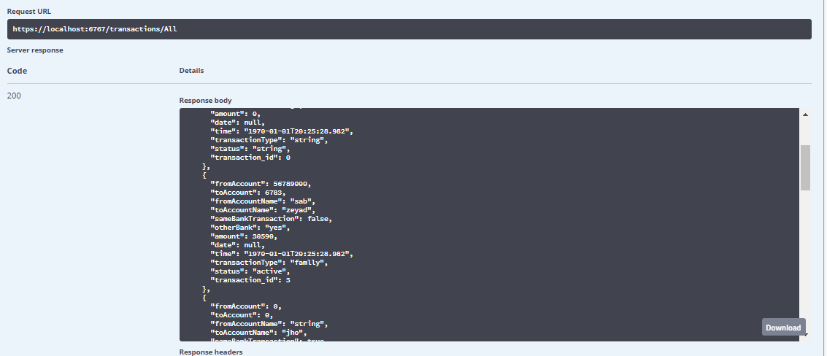

This is my repository link

<https://github.com/ghaidagg/saib-capstone-project.git>

this is my swagger link

[Swagger UI](https://localhost:6767/swagger-ui.html#/)

*note I upload a file with all swagger steps