

KING KHALID UNIVERSITY COLLEGE OF COMPUTER SCIENCE

DEEP LEARNING APPROACH FOR ENVIRONMENTAL STRESS DETECTION IN AGRICULTURE

By
Ghala Ali Al-Hasanaih – 444808397 Sara Abdullah Al-Mazni – 444808321 Reemas Al-Qahtani – 444807671 Sadeem Yahya Alamri – 444806839 Esra Hamza Al-Daher – 444815622

Supervised by: Dr. Ali Algrawi

ABSTRACT
This project focuses on analyzing environmental stress in plants using advanced deep learning models. The proposed system performs accurate stress detection and severity assessment through image analysis of plant leaves and canopies. Predictive algorithms are employed to forecast potential stress before visible symptoms appear, allowing early intervention and precision management. The model identifies possible damages caused by drought, heat, or nutrient deficiency and suggests preventive actions to minimize risks and protect crop health. By integrating computer vision, machine learning, and real-time monitoring, the system enhances decision-making for sustainable farming. Ultimately, this AI-based approach aims to improve agricultural accuracy, resilience, and productivity, contributing to smarter, data-driven environmental management in the agricultural domain

ACKNOWLEDGEMENT

We are grateful to our supervisor for their invaluable advice and continuous support throughout this project. Their guidance and constructive feedback greatly helped us improve our work and deepen our understanding.

We also thank our families and friends for their support and encouragement, which played an important role in completing this project. In addition, we appreciate the college’s academic staff for providing us with the opportunity and resources that supported our progress

Signature of the students


Esra Al-Daher Ghala Ali Remas AlQahtani Sara Al-Mazni
Sadeem Alamri
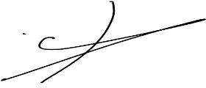




Name & Signature of the supervisor: Dr. Ali Alqrawi

Date of examination 11 December 2025

Table of Contents

ABSTRACT ii
ACKNOWLEDGEMENT iii
Table of Contents iv
CHAPTER 1: INTRODUCTION 1
CHAPTER 2: REVIEW OF LITERATURE 2
  - INTRODUCTION 2
  - THEORETICAL BASIS: THE ROLE OF REMOTE SENSING AND MACHINE LEARNING IN
ANALYSIS 2
  - THE SHIFT TOWARDS DEEP LEARNING AND UNMANNED AERIAL VEHICLES (UAVS)…2
  - REVIEW OF EXISTING SYSTEMS AND STUDIES 3
CHAPTER 3 : DESCRIPTION OF THE PROJECT AND SYSTEM DESIGN 5
  - ProjectDesign 5
  - High-Level Design (HLD)… 6
  - Low-Level Design (LLD)… 8
  - Target Population… 9
  - UML DIAGRAMS 10
  - PROTOTYPE 17
CHAPTER 4: SYSTEM IMPLEMENTATION AND RESULT 26
  - SYSTEM IMPLEMENTATION 27
  - IMPLEMENTATION WORKFLOW… 33
  - SYSTEM WORKFLOW EXECUTION 33
  - SYSTEM FUNCTIONALITY 34
  - RESULTS AND EVALUATION 34
  - CHALLENGES 35
  - TESTING AND VALIDATION 36
CHAPTER 5: SUMMARY AND CONCLUSIONS… 37
  - SUMMRAY OF PROJECT PHASES… 37
  - KEY ACHIEVEMENTS AND FINDINGS… 39
  - CONCLUSIONS… 40
  - FUTURE WORK AND IMPROVMENTS 40
CHAPTER 6: APPENDIX 42
APPENDIX I: SYSTEM SCREENSHOTS 42
APPENDIX II: DATASET 49
APPENDIX III: MODEL DETAILS 50
APPENDIX IIII: MODEL CODE… 51
APPENDIX IIV: DATABASE 53
APPENDIX IIIV: TIMELINE 56
CHAPTER 7: LITERATURE CITED 57

Classification: Personal

CHAPTER 1: INTRODUCTION

A number of environmental issues, such as rising temperatures, water scarcity, and nutritional deficiencies, have had an increasing impact on Saudi Arabian agriculture. Significant environmental stress caused by these factors has weakened crop resilience, decreased plant development, and resulted in long-term agricultural losses. Early identification has become essential for increasing production and safeguarding agricultural resources because many stress symptoms don't show up until damage has already been done.
Plant stress detection has a lot of potential because to recent developments in computer vision and deep learning (DL). Convolutional neural networks (CNNs) have been effectively applied in several research to categorise abiotic stressors and plant diseases using image-based data. For example, a thorough analysis showed that CNN models with excellent accuracy in leaf disease and stress classification tasks include VGG, ResNet, and EfficientNet.

Systems based on RGB picture datasets, in particular, have been shown to be successful in detecting several forms of stress, including water stress and nutrient deficits.
Based by these advancements, the current study suggests a deep learning-based system that uses image analysis to identify, forecast, and quantify plant stress. The system is intended to: (1) classify stressors (such as heat, drought, and nutrient deficiencies); (2) anticipate early stress before symptoms manifest; (3) assess the probable severity of damage; and (4) provide farmers with preventive measures. This design is in line with recent studies that support multi-task DL frameworks as effective instruments for precision agriculture. These frameworks can classify stress types, estimate their intensity, and provide early warning.
Through the integration of various functions, the system seeks to offer practical insights that facilitate timely and well-informed agricultural decisions. The anticipated result is a tool that improves crop resilience, lowers losses, and supports sustainable farming methods in areas that experience severe environmental and climatic stressors, such as a large portion of Saudi Arabia.

CHAPTER 2: REVIEW OF LITERATURE

INTRODUCTION
In this chapter, we present a comprehensive review of the literature on the current state of environmental stress detection and prediction in agriculture. The chapter traces the evolution of methodologies from traditional observation-based techniques to modern deep learning models, with a particular focus on the growing role of artificial intelligence (AI) and image-based analysis. This review also highlights the most significant research developments, highlighting their strengths and limitations, and shows how the current project benefits from these studies to address existing challenges, particularly those related to the agricultural context in Saudi Arabia.

THEORETICAL BASIS: THE ROLE OF REMOTE SENSING AND MACHINE LEARNING IN ANALYSIS
Modern stress detection in agriculture increasingly relies on advanced technological tools, forming the theoretical foundation for predictive analysis. This transition establishes a direct link between technological innovation and more accurate detection of plant stress. Detection of plant stress now centers on using advanced tools to identify subtle stress indicators invisible to the human eye. Remote sensing, image analysis, and artificial intelligence (AI) have become core components, predicting stress by analyzing plant attributes like color, temperature, and leaf composition. Integrating computer vision, machine learning, and real-time monitoring not only enhances sustainable agriculture decision-making but also strengthens the case for adopting AI-driven methods as the main path to more accurate, flexible, and productive environmental management.

THE SHIFT TOWARDS DEEP LEARNING AND UNMANNED AERIAL VEHICLES (UAVS)

The past decade has seen a radical shift in crop monitoring methodologies, with deep learning and remote sensing using unmanned aerial vehicles (UAVs) becoming the main drivers of a new generation of precision agriculture. Since around 2015, the integration of deep learning with UAV data has revolutionized research into plant stress detection. Previously, traditional remote sensing methods relied heavily

on simple spectral indices such as the Normalized Difference Vegetation Index (NDVI), which lack the ability to identify problems in their early stages or distinguish between different types of stress. Deep learning, particularly convolutional neural network models (CNN), has enabled the extraction of unprecedented features from complex, high-dimensional datasets, whether they are regular images or hyperspectral images. The combination of high-resolution aerial images captured by drones—which provide data at the canopy and plant part level—and the processing power of deep models has enabled the creation of systems capable of large-scale, real-time monitoring and pixel-level analysis. This advancement has enabled researchers and farmers to move from late detection to proactive prediction, ensuring targeted interventions and significantly reducing damage caused by environmental stress.
This collaboration between deep learning and drone imaging forms the basis for advanced methodologies, providing a powerful and effective tool for enhancing the accuracy and flexibility of crop management.

REVIEW OF EXISTING SYSTEMS AND STUDIES
This section reviews the methodology and technological models previously developed to detect plant stress, providing a critical assessment of their strengths and limitations. It is necessary to analyze similar research and studies that have addressed the application of artificial intelligence and remote sensing technologies in agriculture. These works have shown tremendous potential, but they have also revealed ongoing challenges related to accuracy and generalization.

Notable examples of reviewed systems and methodologies:

UAV-based Crop Stress Detection:
  - Methodology: These studies focus on the use of high-resolution images (usually multispectral or hyperspectral) captured by unmanned aerial vehicles. Traditional machine learning algorithms or deep learning models are trained on this data to classify the condition of plants (healthy, stressed, diseased).
  - Strength: Provides very high spatial accuracy and the ability to effectively monitor large areas repeatedly.
  - Limitations: Requires high computing power to process large amounts of data (Big Data), and its accuracy may be affected by lighting and shadow conditions.

Convolutional Neural Network Frameworks for Spectral Imaging:
  - Methodology: These models utilize the deep architecture of CNNs (such as ResNet or Inception) to analyze spectral and spatial characteristics in plant images. This approach is characterized by its ability to detect complex and nonlinear patterns associated with stress.
  - Strengths: High accuracy in classification and spatial localization of stress areas in the image, especially in the early stages of stress.
  - Limitations: Requires large, accurately labeled datasets for training, and may be less efficient in dealing with high variability in stress types.

Deep Learning Systems for Crop Leaf Diseases:

  - Methodology: These systems focus on detecting and classifying plant diseases and pests using images of leaves taken with standard RGB cameras or mobile phone cameras.
  - Strength: Easy to implement and access, as they do not require specialized sensors and can be part of decision-making tools for farmers.
  - Limitations: Ineffective in detecting hidden environmental stress (such as drought or heat) before visible symptoms appear on the leaves.

3D Analysis Systems for Early Stress Signatures:

  - Methodology: Uses 3D imaging techniques (such as LiDAR or photogrammetry from drones) to analyze the geometric structure of the plant canopy, as changes in plant height and canopy density are early indicators of stress.
  - Strength: Provides an additional (structural) dimension for stress detection, enhancing the predictive power of models.
  - Limitations: Significant complexity in collecting and processing 3D data, and high cost associated with sensors.

Identifying the research gap:
Despite significant advances in these systems, there remains a gap in the availability of robust, generalizable models specifically designed to detect and predict multiple environmental stresses (e.g., drought and heat) simultaneously, using spectral and spatial data. There is also an urgent need to develop computationally optimized models that can be integrated into real-time monitoring systems applicable in local agricultural environments.

Therefore, the current project methodology builds on the strengths of previous research, focusing on overcoming the limitations of early detection and combining stress types, providing a solid basis for the development of a practical and optimized model.

CHAPTER 3: DESCRIPTION OF THE PROJECT AND SYSTEM DESIGN

PROJECT DESIGN
This project is presented as a comprehensive roadmap that guides the development process from conceptualization to deployment. This roadmap ensures that each stage of the system is carefully planned, executed, and validated, allowing for replicability and scalability in real-world agricultural environments. By following the Waterfall methodology, the project progresses in a sequential manner.This structured approach guarantees that requirements are clearly defined, designs are thoroughly documented, and implementations are rigorously tested before deployment.
The roadmap begins with the High-Level Design (HLD), which establishes the system’s
architecture, identifies its core components, and sets the initial design principles. Following HLD, the Low-Level Design (LLD) specifies the technical details of each component, including workflows, database schemas, API endpoints, and user interface elements.
Once the design phases are complete, the Implementation stage translates these specifications into code, integrating the Faster R-CNN model with backend services and frontend dashboards. The testing phase validates functionality, performance, and usability, ensuring that the system meets its objectives with accuracy and reliability.
Finally, the deployment and maintenance phase delivers the system to end users. Within this roadmap, the system is designed to perform four core functions are:
- Stress detection
- Prediction problem
- Damage estimation
- Generate preventive actions

HIGH-LEVEL DESIGN(HLD)
The High-Level Design (HLD) describes the system architecture, core components, and initial design principles. It provides a structural overview of how the major layers of the system interact to perform stress analysis and generate preventive recommendations. As the foundation of the system, the HLD guides the Low-Level Design (LLD), Implementation, Testing, and Deployment phases.

System architecture
The system architecture consists of three main layers:
- Frontend Layer
  - Developed using HTML, CSS, JavaScript, and React.js
  - Allows users to upload images
  - Displays stress detection results, severity levels, and preventive recommendations
  - Ensures a responsive, user-friendly interface
- Backend Layer
  - Communicates with the frontend via RESTful APIs
  - Consists of:
  - Receiver Module: receives images from users
  - Processing Module: sends images to the model and interprets outputs
  - Database Module: stores results, user data, and metadata
  - Response Module: formats and returns the results to the frontend
- CNN Model Layer
  - Performs stress detection, prediction, and severity estimation
  - Generates preventive action recommendations based solely on image datasets
  - Integrated with backend services for real-time inference

Core Components
The system includes several core components that work cohesively to achieve its intended functionality:
- Frontend Interface
- Provides an intuitive platform for image upload and result visualization.
- Designed for simplicity and accessibility.
- Ensures minimal user effort for non-technical users such as farmers.
- Backend Services
- Acts as a communication hub between the frontend, deep learning model, and database.
- Implements RESTful APIs for structured and secure data exchange.
- Handles image processing, request management, and delivery of model predictions.
- CNN Deep Learning Model
- The central analytical engine of the system.
- Performs environmental stress detection, severity estimation, and predictive analysis.
- Outputs bounding stress types, and recommended actions.
- Database
- Stores processed images, predictions, timestamps, and user profiles
- Ensures organized and efficient data retrieval
- Supports long-term storage for research and analysis

Initial Design Principles
      - Modularity
      - Scalability
      - Accuracy
      - Usability
      - Maintainability

LOW-LEVEL DESIGN (LLD)
The Low-Level Design (LLD) phase is where detailed specifications for each component are defined. It describes the internal workflow and step-by-step processing of the system.
The LLD workflow includes:
- Image Upload: User submits a crop image through the frontend.
- Preprocessing: Image is resized, normalized, and enhanced for model input.
- CNN Stress Analysis: The model performs detection and classification.
- Damage Estimation: Stress severity is quantified and analyzed.
- Preventive Action Generation: Recommendations are generated based on the stress type.
- Database Storage: Results and metadata are saved.
- Result Delivery: Final outputs are sent to the frontend for user display.

TARGET POPULATION

- Farmers
  - Benefit from early stress detection
  - Receive accurate, image-based assessments
  - Gain preventive recommendations to avoid crop loss
  - Can make informed decisions about irrigation, fertilization, and pest control

- Agricultural Researchers
  - Access reliable datasets
  - Use automated stress analysis for experiments
  - Gain insights into local crop behavior

By considering the design stages, the project ensures usability and effectiveness:

  - HLD: Guarantees scalability for large-scale farming.
  - LLD: Provides detailed specifications for practical implementation.
  - Implementation and Testing: Ensure accuracy and reliability of stress detection.
  - Deployment: Offers accessible tools for real-world agricultural environments.

UML DIAGRAMS
Unified Modeling Language (UML) is a general-purpose modeling language. The main aim of UML is to define a standard way to visualize the way a system has been designed.

Use case diagram
Use Case Diagrams are used to depict the functionality of a system or a part of a system. They are widely used to illustrate the functional requirements of the system and its interaction with external actors.

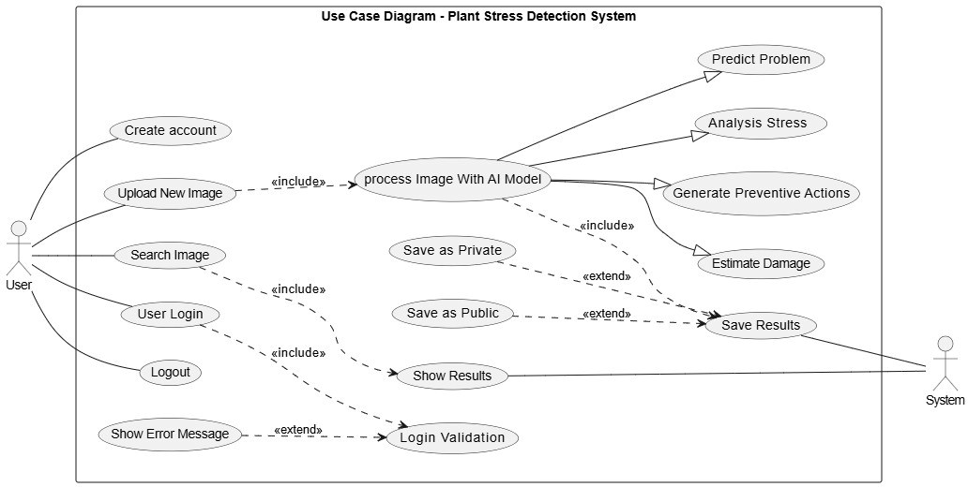

Sequence Diagram
A sequence diagram simply depicts interaction between objects in a sequential order.

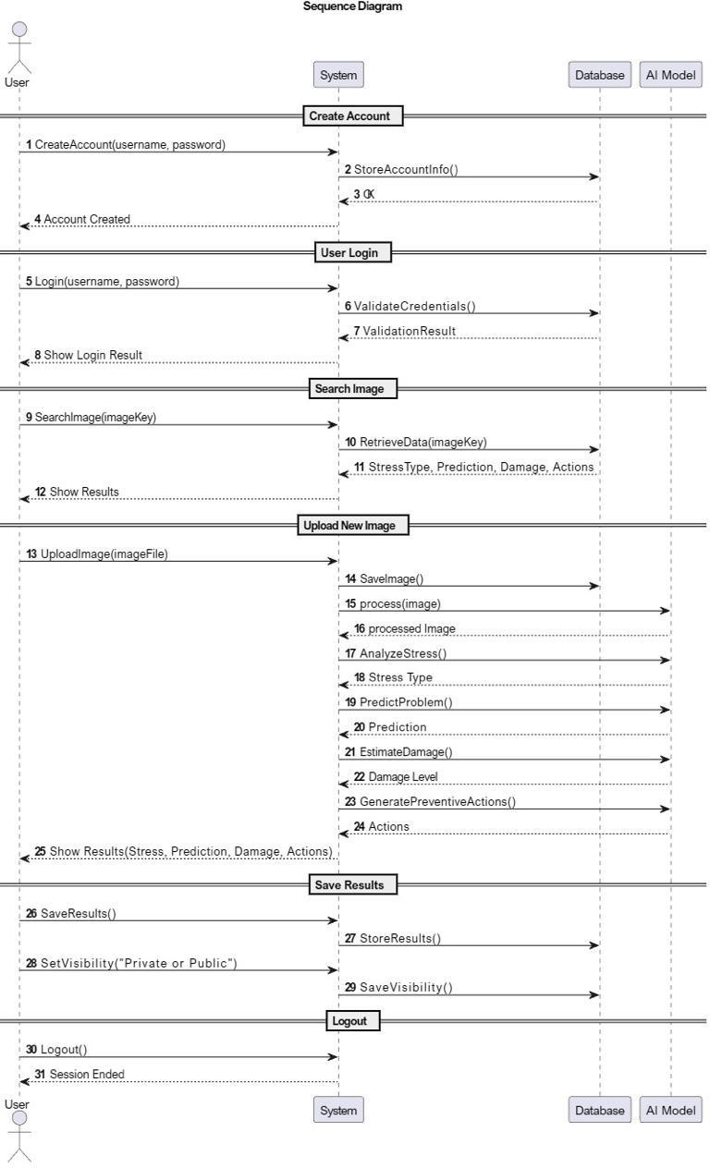

Activity Diagram
Activity diagrams are graphical representations of workflows of stepwise activities and actions with support for choice, iteration, and concurrency. In the UML activity diagrams are intended to model both computational and organizational processes, as well as the data flows intersecting with the related activities.
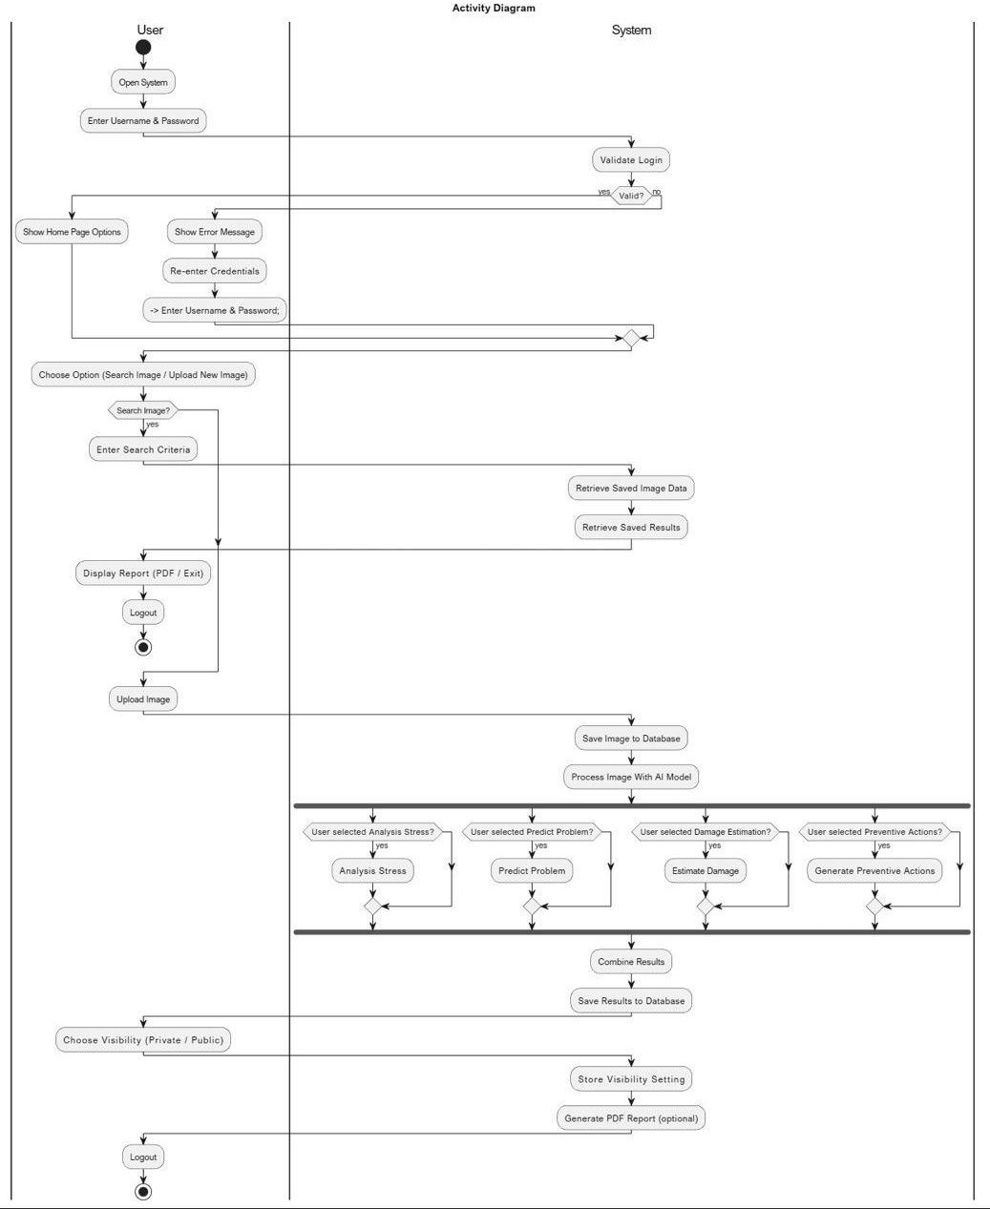

State Diagram
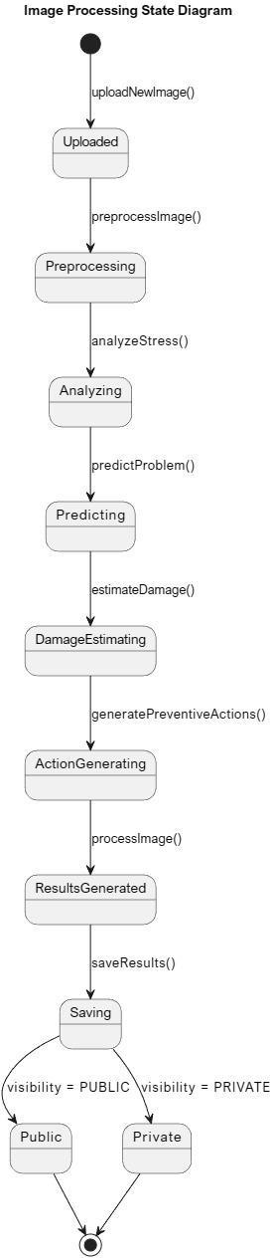
A state diagram is used to represent the condition of the system or part of the system at finite instances of time. It’s a behavioral diagram and it represents the behavior using finite state transitions.

Class Diagram
A class diagram visually represents the structure of a system by showing its classes, attributes, methods, and the relationships between them.

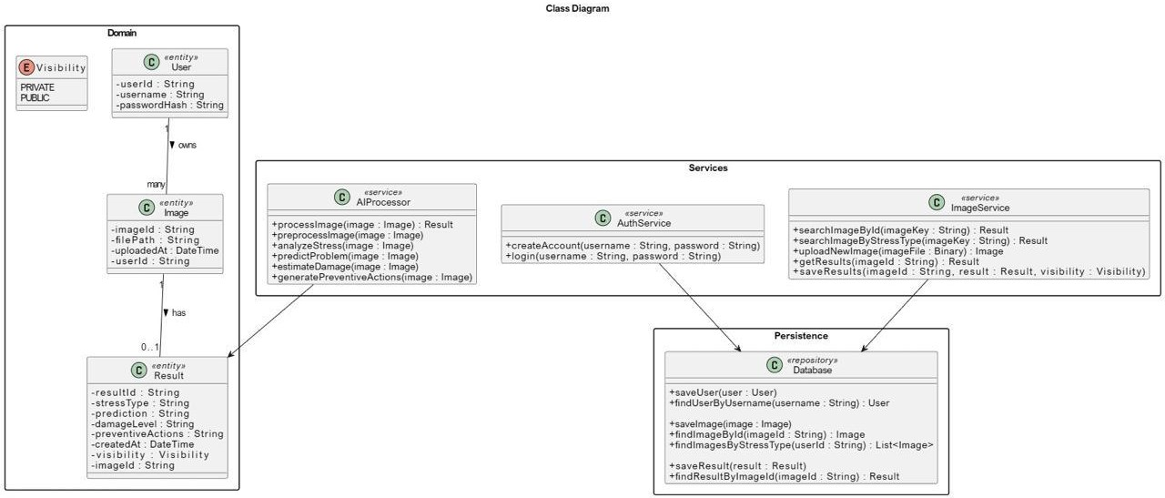

Collaboration Diagram
A collaboration diagram, also known as a communication diagram, is a visual representation of the relationships and interactions among software objects within Unified Modeling Language (UML).

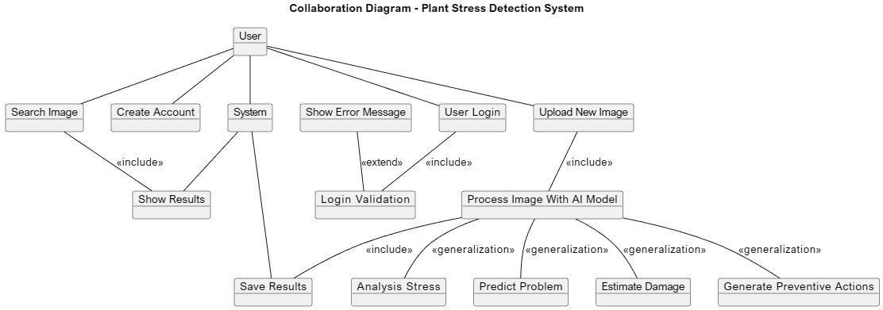

Entity Relationship Diagram (ERD)
The Entity-Relationship (ER Model) is a conceptual model for designing a database. This model represents the logical structure of a database, including entities, their attributes and relationships between them.

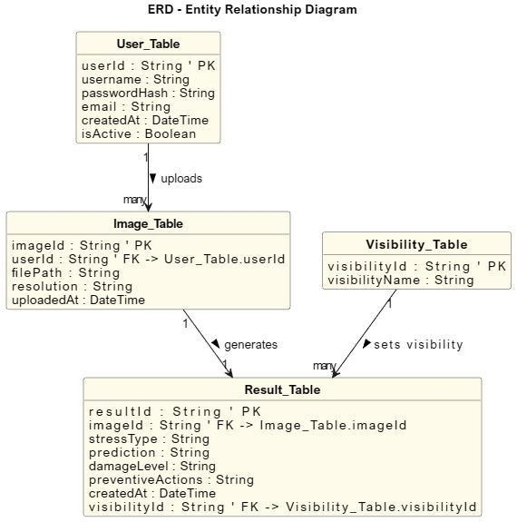

PROTOTYPE

The prototype demonstrates:
- User Authentication and Access:
- The prototype includes login and sign-up interfaces, enabling secure access.
- User accounts allow personalized storage of analysis reports and retrieval of past results.
- Dashboard Interface:

- The dashboard provides an overview of total analysis, and critical alerts.
- Users can upload new crop images or search for saved images.
- Real-time monitoring ensures that farmers are immediately notified of urgent stress conditions.
- Analysis Workflow:

- Image Input: User upload crop images through the dashboard.
- CNN Analysis: The Faster R-CNN model processes the image to detect stress symptoms.
- Stress Type Identification: The system identifies specific stress types such as Citrus Black Spot or Drought Stress.
- Prediction Before Problem: The system forecasts potential spread or worsening of the detected stress if untreated.
- Damage Estimation: Severity levels are assigned to quantify the extent of damage.
- Preventive Actions: Actionable recommendations are generated, such as pruning infected branches, applying fungicides, or immediate irrigation.
- Report Generation:

- PDF reports can be generated for printing or sharing.
- Reports include diagnosis, severity, impact prediction, and recommended actions.

- Each report is linked to an image ID for traceability and verification.

- Data Management:

- Users can choose privacy levels (public or private) when saving reports.
- Stored analyses can be searched by image ID or stress type.
User interface
Environmental factors such as drought, heat, and salinity negatively affect agricultural production, making early detection essential. Through an interactive user interface, this prototype allows users to easily upload plant images and instantly analyze them using deep learning techniques. The system classifies different stress types and displays the results visually with early alerts. The interface is designed to support users in making faster decisions about plant conditions and improving crop management. Ultimately, this tool contributes to monitoring plant health and promoting sustainable agricultural production.

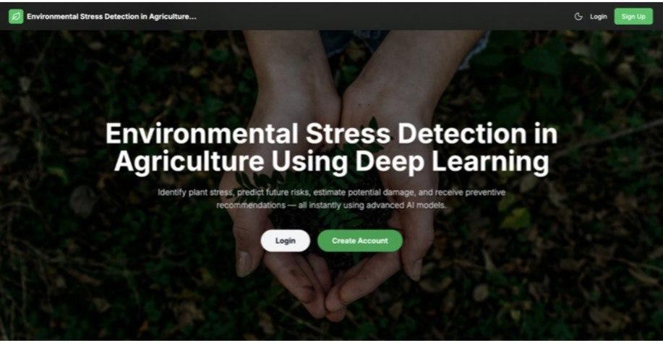





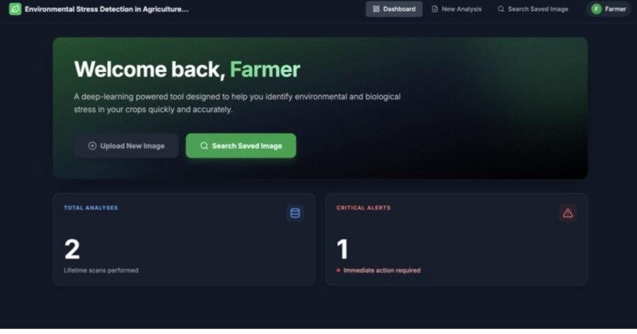

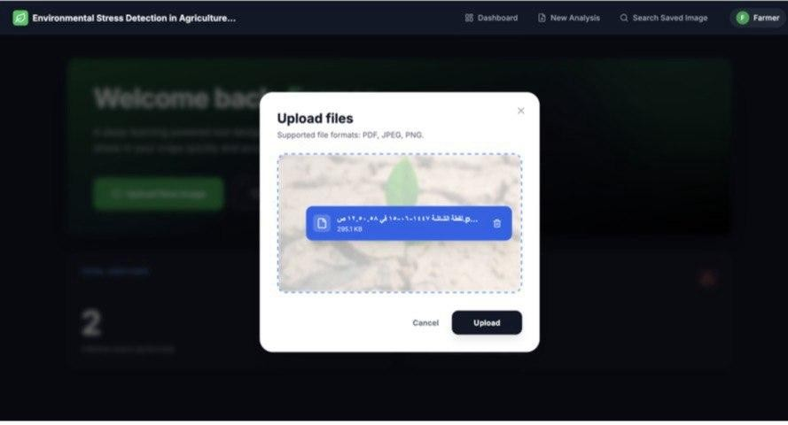

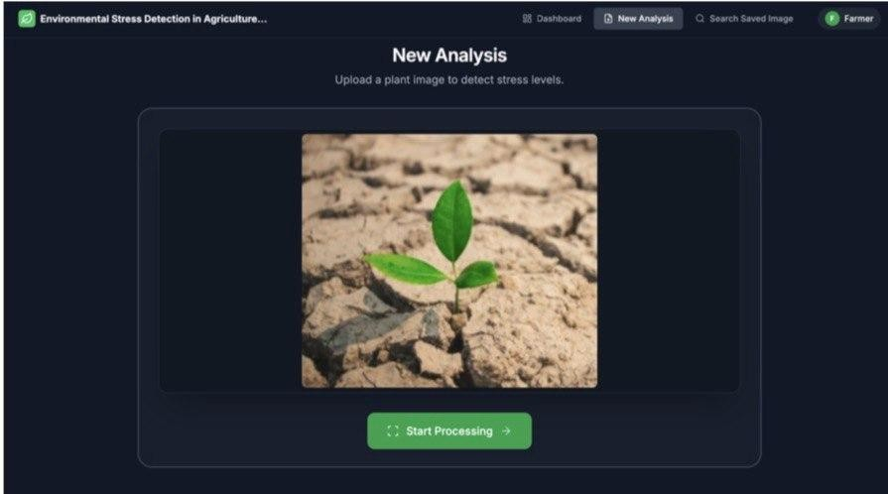

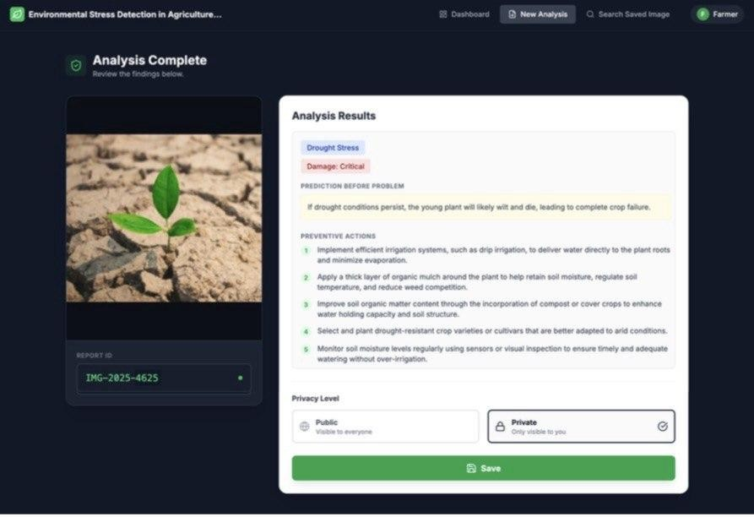



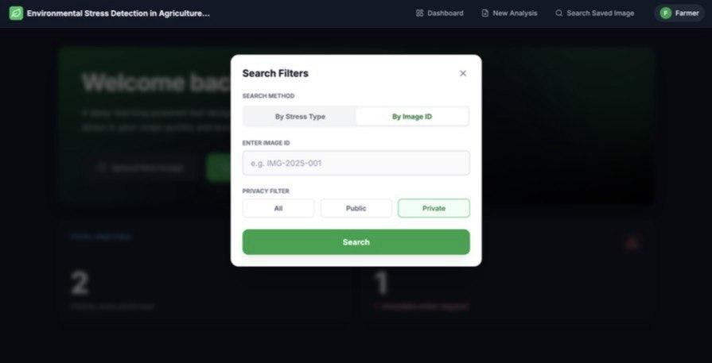

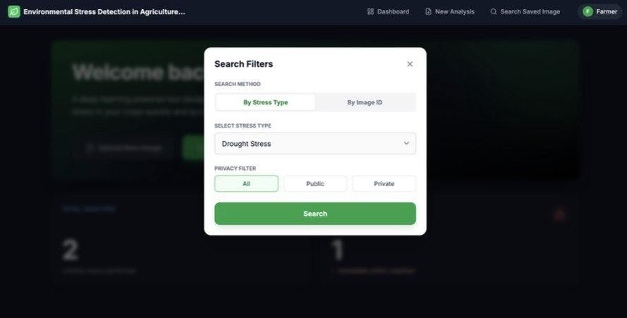

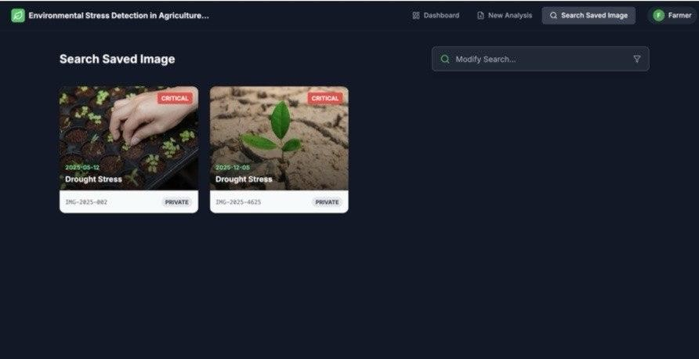

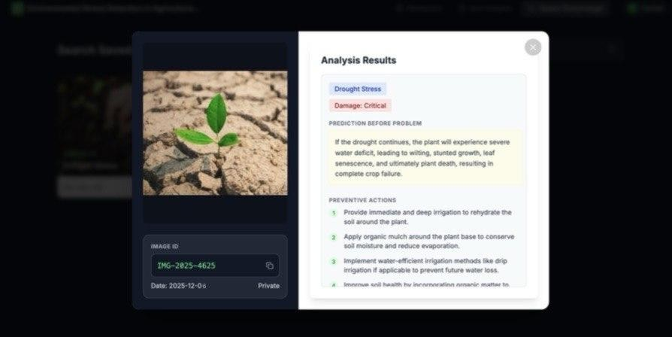



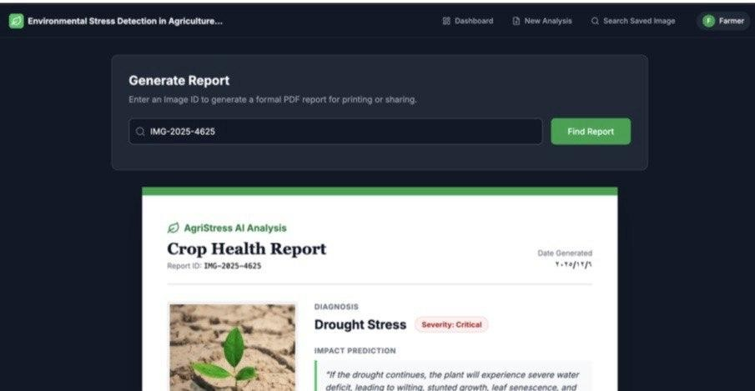

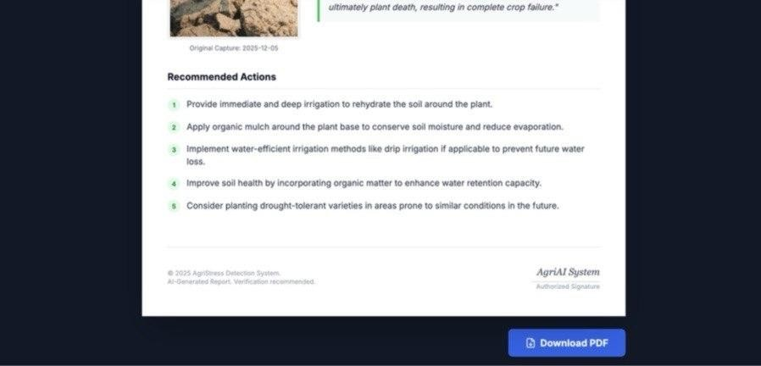

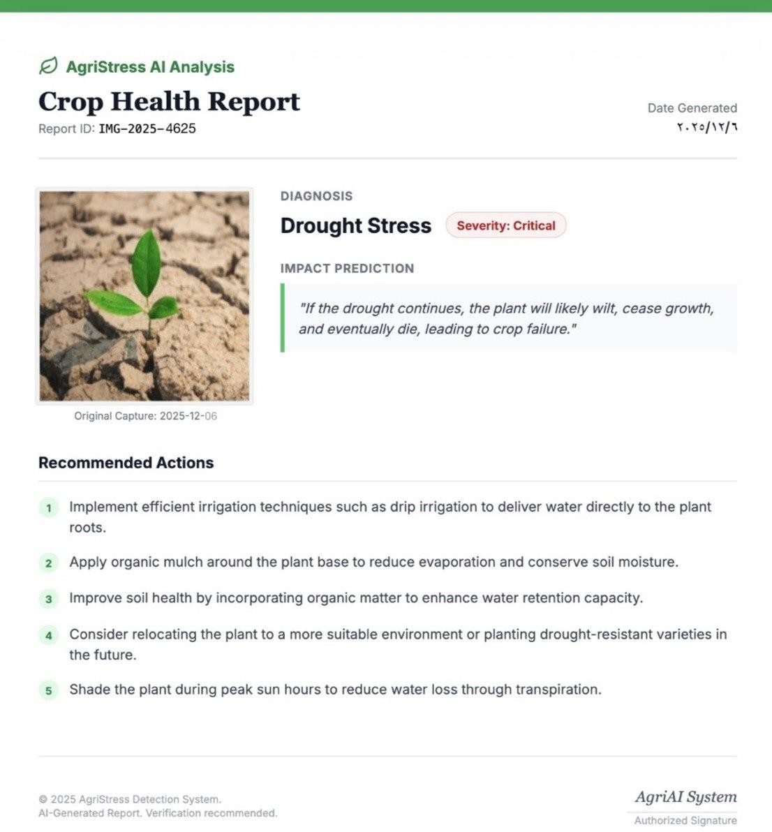

CHAPTER 4 : SYSTEM IMPLEMENTATION AND RESULTS
This chapter describes how a system for environmental stress detection in plants was implemented based on High-Level Design (HLD) and Low-Level Design(LLD). The implementation phase focuses on transforming architectural components into working modules, ensuring that each layer of the system operates coherently to deliver the best functionality.
The system was developed as website, integrating multiple technologies, including a deep learning model based on Faster R-CNN, a backend service for data processing and communication, and a simple user frontend interface for interaction with the system. The backend was implemented using Python because it has strong support for machine learning frameworks and data processing libraries, while C was utilized to enhance performance in computationally intensive operations, contributing to faster execution and efficient resource handling.
The overall workflow, from image uploaded to stress detection, severity estimation, and preventive action generation, was executed and validated to ensure consistency and reliability. During implementation, attention was given to dataset selection and model training. One of the considerations was the availability and quality of labeled agricultural datasets. It was observed that while datasets for certain crops, especially tomato plants, were relatively well-organized and sufficient for training, datasets for other plants were limited and inconsistent. As a result, the system demonstrated more reliable and consistent results when applied to tomato plants, which became the primary focus for performance optimization and evaluation in this project.

SYSTEM IMPLEMENTATION
The implementation phase translates the structured design into a fully functional system by integrating the frontend, backend, database, and Faster R-CNN model into a cohesive architecture.

Frontend Implementation
The frontend was developed using web technologies, including HTML, CSS, JavaScript, and React.js, to provide an interactive and user-friendly interface. The design focused on simplicity and accessibility to ensure that users can easily interact with the system without requiring technical expertise.
The frontend interface allows users to upload images of plant leaves directly from their devices. Once an image is uploaded, it is sent to the backend through an API request, and the system processes it in real time. The results are then displayed in an organized manner, including stress type, severity levels, and recommended preventive actions.
After viewing the results, users can control the visibility of the analyzed image by setting it as public or private. The system also enables users to search for saved images stored in the database using the image path. In addition, users have the ability to download a report of the analyzed image, which includes the diagnosis results and recommended actions.

Figure 4.1.1 : The figure shows the user interface where users can upload plant leaf image to analysis
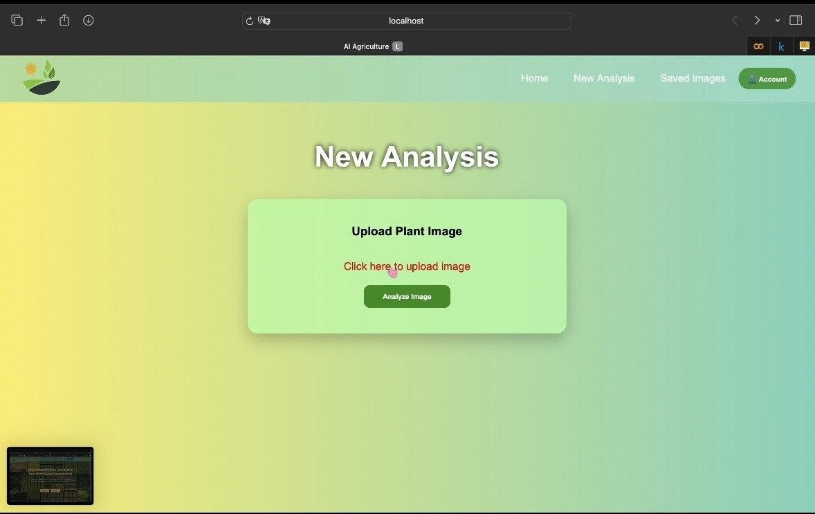

Example of code snippet:
function Login(){
const navigate = useNavigate()
const [showSignup,setShowSignup] = useState(false)

const [name,setName] = useState("") const [email,setEmail] = useState("")
const [password,setPassword] = useState("")
const [confirmPassword,setConfirmPassword] = useState("")

Backend implementation
The backend was implemented using a RESTful API to ensure efficient and reliable communication between the frontend and the deep learning model. It acts as the central processing unit of the system, responsible for handling requests, managing data flow, and coordinating interactions between different components.
The backend was developed using Python due to its strong ecosystem of libraries for machine learning, image processing, and API development. Additionally, the C programming language was incorporated to optimize execution speed and improve computational efficiency.
The backend consists of several interconnected modules. The Receiver Module is responsible for accepting image uploads from the frontend and validating the input data.
The Database Module is responsible for storing data, including users’ information, images, and results. The Response Module formats the processed results into structured responses in JSON format, and sends them back to the frontend visualization.

Model Implementation ( Faster R-CNN )
The core of the system is the deep learning model based on Faster R-CNN, which is used for classification. The model was implemented using the deep learning framework PyTorch, enabling efficient training and inference. To enhance performance, EfficientNet-B3 was integrated as a backbone network for feature extraction.
During implementation, the model was trained on a labeled dataset containing images of tomato leaves affected by different types of environmental stress. The training process involved multiple stages, including data preprocessing, annotation handling, model fine-tuning, and performance evaluation.
The model performs several tasks simultaneously. It detects stress, classifies the type of stress, and estimates the severity based on the extent of the affected area.
It was observed during implementation that the availability of high-quality datasets significantly influenced model performance. The model achieved higher accuracy when trained on well-annotated tomato datasets, while performance on other plant types was lower due to limited data. As a result, the implementation focused primarily on optimizing performance for tomato plants.

Figure 4.1.4: The figure shows Confusion Matrix for model
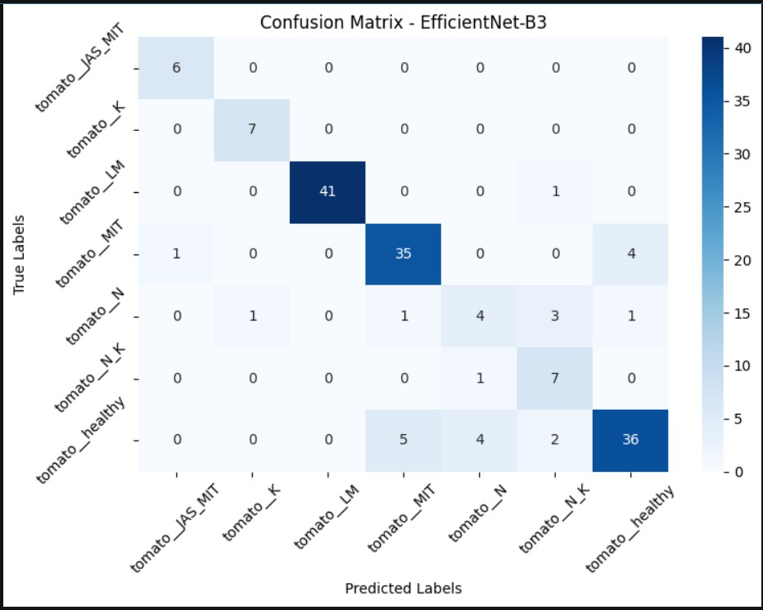

Example of code snippet:
model = models.efficientnet_b3(weights=models.EfficientNet_B3_Weights.DEFAULT) num_ftrs = model.classifier[1].in_features
model.classifier = nn.Sequential(
nn.Dropout(p=0.5), # strong protection against overfitting nn.Linear(num_ftrs, len(class_names))
)
model = model.to(device)

Database implementation
The database was implemented to store and manage system data. A relational database management system MySQL,was used to ensure efficient data organization, consistency, and fast retrieval.
It consists of several tables, including:
- Users Table
This table stores information about the system users. It contains a unique identifier for each user along with their personal details such as username, email, and password. It also includes account status and the creation date. This table is essential for user authentication and management within the system.
- Images Table
This table stores information about images uploaded by users. Each record includes a unique image ID, the associated user ID, the path of the image, image resolution, and upload timestamp. It is linked to the Users table through a foreign key relationship, ensuring that each image is associated with a specific user.
- Result Table
This table stores the results generated by the Faster R-CNN model after processing the uploaded images. It includes stress type, prediction output, damage level, and recommended preventive actions. It is linked to both the Image and Visibility tables through foreign keys, ensuring proper mapping between input data, results, and access control.
- Visibility Table
This table defines the visibility settings for system results. It contains predefined values that determine whether a result is public or private. This allows users to control the accessibility of their analysis results, enhancing data privacy and user control within the system.

Figure 4.1.4: The figure shows Image table
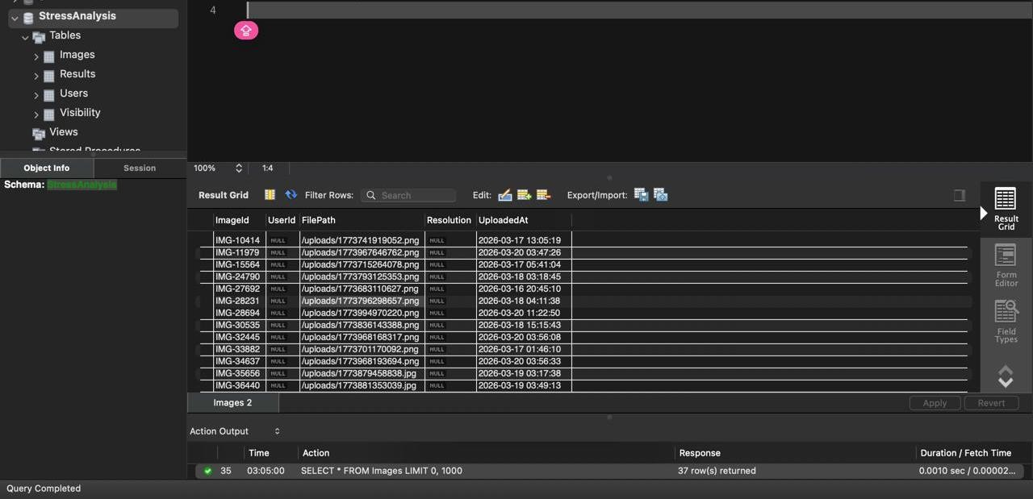

Example of code snippet:
CREATE DATABASE StressAnalysis; USE StressAnalysis
CREATE TABLE Users (
UserId VARCHAR(50) PRIMARY KEY, UserName VARCHAR(100) NOT NULL, Password VARCHAR(255) NOT NULL, Email VARCHAR(150) NOT NULL,
CreatedAt DATETIME,
IsActive BOOLEAN);

IMPLEMENTATION WORKFLOW

- Model Development:
The Faster R-CNN model with EfficientNet-B3 backbone was trained and optimized using labled plant stress images.
- Database Development:
The database was implemented using MySQL based on an ERD. 3- Frontend Development:
A user-friendly interface was built using React.js to allow image upload and display results.
4- Backend Integration:
RESTful API’s were developed to connect the frontend with the traind model and database system.

SYSTEM WORKFLOW EXECUTION
The system workflow represents the sequence of operations performed from when a user uploads an image until the final results are displayed. This workflow was implemented according to the specifications in the Low-Level Design (LLD), ensuring consistency and efficiency across all stages.
The process begins when the user logs into the system or creates a new account through the frontend interface. Once authenticated, the user uploads an image via the interface. The image is then transmitted to the backend through a RESTful API request.
The backend receives the image, then it is forwarded to the Faster R-CNN model for analysis. The model detects regions of interest, classifies the type of environmental stress. In addition, the system estimates the severity of stress by analyzing the proportion of the affected region relative to the entire image.
Following the detection phase, the system generates recommended prevention based on the identified stress type to help users in taken appropriate actions.
The results are then presented to the user through the frontend interface,including detection outputs and recommendations. The user can choose the visibility of the results by setting them as public or private.
The results are stored in the database and linked to the user’s account. The system also provides the option to download a detailed report summarizing the analysis, detected stress, severity level, and recommended actions.

SYSTEM FUNCTIONALITY
The system successfully implements the four core functions defined in Chapter 3:
- Stress Detection
The model identifies stressed regions in plant images.
- Prediction Problem
The system predicts the type of environmental stress affecting the plant.
- Damage Estimation
Severity is calculated based on the affected area and classification confidence.
- Preventive Action Generation Recommendations are generated automatically.

RESULTS AND EVALUATION
The implemented system successfully achieves its primary objectives by performing stress detection, prediction, damage estimation, and recommendation generation. The outputs are presented in a user-friendly format, allowing users to interpret results easily.

Model Performance
The model achieved an overall accuracy of 88% on the test dataset, demonstrating strong performance in detecting and classifying various types of plant environmental stress on tomato plants.

Sample Output
Figure 4.5.2: Stress Detection Result

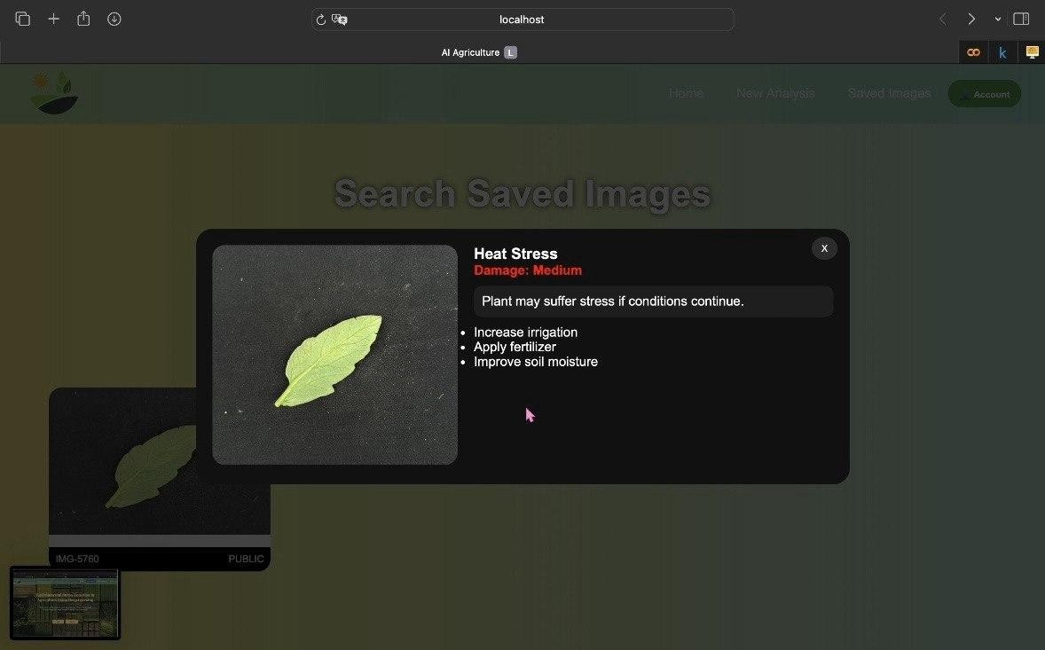

Testing Result
The system was tested across multiple scenarios:
      - Different types of stress
      - Different light conditions
      - Different plant species
Results showed high detection accuracy in clear images, a slight performance drop in low-quality images, and reliable recommendation generation.

CHALLENGES
During the implementation , several challenges were encountered that affected system performance and required careful handling.
One of the major challenges was the limited availability of suitable datasets for multiple plant species. While datasets for certain crops were available, they were often imbalanced or lacked sufficient diversity. When experimenting with datasets that

included a wide variety of plant types, the model overall accuracy decreased. This was due to the increased variability in plant characteristics and the insufficient number of labeled samples for each class.
It was observed that the model achieved higher accuracy when trained on tomato datasets, as they were more comprehensive and better labeled compared to datasets of other plants. In contrast, the performance of the model on other plant types was relatively lower due to insufficient and less consistent training data.
Another challenge involved optimizing model performance while maintaining reasonable processing time. High-resolution images increased computational cost, which required optimization techniques such as image resizing.
In addition, integrating different components, including the frontend, backend, database, and deep learning model, posed challenges in ensuring communication and data consistency.

TESTING AND VALIDATION
To ensure that the system meets the requirements, a testing and validation process was conducted. This process evaluates system functionality, performance, accuracy, and usability.
Functional testing was conducted to verify that all system components operate correctly. This includes testing image upload functionality, API response, and result display.
Performance testing focused on measuring system responsiveness and inference time.
Accuracy testing was conducted using standard evaluation metrics. The model predictions were compared against ground truth labels to assess their effectiveness in detecting and classifying plant stress.
Usability testing was also performed to ensure that the system is easy to use and accessible to non-technical users.
The evaluation results indicate that the system performs effectively in detecting environmental stress in plants, particularly for tomato crops. Additionally, the results confirm that the system successfully meets the objectives defined in the High-Level Design (HLD), including system integration, real-time processing capability, and user accessibility.

Chapter 5: SUMMARY AND CONCLUSIONS
A comprehensive summary of the project’s progress from the High-Level Design phase to deployment, highlighting the major achievements, system performance, and how each phase contributed to the final functionality. The chapter also presents the main conclusions drawn from the system’s implementation and evaluation, along with proposed future improvements that could enhance accuracy, scalability, and real-world applicability.

SUMMRAY OF PROJECT PHASES
This project followed a structured development process beginning with the High-Level Design (HLD) and progressing through Low-Level Design (LLD), implementation, testing, and deployment. Each phase contributed essential components that shaped the final system for environmental stress detection in agriculture.

High-Level Design (HLD)
The HLD phase established the overall architecture of the system, defining the three main layers:
    - Frontend Layer for user interaction and image upload.
    - Backend Layer for processing, communication, and data management.
    - Deep Learning Model Layer for stress detection, severity estimation, and prediction.
This phase ensured that the system was modular, scalable, and aligned with the project’s
goals of real-time stress analysis and user accessibility.

Low-Level Design (LLD)
The LLD phase translated the architectural blueprint into detailed workflows. It defined:
    - Image preprocessing steps
    - Model inference pipeline
    - Database schema (Users, Images, Results, Visibility)
    - API endpoints and data flow
    - User interface behavior

This phase ensured that each component had clear specifications, enabling smooth implementation.

Implementation Phase
During implementation, the system was developed as a functional web application integrating:
    - React.js frontend for image upload, result visualization, and report generation
    - Python backend with optimized C modules for performance
    - MySQL database for structured data storage
    - Faster R-CNN with EfficientNet-B3 backbone for stress detection and classification
The model was trained primarily on tomato plant datasets due to their availability and annotation quality, resulting in higher accuracy for this crop type.

Testing and Validation
The system was tested to ensure:
    - Correct stress classification
    - Accurate severity estimation
    - Smooth communication between frontend, backend, and database
    - Reliable report generation and user authentication
Confusion matrix results confirmed strong performance on tomato datasets, validating the
model’s effectiveness.

Deployment Phase
The final system was deployed as a web-based platform enabling:
    - Real-time image analysis
    - User account management
    - Report downloading
    - Public/private result visibility
    - Search functionality for stored analyses

Deployment ensured that the system was accessible, functional, and ready for real-world agricultural use.

KEY ACHIEVEMENTS AND FINDINGS
The project successfully achieved its core objectives:

Accurate Stress Detection
The Faster R-CNN model demonstrated strong performance in identifying stress types such as drought, heat, and disease symptoms, particularly in tomato plants.

Severity Estimation and Prediction
The system not only detected stress but also estimated its severity and predicted potential progression, supporting early intervention.

Real-Time Analysis
The integration of the model with the backend enabled fast inference, allowing users to receive results within seconds.

User-Friendly Interface
The frontend provided an intuitive experience for farmers and researchers, requiring no technical expertise.

Structured Data Management
The MySQL database ensured organized storage of images, results, and user information, supporting long-term research and monitoring.

Alignment with HLD and LLD
The final system closely followed the initial design principles, demonstrating:
  - Modularity
  - Scalability
  - Maintainability
  - Practical usability
Each phase contributed directly to the system’s final functionality, validating the design
approach.

CONCLUSIONS
This project demonstrates the effectiveness of deep learning—specifically Faster R-CNN with EfficientNet-B3—in detecting environmental stress in plants using image-based analysis. The system provides a comprehensive solution that includes stress classification, severity estimation, prediction, and preventive recommendations.
The results confirm that AI-driven agricultural monitoring can significantly enhance early detection, reduce crop losses, and support sustainable farming practices. The system’s performance was strongest on tomato datasets, highlighting the importance of high-quality labeled data in agricultural AI applications.
Overall, the project successfully delivered a functional, scalable, and user-centered system aligned with the initial objectives and design specifications.

FUTURE WORK AND IMPROVMENTS
Although the system achieved its goals, several enhancements can further improve performance and expand its applicability:

Expanding the Dataset
  - Collecting more diverse datasets for different crops
  - Improving annotation quality
  - Including multispectral or hyperspectral images
This would increase model generalization across plant species.

Enhancing the Model
  - Experimenting with YOLOv8, DETR, or Vision Transformers
  - Adding multi-task learning for simultaneous stress type + severity prediction
  - Incorporating temporal data for long-term stress monitoring

Improving the HLD
  - Adding a dedicated module for drone-based image ingestion
  - Integrating cloud-based GPU inference for faster processing
  - Supporting offline mobile app functionality for field use

Real-Time Deployment Enhancements
  - IoT sensor integration (soil moisture, temperature, humidity)
  - Automated irrigation or fertilization triggers
  - Dashboard analytics for long-term farm monitoring

User Experience Improvements
  - Multi-language support (Arabic/English)
  - Voice-based interaction for farmers
  - More detailed PDF reports with charts and visualizations

Final Statement
The project successfully demonstrates how deep learning can transform agricultural stress detection into a fast, accurate, and accessible process. With further enhancements in datasets, model architecture, and system integration, the system has strong potential to evolve into a comprehensive precision agriculture platform capable of supporting farmers across diverse environments.

CHAPTER 6: APPENDIX

Appendix I: System Screenshots
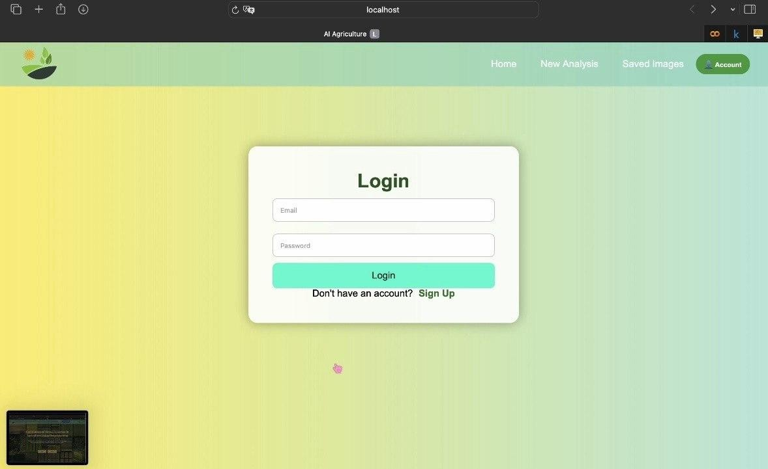
Figure A1: Login Interface

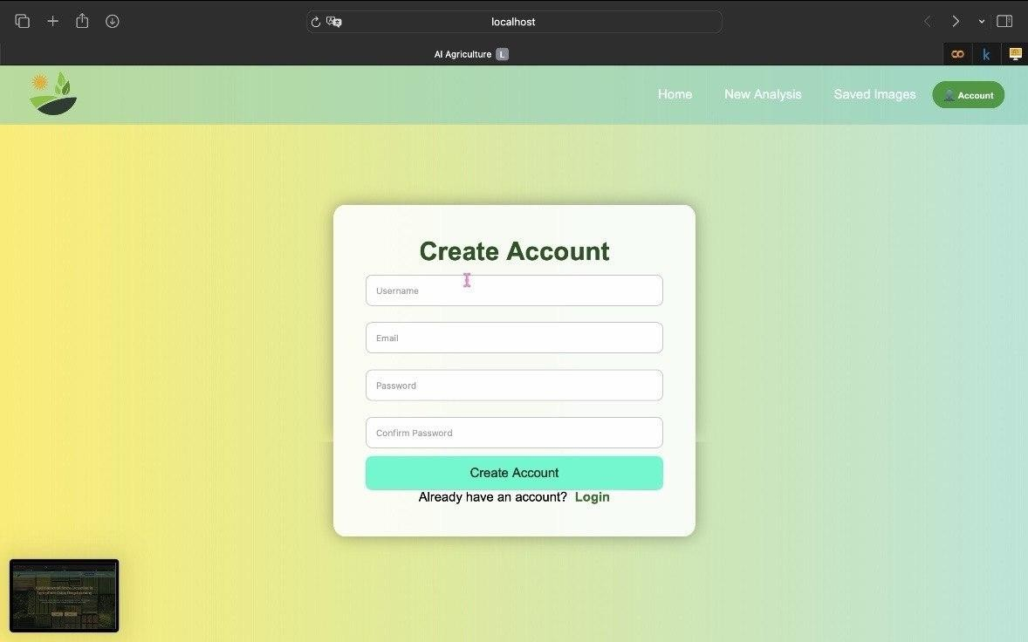
Figure A2: Create Account Interface
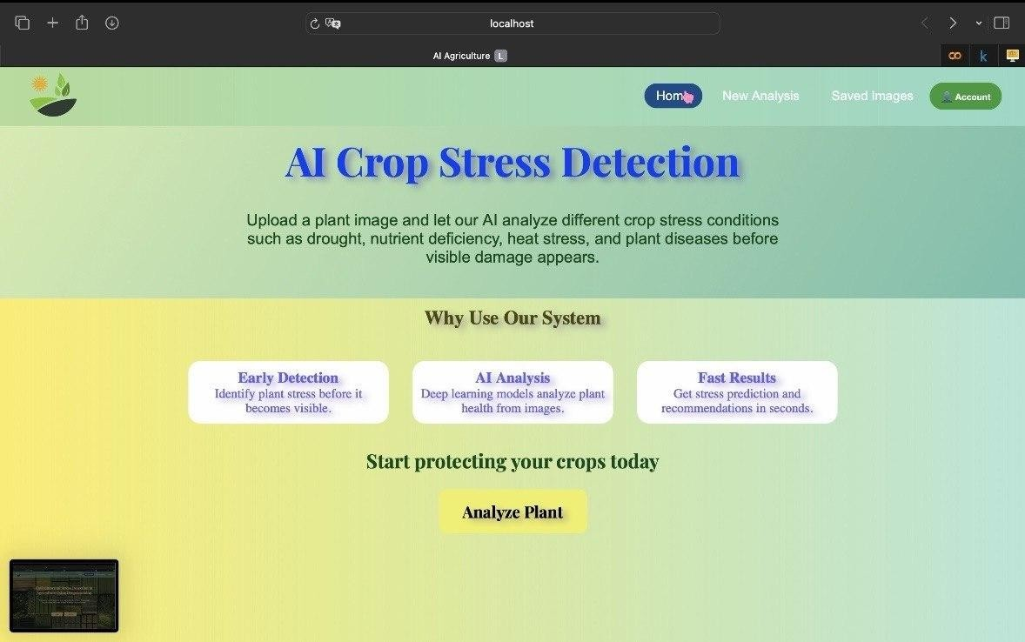
Figure A3: Dashboard


Figure A4: Image Upload

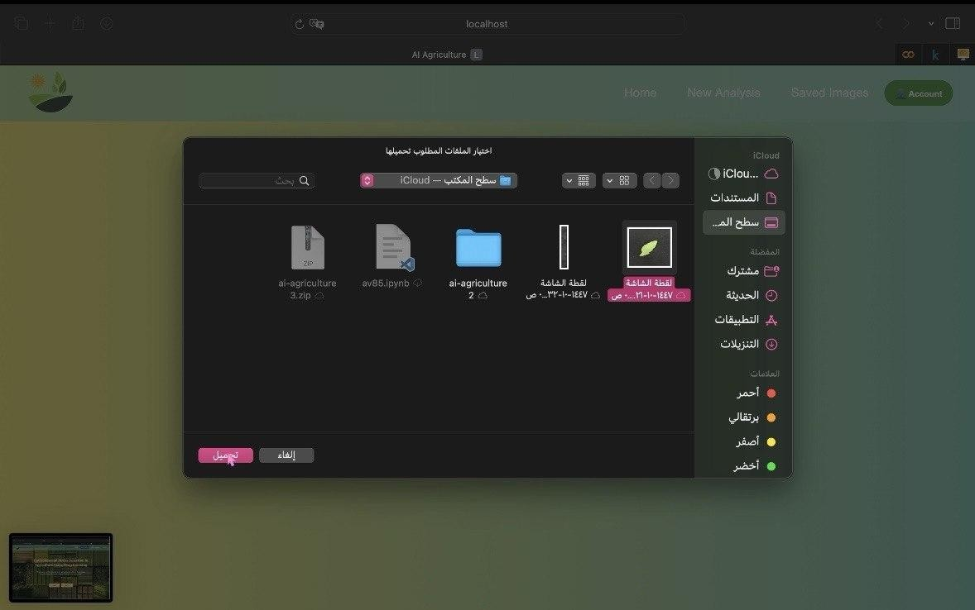

Figure A4: Image Upload Screen
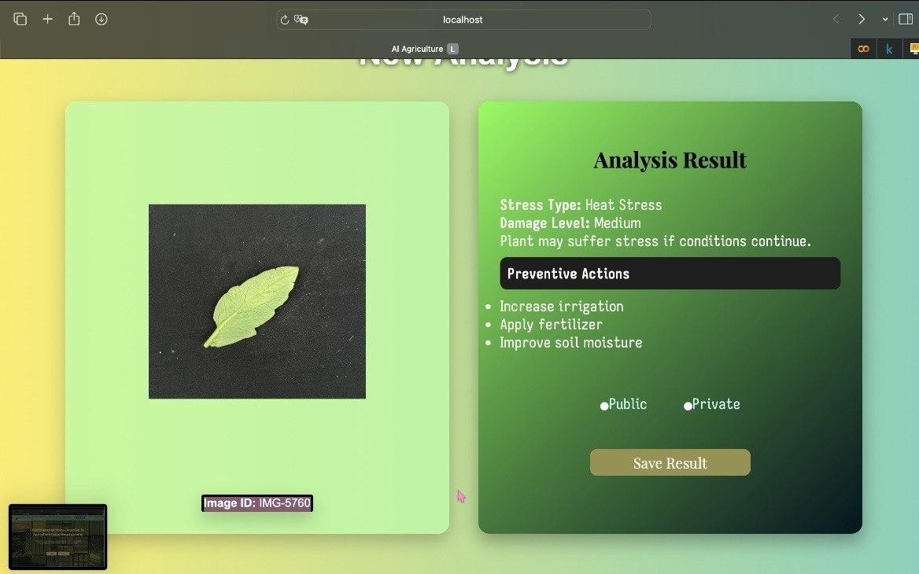
Figure A5: Stress Detection Result

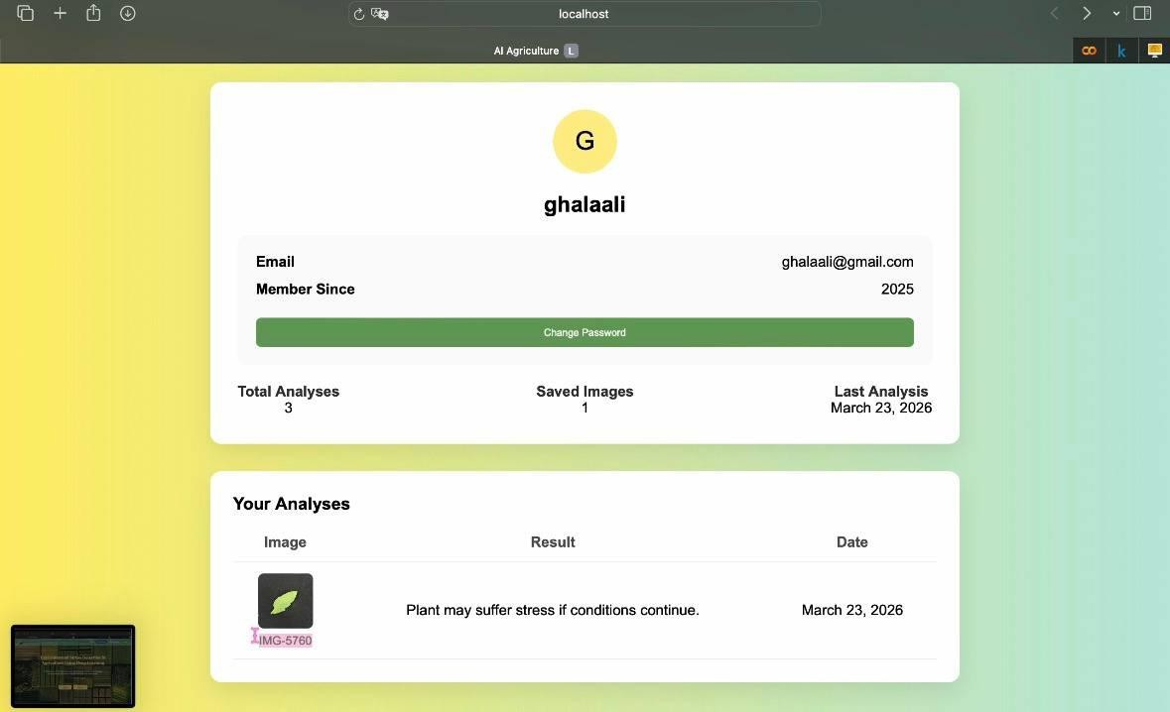

Figure A6: Personal Home
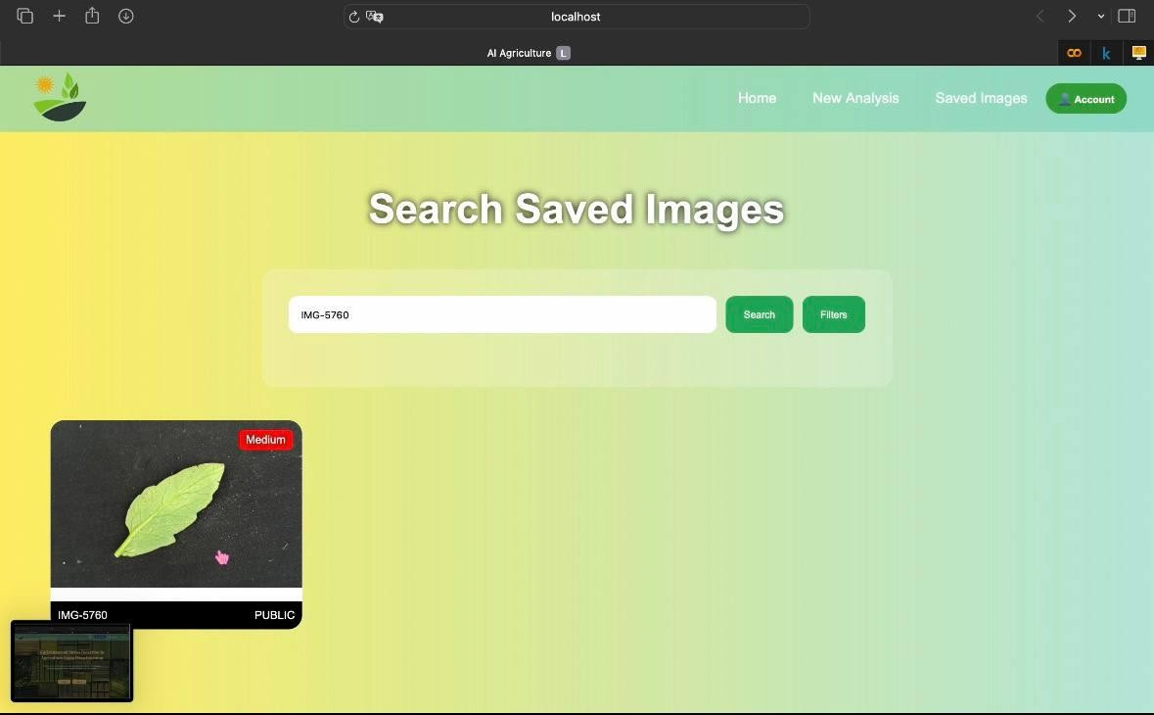

Figure A7: Search Saved Image Screen



Figure A8: Stress Detection Result
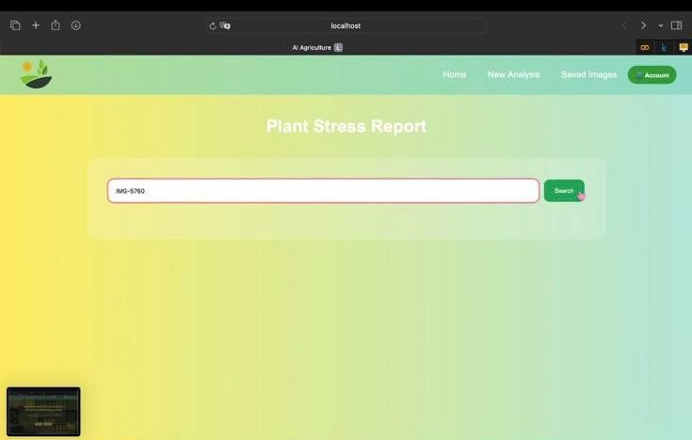
Figure A: Search plant Stress Report

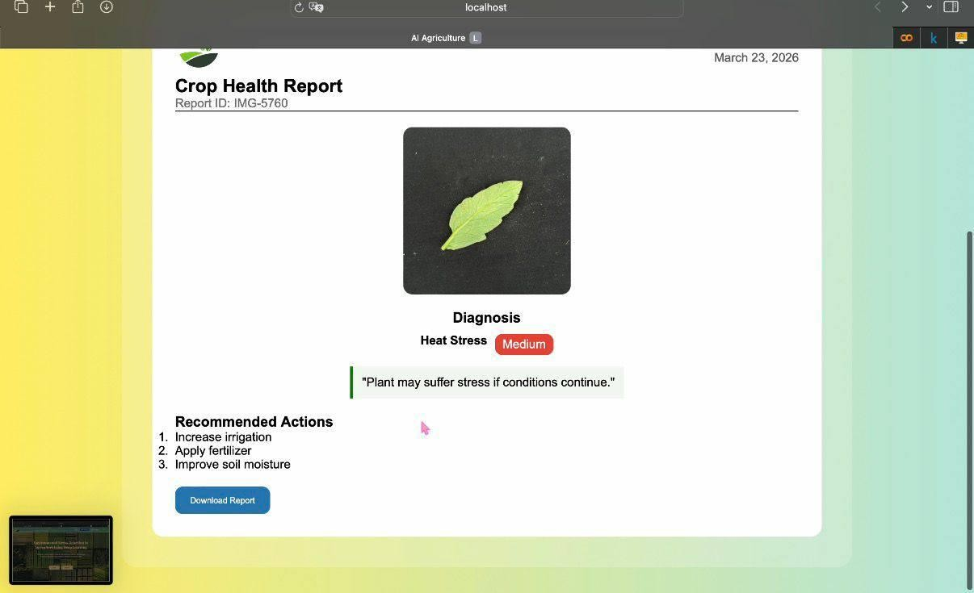
Figure A10: Generated Report

Appendix II: Dataset

The dataset used in this project consists of tomato plant images collected and categorized into three classes: Healthy, Diseased, and Nutrient Deficiency Source: kaggle.com

Healthy Diseased Nutrient Deficiency

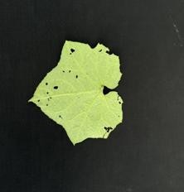


All images resized to 300×300 pixels

Appendix III: Model Details

Model name:EfficientNet-B3 epochs: 20
Accuracy:86%-88%

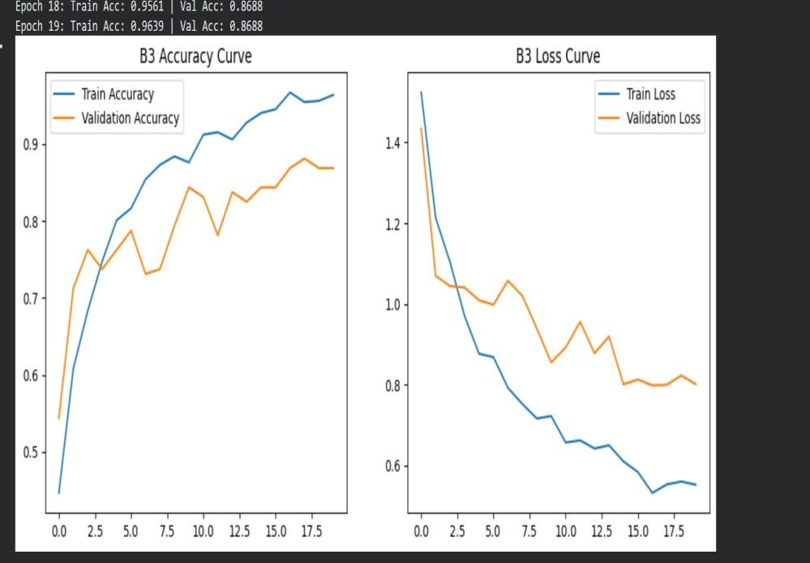

Appendix IIII: Model Code
Data Loading
path = kagglehub.dataset_download("raiaone/olid-i") target_plant = "tomato"

full_dataset = datasets.ImageFolder(path)

indices = [i for i, (p, t) in enumerate(full_dataset.imgs) if full_dataset.classes[t].startswith(target_plant)]

train_idx, val_idx = train_test_split( list(range(len(indices))), test_size=0.2,
random_state=42, stratify=[full_dataset.targets[i] for i in indices]
)

Model Training model =
models.efficientnet_b3(weights=models.EfficientNet_B3_Weights.DEFAULT) num_ftrs = model.classifier[1].in_features

model.classifier = nn.Sequential( nn.Dropout(p=0.5), nn.Linear(num_ftrs, len(class_names))
)

model = model.to(device)

criterion = nn.CrossEntropyLoss(label_smoothing=0.1)
optimizer = optim.AdamW(model.parameters(), lr=0.0006, weight_decay=0.01)

def train_b3(num_epochs=20):
for epoch in range(num_epochs): model.train()

for inputs, labels in train_loader:
inputs, labels = inputs.to(device), labels.to(device)

optimizer.zero_grad() outputs = model(inputs)
loss = criterion(outputs, labels) loss.backward() optimizer.step()

train_b3(num_epochs=20)

Appendix IIV: Database
Users → stores user information Image → stores uploaded plant images
Result → stores model predictions and stress analysis Visibility → controls data access (public/private)



Code:

CREATE DATABASE StressAnalysis; USE StressAnalysis
CREATE TABLE Users (
UserId VARCHAR(50) PRIMARY KEY, UserName VARCHAR(100) NOT NULL, Password VARCHAR(255) NOT NULL, Email VARCHAR(150) NOT NULL,
CreatedAt DATETIME, IsActive BOOLEAN);
CREATE TABLE Image (
ImageId VARCHAR(50) PRIMARY KEY, UserId VARCHAR(50),
FilePath VARCHAR(255),
Resolution VARCHAR(50), UploadedAt DATETIME, CONSTRAINT FK_Image_User FOREIGN KEY (UserId) REFERENCES
Users(UserId));
CREATE TABLE Visibility (
VisibilityId VARCHAR(50) PRIMARY KEY,
VisibilityName VARCHAR(100)
)
INSERT INTO Visibility (VisibilityId, VisibilityName) VALUES ('1', 'Public’)

,('2', 'Private’);
CREATE TABLE Result (
ResultId VARCHAR(50) PRIMARY KEY, ImageId VARCHAR(50),
StressType VARCHAR(100), Prediction VARCHAR(255), DamageLevel VARCHAR(50), PreventiveActions VARCHAR(255), CreatedAt DATETIME,
VisibilityId VARCHAR(50), CONSTRAINT FK_Result_Image
FOREIGN KEY (ImageId) REFERENCES Image(ImageId), CONSTRAINT FK_Result_Visibility
FOREIGN KEY (VisibilityId) REFERENCES Visibility(VisibilityId)

Appendix IIIV: Timeline

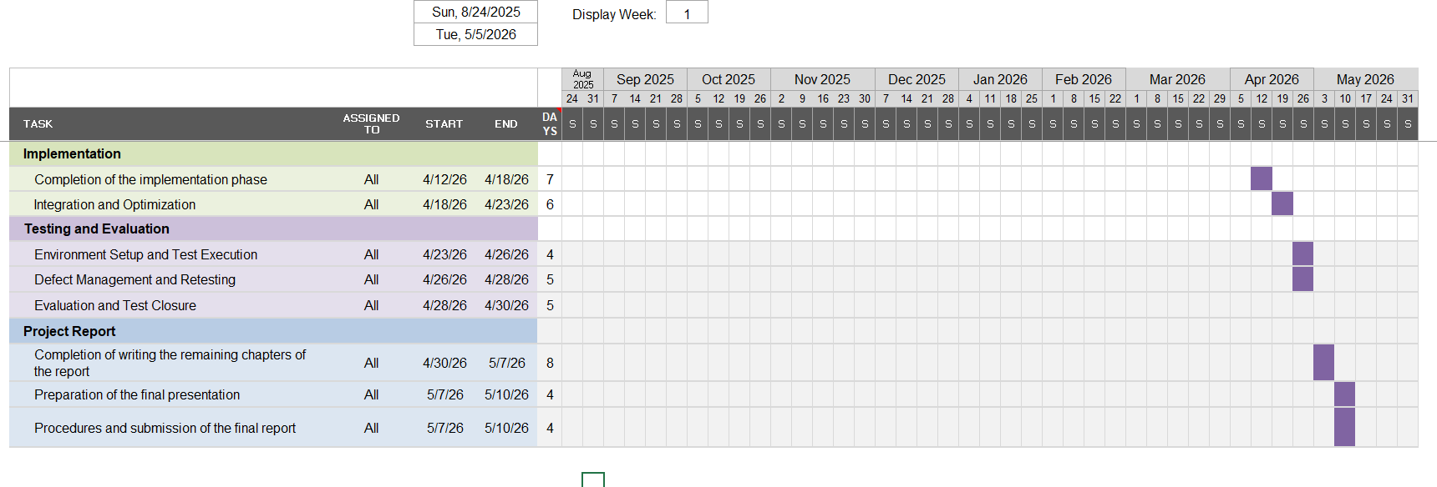

CHAPTER 7: LITERATURE CITED

- M. F. Taha et al., “Using Deep Convolutional Neural Network for Image-Based Diagnosis of
Nutrient Deficiencies in Plants Grown in Aquaponics,” Chemosensors, vol. 10, no. 2, p. 45, 2022.
- “Deep learning for plant stress detection: A comprehensive review of technologies,
challenges, and future directions,” Computers and Electronics in Agriculture, vol. 229, p. 109734,
2025.
- “Deep learning methods for biotic and abiotic stresses detection and classification in fruits and vegetables: State of the art and perspectives,” Artificial Intelligence in Agriculture, vol. 9, 2023.
- “Plant leaf disease detection and classification using convolution neural networks model: A review,” Artificial Intelligence Review, 2025.
- “Deep Learning for Plant Stress Phenotyping: Trends and Future Perspectives,” Trends in
Plant Science, vol. 23, no. 10, pp. 883–898, 2018.
- R. S. Pressman, Software Engineering: A Practitioner’s Approach, 8th ed., New York, NY,
USA: McGraw-Hill, 2014.
- I. Sommerville, Software Engineering, 10th ed., Boston, MA, USA: Pearson, 2016.
- M. Pérez-Patricio et al., “Plant Stress Detection Using a Three-Dimensional Analysis from a
Single RGB Image,” Sensors, vol. 24, no. 23, p. 7860, 2024.
- S. Poornima and A. Shirly Edward, “MLVI-CNN: A hyperspectral stress detection framework using machine learning-optimized indices and deep learning for precision agriculture,” Frontiers in Plant Science, vol. 16, p. 1631928, 2025.
- J. G. M. Esgario, R. A. Krohling, and J. A. Ventura, “Deep Learning for Classification and Severity Estimation of Coffee Leaf Biotic Stress,” arXiv preprint arXiv:1907.11561, 2019.
- “Detecting Plant Stress Using Thermal and Optical Imagery From an Unoccupied Aerial Vehicle,” Frontiers in Plant Science, 2021.
- K. Wang and Y. Jin, “Mapping Walnut Water Stress with High Resolution Multispectral UAV Imagery and Machine Learning,” arXiv preprint arXiv:2401.01375, 2023.

