DEVELOPING ELECTRONIC RESEARCH GROUP

FOR MSRC WEBSITE

A Capstone Project

presented to the Faculty of the

College of Information Technology

Mindanao State University

In Partial Fulfillment of the Requirements

for the degree Bachelor of Science in Information Technology

By

Zul-Qarnain Ayo Ronsing

Saddam Barani Solaiman

Mrs. Mudzna J. Muin-Asakil

Adviser

April, 2014

**Table of Contents**

**List of Figures**

Figure 2.2.1 – 1: Facebook Groups Create New Group Page 13

Figure 2.2.2 – 1: Google Group Page 14

Figure 2.2.3 – 1: Yahoo! Groups Create New Group Page 15

Figure 3.1 – 1: Mamitua Saber Research Center Organizational Chart 18

Figure 3.2 – 1: Workflow Diagram 19

**List of Tables**

Table 3.3.1: Developer’s Hardware Requirements 20

Table 3.3.2: Developer’s Software Requirements 20

Table 3.4.1: User’s Hardware Requirements 20

Table 3.4.2: User’s Software Requirements 21

Table 3.4.3: User’s Network Requirements 21

**Chapter 1 1**

**Introduction 1**

1.1 Project Context 2

1.2 Purpose and Description 3

1.3 Objectives 4

1.4 Scope and Limitation 4

**Chapter 2 6**

**Review of Related Literature and System 6**

2.1 Review of Related Theories 6

2.1.1 eGroups 6

2.1.2 Internet Forum or Message Board 6

2.1.3 Structure of Internet Forum Site 7

2.1.3.1 User groups 8

Moderators 8

Administrator 9

2.1.3.2 Post 9

2.1.4 Common Features of Internet Forum Site 10

2.1.4.1 Private Message 10

2.1.4.2 Attachments 11

2.1.4.3 BBcode and HTML 11

2.1.4.4 Emoticons 12

2.1.4.5 Poll 12

2.2 Related System or Project 13

2.2.1 Facebook Groups 13

2.2.2 Google Groups 14

2.2.3 Yahoo! Groups 15

Features Offered by Yahoo! Groups 15

Group Members 15

Administration 16

**Chapter 3 17**

**Technical Background 17**

3.1 Organizational Chart 18

3.2 Workflow 18

Admin 18

Research Group Leader or Administrator 19

Researcher 19

3.3 Developer’s Requirements 20

3.3.1 Hardware Requirements (Minimum Specification) 20

3.3.2 Software Requirements (Minimum Specification) 20

3.4 User’s Requirements 20

3.4.1 Hardware Requirements (Minimum Specification) 20

3.4.2 Software Requirements (Minimum Specification) 21

3.4.3 Network Requirements (Minimum Specification) 21

**Conceptual Framework** 22

**References** 23

**Chapter 1**

**Introduction**

A research group comprises positions that are primarily involved in the application of comprehensive scientific and professional knowledge to the planning, conduct, evaluation and management of fundamental research, knowledge enhancement, technology development and innovation relevant to define science, historical research and archival science, mathematics and natural sciences.

This proposed capstone project entitled *“Developing Electronic Research Group for MSRC Website”* is an online discussion site where users can hold conversation in the form of post messaging. It is sometimes called an *internet forum* or *message board site*. A section of website that allows a user to collaborate and communicate with the other users by posting messages.

Additionally, the background of the institution where this proposed capstone project will be deployed, *Mamitua Saber Research Center* – is an institution in *Mindanao State University* endowed for doing research. In their present operation, one of their problem is when they create a research group in the said university that the individual or group of researcher in the different colleges of *Mindanao State University* is hard to be invited by the research group leader or the individual researcher has a difficulties in joining himself/herself in the newly created research group. And also after each one of the member has finally joined in the research group they struggle on meeting each other to collaborate with their research.

So, the researcher came up with the idea to create a website for *Mamitua Saber Research Center* with a feature of an internet forum site to help the individual researcher or group of researcher in *Mindanao State University* to collaborate and interact with their members about their research without physical interaction. And the individual or group of researcher can easily be invited or join himself/herself in the newly created research group.

* 1. **Project Context**

This capstone project entitled *“Developing Electronic Research Group for MSRC Website”* is an online community site where users can communicate, interact and collaborate with their research by posting, commenting and attaching file in this web based project. This project is mainly focused on the improvements of the design, development and implementation of an online forum website for *Mamitua Saber Research Center.* Furthermore, this project is intended for the group or individual researchers in *Mindanao State University* to easily collaborate and discuss their research work through online.

The proposed system differs from the usual social networking sites. It is an online community site where users may read, post and/or attach file of any progressive research works. The users of the proposed system can also poll a question/topic if they think it is helpful with them. However, one should have an account first and approved by the administrator before they can join and use all the features of the system (*e.g. communicate with research group members, make avatar of his/her profile, create research group*).

Features of this proposed project are: it allows the user to communicate and collaborate with other users by posting messages through online; *(2)* archive, store or attach file in the form of pdf, doc or zip and the like in this web based project; *(3)* users can create their own account for ownership of any research studies that they conducted or contributed or participated; *(4)* users can also poll questions if they would like to; *(5)* administrator can create project research group by the approval of MSRC director; *(6)* it has an administrator or moderator account that secure and maintain the functionality and the design of the project and filter those unnecessary or unethical post/comment.

This proposed capstone project embody the idea of an online community website where all researchers in the *Mindanao State University* can collaborate, interact with each other and can keep their work through the online website by creating a post message/topic. This website will serves as the medium of communication of all researchers in the university.

This proposed system for *Mamitua Saber Research Center* has started on March 2014 and is expected to be done at the end of the month of September 2014.

* 1. **Purpose and Description**

Proposed system entitled *“Developing Electronic Research Group for MSRC Website”* shall embody the idea of an online community where researchers of the *Mindanao State University* can communicate, collaborate with the other researchers in the university, share or archived their ongoing research study, and/or help them gather relevant data or information for the benefit of their research study.

The main goal of this proposed capstone project is to enable all the researcher either by group or individual researcher at *Mindanao State University* to work together simultaneously through this proposed web based project. And also for them to be able to archive their research study through online. In addition, this project is proposed to help the individual or group of researchers to gather relevant data or information they need for their research study as well as to share their knowledge and research studies to the research community of the *Mindanao State University*.

With the advent of new technology and the uprising of modernization of the community, the researchers proposed this capstone project to help *Mindanao State University* in understanding its vision and mission in the year 2020 to be one of the world class universities in Asia and to be able to cope up with the fast uprising of new technologies.

* 1. **Objectives**

This proposed capstone project entitled *“Developing Electronic Research Group for MSRC Website”* aims to develop an online community forum website where individual researcher can communicate or collaborate with the other researcher through *Mamitua Saber Research Center*. It will allow the researchers of the university particularly to store their files online, enable them to view all their research works that they have already contributed.

To attain the main goal of the proposed project the following specific objectives are necessary:

* Study the standard process or procedure set by MSRC or MSU in creating and joining research group.
* Study and design database structure of the e-group.
* Design and implement a system requirements for the proposed project.
* Test and evaluate the e-group system performance.
  1. **Scope and Limitations**

This proposed capstone project entitled *“Developing Electronic Research Group for MSRC Website”* is limited on the design, development and implementation of a working online forum website for the researcher in MSU-Main Campus. Moreover, the processes involved are: to allow the researcher in the university to register an account in this web based project; *(2)* the administrator can create research group; *(3)* create/comment a post/topic; *(4)* attach/store file in the form of doc, pdf or zip file; *(5)* poll a question/topic; *(6)* can modify their account information; *(7)* delete/modify their own post/comment; *(8)* administrator or moderator can approve the request of a user in joining to the research group. Moreover, the research group leader in a research group may transfer his position as the administrator of the group to the other researcher or member in a group if in case of substitution of position.

Deleting/modifying other’s post or comment by not authorized account, publish research study or submission of articles/research, organizing research conference, private messaging of users using the website are not supported by this project. A research group can only be created by the approval of the director of *Mamitua Saber Research Center.* And an individual can only join particular research upon the approval of the moderator or administrator.

**Chapter 2**

**Review of Related Literature and System**

**2.1 Review of Related Concepts**

**2.1.1 eGroups**

eGroups is an email list management website. The site allowed users to create their own mailing lists and allowed others to sign up for membership on the list. The website provided archives of the messages as well as list management functionality. Each group also had a shared calendar, file space, group chat, and a simple database. It provides a gathering place on the internet for groups to send and receive emails, scheduled meetings, share files and photos, or have private group chat.

**2.1.2 Internet Forum or Message Board**

An internet forum or message board is an online discussion area on a website where website members can post discussions and read and respond to post by other forum members. A forum can be focused on nearly any subject and sense of an online community, or virtual community, tends to develop among forum members.

This type of forum may also called a message board, discussion group, bulletin board, or web forum, but it differs from a blog, the name for a web log, as a blog is usually written by one user and usually only allows for the responses of others to the blog material. A forum usually allows all members to make posts and start new topics.

An Internet forum is also different from a chat room in that messages are often longer than one line of text, and are at least temporarily archived. Members in a chat room usually all chat or communicate at the same time, while members in a discussion group post messages to be read by others whenever they happen to log on. Forums also tend to be more topic-focused than chat rooms.

Before a prospective member joins a group and makes posts to others, he or she is usually required to register. The prospective member must usually agree to follow certain online rules, sometimes called netiquette, such as to respect other members and refrain from using profanity. When a member is approved by the administrator or moderator, the member usually chooses his or her own user name and password, although sometimes, a password is supplied. An avatar, or photograph or picture, supplied by the member might appear under the member's user name in each post.

Depending on the forum's settings, users can be anonymous or have to register with the forum and then subsequently log-in in order to post messages. On most forums, users do not have to log in to read existing messages.

The separate conversations in a forum are called threads, and they are made up of member-written posts. Members can usually edit their own posts, start new topics, post in their choice of threads, and edit their profile. A profile usually lists optional information about each forum member, such as the city they are located in and their interests.

An Internet forum administrator or monitor may also participate in the forum. An administrator can usually modify threads as well as move or delete threads if necessary. He or she can also usually change software items in the forum. Moderators often help the administrator and monitor and guide the discussion to make sure the forum rules are being followed.

**2.1.3 Structure of Internet Forum Site**

A forum consists of a tree like directory structure. The top end is "Categories". A forum can be divided into categories for the relevant discussions. Under the categories are sub-forums and these sub-forums can further have more sub-forums. The *topics* (commonly called *threads*) come under the lowest level of sub-forums and these are the places under which members can start their discussions or *posts*. Logically forums are organized into a finite set of generic topics (usually with one main topic) driven and updated by a group known as *members*, and governed by a group known as *moderators*.It can also have a graph structure. All message boards will use one of three possible display formats. Each of the three basic message board display formats: Non-Threaded/Semi-Threaded/Fully Threaded, has its own advantages and disadvantages. If messages are not related to one another at all a Non-Threaded format is best. If a user has a message topic and multiple replies to that message topic a semi-threaded format is best. If a user has a message topic and replies to that message topic, and replies to replies, then a fully threaded format is best.

**2.1.3.1 User groups**

Internally, Western-style forums organize visitors and logged in members into user groups. Privileges and rights are given based on these groups. A user of the forum can automatically be promoted to a more privileged user group based on criteria set by the administrator. A person viewing a closed thread as a *member* will see a box saying he does not have the right to submit messages there, but a *moderator* will likely see the same box granting him access to more than just posting messages.

An unregistered user of the site is commonly known as a *guest* or *visitor*. Guests are typically granted access to all functions that do not require database alterations or breach privacy. A guest can usually view the contents of the forum or use such features as *read marking*, but occasionally an administrator will disallow visitors to read their forum as an incentive to become a registered member. A person who is a very frequent visitor of the forum, a section or even a thread is referred to as a lurker and the habit is referred to as *lurking*. Registered members often will refer to themselves as *lurking* in a particular location, which is to say they have no intention of participating in that section but enjoy reading the contributions to it.

#### Moderators

The *moderators* (short singular form: "mod") are users (or employees) of the forum who are granted access to the posts and threads of all members for the purpose of *moderating discussion* (similar to arbitration) and also keeping the forum clean (neutralizing spam and spambots etc.). Moderators also answer users' concerns about the forum, general questions, as well as respond to specific complaints. Common privileges of moderators include: deleting, merging, moving, and splitting of posts and threads, locking, renaming, stickying of threads, banning, suspending, unsuspending, unbanning, warning the members, or adding, editing, removing the polls of threads. "Junior Modding", "Backseat Modding", or "Forum copping" can refer negatively to the behavior of ordinary users who take a moderator-like tone in criticizing other members.

Essentially, it is the duty of the moderator to manage the day-to-day affairs of a forum or board as it applies to the stream of user contributions and interactions. The relative effectiveness of this user management directly impacts the quality of a forum in general, its appeal, and its usefulness as a community of interrelated users.

* **Administrator**

The *administrators* (short form: "admin") manage the technical details required for running the site. As such, they may promote (and demote) members to/from moderators, manage the rules, create sections and sub-sections, as well as perform any database operations (database backup etc.). Administrators often also act as moderators. Administrators may also make forum-wide announcements, or change the appearance (known as the skin) of a forum. There are also many forums where administrators share their knowledge.

**2.1.3.2 Post**

A *post* is a user-submitted message enclosed into a block containing the user's details and the date and time it was submitted. Members are usually allowed to edit or delete their own posts. Posts are contained in threads, where they appear as blocks one after another. The first post starts the thread; this may be called the TS (thread starter) or OP (original post). Posts that follow in the thread are meant to continue discussion about that post, or respond to other replies; it is not uncommon for discussions to be derailed.

On Western forums, the classic way to show a member's own details (such as name and avatar) has been on the left side of the post, in a narrow column of fixed width, with the post controls located on the right, at the bottom of the main body, above the signature block. In more recent forum software implementations, the Asian style of displaying the members' details above the post has been copied.

Posts have an internal limit usually measured in characters. Often one is required to have a message of minimum length of 10 characters. There is always an upper limit but it is rarely reached – most boards have it at either 10,000, 20,000, 30,000, or 50,000 characters.

Most forums keep track of a user's postcount. The postcount is a measurement of how many posts a certain user has made. Users with higher postcounts are often considered more reputable than users with lower postcounts, but not always. For instance some forums have disabled postcounts with the hopes that doing so will emphasize the quality of information over quantity.

**2.1.4 Common Features of Internet Forum Site**

By default to be an Internet forum, the web application needs an ability to submit threads and replies. Typically, threads are in newer to older view, and replies in older to newer view.

**2.1.4.1 Private message**

A *private message*, or PM for short, is a message sent in private from a member to one or more other members. The ability to send so-called carbon copies is sometimes available. When sending a *carbon copy* (cc), the users to whom the message is sent directly will not be aware of the recipients of the carbon copy or even if one was sent in the first place.

Private messages are generally used for personal conversations. They can also be used with tripcodes—a message is addressed to a public trip and can be picked up by typing in the tripcode.

**2.1.4.2 Attachments**

An attachment can be almost any file. When someone attaches a file to a person's post they are uploading the file to the forum's server. Forums usually have very strict limit on what can be attached and what cannot (among which the size of the files in question). Attachments can be part of a thread, social group, etc.

**2.1.4.3 BBCode and HTML**

HyperText Markup Language (HTML) is sometimes allowed but usually its use is discouraged or when allowed, it is extensively filtered. Modern bulletin board systems often will have it disabled altogether or allow only administrators use it, as allowing it on any normal user level is considered a security risk due to a high rate of XSS vulnerabilities. When HTML is disabled Bulletin Board Code (BBCode) is the most common preferred alternative. BBCode usually consists of a tag, similar to HTML only instead of < and > the tagname is enclosed within square brackets (meaning: [ and ]). Commonly [i] is used for italic type, [b] is used for bold, [u] for underline, [color="value"] for color and [list] for lists, as well as [img] for images and [url] for links.

The following example BBCode: [b]This[/b] is [i]clever[/i] [b][i]text[/i][/b] when the post is viewed the code is rendered to HTML and will appear as: **This** is *clever* ***text***.

Many forum packages offer a way to create Custom BBCodes, or BBcodes that are not built into the package, where the administrator of the board can create complex BBCodes to allow the use of JavaScript or iframe functions in posts, for example embedding a YouTube or Google Video complete with viewer directly into a post.

**2.1.4.4 Emoticon**

An emoticon or *smiley* is a symbol or combination of symbols used to convey emotional content in written or message form. Forums implement a system through which some of the text representations of an emoticons (e.g. xD, :p) are rendered as a small image. Depending on what part of the world the forum's topic originates (since most forums are international) smilies can be replaced by other forms of similar graphics, an example would be kaoani (e.g. *(^O^)*, (^-^)b), or even text between special symbols (e.g. :blink:, :idea:).

**2.1.4.5 Poll**

Most forums implement an opinion poll system for threads. Most implementations allow for single-choice or multi-choice (sometimes limited to a certain number) when selecting options as well as private or public display of voters. Polls can be set to expire after a certain date or in some cases after a number of days from its creation. Members vote in a poll and a statistic is displayed graphically.

**2.2 Related System/Project**

**2.2.1 Facebook Groups**

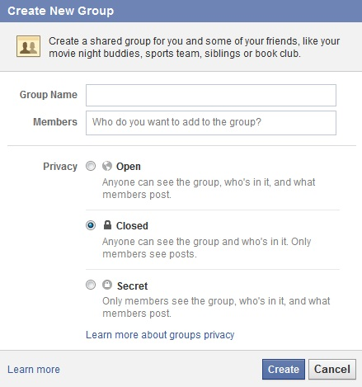

**Figure 2.2.1 – 1: Facebook Group Create New Group Page.**

Facebook Groups can be created by individual users. Groups allow members to post content such as links, media, questions, events, editable documents, and comments on these items. Facebook users cannot join more than 300 groups.

Groups are used for collaboration and allow discussions, events, and numerous other activities. They are a way of enabling a number of people to come together online to share information and discuss specific subjects. They are increasingly used by clubs, companies and public sector organizations to engage with stakeholders, be they members of the public, employees, members, service users, shareholders or customers. Groups can have three different levels of privacy settings:

* "Open" means both the group, its members and their comments is visible to the public (which includes non-members) but they cannot interact without joining.
* "Closed" means the group and its members are visible to the public but their comments are not visible until the user has joined the group.
* "Secret" means that nothing can be viewed by the public unless a member specifically invites another user to join the group.

**2.2.2 Google Groups**

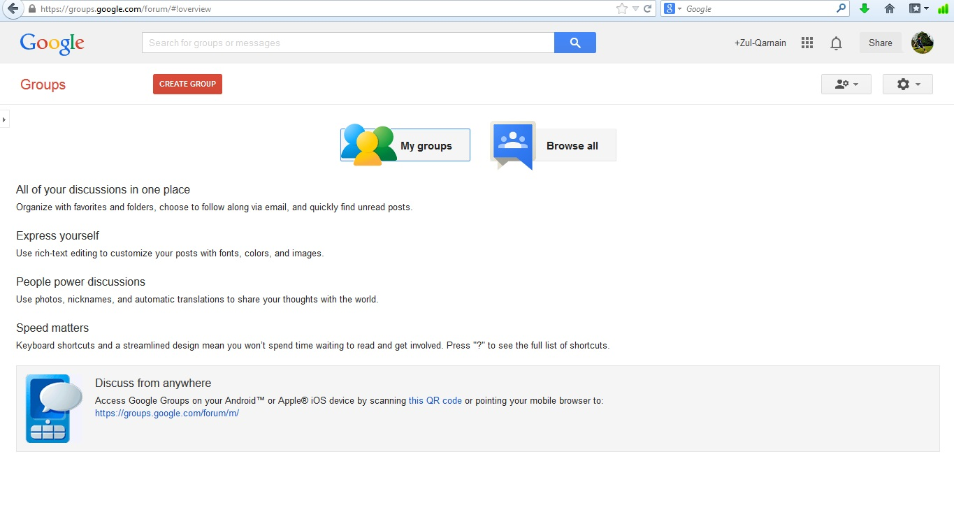

**Figure 2.2.2 – 1: Google Group Page.**

Google Groups is a service from Google Inc. that provides discussion groups for people sharing common interests. The Groups service also provides a gateway to Usenet newsgroups via a shared user interface.

Google Groups offers at least two kinds of discussion group; in both cases users can participate in threaded conversations, either through a web interface or by e-mail. The first kind are forums specific to Google Groups which are inaccessible by NNTP and act more like mailing lists. The second kind are Usenet groups, for which Google Groups acts as gateway and unofficial archive (the Google Groups archive of Usenet newsgroup postings dates back to 1981). Through the Google Groups user interface, users can read and post to Usenet groups. Despite the archive and gateway, Google Groups does not currently provide a means of accessing Usenet via groups for NNTP. Google seemingly also does not respond to externally generated control messages.

In addition to accessing Google and Usenet groups, registered users can also set up mailing list archives for e-mail lists that are hosted elsewhere.

**2.2.3 Yahoo Groups**

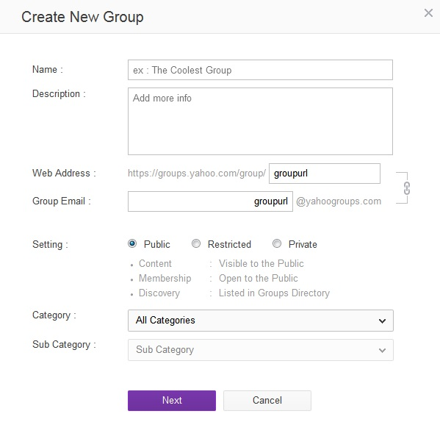

**Figure 2.2.3 – 1: Yahoo Groups Create New Group Page.**

Yahoo! Groups is one of the world’s largest collections of online discussion boards. The term Groups refers to Internet communication which is a hybrid between an electronic mailing list and a threaded Internet forum, in other words, Group messages can be read and posted by e-mail or on the Group's webpage like a web forum. In addition, members can choose whether to receive individual, daily digest or Special Delivery e-mails, or simply read Group posts on the Group’s web site. Groups can be created with public or member-only access. Some Groups are simply announcement bulletin boards, to which only the Group moderators can post, while others are discussion forums.

**Features offered by Yahoo! Groups:**

* **Group members**
  + Messages: Post via web or email to group. No edit function except delete.
  + Photo album (100GB): Organized into album/thumbnail structure.
  + File storage (100MB): Capable of storing any file format.
  + Link directory: Options for folders, text labels for each link.
  + Poll: Members can create multiple-choice polls, including various options for ID display.
  + Database: Up to ten tables, each with up to one thousand rows and up to ten columns.
  + Member list: Scroll of registered member profiles, and the basics of the information they provide.
  + Calendar: Scheduling system for clubs with regular events.
  + Promote: HTML box for website display (to join a group).
* **Administration** (owners or managers who can do post approval)
  + Invite: to invite more members by email.
  + Management of members (approve new members, delete members).
  + Management of messages (approve new messages, delete messages).
  + Options: Edit of the group homepage display text etc.
  + Post approval: It is possible to switch to strict moderation if required.
  + Web tools management: Options are off, public, members, administrators.

**Chapter 3**

**Technical Background**

***Mamitua Saber Research Center*** (formerly known as the *University Research Center*) is an establishment in *Mindanao State University* endowed for doing research. It was created to implement a provision of University Charter, which is, to undertake research on “Filipino native culture, art, science, philosophy and literature. The present operation that perform by the employees of the said establishment is to collect and evaluate a research and publish it after its evaluation.

In addition, the said center applied a new development in their research operation. Though this is new and experimental, the center wanted to group down researchers according to their field of expertise or discipline (*e.g. Science and Technology, social sciences*). This will allows researchers to be involved with other researchers in the different colleges or campus to work together. With this scheme, problem on communication should be addressed. There should be proper channel on how they will invite individual researcher in joining their research group.

Moreover, the individual or group of researcher of *Mindanao State University* needs to collaborate personally to exchange information and to talk about their research. In view of that, the developers of this proposed capstone project came up with the idea to create an online forum website for *Mamitua Saber Research Center*, so that the group researcher or individual researcher of the *Mindanao State University* can interact and collaborate together about their research using the fastest technology.

**3.1 Organizational Chart**

Figure 3.1 below shows the organizational chart of *Mamitua Saber Research Center.*

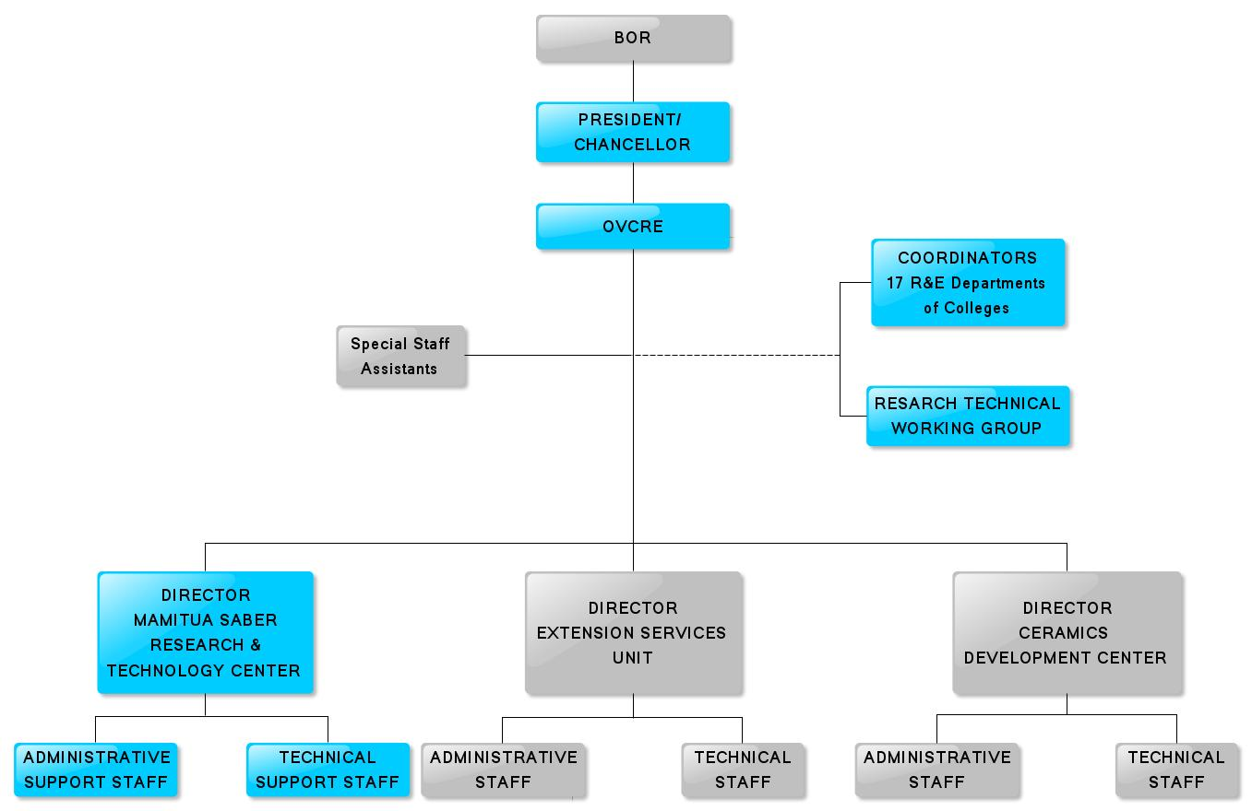

**Figure 3.1. Mamitua Saber Research Center Organizational Chart.**

**3.2 Workflow**

Figure 3.2 below shows the workflow of the proposed capstone project.

* **Admin**

The admin can moderate discussion, neutralize spam and spambots and also he is the only one who can create a research group by the approval of the *MSRC* director. After creating a research group project, he will then assign a researcher to be the administrator of the newly created group. If the researcher he want to assign as the administrator of the newly created group will reject his invitation, he can assign another researcher as the administrator of the group, until some researcher accept his invitation.

* **Research Group Leader or Administrator**

The administrator of the group is the one who invites researcher to be a member of the group and work together with the newly created research. He may also pass his position as the administrator of the group only to the other member of the research group. He also the one who approves the request of the researcher to join in the group.

* **Researcher**

A researcher may only join in a group via *(1)* the invitation of the research group leader and accept it, and also by *(2)* the approval of the research group leader if he sent a request to join in a specific group. A researcher may also become an administrator of the group if the research group leader pass the administration of the group to him and accept it.

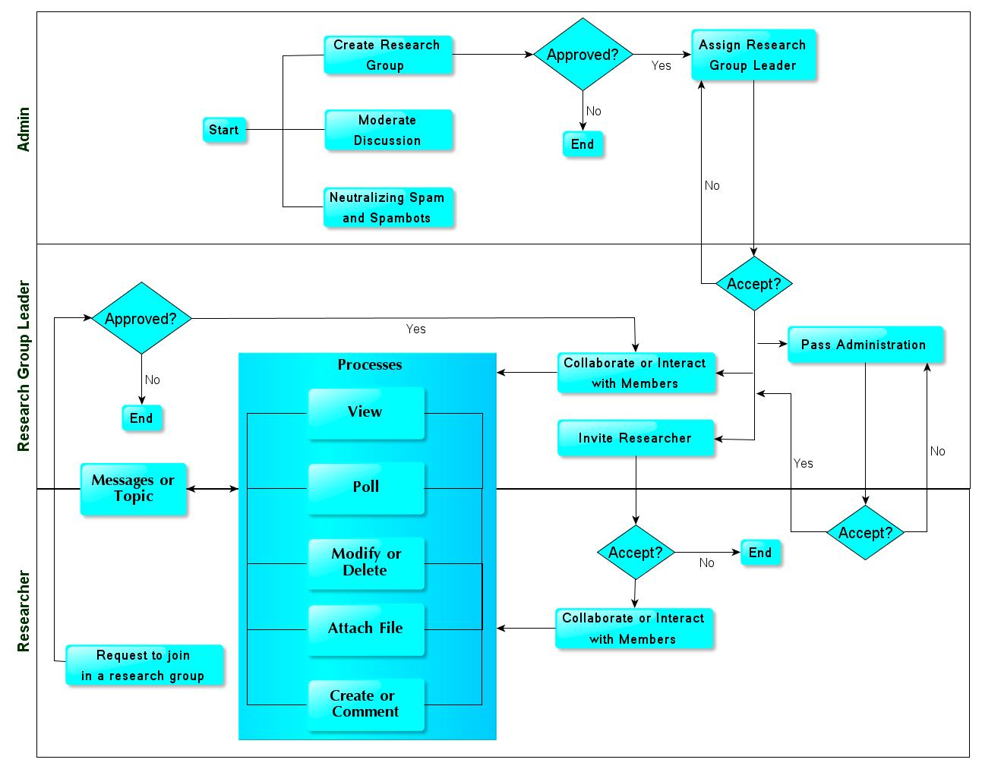

**Figure 3.2. Workflow Diagram.**

**3.3 Developer’s Requirements**

**3.3.1 Hardware Requirements**

**Table 3.3.1 Developer’s Hardware Requirements.**

|  |  |
| --- | --- |
| **Specifications** |  |
| Processor | i5-2430M @ 2.40GHz |
| Memory | 4 GB |
| Storage | 500 GB |
| Display | 14.0" 16:9 HD (1366x768) LED Backlight |
| Keyboard | Standard |
| Pointing Device | Touchpad |

**3.3.2 Software Requirements**

**Table 3.3.2 Developer’s Software Requirements.**

|  |  |
| --- | --- |
| **Specifications** |  |
| Operating System | Windows 7 Ultimate |
| UML | yEd Graph Editor |
| DBMS | MySQL 5.0 |
| Scripting Language | PHP, HTML 5, CSS 3, Ajax, jQuery |
| Development Environment | Aptana Studio 3, Notepad++ |
| PHP Frameworks | CodeIgniter 2.1.2 |

**3.4 User’s Requirements**

**3.4.1 Hardware Requirements (Minimum Specification)**

**Table 3.4.1 User’s Hardware Requirements.**

|  |  |
| --- | --- |
| **Specifications** |  |
| Processor | AMD Processor or better |
| Memory | 2 GB |
| Storage | 100 GB |
| Display | 14” Monitor |
| Keyboard | Standard |
| Mouse | Optical Mouse |

**3.4.2 Software Requirements (Minimum Specification)**

**Table 3.4.2 User’s Software Requirements.**

|  |  |
| --- | --- |
| **Specifications** |  |
| Operating System | Windows XP, Windows 7, Linux |
| Browser | Mozilla Firefox 12.0 or Higher Version, Google Chrome |

**3.4.3 Network Requirements (Minimum Specification)**

**Table 3.4.3 User’s Network Requirements.**

|  |  |
| --- | --- |
| **Specifications** |  |
| Connectors | RJ45 |
| Cable | UTP Cable CAT5 |
| Hub | 1000 Mbps 20 ports |

**Conceptual Framework**

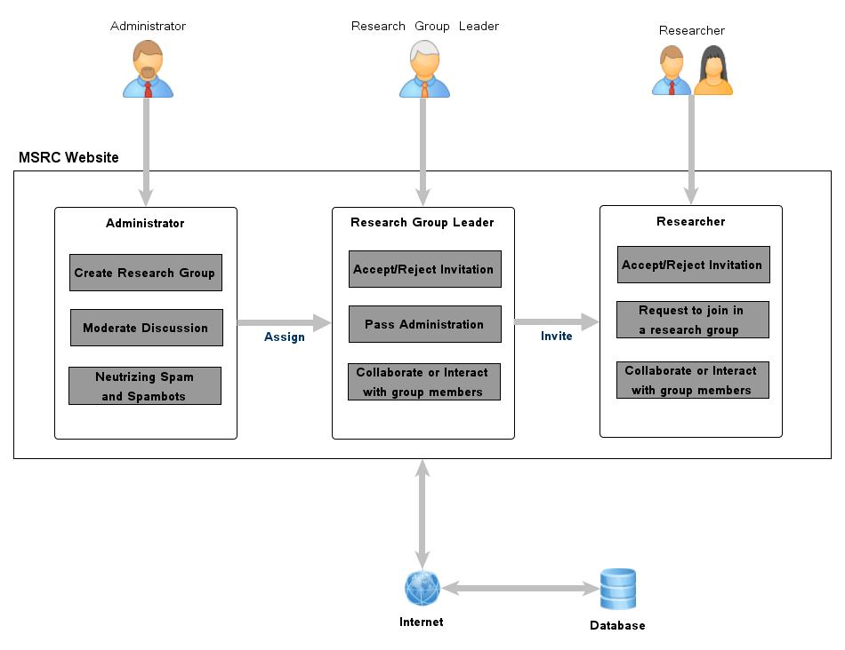

**Figure 4.0. Conceptual Framework of the Project.**