Nama : Ghana ardian ilham samudra

Nim : 124200042

**Tugas basis data B /** *Penyewaan dvd*

1. ERD

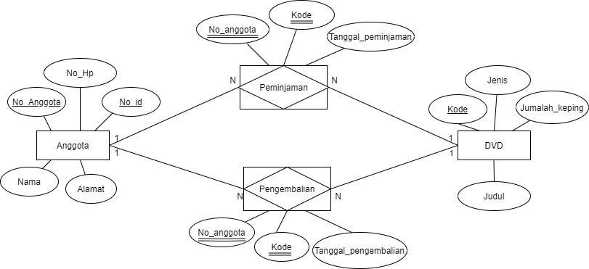

1. Tabel

A.tabel Anggota

|  |  |  |  |  |
| --- | --- | --- | --- | --- |
| **Field** | **Tipe** | **Constraint** | **Key** | **Keterangan** |
| No_anggota | Char(9) | Not null unique | Primary | Nomor anggota |
| Alamat | Vachar(60) |  |  | Alamat anggota |
| Nama | Vachar(25) | Not null |  | Nama anggota |
| No_Hp | Vachar(13) | Not null |  | No Hp anggota |
| No_id | Char(11) | Not null |  | ID anggota |
|  |  |  |  |  |

B.tabel DVD

|  |  |  |  |  |
| --- | --- | --- | --- | --- |
| **Field** | **Tipe** | **Constraint** | **Key** | **Keterangan** |
| Kode | Char(7) | Not null | Primary | Kode DVD |
| Jenis | Vachar(12) |  |  | Jenis DVD |
| Jumlah_keping | Vachar(3) | Not null |  | Jumlah DVD |
| Judul | Vachar(40) | Not null |  | Judul DVD |

C.tabel Peminjaman

|  |  |  |  |  |
| --- | --- | --- | --- | --- |
| Field | Tipe | Constraint | Key | Keterangan |
| No_anggota | Char(9) | Not null | Foreign | Nomor anggota |
| Kode | Char(7) | Not null | Foreign | Kode DVD |
| Tanggal_peminjaman | Vachar(25) | Not null |  | Tanggal peminjaman |

D.tabel Pengembalian

|  |  |  |  |  |
| --- | --- | --- | --- | --- |
| Field | Tipe | Constraint | Key | Keterangan |
| No_anggota | Char(9) | Not null | Foreign | Nomor anggota |
| Kode | Char(7) | Not null | Foreign | Kode DVD |
| Tanggal_pengembalian | Vachar(25) | Not null |  | Tanggal pengembalian |
|  |  |  |  |  |

1. Relasi antar table (RAT)

