PCB Component Detection & Segmentation: A Multi-Model Evaluation

1. Abstract & Introduction
The automated optical inspection of Printed Circuit Boards (PCBs) is a critical step in modern electronics manufacturing. While bounding-box object detection algorithms (such as YOLO) are highly efficient at localizing components, they lack the pixel-level precision required for advanced defect analysis, soldering inspection, and component masking.
This project explores the efficacy of transitioning from bounding-box detection to precise polygon mask segmentation. Specifically, we investigate whether foundational zero-shot models—such as Meta’s Segment Anything Model (SAM)—can be utilized either as a direct production inference engine or as an offline "knowledge distiller" to train lightweight YOLO segmentation models.

2. Dataset Architecture & The Render Script
The foundation of this benchmark is the FICS PCB Dataset, which initially contained only human-annotated bounding box coordinates. To prepare this data for a massive segmentation pipeline, several critical preprocessing steps were taken, including migrating the raw dataset JSONs to a clean train/val/test hierarchy on Kaggle's cloud GPUs.

The render-masks.py Utility
Because visual verification is critical when transitioning from bounding boxes to polygon masks, we developed a custom Python rendering engine (render-masks.py). This script parses the JSON coordinate outputs generated by the models and mathematically constructs filled polygons using OpenCV and NumPy. It features:
- Alpha Blending: Masks are overlaid onto the raw .jpg PCB images with a 45% alpha transparency, allowing engineers to see both the component and the AI's exact segmentation boundaries simultaneously.
- Dynamic Color Mapping: Each unique component class is assigned a distinct RGB color.
- Format Agnosticism: It natively handles both LabelMe dictionary formats and raw Kaggle coordinate lists.

Visual Rendering Examples:
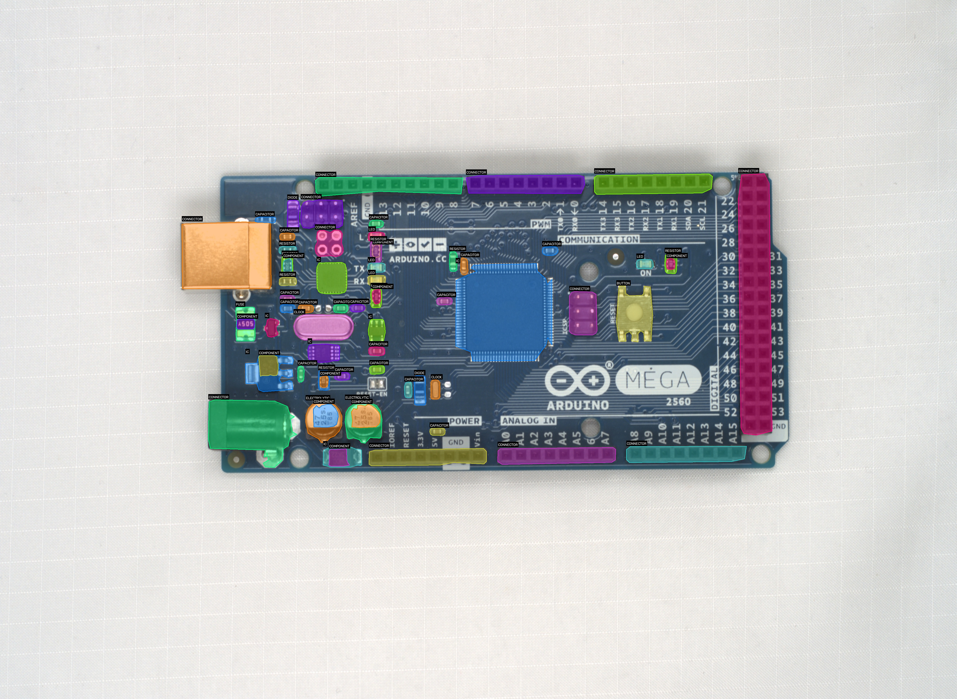
Figure 1: Transparent segmentation masks generated over an Arduino Mega board.
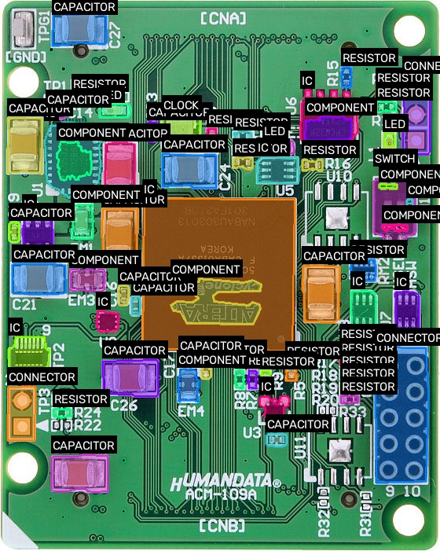
Figure 2: Component boundaries mapped on an ACM-109 board using render-masks.py.

3. Methodology: The Four-Pipeline Benchmark
To rigorously evaluate the best path to component segmentation, we constructed an end-to-end multi-model pipeline consisting of four distinct phases:

Pipeline 1: Baseline YOLO Bounding Box (YOLO-BB)
Trained natively on the human-annotated bounding box dataset for 50 epochs to establish a high-accuracy baseline.

Pipeline 2: SAM-Distilled YOLO-seg (BB Prompted)
We utilized SAM as an offline annotator. The ground-truth human bounding boxes were passed into SAM as positional prompts. SAM generated highly accurate polygon pseudo-masks for all 4,678 images. A YOLO-seg model was then trained on these pseudo-masks to test if SAM's zero-shot knowledge could be "distilled" into a lightweight model.

Pipeline 3: SAM-Distilled YOLO-seg (Auto Grid)
SAM was executed in "Everything" mode (automatic grid prompting) across the dataset, generating blind pseudo-masks without human bounding-box guidance. A separate YOLO-seg model was trained on this to evaluate SAM's raw, unprompted capability.

Pipeline 4: Zero-Shot Inference Pipeline (YOLO -> SAM)
Unlike Pipelines 2 and 3 (which trained a YOLO segmentation model), Pipeline 4 simulates a heavy production environment where SAM is used directly during runtime inference.
The Loop: An image is passed into the Baseline YOLO-BB model (Pipeline 1). The model detects the component and draws a bounding box. That coordinate box is immediately passed into the massive SAM ViT-B model as a dynamic prompt to generate the pixel mask.
The Problem: While highly flexible, running a foundational vision transformer like SAM for every single component detection on a factory floor is computationally paralyzing. We evaluated this loop using pixel-perfect Mean Intersection over Union (mIoU) against the ground truth to see if the accuracy justified the computational cost.

4. Quantitative Results
Model Pipeline | Box mAP@50 | Mask mAP@50 | Mean IoU | Precision | Recall
YOLO-BB (Baseline) | 0.966 | N/A | N/A | 0.934 | 0.952
YOLO-seg (BB Pseudo-labels) | 0.954 | 0.937 | N/A | 0.937 | 0.914
YOLO-seg (Auto Pseudo-labels) | 0.913 | 0.902 | N/A | 0.862 | 0.887
YOLO -> SAM (Zero-shot) | Uses Baseline | N/A | 0.502 | N/A | N/A

5. Qualitative Analysis & Conclusions
1. The Necessity of Prompts: Comparing Pipeline 2 and Pipeline 3 reveals that foundational models like SAM heavily rely on contextual prompts. When guided by bounding boxes (Pipeline 2), the distilled YOLO model achieved an impressive 93.7% mask mAP. When running blindly without prompts (Pipeline 3), mask accuracy dropped to 90.2%.
2. Zero-Shot Inference is Suboptimal for Production: Pipeline 4 (the runtime YOLO->SAM loop) achieved a Mean IoU of 0.502. While respectable for a zero-shot foundational model, it is incredibly computationally expensive and significantly slower than native YOLO inference, making it unviable for high-speed manufacturing lines.
3. The Distillation Advantage: The ultimate conclusion of this benchmark is the overwhelming success of Pipeline 2. By utilizing SAM purely as an offline tool to generate pseudo-masks guided by human labels, we successfully distilled SAM's zero-shot segmentation knowledge into a lightweight, deployable YOLO-seg architecture. This hybrid approach resulted in a model that is both highly accurate (93.7% mask mAP) and extremely fast.

Additional Component Mask Examples
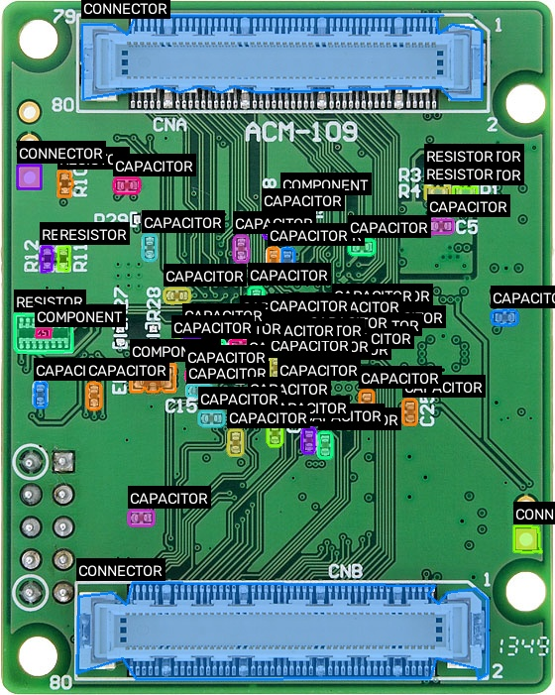
Mask sample: ACM-109_Bottom-masked.jpg
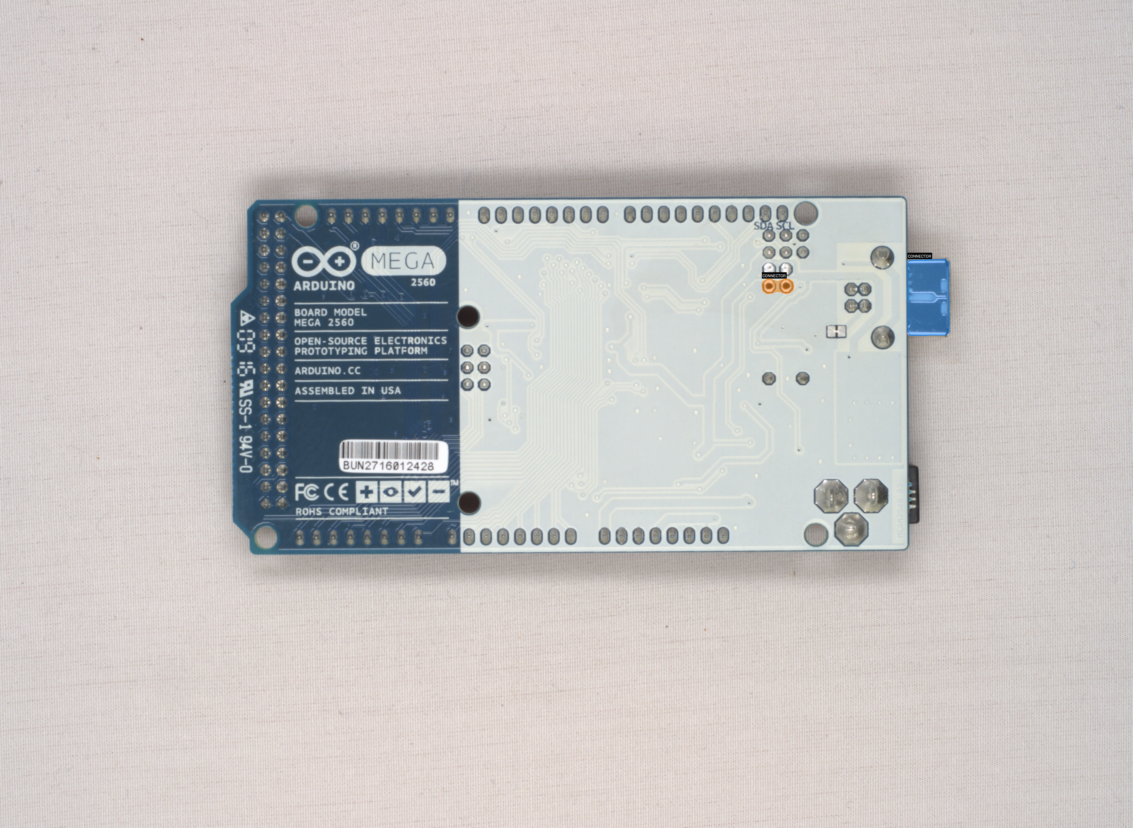
Mask sample: ArduinoMega_Bottom-masked.jpg
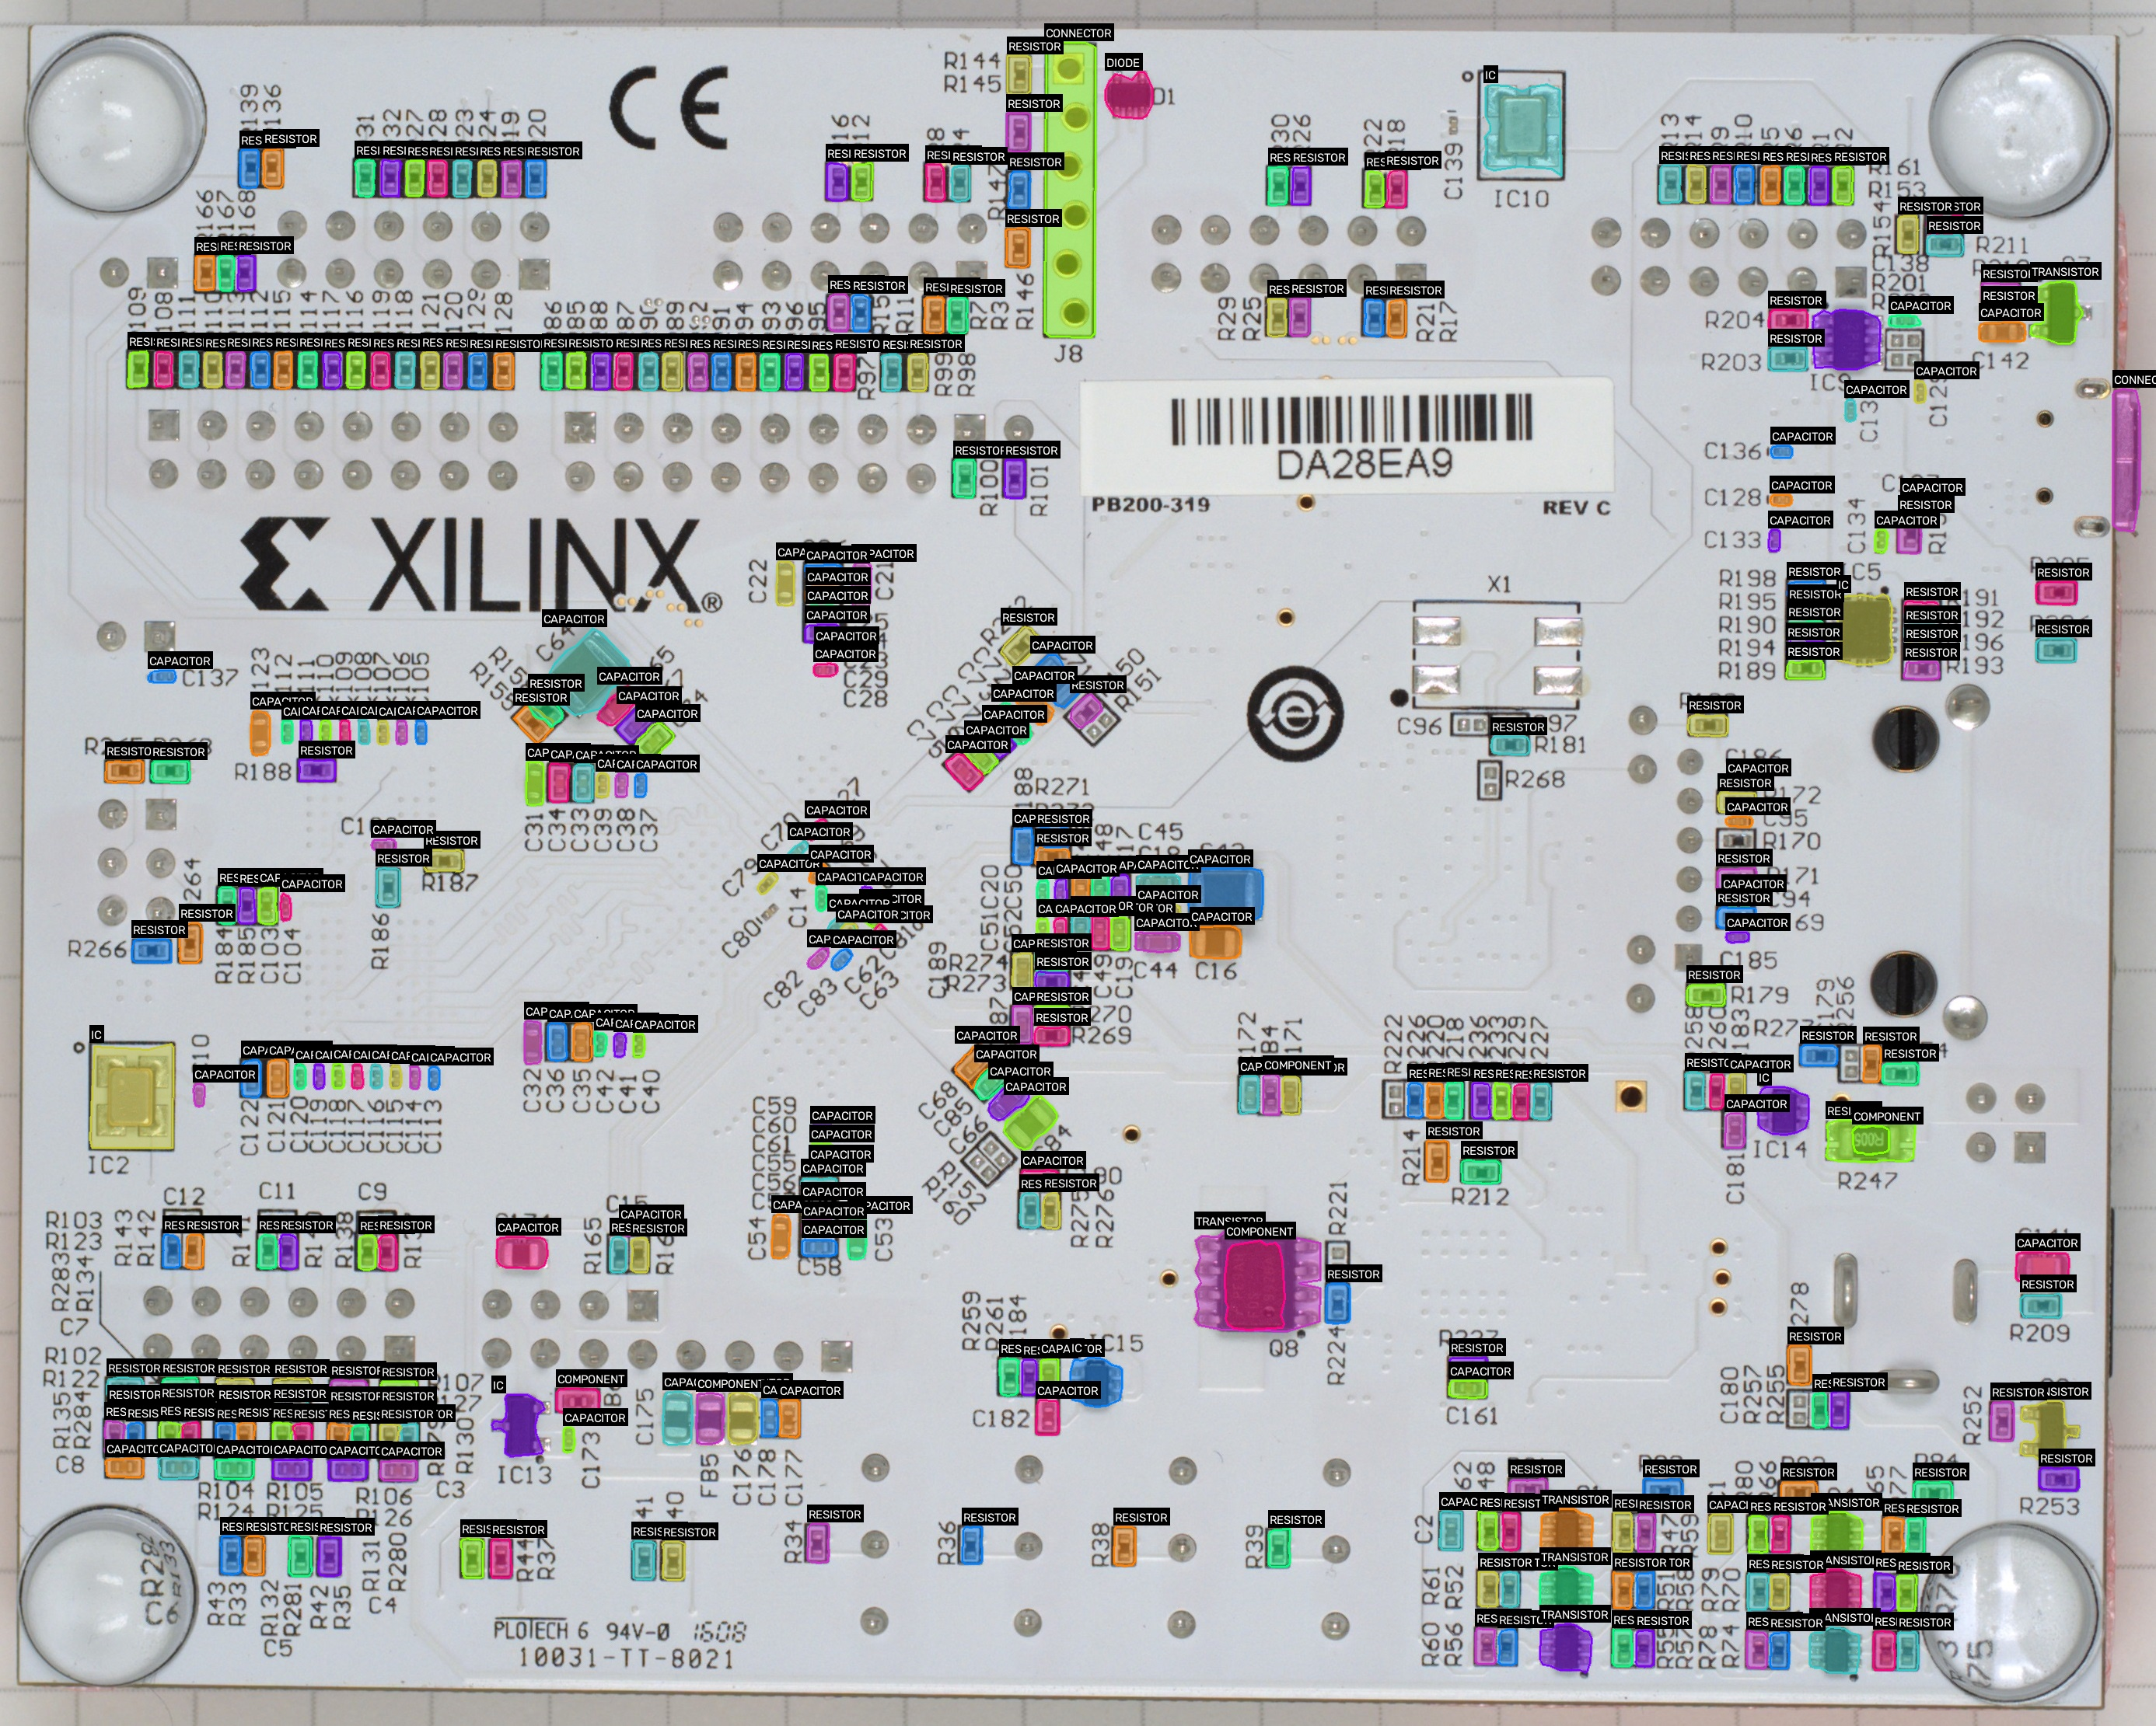
Mask sample: Arty_Bottom-masked.jpg
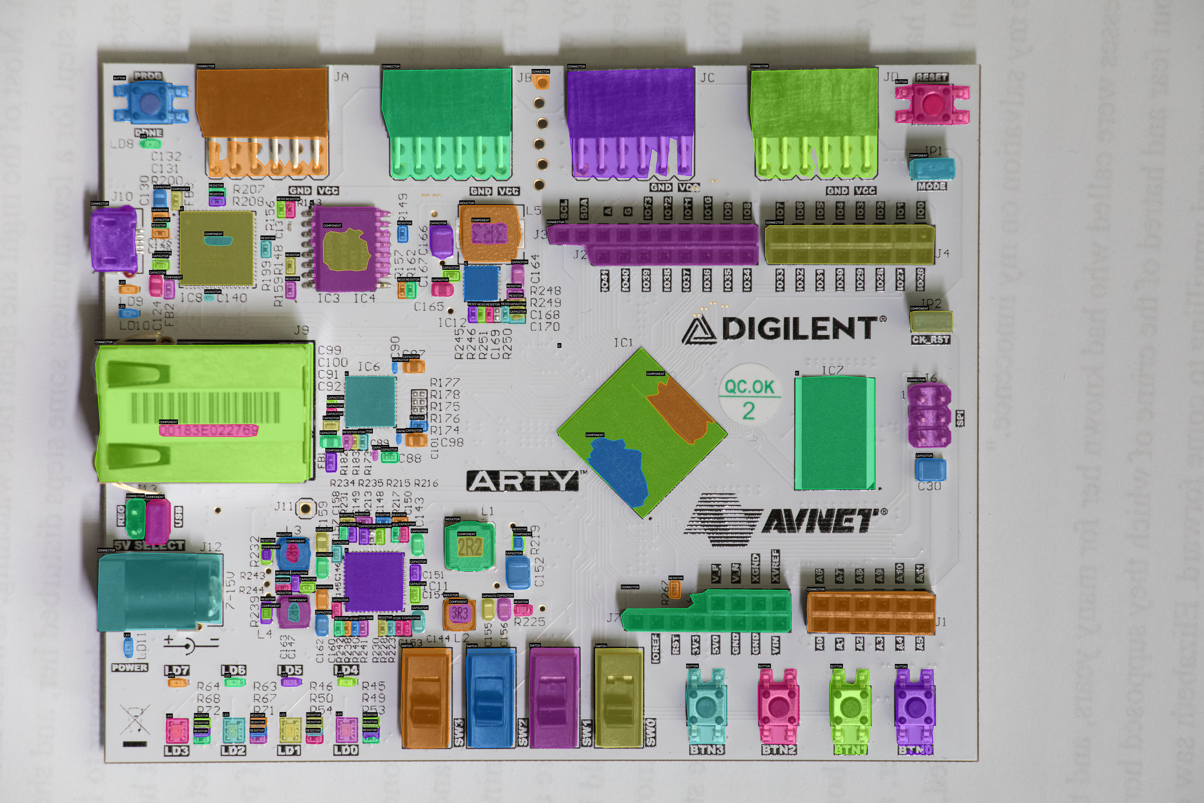
Mask sample: Arty_Top-masked.jpg
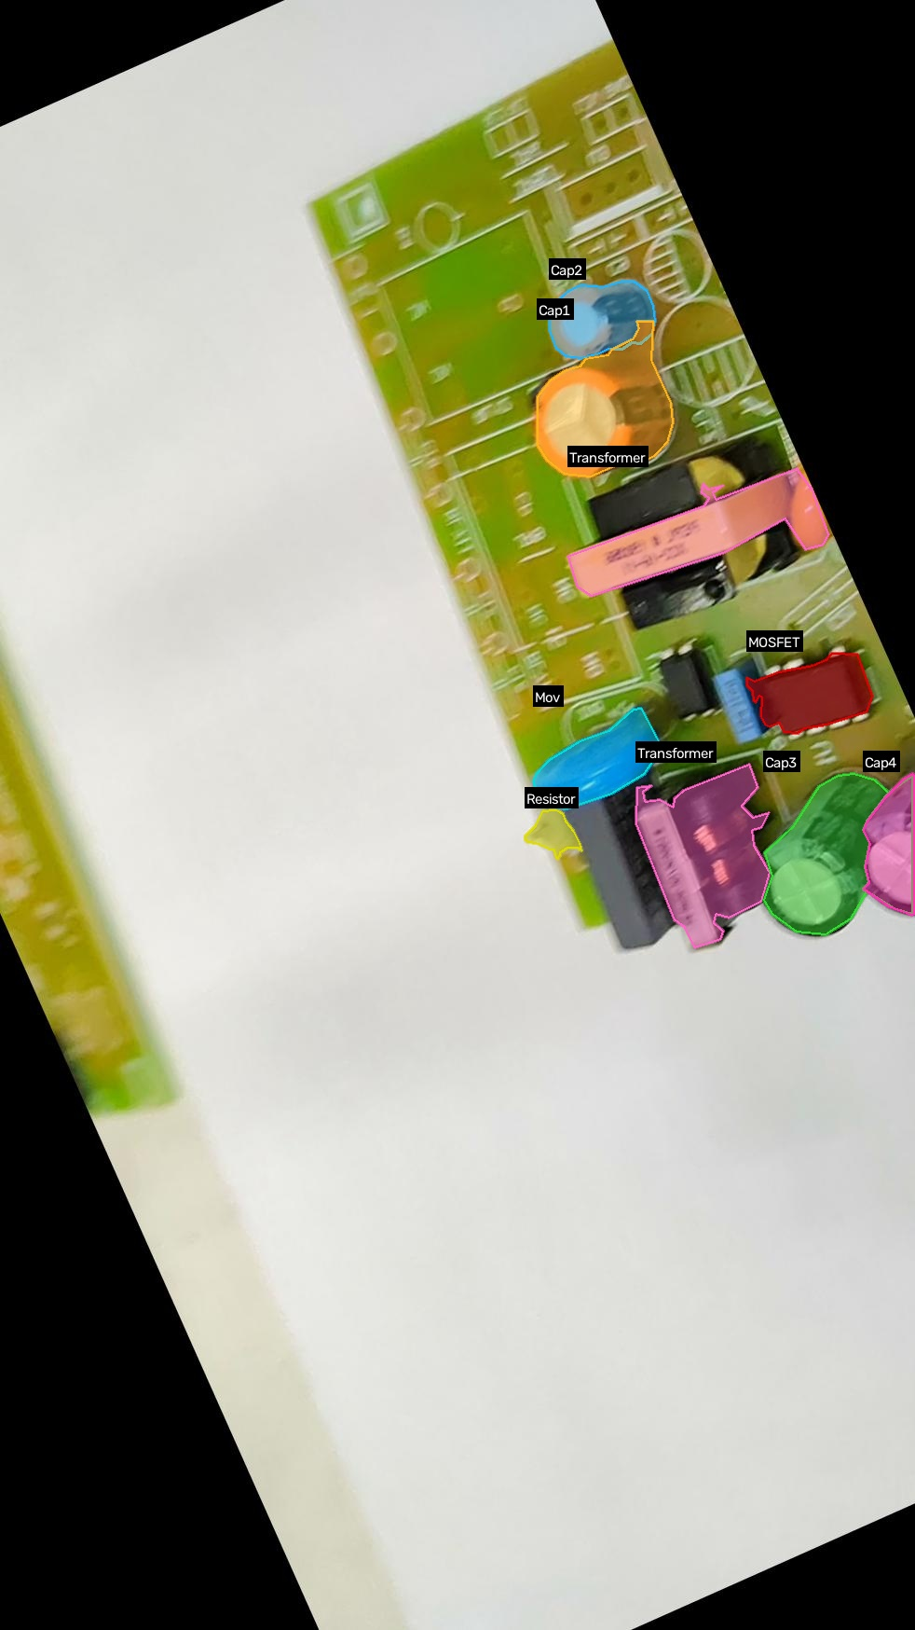
Mask sample: VID20210601144014-45_jpg.rf.1fc301cb2464b72cbf29ddae321791c3-masked.jpg
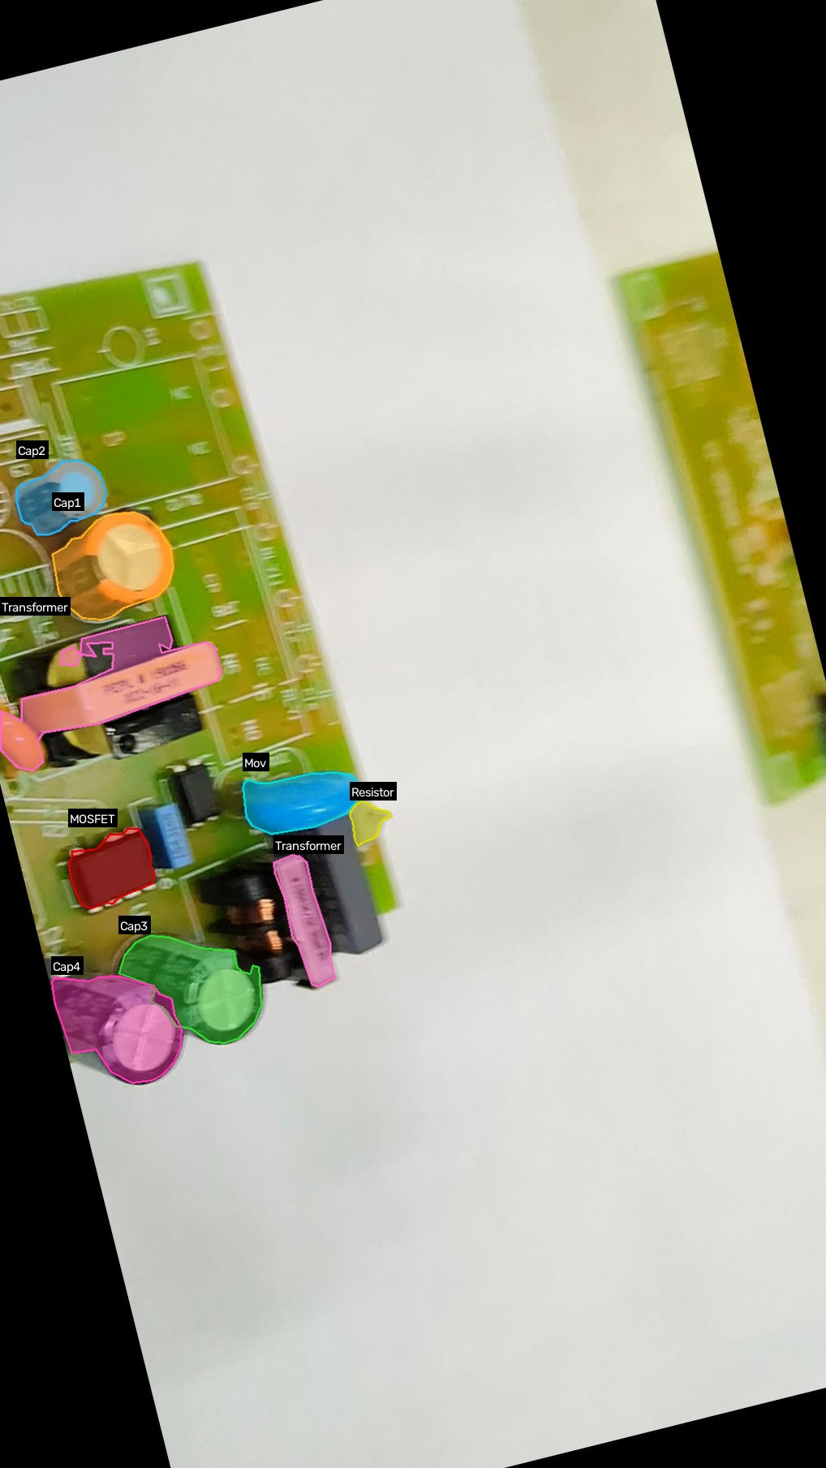
Mask sample: VID20210601144014-45_jpg.rf.2348d3566c3d3a8eacb33547d69612ad-masked.jpg
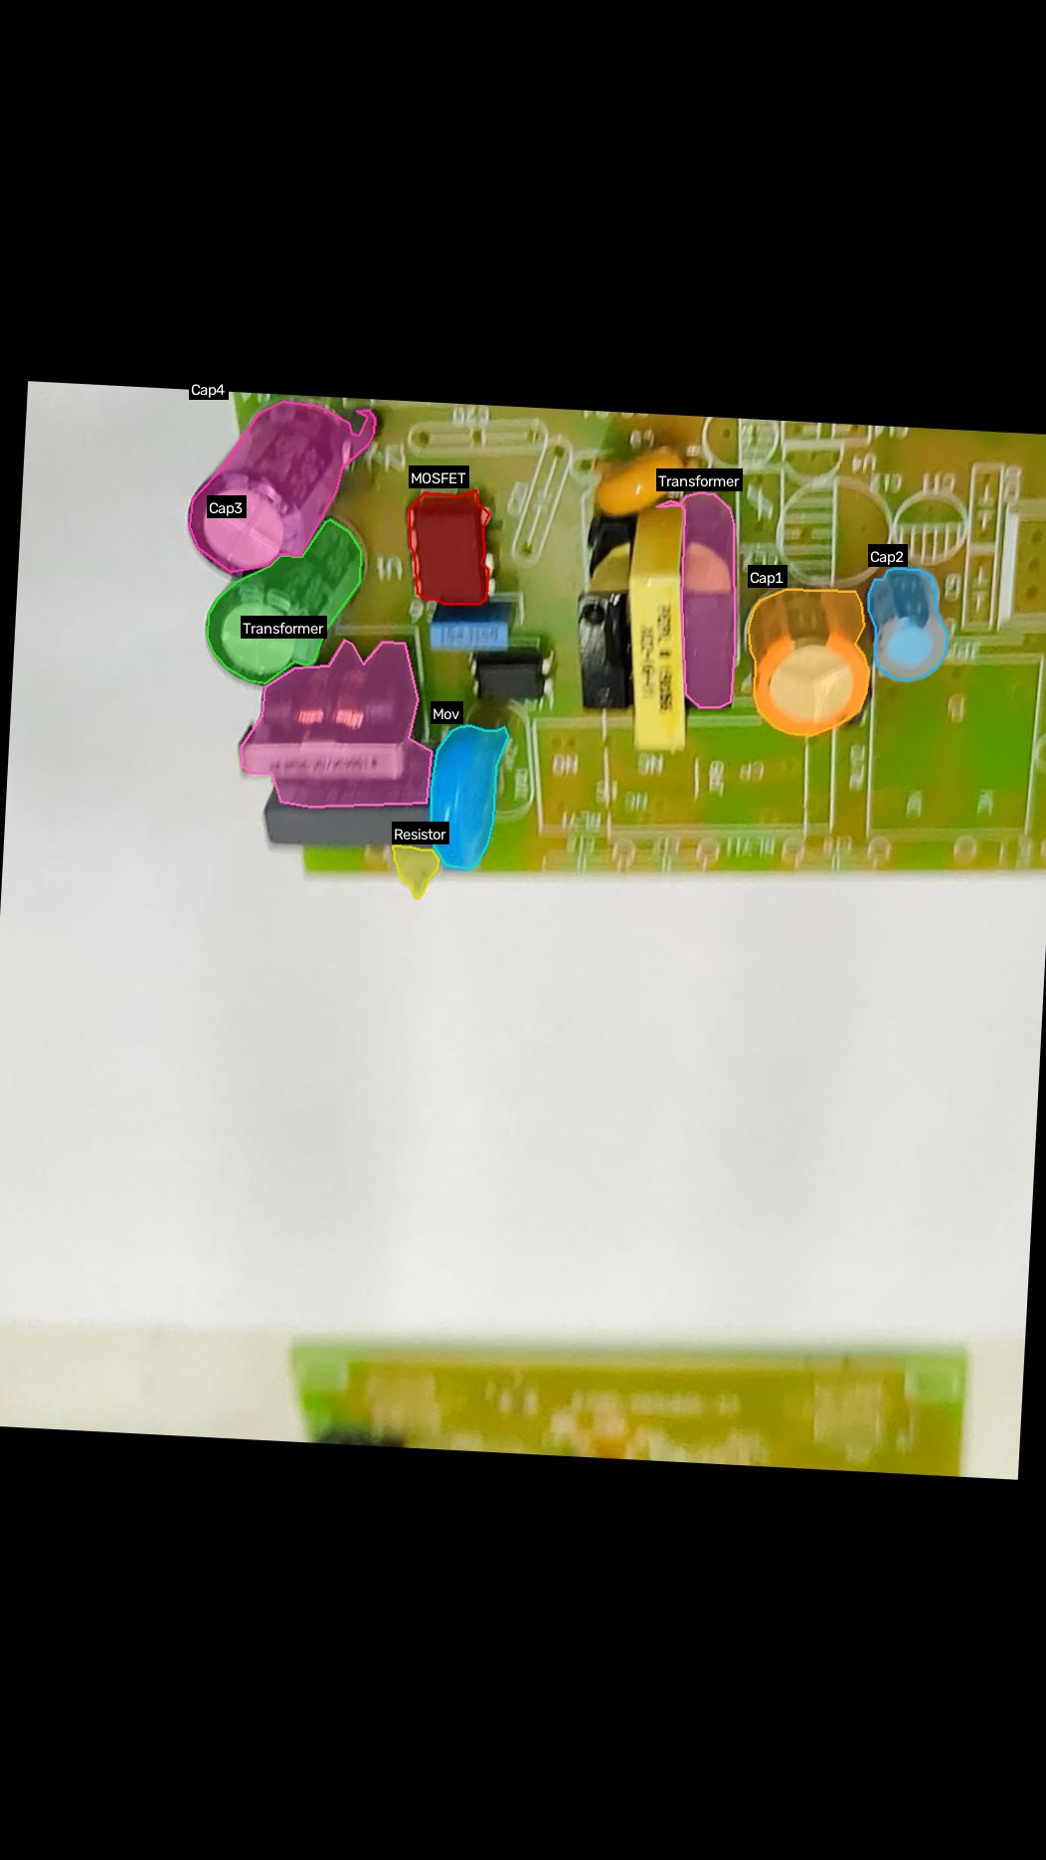
Mask sample: VID20210601144014-45_jpg.rf.2cd9c9b90a2c9a8c46f23b4973a559ba-masked.jpg
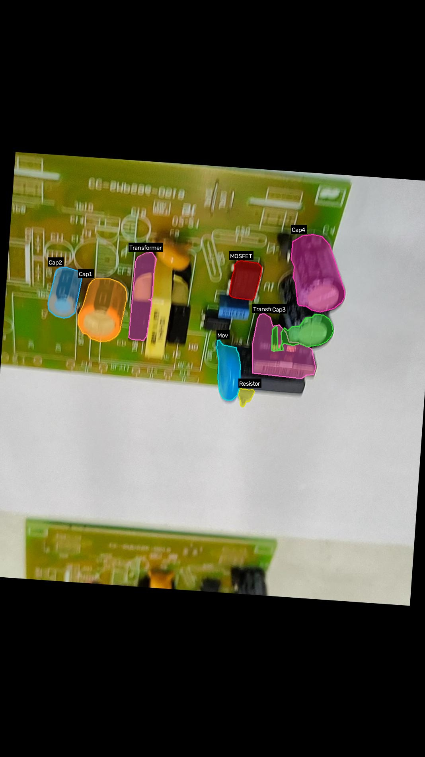
Mask sample: VID20210601144014-60_jpg.rf.1096d8e15ca66966a819802f64cbfad4-masked.jpg

6. Training Plots & Validation Results
Below are the training curves, confusion matrices, and validation prediction batches generated during the Kaggle multi-GPU training run for the winning Pipeline 2 model (YOLO-seg trained on BB pseudo-labels).

Training Results (F1, Loss, mAP)
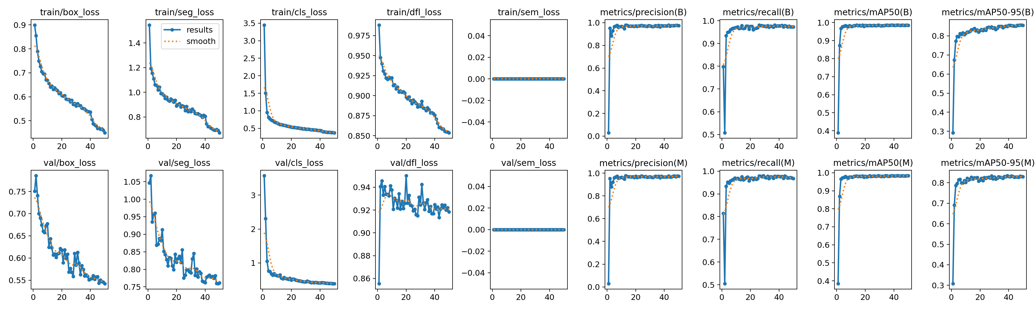

Confusion Matrix
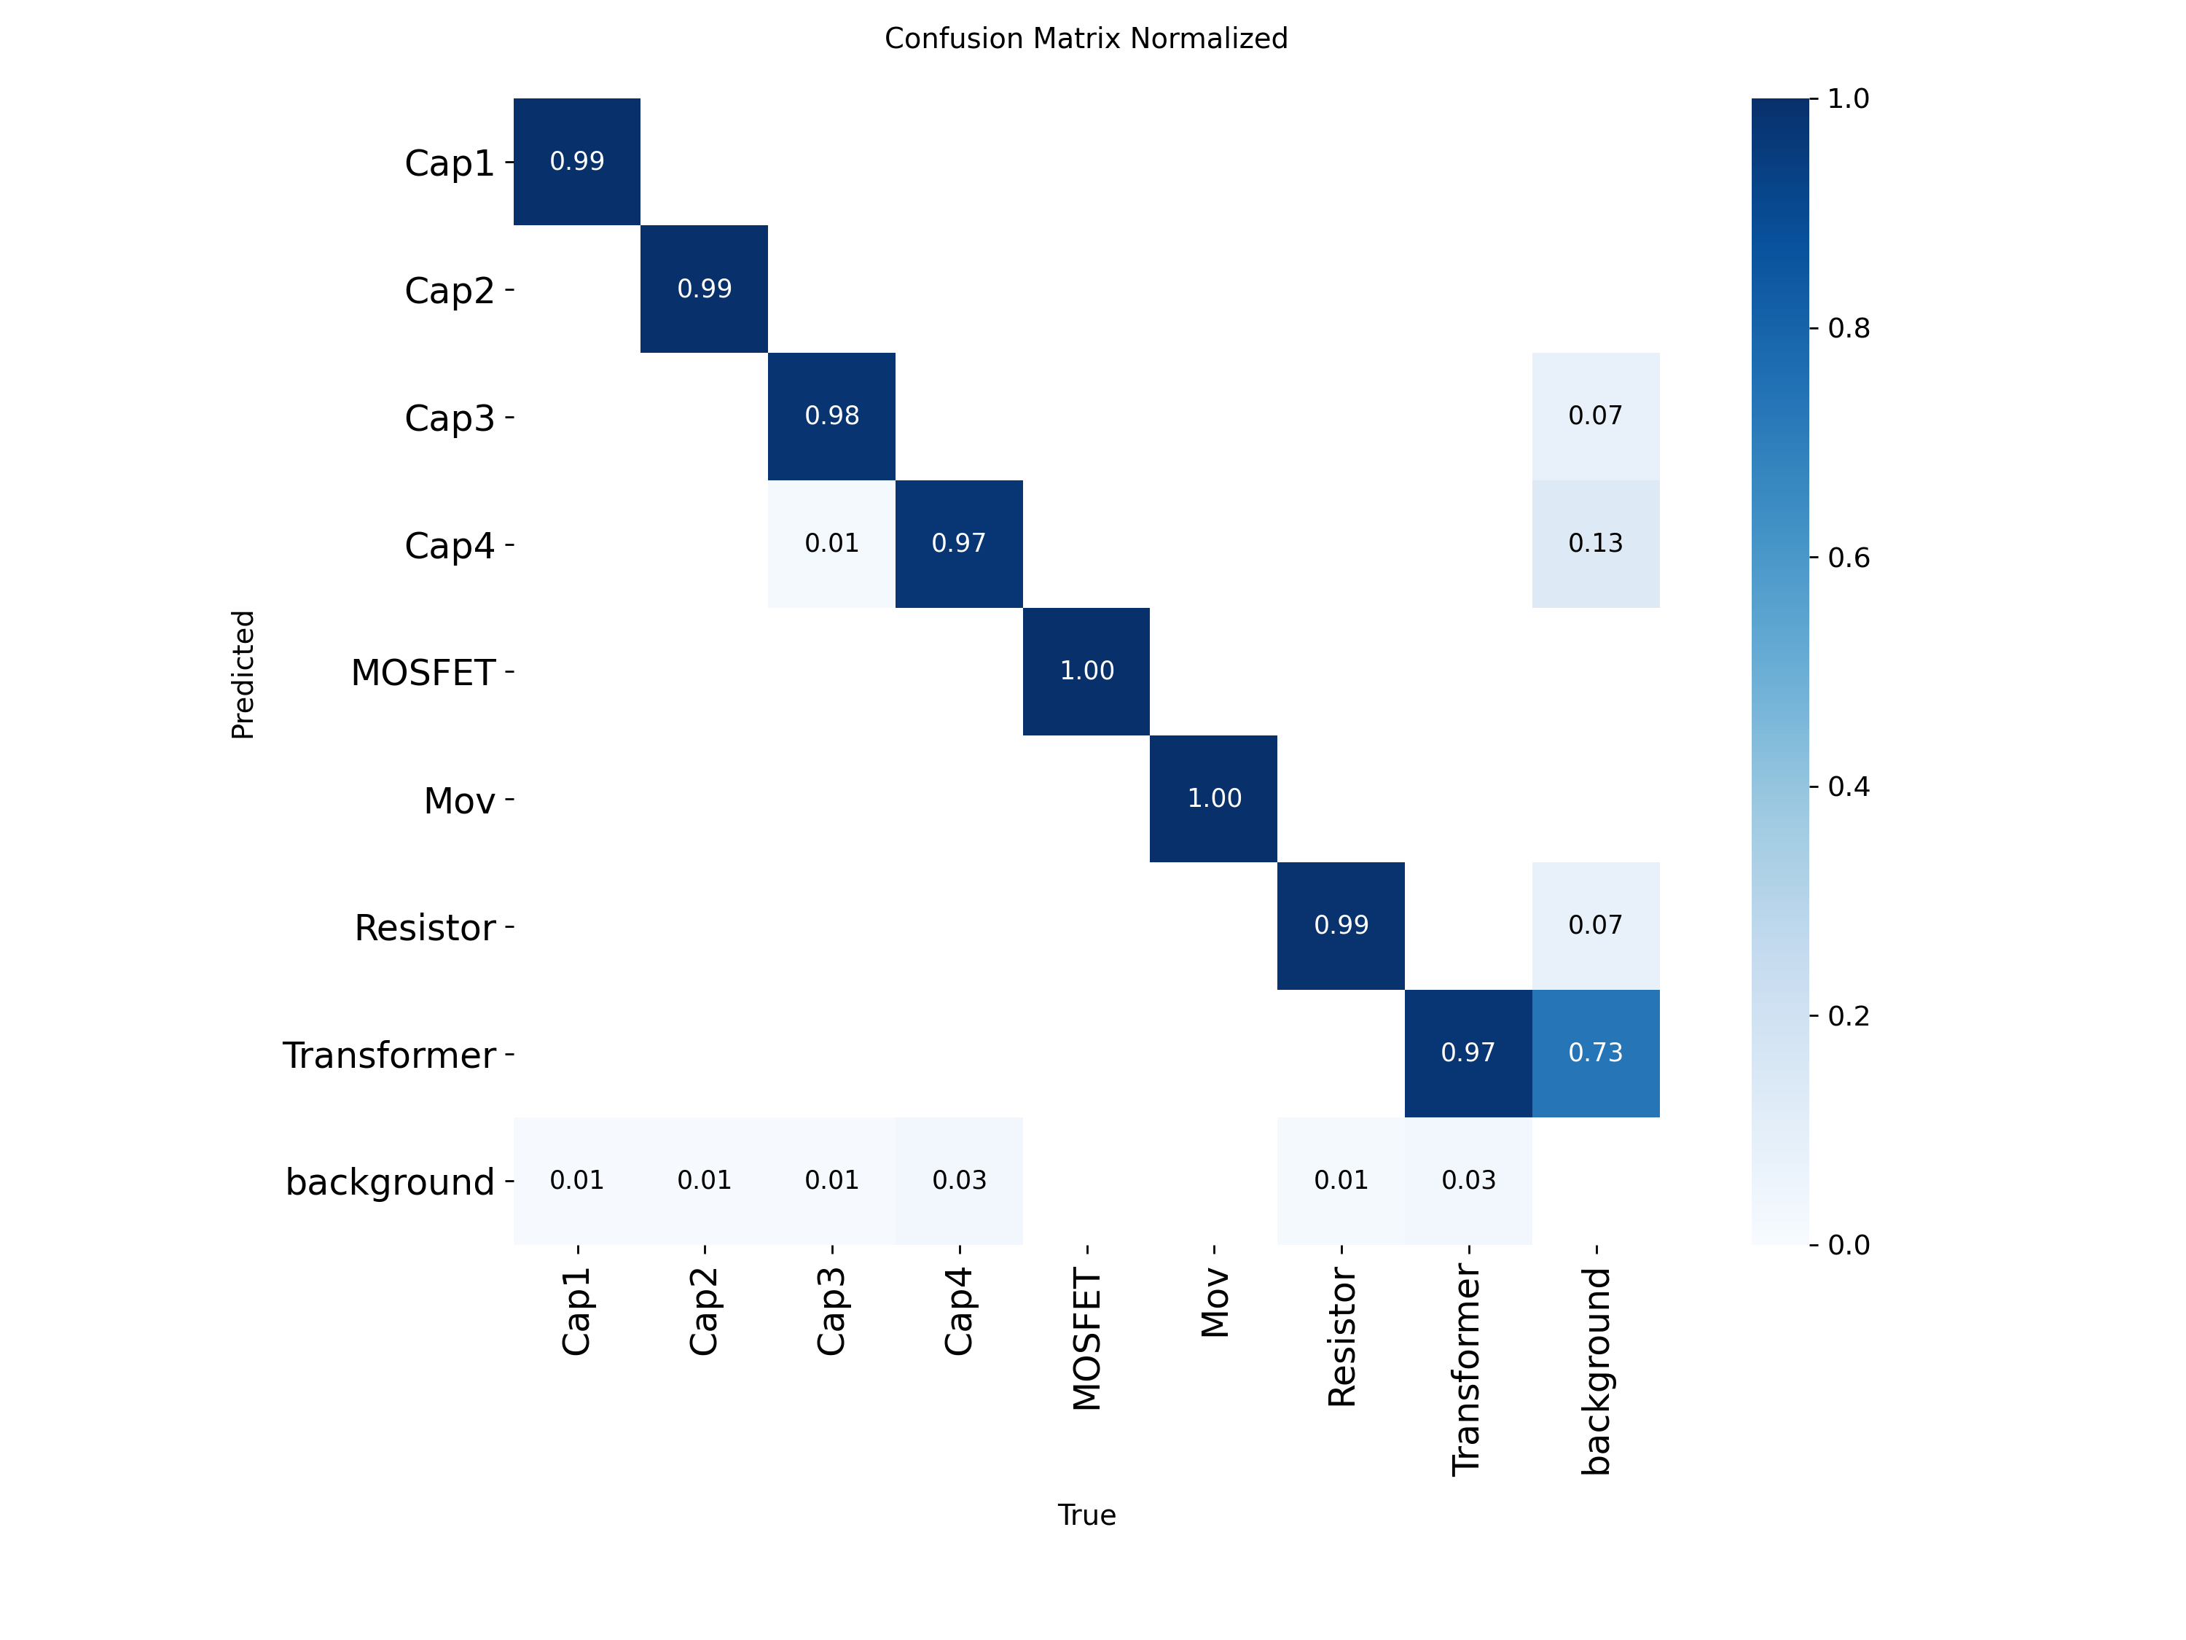

Validation Batch 0 Predictions
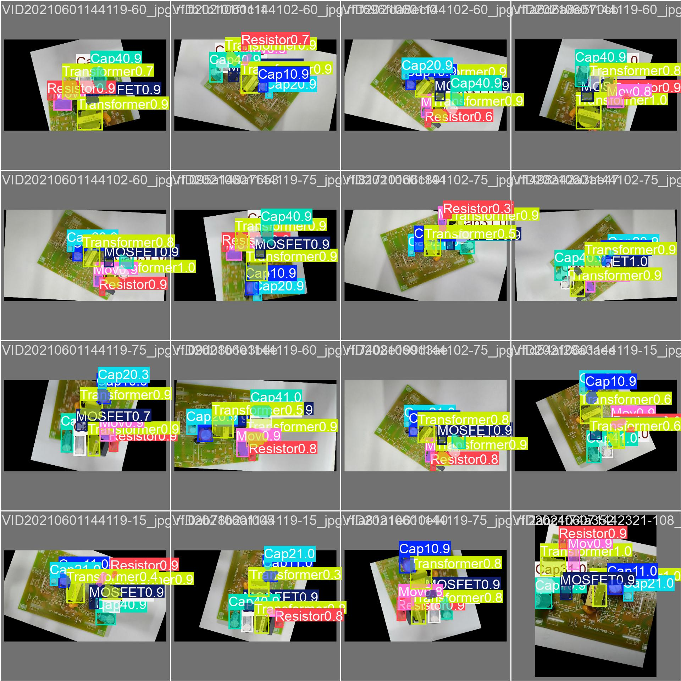

Validation Batch 1 Predictions
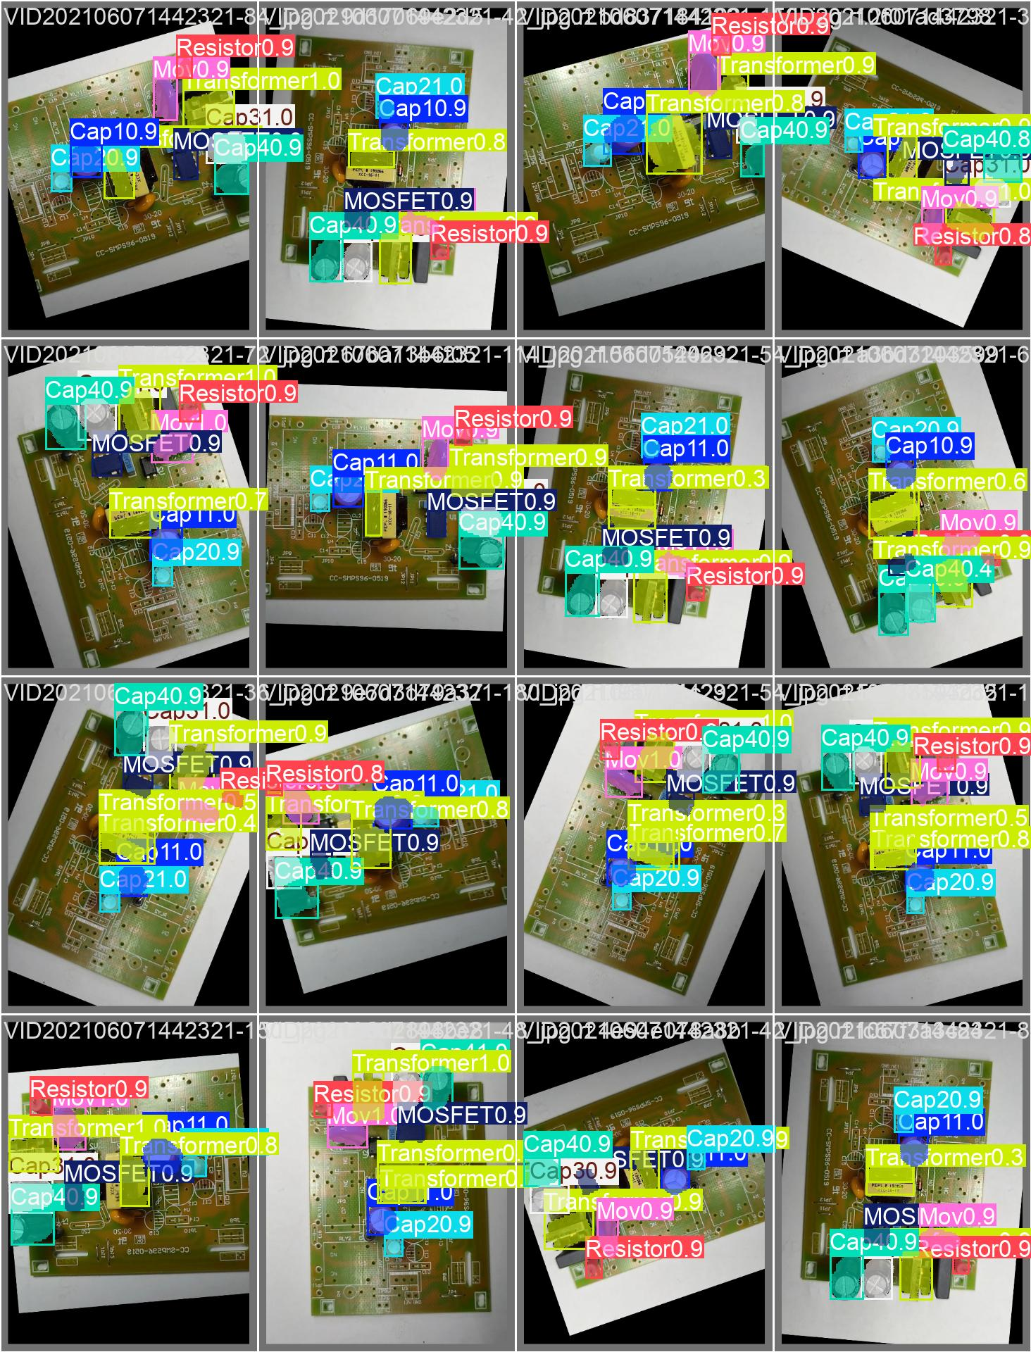

Validation Batch 2 Predictions


