**C# ASSIGNMENT 2**

1. A farmer is asking you to tell him how many legs can be counted among all his animals. The farmer breeds three species:

chickens = 2 legs

cows = 4 legs

pigs = 4 legs

The farmer has counted his animals and he gives you a subtotal for each species. You have to implement a function that returns the total number of legs of all the animals.

**CODE :**

using Basic_Program;

using System.Net.Http.Headers;

class Demo1

{

public static void Main(string[] args)

{

Console.WriteLine("Enter the chicken count");

int chicken = Convert.ToInt32(Console.ReadLine());

Console.WriteLine("Enter the cow count");

int cow = Convert.ToInt32(Console.ReadLine());

Console.WriteLine("Enter the pig count");

int pig = Convert.ToInt32(Console.ReadLine());

Animal1 animal1 = new Animal1(chicken, cow, pig);

Console.WriteLine(animal1.count_legs());

}

}

using System;

using System.Collections.Generic;

using System.Linq;

using System.Text;

using System.Threading.Tasks;

namespace Basic_Program

{

internal class Animal1

{

private int chickens;

private int cows;

private int pigs;

public Animal1(int chickens, int cows, int pigs)

{

this.Chickens = chickens;

this.Cows = cows;

this.Pigs = pigs;

}

public int Chickens { get => chickens; set => chickens = value; }

public int Cows { get => cows; set => cows = value; }

public int Pigs { get => pigs; set => pigs = value; }

public int count_legs()

{

int result = (this.Chickens * 2) + (this.Cows * 4) + (this.Pigs * 4);

return result;

}

}

}

**OUTPUT**

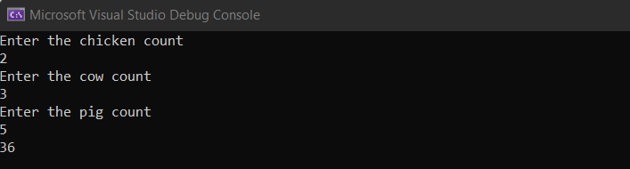

2. Create a function that takes the number of wins, draws and losses and calculates the number of

points a football team has obtained so far.

wins get 3 points draws get 1 point losses get 0 points

**CODE :**

using Basic_Program;

using System.Net.Http.Headers;

class Demo1

{

public static void Main(string[] args)

{

Console.WriteLine("Enter the number of wins");

int wins = Convert.ToInt32(Console.ReadLine());

Console.WriteLine("Enter the number of draws");

int draws = Convert.ToInt32(Console.ReadLine());

Console.WriteLine("Enter the losses");

int losses = Convert.ToInt32(Console.ReadLine());

Football football = new Football();

Console.WriteLine(football.FootballPoints(wins, draws, losses));

}

}

using System;

using System.Collections.Generic;

using System.Linq;

using System.Text;

using System.Threading.Tasks;

namespace Basic_Program

{

internal class Football

{

private int wins;

private int draws;

private int losses;

public int Wins { get => wins; set => wins = value; }

public int Draws { get => draws; set => draws = value; }

public int Losses { get => losses; set => losses = value; }

public int FootballPoints(int wins, int draws, int losses)

{

int result = (wins * 3) + (draws * 1) + (losses * 0);

return result;

}

}

}

**OUTPUT:**

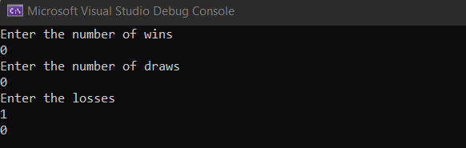

3. Create a function that takes three arguments prob, prize, pay and returns true if prob * prize > pay otherwise return false.

**CODE:**

using Basic_Program;

using System.Net.Http.Headers;

class Demo1

{

public static void Main(string[] args)

{

Console.WriteLine("Enter the prob");

double prob = Convert.ToDouble(Console.ReadLine());

Console.WriteLine("Enter the prize");

int prize = Convert.ToInt32(Console.ReadLine());

Console.WriteLine("Enter the pay");

int pay = Convert.ToInt32(Console.ReadLine());

Gamble gamble = new Gamble();

Console.WriteLine(gamble.ProfitableGamble(prob, prize, pay));

}

}

using System;

using System.Collections.Generic;

using System.Linq;

using System.Text;

using System.Threading.Tasks;

namespace Basic_Program

{

internal class Gamble

{

private double prob;

private int prize;

private int pay;

public double Prob { get => prob; set => prob = value; }

public int Prize { get => prize; set => prize = value; }

public int Pay { get => pay; set => pay = value; }

public bool ProfitableGamble(double prob, int prize, int pay)

{

if (prob * prize > pay)

{

return true;

}

else

{

return false;

}

}

}

}

**OUTPUT:**

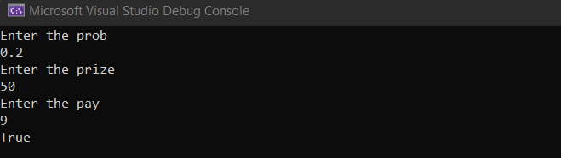

4. Write a function that takes a number n and returns the number of stacked boxes in a model n levels high, visible and invisible.

**CODE:**

using Basic_Program;

using System.Net.Http.Headers;

class Demo1

{

public static void Main(string[] args)

{

Console.WriteLine("Enter the number");

int number = Convert.ToInt32(Console.ReadLine());

Box box = new Box();

Console.WriteLine("Number os stacked boxes : " + box.StackBoxes(number));

}

}

using System;

using System.Collections.Generic;

using System.Linq;

using System.Text;

using System.Threading.Tasks;

namespace Basic_Program

{

internal class Box

{

private int number;

public int Number { get => number; set => number = value; }

public int StackBoxes(int number)

{

return number * number;

}

}

}

**OUTPUT:**

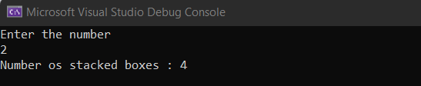

5. A bartender is writing a simple program to determine whether he should serve drinks to someone. He only serves drinks to people 18 and older and when he&#39;s not on break. Given the person&#39;s age, and whether break time is in session, create a function which returns whether he should serve drinks.

**CODE:**

using Basic_Program;

using System.Net.Http.Headers;

class Demo1

{

public static void Main(string[] args)

{

Console.WriteLine("Enter the age");

int age = Convert.ToInt32(Console.ReadLine());

Console.WriteLine("Enter the breaktime");

bool breaktime = Convert.ToBoolean(Console.ReadLine());

Bartender bartender = new Bartender();

Console.WriteLine(bartender.ShouldServeDrinks(age, breaktime));

}

}

using System;

using System.Collections.Generic;

using System.Linq;

using System.Text;

using System.Threading.Tasks;

namespace Basic_Program

{

internal class Bartender

{

private int age;

private bool breaktime;

public int Age { get => age; set => age = value; }

public bool Breaktime { get => breaktime; set => breaktime = value; }

public bool ShouldServeDrinks(int age, bool breaktime)

{

if ((age>= 18) && (breaktime==false))

{

return true;

}

else

{

return false;

}

}

}

}

**CODE:**

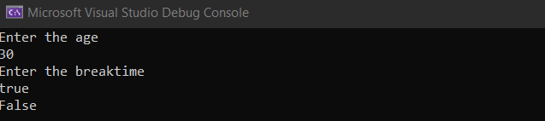

6. For each of the 6 coffee cups I buy, I get a 7th cup free. In total, I get 7 cups. Create a function that takes n cups bought and return the total number of cups I would get.

**CODE:**

using Basic_Program;

using System.Net.Http.Headers;

class Demo1

{

public static void Main(string[] args)

{

Console.WriteLine("Enter the cup count");

int cup = Convert.ToInt32(Console.ReadLine());

Coffee coffee = new Coffee();

Console.WriteLine("Total Number of cups : " + coffee.TotalCups(cup));

}

}

using System;

using System.Collections.Generic;

using System.Linq;

using System.Text;

using System.Threading.Tasks;

namespace Basic_Program

{

internal class Coffee

{

private int cups;

public int Cups { get => cups; set => cups = value; }

public int TotalCups(int cups)

{

int total_cups = (cups / 6) + cups;

return total_cups;

}

}

}

**OUTPUT:**

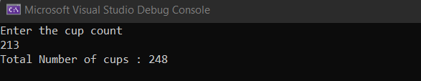

7. Create a function that adds a string ending to each member in an array.

**CODE:**

using Basic_Program;

using System.Net.Http.Headers;

class Demo1

{

public static void Main(string[] args)

{

Ending ending = new Ending();

string[] temp = { "clever", "meek", "hurried", "nice"};

ending.AddEnding(temp, "ly");

}

}

using System;

using System.Collections.Generic;

using System.Linq;

using System.Text;

using System.Threading.Tasks;

namespace Basic_Program

{

internal class Ending

{

public void AddEnding(string[] words, string addon)

{

for(int i=0;i<words.Length;i++)

{

words[i] = words[i] + addon;

}

for (int i = 0; i < words.Length; i++)

{

Console.Write(words[i] + " ");

}

}

}

}

**OUTPUT:**



8. Create a function that returns how many possible arrangements can come from a certain number

of switches (on / off). In other words, for a given number of switches, how many different

patterns of on and off can we have?

**CODE:**

using Basic_Program;

using System.Net.Http.Headers;

class Demo1

{

public static void Main(string[] args)

{

Console.WriteLine("Enter the number of switches");

int num = Convert.ToInt32(Console.ReadLine());

Switch switches = new Switch();

Console.WriteLine(switches.PosCom(num));

}

}

using System;

using System.Collections.Generic;

using System.Linq;

using System.Text;

using System.Threading.Tasks;

namespace Basic_Program

{

internal class Switch

{

public int PosCom(int num)

{

return (int)Math.Pow(2, num);

}

}

}

**OUTPUT:**

