Infosys Springboard Virtual Internship 6.0 Completion Report
Batch Number-4
Start date-Oct 13
Names:
Ghanaswamy V N
Aditya Ranjan
Santosh Kumar

Internship Duration: 8 Weeks

1.Project Title

SmartShelfX AI Based Inventory Forecast and Auto Restock

2. Project Objective

To develop an intelligent inventory management system that forecasts future stock demand using past sales data and automatically restocks items when quantities fall below threshold levels.

3. Project description in detail

he SmartShelfX project involved designing and developing an AI-based inventory forecasting and auto-restocking system using Java Spring Boot for backend services, React for the frontend interface, and PostgreSQL as the primary database. The system aimed to help retailers and warehouses efficiently manage inventory, reduce stock-outs, and optimize replenishment processes.
The frontend was developed using React to provide an interactive and responsive dashboard for monitoring real-time inventory levels, sales trends, demand forecasts, and restocking alerts. The user interface focused on usability and clarity, enabling managers to make informed inventory decisions quickly.
Backend services were implemented using Spring Boot, exposing RESTful APIs to handle inventory management, forecasting logic, and business workflows. The application processed historical sales data and applied demand forecasting algorithms to predict future stock requirements and dynamically calculate reorder points.
The system was integrated with a PostgreSQL database using Spring Data JPA/Hibernate to store and manage product details, stock levels, supplier information, and transaction history. Based on forecasted demand and predefined thresholds, the system automatically generated restock recommendations or initiated auto-restock requests.
Additional features included low-stock and overstock alerts, role-based access control for administrators and inventory managers, and analytical dashboards displaying key performance metrics such as inventory turnover and forecast accuracy.
The project emphasized scalability, automation, and reliability, demonstrating how AI-driven decision support can improve inventory planning, reduce operational costs, and enhance overall supply chain efficiency.

4. Timeline Overview
Week | Activities Planned | Activities Completed
Week 1 |  | Completed UI and backend setup
  Setup environment, learn Streamlit, FastAPI
Week 2 | Implement user authentication | Completed secure login and JWT authentication
Week 3 | Inventory Catalog & Product Management | Completed the inventory management.
Week 4 | Stock-In / Stock-Out Transactions | Track timestamps, quantities, and handlers  Calculate real-time inventory
Week 5 | AI-Based Demand Forecasting | Analyze historical stock data  Predict demand for each item
Week 6 | Auto-Restock Recommendation & Purchase Orders | AI suggests items to reorder  Auto-generate purchase order (PO) for vendor approval
Week 7 | Alerts & Notifications Module | Low stock alerts  Expiry alerts (for perishable goods)
Week 8 | Analytics Dashboard & Reports | Inventory trends  Monthly purchase/sales comparison  Top restocked items

5a. Key Milestones
Milestone | Description | Date Achieved
Project Kickoff | Initial planning and brief explanation on entire project | Oct
Prototype/First Draft | Inventory Catalog & Product Management | Oct
Mid-Term Review | AI-Based Demand Forecasting | Nov
Final Submission | Auto-Restock Recommendation & Purchase Orders | Nov
Presentation | Final demo to mentor and peers | Dec

5b. Project execution details

The project was divided into four milestones—User Management, Inventory Tracking, Demand Forecasting, and Auto-Restock & Deployment. Each milestone followed a modular development approach with periodic testing and reviews. React was used for building the frontend interface, while Spring Boot handled backend services and business logic. PostgreSQL was used for data persistence and inventory transaction management. Demand forecasting logic was implemented in Java to predict future stock requirements, and automated restock rules were applied based on forecast results. The application was deployed on a server environment, ensuring reliable access and system stability.

6. Snapshots / Screenshots
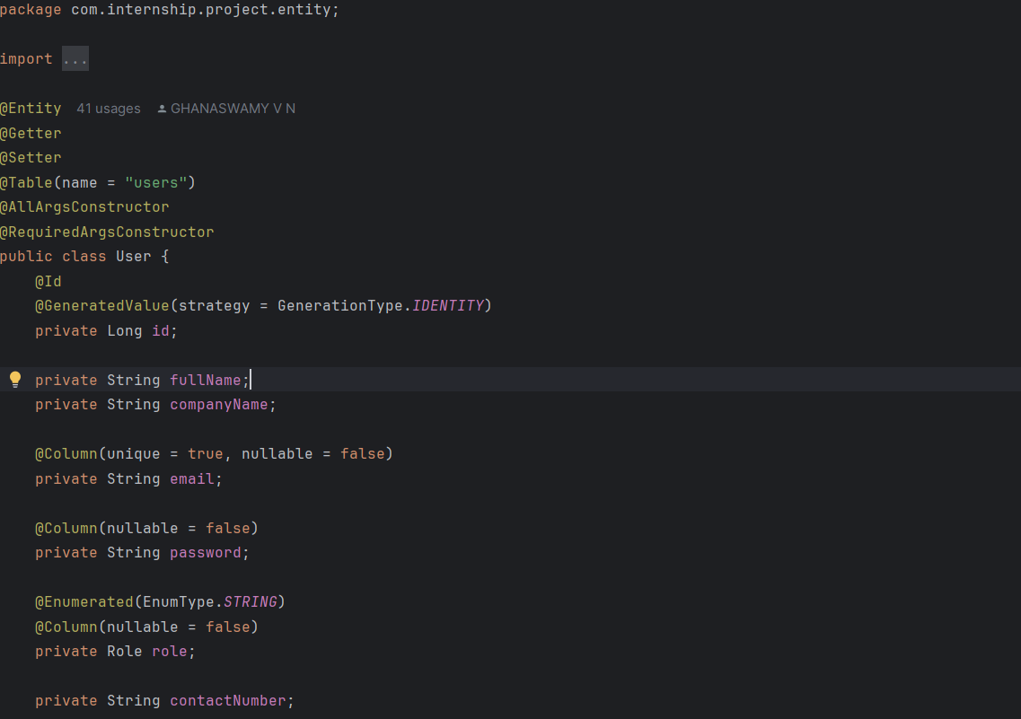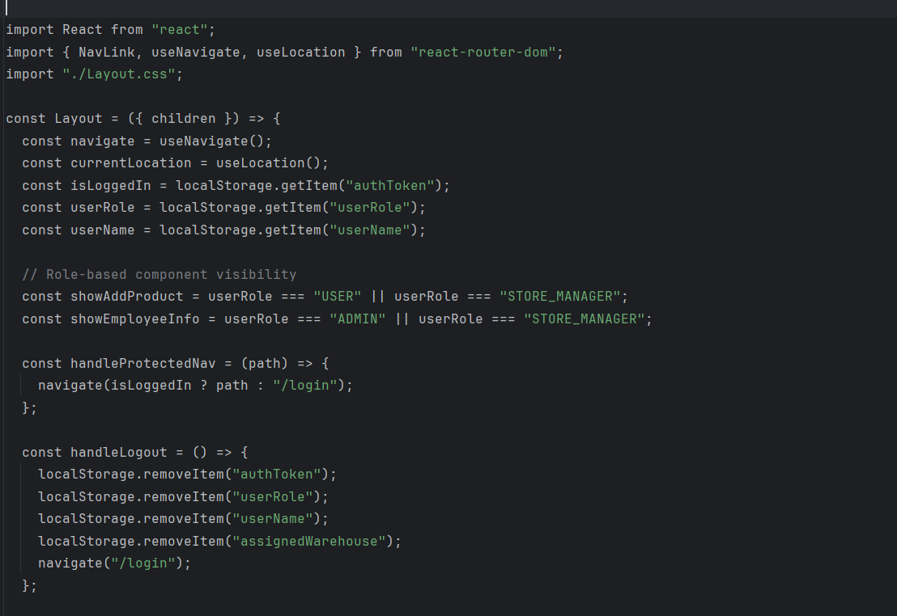

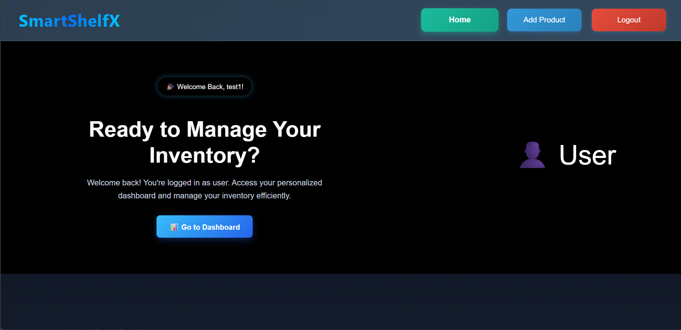
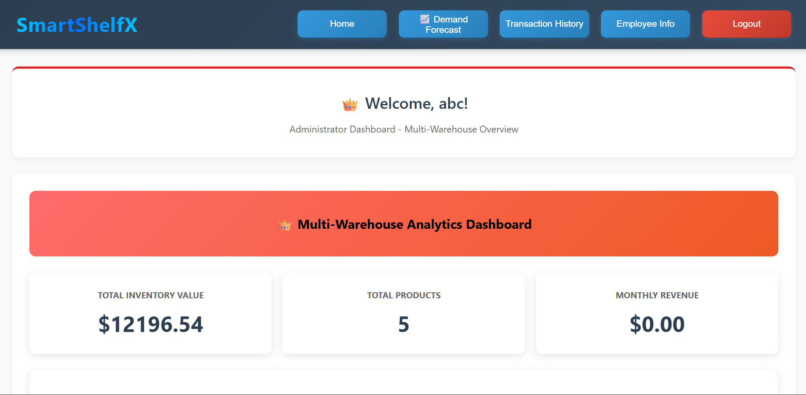

7. Challenges Faced
- Integrating React with Spring Boot APIs initially caused data synchronization and state-management issues.
- Cleaning and normalizing large historical sales datasets required significant time and careful preprocessing.
- Demand forecasting logic sometimes produced inaccurate predictions for irregular or seasonal sales patterns, which was mitigated by adjusting thresholds and validation rules.
- Limited server and database resources during deployment required query optimization and efficient backend configuration.

8. Learnings & Skills Acquired
- Hands-on experience with Java Spring Boot, React, and PostgreSQL for full-stack application development.
- Practical knowledge of designing and consuming RESTful APIs and integrating frontend and backend systems.
- Improved understanding of data analysis and demand forecasting concepts for inventory management.
- Experience in database design, query optimization, and transaction handling using PostgreSQL.
- Exposure to application deployment, performance optimization, and system scalability considerations.

• Testimonials from team

“The project enhanced our practical skills in full-stack development using Spring Boot and React.”
“Designing an AI-based inventory forecasting system was both challenging and rewarding.”
“We gained confidence in building and deploying real-world, data-driven enterprise applications.”

10. Conclusion
This project provided valuable experience in designing, developing, and deploying an AI-driven inventory forecasting and auto-restocking system. It enhanced both technical and problem-solving skills, while strengthening understanding of full-stack development, database management, and predictive analytics. The project aligned well with the students’ academic and career goals in software engineering, data-driven decision-making, and enterprise application development.

11. Acknowledgements
We sincerely thank Infosys Springboard, our mentors, and the academic coordinators for their continuous guidance, support, and encouragement throughout this internship.

