# MIDDLE EAST TECHNICAL UNIVERSITY

# DEPARTMENT OF ELECTRICAL AND ELECTRONICS ENGINEERING

# EE 564: DESIGN OF ELECTRICAL MACHINES

# PROJECT – 2

## Göksenin Hande Bayazıt – 2093441

## Submission Date: Apr. 29, 2018

# Introduction:

In the scope of this project, a PM synchronous machine with a diameter of 240 mm is designed, as a part of design of an integrated modular motor drive system. Considering the previous design with the larger outer diameter, in this iteration, aspect ratio will be increased as the diameter becomes smaller with same output power (and torque). Motor parameters will be analyzed in detail using both analytical calculation techniques and computational tools.

# Winding Design:

Basic properties of the motor may be summarized as follows:

* Number of slots: 24
* Number of poles: 20
* Stator outer diameter: 240 mm
* Stator inner diameter: 150 mm
* Rotor outer diameter: 147 mm
* Rotor inner diameter: 120 mm
* Magnet thickness (included in rotor diameter): 4.5 mm
* Airgap: 1.5 mm
* Number of modules: 4 (considered as 2 series, 2 parallel)

Slot dimensions are given in Figure 1, below:

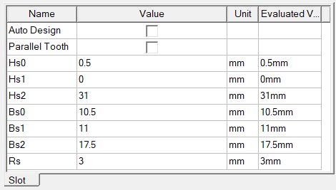

Figure 1: Slot Dimensions

Slot dimension may be approximated to a trapezoid, therefore slot area may be found as:

Lamination type and appearance is provided in Figure 2.

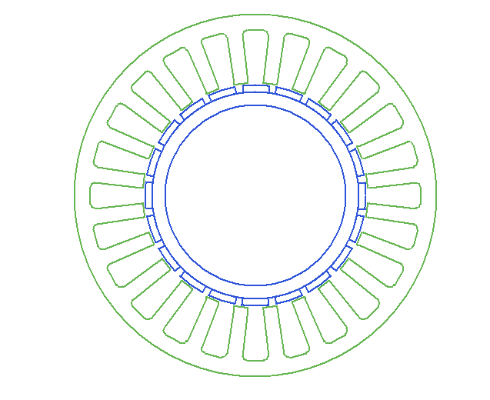

Figure 2: Stator Lamination

## Winding Configuration:

The machine will have a fractional slot, double layer winding.

Winding configuration:

|  |  |  |  |  |  |  |  |  |  |  |  |  |  |  |  |  |  |  |  |  |  |  |  |
| --- | --- | --- | --- | --- | --- | --- | --- | --- | --- | --- | --- | --- | --- | --- | --- | --- | --- | --- | --- | --- | --- | --- | --- |
| A- | A | C | C- | B- | B | A | A- | C- | C | B | B- | A- | A | C | C- | B- | B | A | A- | C- | C | B | B- |
| B | A | A- | C- | C | B | B- | A- | A | C | C- | B- | B | A | A- | C- | C | B | B- | A- | A | C | C- | B- |

Connection of the coils is given in Figure 3.

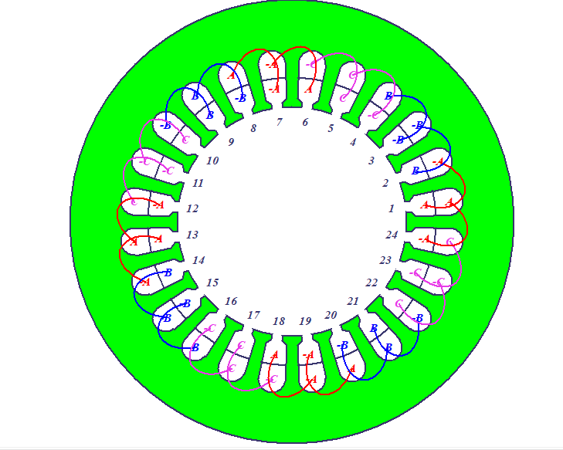

Figure 3: Winding Configuration

For this winding configuration, MMF waveforms for two different excitation cases are given in Figures 4 and 5.

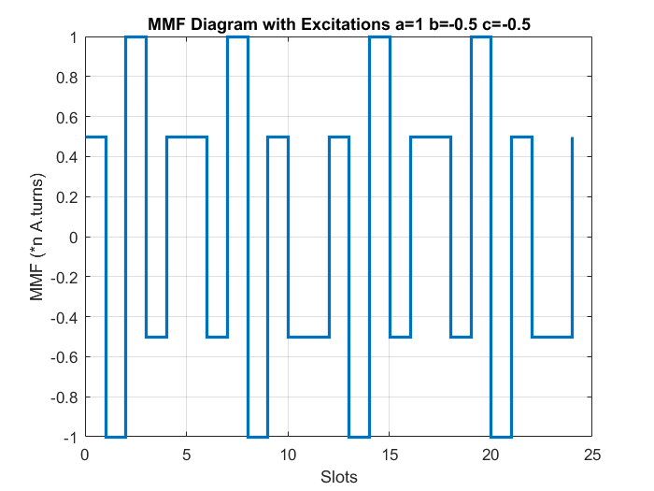

Figure 4: MMF Waveform for Ia=1, Ib=-0.5, Ic=-0.5

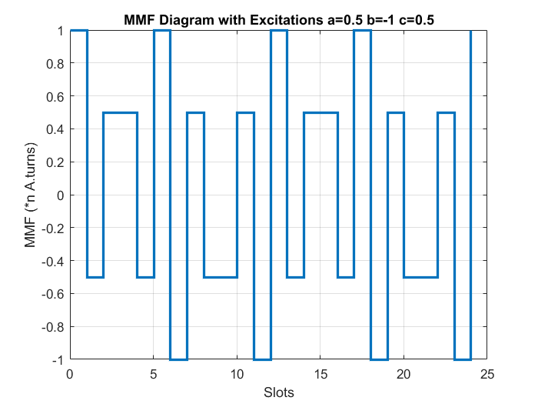

Figure 5: MMF Waveform for Ia=0.5, Ib=-1, Ic=0.5

## Winding Factor:

Pitch factor for nth harmonic order:

Table 1: Pitch Factors for First 4 Harmonics

|  |  |
| --- | --- |
| Harmonic Order | k_p |
| 1 | 0.966 |
| 3 | -0.707 |
| 5 | 0.259 |
| 7 | 0.259 |

For a fractional slot winding, distribution factor is not calculated with the conventional, formula, it is calculated with vectoral approach. Referring to Table 2.10 of our textbook[1], winding factor for first harmonic is 0.933.

## Number of Turns and Fill Factor[2]:

As a design constraint, Vl-l,rms=.

Due to “2 series 2 parallel” configuration and Y connection, we may consider voltage and current ratings of each module as 82 V and 8.7 A, in rms.

Recalling the induced voltage formula:

Let’s define L=180 mm and specify (magnetic loading):

Let’s choose J=4.5 A/mm2

Wire size is 1.628 mm (diameter), AWG14.

# Motor Parameter Estimation:

## Magnetic and Electric Loading:

While calculating the flux per pole, (magnetic loading) is chosen as 0.8 T, which is safe. As the teeth and tooth openings have approximately same length, at teeth may be calculated as:

This value is also safe, where stator steel is far from saturation point.

For electric loading:

## Approximate Torque Calculation:

## Equivalent Circuit Parameters:

* Phase resistance:

Assuming that end windings will be 10% of the coil length:

At 75oC, for copper.

* Phase inductance:

Phase inductance can be calculated with reluctance of the airgap.

## Losses:

* Copper loss:
* Core loss:

# Detailed Analysis and Verification

Using Rmxprt and Maxwell2D tools, designed machine is simulated and analytical calculations are verified. Rmxprt design results are provided in Appendix 1, necessary parameters are highlighted. Results are as follows:

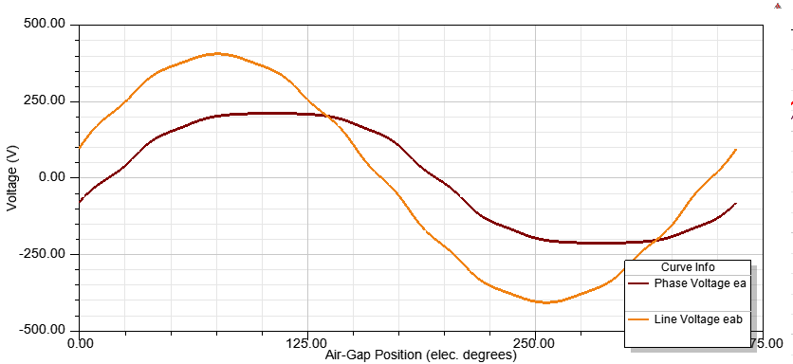

Figure 6: Induced Voltages (Rmxprt)

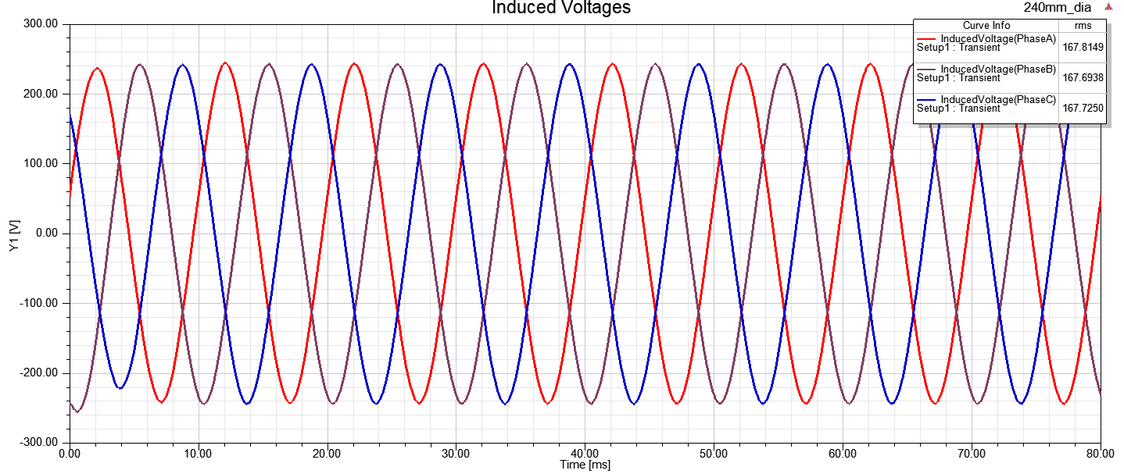

Figure 7: Induced Voltages (Maxwell2D)

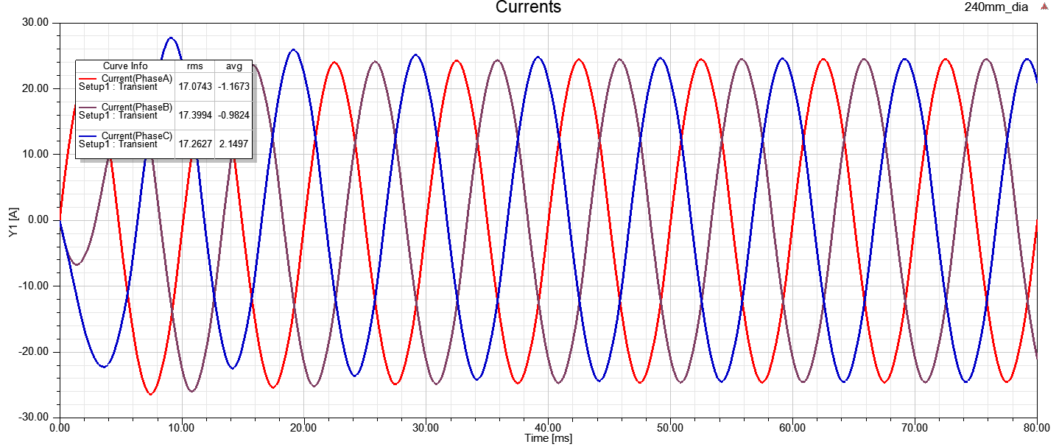

Figure 8: Phase Currents (Maxwell2D)

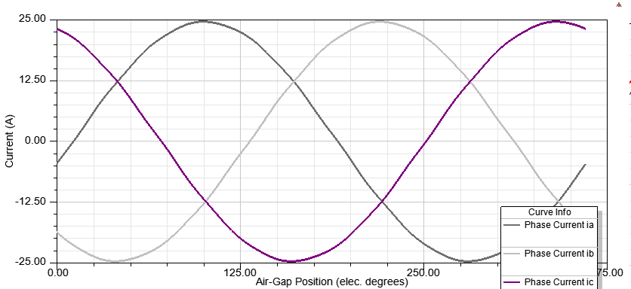

Figure 8: Phase Currents (Rmxprt)

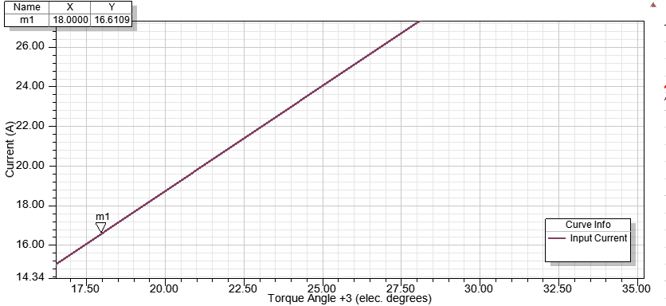

Figure 9: Load Angle vs. Phase Current (Operating point is shown with the marker.)

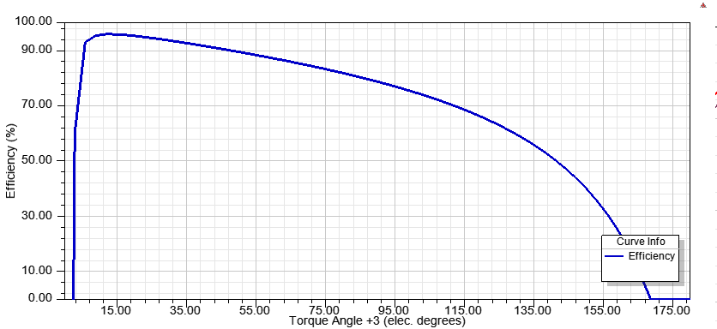

Figure 10: Load Angle vs. Efficiency

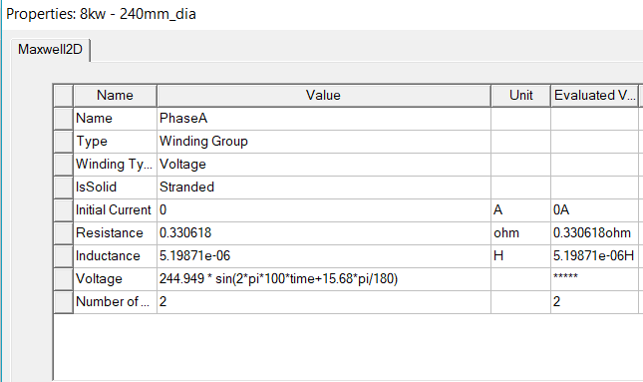

Figure 11: Phase Resistance and Inductance

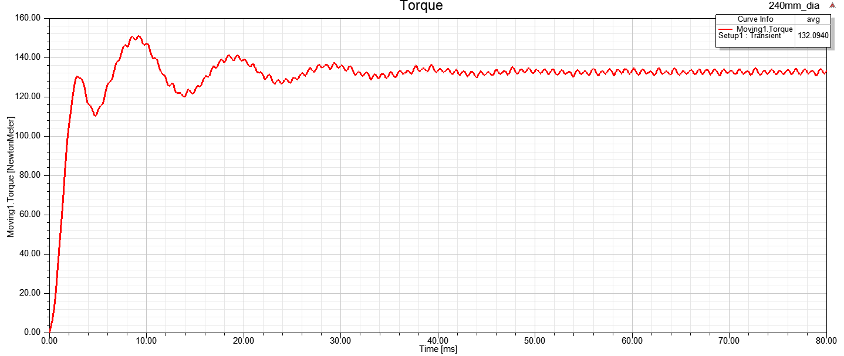

Figure 12: Output Torque

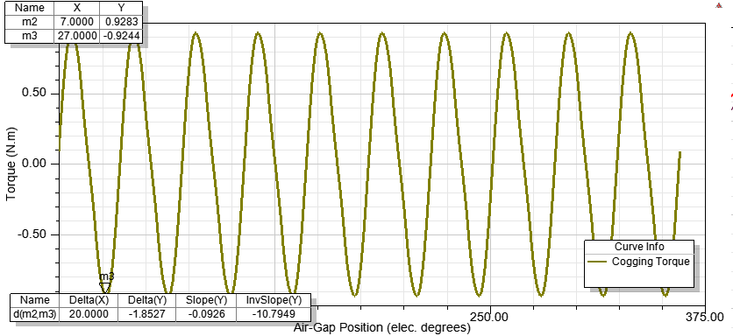

Figure 13: Cogging Torque

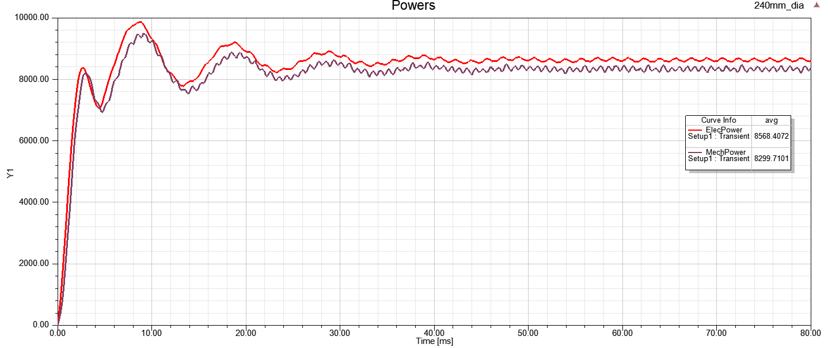

Figure 14: Input and Output Powers

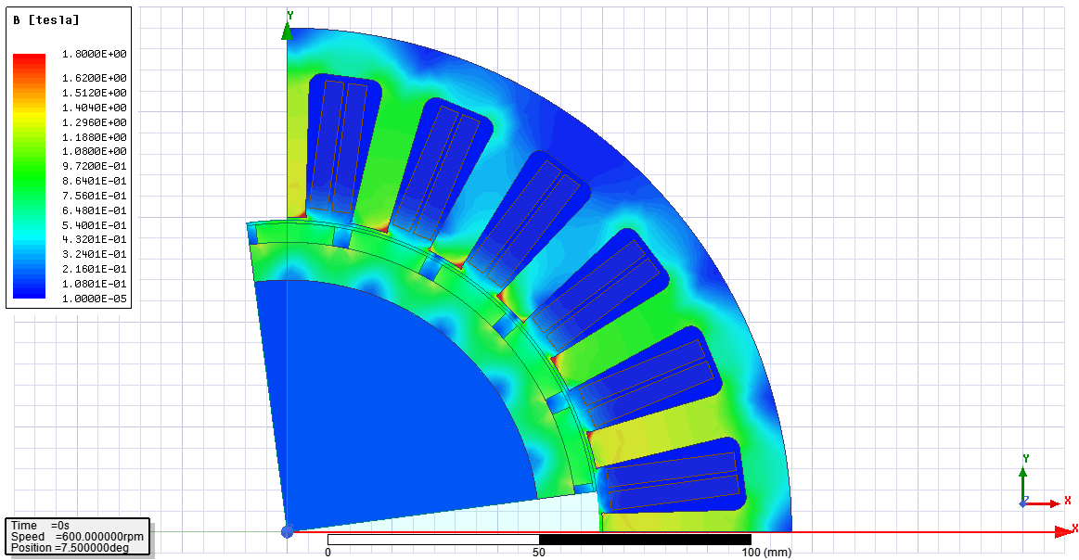

Figure 15-a: Flux Density Distribution at t=0 s

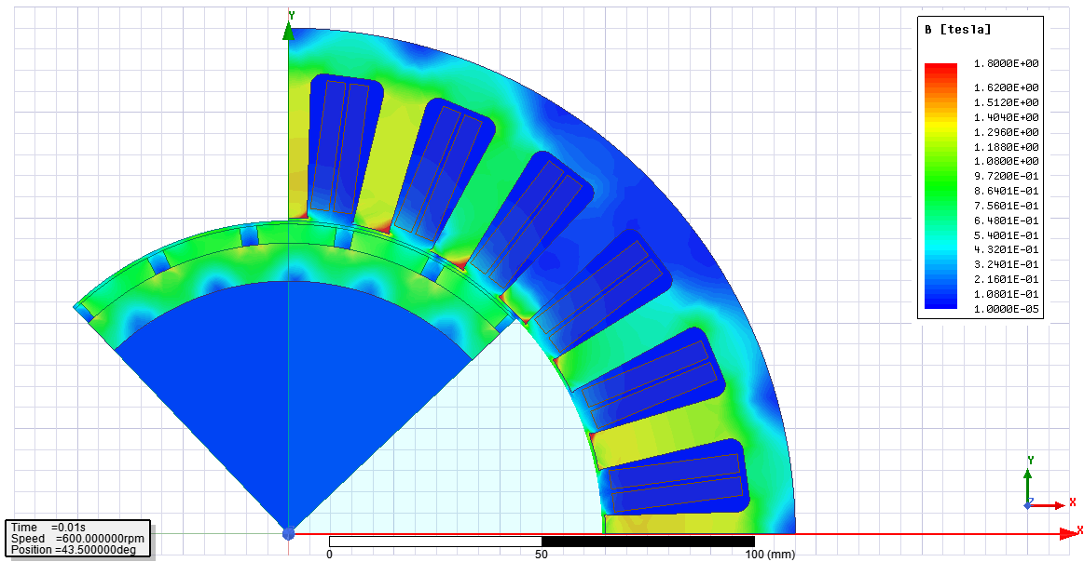

Figure 15-a: Flux Density Distribution at t=0.01 s

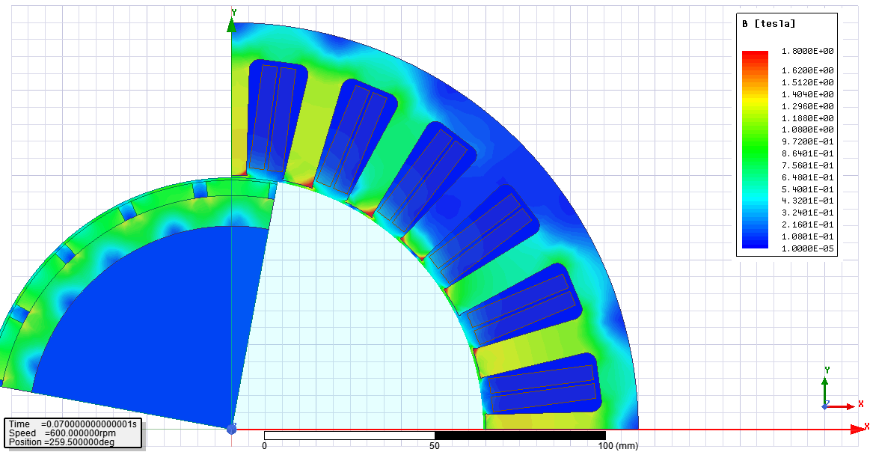

Figure 15-a: Flux Density Distribution at t=0.07 s

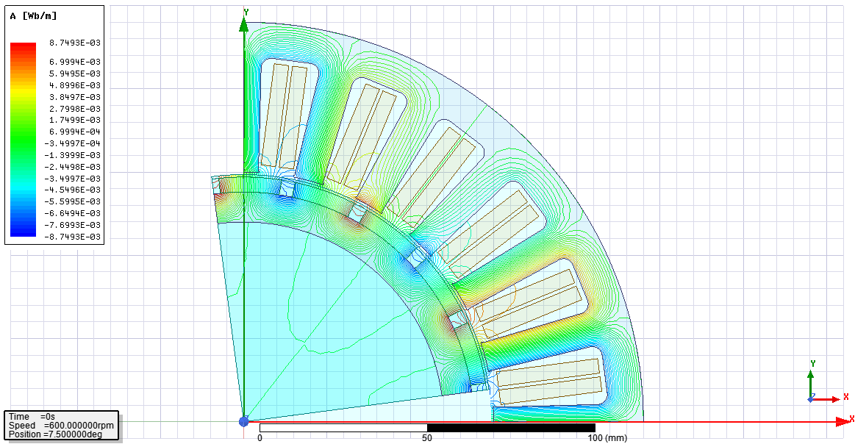

Figure 16: Flux Lines at t=0 s

## Comments and Comparison:

Considering the analytical calculations and simulation results, it can be seen that analytical calculations are mostly compatible with simulation results. Voltage and current ratings, flux densities are the parameters which have the least discrepancy among two analysis methods. However, inductance, resistance and loss calculations are far from being accurate.

In the analytical calculation process, optimal number of turns is found as 46, however in simulation, number of turns is considered as 40. The reason for that is to reduce the fill factor, in order to ease the production (especially winding process) of the motor. As all of the parameters have been calculated and considered in safe margins, such a discrepancy is quite acceptable.

# Conclusion:

In this project, machine part of an integrated modular motor drive system has been designed. The main aim was to reduce the outer diameter to 240 mm from 300 mm, without changing voltage, power and torque ratings, because of production concerns. To achieve this number of turns has been decreased 2/3 of its initial value and axial length has been increased by 80%, to keep the flux per pole (to have same amount of induced voltage). In the design process, fill factor was an important concern, due to the production and winding of the stator. For that reason, axial length and number of turns have been changed in safe margins. Analytical calculations have been verified and compared with simulation data and it is seen that most of the results obtained via simulation are compatible with analytical ones.

# References:

[1] Pyrhönen, J., Jokinen, T., Hrabovcová, V., & Niemelä, H. (2014). Design of rotating electrical machines. Chichester: Wiley.

[2] EE564 Lecture Notes by Ozan Keysan. Retrived from: <http://keysan.me/ee564>

# Appendix: Rmxprt Design Sheet

ADJUSTABLE-SPEED PERMANENT MAGNET SYNCHRONOUS MOTOR DESIGN

File: Setup2.res

GENERAL DATA

Rated Output Power (kW): 8.5

Rated Voltage (V): 300

Number of Poles: 20

Frequency (Hz): 100

Frictional Loss (W): 12

Windage Loss (W): 0

Rotor Position: Inner

Type of Circuit: Y3

Type of Source: Sine

Domain: Time

Operating Temperature (C): 75

STATOR DATA

Number of Stator Slots: 24

Outer Diameter of Stator (mm): 240

Inner Diameter of Stator (mm): 150

Type of Stator Slot: 4

Stator Slot

hs0 (mm): 0.5

hs1 (mm): 0

hs2 (mm): 31

bs0 (mm): 10.5

bs1 (mm): 11

bs2 (mm): 17.5

rs (mm): 3

Top Tooth Width (mm): 8.75553

Bottom Tooth Width (mm): 10.4038

Skew Width (Number of Slots): 0

Length of Stator Core (mm): 180

Stacking Factor of Stator Core: 0.92

Type of Steel: m250-35a

Designed Wedge Thickness (mm): 4.64882e-005

Slot Insulation Thickness (mm): 0.3

Layer Insulation Thickness (mm): 0.3

End Length Adjustment (mm): 0

Number of Parallel Branches: 2

Number of Conductors per Slot: 80

Type of Coils: 21

Average Coil Pitch: 1

Number of Wires per Conductor: 1

Wire Diameter (mm): 1.628

Wire Wrap Thickness (mm): 0

Slot Area (mm^2): 495.637

Net Slot Area (mm^2): 454.712

Limited Slot Fill Factor (%): 75

Stator Slot Fill Factor (%): 46.6296

Coil Half-Turn Length (mm): 198.219

Wire Resistivity (ohm.mm^2/m): 0.0217

ROTOR DATA

Minimum Air Gap (mm): 1.5

Inner Diameter (mm): 120

Length of Rotor (mm): 180

Stacking Factor of Iron Core: 0.95

Type of Steel: steel_1010

Polar Arc Radius (mm): 73.5

Mechanical Pole Embrace: 0.82

Electrical Pole Embrace: 0.784893

Max. Thickness of Magnet (mm): 4.5

Width of Magnet (mm): 18.3548

Type of Magnet: NdFe45H

Type of Rotor: 1

Magnetic Shaft: No

PERMANENT MAGNET DATA

Residual Flux Density (Tesla): 1.32

Coercive Force (kA/m): 995

Maximum Energy Density (kJ/m^3): 328.35

Relative Recoil Permeability: 1.05573

Demagnetized Flux Density (Tesla): 0

Recoil Residual Flux Density (Tesla): 1.32

Recoil Coercive Force (kA/m): 995

MATERIAL CONSUMPTION

Armature Wire Density (kg/m^3): 8900

Permanent Magnet Density (kg/m^3): 7400

Armature Core Steel Density (kg/m^3): 7872

Rotor Core Steel Density (kg/m^3): 7872

Armature Copper Weight (kg): 7.05075

Permanent Magnet Weight (kg): 2.20037

Armature Core Steel Weight (kg): 20.4303

Rotor Core Steel Weight (kg): 4.90979

Total Net Weight (kg): 34.5912

Armature Core Steel Consumption (kg): 76.9765

Rotor Core Steel Consumption (kg): 26.7621

STEADY STATE PARAMETERS

Stator Winding Factor: 0.933013

D-Axis Reactive Inductance Lad (H): 0.000991566

Q-Axis Reactive Inductance Laq (H): 0.000991566

D-Axis Inductance L1+Lad (H): 0.00430013

Q-Axis Inductance L1+Laq (H): 0.00430013

Armature Leakage Inductance L1 (H): 0.00330857

Zero-Sequence Inductance L0 (H): 0.00279157

Armature Phase Resistance R1 (H): 0.330618

Armature Phase Resistance at 20C (ohm): 0.27196

NO-LOAD MAGNETIC DATA

Stator-Teeth Flux Density (Tesla): 1.61183

Stator-Yoke Flux Density (Tesla): 0.687196

Rotor-Yoke Flux Density (Tesla): 0.850355

Air-Gap Flux Density (Tesla): 0.773386

Magnet Flux Density (Tesla): 0.827659

Stator-Teeth By-Pass Factor: 0.00548454

Stator-Yoke By-Pass Factor: 1.05982e-005

Rotor-Yoke By-Pass Factor: 5.53394e-005

Stator-Teeth Ampere Turns (A.T): 132.083

Stator-Yoke Ampere Turns (A.T): 0.88214

Rotor-Yoke Ampere Turns (A.T): 5.16357

Air-Gap Ampere Turns (A.T): 1531.59

Magnet Ampere Turns (A.T): -1670.04

Leakage-Flux Factor: 1

Correction Factor for Magnetic

Circuit Length of Stator Yoke: 0.738369

Correction Factor for Magnetic

Circuit Length of Rotor Yoke: 0.723754

No-Load Line Current (A): 3.25843

No-Load Input Power (W): 132.148

Cogging Torque (N.m): 0.928347

FULL-LOAD DATA

Maximum Line Induced Voltage (V): 404.664

Root-Mean-Square Line Current (A): 17.3318

Root-Mean-Square Phase Current (A): 17.3318

Armature Thermal Load (A^2/mm^3): 146.99

Specific Electric Loading (A/mm): 35.308

Armature Current Density (A/mm^2): 4.16307

Frictional and Windage Loss (W): 12

Iron-Core Loss (W): 108.968

Armature Copper Loss (W): 297.943

Total Loss (W): 418.911

Output Power (W): 8503.05

Input Power (W): 8921.96

Efficiency (%): 95.3047

Synchronous Speed (rpm): 600

Rated Torque (N.m): 135.33

Torque Angle (degree): 15.68

Maximum Output Power (W): 27079.6

WINDING ARRANGEMENT

The 3-phase, 2-layer winding can be arranged in 6 slots as below:

ABYZCA

Angle per slot (elec. degrees): 150

Phase-A axis (elec. degrees): 90

First slot center (elec. degrees): 0

TRANSIENT FEA INPUT DATA

For Armature Winding:

Number of Turns: 320

Parallel Branches: 2

Terminal Resistance (ohm): 0.330618

End Leakage Inductance (H): 5.19871e-006

2D Equivalent Value:

Equivalent Model Depth (mm): 180

Equivalent Stator Stacking Factor: 0.92

Equivalent Rotor Stacking Factor: 0.95

Equivalent Br (Tesla): 1.32

Equivalent Hc (kA/m): 995

Estimated Rotor Inertial Moment (kg m^2): 0.064363