# MIDDLE EAST TECHNICAL UNIVERSITY

# DEPARTMENT OF ELECTRICAL AND ELECTRONICS ENGINEERING

# EE 564: DESIGN OF ELECTRICAL MACHINES

# PROJECT – 3

## Göksenin Hande Bayazıt – 2093441

## Submission Date: Jun. 4, 2018

# Introduction:

In the scope of this project, a traction squirrel cage induction machine is designed. Motor parameters will be analyzed in detail using both analytical calculation techniques and computational tools. Specifications of the machine are as follows:

* Rated Power Output: 1280 kW
* Line-to-line voltage: 1350 V
* Number of poles: 6
* Rated Speed: 1520 rpm (72 km/h) (driven with 78 Hz inverter)
* Rated Motor Torque: 7843 Nm
* Cooling: Forced Air Cooling
* Insulating Class: 200C
* Train Wheel Diameter: 1210 mm
* Maximum Speed: 140 km/h
* Gear Ratio: 4.82

# Sizing:

For size estimation, initially an appropriate mechanical machine constant is chosen and throughout the design process (iterations), mechanical machine constant kept within the appropriate boundaries. For a 6 pole 1280 kW machine, Cmech should be around 250-320 kW.s/m3. Let Cmech=260.

$$P_{mech}=\frac{C_{mech}D^{2}l^{'}f}{p} \\ D^{2}l^{'}=0.1893$$

Let $χ=\frac{l^{'}}{D}=1.5$

$$D=0.502 m \\ l^{'}=0.752 m$$

Let’s choose magnetic loading $\hat{B_{δ}}=0.8 T$ and assume that winding factor is around 0.95

$$E=\frac{\frac{2π}{\sqrt{2}}fk_{w}N_{ph}B_{avg}l^{'}Dπ}{2p} \\ \frac{1350}{\sqrt{3}}=\frac{2π}{\sqrt{2}}*78*0.95*N_{ph}*\frac{2}{π}0.8π*0.502*\frac{0.752}{6} \\ N_{ph}=23.6$$

This is not possible since number of turns should be an integer. Let’s take **Nph as 24** and recalculate D and l’.

$$\frac{1350}{\sqrt{3}}=\frac{2π}{\sqrt{2}}*78*0.95*24*\frac{2}{π}0.8π*\frac{D^{2}χ}{6} \\ D^{2}χ=0.3699 \\ D^{3}χ=0.1893 \\ D=0.51 m \\ l^{'}=0.73 m$$

Airgap length:

$$δ=0.18+0.006P^{0.4} \\ δ=1.85 mm$$

Stator outer diameter:

$$\frac{D_{o}}{D_{i}}=1.78 for p=3 \\ D_{o}=0.91 m$$

Back core length (assuming peak flux density in back core will be 1.5 T):

$$t_{yoke}=\frac{\frac{\hat{B_{δ}}}{\hat{B_{y}}}πD}{4p} \\ t_{yoke}=70 mm$$

Input apparent power (assuming 95% efficiency and 0.9 power factor):

$$S_{i}=\frac{1280}{0.9*0.95}=1500 kVA \\ S_{i}=\frac{π^{2}}{\sqrt{2}}\left(\frac{f}{p}\right)k_{w}A\hat{B_{δ}}D^{2}l^{'} \\ A=57287 kA/m$$

Electric loading value is within boundaries and is acceptable.

# Winding Design:

Number of turns per phase is chosen as 24.

$$q=\frac{N_{ph}}{N_{cond} p}$$

Let q=4 and number of turns per conductor be 2.

$$Q_{S}=q*m*2p \\ Q_{s}=72 slots$$

For this case, an appropriate **slot number for rotor is 84** (with a skew width of 2 slots).

Winding diagram of stator is as follows:

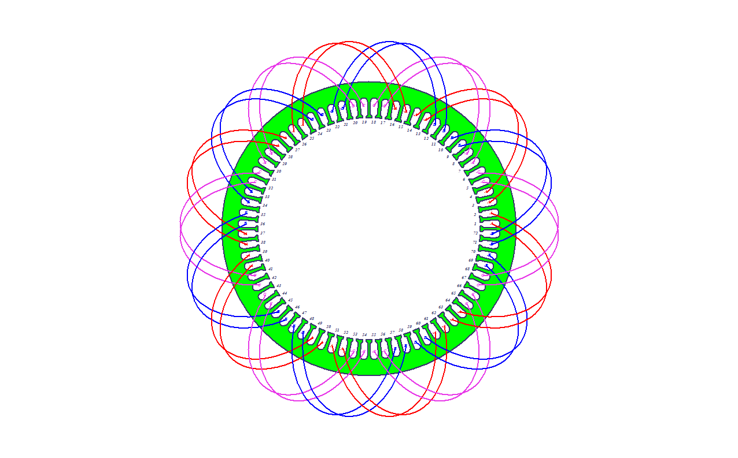

Figure 1: Stator Winding Diagram

## Winding Factor:

Winding factor for hth harmonic order:

$$k_{p}(h)=\sin\left(\frac{λ}{2}h\right) \\ k_{d}\left(h\right)=\frac{\sin\left(\frac{qhα}{2}\right)}{q\sin\left(\frac{hα}{2}\right)} \\ k_{w}(h)=k_{d}(h)k_{p}(h)$$

|  |  |  |  |
| --- | --- | --- | --- |
|  | kd | kp | kw |
| 1 | 0.9577 | 1 | 0.9577 |
| 3 | 0.6533 | -1 | -0.6533 |
| 5 | 0.2053 | 1 | 0.2053 |
| 7 | -0.1576 | -1 | 0.1576 |
| 9 | -0.2706 | 1 | -0.2706 |

# Conductor and Slot Size:

$$I_{ph}=\frac{S_{i}}{3V_{ph}} \\ I_{ph}=\frac{1.5E6}{3*779}=642 A$$

As cooling is achieved by forced air cooling, let’s assume J=7 A/mm2.

Using two AWG0 size cables in parallel, we obtain Acond= 107 mm2. Dcond=8.25 mm.

Slot width should be at least a bit larger than conductor diameter.

Slot dimensions are as given in Figure 2.

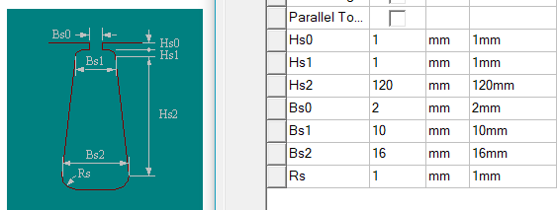

Figure 2: Slot Dimensions

Assuming that the slot is trapezoidal, slot area can be calculated as:

$$A=\frac{B_{s1}+B_{s2}}{2}H_{s}=1560 mm^{2} \\ ff=\frac{A_{cond}}{A}=\frac{107*2}{1560}=13.7\%$$

# Motor Parameter Estimation:

## Teeth Flux Density:

While calculating the flux per pole, $\hat{B}$ (magnetic loading) is chosen as 0.8 T, which is safe. As the teeth and tooth openings have approximately same length, $\hat{B}$ at teeth may be calculated as:

$${\hat{B}}_{teeth}={\hat{B}}_{gap}*\frac{A_{teeth}+A_{opening}}{A_{teeth}}=0.8*2=1.6 T$$

This value is also safe, where stator steel is far from saturation point.

## Approximate Torque Calculation:

$$τ=σ_{tan}2π{(\frac{D_{rotor}}{2})}^{2}L \\ σ_{tan}=\frac{A \hat{B}}{\sqrt{2}}=\frac{0.8*57287}{\sqrt{2}}=32406 \\ τ=32406*2*π*{\left(0.253\right)}^{2}*0.73=9514 Nm$$

## Equivalent Circuit Parameters:

* Phase resistance:

$$R_{ph}=\frac{ρ N_{ph}l_{turn}}{A_{cu}}$$

Assuming that end windings will be 10% of the coil length:

At 75oC, for copper.

$$R_{ph}=\frac{2.04 {10}^{-8}*48*1.606}{107 {10}^{-6}}=0.0147 Ω$$

* Phase inductance:

Phase inductance can be calculated with reluctance of the airgap.

$$R=\frac{l_{gap}}{\frac{πD}{2p}l'*\left(\frac{pole}{phase}\right)*μ_{0}}=\frac{1.85 {10}^{-3}}{π*0.51*\frac{0.73}{6} \left(\frac{6}{3}\right)*4π{10}^{-7}}=3776 \\ L=\frac{N_{ph}^{2}}{R}=\frac{{24}^{2}}{3776}=153 mH$$

# Material Properties and Mass:

Core: JFE_Steel_50JN600 type steel is used since it has relatively low core loss compared to the materials that have high flux density ratings.

$$V_{stator}={\left(\frac{D_{out}-D}{2}\right)}^{2}πl^{'}=91.7 l \\ m_{stator}=V_{stator}ρ=91.7*7.75=710 kg \\ V_{rotor}={\left(\frac{D_{rotor}-D_{shaft}}{2}\right)}^{2}πl^{'}=29 l \\ m_{rotor}=V_{rotor}ρ=227 kg \\ m_{cu}={3ρ}_{cu}l_{ph}A_{cond}=222 kg$$

# Losses:

* Copper loss:
$$P_{cu}=3*I_{ph}^{2}*R_{ph}=3*{\left(642\right)}^{2}*0.0147=18.2 kW$$

* Core loss:

$$P_{core,max}=k*m_{core}=5.62*\left(710+227\right)=5.3 kW$$

# RMXprt and Maxwell 2D Design:

RMXprt design results are given in Appendix. Below, on Figures 3-6, Maxwell 2D results are presented.

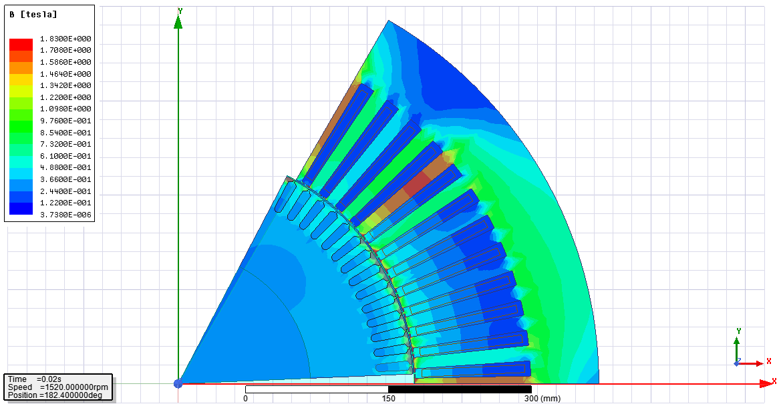

Figure 3: Flux Density Distribution

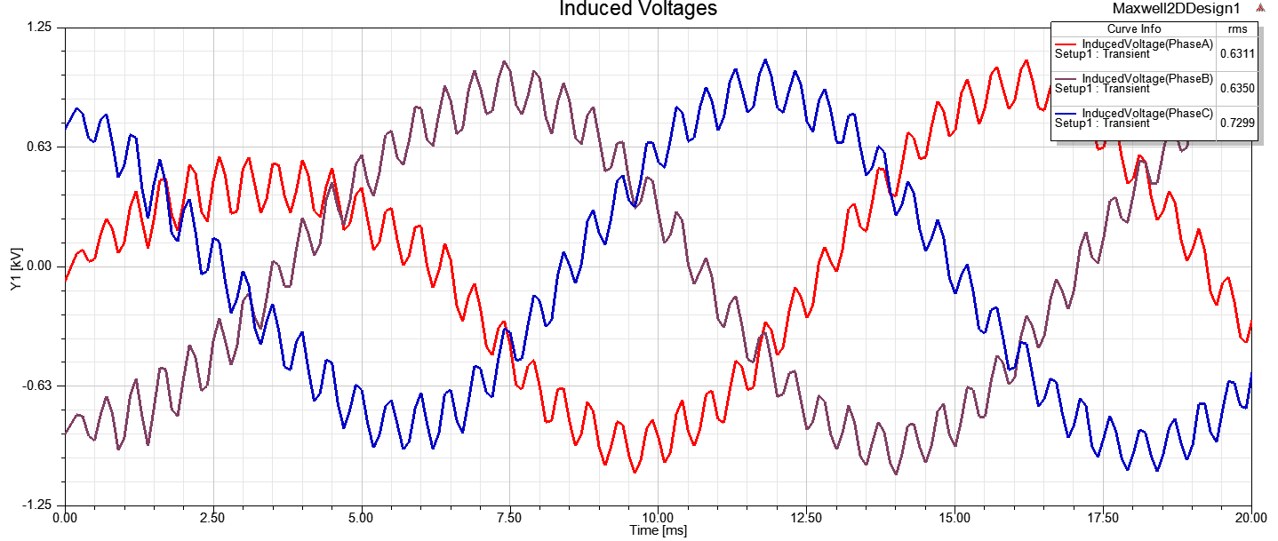

Figure 4: Induced Voltages

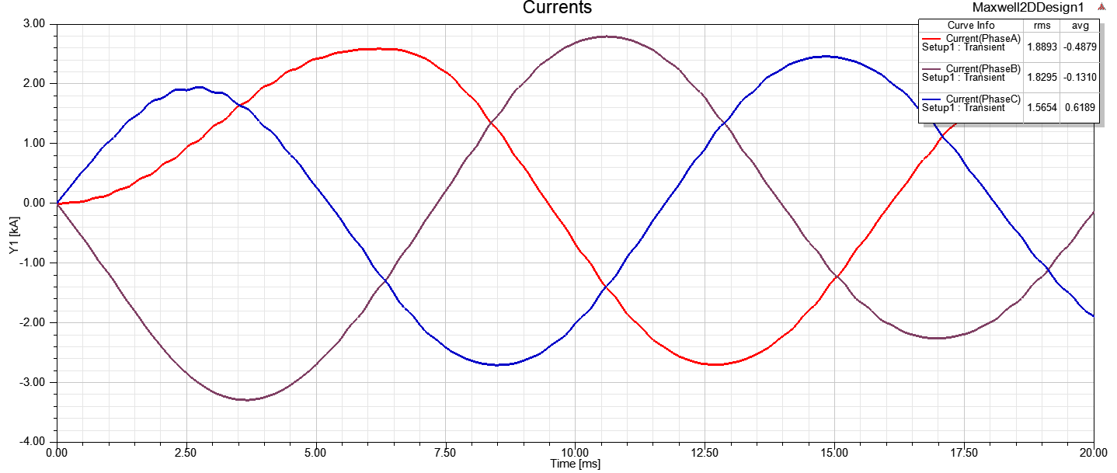

Figure 5: Phase Currents

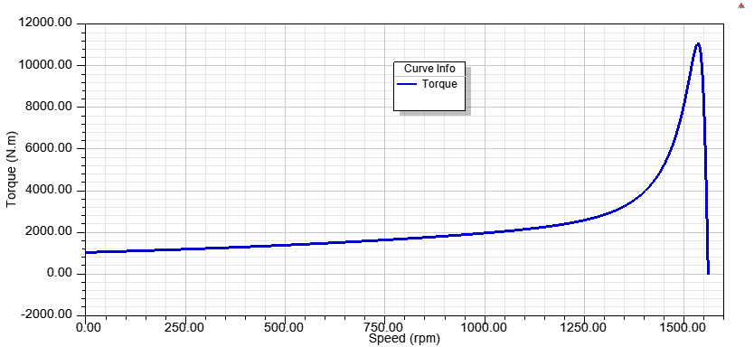

Figure 6: Torque-Speed Curve of the Machine

# Conclusion:

To summarize, we can conclude that analytical results are compatible with FEA results in a large extent. However, loss, resistance and inductance calculations are not quite reliable since they are calculated with rough assumptions.

# Appendix: Rmxprt Design Results

Three-Phase Induction Machine Design

GENERAL DATA

Given Output Power (kW): 1280

Rated Voltage (V): 1350

Winding Connection: Wye

Number of Poles: 6

Given Speed (rpm): 1520

Frequency (Hz): 78

Stray Loss (W): 12800

Frictional Loss (W): 48.7179

Windage Loss (W): 0

Operation Mode: Motor

Type of Load: Constant Power

Operating Temperature (C): 75

STATOR DATA

Number of Stator Slots: 72

Outer Diameter of Stator (mm): 910

Inner Diameter of Stator (mm): 510

Type of Stator Slot: 4

Stator Slot

hs0 (mm): 1

hs1 (mm): 1

hs2 (mm): 120

bs0 (mm): 2

bs1 (mm): 10

bs2 (mm): 16

rs (mm): 1

Top Tooth Width (mm): 12.4297

Bottom Tooth Width (mm): 16.9041

Length of Stator Core (mm): 730

Stacking Factor of Stator Core: 0.95

Type of Steel: JFE_Steel_50JN600

Number of lamination sectors 0

Press board thickness (mm): 0

Magnetic press board No

Number of Parallel Branches: 2

Type of Coils: 11

Coil Pitch: 1

Number of Conductors per Slot: 4

Number of Wires per Conductor: 1

Wire Diameter (mm): 8.252

Wire Wrap Thickness (mm): 0

Wedge Thickness (mm): 0

Slot Liner Thickness (mm): 0

Layer Insulation (mm): 0

Slot Area (mm^2): 1587.14

Net Slot Area (mm^2): 1575.98

Slot Fill Factor (%): 17.2833

Limited Slot Fill Factor (%): 50

Wire Resistivity (ohm.mm^2/m): 0.0217

Conductor Length Adjustment (mm): 0

End Length Correction Factor 1

End Leakage Reactance Correction Factor 1

ROTOR DATA

Number of Rotor Slots: 84

Air Gap (mm): 1.85

Inner Diameter of Rotor (mm): 280

Type of Rotor Slot: 2

Rotor Slot

hs0 (mm): 2

hs1 (mm): 2.5

hs2 (mm): 30

bs0 (mm): 2

bs1 (mm): 10

bs2 (mm): 8

Cast Rotor: Yes

Half Slot: No

Length of Rotor (mm): 730

Stacking Factor of Rotor Core: 0.95

Type of Steel: steel_1010

Skew Width: 2

End Length of Bar (mm): 0

Height of End Ring (mm): 20

Width of End Ring (mm): 12

Resistivity of Rotor Bar

at 75 Centigrade (ohm.mm^2/m): 0.0172414

Resistivity of Rotor Ring

at 75 Centigrade (ohm.mm^2/m): 0.0172414

Magnetic Shaft: No

MATERIAL CONSUMPTION

Armature Copper Density (kg/m^3): 8900

Rotor Bar Material Density (kg/m^3): 8933

Rotor Ring Material Density (kg/m^3): 8933

Armature Core Steel Density (kg/m^3): 7750

Rotor Core Steel Density (kg/m^3): 7872

Armature Copper Weight (kg): 148.963

Rotor Bar Material Weight (kg): 172.073

Rotor Ring Material Weight (kg): 6.49689

Armature Core Steel Weight (kg): 1783.47

Rotor Core Steel Weight (kg): 618.893

Total Net Weight (kg): 2729.9

Armature Core Steel Consumption (kg): 4480.12

Rotor Core Steel Consumption (kg): 1416.05

RATED-LOAD OPERATION

Stator Resistance (ohm): 0.0105816

Stator Resistance at 20C (ohm): 0.0087042

Stator Leakage Reactance (ohm): 0.298541

Rotor Resistance (ohm): 0.00709357

Rotor Leakage Reactance (ohm): 0.163762

Resistance Corresponding to

Iron-Core Loss (ohm): 63.1582

Magnetizing Reactance (ohm): 5.53723

Stator Phase Current (A): 675.637

Current Corresponding to

Iron-Core Loss (A): 10.8273

Magnetizing Current (A): 123.497

Rotor Phase Current (A): 635.329

Copper Loss of Stator Winding (W): 14491

Copper Loss of Rotor Winding (W): 8589.82

Iron-Core Loss (W): 22212.2

Frictional and Windage Loss (W): 49.6666

Stray Loss (W): 12800

Total Loss (W): 58142.7

Input Power (kW): 1337.71

Output Power (kW): 1279.56

Mechanical Shaft Torque (N.m): 7885.23

Efficiency (%): 95.6536

Power Factor: 0.838644

Rated Slip: 0.00666806

Rated Shaft Speed (rpm): 1549.6

NO-LOAD OPERATION

No-Load Stator Resistance (ohm): 0.0105816

No-Load Stator Leakage Reactance (ohm): 0.299532

No-Load Rotor Resistance (ohm): 0.00708999

No-Load Rotor Leakage Reactance (ohm): 0.165139

No-Load Stator Phase Current (A): 134.087

No-Load Iron-Core Loss (W): 25961.5

No-Load Input Power (W): 40838.2

No-Load Power Factor: 0.0894269

No-Load Slip: 6.51178e-006

No-Load Shaft Speed (rpm): 1559.99

BREAK-DOWN OPERATION

Break-Down Slip: 0.016

Break-Down Torque (N.m): 11073.4

Break-Down Torque Ratio: 1.40432

Break-Down Phase Current (A): 1210.33

LOCKED-ROTOR OPERATION

Locked-Rotor Torque (N.m): 1051.16

Locked-Rotor Phase Current (A): 1857.68

Locked-Rotor Torque Ratio: 0.133308

Locked-Rotor Current Ratio: 2.74953

Locked-Rotor Stator Resistance (ohm): 0.0105816

Locked-Rotor Stator

Leakage Reactance (ohm): 0.293154

Locked-Rotor Rotor Resistance (ohm): 0.0173796

Locked-Rotor Rotor

Leakage Reactance (ohm): 0.128444

DETAILED DATA AT RATED OPERATION

Stator Slot Leakage Reactance (ohm): 0.194765

Stator End-Winding Leakage

Reactance (ohm): 0.063248

Stator Differential Leakage

Reactance (ohm): 0.0405284

Rotor Slot Leakage Reactance (ohm): 0.0838629

Rotor End-Winding Leakage

Reactance (ohm): 0.00749033

Rotor Differential Leakage

Reactance (ohm): 0.0257008

Skewing Leakage Reactance (ohm): 0.046708

Stator Winding Factor: 0.957662

Stator-Teeth Flux Density (Tesla): 1.08306

Rotor-Teeth Flux Density (Tesla): 1.5934

Stator-Yoke Flux Density (Tesla): 0.809616

Rotor-Yoke Flux Density (Tesla): 0.824

Air-Gap Flux Density (Tesla): 0.672859

Stator-Teeth Ampere Turns (A.T): 17.0405

Rotor-Teeth Ampere Turns (A.T): 141.235

Stator-Yoke Ampere Turns (A.T): 16.1677

Rotor-Yoke Ampere Turns (A.T): 43.9895

Air-Gap Ampere Turns (A.T): 1037.49

Correction Factor for Magnetic

Circuit Length of Stator Yoke: 0.7

Correction Factor for Magnetic

Circuit Length of Rotor Yoke: 0.7

Saturation Factor for Teeth: 1.15256

Saturation Factor for Teeth & Yoke: 1.21054

Induced-Voltage Factor: 0.877358

Stator Current Density (A/mm^2): 6.31648

Specific Electric Loading (A/mm): 60.7234

Stator Thermal Load (A^2/mm^3): 383.558

Rotor Bar Current Density (A/mm^2): 3.36371

Rotor Ring Current Density (A/mm^2): 19.4077

Half-Turn Length of

Stator Winding (mm): 1086.64

WINDING ARRANGEMENT

The 3-phase, 1-layer winding can be arranged in 24 slots as below:

AAAAZZZZBBBBXXXXCCCCYYYY

Angle per slot (elec. degrees): 15

Phase-A axis (elec. degrees): 112.5

First slot center (elec. degrees): 0

TRANSIENT FEA INPUT DATA

For one phase of the Stator Winding:

Number of Turns: 48

Parallel Branches: 2

Terminal Resistance (ohm): 0.0105816

End Leakage Inductance (H): 0.000129054

For Rotor End Ring Between Two Bars of One Side:

Equivalent Ring Resistance (ohm): 1.29583e-006

Equivalent Ring Inductance (H): 3.62853e-008

2D Equivalent Value:

Equivalent Model Depth (mm): 730

Equivalent Stator Stacking Factor: 0.95

Equivalent Rotor Stacking Factor: 0.95

Estimated Rotor Inertial Moment (kg m^2): 36.7324