Middle East Technical University

Department of Electrical and Electronics Engineering

EE568 - Selected Topics on Electrical Machines

Spring 2019 – 2020

Project #3: PM Motor Comparison Analysis

May 4th , 2020

Introduction

In this project, basic permanent magnet design procedure will be followed. Effects of magnetic and electrical loading on machine sizing, effect of slot ratio and magnet type on machine performance will be investigated. Initial designs that start with assumptions will be optimized to obtain maximum output torque using an analytical approach.

Q1 – Magnetic Loading

**Part A and B:**

Magnetic equivalent circuit for one pole pair is given in Figure 1. Here, rotor and stator reluctances can be ignored assuming high permeability. Also, leakage between magnets are ignored for simplicity.



Figure 1: Magnetic equivalent circuit

For N42 magnet grade, and , where . Using these properties, operating point of the magnet can be calculated for a thickness of 4 mm and an airgap of 1 mm. Reluctances of the magnet and the gap can be found as:

Using the equivalent circuit, the magnetic flux density in the airgap can be calculated as:

This value is average magnetic field density for full magnet embrace. As the real embrace is 0.8, average magnetic field can be found as:

Fundamental of this field is calculated as:

Magnetic loading of the machine, which is the average of this fundamental airgap flux density is calculated as below:

Load line of this operating point is shown on the BH curve of the magnet, in Figure 2.



Figure 2: Load angle of the magnet

**Part C:**

Magnetic field of this machine is modelled in Ansys Maxwell ignoring slotting and winding effects. This model is shown in Figure 3.

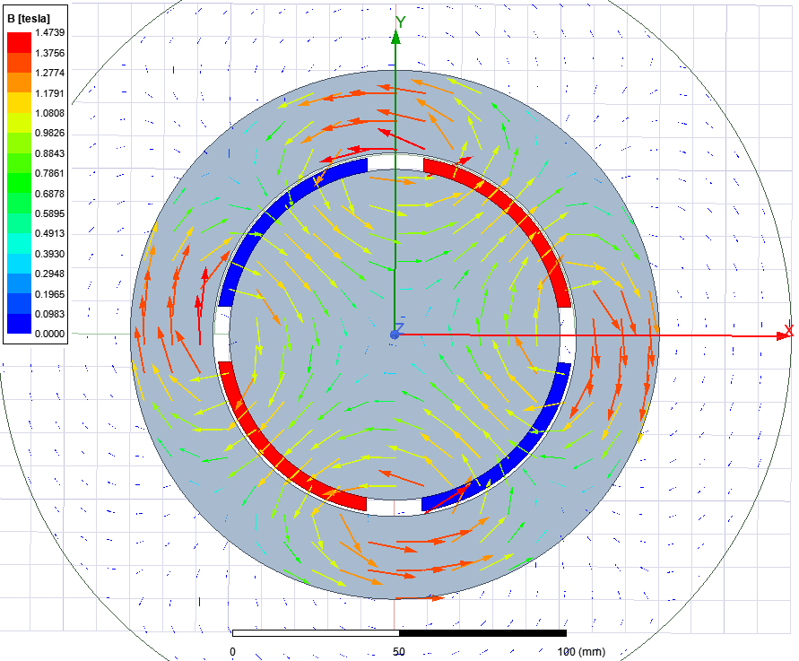

Figure 3: FEA modelling of the magnetic field of the machine

Magnitude of the airgap flux density is obtained as a function of rotor angle. As it is provided in terms of magnitude, direction of the vectors is ignored. Hence, the negative section of the waveform is inverted. The results are compatible with the ones obtained analytically.

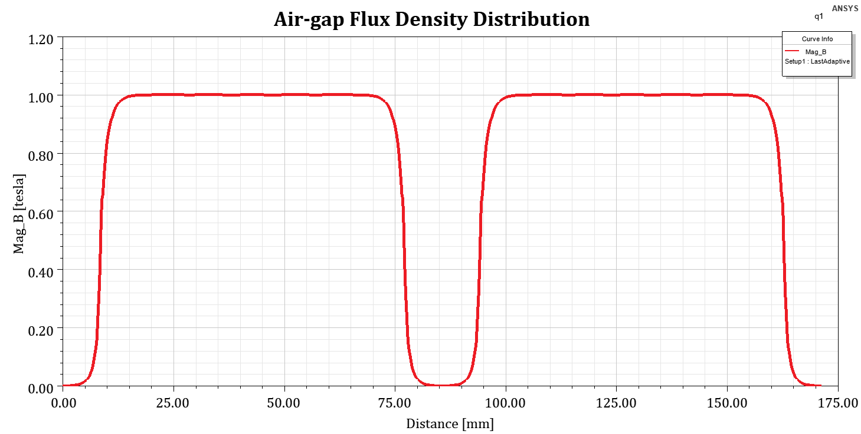

Figure 4: Airgap flux density distribution of the machine

Q2 – Electrical Loading & Machine Sizing

**Part A:**

To determine the number of slots, inner circumference of the stator must be known. For this part, slot openings and teeth width are taken as equal. As a rule of thumb, each tooth should not be thinner than 7 mm. Maximum number of slots can be calculated as:

Slot number possibilities are 12, 15, 18, 21 and 24. Using Emetor winding analysis tool, all these possibilities have been compared and single layer 24 slotted-winding is chosen as the most feasible one, because of its high winding factor and low MMF harmonics. These are shown and compared in Figure 5 and 6.

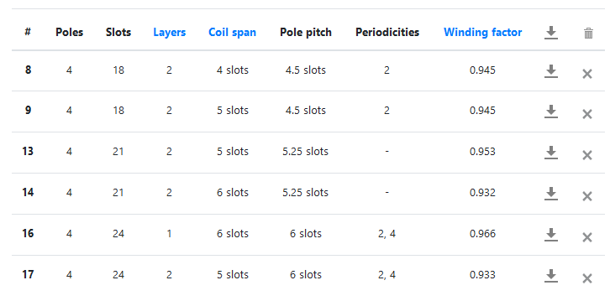

Figure 5: Winding factors

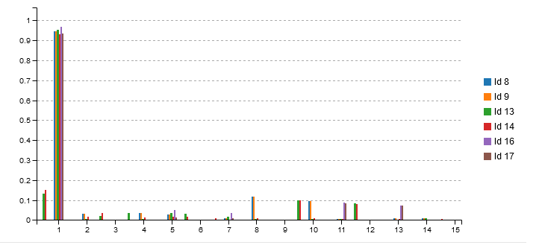

Figure 6: MMF harmonics

**Part B:**

Minimum cable cross-section area for given current and current density values is:

AWG20 has a cross section area of and is suitable for this design.

**Part C:**

In this design, outer diameter of the stator is chosen as (as given in T.J. Miller lecture notes):

Slot ratio is chosen as 0.6, close to optimum torque production point.

Slot outer diameter becomes:

Back core length becomes 12 mm and slot height becomes 36.5 mm.

Stack length of the machine is taken as 0.95, and effective length becomes 105 mm.

To determine number of turns per slot, slot area should be calculated. Obviously, slot area can be approximated to a trapezoid with base lengths and height of:

Assuming a fill factor of 0.6, total copper area becomes:

In this area,

AWG20 cables can be placed.

**Part D:**

As number of turns per slot is also known, electrical loading can be obtained as follows:

**Part E and F:**

Having obtained all dimensions, electrical loading and magnetic loading; tangential stress, output torque and power can also be calculated.

Q3 – Optimization

**Part A:**

In this part, to optimize the designed machine, we have to define a cost function. As our aim is to maximize the torque with respect to rotor outer radius, the optimization problem can be identified as:

Where the torque function can be defined as:

In the previous parts, obtained was already a boundary value. Therefore, no further increase for magnetic loading is needed. Following parameters will be taken as same for this optimization problem:

* Number of slots, 24
* Current, 2.5 A
* Air-gap, 1 mm
* Magnet thickness, 4 mm
* Cable gauge, AWG20

Electric loading of the machine is also a function of rotor radius.

Number of turns per slot can be determined as long as slot dimensions are known. To determine the dimensions of the slot, we have to know the length of the back core. Assuming there will be a maximum flux density of 1.5 T in the back core, its length can be defined as a function of r as follows:

Each slot area can be calculated as a trapezoid (assuming equal tooth width with slot opening), with base lengths

Therefore, electric loading and torque becomes:

Using WolframAlpha, derivative of the torque function is calculated. Local maxima points appear at:

For these values, optimum rotor radius for maximum torque is 27 mm. The dimensions of the machine are as follows:

* Rotor radius: 24.5 mm
* Air-gap length: 1 mm
* Magnet thickness: 4 mm
* Back core length: 15.5 mm
* Slot height: 35 mm
* Stator inner radius: 29.5 mm
* Slot outer radius: 64.5 mm
* Slot ratio: 0.46

Solving for the equation, number of turns per slot becomes 390 For this number, electric loading of the machine can be calculated as follows:

Apparently, this value is too large. In practice, cooling this machine with natural convection would be impossible. Liquid cooling should be applied. If the machine should be cooled naturally, then penalty or barrier constraints can be added for electrical loading to optimization problem.

Magnetic loading is the same as in previous part. It can be calculated as:

As a result, stress, torque and output power can be calculated as follows:

These results have also been verified using FEA. Winding configuration, full-load and flux density performance parameters and airgap flux density distribution of the machine are shown in Figures 7-10.

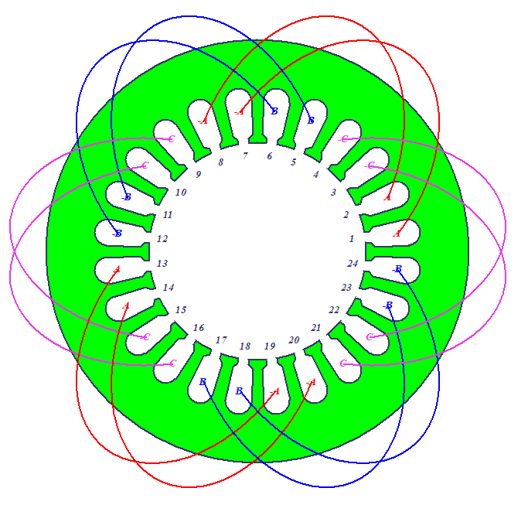

Figure 7: Winding configuration

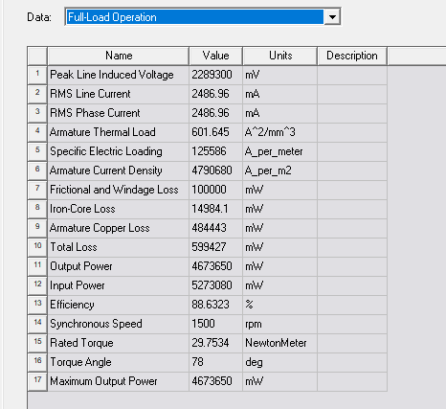

Figure 8: Full-load performance

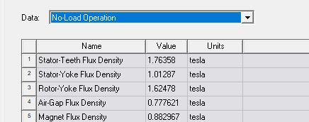

Figure 9: Flux density distribution in the system

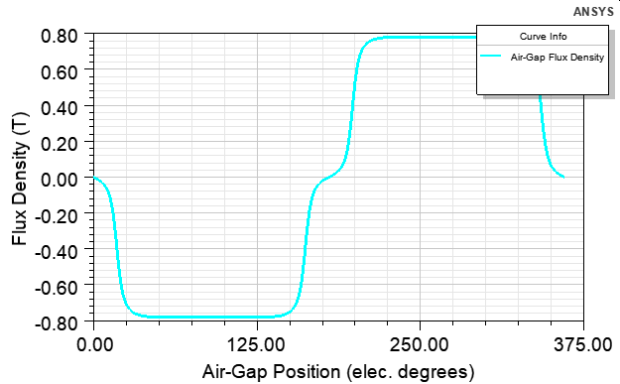

Figure 10: Air-gap flux density distribution

**Part B:**

**Replacing the NdFeB magnets with ferrite decreases the magnetic loading of the machine and we can expect a significant drop in torque and output power of the machine. With the same magnet size and air-gap length, the new magnetic loading can be calculated as follows:**

**The other performance parameters will also decrease with the same ratio.**

**Part C:**

**Optimization of the machine with ferrite magnets introduces many design parameters to the problem. Therefore, several assumptions should be made. In ferrite machine, we know that the magnets will be thicker, teeth and back core will be thinner. We can start the design process with magnet thickness assumption.**

**Let magnet thickness be 10 mm, embrace be 0.8 and the air-gap length be 1 mm. Using magnetic equivalent circuit approach, air-gap flux density and magnetic loading can be calculated as follows:**

**Tooth flux density can reach up to 1.4-1.5 T. If the ratio of slot opening to tooth width becomes 5, the flux density at the tooth becomes 6 times of air-gap flux density and reaches 1.44 T. Back core length can be expressed as a function of rotor outer radius, which can be used as optimization variable, similar to the previous part.**

Electric loading of the machine can be expressed as:

Similar to the previous part, there will be a maximum flux density of 1.5 T in the back core, its length can be defined as a function of r as follows:

Each slot area can be calculated as a trapezoid (assuming equal tooth width with slot opening), with base lengths

Therefore, electric loading and torque becomes:

Using WolframAlpha, derivative of the torque function is calculated. Local maxima points appear at:

For these values, optimum rotor radius for maximum torque is 33.5 mm. The dimensions of the machine are as follows:

* Rotor radius: 32.5 mm
* Air-gap length: 1 mm
* Magnet thickness: 10 mm
* Back core length: 8.5 mm
* Slot height: 28 mm
* Stator inner radius: 43.5 mm
* Slot outer radius: 71.5 mm
* Slot ratio: 0.61

Solving for the equation, number of turns per slot becomes 421. For this number, electric loading of the machine can be calculated as follows:

As a result, stress, torque and output power can be calculated as follows:

**Comparison:**

* In a local supplier, [neodymium magnets](https://www.dunyamagnet.com/neodyum-miknatis-jumbo-boy-cok-buyuk-cok-guclu-100mmx50mmx20mm-pmu337) are sold approximately 13 times expensively than [ferrite magnets](https://www.dunyamagnet.com/100x50x20-buyuk-guclu-ferrit-komur-seramik-magnet-miknatis-pmu310). In ferrite machine, magnet volume is 2.5 times of initial design. Therefore, **magnet cost is much smaller in ferrite machine.**
* Both machines’ axial length and slot number values are equal, where ferrite machine has larger number of turns in each slot. This increases the amount of copper used in ferrite machine. Therefore, **copper losses and copper price are larger in ferrite machine.**
* Ferrite machine has a larger rotor volume, however both machines have the same total volume. As the output power of the machine with NdFeB magnets are larger, **its power and torque density are also larger compared to the ferrite machine.**

Conclusion:

In this project, two machines (with rare earth and ferrite magnets) have been designed. They have been optimized to obtain maximum output torque. Finally, advantages and drawbacks of ferrite machine on Nd machine have been investigated.