ELE613 – SWITCH MODE POWER SUPPLIES

HOMEWORK 1

**Q1)** The topology to be analyzed and simulated in this homework is a buck converter with the following specifications:

For simulations, Simulink environment is preferred and the simulation model is shown in Figure 1, below.

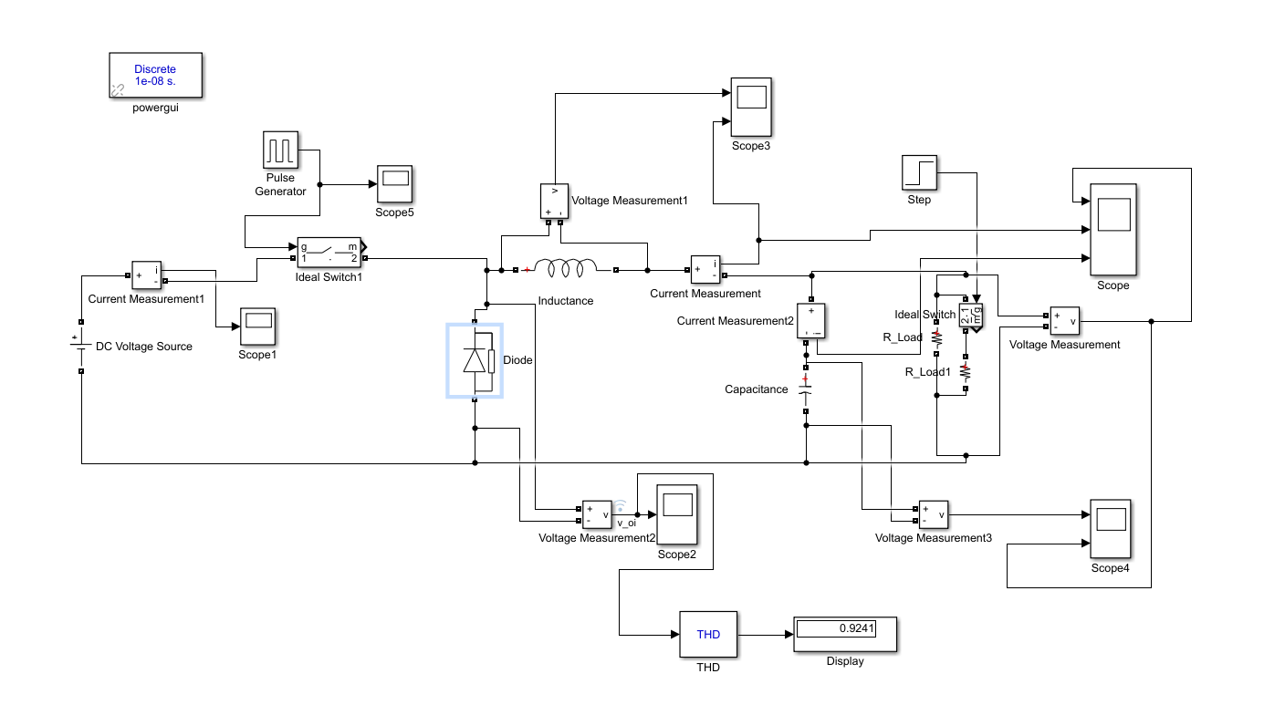

Figure 1: Simulation Model of the Buck Converter

Inductor voltage and current waveforms (for part (a)) and output voltage, inductor current and capacitor current waveforms (for part (b)) are provided in Figures 2 and 3, respectively.

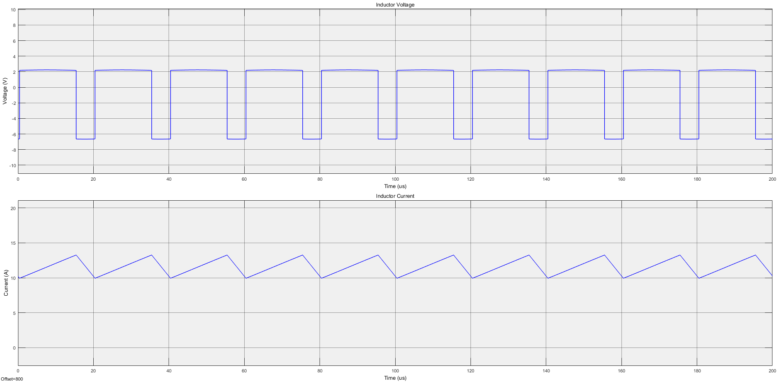

Figure 2: Inductor Voltage and Current

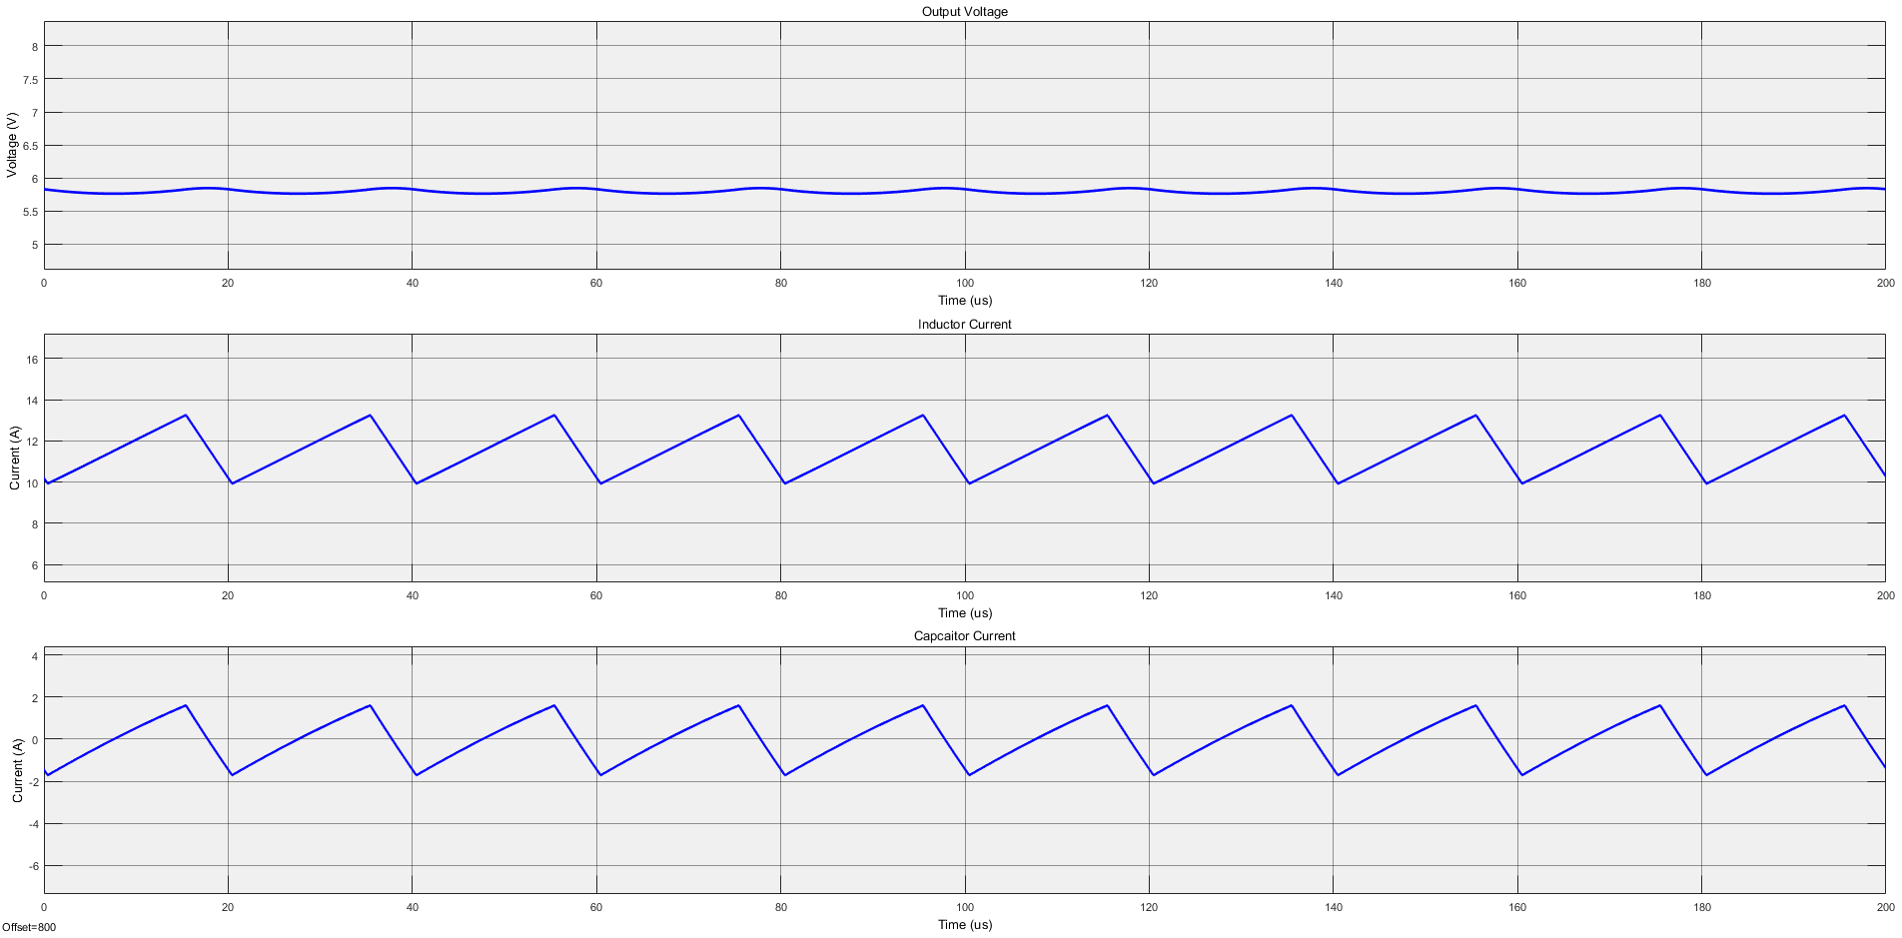

Figure 3: Output Voltage, Inductor Current and Capacitor Current

**Q2)** FFT analysis is performed using powergui toolbox of Simulink. Harmonic components are shown with respect to their orders, on the graph given in Figure 4, below.

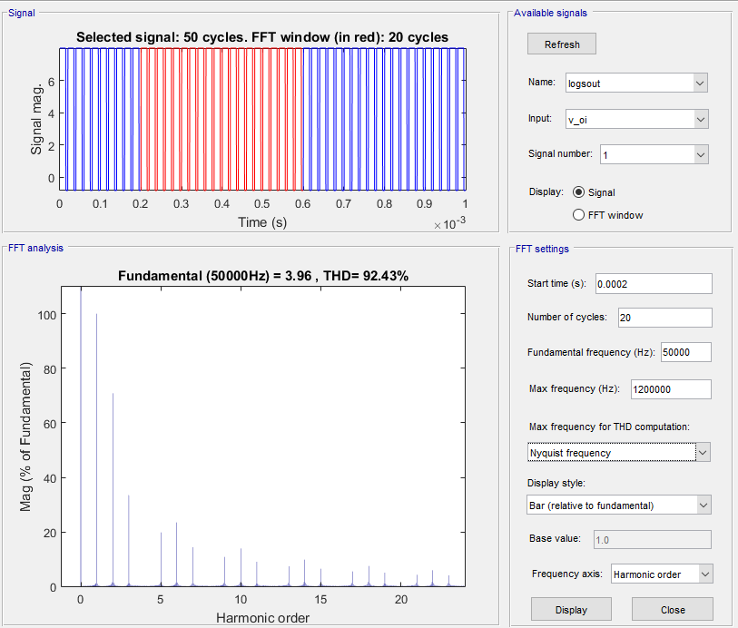

Figure 4: FFT Analysis Results

**Q3)** Discontinuous mode inductor voltage and current waveforms and output voltage waveform are given in Figure 5 and 6, respectively.

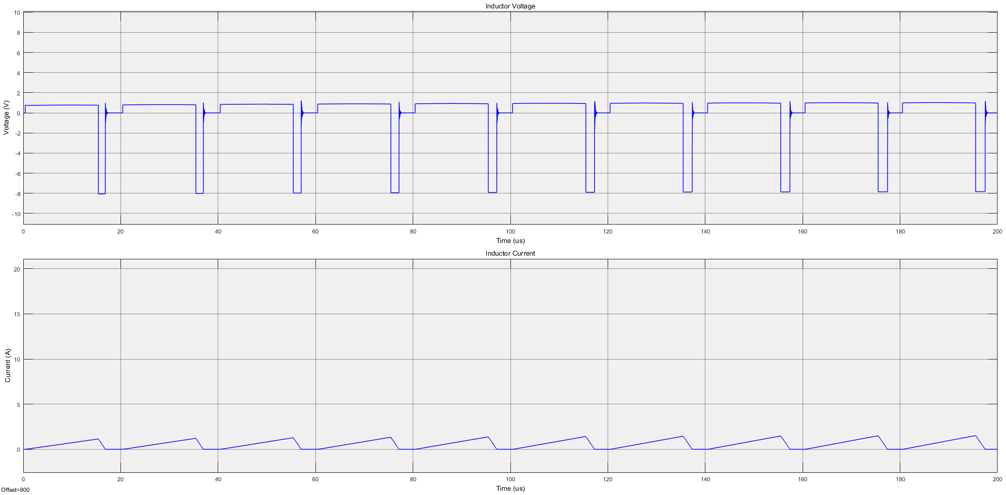

Figure 5: Discontinuous Mode Inductor Voltage and Current

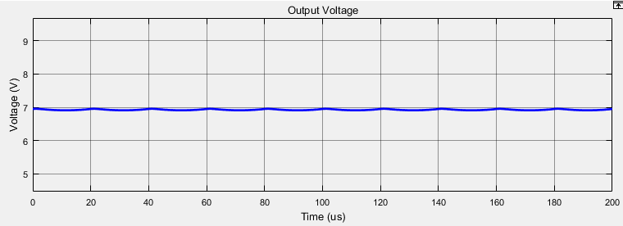

Figure 6: Discontinuous Mode Output Voltage Waveform

Simulation results should agree with the following equation:

Replacing the variables as follows:

We get the following equality:

This result is verified with the output voltage waveform of simulation, given in Figure 6.

**Q4)** Analytical calculation can be done as follows:

In Figures 7, 8 and 9, capacitor voltage and inductor current ripple waveforms and their peak to peak values are given, respectively.

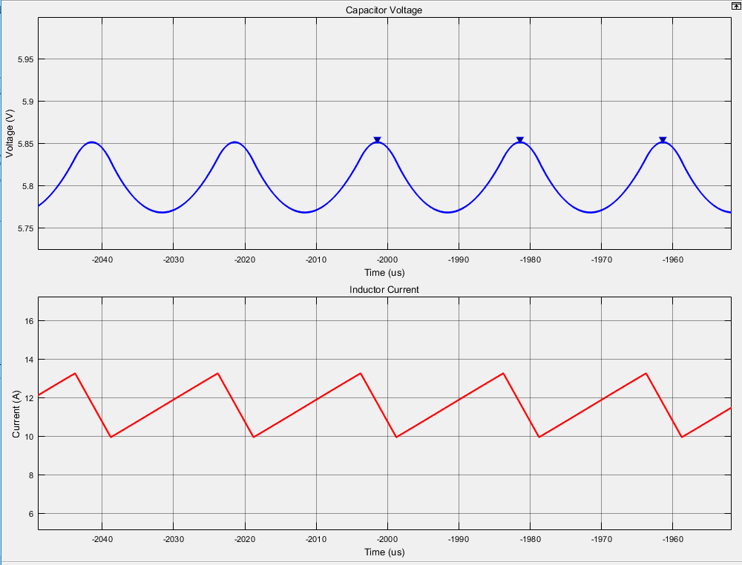

Figure 7: Capacitor Voltage and Inductor Current

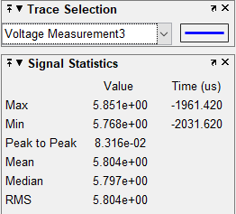

Figure 8: Capacitor Voltage Peak-To-Peak Value

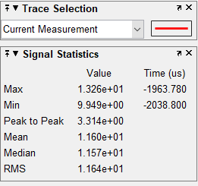

Figure 9: Inductor Current Peak-To-Peak Value

As provided in figures, capacitor voltage ripple is 40 times larger than the inductor current ripple, which actually agrees with the analytical calculations.

**Q5)** Capacitor current swing is equal to inductor current swing and average of the capacitor current is zero, therefore it can be calculated as the RMS of a triangular wave with amplitude

**Q6)** In the presence of ESR, we may assume that output voltage ripple is caused only by voltage drop on ESR. Therefore it can be calculated as:

Here, we know that current ripple on the capacitor is equal to that of the inductance, hence:

Simulation results for this part are given in Figures 10, 11 and 12.

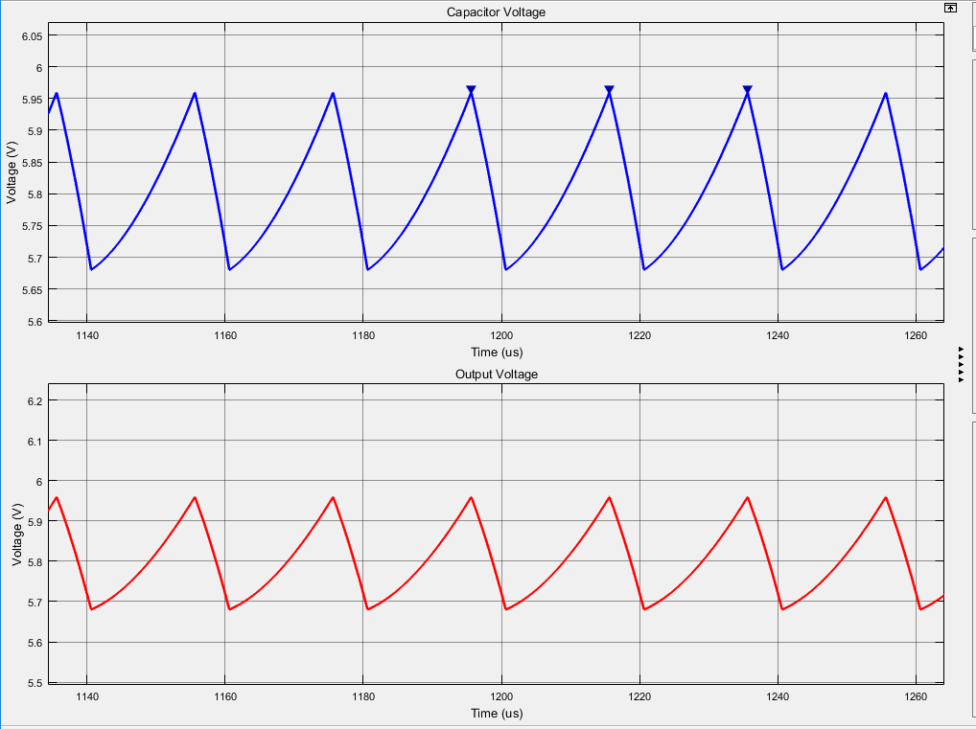

Figure 10: Capacitor and Output Voltage Waveforms

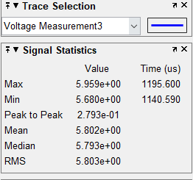

Figure 11: Capacitor Voltage Ripple

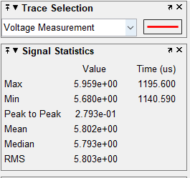

Figure 12: Output Voltage Ripple

As can be observed in simulation results, capacitor (including ESR) voltage ripple is equal to output voltage ripple, which verifies the initial assumption.