ELE613 – SWITCH MODE POWER SUPPLIES

HOMEWORK 2

The topology to be analyzed and simulated in this homework is a flyback converter with the following specifications:

$V_{d}=310 Vdc$

$L_{m}=40μH,\frac{N_{1}}{N_{2}}=12$

$C=200μF$

$R_{load}=2 Ω$

$f_{s}=100 kHz$

$D=0.4$

For simulations, Simulink environment is preferred and the simulation model is shown in Figure 1, below. It is observed that the circuit operates in discontinuous mode when load resistance is $2 Ω$. As increasing load resistance in Q5 would also not change this and we would not be able to see the differences between two operation modes, load resistance it is chosen as $0.1 Ω$ for Q1-4 and $2 Ω$ for Q5.

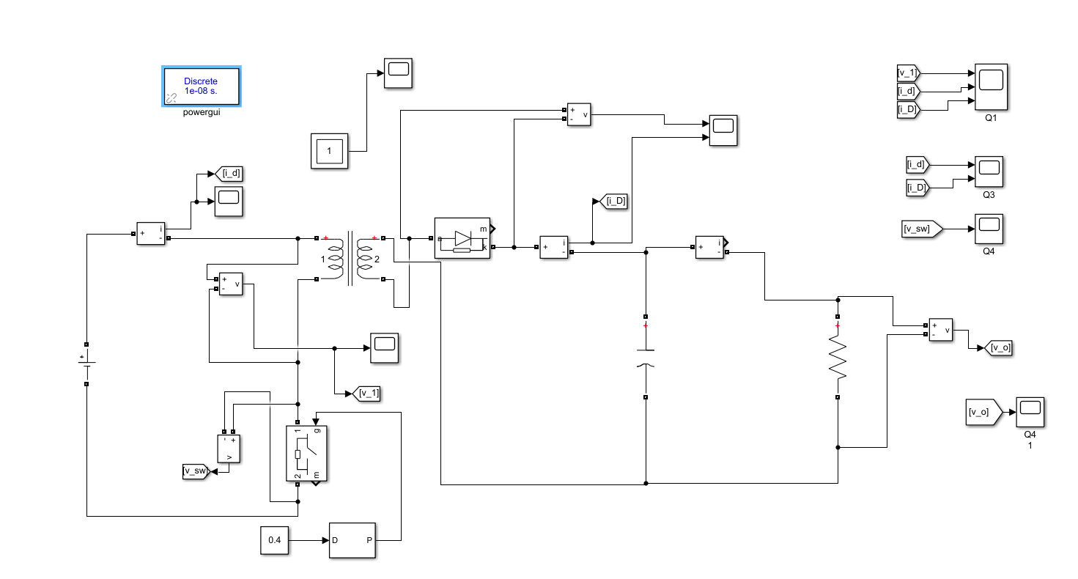

Figure 1: Simulation Model of the Flyback Converter

**Q1)** Primary voltage and current waveforms and diode current waveform are provided in Figure 2.

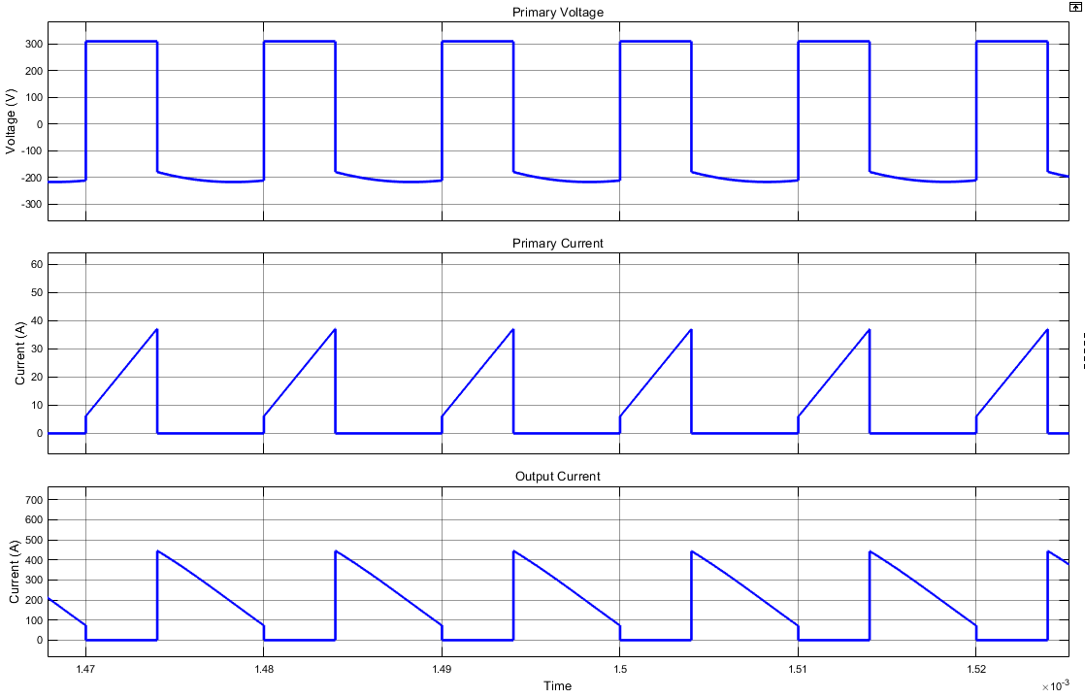

Figure 2: Primary Voltage, Primary Current and Output Current

**Q2)** Primary voltage, switch current and diode current waveforms during a switch transition are provided in Figure 3.

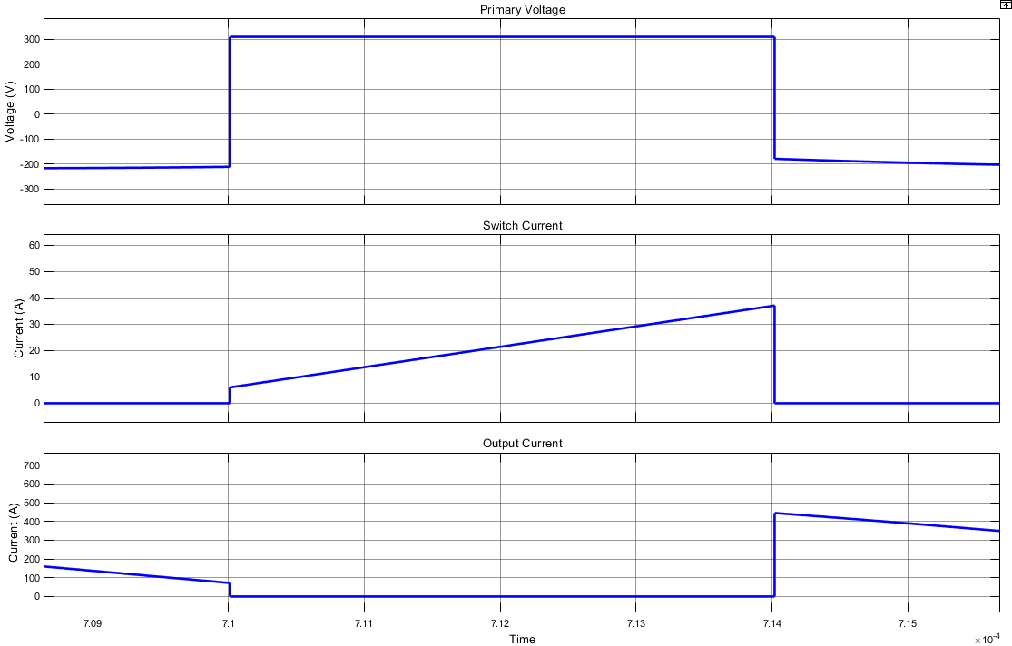

Figure 3: Primary Voltage, Swicth Current and Output Current in a Switch Transition

**Q3)** Average values of primary side current, output voltage and output current are shown in Figure 4, below.

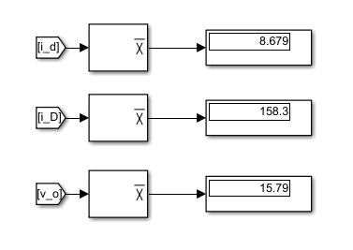

Figure 4: Average Primary Current, Output Current and Output Voltage Values.

Verification: $V_{d}=310 V$

$$\frac{{V_{d}I}_{d}}{{V_{o}I}_{o}}=\frac{8.68*310}{15.8*158}=1.07$$

**Q4)** Swicth voltage waveform is shown in Figure 5, below. It can be easily seen that its peak value is $v_{sw}=\frac{V_{d}}{1-D}=\frac{310}{0.6}=517 V.$

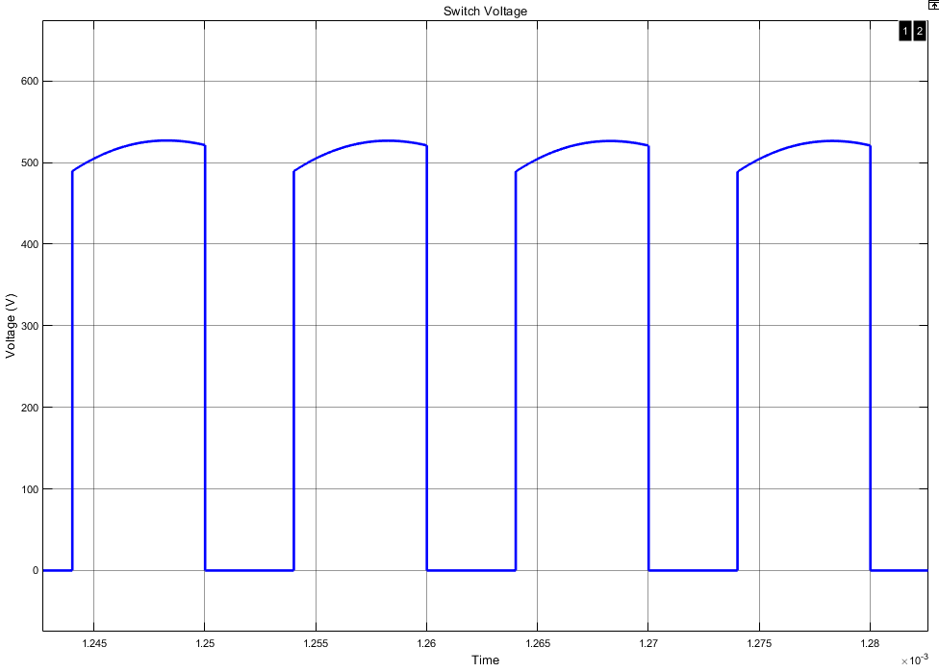

Figure 5: Switch Voltage

**Q4)** Discontinuous mode operation of the converter can be observed in this part where load resistance is 2 $Ω$. Primary voltage and current waveforms and diode current waveform are provided in Figure 6 and switch transition waveforms are shown in Figure 7.

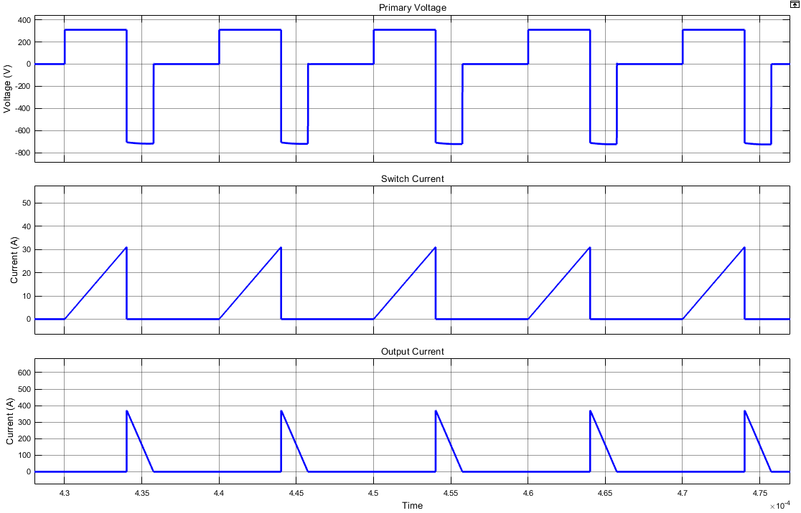

Figure 6: Primary Voltage, Primary Current and Output Current in DCM

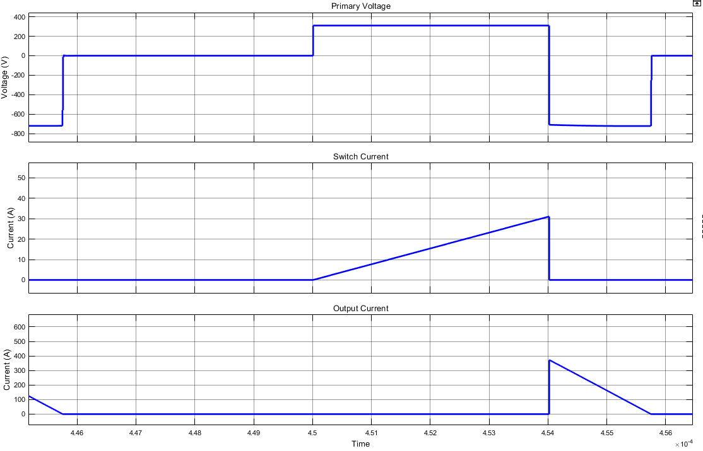

Figure 7: Primary Voltage, Swicth Current and Output Current in a Switch Transition in DCM