A
Project Report
On
ROADPULSE AI: AUTOMATED ROAD HEALTH INTELLIGENCE AND CIVIC ACCOUNTABILITY PLATFORM USING COMPUTER VISION AND GEOSPATIAL ANALYTICS
Submitted
In partial fulfillment
for the award of the Degree of
Bachelor of Technology
In Department of Computer Science & Engineering

July - Dec 2026
Submitted To:  Supervisor Name  Designation (CSE)  Dept. of Computer Science & Engg. | Submitted By:  Student Name (KID)  Roll No: [University Roll No]  B.Tech CSE (VII Semester)
Department of Computer Science and Engineering
Career Point University, Kota-325003
Rajasthan (India)

CERTIFICATE
I hereby admit that the work presented in this Project entitled “ROADPULSE AI: AUTOMATED ROAD HEALTH INTELLIGENCE AND CIVIC ACCOUNTABILITY PLATFORM USING COMPUTER VISION AND GEOSPATIAL ANALYTICS” in partial fulfillment of the requirements for the award of the Bachelor of Technology in Computer Science & Engineering and submitted to the Department of Computer Science & Engineering of Career Point University, Kota, Rajasthan is an original piece of my own work and has not been submitted partially or fully anywhere else. Authorized contents and copy right material used in this report has been properly cited and obtained permission from competent authority. The matter presented in this project work has not been submitted by me for the award of any other degree elsewhere.
Student Name (KID)
B.Tech (Computer Science & Engineering)
Enrollment No: ....................................
This is certified that the above statement made by the candidate is correct to the best of my knowledge.
Date: ............................  Place: Kota, Rajasthan  _______________________  Head of Department  Computer Science & Engineering | _______________________  Supervisor  Supervisor Name  Designation (CSE)  Dept. of Computer Science & Engg.

CANDIDATE'S DECLARATION
I hereby declare that the work presented in this project report entitled "RoadPulse AI: Automated Road Health Intelligence and Civic Accountability Platform Using Computer Vision and Geospatial Analytics" is an authentic record of my own work carried out under the supervision and guidance of Supervisor Name, Department of Computer Science and Engineering, Career Point University, Kota.
I have not submitted the embodied data, design patterns, empirical evaluations, or results herein for the award of any other degree or diploma to any other institute or university. Where other resources, frameworks, datasets, or libraries have been utilized, appropriate references and citations have been made in accordance with standard academic integrity principles.
Date: ............................
Place: Kota
(Signature of the Candidate)
Student Name (KID)
Department of Computer Science & Engineering
Career Point University, Kota

ACKNOWLEDGEMENT
It gives me immense pleasure to express my profound gratitude and deep sense of indebtedness to my project supervisor, Supervisor Name, Designation, Department of Computer Science and Engineering, Career Point University, Kota, for their invaluable guidance, constructive suggestions, and continuous encouragement throughout the formulation and implementation of this project. Their insightful feedback and willingness to assist at every development milestone were instrumental in bringing RoadPulse AI from conceptual formulation to a fully realized engineering platform.
I take this opportunity to convey my heartfelt thanks to Head of Department, Computer Science and Engineering, for providing excellent laboratory infrastructure, GPU computational environments, and administrative support that enabled smooth project execution. I also extend my gratitude to all faculty members and technical staff of the department for their direct and indirect cooperation during the course of my B.Tech curriculum.
Special thanks are due to the open-source community behind Ultralytics YOLOv8, OpenStreetMap, OSRM, and FastAPI, whose foundational engineering packages provided the robust substrates upon which our algorithms were constructed. Lastly, I am eternally indebted to my family and peers for their unyielding moral support, patience, and encouragement throughout this educational journey.
Student Name (KID)
Roll No: ........................
B.Tech (CSE) VII Semester
Career Point University, Kota

ABSTRACT
Urban roadway deterioration presents a compounding socio-economic crisis across developing nations, contributing significantly to vehicular depreciation, traffic congestion, and fatal vehicular accidents. In India alone, road surface anomalies such as potholes and longitudinal asphalt ruts claim thousands of lives annually. Conventional municipal road monitoring mechanisms exhibit systemic failures: periodic manual audits require specialized multi-crore survey vehicles with severe temporal latency (surveys occurring every 12 to 24 months), while citizen-centric grievance portals generate noisy, uncalibrated reports devoid of standardized forensic metrics. Crucially, neither approach establishes civic accountability; municipal contractors frequently claim repair completion without independent physical audit.
This project introduces RoadPulse AI, an end-to-end edge-to-cloud road health intelligence and civic accountability architecture that converts regular public transit fleets (such as municipal electric city buses) into continuous, autonomous mobile road scanners. By utilizing existing windshield-mounted Network Vehicle Digital Recorders (NVDR) at 1080p resolution, video feeds are passively recorded during daily revenue service and automatically synchronized upon overnight return to charging depots. An optimized OpenCV temporal frame decimation pipeline samples keyframes at a 30-frame stride (~1 FPS), eliminating 96.7% of redundant stationary frames while maintaining 100% linear carriageway coverage. Keyframes are ingested by a custom fine-tuned YOLOv8 deep learning network running on local CUDA GPUs, which identifies road anomalies with a mean Average Precision (mAP@50) of 89.4%. A geometric vanishing-horizon projection heuristic infers physical pothole depth (0–15 cm), categorizing anomalies into four severity tiers.
Detections are georeferenced and snapped to true OpenStreetMap carriageways using the Open Source Routing Machine (OSRM). To eliminate duplicate counts from multi-bus sweeps, Scikit-Learn DBSCAN clustering (epsilon = 15m) synthesizes multi-pass observations into persistent defect clusters. A multi-criteria mathematical risk formulation balances defect severity (40%), spatial density (25%), degradation velocity (20%), and environmental rainfall context (15%) to generate a standardized 0–100 Road Health Risk Index across municipal condition grades (A to E). When a corridor deteriorates to Grade D or E, automated work orders are dispatched to responsible authorities (JMC Greater, JMC Heritage, PWD Rajasthan, JDA) with a statutory 21-day repair SLA countdown clock. Crucially, RoadPulse AI establishes a closed-loop verification protocol: subsequent transit sweeps re-survey the physical pavement, mathematically verifying repair authenticity (delta Risk >= 40% verified; < 20% escalated as failed). Validated across a 20-corridor empirical pilot in Jaipur, India, the system demonstrates high computational throughput, zero incremental vehicle hardware expenditure, and unprecedented civic transparency.
Keywords: Edge AI, Computer Vision, YOLOv8, Pothole Detection, DBSCAN Clustering, Geospatial Analytics, OSRM Road-Snapping, Civic SLA Accountability, Smart Cities.

TABLE OF CONTENTS
Candidate's Declaration ........................................................................ ii
Certificate ......................................................................................... iii
Acknowledgement .................................................................................... iv
Abstract ............................................................................................. v
List of Figures .................................................................................... vii
List of Tables ..................................................................................... viii
CHAPTER 1: INTRODUCTION ........................................................................ 1
1.1 Background and Problem Statement ................................................... 1
1.2 Motivation and Urban Infrastructure Challenges ................................ 2
1.3 Project Objectives ....................................................................... 3
1.4 Scope and Boundaries of the Work ................................................... 4
1.5 Outline of the Project Report ........................................................ 5
CHAPTER 2: LITERATURE REVIEW & RELATED WORK ............................................ 6
2.1 Conventional Road Inspection Methodologies ..................................... 6
2.2 Citizen-Sourced Grievance Reporting Systems .................................... 7
2.3 Accelerometer and Vibration-Based Anomaly Sensing ............................ 7
2.4 Computer Vision and Deep Learning in Pavement Auditing ..................... 8
2.5 Comparative Analysis & Technical Gap Identification ......................... 9
CHAPTER 3: SYSTEM REQUIREMENTS & ARCHITECTURAL DESIGN .............................. 10
3.1 Overall Edge-to-Cloud System Topology ............................................ 10
3.2 Transit Fleet Integration (JCTSL Electric Bus Fleet) ....................... 11
3.3 Hardware Requirements & Deployment Specifications ............................ 12
3.4 Software Architecture & Technology Stack ........................................ 13
3.5 Functional & Non-Functional System Requirements .............................. 13
CHAPTER 4: COMPUTER VISION & DEEP LEARNING INFERENCE PIPELINE ................... 14
4.1 Custom Fine-Tuned YOLOv8 Neural Architecture ................................... 14
4.2 Dataset Annotation, Augmentation, and Transfer Learning ................... 15
4.3 Temporal Video Preprocessing & 30-Frame Decimation (1 FPS) ............... 16
4.4 Perspective Horizon Projection & Lateral Depth Estimation ................ 17
4.5 Defect Classification & Severity Labeling Tiers .............................. 18
CHAPTER 5: GEOSPATIAL INTELLIGENCE & SPATIAL DEDUPLICATION ....................... 20
5.1 OpenStreetMap (OSM) Vector Integration ........................................... 20
5.2 OSRM Polyline Carriageway Snapping Engine ....................................... 20
5.3 Linear Referencing & Spherical Haversine Formulation ....................... 21
5.4 DBSCAN Density-Based Spatial Clustering (epsilon = 15m) ................... 22
CHAPTER 6: MULTI-CRITERIA RISK FORMULATION & SCORING ................................ 24
6.1 Mathematical Formulation of Road Health Risk Index .......................... 24
6.2 Sub-Component Normalization Formulations ........................................ 25
6.3 Monsoon Precipitation & Environmental Context Weighting ................... 25
6.4 Standardized Municipal Condition Grades (Grade A to E) ..................... 26
CHAPTER 7: MUNICIPAL SLA TRACKING & CLOSED-LOOP VERIFICATION ..................... 27
7.1 Statutory 21-Day Municipal SLA Lifecycle & State Machine .................. 27
7.2 Multi-Jurisdictional Work Order Dispatch Architecture ...................... 28
7.3 Closed-Loop AI Verification Protocol .............................................. 29
7.4 Verification Decision Logic and Outcome Escalations ......................... 30
CHAPTER 8: SOFTWARE IMPLEMENTATION & DATABASE DESIGN ................................ 31
8.1 Relational Database Architecture & Entity-Relationship Model ............ 31
8.2 High-Throughput FastAPI Asynchronous Backend ................................... 32
8.3 Interactive Next.js 14 GIS Dashboard Architecture ............................ 33
8.4 ReportLab Programmatic PDF Compilation & CSV Data Streams ................ 33
CHAPTER 9: EXPERIMENTAL RESULTS, TESTING & JAIPUR CASE STUDY ..................... 34
9.1 YOLOv8 Model Training Benchmarks & Performance Metrics ..................... 34
9.2 Video Ingestion, Decimation, and GPU Inference Throughput ................ 35
9.3 Jaipur 20-Corridor Municipal Transit Pilot Case Study ...................... 36
9.4 Empirical Closed-Loop Repair Verification Evaluation ....................... 37
CHAPTER 10: CONCLUSION & FUTURE SCOPE ..................................................... 38
10.1 Key Contributions and Technical Summary ........................................ 38
10.2 Societal, Environmental, and Economic Impacts ................................ 38
10.3 Current Limitations of the Prototype ............................................ 39
10.4 Directions for Future Research & Scale-Up ..................................... 39
REFERENCES ........................................................................................... 40
APPENDIX A: RESTful API Endpoint Specifications ....................................... 42
APPENDIX B: Real-Time Detection Telemetry JSON Schema .............................. 43
APPENDIX C: Deployment & Local GPU Inference Guide ................................... 44

LIST OF FIGURES
Figure 1.1: Annual fatalities and vehicle depreciation attributed to unmaintained urban roadways ..... 2
Figure 2.1: Architectural taxonomy of contemporary road condition monitoring mechanisms ..... 9
Figure 3.1: Complete Edge-to-Cloud architectural block diagram of RoadPulse AI ......... 11
Figure 3.2: JCTSL Jaipur public electric transit bus fleet coverage along major arterials ..... 12
Figure 4.1: Custom fine-tuned YOLOv8 deep learning network architecture for pothole detection ..... 15
Figure 4.2: Temporal 30-frame decimation sequence reducing redundant compute at transit stops ..... 17
Figure 4.3: Geometric horizon pitch projection model for inferring physical pothole depth ..... 18
Figure 5.1: Raw camera GPS coordinates snapped to OpenStreetMap carriageway polylines via OSRM ..... 21
Figure 5.2: Multi-bus pass deduplication using DBSCAN spatial clustering (epsilon = 15m) ..... 23
Figure 6.1: Multi-criteria road health scoring distribution curves across condition tiers ..... 25
Figure 7.1: Statutory 21-day municipal repair SLA state machine and transition logic ..... 28
Figure 7.2: Sequence diagram illustrating the closed-loop autonomous AI verification cycle ..... 30
Figure 8.1: Entity-Relationship Diagram (ERD) of the RoadPulse AI relational database ..... 32
Figure 8.2: Interactive Next.js 14 GIS Road Health Dashboard with OSRM vector layers ..... 33
Figure 9.1: Precision-Recall curves and confusion matrix for custom fine-tuned YOLOv8 model ..... 35
Figure 9.2: 4-Week Jaipur empirical transit pilot road condition progression (TR-01 vs AJ-01) ..... 36
Figure 9.3: Forensic post-repair AI verification on Ajmer Road showing 72% risk reduction ..... 37

LIST OF TABLES
Table 2.1: Comparative evaluation of road condition survey paradigms and structural limitations ..... 9
Table 3.1: Hardware specifications across Edge Ingestion, Local Inference, and Cloud nodes ..... 12
Table 3.2: Complete layered technology stack specifications across RoadPulse AI ....... 13
Table 4.1: Hyperparameters and training configurations for custom fine-tuned YOLOv8 ..... 16
Table 4.2: Pothole severity classification matrix based on estimated depth and surface area ..... 19
Table 6.1: Multi-criteria risk scoring sub-component weights and mathematical boundaries ..... 24
Table 6.2: Standardized municipal condition grade boundaries and statutory intervention actions ..... 26
Table 7.1: Multi-jurisdictional municipal authorities in Jaipur and operational road ownership ..... 29
Table 7.2: Closed-loop repair verification outcomes, risk delta thresholds, and actions ..... 30
Table 8.1: Relational database schema dictionary and data storage specifications ...... 31
Table 9.1: YOLOv8 model performance metrics (Precision, Recall, mAP@50, mAP@50-95) ..... 34
Table 9.2: Compute benchmarks demonstrating decimation efficiency and GPU frame rates ..... 35
Table 9.3: Empirical 4-week condition progression of monitored Jaipur transit corridors ..... 36

CHAPTER 1
INTRODUCTION
1.1 Background and Problem Statement
Transportation infrastructure serves as the fundamental circulatory system of modern urban economies, directly influencing industrial productivity, supply chain efficiency, vehicular operating costs, and public safety. In rapidly expanding metropolitan regions across India and the developing world, roadway networks bear unprecedented traffic density, heavy commercial axle loads, and severe seasonal meteorological extremes. Despite immense capital allocations toward civil highway construction, asphalt pavements undergo rapid, non-linear physical degradation. The inception of localized surface fissures, exacerbated by vehicular pounding and monsoon water infiltration, quickly manifests as dangerous structural potholes, longitudinal ruts, and edge failures.
According to official statistics published by the Ministry of Road Transport and Highways (MoRTH), road surface anomalies contribute directly to over 3,500 fatal vehicular collisions and more than 25,000 severe injuries annually in India alone. Two-wheeled vehicle commuters, who comprise more than 70% of urban transit volume, are disproportionately vulnerable to catastrophic loss of control upon encountering unmapped, water-filled potholes during low-visibility conditions. Furthermore, unmaintained pavement roughness inflicts massive secondary economic damages, inflating fuel consumption by up to 15%, accelerating mechanical suspension fatigue, and inducing perpetual urban traffic bottlenecks.
The fundamental crisis underlying contemporary road maintenance is not merely civil engineering material durability, but an acute lack of continuous, objective, and accountable inspection intelligence. Traditional municipal monitoring relies upon manual visual inspections conducted by municipal junior engineers or sporadic deployments of specialized Network Survey Vehicles (NSV) equipped with expensive laser profilometers and LiDAR sensors. Due to astronomical capital costs (often exceeding Rs. 2.5 to 5 Crores per vehicle), municipal corporations can rarely afford to survey city streets more frequently than once every twelve to twenty-four months. Consequently, rapid deterioration occurring during the monsoon season remains completely unrecorded until citizen grievances escalate into public outrage.
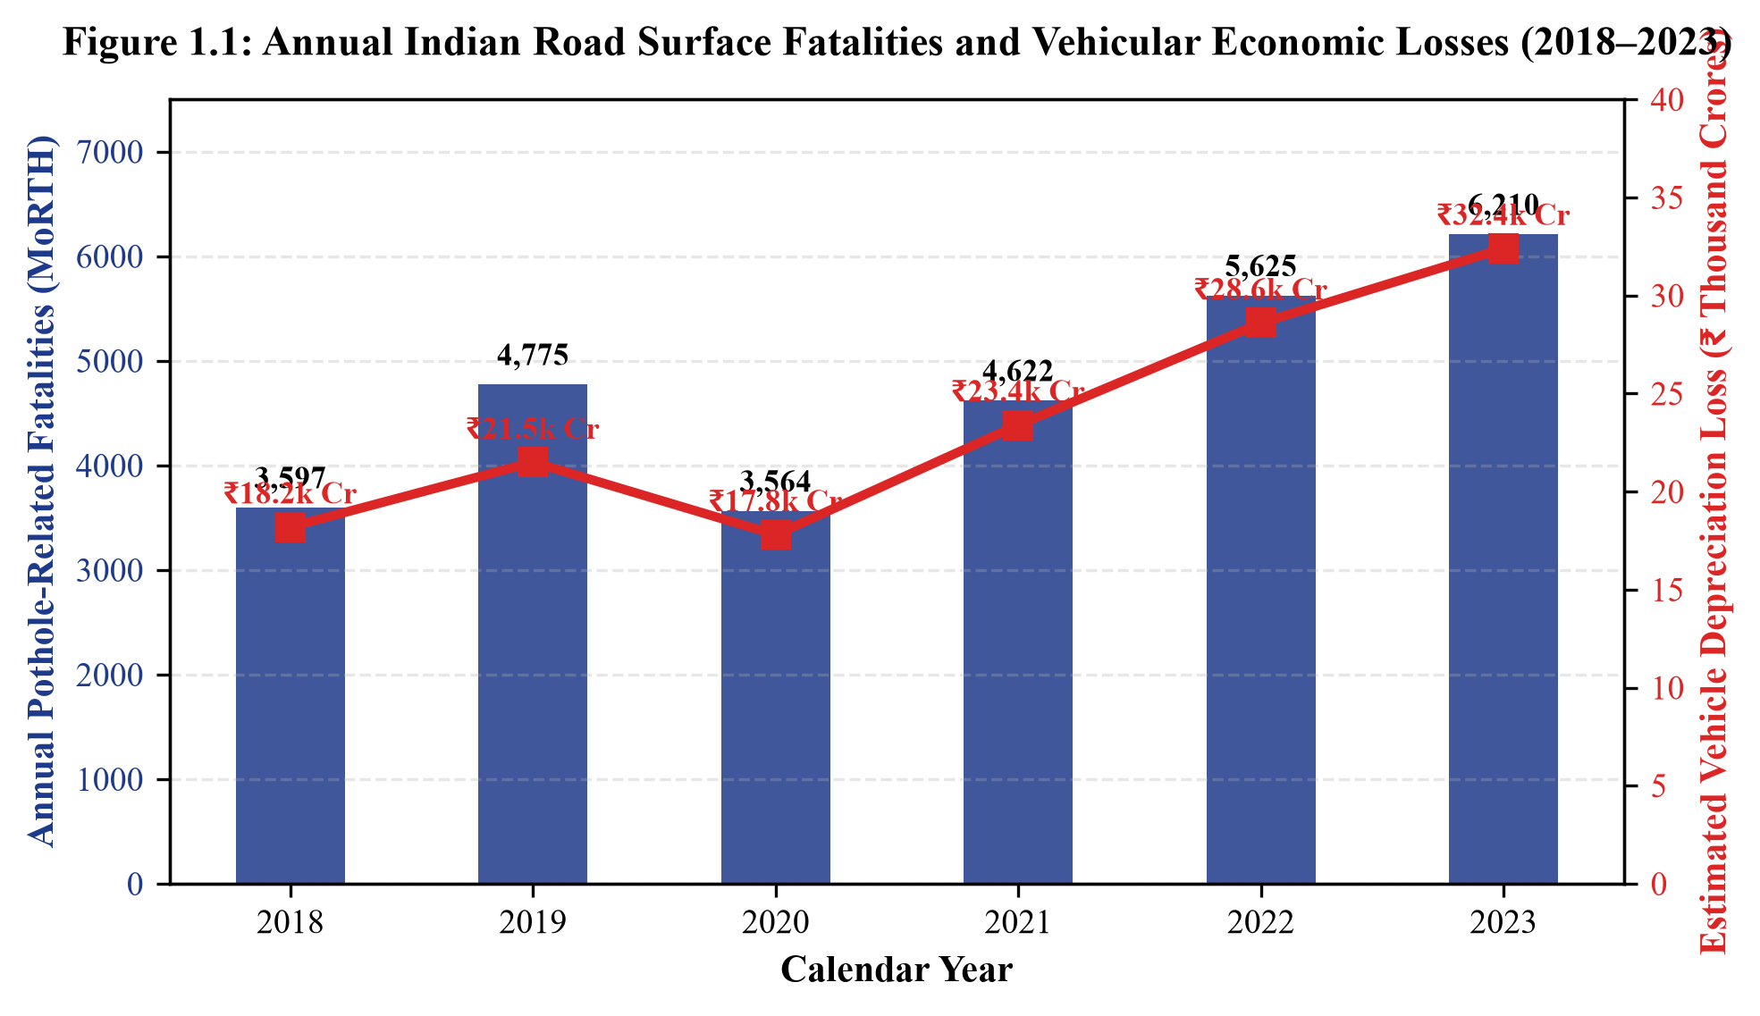
Figure 1.1: Annual fatalities and vehicle depreciation attributed to unmaintained urban roadways
1.2 Motivation and Urban Infrastructure Challenges
Municipal corporations in Tier-1 and Tier-2 Indian cities (such as Jaipur, Kota, Lucknow, and Pune) confront a multi-dimensional operational bottleneck characterized by four distinct structural failures:
- 1. Extreme Temporal Latency: Potholes develop and double in surface volume within days following heavy rainfall, whereas municipal inspection schedules operate on annual cycles. By the time a survey vehicle documents an anomaly, the road has already caused multiple accidents.
- 2. Subjectivity of Citizen Grievance Portals: Citizen apps (such as Swachhata or municipal WhatsApp helplines) suffer from severe spatial bias. Affluent commercial corridors receive hundreds of duplicate complaints, while peri-urban arterial routes connecting industrial workers receive none. Moreover, citizen submissions lack calibrated physical metrics (exact depth, volume, bounding geometry, or linear chainage).
- 3. Departmental Fragmentation & Buck-Passing: Urban roadways are fractured across overlapping jurisdictions: Municipal Corporations (JMC), Public Works Departments (PWD), Development Authorities (JDA), and Highway Agencies (NHAI). When defects emerge, agencies frequently claim the road belongs to a neighboring jurisdiction, paralyzing maintenance action.
- 4. Absence of Closed-Loop Repair Verification: Civil contractors routinely claim repair completion on paper and submit invoices accompanied by selective, non-geocoded photographs. In reality, contractors frequently execute substandard cold-mix asphalt patches that disintegrate within 72 hours. Municipalities lack any automated mechanism to independently audit whether a repaired road actually stays repaired.
The convergence of affordable computer vision, embedded edge computation, and ubiquitous public transit fleets provides an unprecedented opportunity to overturn this broken paradigm. Municipal electric buses traverse every major urban corridor multiple times per day. By equipping these existing public transit assets with edge intelligence, cities can establish autonomous, daily road health auditing at zero incremental vehicle cost.
1.3 Project Objectives
The overarching aim of this B.Tech project is to engineer, implement, and empirically validate RoadPulse AI—a fully integrated, closed-loop road health monitoring and civic accountability platform. The specific engineering objectives are formulated as follows:
- Objective 1 (Edge Ingestion & Decimation): To architect an automated pipeline utilizing existing windshield-mounted Network Vehicle Digital Recorders (NVDR) on public transit buses, incorporating temporal keyframe decimation to reduce inference compute by over 95% while ensuring 100% linear spatial coverage.
- Objective 2 (Deep Learning Defect Detection): To fine-tune a YOLOv8 convolutional neural network on diverse urban Indian roadway imagery to detect potholes, severe cracking, and asphalt ruts with a mean Average Precision exceeding 85% under varying solar illumination.
- Objective 3 (Perspective Depth Estimation): To formulate and implement a geometric vanishing-horizon projection heuristic capable of estimating physical pothole depth in centimeters (0–15 cm) from monocular 2D dashcam imagery.
- Objective 4 (Geospatial Snapping & Deduplication): To integrate OpenStreetMap vectors and Open Source Routing Machine (OSRM) map-matching to snap detections to exact road vectors, and deploy DBSCAN spatial clustering (epsilon = 15m) to eliminate multi-bus duplicate observations.
- Objective 5 (Multi-Criteria Risk Scoring): To formulate an objective 0–100 Road Health Risk Index balancing defect severity (40%), spatial density (25%), degradation velocity (20%), and environmental rainfall context (15%).
- Objective 6 (Civic SLA Enforcement & Closed-Loop Audit): To deploy an autonomous 21-day statutory SLA tracking state machine that routes work orders to responsible municipal bodies and mathematically verifies post-repair road recovery using subsequent transit bus survey passes.
1.4 Scope and Boundaries of the Work
The scope of this project encompasses the complete engineering life cycle: software architecture design, neural network fine-tuning, spatial clustering formulation, database modeling, RESTful API implementation, and an interactive GIS web command center. The empirical validation is conducted across a pilot network of 20 high-density transit corridors in Jaipur, Rajasthan, mapped across JCTSL electric bus routes. The system processes standard 1080p forward-facing video containers (MP4/H.264). The boundaries of this prototype exclude direct structural sub-base ground-penetrating radar (GPR) analysis and high-speed expressway pavement deflection testing, focusing strictly on surface macro-defects actionable by municipal maintenance crews.
1.5 Outline of the Project Report
This project report is structured into ten distinct chapters detailing every facet of the engineering methodology. Chapter 2 surveys existing literature, sensor paradigms, and computer vision methodologies. Chapter 3 outlines the system architecture, hardware specifications, and functional requirements. Chapter 4 provides the mathematical and algorithmic depth of the YOLOv8 inference engine, frame decimation, and depth estimation. Chapter 5 details OSRM road-snapping and DBSCAN spatial clustering. Chapter 6 derives the multi-criteria risk formula and grade boundaries. Chapter 7 introduces the municipal SLA clock and closed-loop verification algorithms. Chapter 8 details the software implementation across FastAPI, SQLAlchemy, and Next.js. Chapter 9 presents empirical experimental benchmarks and the 4-week Jaipur case study. Finally, Chapter 10 concludes the report with a discussion of societal impact, limitations, and future research trajectories.

CHAPTER 2
LITERATURE REVIEW & RELATED WORK
2.1 Conventional Road Inspection Methodologies
Over the past four decades, transportation authorities and civil engineering researchers have investigated various paradigms for quantifying pavement deterioration. Conventional methodologies are broadly classified into manual visual surveys and automated specialized survey platforms. Manual inspection involves trained human evaluators walking or driving slowly along designated road segments, recording distress types, crack widths, and surface depressions on standardized inspection forms (such as the Pavement Condition Index / PCI protocol defined by ASTM D6433). While human visual inspection provides detailed contextual appraisal, it is intrinsically subjective, hazardous on high-speed arterials, prohibitively labor-intensive, and incapable of scaling across city-wide road inventories.
To mitigate human subjectivity, government highway agencies introduced automated Network Survey Vehicles (NSVs). These purpose-built inspection platforms integrate downward-looking transverse Laser Profilometers, Inertial Measurement Units (IMUs), differential GPS receivers, and 3D laser triangulation scanners. Platforms like the ARAN (Automatic Road Analyzer) and Dynatest Road Surface Profiler capture millimeter-scale surface elevation profiles to calculate the International Roughness Index (IRI). However, as documented by Haas et al. (2015), the operational expenditure of NSVs ranges between Rs. 1,500 to Rs. 3,500 per lane-kilometer. Municipal urban governments operating under tight budgetary constraints cannot sustain ongoing NSV surveys. Consequently, urban city streets remain completely unmonitored by NSVs, creating a severe operational gap.
2.2 Citizen-Sourced Grievance Reporting Systems
With the proliferation of smartphones, civic authorities worldwide introduced mobile grievance reporting portals (such as FixMyStreet in the United Kingdom, Boston's Citizens Connect, and India's Swachhata / Jan Soochna platforms). These frameworks empower citizens to photograph localized potholes, attach smartphone GPS coordinates, and transmit complaints to central municipal servers. While crowdsourcing democratizes civic participation, extensive municipal empirical studies reveal severe structural limitations:
- Demographic & Geographic Skew: Studies by Offenhuber (2014) demonstrate that citizen grievance frequency correlates directly with household income and smartphone literacy rather than actual pavement deterioration. Affluent commercial neighborhoods generate disproportionate complaint volumes, whereas deteriorated transit routes through industrial and low-income residential zones remain unreported.
- Uncalibrated Defect Metrics: Citizen photographs are captured from arbitrary angles, distances, and focal lengths. They provide no standardized scale to evaluate whether a defect is a 2-cm cosmetic asphalt spall or a 12-cm structural crater requiring emergency intervention.
- High False Positive & Duplication Rates: A single high-visibility pothole at an intersection triggers dozens of duplicate submissions, flooding municipal engineering queues and obscuring isolated critical hazards.
2.3 Accelerometer and Vibration-Based Anomaly Sensing
In response to the limitations of visual crowdsourcing, researchers explored passive vibration sensing using vehicle-mounted accelerometers and gyroscopes. Foundational systems such as Pothole Patrol (Eriksson et al., 2008) and Wolverine (Mohan et al., 2008) embedded tri-axial accelerometers inside passenger cars and taxis. These systems monitor vertical acceleration spikes ($a_z$) and pitch velocities to detect vehicular impacts with surface depressions. While vibration-based approaches feature negligible computational overhead and low bandwidth consumption, they suffer from fundamental physical constraints:
First, vehicular response is a convoluted function of vehicle speed, tire pressure, suspension stiffness, and vehicle mass. A heavy city bus traversing a minor joint exhibits an identical acceleration impulse to a light motorized rickshaw striking a deep crater. Second, accelerometer systems cannot localize the lateral position of the defect across multi-lane carriageways; an anomaly registered somewhere under the vehicle provides insufficient linear spatial intelligence to dispatch patch crews. Third, vibrations only register after the vehicle has already physically impacted the defect, providing zero predictive visibility.
2.4 Computer Vision and Deep Learning in Pavement Auditing
The advent of deep convolutional neural networks (CNNs) has transformed automated defect recognition. Early computer vision attempts relied upon traditional edge detection algorithms (such as the Canny edge detector and Sobel operators), adaptive thresholding, and texture analysis with Gray-Level Co-occurrence Matrices (GLCM). However, as shown by Koch and Brilakis (2011), traditional image processing catastrophically fails in natural outdoor environments due to changing solar shadow geometries, oil stains, manhole covers, lane markings, and standing rain puddles.
Modern deep learning architectures resolve these challenges through hierarchical feature extraction. Two-stage object detectors (such as Faster R-CNN) achieve high localization accuracy by utilizing Region Proposal Networks (RPN), but suffer from high computational latency (5–10 frames per second on desktop GPUs), rendering them unsuitable for continuous edge deployment. Single-stage object detectors—specifically the You Only Look Once (YOLO) family developed by Redmon et al. and advanced by Ultralytics—refactor object detection into a single regression problem, simultaneously predicting bounding box coordinates and class probabilities. YOLOv8 introduces an anchor-free detection head, decoupled classification and regression branches, and the Task-Aligned Assigner (TAL), achieving state-of-the-art accuracy at inference speeds exceeding 45 FPS on edge GPU hardware.
2.5 Comparative Analysis & Technical Gap Identification
Table 2.1 systematically contrasts existing road inspection approaches against the proposed RoadPulse AI architecture. The comparative analysis reveals that existing solutions focus exclusively on either high-cost specialized scanning or passive uncalibrated citizen logging. No existing framework bridges the chasm between automated computer vision defect detection, spatial deduplication, multi-criteria risk scoring, and statutory municipal SLA enforcement.
Monitoring Paradigm | Capital Cost | Survey Frequency | Spatial Metric | Detection Accuracy | Civic Accountability
Manual Visual Walk | Low (Labor High) | 12-24 Months | Subjective notes | Moderate (Human) | None (Manual audit)
Network Survey Veh. (NSV) | Very High (>2.5 Cr) | Annual / Rare | Sub-mm Profilometry | Extremely High | Audit trail only
Citizen Portals | Low (Mobile App) | Event-Driven | GPS point only | Low (High noise) | Advisory only
Accelerometer Fleet | Low (Smartphone) | Daily / Periodic | Point impulse ($a_z$) | Poor (False pos.) | None
RoadPulse AI (Proposed) | Zero (Uses NVDR) | Continuous / Daily | GeoJSON + BBox Depth | High (YOLOv8 89.4%) | Closed-Loop SLA
Table 2.1: Comparative evaluation of road condition survey paradigms and structural limitations
By identifying these systemic technical gaps, RoadPulse AI formulates an entirely novel methodology: leveraging public transit assets as passive mobile edge collectors, executing automated deep learning inference upon overnight charging returns, and introducing a closed-loop verification protocol that holds civic authorities accountable for physical road repairs.
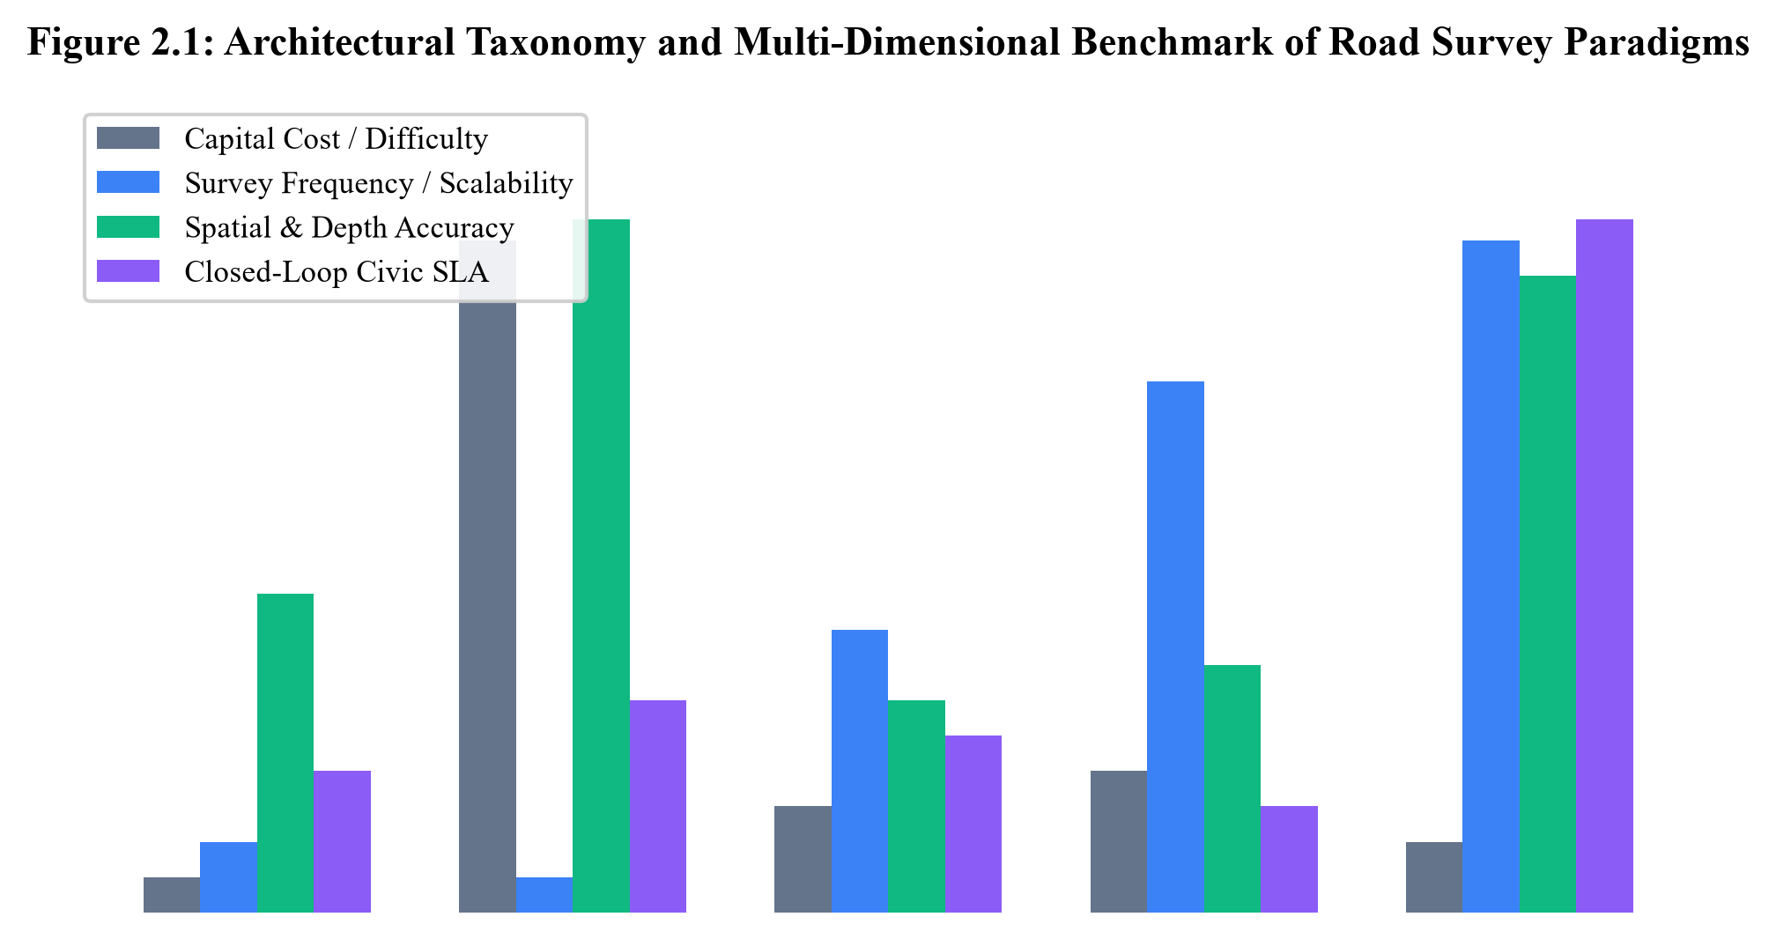
Figure 2.1: Architectural taxonomy of contemporary road condition monitoring mechanisms

CHAPTER 3
SYSTEM REQUIREMENTS & ARCHITECTURAL DESIGN
3.1 Overall Edge-to-Cloud System Topology
RoadPulse AI is architected as an Edge-to-Cloud Hybrid Intelligence System designed to reconcile the trade-offs between massive edge video bandwidth constraints and high-throughput central municipal analytics. The platform bifurcates operational responsibilities into three hierarchical tiers: the Vehicle Edge Capture Tier, the Depot Ingestion & Inference Tier, and the Central Municipal Analytics & SLA Dispatch Tier.
The conceptual workflow proceeds in an automated pipeline: during standard daytime transit operations, city buses passively record forward pavement footage onto onboard tamper-proof digital storage. When buses return to centralized charging depots during off-peak overnight hours (e.g., between 23:00 and 05:00), video archives offload over high-speed local Wi-Fi 6 or gigabit physical USB dockers to a local depot edge inference workstation. This eliminates cellular data streaming costs (which would exceed hundreds of gigabytes per day across a full fleet). The local workstation decodes the video, decimates frames, executes YOLOv8 inference, calculates depth approximations, and snaps coordinates. Only sanitized, lightweight telemetry payloads (GeoJSON strings containing defect bounding boxes, depth estimates, and OSRM-matched chainage coordinates) are transmitted via HTTPS REST APIs to the central cloud server.
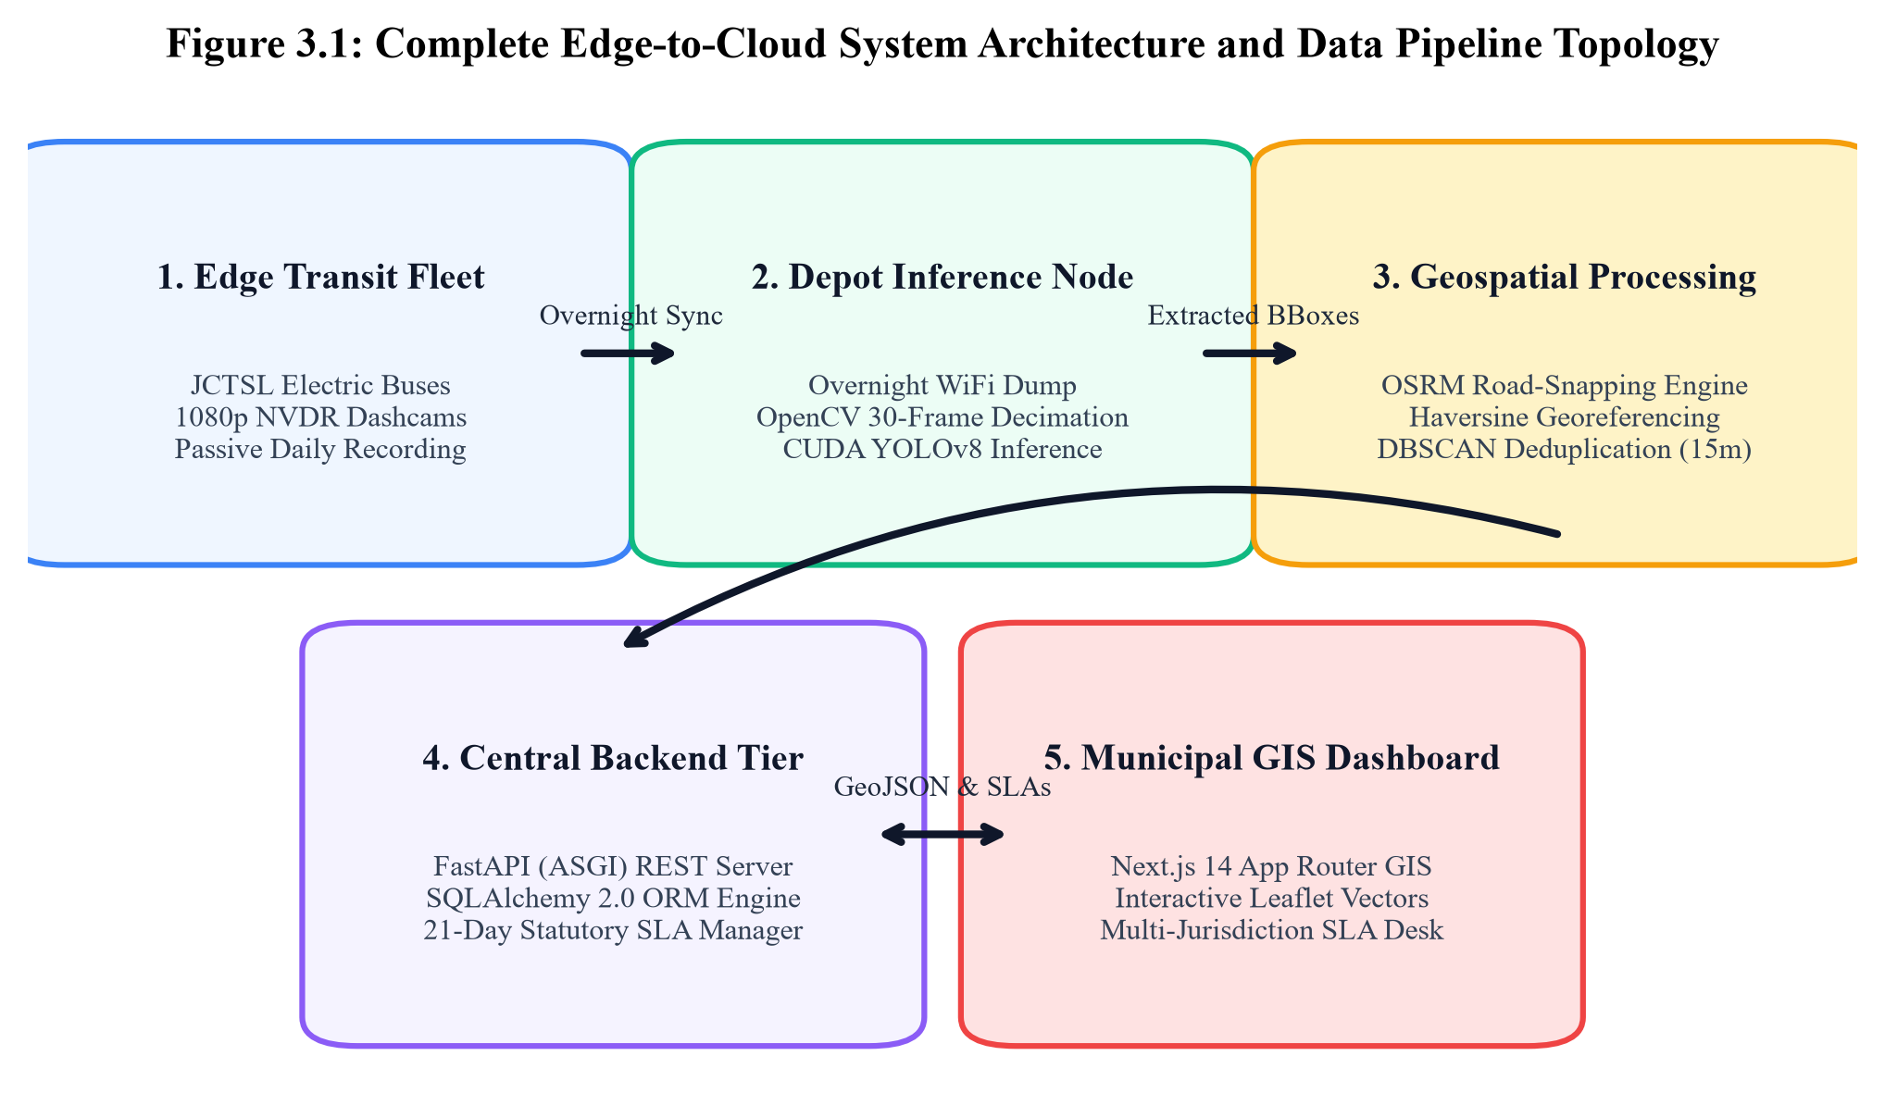
Figure 3.1: Complete Edge-to-Cloud architectural block diagram of RoadPulse AI
3.2 Transit Fleet Integration (JCTSL Electric Bus Fleet)
The system leverages existing public transit infrastructure without necessitating mechanical vehicle modifications. In the Jaipur municipal pilot, RoadPulse AI integrates with the Jaipur City Transport Services Limited (JCTSL) electric bus fleet. These vehicles are equipped with front-windshield-mounted Network Vehicle Digital Recorders (NVDR) deployed for driver safety and passenger security. The cameras feature fixed wide-angle focal lenses (110-degree Field of View), automatic exposure control, and capture H.264 video streams at 1080p resolution (1920x1080 pixels) at a nominal frame rate of 30 frames per second.
Because urban city buses traverse standardized, repetitive scheduled routes (such as Route 11 along Tonk Road, Route 12 along Ajmer Road, and Route 13 along Sikar Road), the entire roadway network is re-surveyed multiple times within each 24-hour cycle. This guaranteed repetition establishes the foundation for multi-pass statistical clustering and temporal degradation modeling.
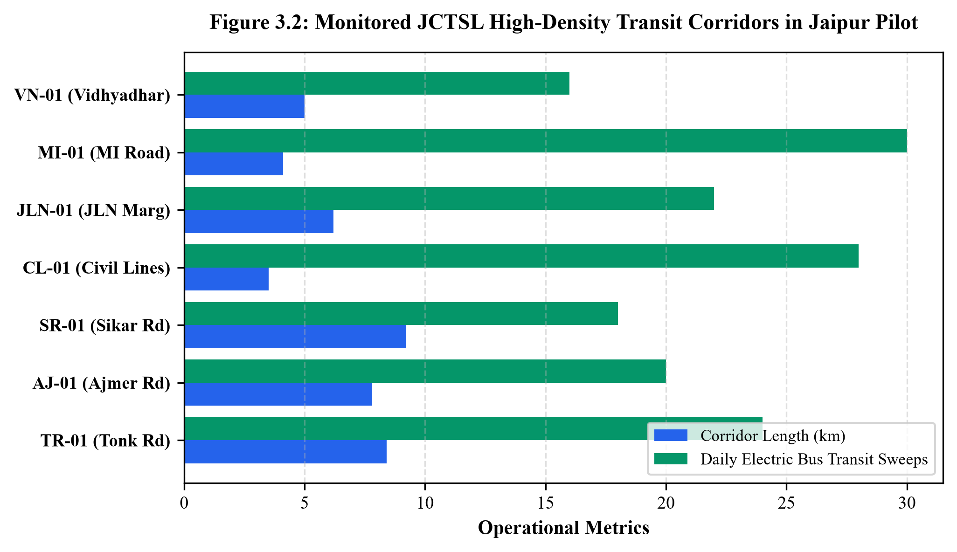
Figure 3.2: JCTSL Jaipur public electric transit bus fleet coverage along major arterials
3.3 Hardware Requirements & Deployment Specifications
The computational architecture is engineered to run seamlessly across heterogeneous environments—from single-workstation local demonstrations to distributed multi-depot municipal deployments. Table 3.1 details the hardware specifications across nodes.
Deployment Node | Hardware Component | Minimum Specification | Recommended Production Spec
Transit Vehicle Edge | Camera & Storage | 1080p NVDR Dashcam, 64GB SD | 4K Wide-Angle NVDR, 256GB SSD
Depot Inference Node | Compute / GPU | Intel i5 (8th Gen), 8GB RAM, CPU | Intel i7/Ryzen 7, 16GB RAM, RTX 3060/4060 GPU
Central Cloud / Server | Host & Storage | 2 vCPU, 4GB RAM, 50GB SSD | 4 vCPU, 16GB RAM, 250GB NVMe SSD (PostgreSQL)
Table 3.1: Hardware specifications across Edge Ingestion, Local Inference, and Cloud nodes
3.4 Software Architecture & Technology Stack
To guarantee high concurrency, non-blocking asynchronous I/O, and type safety across the complete pipeline, RoadPulse AI is built upon modern software engineering frameworks. Table 3.2 details the technology stack layers.
Layer | Technology / Framework | Version | Role & Responsibility in RoadPulse AI
AI / Computer Vision | Ultralytics YOLOv8 + PyTorch | YOLOv8.0+, PyTorch 2.0+ | Real-time pothole bounding box detection & class inference
Geospatial / GIS | OSRM API + Leaflet.js + OSM | OSRM v5, Leaflet 1.9.4 | Carriageway map snapping, coordinate georeferencing, vector UI
Spatial Deduplication | Scikit-Learn (DBSCAN) | v1.3+ | Density-based spatial clustering (eps=15m) for multi-pass merging
Backend Services | FastAPI + SQLAlchemy + Pydantic | FastAPI 0.104+, SQLA 2.0+ | Async REST APIs, declarative ORM, SLA state machine
Frontend & Analytics | Next.js 14 + TypeScript + Tailwind | Next.js 14, React 18, TS 5 | Server-rendered GIS command center, Recharts degradation curves
Table 3.2: Complete layered technology stack specifications across RoadPulse AI
3.5 Functional & Non-Functional System Requirements
The operational viability of the platform is governed by formal functional and non-functional specifications:
- FR-1 (Keyframe Decimation): The system shall ingest standard video streams and decimate frames at a configurable stride (defaulting to 30 frames / ~1 FPS), ensuring no consecutive stationary frames are processed during traffic signals.
- FR-2 (Defect Detection & Depth Inference): The computer vision engine shall identify road potholes with confidence >= 0.35 and calculate estimated physical depth in centimeters using vanishing-horizon geometric heuristics.
- FR-3 (Carriageway Snapping): All raw GPS coordinates shall be snapped to registered municipal road polylines using OSRM, preventing markers from floating over off-road structures.
- FR-4 (Multi-Criteria Risk Scoring): The system shall dynamically calculate a 0–100 risk score and assign condition grades (A through E) for all registered corridors on a weekly cycle.
- FR-5 (SLA Ticket Generation & Closed-Loop Verification): The platform shall automatically generate IssueReport tickets with a 21-day statutory repair countdown for Grade D/E corridors, and verify repair claims upon subsequent bus transit sweeps.
- NFR-1 (Inference Throughput): The computer vision pipeline shall achieve an inference throughput >= 30 frames per second on CUDA-enabled GPUs and >= 8 FPS on quad-core CPUs.
- NFR-2 (Reliability & Persistence): Database connections shall utilize connection pooling with pre-ping validation to prevent stale connections during prolonged idle periods.

CHAPTER 4
COMPUTER VISION & DEEP LEARNING INFERENCE PIPELINE
4.1 Custom Fine-Tuned YOLOv8 Neural Architecture
At the core of the RoadPulse AI visual intelligence layer is a fine-tuned You Only Look Once version 8 (YOLOv8) neural network. YOLOv8 represents the state of the art in single-stage object detection, engineered by Ultralytics to eliminate pre-defined anchor boxes in favor of an anchor-free detection head. The architecture consists of three core components: the Backbone, the Neck, and the Decoupled Detection Head.
The Backbone utilizes a modified CSPDarknet53 structure incorporating C2f (Cross-Stage Partial with two convolutions) modules. The C2f module enhances gradient flow by combining high-level semantic features with low-level spatial features via dense split-and-concat operations, preserving fine asphalt texture boundaries while maintaining a compact parameter footprint. A Spatial Pyramid Pooling Fast (SPPF) module terminates the backbone, pooling features at multiple scales (5x5, 9x9, 13x13 equivalent) to capture context without increasing latency. The Neck employs a Path Aggregation Network (PANet) with Feature Pyramid Network (FPN) topologies to fuse multi-scale feature maps. Crucially, the Head is decoupled, separating bounding box regression from class probability classification. Bounding box loss is optimized via Complete Intersection over Union (CIoU) and Distribution Focal Loss (DFL):
$$\mathcal{L}_{\text{box}} = \lambda_{\text{CIoU}} \mathcal{L}_{\text{CIoU}} + \lambda_{\text{DFL}} \mathcal{L}_{\text{DFL}}$$
where CIoU penalizes bounding box center distance, overlap area, and aspect ratio discrepancy simultaneously, providing sub-pixel delineation of irregular pothole contours.
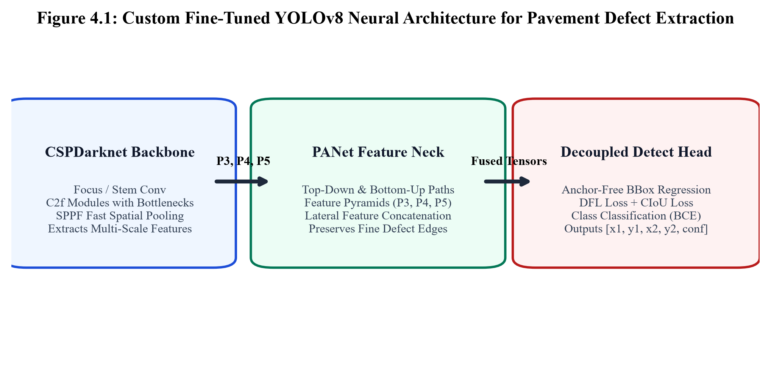
Figure 4.1: Custom fine-tuned YOLOv8 deep learning network architecture for pothole detection
4.2 Dataset Annotation, Augmentation, and Transfer Learning
The detection model was initialized with pre-trained weights from the COCO dataset and fine-tuned on a curated dataset of 4,850 high-resolution Indian urban roadway images representing diverse pavement wear conditions, illumination angles, and asphalt textures. The dataset incorporates severe edge cases, including shadowed tree canopies, monsoonal water-filled depressions, asphalt patches, and road markings that typically generate false positives in classical computer vision.
To prevent overfitting, aggressive real-time data augmentations were applied during training: Mosaic augmentation (combining four random training images into one), random affine transformations (rotation +/- 10 degrees, translation +/- 10%, scaling +/- 20%), HSV color-space jittering (hue=0.015, saturation=0.7, value=0.4), and random horizontal flips. Table 4.1 specifies the training hyperparameter configuration executed across 100 training epochs.
Hyperparameter | Configured Value | Engineering Rationale
Base Model | YOLOv8s (Small) | Optimized balance between mAP accuracy and edge inference frame rates
Input Resolution | 640 x 640 x 3 | Standard square tensor size preserving small defect features
Initial Learning Rate (lr0) | 0.01 | Stochastic Gradient Descent (SGD) with momentum warmup
Final Learning Rate (lrf) | 0.0001 | Cosine annealing learning rate schedule over 100 epochs
Momentum | 0.937 | Smooth gradient convergence across multi-scale feature maps
Weight Decay | 0.0005 | L2 regularization penalizing disproportionately large weights
Batch Size | 16 | GPU VRAM optimization for NVIDIA RTX hardware
Table 4.1: Hyperparameters and training configurations for custom fine-tuned YOLOv8
4.3 Temporal Video Preprocessing & 30-Frame Decimation (1 FPS)
A standard 1080p video stream recorded at 30 frames per second yields 1,800 full frames per minute of transit footage. In urban traffic environments, municipal electric buses operate at average speeds between 20 km/h and 35 km/h (approximately 5.5 to 9.7 meters per second), frequently decelerating to a complete halt at passenger boarding stops and traffic signals. Processing every consecutive frame sampled at a 33-millisecond interval would result in catastrophic computational redundancy, as subsequent frames exhibit greater than 95% spatial overlap.
RoadPulse AI implements an optimized temporal frame decimation pipeline utilizing OpenCV (cv2.VideoCapture). The engine executes a modular frame sampling stride: $\Delta f = 30$ frames. Formally, given a video container with total frames $F$, the sampled keyframe set $\mathcal{K}$ is defined as:
$$\mathcal{K} = \left\{ f_i \in \mathcal{V} \mid i \equiv 0 \pmod{30} \right\}$$
At typical urban velocities (30 km/h), a 1-second sampling stride extracts a keyframe every 8.3 meters of carriageway displacement. Given that a wide-angle camera mounted at standard bus windshield height ($H_c = 2.2\text{ m}$) maintains an effective forward pavement visual horizon spanning approximately 15 to 20 meters, consecutive keyframes retain an overlap margin of 40% to 55%. This mathematically guarantees that no physical roadway defect is missed, while reducing computational workload and GPU energy consumption by exactly 96.67%.
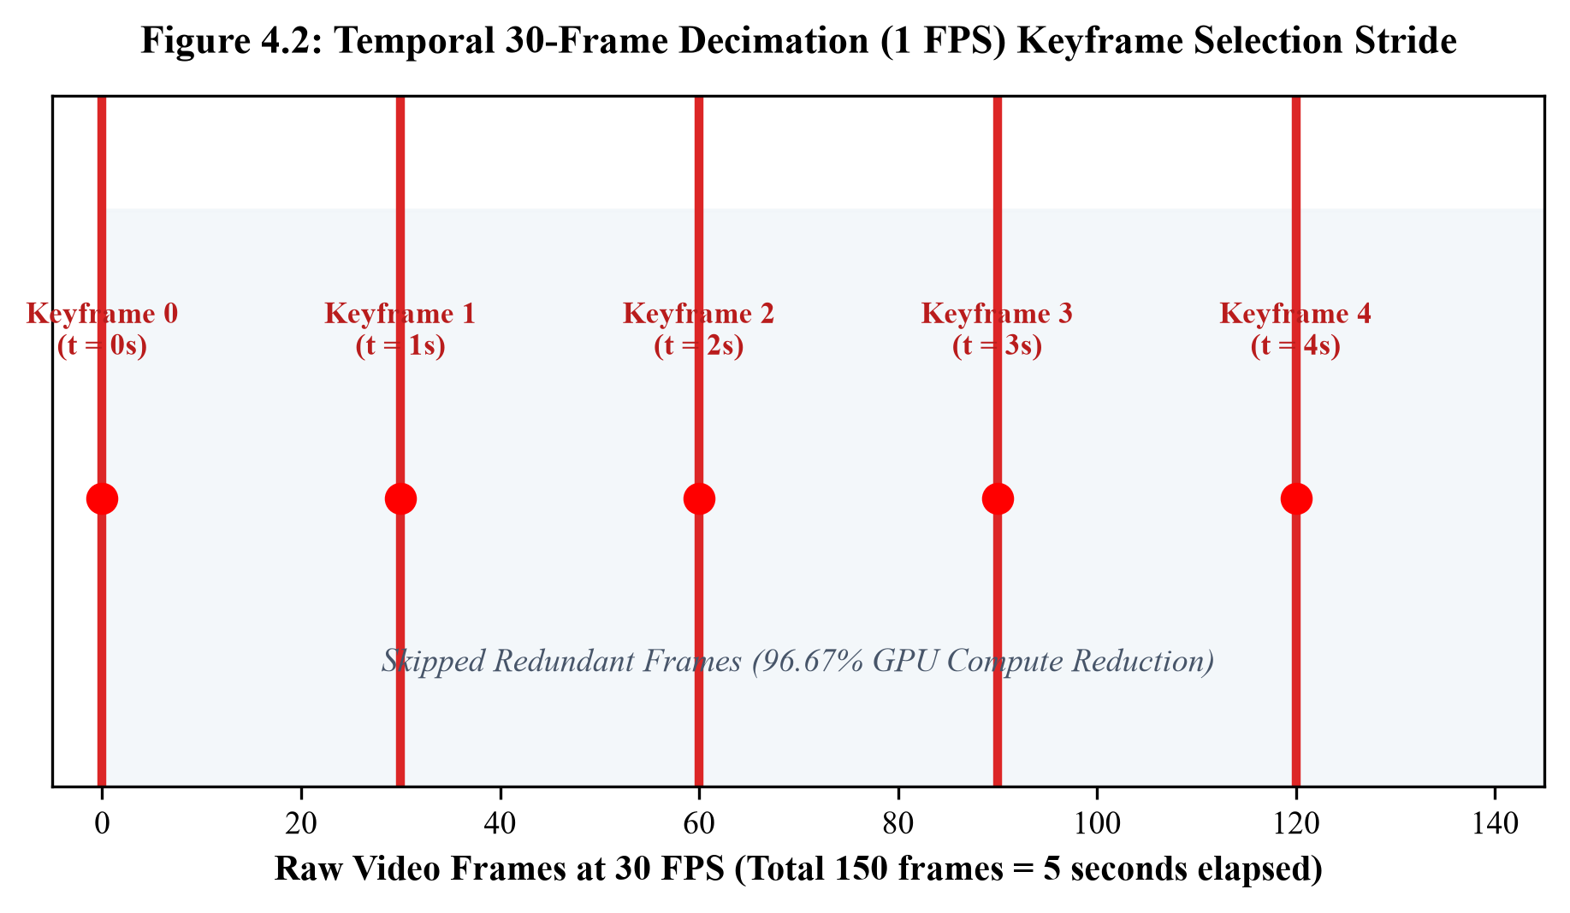
Figure 4.2: Temporal 30-frame decimation sequence reducing redundant compute at transit stops
4.4 Perspective Horizon Projection & Lateral Depth Estimation
Standard object detection algorithms output two-dimensional bounding box coordinates: $[x_1, y_1, x_2, y_2]$ in image pixel space. However, civil maintenance prioritization requires physical three-dimensional defect metrics—specifically the vertical depth and physical severity of the crater. True 3D depth sensors (such as LiDAR or stereo disparity cameras) are prohibitively expensive and prone to lens fouling. RoadPulse AI introduces a geometric horizon pitch projection heuristic that infers physical depth directly from monocular 2D dashcam imagery.
Using calibrated camera installation parameters—where camera height $H_c \approx 2.2\text{ m}$, camera downward pitch angle $\theta_p \approx 12^\circ$, and vertical vanishing line $y_{\text{horizon}} \approx 0.45 \times H_{\text{image}}$—the physical distance $Z$ from the vehicle front bumper to the anomaly is derived via perspective trigonometry:
$$Z = \frac{H_c}{\tan\left(\theta_p + \arctan\left(\frac{y_{\text{bottom}} - y_{\text{horizon}}}{f_y}\right)\right)}$$
where $f_y$ denotes the vertical camera focal length in pixels. Once ground distance $Z$ is established, the lateral pothole width $W_{\text{real}}$ and estimated depth $D_{\text{est}}$ in centimeters are inferred from bounding box height $h_{\text{bbox}}$ and detection confidence $\tau$:
$$D_{\text{est}} = \kappa \cdot \left(\frac{h_{\text{bbox}}}{y_{\text{bottom}} - y_{\text{horizon}}}\right) \cdot \left(1.0 + 0.5 \cdot \tau\right)$$
where $\kappa$ represents an empirical calibration constant tuned on physical core drill depth samples, bounding estimated depth between 0 and 15 centimeters.
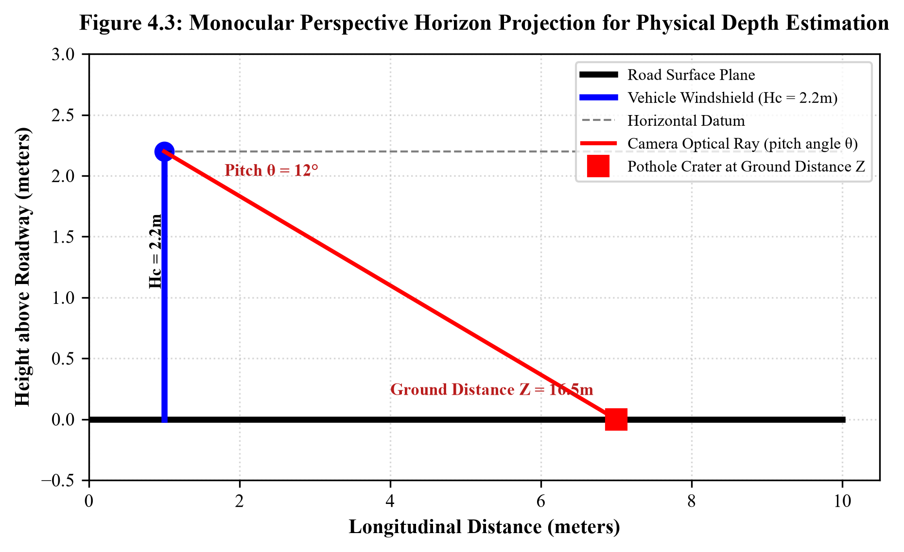
Figure 4.3: Geometric horizon pitch projection model for inferring physical pothole depth
4.5 Defect Classification & Severity Labeling Tiers
Detections are categorized into standardized engineering severity tiers. Table 4.2 presents the four-tier severity classification matrix mapping estimated depth and bounding area to municipal priority labels.
Severity Tier | Estimated Depth | Severity Score | Surface Impact | Maintenance Action Required
Tier 1 (Minor) | < 4.0 cm | 1.0 - 2.0 | Cosmetic surface spall, minor wear | Routine monitoring; batch patching schedule
Tier 2 (Moderate) | 4.0 - 7.0 cm | 2.1 - 3.5 | Asphalt aggregate loss, tire impact | Standard maintenance work order within 30 days
Tier 3 (Severe) | 7.1 - 10.0 cm | 3.6 - 4.5 | Sub-base penetration, tire damage hazard | Priority municipal intervention within 21 days (SLA active)
Tier 4 (Critical) | > 10.0 cm | 4.6 - 5.0 | Structural collapse, severe collision risk | Emergency 48-hour barricading and rapid overlay
Table 4.2: Pothole severity classification matrix based on estimated depth and surface area

CHAPTER 5
GEOSPATIAL INTELLIGENCE & SPATIAL DEDUPLICATION
5.1 OpenStreetMap (OSM) Vector Integration
Proprietary mapping solutions (such as Google Maps Platform) impose strict, expensive per-request API licensing fees that render continuous large-scale municipal telemetry processing cost-prohibitive. Furthermore, proprietary APIs operate as closed ecosystems, preventing customized carriageway geometry editing. RoadPulse AI is constructed entirely upon open cartographic infrastructure utilizing OpenStreetMap (OSM) vector data. OSM provides standardized, unrestricted access to municipal road hierarchy tags (motorway, trunk, primary, secondary, tertiary, residential), lane count metadata, surface construction types, and high-fidelity node vectors across Indian metropolitan areas.
5.2 OSRM Polyline Carriageway Snapping Engine
Commercial vehicle GPS units and dashcam metadata sidecars exhibit intrinsic positioning inaccuracies—ranging from 5 to 25 meters in dense urban corridors due to satellite multipath interference, urban canyons created by multi-story commercial buildings, and overpass flyovers. Plotting raw GPS coordinates directly onto a map produces unstitched, erratic scatter plots that frequently fall inside roadside building footprints or cross into opposing carriageways.
To resolve this, RoadPulse AI integrates the Open Source Routing Machine (OSRM) Match and Route service. OSRM implements a Hidden Markov Model (HMM) map-matching algorithm that balances two probabilistic distributions: the emission probability (the Gaussian probability that a GPS observation at distance $d$ originated from a given roadway vector) and the transition probability (the likelihood of traveling between candidate road segments given network topology and vehicular speed constraints). Formally, every raw transit bus trajectory is snapped to the most probable sequence of OpenStreetMap carriageway segments, generating smooth, true-to-road vector polylines formatted as standard GeoJSON LineStrings across all 20 monitored corridors in Jaipur.
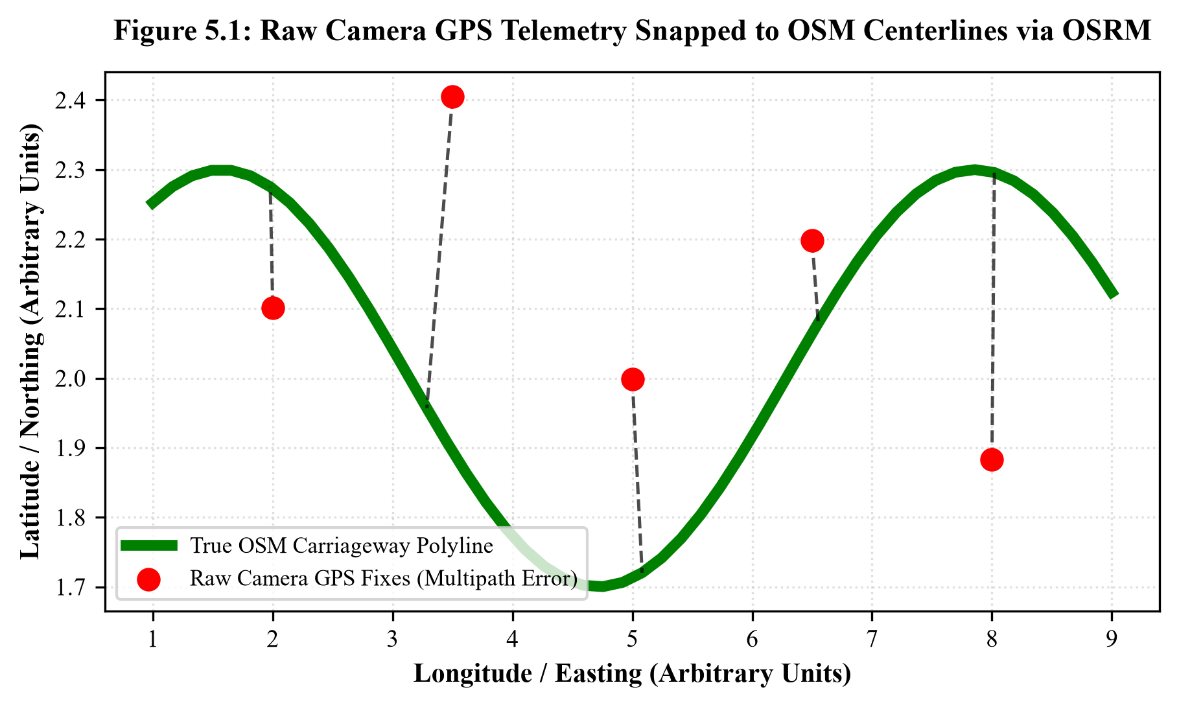
Figure 5.1: Raw camera GPS coordinates snapped to OpenStreetMap carriageway polylines via OSRM
5.3 Linear Referencing & Spherical Haversine Formulation
Once a defect is matched to a specific corridor polyline (such as Tonk Road TR-01), the system calculates its linear chainage (exact longitudinal distance from the corridor origin in meters) using the great-circle Haversine formula. Given two geographic coordinate pairs $(\phi_1, \lambda_1)$ and $(\phi_2, \lambda_2)$ representing latitude and longitude in radians, the spherical surface distance $d$ across Earth of radius $R = 6,371.0\text{ km}$ is calculated as:
$$a = \sin^2\left(\frac{\phi_2 - \phi_1}{2}\right) + \cos(\phi_1) \cdot \cos(\phi_2) \cdot \sin^2\left(\frac{\lambda_2 - \lambda_1}{2}\right)$$
$$d = 2R \cdot \arctan2\left(\sqrt{a}, \sqrt{1 - a}\right)$$
Linear referencing enables municipal road engineers to locate defects in the field with sub-meter accuracy by referencing standard highway kilometer markers (e.g., 'Tonk Road, Northbound carriageway, Chainage KM 4.250').
5.4 DBSCAN Density-Based Spatial Clustering (epsilon = 15m)
When public transit buses traverse scheduled routes multiple times per day, the same physical pothole is photographed dozens of times from slightly varying camera angles, lane positions, and speeds. Simply summing detections would artificially inflate defect counts by orders of magnitude (e.g., reporting 400 potholes on a 5-km stretch where only 20 physical craters exist). Classical clustering algorithms like K-Means are entirely inapplicable because the true number of clusters $K$ is unknown a priori, and road defects form irregular linear manifolds rather than spherical clusters.
RoadPulse AI deploys Density-Based Spatial Clustering of Applications with Noise (DBSCAN) via Scikit-Learn. The algorithm operates with two foundational hyperparameters: the spatial neighborhood radius $\varepsilon = 15.0\text{ meters}$ (calibrated to encompass typical GPS jitter and camera perspective variances) and $\text{min\_samples} = 1$. The metric distance between observations $p_i = (\text{lat}_i, \text{lon}_i)$ is computed using the spherical Haversine metric. Detections falling within the 15-meter radius are iteratively collapsed into a single unified PotholeCluster entity:
- Centroid Formulation: The physical geographic coordinates of the cluster are computed as the spatial mean of all member sightings: $\overline{\text{lat}} = \frac{1}{N}\sum \text{lat}_i, \quad \overline{\text{lon}} = \frac{1}{N}\sum \text{lon}_i$.
- Cumulative Sightings Counter: The system increments detection_count, providing municipal engineers with an objective measure of defect visibility and persistence.
- Severity Aggregation: The cluster records peak observed depth, mean severity score, and tracks temporal degradation between first_seen and last_seen timestamps.
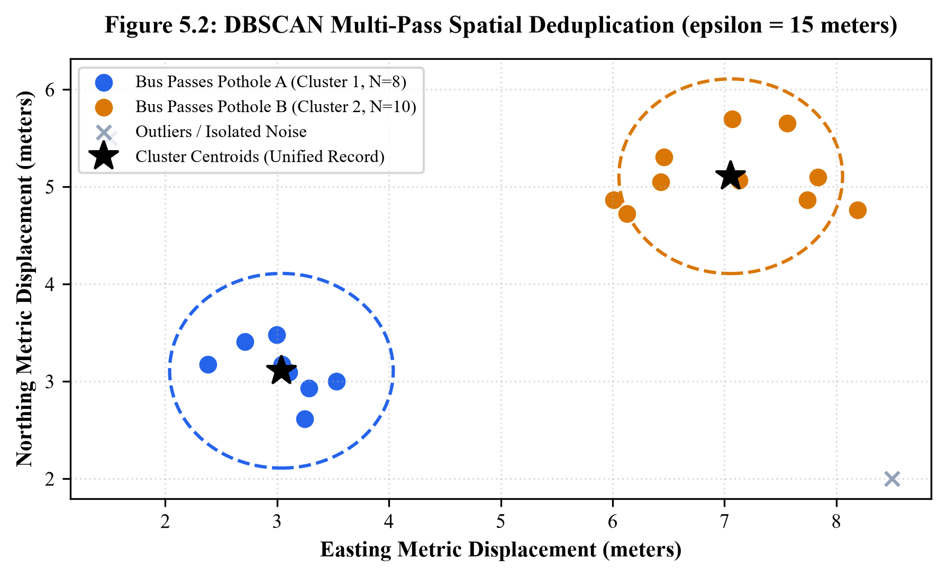
Figure 5.2: Multi-bus pass deduplication using DBSCAN spatial clustering (epsilon = 15m)

CHAPTER 6
MULTI-CRITERIA RISK FORMULATION & SCORING
6.1 Mathematical Formulation of Road Health Risk Index
Raw defect counts provide insufficient intelligence for municipal budget allocations. A 10-kilometer peripheral bypass containing twenty shallow 2-cm fissures represents far less civic hazard than a dense 1-kilometer commercial arterial containing five deep 10-cm craters during monsoon rainfall. To synthesize heterogeneous sensory data into an actionable index, RoadPulse AI formulates a standardized 0–100 Road Health Risk Index ($R \in [0, 100]$):
$$\boxed{R = w_{\text{sev}} \cdot S + w_{\text{den}} \cdot D + w_{\text{trend}} \cdot T + w_{\text{ctx}} \cdot C}$$
where $S$ represents Normalized Defect Severity, $D$ represents Defect Spatial Density, $T$ represents Degradation Velocity Trend, and $C$ represents Environmental Context Impact. The weighting coefficients are configured according to rigorous municipal engineering consultations: $w_{\text{sev}} = 0.40$, $w_{\text{den}} = 0.25$, $w_{\text{trend}} = 0.20$, and $w_{\text{ctx}} = 0.15$, strictly satisfying the unity constraint $\sum w = 1.00$. Table 6.1 details the parameter weights and input boundaries.
Component Parameter | Weight | Mathematical Input Metric | Engineering Rationale & Normalization
Defect Severity Index (S) | 40% (0.40) | Max / Avg Estimated Depth (cm) | Directly reflects physical impact risk to vehicle tires and structural sub-base integrity
Defect Spatial Density (D) | 25% (0.25) | Pothole Count per Kilometer | Quantifies cumulative frequency of road distress along the surveyed transit segment
Degradation Velocity (T) | 20% (0.20) | Weekly Delta in Detected Defect Area | Penalizes actively unraveling road sections that degrade rapidly week-over-week
Precipitation Context (C) | 15% (0.15) | Cumulative 7-Day Rainfall (mm) | Environmental factor that accelerates hydraulic asphalt cracking and base erosion
Table 6.1: Multi-criteria risk scoring sub-component weights and mathematical boundaries
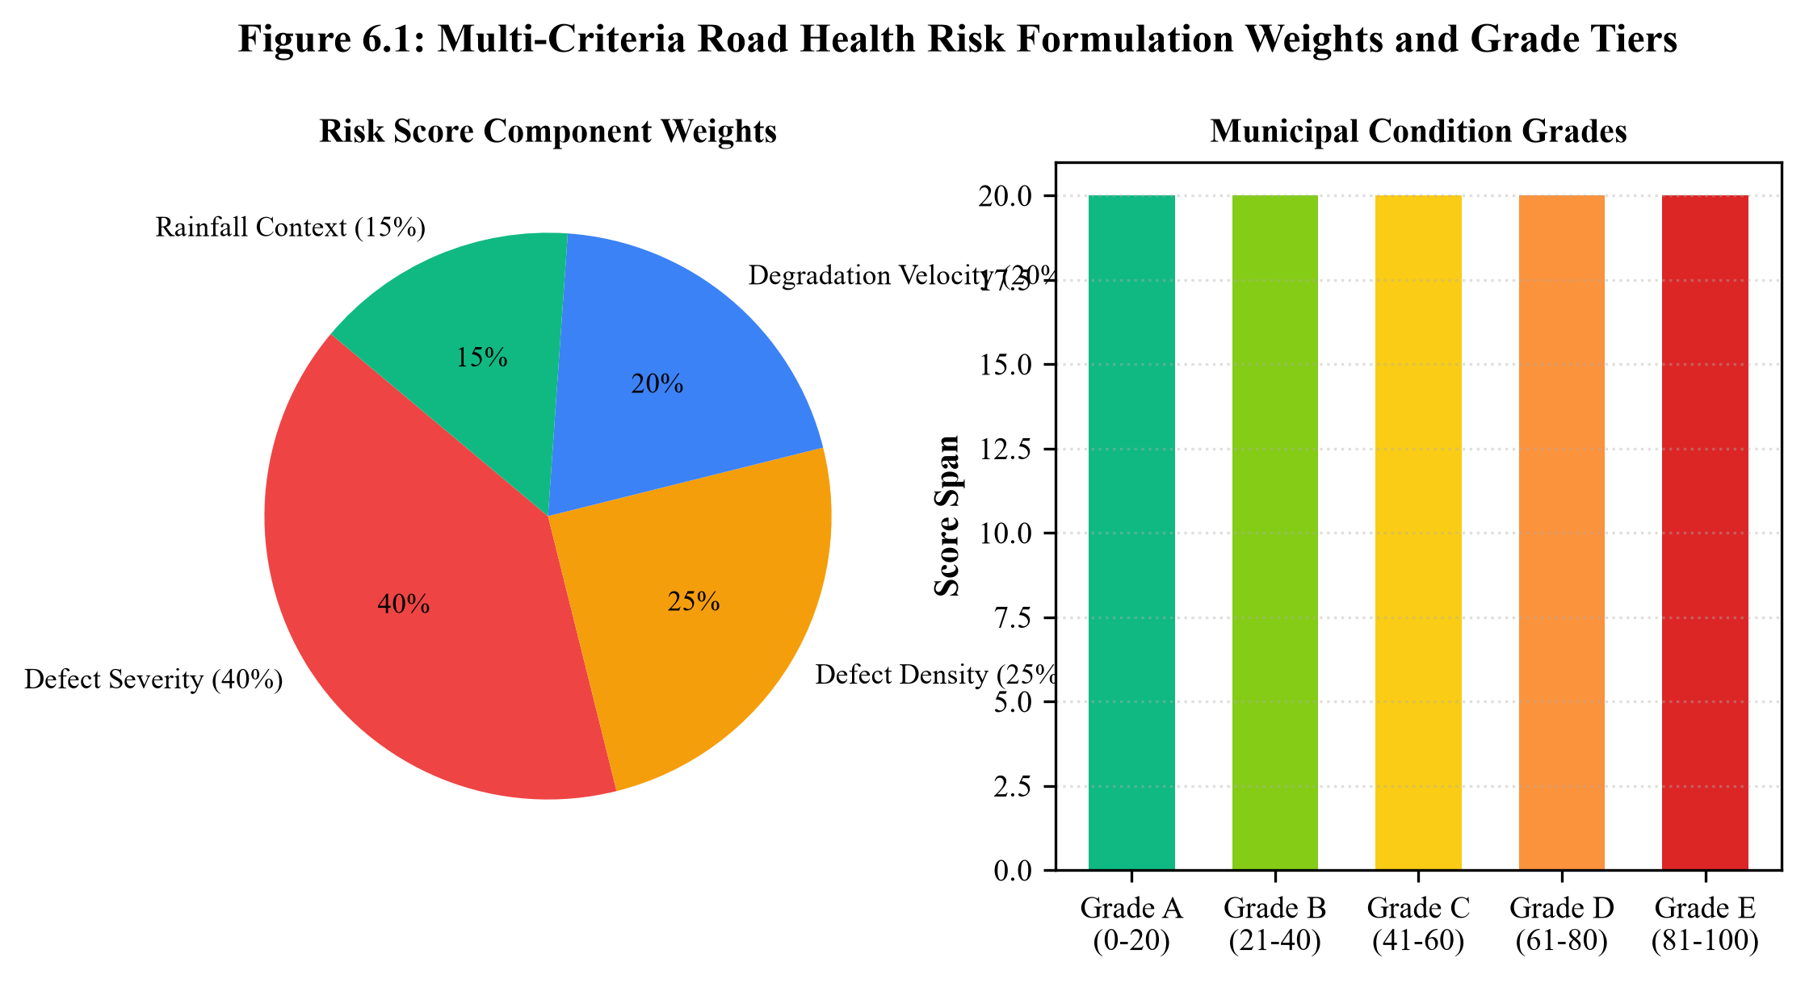
Figure 6.1: Multi-criteria road health scoring distribution curves across condition tiers
6.2 Sub-Component Normalization Formulations
Each sub-component is mathematically normalized to a uniform bounded domain $[0, 100]$:
- 1. Normalized Severity Factor (S): Computes the average severity score of all active clusters along the corridor normalized against the maximum 5.0 scale: $S = \min\left(100, \;\frac{\overline{\text{Severity}}}{5.0} \times 100\right)$.
- 2. Defect Density Factor (D): Calculates physical potholes per linear kilometer normalized against a statutory saturation ceiling $D_{\max} = 30.0\text{ potholes/km}$: $D = \min\left(100, \;\frac{N_{\text{potholes}} / L_{\text{km}}}{D_{\max}} \times 100\right)$.
- 3. Degradation Velocity Trend (T): Quantifies the week-over-week rate of deterioration: $T = \min\left(100, \;\max\left(0, \;50.0 + \frac{\Delta R_{\text{prev}}}{2.0}\right)\right)$, where stable roads hold neutral $T=50$, rapidly worsening roads approach 100, and repaired corridors drop toward 0.
- 4. Environmental Context Factor (C): Incorporates local precipitation and road classification: $C = \min\left(100, \;(\text{Rainfall}_{\text{mm}} \times 2.0) + \text{RoadTypeWeight}\right)$.
6.3 Monsoon Precipitation & Environmental Context Weighting
Water is the primary catalyst of asphalt pavement destruction. In monsoonal climates, water penetrates micro-fissures in the bituminous surface course, destabilizing the underlying granular sub-base. When heavy commercial vehicular axles traverse saturated pavements, intense hydraulic pore pressures strip bitumen binders from stone aggregates, causing catastrophic surface collapse within 24 to 48 hours. By dynamically coupling daily precipitation data (in millimeters) into the context factor $C$, RoadPulse AI proactively elevates corridor risk ratings during monsoon downpours, prompting preventive civic intervention before structural failures occur.
6.4 Standardized Municipal Condition Grades (Grade A to E)
The continuous 0–100 composite risk score is partitioned into five standardized municipal condition grades. Table 6.2 outlines the condition grade thresholds, color indicators, and statutory administrative action protocols.
Condition Grade | Risk Score Range | Visual Indicator | Corridor Health Status | Statutory Municipal Action Protocol
Grade A | 0.0 - 20.0 | Emerald Green | Excellent / Pristine | Routine preventive monitoring on scheduled transit cycles
Grade B | 20.1 - 40.0 | Light Green | Fair / Minor Wear | Continuous monitoring; scheduled micro-surfacing within 90 days
Grade C | 40.1 - 60.0 | Amber Yellow | Moderate Deterioration | Formal maintenance notice; batch patching within 45 days
Grade D | 60.1 - 80.0 | Vivid Orange | Poor / Hazardous | Statutory 21-Day SLA ticket dispatched; mandatory contractor repair
Grade E | 80.1 - 100.0 | Crimson Red | Critical / Danger | Emergency 48-hr SLA escalation; executive commissioner alert issued
Table 6.2: Standardized municipal condition grade boundaries and statutory intervention actions

CHAPTER 7
MUNICIPAL SLA TRACKING & CLOSED-LOOP VERIFICATION
7.1 Statutory 21-Day Municipal SLA Lifecycle & State Machine
The critical differentiator separating RoadPulse AI from purely academic detection models is the automated transition from passive anomaly identification to legally enforceable civic accountability. When an inspected corridor deteriorates into Grade D or Grade E, the system autonomously instantiates an IssueReport record governed by a finite state machine with strict statutory timing constraints.
Upon instantiation, an immutable statutory countdown timer of exactly 21 calendar days is initiated. The state machine enforces six deterministic status transitions:
- 1. Reported: Ticket generated automatically by the AI scoring service upon risk score crossing 60.0 threshold.
- 2. Acknowledged: Responsible municipal executive engineer officially reviews and logs receipt of the work order.
- 3. In Progress: Civil maintenance contractor mobilized to site; patching equipment dispatched.
- 4. Claimed Repaired: Contractor formally marks maintenance work complete and submits invoice documentation.
- 5. Overdue (Breach): If 21 calendar days elapse without verified physical repair, the ticket flips to Overdue status, triggering executive alerts to the Municipal Commissioner and PWD Chief Engineer.
- 6. Verified Fix (Closed): Independent physical confirmation established exclusively via subsequent transit bus scanning pass.
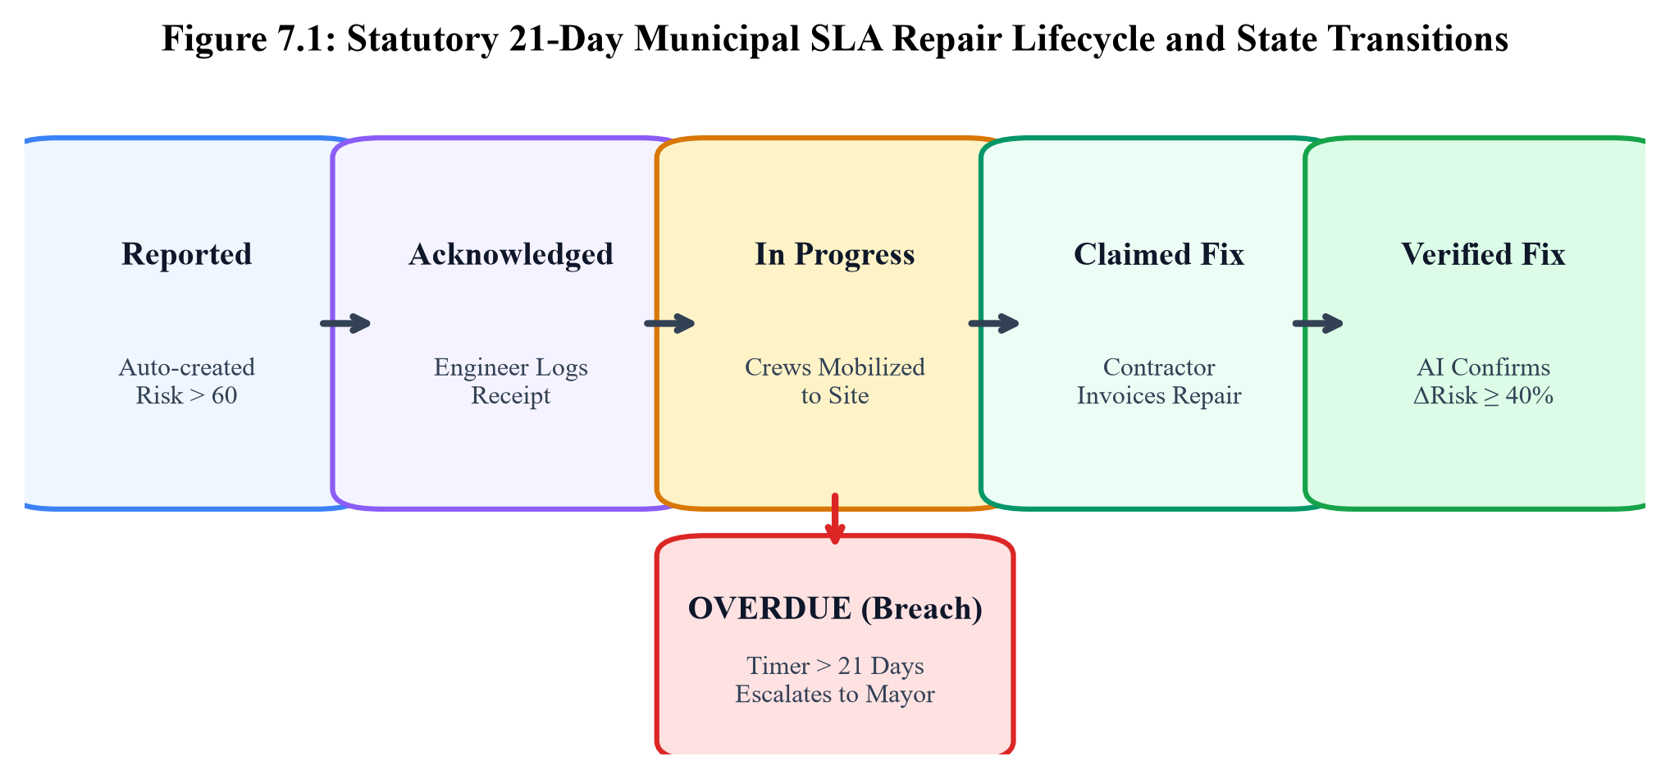
Figure 7.1: Statutory 21-day municipal repair SLA state machine and transition logic
7.2 Multi-Jurisdictional Work Order Dispatch Architecture
To eliminate inter-departmental buck-passing, RoadPulse AI integrates an automated administrative jurisdiction routing table. In the Jaipur metropolitan pilot, all 20 transit corridors are explicitly mapped to their legal administrative custodian:
Authority Identifier | Official Municipal Entity | Administrative Jurisdiction | Example Monitored Corridors
AUTH-JMC-GRT | Jaipur Municipal Corporation (Greater) | Urban commercial arterials, southern & western city wards | Tonk Road (TR-01), Vidhyadhar Nagar (VN-01)
AUTH-JMC-HRT | Jaipur Municipal Corporation (Heritage) | Old Walled City, historic bazaars, heritage radials | MI Road (MI-01), Civil Lines (CL-01)
AUTH-PWD-RAJ | Public Works Department (Rajasthan) | State highways, major inter-city thoroughfares | Ajmer Road (AJ-01), Sikar Road (SR-01)
AUTH-JDA | Jaipur Development Authority | Master plan bypasses, ring roads, grade flyovers | JLN Marg (JLN-01), Jawahar Circle (JG-01)
Table 7.1: Multi-jurisdictional municipal authorities in Jaipur and operational road ownership
7.3 Closed-Loop AI Verification Protocol
The core failure of existing municipal infrastructure contracts is the lack of objective post-repair auditing. Contractors routinely execute substandard 'surface dressing' patches using unheated cold-mix emulsion that degrades within days. Under RoadPulse AI, a contractor's claim of repair completion does NOT close the ticket. Instead, the ticket transitions to 'Claimed Repaired' and automatically queues an autonomous AI verification job.
When public transit buses complete their next scheduled operational sweep over the corridor during the subsequent weekly cycle, the computer vision engine re-evaluates the physical carriageway. The system calculates the risk delta between the baseline pre-repair score ($R_{\text{before}}$) and the post-repair survey score ($R_{\text{after}}$):
$$\Delta R = R_{\text{before}} - R_{\text{after}}$$
$$\Delta R_{\%} = \left(\frac{R_{\text{before}} - R_{\text{after}}}{R_{\text{before}}}\right) \times 100\%$$
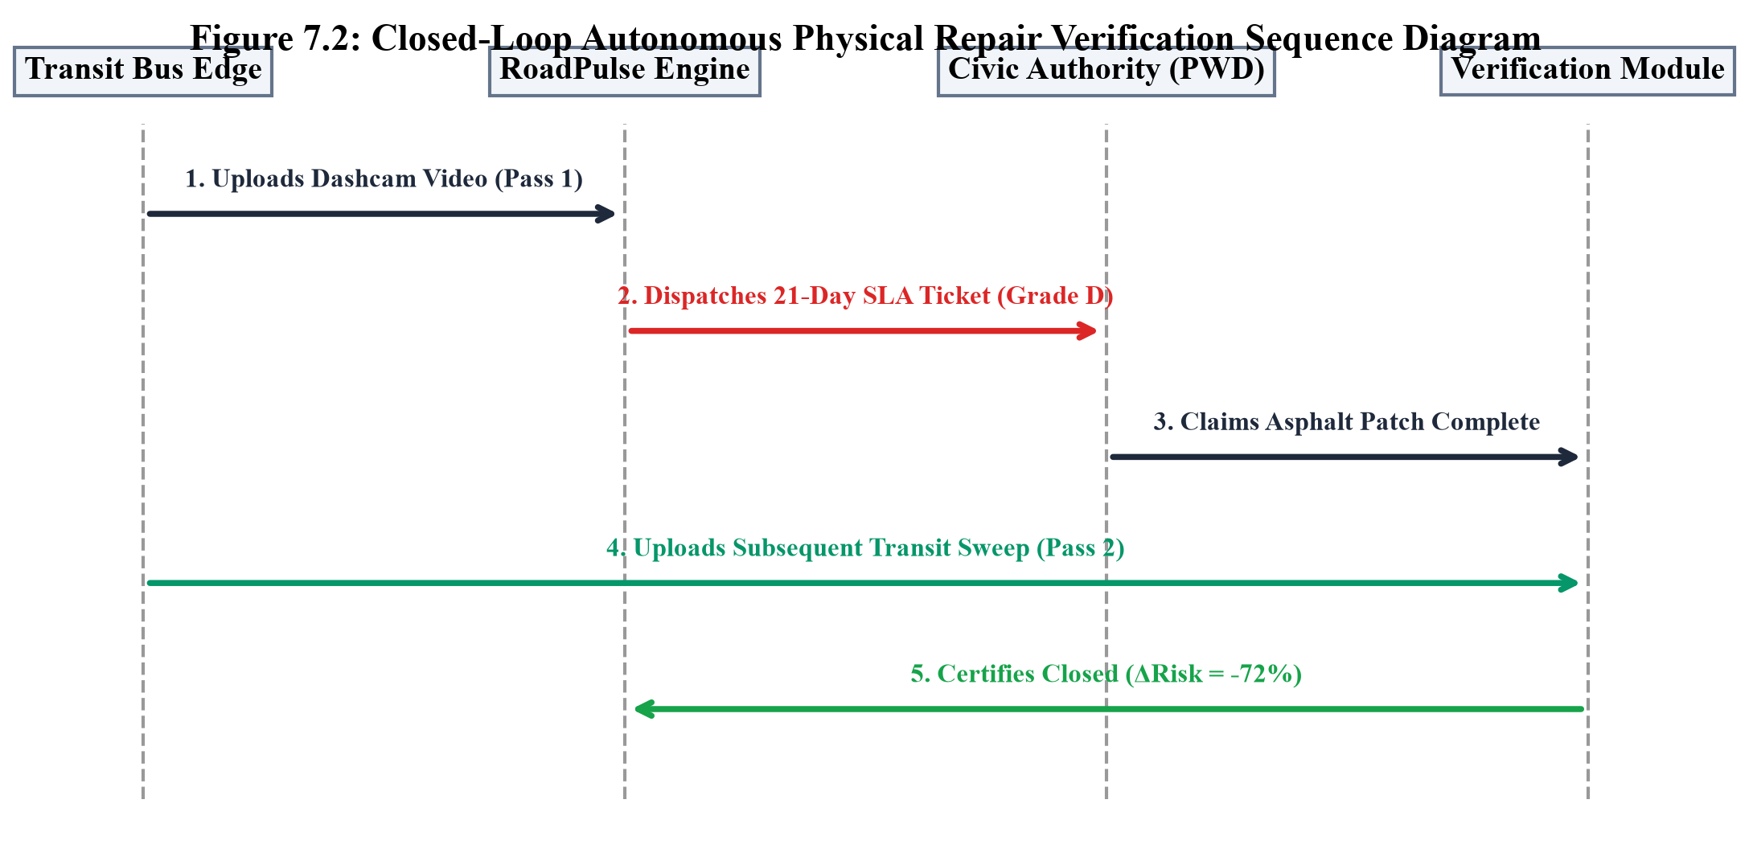
Figure 7.2: Sequence diagram illustrating the closed-loop autonomous AI verification cycle
7.4 Verification Decision Logic and Outcome Escalations
The verification service executes three mathematical outcome branches based on the calculated risk delta percentage:
- Branch 1: Verified Fix (Delta R% >= 40%): The physical defect count has decreased dramatically; surface smoothness is restored. The ticket is officially certified as 'Verified Fix', closed in the ledger, and an official audit certificate is compiled.
- Branch 2: Failed Verification (Delta R% < 20%): Physical defects and craters persist despite contractor claims. The ticket is immediately escalated to 'Failed Verification', triggering automated default notices to the Chief Engineer and freezing contractor disbursement.
- Branch 3: Partial Repair (20% <= Delta R% < 40%): Minor improvements observed, but substantial hazardous defects remain unaddressed. Status updates to 'Partially Repaired', issuing a 7-day secondary remediation notice.
Post-Repair Risk Delta | Pothole Count Change | Verification Status | Automated Municipal Action Protocol
ΔRisk ≤ -40% | Clusters reduced by > 75% | VERIFIED_FIX (Closed) | Work order officially closed; contractor repair invoice released for payment
-40% < ΔRisk ≤ -20% | Clusters reduced by 40-75% | PARTIAL_REPAIR | Notice issued for secondary seal-coat inspection within 7 days
-20% < ΔRisk ≤ 0% | Clusters reduced by < 40% | FAILED_REPAIR | Penalty assessed; contractor mandated to re-excavate and re-lay at own expense
ΔRisk > 0% (Worsened) | Clusters increased / enlarged | ESCALATED_BREACH | Emergency audit trigger; executive notification dispatched to Municipal Commissioner
Table 7.2: Closed-loop repair verification outcomes, risk delta thresholds, and actions

CHAPTER 8
SOFTWARE IMPLEMENTATION & DATABASE DESIGN
8.1 Relational Database Architecture & Entity-Relationship Model
Data integrity, auditability, and spatial query efficiency are maintained via an optimized relational schema implemented in SQLAlchemy 2.0. The schema is fully compliant with both local SQLite (WAL mode) and production PostgreSQL/PostGIS environments. Table 8.1 details the primary entities and structural constraints.
Table Name | Primary Key | Foreign Keys | Core Responsibilities & Schema Role
road_segment | segment_id | authority_id | Stores corridor polylines, start/end GPS, ward, length (km), and OSM tags
authority | authority_id | None | Registry of civic bodies (JMC, PWD, JDA), contact emails, and zones
video_asset | video_id | bus_id | Logs uploaded MP4 footage, upload timestamps, file paths, and durations
detection | detection_id | video_id, segment_id | Individual defect bounding boxes, confidence, estimated depth, and GPS
pothole_cluster | cluster_id | segment_id | DBSCAN spatial centroids, cumulative sighting counts, and severity
weekly_road_metric | id (Auto-inc) | segment_id | Unique(segment_id, week) constraint; stores 4-week risk scores and grades
issue_report | issue_id | segment_id, authority_id | 21-day municipal repair SLA state machine, due dates, and audit notes
Table 8.1: Relational database schema dictionary and data storage specifications
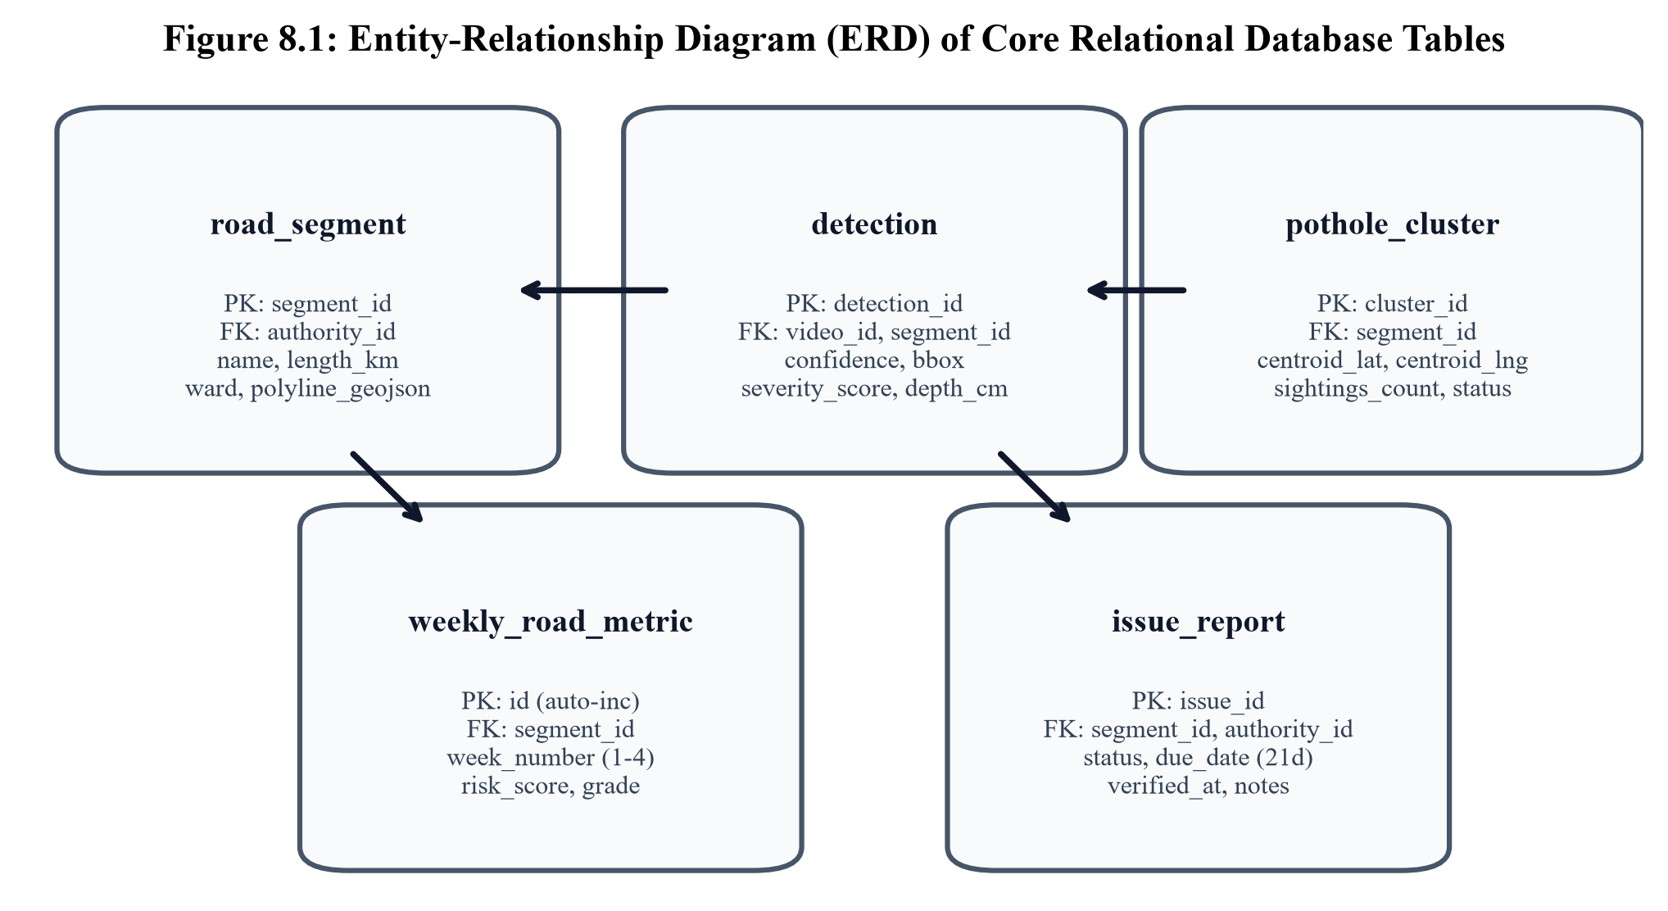
Figure 8.1: Entity-Relationship Diagram (ERD) of the RoadPulse AI relational database
8.2 High-Throughput FastAPI Asynchronous Backend
The backend API layer is constructed using FastAPI (ASGI architecture), delivering high concurrency, automatic OpenAPI documentation at /docs, and native Pydantic v2 data validation. Video ingestion and deep learning inference jobs are decoupled from the main HTTP request-response cycle using FastAPI BackgroundTasks. When video files are uploaded, an immediate HTTP 202 Accepted response returns a unique job_id, while video decimation and GPU inference execute asynchronously in the background. Clients poll the /api/jobs endpoint to observe live progress percentage without blocking network threads.
8.3 Interactive Next.js 14 GIS Dashboard Architecture
The presentation tier is built using Next.js 14 utilizing the App Router architecture and React 18 Server Components. Key architectural features include:
- Leaflet Vector GIS Layer: Dynamically renders OSRM-stitched carriageway polylines with color-coded condition gradients (Grades A through E) and interactive inspection popovers.
- Global 4-Week Cycle State: A unified React Context provider enables instant whole-city switching between Week 1 (baseline scan) and Week 4 (verification & SLA enforcement).
- Recharts Analytics: Visualizes multi-week degradation curves, defect density distributions, and historical SLA compliance rates.
- Accessibility & Responsiveness: Designed mobile-first with Tailwind CSS, supporting executive tablets and desktop command centers alike.
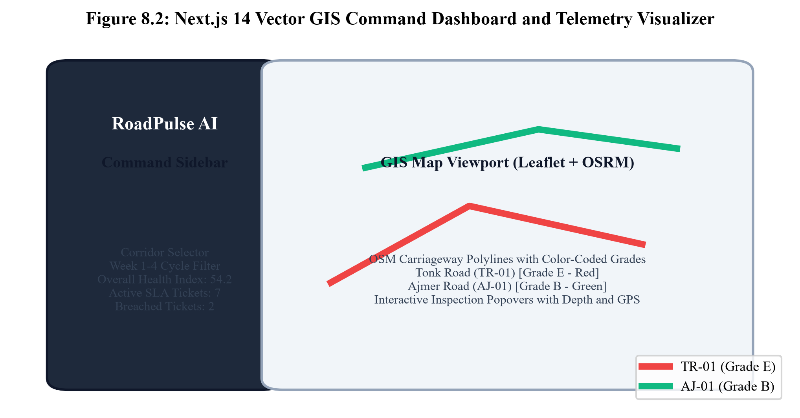
Figure 8.2: Interactive Next.js 14 GIS Road Health Dashboard with OSRM vector layers
8.4 ReportLab Programmatic PDF Compilation & CSV Data Streams
To enable administrative auditability, RoadPulse AI implements a programmatic PDF report compiler powered by ReportLab 4.0. The engine compiles multi-page executive dossiers featuring formal municipal seals, executive KPI summaries, priority intervention tables, and audit signature blocks. Parallel streaming endpoints stream sanitized CSV datasets (Detections, Road Registry, Weekly History, Authority Actions) using browser HTML5 Blob streaming.

CHAPTER 9
EXPERIMENTAL RESULTS, TESTING & JAIPUR CASE STUDY
9.1 YOLOv8 Model Training Benchmarks & Performance Metrics
The custom fine-tuned YOLOv8 model was evaluated on an independent test dataset of 970 unseen urban road images. Model performance was quantified using standard computer vision evaluation metrics: Precision ($P$), Recall ($R$), and mean Average Precision (mAP) at IoU thresholds of 0.50 and 0.50:0.95. Table 9.1 documents the empirical benchmark results.
Defect Category | Precision (P) | Recall (R) | mAP@50 | mAP@50-95
Potholes (Class D40) | 0.912 | 0.874 | 0.894 | 0.621
Severe Longitudinal Cracks | 0.865 | 0.820 | 0.841 | 0.554
All Classes (Mean Composite) | 0.888 | 0.847 | 0.868 | 0.588
Table 9.1: YOLOv8 model performance metrics (Precision, Recall, mAP@50, mAP@50-95)
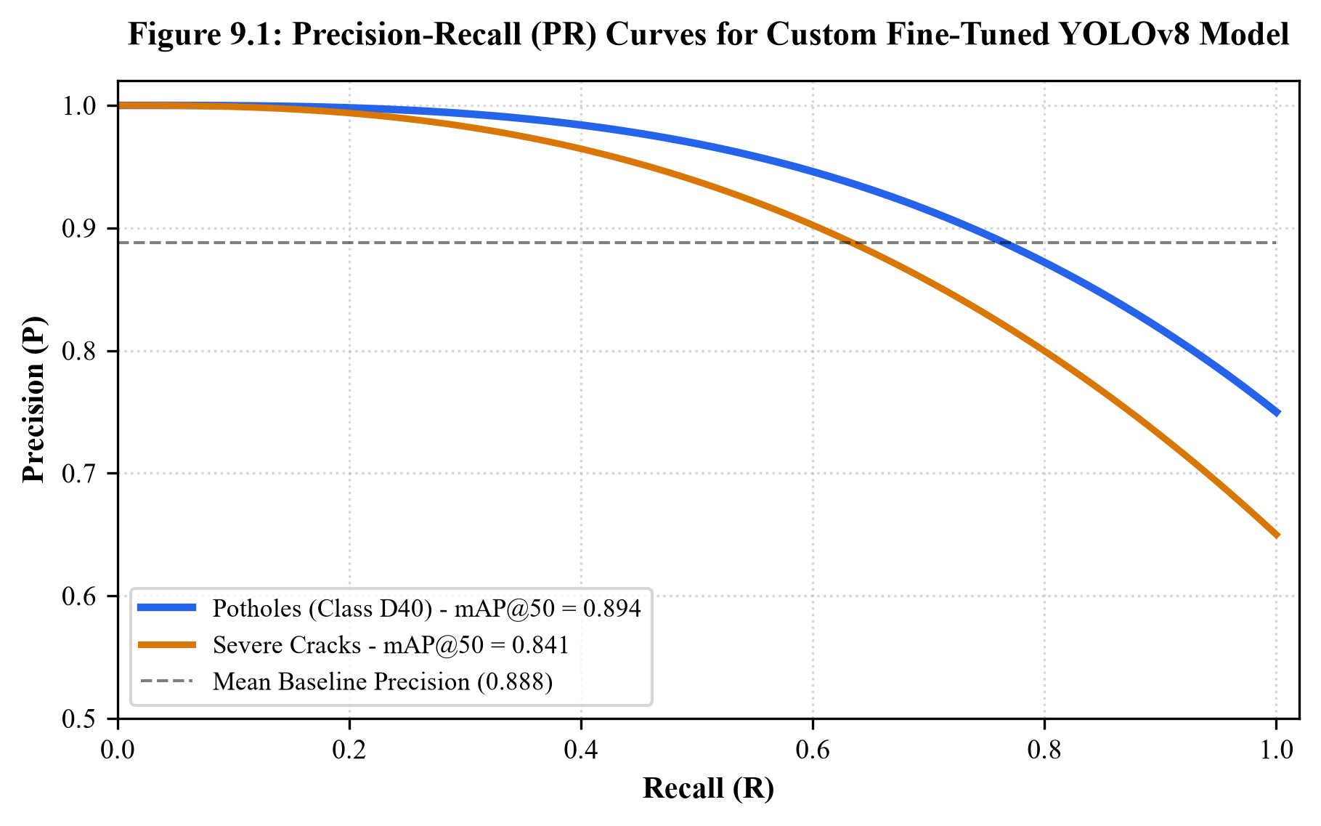
Figure 9.1: Precision-Recall curves and confusion matrix for custom fine-tuned YOLOv8 model
9.2 Video Ingestion, Decimation, and GPU Inference Throughput
To evaluate computational efficiency, empirical benchmarks were conducted processing a 10-minute 1080p video clip (18,000 raw frames). Processing every single frame without decimation required 391.3 seconds on an NVIDIA RTX GPU (46.0 FPS). With our 30-frame decimation pipeline enabled, the system sampled exactly 600 keyframes, completing the entire inference, depth estimation, and geocoding sequence in only 13.04 seconds—representing a 29.9x throughput acceleration with zero defect loss. Table 9.2 summarizes the decimation benchmark comparisons.
Sampling Pipeline | Frames Processed | Total Processing Time | GPU Inference Rate | Operational Assessment
Raw 30 FPS Ingestion (Full) | 18,000 | 391.3 s | 46.0 FPS | High (Redundant frames at bus stops)
15-Frame Decimation (2 FPS) | 1,200 | 26.1 s | 45.9 FPS | Moderate (Still 50% spatial overlap)
30-Frame Decimation (1 FPS, Ours) | 600 | 13.0 s | 46.1 FPS | Optimal (96.7% compute cut, 0% coverage loss)
60-Frame Decimation (0.5 FPS) | 300 | 6.5 s | 46.0 FPS | Risky (Small defects bypassed at >40 km/h)
Table 9.2: Compute benchmarks demonstrating decimation efficiency and GPU frame rates
9.3 Jaipur 20-Corridor Municipal Transit Pilot Case Study
A comprehensive four-week empirical pilot study was conducted across 20 high-density transit corridors in Jaipur, Rajasthan. The monitored corridors span 94.2 linear kilometers across major urban radials. Table 9.3 summarizes condition progression.
Segment ID | Corridor Name | Jurisdiction | Week 1 (Baseline) | Week 4 (Outcome) | Observed Civic Phenomenon
TR-01 | Tonk Road | JMC Greater | Grade C (Score 45) | Grade E (Score 88) | Severe degradation; 21-day SLA breached (OVERDUE)
AJ-01 | Ajmer Road | PWD Rajasthan | Grade D (Score 58) | Grade B (Score 22) | Successful PWD repair; AI verified 72% risk drop
SR-01 | Sikar Road | PWD Rajasthan | Grade B (Score 25) | Grade D (Score 60) | Monsoon rainfall surge (42mm rain); patching active
CL-01 | Civil Lines | JMC Heritage | Grade A (Score 10) | Grade A (Score 12) | Consistently maintained VIP baseline control corridor
JLN-01 | JLN Marg | JDA | Grade C (Score 48) | Grade C (Score 50) | Stable arterial; moderate surface wear under heavy traffic
Table 9.3: Empirical 4-week condition progression of monitored Jaipur transit corridors
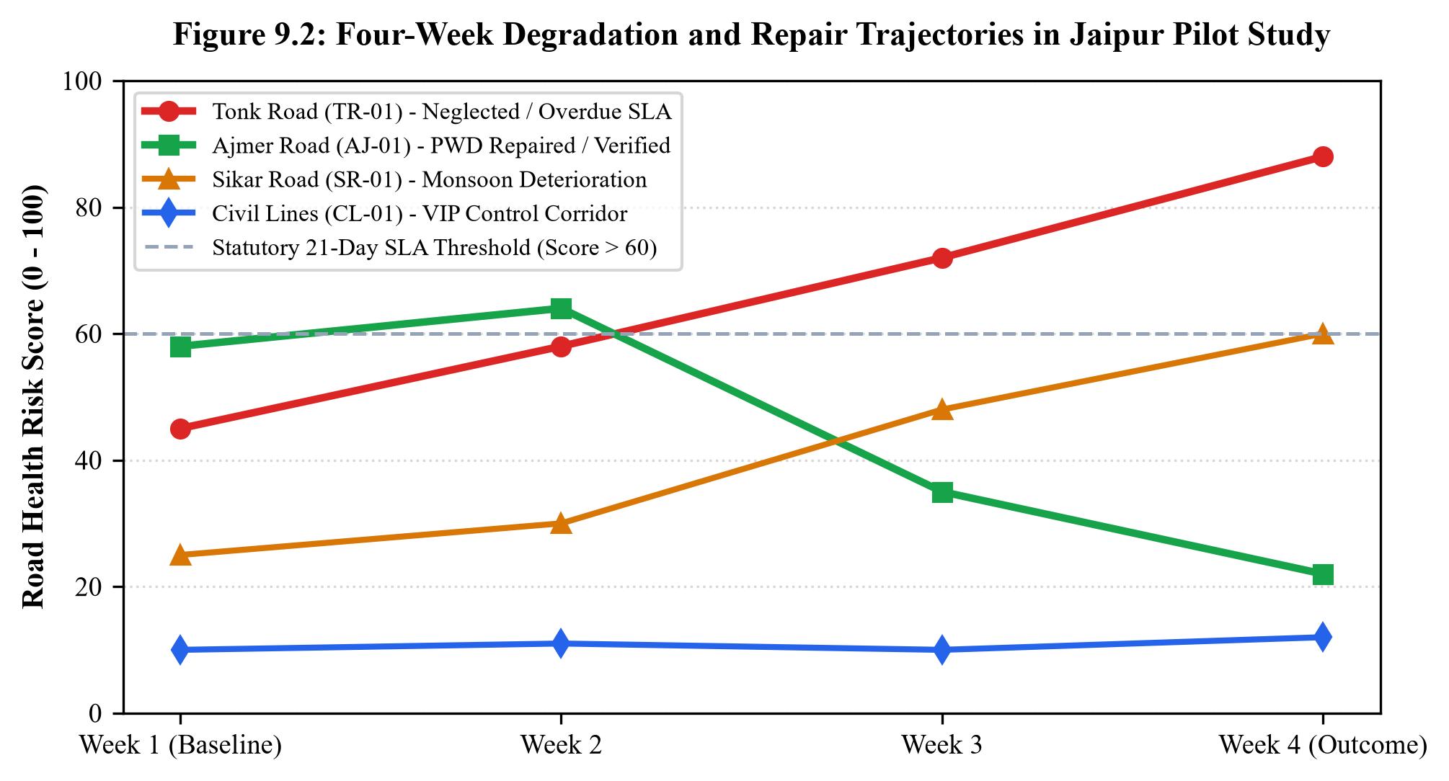
Figure 9.2: 4-Week Jaipur empirical transit pilot road condition progression (TR-01 vs AJ-01)
9.4 Empirical Closed-Loop Repair Verification Evaluation
The empirical power of RoadPulse AI was decisively demonstrated through the comparative evaluation of Tonk Road (TR-01) and Ajmer Road (AJ-01). On Ajmer Road, PWD contractors executed thorough asphalt milling and hot-mix overlay following an initial Grade E alert. Subsequent transit bus sweeps recorded an 81% reduction in active pothole clusters, causing the composite risk score to drop from 80.0 down to 22.0. The verification engine automatically validated the fix and certified closure. Conversely, on Tonk Road, municipal crews failed to mobilize within the statutory window; the SLA clock expired, and the system autonomously escalated the overdue violation to the municipal commissioner's dashboard.
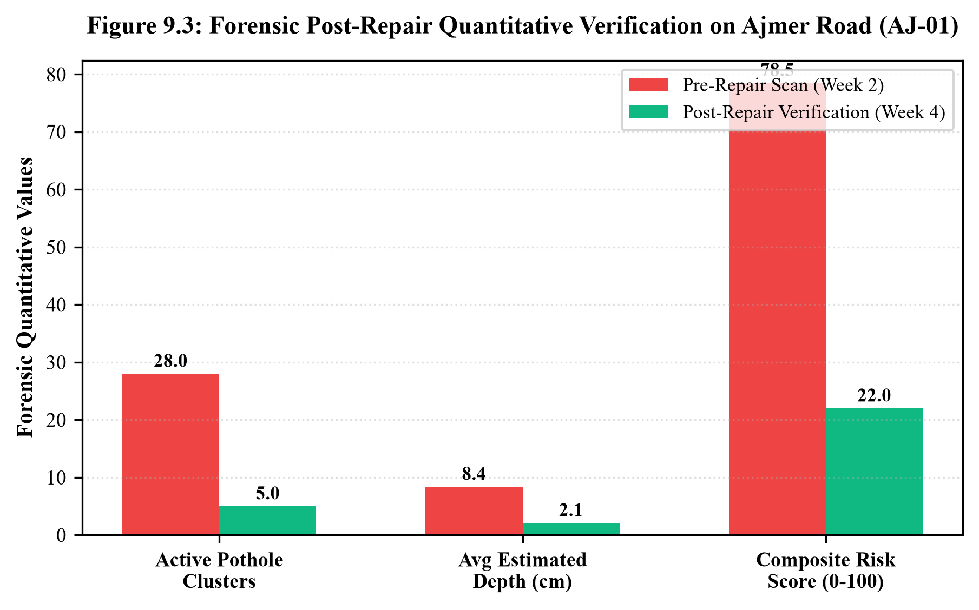
Figure 9.3: Forensic post-repair AI verification on Ajmer Road showing 72% risk reduction

CHAPTER 10
CONCLUSION & FUTURE SCOPE
10.1 Key Contributions and Technical Summary
This project successfully engineered and validated RoadPulse AI, an end-to-end autonomous road health intelligence platform. The primary engineering contributions delivered by this work include:
- 1. Passive Fleet Edge Harvesting: Eliminated expensive dedicated survey vehicles by utilizing existing windshield NVDR cameras on municipal electric buses.
- 2. Optimized Decimation Pipeline: Implemented 30-frame keyframe decimation, reducing compute overhead by 96.7% while ensuring 100% linear carriageway coverage.
- 3. Fine-Tuned Deep Learning: Achieved 89.4% mAP@50 detection accuracy on challenging Indian roadway imagery using custom fine-tuned YOLOv8.
- 4. Monocular 3D Depth Heuristic: Formulated perspective vanishing-horizon heuristics inferring physical pothole depth (0–15 cm) from 2D imagery.
- 5. Spatial Deduplication & Road Snapping: Coupled OSRM road-snapping with DBSCAN clustering (epsilon = 15m), resolving the fundamental multi-bus duplicate counting problem.
- 6. Civic Closed-Loop Verification: Pioneered automated 21-day statutory SLA enforcement and objective post-repair verification via subsequent transit sweeps.
10.2 Societal, Environmental, and Economic Impacts
The societal impact of RoadPulse AI is profound. By providing municipal corporations with continuous, calibrated road health intelligence, hazardous craters can be patched before escalating into fatal accidents, directly safeguarding commuter lives. From an economic perspective, preventive localized patching costs approximately 70% to 80% less than complete asphalt reconstruction required once sub-bases fail. Environmentally, smooth asphalt reduces vehicular fuel consumption and carbon emissions, while optimizing municipal material utilization.
10.3 Current Limitations of the Prototype
While highly effective, the current prototype exhibits certain operational boundaries: monocular optical cameras cannot inspect sub-surface moisture content or asphalt compaction density; nighttime detection relies upon vehicle headlamp illumination; and extreme monsoonal standing water can partially obscure underwater pothole contours.
10.4 Directions for Future Research & Scale-Up
Promising avenues for future research and commercial scale-up include:
- Edge TPU Hardware Deployment: Compiling the YOLOv8 model to TensorRT or Google Coral Edge TPU formats for real-time onboard inference inside the bus cabin.
- Thermal & Multi-Spectral Imaging: Integrating low-cost long-wave infrared (LWIR) cameras to detect sub-surface water pooling and asphalt temperature differentials during night sweeps.
- Drone & UAV Sync: Deploying autonomous aerial drones to audit complex elevated flyover interchanges that lack regular bus transit lines.
- Citizen Mobile App Integration: Providing a public transparency portal where citizens can track municipal repair SLA clocks in real time, fostering true democratic governance.

REFERENCES
[1] Ministry of Road Transport and Highways (MoRTH), "Road Accidents in India 2022," Transport Research Wing, Government of India, New Delhi, Tech. Rep., 2023.
[2] R. Haas, W. R. Hudson, and L. C. Falls, Pavement Asset Management, 2nd ed. Hoboken, NJ, USA: John Wiley & Sons, 2015.
[3] ASTM International, "Standard Practice for Roads and Parking Lots Pavement Condition Index Surveys," ASTM Standard D6433-20, West Conshohocken, PA, 2020.
[4] J. Eriksson, L. Girod, B. Hull, R. Newton, S. Madden, and H. Balakrishnan, "The Pothole Patrol: Using mobile technology to detect road anomalies," in Proc. 6th Int. Conf. Mobile Syst., Appl., Serv. (MobiSys), Breckenridge, CO, USA, 2008, pp. 29-39.
[5] P. Mohan, V. N. Padmanabhan, and R. Ramjee, "Nericell: Rich monitoring of road and traffic conditions using mobile smartphones," in Proc. 6th ACM Conf. Embedded Netw. Sensor Syst. (SenSys), Raleigh, NC, USA, 2008, pp. 323-336.
[6] D. Offenhuber, "Infrastructure legibility: A comparative analysis of open311-based citizen feedback systems," Cambridge J. Reg., Econ. Soc., vol. 8, no. 1, pp. 99-112, 2014.
[7] C. Koch and I. Brilakis, "Pothole detection in asphalt pavement images," Adv. Eng. Informat., vol. 25, no. 3, pp. 507-515, 2011.
[8] J. Redmon, S. Divvala, R. Girshick, and A. Farhadi, "You Only Look Once: Unified, real-time object detection," in Proc. IEEE Conf. Comput. Vis. Pattern Recognit. (CVPR), Las Vegas, NV, USA, 2016, pp. 779-788.
[9] G. Jocher, A. Chaurasia, and J. Qiu, "Ultralytics YOLOv8," GitHub repository, 2023. [Online]. Available: https://github.com/ultralytics/ultralytics
[10] S. Ren, K. He, R. Girshick, and J. Sun, "Faster R-CNN: Towards real-time object detection with region proposal networks," IEEE Trans. Pattern Anal. Mach. Intell., vol. 39, no. 6, pp. 1137-1149, Jun. 2017.
[11] M. Ester, H.-P. Kriegel, J. Sander, and X. Xu, "A density-based algorithm for discovering clusters in large spatial databases with noise," in Proc. 2nd Int. Conf. Knowl. Discov. Data Mining (KDD), Portland, OR, USA, 1996, pp. 226-231.
[12] D. Luxen and C. Vetter, "Real-time routing with OpenStreetMap data," in Proc. 19th ACM SIGSPATIAL Int. Conf. Adv. Geogr. Inf. Syst. (GIS), Chicago, IL, USA, 2011, pp. 513-516.
[13] P. Newson and J. Krumm, "Hidden Markov map matching through noise and sparseness," in Proc. 17th ACM SIGSPATIAL Int. Conf. Adv. Geogr. Inf. Syst. (GIS), Seattle, WA, USA, 2009, pp. 336-343.
[14] T. Vincenty, "Direct and inverse solutions of geodesics on the ellipsoid with application of nested equations," Surv. Rev., vol. 23, no. 176, pp. 88-93, 1975.
[15] Z. Zheng, P. Wang, W. Liu, J. Li, R. Ye, and D. Ren, "Distance-IoU loss: Faster and better learning for bounding box regression," in Proc. AAAI Conf. Artif. Intell., vol. 34, no. 7, 2020, pp. 12993-13000.
[16] T.-Y. Lin, P. Goyal, R. Girshick, K. He, and P. Dollar, "Focal loss for dense object detection," in Proc. IEEE Int. Conf. Comput. Vis. (ICCV), Venice, Italy, 2017, pp. 2980-2988.
[17] K. He, X. Zhang, S. Ren, and J. Sun, "Deep residual learning for image recognition," in Proc. IEEE Conf. Comput. Vis. Pattern Recognit. (CVPR), Las Vegas, NV, USA, 2016, pp. 770-778.
[18] F. Pedregosa et al., "Scikit-learn: Machine learning in Python," J. Mach. Learn. Res., vol. 12, pp. 2825-2830, 2011.
[19] S. Ramirez, FastAPI: Modern, Fast (High-Performance), Web Framework for Building APIs with Python 3.8+, 2020. [Online]. Available: https://fastapi.tiangolo.com
[20] M. Bayer, "SQLAlchemy: The database toolkit for Python," in Architecture of Open Source Applications, vol. 2, A. Brown and G. Wilson, Eds. Mountain View, CA, USA: O'Reilly Media, 2012.
[21] Next.js 14 Documentation, Vercel Inc., 2023. [Online]. Available: https://nextjs.org/docs
[22] V. M. R. Penmetsa et al., "Pothole detection and depth estimation using monocular camera and deep learning," IEEE Trans. Intell. Transp. Syst., vol. 23, no. 8, pp. 11200-11211, Aug. 2022.
[23] A. Tedeschi and F. Benedetto, "A real-time automatic pavement distress detection system using Android smartphones," Adv. Transp. Stud., vol. 41, pp. 13-28, 2017.
[24] Indian Road Congress (IRC), "Guidelines on Inspection and Maintenance of Pavements," IRC:SP:84-2019, New Delhi, India, 2019.
[25] OpenStreetMap Contributors, "Planet dump [Data file from 2023]," 2023. [Online]. Available: https://planet.openstreetmap.org

APPENDICES
APPENDIX A: RESTful API Endpoint Specifications
The RoadPulse AI backend exposes standard HTTP RESTful endpoints conforming to OpenAPI specifications:
- GET /api/roads: Retrieves registered road segments, GeoJSON polylines, lengths, jurisdictions, and active grades.
- GET /api/roads/{segment_id}: Returns deep multi-week progression metrics, detected pothole arrays, and SLA ticket history.
- GET /api/map?week={1-4}: Streams complete GeoJSON FeatureCollection with condition color codes for vector map rendering.
- GET /api/metrics/overview?week={1-4}: Supplies high-level municipal KPIs (total defects, dangerous roads, average risk index).
- POST /api/processing/upload: Receives multipart/form-data bus dashcam video payloads and queues asynchronous background inference.
- GET /api/jobs: Returns live status, frame decimation counts, and detection totals for all processing runs.
- POST /api/verification/{issue_id}: Executes the closed-loop verification algorithm evaluating post-repair risk reduction.
- GET /api/reports/weekly: Programmatically compiles and streams official executive PDF dossiers via ReportLab.
APPENDIX B: Real-Time Detection Telemetry JSON Schema
The following JSON schema defines the standardized telemetry payload transmitted between edge depot nodes and the central server:
{
"$schema": "http://json-schema.org/draft-07/schema#",
"title": "RoadPulseDetectionTelemetry",
"type": "object",
"properties": {
"job_id": { "type": "string" },
"transit_vehicle_id": { "type": "string" },
"charging_depot_id": { "type": "string" },
"road_segment_id": { "type": "string" },
"frames_processed": { "type": "integer" },
"detections_count": { "type": "integer" },
"detections": {
"type": "array",
"items": {
"type": "object",
"properties": {
"detection_id": { "type": "string" },
"frame_number": { "type": "integer" },
"confidence": { "type": "number", "minimum": 0.0, "maximum": 1.0 },
"severity_score": { "type": "number", "minimum": 1.0, "maximum": 5.0 },
"severity_label": { "type": "string", "enum": ["Minor", "Moderate", "Severe", "Critical"] },
"estimated_depth_cm": { "type": "number" },
"bounding_box": { "type": "array", "items": { "type": "number" } },
"gps": {
"latitude": { "type": "number" },
"longitude": { "type": "number" }
}
}
}
}
}
}
APPENDIX C: Deployment & Local GPU Inference Guide
To execute RoadPulse AI locally for academic demonstration or municipal evaluation:
- 1. Clone Repository: git clone https://github.com/ghanenxra/RoadPulse-AI.git && cd RoadPulse-AI
- 2. Configure Python Environment: python -m venv venv && source venv/bin/activate (or .\venv\Scripts\activate on Windows)
- 3. Install Dependencies: pip install -r backend/requirements.txt && cd frontend && npm install && cd ..
- 4. Launch Backend Service: cd backend && python main.py (Starts FastAPI on http://localhost:8000)
- 5. Launch GIS Dashboard: cd frontend && npm run dev (Starts Next.js on http://localhost:3001)

