Project 2: Digital Advertising Budget Optimizer
Extending the Sunscreen Product Sentiment Analysis project: scaling to 10 million records, Pandas vs MapReduce vs Spark, and a budget recommendation engine
Big Data Analytics | Project 2 | 08 November 2026

1. Executive summary
- This project studies a simulated advertising business for a sunscreen brand (10,000,000 records, 5 platforms, 15 campaigns, 2025-11-03 to 2026-11-01), Big Data processing, and a budget recommendation engine.
- Overall performance on the simulated history: spend Rs 12,376,737, revenue Rs 26,058,231, ROAS 2.11, CTR 1.02%, CPC Rs 45, CPA Rs 844, conversion rate 5.4%.
- Pandas, MapReduce and Spark were run on 10K, 100K, 1M and 10M records. All engines returned the same answers (verified).
- For the next Rs 1,000,000 (spent over 4 weeks) the engine recommends Google 46%, Instagram 29%, Facebook 11%, YouTube 9%, TikTok 5%. Predicted revenue is Rs 1,684,338 (ROAS 1.68), 9% above an equal split and 8% above repeating last year's split (model-based estimates).
All advertising data in this report is simulated. The simulation is built so that the true behaviour (diminishing returns, seasonality) is known, which lets the report check that the engine recovers it.

2. Data and simulation design
Each record is one slice of ad delivery with the fields requested in the project brief:
Field | Meaning
date, campaign, platform | When, which of the 15 campaigns, which of Facebook / Instagram / Google / TikTok / YouTube
impressions, clicks | Ads shown, ads clicked
spend, conversions, revenue | Rupees spent, purchases made, rupees earned
age, gender, city, device | Audience segment of the record (8 cities, 3 devices)

The business is the same at every size (about Rs 12,000,000 of spend over 52 weeks). A bigger file is a finer-grained log of that same business, so KPIs and advice are comparable across sizes. Behaviour is built in as follows:
- Each platform has its own cost per 1,000 impressions, click rate, order value and ROAS (table below).
- Diminishing returns: when a campaign spends more in a week, its conversion rate falls, so revenue grows like spend to the power b (b < 1).
- Seasonality: sunscreen converts best in summer (+35% at the June peak, -35% in winter).
- Small, realistic differences by device, gender and age group.
Platform | Cost per 1000 impr. (Rs) | Click rate | Order value (Rs) | Base ROAS | True b | Last year's budget share
Facebook | 420 | 1.1% | 1800 | 2.0 | 0.8 | 28%
Instagram | 520 | 0.9% | 1900 | 2.5 | 0.75 | 22%
Google | 900 | 3.0% | 1800 | 3.6 | 0.7 | 20%
TikTok | 300 | 0.8% | 1500 | 1.3 | 0.9 | 15%
YouTube | 450 | 0.6% | 1700 | 1.8 | 0.85 | 15%

Scale | Records | Parquet files | Size on disk
10K | 10,000 | 1 | 0.2 MB
100K | 100,000 | 1 | 1.0 MB
1M | 1,000,000 | 1 | 6.1 MB
10M | 10,000,000 | 10 | 48.6 MB

3. Campaign performance metrics
Metric | Formula | Meaning
CTR | clicks / impressions | How often people click
CPC | spend / clicks | Rs per click
CPA | spend / conversions | Rs per purchase
Conversion rate | conversions / clicks | Clicks that become purchases
ROAS | revenue / spend | Rs earned per Rs 1 spent
Revenue / profit | sum of revenue; revenue - spend | Before product costs

KPIs are always computed from summed counts, never by averaging per-record ratios, which would be wrong for ratios. Results on 10,000,000 records:
Platform | Spend (Rs) | Revenue (Rs) | CTR | CPC | CPA | Conv. rate | ROAS
Google | 2,373,527 | 7,828,723 | 2.79% | 32.2 | 544 | 5.9% | 3.30
Instagram | 2,847,021 | 6,604,407 | 0.83% | 62.6 | 821 | 7.6% | 2.32
Facebook | 3,494,095 | 6,392,487 | 1.02% | 41.1 | 983 | 4.2% | 1.83
YouTube | 1,781,955 | 2,991,654 | 0.56% | 80.7 | 1,002 | 8.1% | 1.68
TikTok | 1,880,138 | 2,240,960 | 0.74% | 40.4 | 1,253 | 3.2% | 1.19

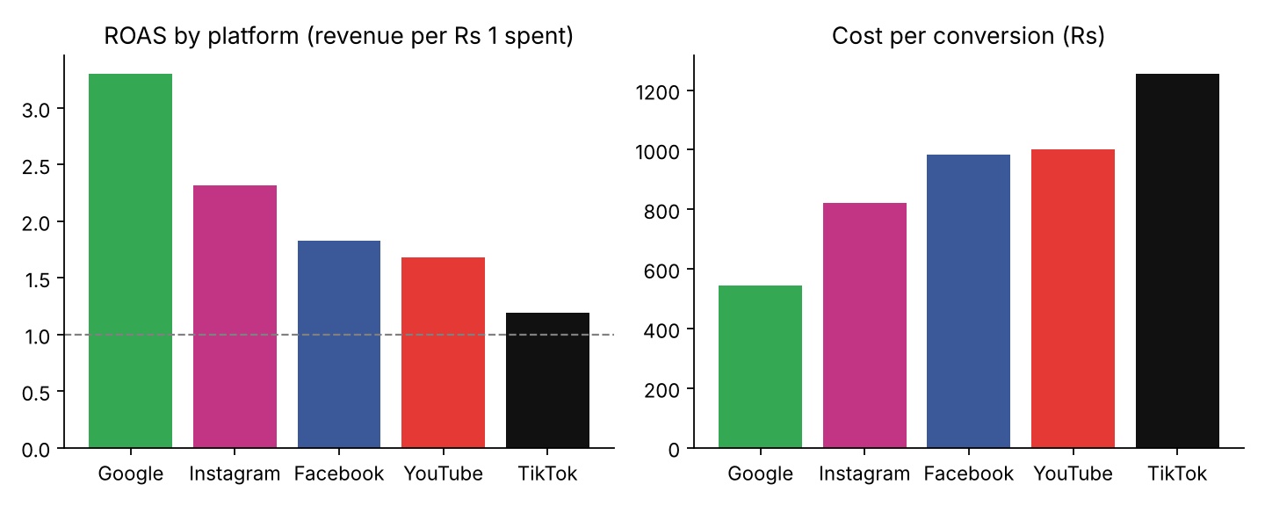
Figure 1: ROAS and cost per conversion by platform
Campaign verdicts use ROAS bands: 3.0 and above = Scale up, 2.0 to 3.0 = Maintain, 1.0 to 2.0 = Optimise, below 1.0 = Cut / rework.
Campaign | Spend (Rs) | ROAS | CPA | Verdict
Google | SPF50 Summer Launch | 750,318 | 3.58 | 508 | Scale up
Google | Oily Skin Gel | 809,277 | 3.20 | 553 | Scale up
Google | No White Cast Stick | 813,933 | 3.13 | 572 | Scale up
Instagram | Oily Skin Gel | 925,908 | 2.51 | 764 | Maintain
Instagram | No White Cast Stick | 930,080 | 2.27 | 838 | Maintain
Instagram | SPF50 Summer Launch | 991,033 | 2.19 | 866 | Maintain
Facebook | Oily Skin Gel | 1,019,211 | 1.92 | 946 | Optimise
Facebook | No White Cast Stick | 1,185,449 | 1.87 | 965 | Optimise
Facebook | SPF50 Summer Launch | 1,289,434 | 1.72 | 1,032 | Optimise
YouTube | SPF50 Summer Launch | 512,404 | 1.71 | 965 | Optimise
YouTube | No White Cast Stick | 619,783 | 1.71 | 992 | Optimise
YouTube | Oily Skin Gel | 649,769 | 1.63 | 1,043 | Optimise
TikTok | SPF50 Summer Launch | 629,195 | 1.20 | 1,227 | Optimise
TikTok | No White Cast Stick | 595,565 | 1.19 | 1,243 | Optimise
TikTok | Oily Skin Gel | 655,378 | 1.19 | 1,290 | Optimise

Best and worst device: desktop (ROAS 2.18) and tablet (ROAS 1.81).
Best and worst age group: 25-34 (ROAS 2.66) and 45-64 (ROAS 1.54).

4. Big Data benchmark: Pandas vs MapReduce vs Spark
Two jobs were run on each engine so the answers can be compared:
- Job A (advertising): sum impressions, clicks, spend, conversions and revenue for every platform and campaign. Every KPI follows from these sums.
- Job B (sentiment): classify every sunscreen comment with a TF-IDF and Logistic Regression model (clean text, TF-IDF, Logistic Regression) and count the labels.
- Pandas: load into memory and use vectorised operations on one process.
- MapReduce: the classic model written in plain Python. Map tasks (one per file block) handle one record at a time and combine locally, a shuffle groups results by key, reducers add the partial sums. Runs on all CPU cores with multiprocessing. It illustrates the programming model; it is not Hadoop.
- Spark: PySpark in local mode on the same cores, with the work expressed as DataFrame operations and planned by Spark.
Machine: 2 CPU cores, Python 3.13.18, pandas 3.0.5, PySpark 4.3.0. Times are seconds from reading the files to the final table (median of 3 runs for 10K and 100K, one run for larger sizes). Spark session start-up (7.72 s) is reported separately, and a warm-up job ran before timing.
Job A: advertising KPIs (seconds)
Records | Pandas | MapReduce | Spark | Same answer
10K (10,000) | 0.02 | 0.05 | 0.51 | yes
100K (100,000) | 0.04 | 0.58 | 0.37 | yes
1M (1,000,000) | 0.12 | 4.35 | 0.81 | yes
10M (10,000,000) | 1.42 | 22.92 | 3.01 | yes

Job B: sentiment classification (seconds)
Records | Pandas | MapReduce | Spark | Same answer
10K (10,000) | 0.84 | 0.65 | 1.16 | yes
100K (100,000) | 5.37 | 4.39 | 5.93 | yes
1M (1,000,000) | 59.42 | 43.41 | 39.11 | yes

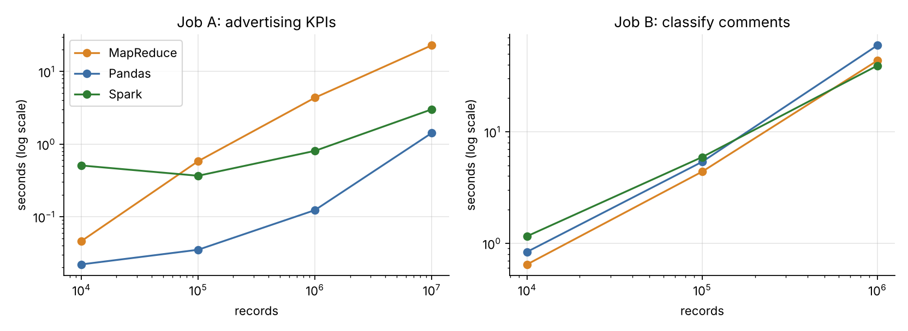
Figure 2: run time against number of records (both axes logarithmic)

What the measurements show
- Job A (advertising KPIs), fastest engine per size: 10K: Pandas (0.02 s); 100K: Pandas (0.04 s); 1M: Pandas (0.12 s); 10M: Pandas (1.42 s).
- At the largest size for Job A (advertising KPIs) (10,000,000 records): Pandas 1.42 s, MapReduce 22.92 s, Spark 3.01 s.
- Job B (sentiment classification), fastest engine per size: 10K: MapReduce (0.65 s); 100K: MapReduce (4.39 s); 1M: Spark (39.11 s).
- At the largest size for Job B (sentiment classification) (1,000,000 records): Pandas 59.42 s, MapReduce 43.41 s, Spark 39.11 s.
Job B stops at 1M records by default because cleaning and scoring text costs tens of microseconds per comment; `python -m adbudget.benchmark --nlp-max 10M` lifts the limit.

How to read this
- Pandas has almost no start-up cost and is very fast for column sums, so it wins at small sizes and often much further than people expect, as long as the data fits in memory. Its limit is memory and a single process, not speed on small data.
- Spark pays a fixed cost (JVM, planning, scheduling), which is why it is slow on small data. It becomes attractive when data no longer fits on one machine, or when the work is CPU-heavy per record and can be spread over many machines. Here all engines share the same few cores, so this test shows start-up and per-record overhead, not the cluster scaling that is Spark's main purpose.
- Record-by-record MapReduce in Python is the slowest for simple sums because each record passes through the interpreter, but it parallelises naturally and teaches the shuffle and reduce ideas that Hadoop and Spark are built on.
- For the CPU-heavy sentiment job the picture changes: at 1,000,000 comments the engines that use every core finish about 1.5 times faster than single-process Pandas, because almost all the time goes into cleaning text and TF-IDF (real computation per record), which parallelises well, instead of into moving data.
- A fast answer is only useful if it is right: every engine's output was compared with Pandas (integers exactly, money to 1e-9).

5. Sentiment model at scale
No Phase 1 model was found when the benchmark ran, so a demo model with the same design (TF-IDF words and word pairs into Logistic Regression) was trained on synthetic sunscreen comments (test accuracy 97.3%, macro-F1 0.97). These timings measure computing cost only; the accuracy of a classifier trained on real comments is reported in the Sunscreen Sentiment Analysis project. Set the SENTIMENT_MODEL environment variable to a trained model file and rerun to score with your own model.
The largest sentiment run classified 1,000,000 comments.

6. Marketing Budget Recommendation Engine
Question from management: where should the next Rs 1,000,000 be spent? Method:
- Learn a response curve for each platform from weekly history: weekly revenue = A x (weekly spend)^b, fitted on a log scale with a yearly seasonal term.
- Choose the split that maximises predicted total revenue. At the optimum one more rupee earns the same on every platform (equal marginal ROAS), except where a platform sits at its limits: at least 5% and at most 50% of the budget, and no more than 125% of the highest weekly spend ever seen on that platform (the curve is not trusted beyond what it has seen).
- Spend is spread evenly over 4 weeks starting 2026-11-02, so the seasonal effect of those weeks is included.
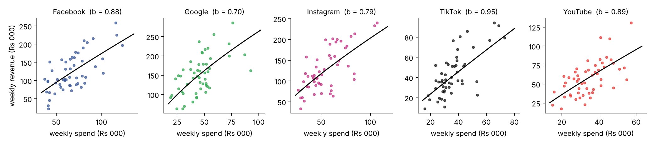
Figure 3: weekly spend against weekly revenue with the fitted curve
Curves are fitted on campaign-weeks (about 150 per platform), which vary spend far more than 52 weekly totals and so pin down b much better; a platform's curve then assumes its campaigns share its spend equally. The curves in Figure 3 are drawn on platform-week totals.
Platform | Fitted b | b used by optimiser | True b (simulation) | R-squared (log) | Weekly spend seen (Rs)
Facebook | 0.88 | 0.88 | 0.8 | 0.72 | 37,382 to 123,149
Google | 0.70 | 0.70 | 0.7 | 0.79 | 19,027 to 92,402
Instagram | 0.79 | 0.79 | 0.75 | 0.76 | 26,673 to 106,940
TikTok | 1.12 | 0.95 | 0.9 | 0.64 | 16,073 to 73,009
YouTube | 0.89 | 0.89 | 0.85 | 0.58 | 15,022 to 57,322

Because the data is simulated, the true exponent is known. The fitted values rank the platforms correctly and sit within about 0.05 to 0.1 of the truth (slightly too high: noise in the data biases b toward 1, so the engine is a little too optimistic about extra spend). The b is kept between 0.2 and 0.95 when optimising (and the curve refitted with b fixed), so a platform whose fit shows no diminishing returns, like TikTok here, is not allowed to absorb the whole budget.

Recommendation
Platform | Share | Spend (Rs) | Predicted revenue (Rs) | Predicted ROAS | Marginal ROAS | Last year's share | Note
Google | 46.2% | 462,000 | 883,569 | 1.91 | 1.35 | 19.2% | at history cap
Instagram | 29.0% | 290,000 | 468,880 | 1.62 | 1.28 | 23.0%
Facebook | 11.2% | 112,000 | 162,625 | 1.45 | 1.28 | 28.2%
YouTube | 8.6% | 86,000 | 123,967 | 1.44 | 1.28 | 14.4%
TikTok | 5.0% | 50,000 | 45,297 | 0.91 | 0.86 | 15.2% | at min share

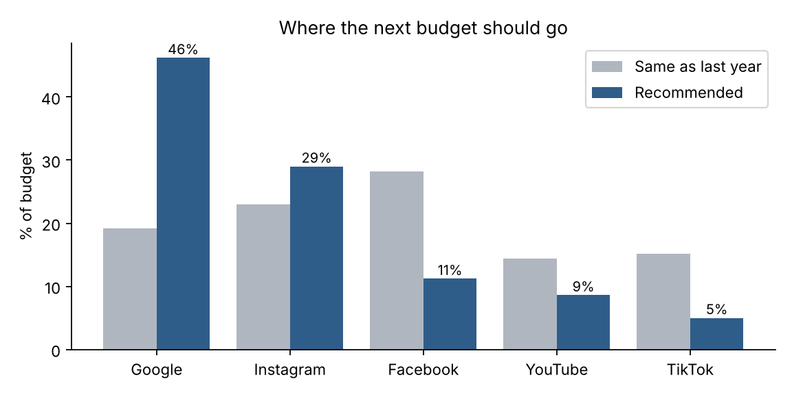
Figure 4: recommended split against last year's split
Marginal ROAS below 1.00 for TikTok means the next rupee there earns back less than a rupee even at the minimum share. The minimum is a business rule (keep a presence on every channel); the engine would cut further without it.
Predicted outcome of the plans (model-based estimates, not observed results):
Plan | Predicted revenue (Rs) | ROAS | Facebook | Instagram | Google | TikTok | YouTube
Recommended | 1,684,338 | 1.68 | 11% | 29% | 46% | 5% | 9%
Equal split | 1,541,542 | 1.54 | 20% | 20% | 20% | 20% | 20%
Same as last year | 1,559,161 | 1.56 | 28% | 23% | 19% | 15% | 14%

How far to trust it
- Held-out test: curves fitted without the last 10 weeks predicted those weeks' revenue with a mean absolute error of 17.4% per platform-week and -13.2% on total revenue.
- Bootstrap (200 refits on resampled weeks), range of the recommended share: Google 35-46%, Instagram 18-43%, Facebook 5-24%, TikTok 5-5%, YouTube 5-24%.
- A negative error means the model under-predicted the held-out weeks. Those weeks are autumn, which the first weeks of the one-year history (November to August) do not contain, so the seasonal term had to extrapolate; more years of data would help.
- Platforms planned outside their historical weekly spend range: Google, Facebook, TikTok. Treat those as extrapolation and increase them in steps, re-measuring each time.
Does the advice depend on dataset size? Recommended share (%) when the engine learns from each size:
Records | Facebook | Instagram | Google | TikTok | YouTube
10,000 | 8.9 | 41.3 | 39.8 | 5.0 | 5.0
100,000 | 13.1 | 25.1 | 46.5 | 5.0 | 10.3
1,000,000 | 16.8 | 25.2 | 46.4 | 5.0 | 6.6
10,000,000 | 11.2 | 29.0 | 46.2 | 5.0 | 8.6

Small samples are noisy (few conversions per campaign-week). Compare the rows to see how far the advice moves as the data grows; the more stable the shares, the more the decision can be trusted.

7. Dashboard and how to run
- `pip install -r requirements.txt` (Java 17 or newer is needed for Spark).
- `python -m adbudget.run_all --quick` (about a minute) or `python -m adbudget.run_all` (all sizes up to 10 million).
- `streamlit run app.py`: change the budget, weeks, limits and start date and see the allocation update; view campaign performance, the benchmark and the scale check.
- `python -m adbudget.budget_recommender --budget 1000000 --weeks 4` gives the recommendation on the command line.

8. Limitations and future work
- The advertising data is simulated. Real campaigns have attribution delays, overlapping audiences and creative fatigue that this model ignores.
- Response curves are simple power laws per platform. Interactions between platforms (a YouTube view followed by a Google search) are not modelled.
- The benchmark uses one machine; MapReduce is an in-process illustration and Spark runs locally. Cluster behaviour (network shuffle, node failure) is not measured.
- Predicted uplift compares plans inside the fitted model; it should be validated with a controlled budget test before a full rollout.
- Future work: link sentiment to advertising (for example, feature the most-praised product aspects found by sentiment analysis in ad copy), use real campaign exports, and add a Bayesian model that reports uncertainty directly.

