DATAFLOW
Student Fee Management System (SFMS)
Milestone 3 — Dataflow Description

Overview
This document describes how data enters, moves through, and exits the SFMS database. Each stage maps directly to specific tables and operations in the schema.

Data Entry Points

1. Administrative Setup (One-Time / Periodic)
department table is populated first, as it is the root of all other data. An administrator inserts department records (e.g., Computer Science, Software Engineering) before any student can be enrolled. This table changes rarely — only when a new program is added.
fee_structure table is populated each academic year by the accounts office. Before a semester begins, the fee amount, due date, and academic year for each (department, semester) combination is entered. This provides the reference figures used later to calculate outstanding dues.

2. Student Enrollment
student table receives data when a new student is admitted. The registrar's office enters the student's roll number, name, contact details, department (FK → department.dept_id), and current semester. Student records are also updated (via UPDATE) when a student advances to the next semester or changes status.
Data dependency: A student record cannot be inserted unless a valid dept_id exists in the department table. The FK constraint fk_student_dept enforces this.

3. Fee Payment Processing
payment table receives a new row every time a student makes a payment — whether full or in installments. The cashier or online portal records the student ID (FK → student.student_id), the amount paid, payment method, and a reference number (for non-cash payments). Multiple payment rows per student are allowed to support installment-based fee collection.
Data dependency: A payment cannot be recorded without a valid student in the student table.

4. Automatic Receipt Generation
receipt table is populated automatically via a database trigger (trg_after_payment_insert). Every time a row is inserted into payment, the trigger fires and creates a corresponding receipt record with a unique receipt number (format: RCP-YYYYMMDD-NNNNN). No manual entry is needed for receipts.
Data dependency: Each receipt row is linked to exactly one payment via payment_id (FK → payment.payment_id).

Data Flow Diagram
The diagram below illustrates the sequential flow of data within the SFMS, from administrative setup through to automated receipt generation and reporting.
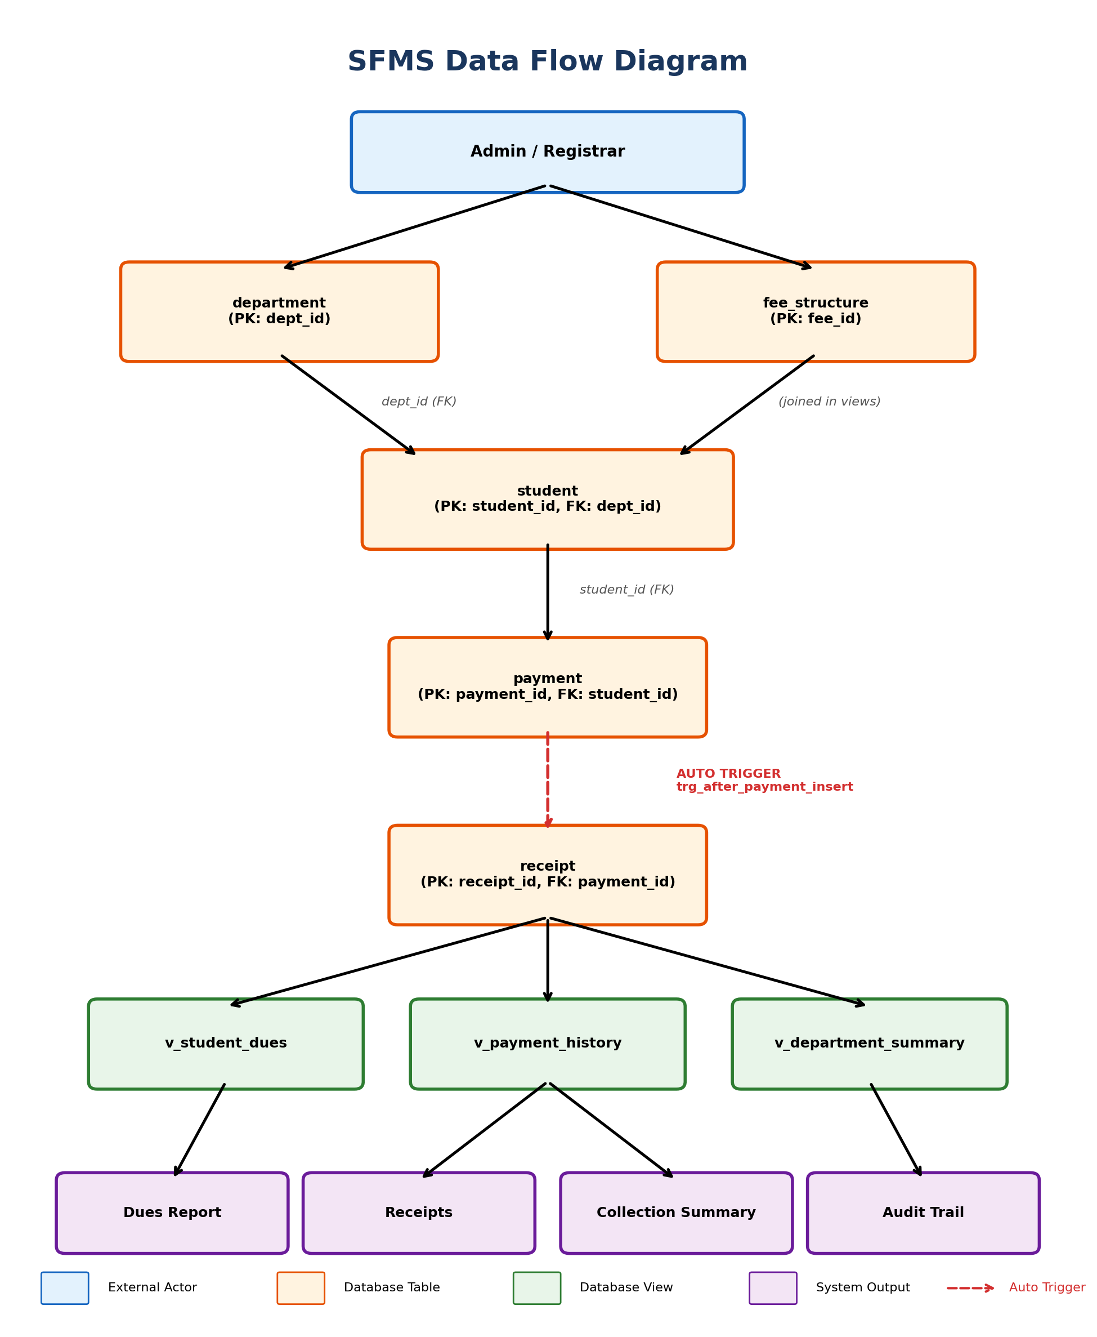

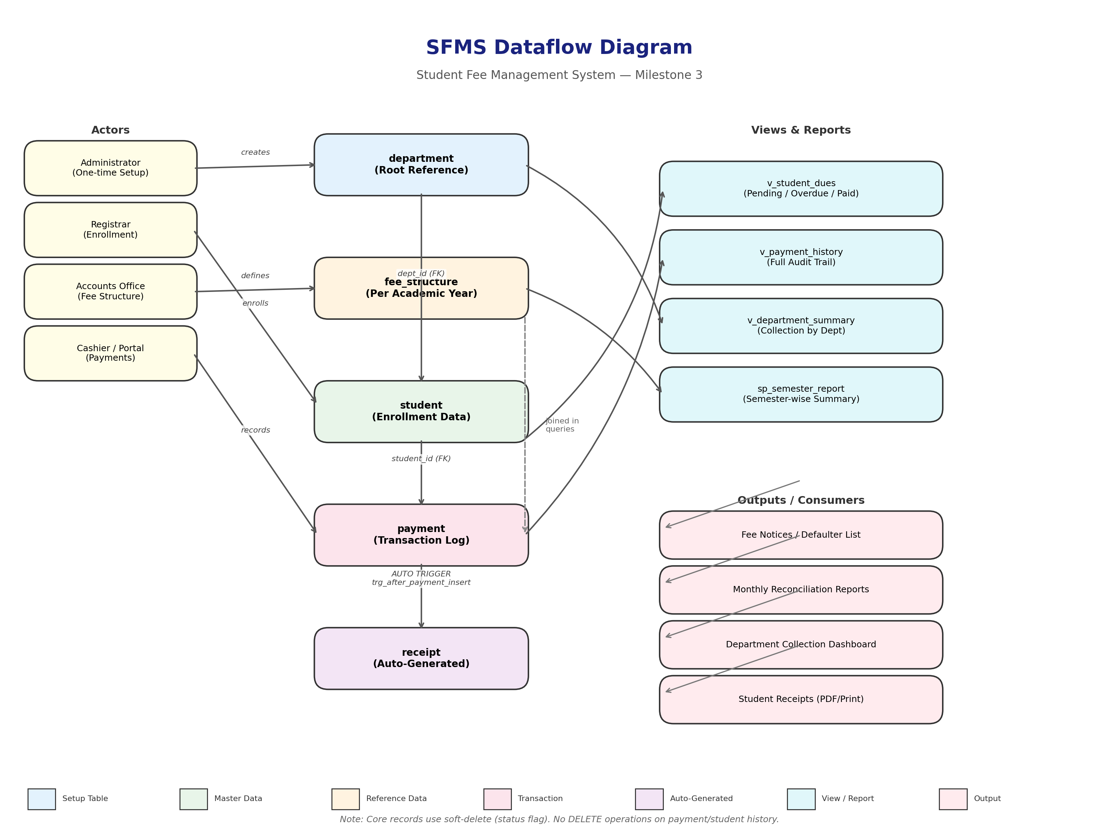

Flow Narrative
The system flow begins when an administrator creates department records, establishing the master reference data. The accounts office then configures fee structures per department and semester. The registrar enrolls students, linking each to a department. When a student pays fees, the cashier records the transaction in the payment table. Upon insert, the database trigger automatically generates a receipt in the receipt table. Finally, views aggregate data across all tables to produce dues reports, payment histories, and department summaries.

Data Movement Through Views and Queries

v_student_dues (View)
Joins student, department, fee_structure, and payment to compute:
- • Total fee owed per student (from fee_structure)
- • Total amount paid (SUM from payment)
- • Pending dues = total_fee − total_paid
- • Payment status: Paid, Overdue, or Pending
This view is queried by the fee collection office to identify defaulters and generate fee notices.

v_payment_history (View)
Joins payment, student, department, and receipt to produce a full audit trail of every transaction. Used for monthly reconciliation reports.

v_department_summary (View)
Aggregates collections per department. Used by the accounts department to monitor overall collection rates.

sp_semester_report (Stored Procedure)
Generates a parameterized semester-wise fee report. Used by academic administration.

Data Outputs
Output | Source | Consumer
Student dues report | v_student_dues | Fee collection office
Payment receipts | receipt + payment + student | Students
Department collection summary | v_department_summary | Accounts department
Semester-wise fee report | sp_semester_report (stored procedure) | Academic administration
Defaulter list | v_student_dues WHERE status = 'Overdue' | Registrar's office

Data Lifecycle
1. Insert: Departments → Students → Fee Structures → Payments (→ Receipts auto-generated)
2. Update: Student semester/status updated each semester; fee structure updated per academic year
3. Delete: Not performed on core records; student status is set to 'Inactive' or 'Graduated' instead of deletion (soft delete pattern), preserving payment history integrity

