# Identity

VIRAL – asal katanya dari VIRUS. VIRAL itu artinya menular/ menyebar.

We are the cause of application trends

Menggambarkan warna dari sifat nama itu sendiri which is virus dan warna yg umumnya menggambarkan itu warna” yg alienish, ex: neon green, purple space,  
GETLOST -

# Inspiration

## Color

* Neon green
* Ambient
* Alien
* Space

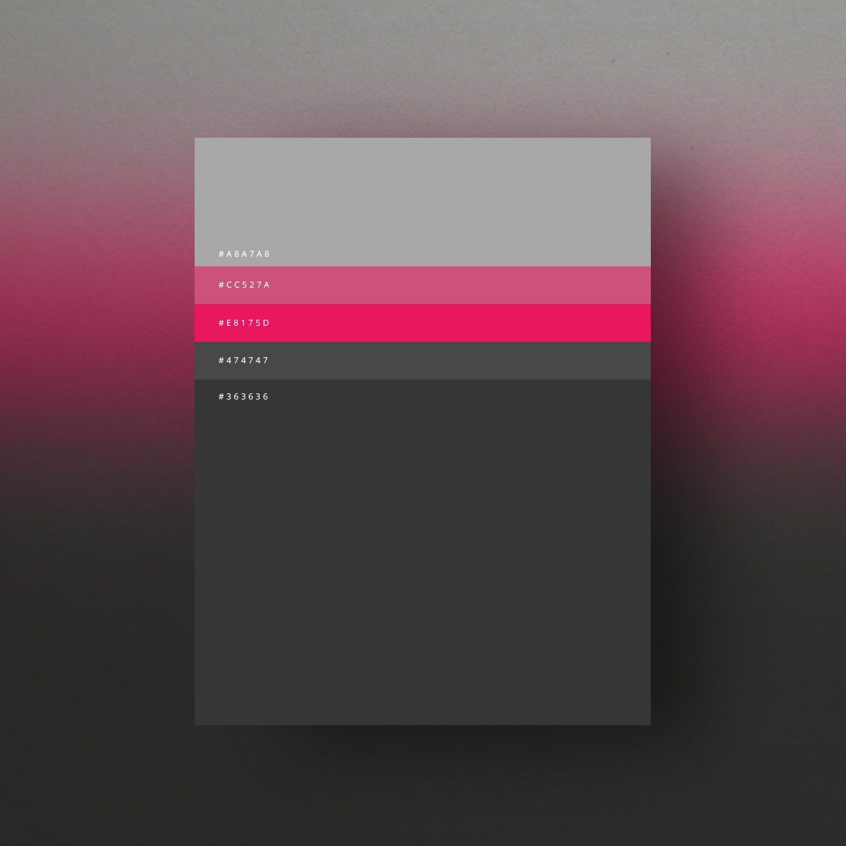

## Logo

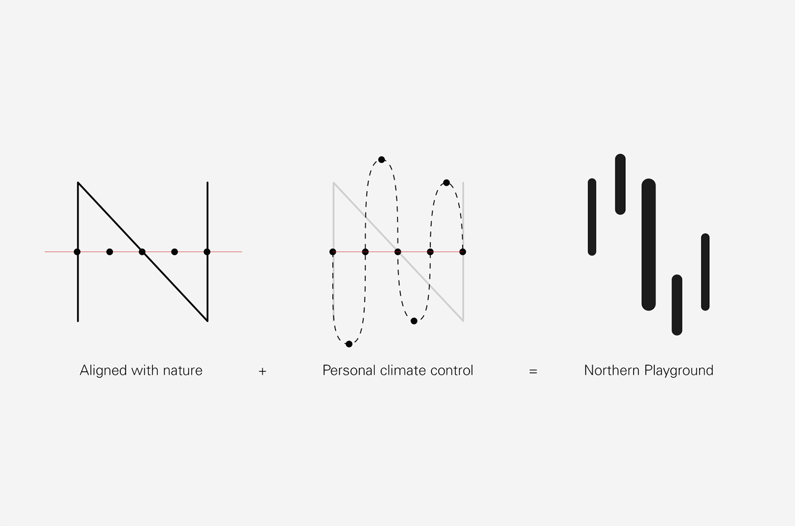

The logo resembles the temperature scale, which reflects the concept – Personal Climate Control. The curves in the symbol makes a graph that goes from cold to warm, uphill and downhill.

<https://www.behance.net/gallery/29229575/Making-Content-Beautiful>

<https://www.behance.net/gallery/35149679/KICHINK-(REBRAND)>

https://www.behance.net/gallery/28551261/INDIE-EXPRESS-

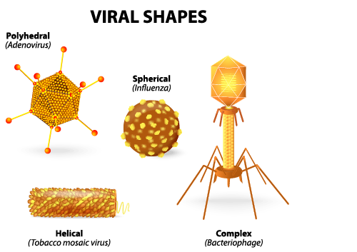

VIRAL LOGO:

V + @ = LOGO

V: VIRAL

@: SESUATU YANG MENGGAMBARKAN IDENTITAS VIRAL

@: MASCOT VIRUS YANG KAYA ROKET, SUKA NEMPLOK

