MyRecs: Personal Content Recommender

Abstract
**MyRecs** is a personal content recommender system that suggests movies, television series, books, YouTube-style videos, and songs aligned with a single user’s expressed taste. The project implements three complementary approaches: **content-based filtering** using TF–IDF and cosine similarity over genre tags and short reviews; **collaborative filtering** via biased matrix factorization (stochastic gradient descent, analogous to Funk SVD) augmented with synthetic “community” users to enable learning from a lone user’s rating history; and **semantic retrieval** using **Sentence-Transformers** (`all-MiniLM-L6-v2`) over concatenated titles, genres, and reviews.
A synthetic dataset of **150 rated items** is generated in code with varied ratings (1–10) and natural-language reviews. Offline evaluation uses a **stratified train/test split** (approximately 20% held out); **Precision@5**, **Recall@5**, and **mean rating of the top-10** ranked held-out items are reported for each method. A **Streamlit** web application presents “Recommendations for Haseeb” with tabbed views and short textual explanations. A **standalone Jupyter notebook** (`recommender_notebook.ipynb`) reproduces the full pipeline on **Google Colab** with a single file upload—no external project folder or zip archive required.
**Keywords:** recommender systems, content-based filtering, matrix factorization, sentence embeddings, TF–IDF, Streamlit, personalisation.
**Executive summary (one minute):** MyRecs reads your personal ratings file (movies, shows, books, videos, songs), builds three different recommendation models—word-based (TF–IDF), collaborative-style matrix factorisation, and neural sentence embeddings—and scores how well each method ranks held-out items you liked. You get numbers (Precision/Recall) and charts, plus an optional Streamlit app that lists “top picks for you” with short explanations.

Table of Contents
- [Introduction](#1-introduction)
- [Objectives and Scope](#2-objectives-and-scope)
- [System Overview](#3-system-overview)
- [Dataset](#4-dataset)
- [Methodology](#5-methodology)
- [Evaluation Metrics](#6-evaluation-metrics)
- [Implementation](#7-implementation)
- [User Interfaces](#8-user-interfaces)
- [Experimental Results](#9-experimental-results)
- [Discussion](#10-discussion)
- [Limitations](#11-limitations)
- [Future Work](#12-future-work)
- [Conclusion](#13-conclusion)
- [References](#14-references)
- [Appendices](#15-appendices)
- [Notebook Output Figures](#16-notebook-output-figures)
- [Optional: Streamlit Screenshots](#17-optional-streamlit-screenshots)

1. Introduction
Recommender systems help users discover items that match their preferences when catalogues are large. **Collaborative filtering** exploits patterns across users and items; **content-based** methods use item descriptions and user history without relying on other users; **embedding-based** methods capture semantics of text for similarity beyond bag-of-words overlap.
**MyRecs** targets a **single-user** scenario: one CSV file holds all ratings and reviews. That design reflects a personal library or journal rather than a multi-user platform. Because classical collaborative filtering needs overlapping users, the system **synthesises additional users** who rate subsets of items with noisy scores derived from global statistics—an established way to stabilise factorisation in demonstration and cold-start settings.

2. Objectives and Scope
**Primary objectives**
- Recommend diverse content types (movies, series, books, YouTube-like entries, songs) from one unified table.
- Combine content-based, collaborative, and embedding-based signals.
- Quantify performance with **Precision@k**, **Recall@k**, and **average true rating of top-N** recommendations on held-out items.
- Provide an interactive **Streamlit** dashboard and a **Colab-ready** notebook for teaching and demos.
**Scope**
- Ratings are **explicit** (1–10).
- The default dataset is **synthetic** but structurally realistic; the same pipelines apply to real CSV data.
- Deployment is **local** (Streamlit) or **cloud notebook** (Colab); production scaling (databases, APIs) is out of scope.

3. System Overview
The system has three logical layers:
- **Data layer:** `my_ratings.csv` with columns `item_id`, `title`, `categories` (comma-separated tags), `my_rating`, `short_review`.
- **Model layer:** Three recommenders score or rank items; `train.py` evaluates them and persists `model/metrics.json` and `model/svd_model.pkl`.
- **Presentation layer:** `app.py` (Streamlit) loads ratings, caches TF–IDF ranks, embedding ranks, and the trained matrix factorisation model.
┌─────────────┐ ┌──────────────────┐ ┌─────────────────┐
│ my_ratings │────▶│ Recommenders │────▶│ Top-10 + scores │
│ .csv │ │ TF-IDF / MF / ST │ │ + explanations │
└─────────────┘ └──────────────────┘ └─────────────────┘
**Sentence-Transformers** runs on **GPU when available** (CUDA via PyTorch); otherwise CPU.

4. Dataset
**Source:** Generated programmatically (`src/data_preparation.py` or the standalone notebook) with fixed random seeds for reproducibility.
**Size:** 150 items.
**Composition (approximate):** movies, series, books, YouTube-style entries, and songs—each row tagged with a primary type inside `categories`.
**Fields**
Column | Description
`item_id` | Integer identifier.
`title` | Synthetic title appropriate to type.
`categories` | Comma-separated genres/tags (e.g. `movie,sci-fi,mystery,slow-burn`).
`my_rating` | Integer 1–10; distribution skewed toward mid–high ratings with a tail of low ratings.
`short_review` | One-sentence style personal comment in English.

**Train/test split for evaluation:** Approximately **80% / 20%**, stratified by rating buckets (low / mid / high) so both splits contain variety. **Relevant** items in the test set for ranking metrics are those with **true rating ≥ 7** (configurable threshold in code).

5. Methodology

5.1 Content-Based Filtering (TF–IDF)
- **Text field:** Concatenation of `categories` and `short_review`.
- **Vectorisation:** `TfidfVectorizer` with unigrams and bigrams, English stop words removed, up to 5000 features (implementation detail may vary slightly between `src` and notebook).
- **User profile:** Weighted average of TF–IDF vectors for training items; weights are proportional to `max(rating − 4, 0.1)` so very low ratings contribute little.
- **Scoring:** Cosine similarity between each candidate document vector and the profile vector.
- **Ranking:** For evaluation, only **held-out** items are ranked; for the dashboard, the full catalogue can be ranked by similarity to the global profile.

5.2 Collaborative Filtering (Biased Matrix Factorisation)
- **Model:** Biased MF: predicted rating \(\hat{r}_{ui} = \mu + b_u + b_i + \mathbf{p}_u^\top \mathbf{q}_i\), trained with **SGD** on squared error with L2 regularisation.
- **Real user:** User ID `0` with all observed ratings from the training split.
- **Synthetic users:** Dozens of additional users rate random subsets of items; ratings are noisy draws around item-level means to simulate a sparse community matrix.
- **Cold items in test:** Items appear in the training graph via synthetic ratings so factors exist for evaluation items.
- **Output:** Predicted ratings in \([1,10]\); candidates sorted by predicted score.

5.3 Embedding-Based Recommender (Sentence-Transformers)
- **Model:** `sentence-transformers/all-MiniLM-L6-v2` (384-dimensional embeddings; normalised).
- **Input text per item:** `title`, `categories`, and `short_review` combined in one string.
- **Profile:** Weighted average of training embeddings (same weighting scheme as TF–IDF profile).
- **Scoring:** Cosine similarity between candidate embeddings and the profile vector (embeddings are L2-normalised by the encoder).

5.4 Explanations (Streamlit)
Explanations are **template-based** and reference: TF–IDF similarity score and favourite genres; predicted rating and training maximum for MF; embedding similarity and titles of top-rated items for the semantic model.

6. Evaluation Metrics
All metrics below are computed on **held-out test items** only, ranked by each method.
Metric | Definition (single user, one list)
**Precision@5** | Of the top 5 recommended test items, the fraction that belong to the **relevant** set (rating ≥ threshold on test).
**Recall@5** | Of all relevant test items, the fraction captured inside the top 5.
**Avg. rating top-10** | Mean of **true** `my_rating` values for the test items that appear in positions 1–10 of that method’s ranking (measures alignment with actual taste among top positions).

**Note:** Absolute values depend on the random split and synthetic data; they should be interpreted comparatively across methods rather than as industry benchmarks.

7. Implementation
**Language:** Python 3.10+
**Core libraries:** `pandas`, `numpy`, `scikit-learn`, `sentence-transformers`, `torch`, `streamlit`, `matplotlib`, `seaborn`.
**Repository layout (high level)**
Path | Role
`data/my_ratings.csv` | Canonical dataset in the repo workflow.
`src/utils.py` | Paths, metrics, train/test split helpers.
`src/data_preparation.py` | Synthetic CSV generation.
`src/content_based.py` | TF–IDF recommender.
`src/collaborative.py` | Biased MF training and prediction.
`src/embedding_recommender.py` | Sentence-Transformer pipeline.
`train.py` | End-to-end evaluation and saving `metrics.json` / `svd_model.pkl`.
`app.py` | Streamlit UI.
`notebooks/recommender_notebook.ipynb` | Self-contained Colab notebook (also works locally); writes to `/content/myrecs_data` on Colab or `./myrecs_data` locally when `/content` is absent.

**Optional:** `scikit-surprise` is not required; a NumPy implementation avoids wheel issues on newer Python versions.

8. User Interfaces

8.1 Streamlit Application (`app.py`)
- **Sidebar:** Sortable table of rated items (`item_id`, `title`, `my_rating`).
- **Main area:** Title “Recommendations for Haseeb”; three tabs—**TF–IDF**, **Collaborative (biased MF)**, **Embeddings**.
- Each tab shows up to **10** rows with title, score label (similarity or predicted rating), genres, and a short explanation.
- **Form:** Add a new item (title, categories, rating, review); appends to CSV, clears caches, retrains SVD on next load.
- **Expandable metrics:** Reads `model/metrics.json` when present.

8.2 Jupyter / Colab Notebook
- Single uploaded **`.ipynb`** file; **Runtime → Run all**.
- Installs packages, defines all functions in-notebook, generates or loads CSV, prints metrics, and shows **rating histogram**, **metrics bar chart**, and **TF–IDF similarity heatmap** for a random sample of items.

9. Experimental Results
The following table is taken from a representative run of `train.py` on the default synthetic dataset (`train_size` ≈ 121, `test_size` ≈ 29). **Your numbers may differ** if the CSV or seed changes.
Method | Precision@5 | Recall@5 | Avg. rating (top-10, test pool)
Content (TF–IDF) | 0.40 | 0.125 | 7.90
Collaborative (biased MF) | 0.40 | 0.125 | 6.40
Sentence-Transformer (MiniLM) | **0.60** | **0.188** | 6.20

**Observation:** On this split, the embedding method achieved the highest Precision@5 and Recall@5 among the three; TF–IDF achieved the highest average rating of the top-10 within the test pool. Differences are scenario-dependent; embedding models often excel when short reviews carry semantic signal.

10. Discussion
- **Complementarity:** TF–IDF is fast and interpretable via token overlap; MF captures latent interactions augmented by synthetic users; embeddings generalise wording and themes beyond vocabulary overlap.
- **Single-user CF:** Synthetic users are a pragmatic device; real multi-user data would replace them and likely change metric behaviour.
- **Evaluation:** Ranking only held-out items avoids leakage but does not simulate true “cold” catalogues; metrics are relative and data-dependent.

11. Limitations
- Synthetic data may not reflect real skew, popularity bias, or drift.
- Single static split; no cross-validation in the default scripts.
- Explanations are heuristic, not causal.
- Streamlit session and Colab runtime are not hardened for concurrent production users.

12. Future Work
- Collect **real** ratings over time and retrain periodically.
- **Hybrid** fusion of scores (learned weights or simple blending).
- **Hyperparameter search** for MF factors, learning rate, and TF–IDF settings.
- Richer metadata (directors, authors, channels) and **cold-start** handling for new items.
- Optional integration with **Surprise** on Python versions where wheels exist, for side-by-side comparison.

13. Conclusion
MyRecs delivers an end-to-end **personal recommender** with three interpretable modelling strands, reproducible offline metrics, a **Streamlit** front end, and a **one-file Colab notebook** suitable for demonstration and coursework. The design balances simplicity (single CSV, no mandatory cloud services) with modern NLP (sentence embeddings) and classical IR (TF–IDF) and collaborative ideas (matrix factorisation).

14. References
- Ricci, F., Rokach, L., & Shapira, B. (Eds.). *Recommender Systems Handbook*. Springer.
- Koren, Y., Bell, R., & Volinsky, C. Matrix factorization techniques for recommender systems. *IEEE Computer*, 2009.
- Reimers, N., & Gurevych, I. Sentence-BERT: Sentence Embeddings using Siamese BERT-Networks. *EMNLP*, 2019.
- Scikit-learn: TF-IDF and cosine similarity documentation.
- Sentence-Transformers documentation: https://www.sbert.net/

15. Appendices

Appendix A: Column Schema (`my_ratings.csv`)
`item_id`, `title`, `categories`, `my_rating`, `short_review`

Appendix B: Commands (local)
pip install -r requirements.txt
python train.py
streamlit run app.py

Appendix C: Regenerating the standalone notebook
From the `notebooks` directory:
python _build_colab_standalone.py

Appendix D: Regenerating report figures (PNG + Word)
From the `MyRecs` project root:
python docs/generate_report_figures.py
python docs/build_report_docx.py

16. Notebook Output Figures
The following figures were **generated automatically** from the same pipeline as `recommender_notebook.ipynb` (train/test split, three methods, plots). To regenerate them after changing data or code, run from the `MyRecs` folder:
python docs/generate_report_figures.py
Files are stored under `docs/screenshots/`.

Figure 1 — Evaluation metrics table
Numeric **Precision@5**, **Recall@5**, and **mean rating of top-10** for TF–IDF, matrix factorisation (MF/SGD), and embedding methods on the held-out test set.
Evaluation metrics table
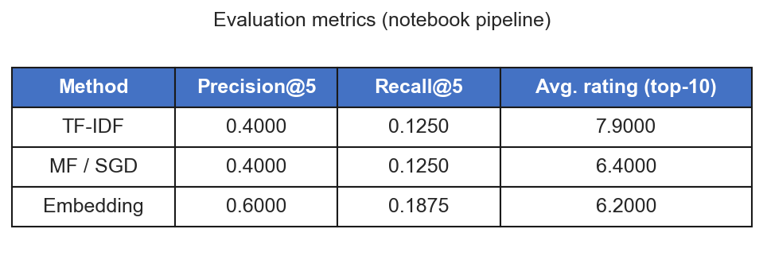

*Figure 1. Offline metrics summary (same evaluation as the notebook “Metrics” section).*

Figure 2 — Distribution of ratings
Bar chart of how often each rating 1–10 appears in the synthetic **150-item** catalogue.
Rating distribution
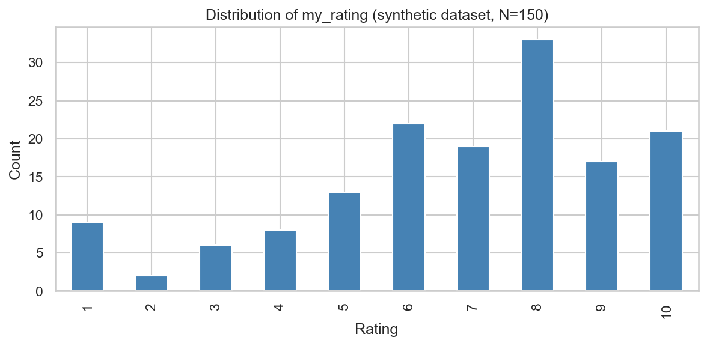

*Figure 2. Distribution of `my_rating` (matches the notebook “Figures” section, first plot).*

Figure 3 — Metrics comparison (bar chart)
Side-by-side comparison of **P@5**, **R@5**, and **AvgTop10** across the three methods.
Metrics bar chart
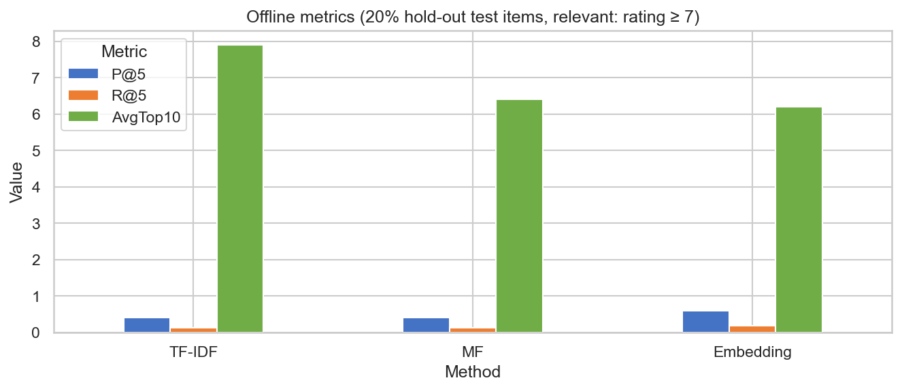

*Figure 3. Bar chart of offline metrics (matches the notebook second plot).*

Figure 4 — TF–IDF cosine similarity heatmap
Pairwise cosine similarity between TF–IDF vectors for a **random sample of 15 items** (titles on axes).
TF-IDF heatmap
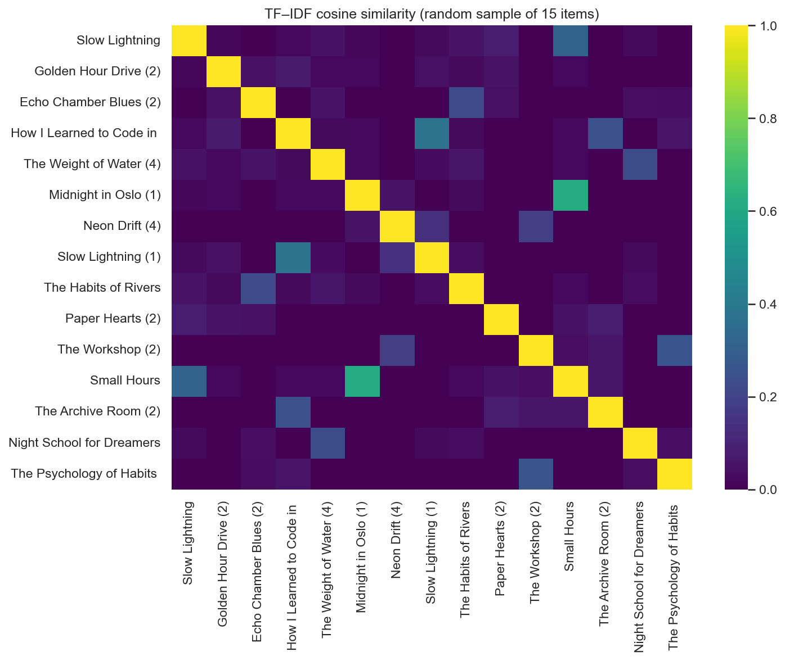

*Figure 4. Similarity heatmap (matches the notebook heatmap cell).*

17. Optional: Streamlit Screenshots
For a complete submission package you may add **manual** browser screenshots after running `streamlit run app.py`:
Suggested file | Content
`screenshots/fig_streamlit_main.png` | Main area with tabs and recommendation table
`screenshots/fig_streamlit_sidebar.png` | Sidebar “My Ratings” table

**End of report**
*Word document: rebuild with `python docs/build_report_docx.py` after updating this file. Figures are embedded when PNGs exist in `docs/screenshots/`.*

