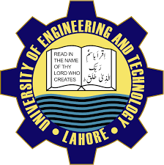

dept of CS, uet lahore

admissions

open
Admissions are now open for the upcoming academic year at UET, offering a wide range of undergraduate and graduate programs. Our institution is renowned for academic excellence, with a faculty of distinguished scholars and researchers.

VISIT US ONLINE
lms.uet.edu.pk
cse.uet.edu.pk
uet.acm@gmail.com
- bsc computer science
- bsc computer engineering
- bsc gaming and animation

