FL-02 – Portfolio Sitemap
FlyRank AI Internship
Week 1 – AI Fluency
Assignment: FL-02 – Draw the Path: Portfolio Sitemap + Toolkit

1. Assignment Objective
The purpose of this assignment is to design a simple, focused portfolio that guides a visitor from landing on the website to taking a clear action. The portfolio emphasizes relevant projects, skills, and contact information.

2. Portfolio Sitemap

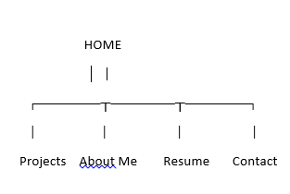

3. Purpose of Each Page
Page | Purpose
Home | Introduce myself and communicate my value proposition.
About Me | Provide a brief background and career goals.
Projects / Case Studies | Showcase internship work and technical projects.
Skills | Highlight technical and professional skills.
Contact | Allow recruiters and clients to reach me.

4. Toolkit Setup
- ChatGPT account created
- Claude account created
- Gemini account created
- Perplexity account created
- Claude Project created

5. Claude Project
Project Name: FlyRank Portfolio Development
Custom Instructions:
• Act as my AI tutor.
• Keep explanations simple and practical.
• Help improve my portfolio while preserving my own writing style.
• Focus on clarity and professionalism.

6. Pressure-Test Prompt
Review my portfolio sitemap. Will this convince an employer hiring a Machine Learning intern? Suggest practical improvements.

7. AI Feedback Summary
• Make Projects more prominent.
• Add a clear Call-to-Action.
• Keep navigation simple.
• Remove unnecessary pages.

8. Changes Made
• Simplified the sitemap.
• Focused on projects.
• Improved navigation.
• Added a dedicated Contact section.

9. Screenshots
Insert screenshots of:
• Claude Project
• Portfolio sitemap sketch
• AI prompt and response

10. Conclusion
This assignment helped me understand how to structure a professional portfolio and how AI can be used as a planning partner while keeping the final decisions my own.

