This is a basic API documentation for the backend service designed to empower Kirana stores in managing their transaction registers. This documentation outlines the endpoints, request parameters, and response formats for the required APIs.

This basic API documentation outlines the endpoints, request parameters, and response formats for the transaction recording and daily reports APIs. It is designed to provide a clear understanding of how to interact with the backend service. Please note that the actual implementation of these APIs would require handling request validation, database interactions, and error handling using Java and Spring Boot.

**Transaction Recording API**

Endpoint: **/transactions/record**

Method: **POST**

**e.g.:** [**http://localhost:8080/transactions/record**](http://localhost:8080/transactions/record)

**Description**

This API is used to record a transaction in the system.

**Request Parameters**

- id (number): The id of the transaction.

- amount (number): The amount of the transaction.

- amountInr (number): The amount of the transaction in INR.

- amountUsd (number): The amount of the transaction in USD.

- currency (string): The currency of the transaction (INR or USD).

- type (string): The type of the transaction (credit or debit).

- date (LocalDate): The type of the transaction date .

**Request Body Example (JSON)**

{

    "amount": 10000.00,

    "currency": "USD",

    "date": "2022-01-15",

    "transactionType": "D"

}

**Response Codes**

- 200 OK - Transaction recorded successfully.

- 400 Bad Request - Invalid request parameters.

- 500 Bad Request – Internal Server Error.

**Response Body**

{

"id": 16,

"amount": 10000.00,

"amountInr": -120.04,

"amountUsd": -10000.00,

"currency": "USD",

"transactionDate": "2024-01-04",

"transactionType": "D"

}

**Transaction Display and Daily Reports API**

Endpoint: **/transactions/dailyReports**

Method: **GET**

**e.g.: http://localhost:8080/transactions/dailyReports?startDate=2024-01-04&endDate=2024-01-04**

**Description**

This API is used to retrieve daily reports of transactions.

**Request Parameters**

- startDate: From Date to get reports of all transactions

- endDate: To Date to get reports of all transactions

**Response Codes**

- 200 OK - Transaction recorded successfully.

- 400 Bad Request - Invalid request parameters.

- 500 Bad Request – Internal Server Error.

**Response Body (JSON)**

[

{

"date": "2024-01-04",

"totalAmount": 32726.01,

"totalAmountInr": 161048.07,

"totalAmountUsd": 1574941.77

}

]

**Screenshots**:

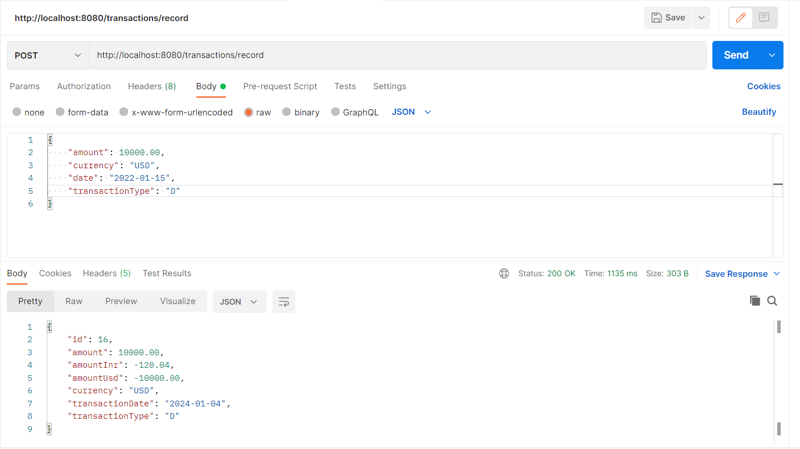

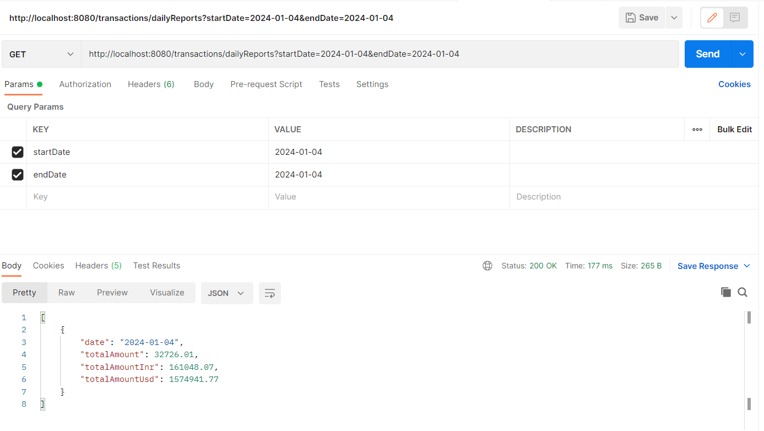

**DB:**

