HOME

**SMART HOME by Oakter**

**Upgrade your Home a smart home without changing any existing appliances; that you have either a ceiling fan or AC or any electrical appliances even your doors or wall mounted switch boxes.**

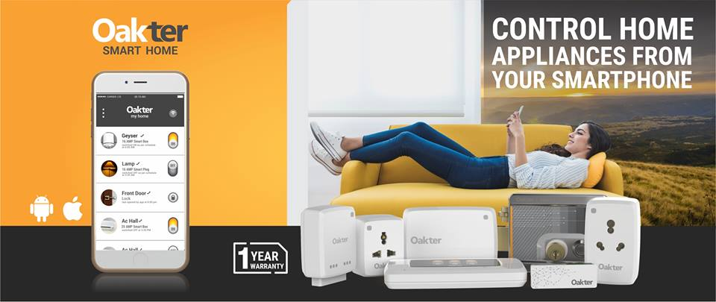

**SMART CLOUD CAMERA by ambicam**

**Looking for a better way to surveillance and monitoring because You can’t be everywhere & Security is everyone’s concern... ...so it’s time to move cloud!**

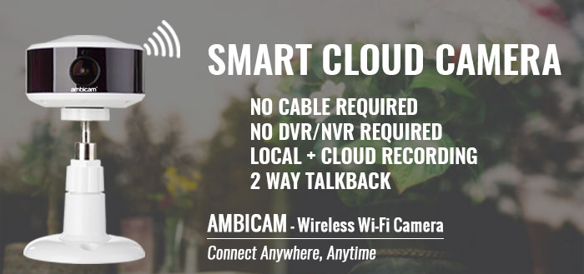

**SMART TRACKING SOLUTION by Tracking Genie**

**Track your vehicle in Real-Time, a complete vehicle tracking solution**

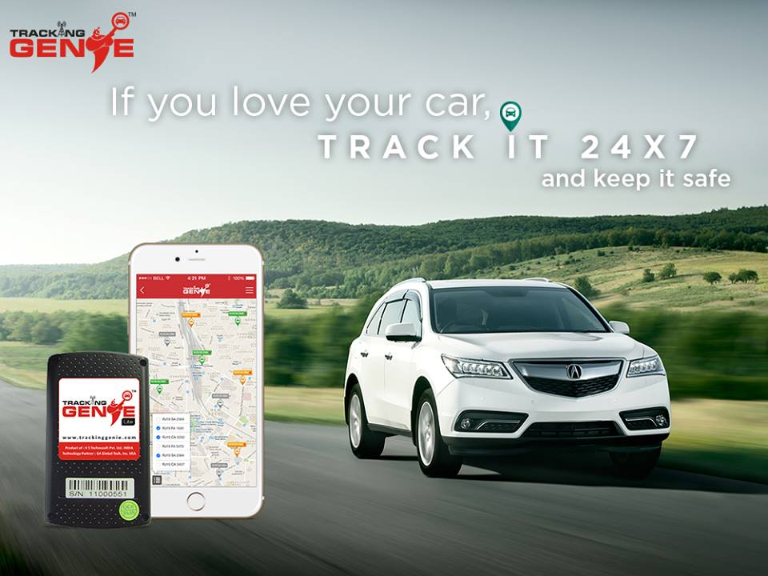

ABOUT US

TRUE BACKEND as our name describes about us more exactly what we do,

We recommend products and services for you as a

**Consultancy**

**Sales & Services**

We make available those products and services to you

**Outsourcing**

We provide assistance for such product and services

By the means of such products and services more correctly we can say best products and services in their field; We digitally upgrade your traditional working environment; make you feel more reliable, get you have more desire i.e. what you want.

PRODUCT &SERVICES

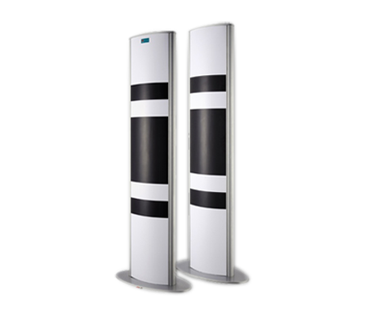  **SCHOOL UPGRADE SYSTEM**

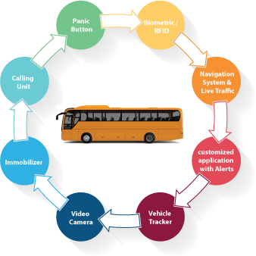 **SCHOOL BUS MONITORING**

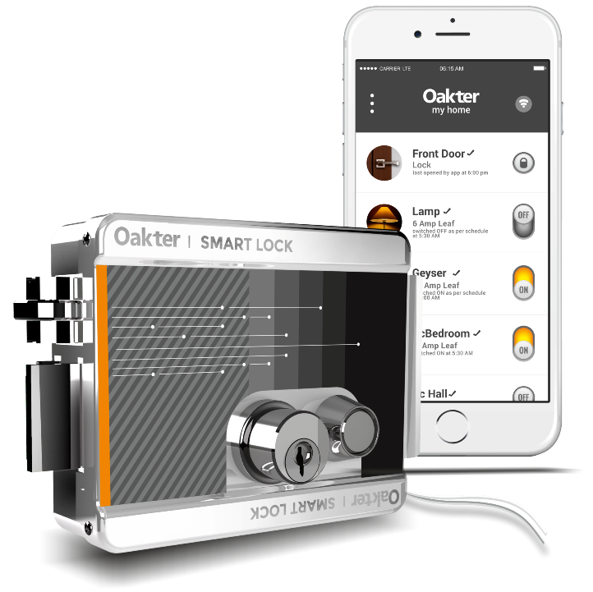

**APARTMENT UPGRADE SYSTEM**



**HOME AUTOMATION SYSTEM**

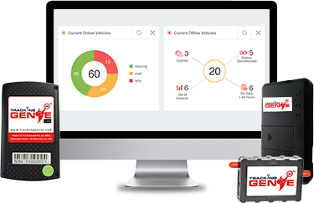

**GPS TRACKING SYSYTEM**

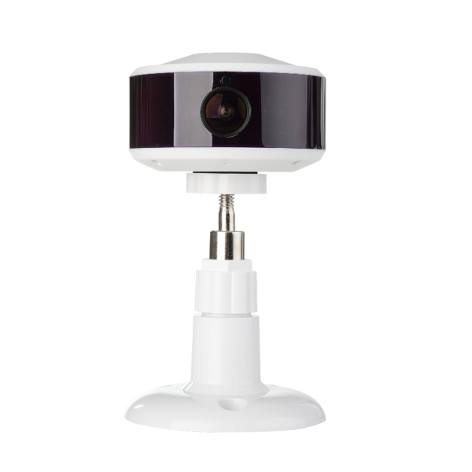

**CCTV SURVEILLANCE SYSTEM**

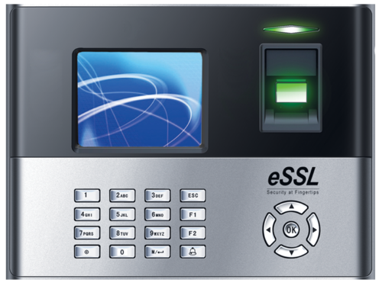 **CENTRALISED ATTENDANCE SYSTEM**

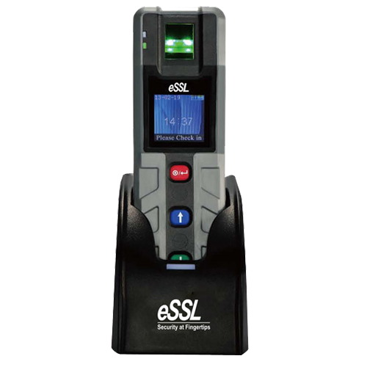 **GUARD PATROLLING SYSTEM**

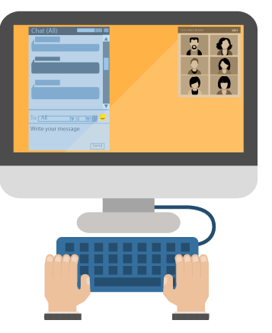 **VIRTUAL CLASSROOM**

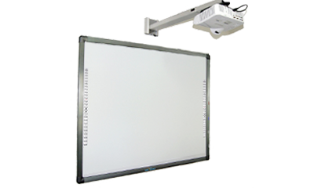 **INTERACTIVE WHITEBOARD**

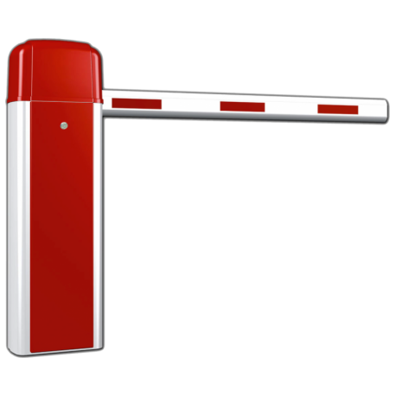 **PARKING BOOM BARRIER**

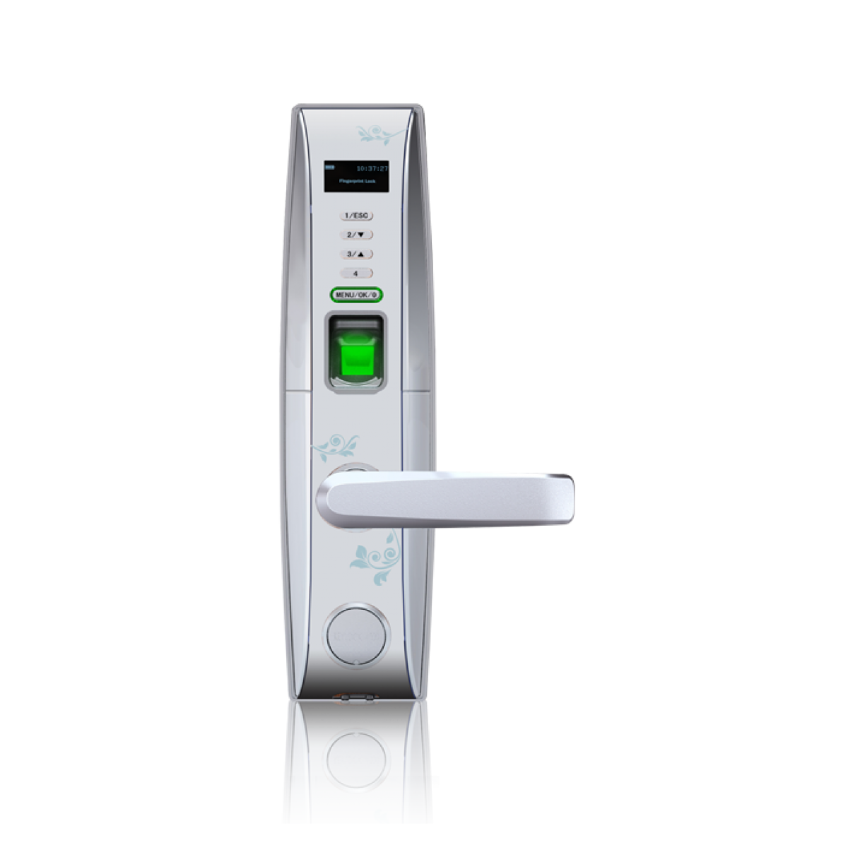 **BIOMATRIC DOOR LOCK**

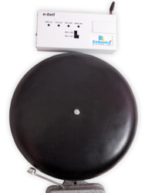 **AUTOMATIC SCHOOL BELL**

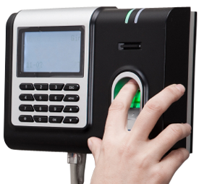 **ACCESS CONTROL SYSTEM**

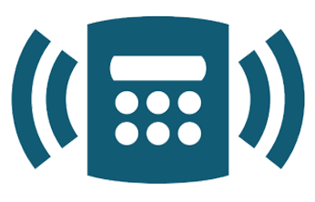**SECURITY ALARM SYSTEM**

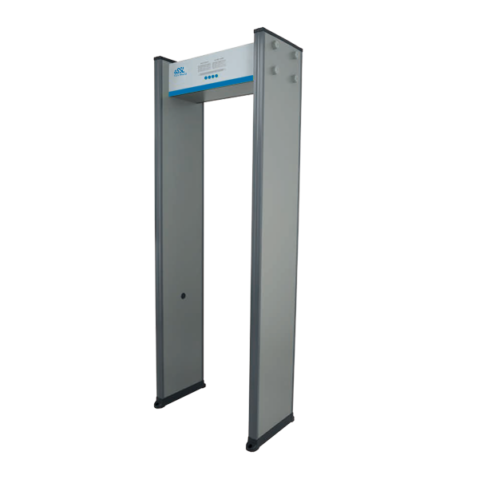 **METAL DETECTOR GATE**

Attachments

Pricing

Contact us (from)email id

[truebackend@gmail.com](mailto:truebackend@gmail.com)

interactive whiteboard and automatic school bell

parking barrier and metal detechter

centralise attendance and access control

security alarm system none

facebook

youtube https://www.youtube.com/channel/UCPkFcHvhfslWKOW3nrsosAg

google+ https://plus.google.com/u/0/112858909645140124531

whatsapp 7070211121