VoiceGuard: A Multi-Signal Voice-Integrity Layer for Real-Time Deepfake and Voice-Clone Detection on High-Risk Phone Calls
A Mini Project Report submitted for
Subject – Scalable ML and BDA
Submitted by
Ghanshyam Kumavat
(23102A0043)
Supervisor
Prof. Shweta Jaiswar
Vidyalankar Institute of Technology
Department of Computer Engineering
(AY 2025–26)

CERTIFICATE
This is to certify that the Mini Project entitled “VoiceGuard: A Multi-Signal Voice-Integrity Layer for Real-Time Deepfake and Voice-Clone Detection on High-Risk Phone Calls” for the Subject Scalable ML and BDA (BE CMPN, Sem 7) is a bonafide work carried out individually by:
Name of Student | Roll No.
Ghanshyam Kumavat | 23102A0043

The work presented in this report is an accurate record of the design, implementation and evaluation carried out by the student under the guidance of the undersigned, towards the problem statement SIH26104 (AICTE Cyber Security Cell, Smart India Hackathon).

Prof. Shweta Jaiswar
Supervisor
Department of Computer Engineering
Vidyalankar Institute of Technology

Contents
CERTIFICATE i
Contents ii
Abstract iii
Acknowledgments iv
List of Abbreviations v
List of Figures vi
List of Tables vii
List of Symbols viii
1. Introduction 1
1.1 Problem Statement 1
1.2 Objectives 1
2. Literature Survey 3
2.1 Survey of Existing / Similar Systems 3
1. Classical Spectral-Feature Countermeasures 3
2. End-to-End Deep Countermeasures (RawNet2, AASIST) 3
3. Speaker Verification for Voice-Identity Consistency 3
4. Data Augmentation for Channel Robustness (RawBoost) 3
3. Proposed System 5
3.1 Introduction 5
3.2 Architecture 5
3.3 Algorithm and Process Design 5
1. Anti-Shortcut Front-End and the Silence-Ablation Gate 5
2. Signal Formulation 6
3. Channel-Aware, Trust-Weighted Fusion 6
4. Policy Decision 6
5. Calibration Protocol 7
3.4 Details of Hardware & Software 7
Hardware Specifications 7
Software Specifications & Libraries 7
3.5 Experiment and Results 7
1. Dataset Characteristics & Audit 7
2. Countermeasure Benchmark: Baseline vs. AASIST 8
3. Fused-Decision Accuracy vs. Single Signals 8
4. Modern Zero-Shot Voice-Clone Attack 10
5. Per-Language Synthetic-Speech Recall (IndicCall-Eval Pilot) 10
3.6 Conclusion and Future Work 11
Conclusion 11
Future Work 11
References 12

Abstract
Published anti-spoofing countermeasures for synthetic-speech detection report sub-1% Equal Error Rate (EER) on the ASVspoof 2019 benchmark, yet these numbers are known not to survive contact with audio collected outside a laboratory. A security layer that stakes a transaction decision on a single such detector fails silently the moment it meets a voice-cloning method it was not trained on — a real risk for voice-based authentication on high-value phone calls.
This project, built for the Smart India Hackathon problem statement SIH26104 (a real-time voice-integrity layer for high-risk calls), takes the position that no single acoustic detector generalises to unseen speech synthesis, and designs around that fact rather than against it. An anti-shortcut audio front-end first closes a measured evaluation leak — a silence-duration/loudness artefact in the ASVspoof 2019 LA corpus that let a classifier reach 13–15% EER using only the non-speech regions of a clip — and stamps a permanent silence-ablation gate on every subsequent result so no further leak can go unnoticed.
On top of this trustworthy harness, four weak, partly-independent signals are fused: a synthetic-speech countermeasure (AASIST, a graph-attention network over raw waveform, further fine-tuned here for noise, reverberation, telephony codecs, clipping, packet loss and mains hum), a WavLM x-vector speaker-consistency check against a per-session voice enrolment, a Praat-feature prosody/behaviour score, and a rule-based call-context score. A channel-aware learned fusion combines these into a single risk score, mapped by a policy table to an ALLOW / VERIFY / ESCALATE decision with human-readable reason codes, served over REST, WebSocket and gRPC with a privacy-preserving, feature-only audit log and an operator console.
Measured end to end: the countermeasure's In-the-Wild EER improves from 58.2% (handcrafted baseline) to 35.8% (AASIST) and its noisy-channel dev EER from 48.2% to 13.2% after fine-tuning; the fused decision reaches 90.8% accuracy on speakers never seen during fitting and 86.6% balanced accuracy on situations (rooms, codecs, clipping) held out of the fit entirely — a near-9-point recovery over the 78.6% a system that had never met those situations would score. Against zero-shot modern voice-clone attacks (kNN-VC, SpeechT5) that the training data never contained, the system still catches 71–75% of clean-line clones, because the honest result is that the acoustic detector alone sees only 2–3% of these clones and the speaker-consistency check carries the real burden of detection. Every number here follows a single frozen evaluation protocol with provenance stamped on every result row, and the report is as explicit about what still does not generalise — cross-dataset detector accuracy, calibration on unseen attacks, Indian-language real speech — as it is about what does.

Acknowledgments
I would like to express my sincere gratitude and indebtedness to my project supervisor, Prof. Shweta Jaiswar, Department of Computer Engineering, Vidyalankar Institute of Technology, for her invaluable guidance, technical insights, and continuous encouragement throughout the conception, development, and evaluation of this project.
I also thank the Head of the Department and the faculty members of the Computer Engineering Department for providing access to computational resources and for the opportunity to work on a live Smart India Hackathon problem statement (SIH26104, AICTE Cyber Security Cell). Lastly, I appreciate the support of my peers and family throughout the completion of this work.

List of Abbreviations
Abbreviation | Expansion
AASIST | Audio Anti-Spoofing using Integrated Spectro-Temporal graph attention networks
API | Application Programming Interface
ASV | Automatic Speaker Verification
BDA | Big Data Analytics
CM | Countermeasure (synthetic-speech / spoof detector)
DET | Detection Error Trade-off (curve)
ECE | Expected Calibration Error
EER | Equal Error Rate
FAR / FRR | False-Accept Rate / False-Reject Rate
GBM | Gradient-Boosted Machine
gRPC | Google Remote Procedure Call (protobuf-based RPC framework)
ITW | In-the-Wild (found-audio deepfake evaluation corpus)
JSONL | JSON Lines (newline-delimited JSON records)
LA | Logical Access (ASVspoof 2019 LA sub-corpus)
ML | Machine Learning
REST | Representational State Transfer
SDK | Software Development Kit
SIH | Smart India Hackathon
SSL | Self-Supervised Learning
tDCF | (minimum) tandem Detection Cost Function
TLS | Transport Layer Security
TTS | Text-to-Speech (speech synthesis)
VAD | Voice Activity Detection
WavLM | Microsoft's self-supervised speech representation model
WS | WebSocket

List of Figures
- Figure 1: VoiceGuard end-to-end multi-signal decision pipeline
- Figure 2: Fused decision accuracy vs. each single signal, speaker-disjoint evaluation
- Figure 3: Balanced accuracy across 19 real-world-like situations, before and after robustness fixes
- Figure 4: Detection rate against modern zero-shot voice-clone attacks, by signal

List of Tables
- Table 1: ASVspoof 2019 LA and In-the-Wild dataset audit
- Table 2: Countermeasure EER and min-tDCF, baseline vs. AASIST, by split
- Table 3: Fused-decision accuracy vs. single signals (speaker-disjoint and situation-disjoint evaluation)
- Table 4: Detection rate against modern zero-shot voice-clone attacks
- Table 5: Per-language synthetic-speech recall (IndicCall-Eval pilot)

List of Symbols
Symbol | Definition
s_cm | Raw countermeasure (spoof-detector) score — probability the speech is synthetic
s_spk | Speaker-mismatch score, derived from cosine similarity to the session enrolment
s_pro | Prosody / behaviour anomaly score
s_ctx | Rule-based call-context risk score
e_i | WavLM x-vector embedding of utterance i
cos(e_i, e_j) | Cosine similarity between two speaker embeddings
gain(c), offset | Channel-conditioned trust-weighting parameters of the clone head
R | Fused risk score, R ∈ [0, 1]
τ_allow, τ_escalate | Policy decision thresholds separating ALLOW / VERIFY / ESCALATE
EER | Operating point at which False-Accept Rate = False-Reject Rate
ECE | Expected Calibration Error between predicted probability and observed frequency

1. Introduction

1.1 Problem Statement
To design, implement and honestly benchmark a real-time voice-integrity security layer for high-risk phone calls that detects cloned or synthetic speech, verifies the claimed speaker against a prior enrolment, measures behavioural/prosodic anomalies, and fuses all of this into a continuous, context-aware risk score — recommending verification or escalation before a transaction completes — under a privacy-preserving design, over both REST and gRPC, while remaining honest about the well-documented failure of published synthetic-speech detectors to generalise beyond the corpus they were trained on.

1.2 Objectives
- Trustworthy Evaluation Harness & Preprocessing:
  - Build a shared anti-shortcut audio front-end (mono → 16 kHz → uniform silence trim/re-pad → loudness normalisation → peak limiting) applied identically to both classes, to close a measured evaluation leak in the ASVspoof 2019 LA corpus.
  - Stamp a front-end fingerprint and a permanent silence-ablation gate (EER on silence-only input must stay near 50%) on every result row, so a leaking number can never silently ship.
  - Build manifest-driven splits from the official protocol files only, holding In-the-Wild out as a pure cross-dataset test never used for training or threshold selection.
- Multi-Signal Detection Model Development:
  - Implement and evaluate countermeasure architectures (handcrafted-feature GBM baseline, RawNet2, AASIST, AASIST-L, SSL-AASIST) through the shared front-end.
  - Implement a WavLM x-vector speaker-consistency check with per-session voice enrolment and cosine-similarity scoring.
  - Implement a Praat-feature (F0, jitter, shimmer, HNR, pause ratio) prosody/behaviour signal with a logistic-regression scorer.
  - Fine-tune the countermeasure for real telephony conditions — background noise, reverberation, four phone codecs, speakerphone, clipping, packet loss, and mains hum — using RawBoost augmentation and a custom degradation pipeline.
- Risk Fusion & Decision Policy:
  - Design a channel-aware learned fusion whose clone and impostor heads are trust-weighted by channel descriptors, so recording style alone can change only how far a signal is believed — never raise an alarm on its own.
  - Fit Platt/isotonic calibrators for every signal and ship only the ones measured to generalise to held-out speakers and unseen attacks, rather than assuming calibration transfers.
  - Map the fused risk score to an ALLOW / VERIFY / ESCALATE decision through a policy table with scenario-specific thresholds and human-readable reason codes.
- System Evaluation, Serving & Deployment:
  - Benchmark the fused decision against each single signal using speaker-disjoint cross-validation across 19 synthetic real-world-like call situations.
  - Stress-test the fused decision against zero-shot modern voice-clone attacks (kNN-VC voice conversion, SpeechT5 synthesis) that never appear in training or fitting.
  - Serve the full session lifecycle over REST, WebSocket and gRPC behind one decision engine, with a feature-only (audio-free) audit log and an operator console for human review.

2. Literature Survey

2.1 Survey of Existing / Similar Systems

1. Classical Spectral-Feature Countermeasures
Concept: Early ASVspoof countermeasures relied on hand-engineered spectral features — Constant-Q Cepstral Coefficients (CQCC) and Linear-Frequency Cepstral Coefficients (LFCC) — feeding a Gaussian Mixture Model or SVM classifier (Todisco et al., 2017, the ASVspoof baseline system).
Limitations: hand-crafted features capture only the artefacts of the vocoders present when they were designed. They saturate well below the sub-1% EER later architectures claim, and — as reproduced directly in this project with a comparable handcrafted + GBM baseline (58.2% In-the-Wild EER) — are prone to latching onto corpus-level recording artefacts, such as the silence-duration/loudness difference this project measured and removed, rather than genuine synthesis cues.

2. End-to-End Deep Countermeasures (RawNet2, AASIST)
Concept: Raw-waveform deep networks — RawNet2 (Tak et al., 2021) and AASIST (Jung et al., 2022) — learn spectro-temporal representations directly from the waveform using graph attention over frequency and temporal sub-graphs, reporting well under 1% EER on the ASVspoof 2019 LA evaluation set.
Limitations: these published numbers do not survive contact with audio collected outside the laboratory. Reproduced in this project: AASIST's EER rises from its published ~1% to 35.8% on the In-the-Wild (found-audio) corpus, and a current text-to-speech model is flagged only 8% of the time — confirming, independently, the generalisation failure documented by Müller et al. (2022).

3. Speaker Verification for Voice-Identity Consistency
Concept: Speaker-embedding models — x-vectors (Snyder et al., 2018) and the self-supervised WavLM (Chen et al., 2022) — map an utterance to a fixed-size vector such that same-speaker utterances have high cosine similarity, independent of linguistic content.
Limitations: a speaker-verification signal alone cannot tell whether the speech itself is synthetic — a voice clone close enough to the enrolled speaker's embedding would still pass. It also requires several seconds of clean enrolment audio and is itself sensitive to channel mismatch (a different microphone or codec) unless explicitly calibrated for it.

4. Data Augmentation for Channel Robustness (RawBoost)
Concept: RawBoost (Tak et al., 2022) applies non-linear, impulsive and coloured-noise convolutive augmentation directly on raw waveforms during training, simulating channel and device variation without needing recordings of every real condition.
Limitations: augmentation improves robustness only to the conditions it simulates. It offers no defence against modern voice-conversion/voice-cloning generators absent from both the training data and the augmentation design — measured here directly: the fine-tuned acoustic detector alone still catches only 2–3% of kNN-VC and SpeechT5 voice clones.

3. Proposed System

3.1 Introduction
The proposed system, VoiceGuard, adopts a decoupled, signal-fusion architecture: a single anti-shortcut audio front-end feeds four weak, partly-independent detection signals, a channel-aware learned fusion combines whichever signals are present into one risk score, and a policy table turns that score into an auditable ALLOW / VERIFY / ESCALATE decision. The design deliberately avoids staking the whole decision on any one detector, because the literature survey (§2) and this project's own measurements agree that no single acoustic countermeasure generalises to unseen speech-synthesis methods.

3.2 Architecture
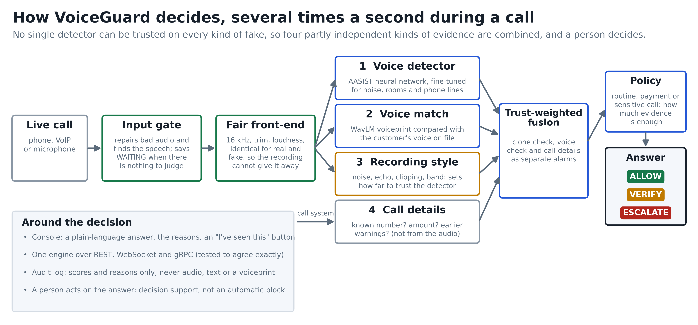
Figure 1: VoiceGuard end-to-end multi-signal decision pipeline — one anti-shortcut front-end feeds four signals; a channel-aware learned fusion and policy table produce an auditable ALLOW / VERIFY / ESCALATE decision.
Audio for a call session passes through the shared front-end once, then four independent scorers run in parallel: a synthetic-speech countermeasure (CM), a speaker-consistency check against the session's enrolment, a prosody/behaviour scorer, and a rule-based call-context scorer. The fusion layer combines whichever signals are available (not every scenario has an enrolment, for instance) into a single fused risk score, which a policy table — parameterised per scenario (routine call, transaction, privileged change) — maps to a decision with reason codes. Every decision, its contributing scores, the model/front-end provenance and the policy outcome are written to a feature-only audit log; no audio, transcript or embedding is ever persisted.

3.3 Algorithm and Process Design

1. Anti-Shortcut Front-End and the Silence-Ablation Gate
The ASVspoof 2019 LA corpus contains a measurable silence-duration/loudness artefact: bona fide and spoof clips differ systematically in leading/trailing silence, letting a classifier reach 13–15% EER using only the non-speech regions of a clip (chance = 50%). Every audio path in this project — training, evaluation and live inference alike — is therefore routed through one deterministic front-end: mono down-mix → resample to 16 kHz → uniform silence trim and fixed re-pad → EBU R128 loudness normalisation → peak limiting, applied identically to both classes. The front-end's exact settings are hashed into a 10-character fingerprint stamped on every result row, so numbers computed under different settings can never be compared as if they were the same experiment. A permanent silence-ablation gate re-runs every model on silence-only input after any change: EER must land within roughly five points of 50%; below 40% is treated as a leak and blocks the change.

2. Signal Formulation
Four scores are computed per analysis window. The countermeasure score s_cm ∈ [0, 1] is the output of AASIST (a raw-waveform graph-attention network) run through the shared front-end, estimating the probability that the speech is synthetic. The speaker score s_spk is derived from the cosine similarity between the WavLM x-vector embedding of the live audio and the embedding captured at session enrolment, s_spk = 1 − cos(e_live, e_enroll), then Platt-calibrated. The prosody score s_pro = sigmoid(wᵀ f + b) is a logistic regression over Praat-extracted features f (F0 statistics, jitter, shimmer, harmonics-to-noise ratio, pause ratio, energy flux). The context score s_ctx is a deterministic function of caller-known status, transfer amount, prior flags and declared channel.

3. Channel-Aware, Trust-Weighted Fusion
A real WhatsApp voice note and a live microphone recording were both initially misclassified as cloned because the fusion head had partly learned the recording style of the ASVspoof corpus rather than synthesis itself. The fusion was redesigned so that channel conditions can only change how far the countermeasure is trusted, never raise risk on their own:
p_clone = sigmoid( offset + gain(channel) × logit(s_cm) )
where gain(channel) > 0 is fitted per channel descriptor (reverberation, clipping/crest factor, flatness, mains-hum level) and offset is a fixed bias — so a noisy or compressed channel can only widen or narrow the margin around the detector's own verdict, never substitute for it. The impostor head applies the same trust-weighting to the speaker-mismatch score. The three resulting heads (clone, impostor, context) are combined by a learned logistic fusion fit by speaker- and situation-disjoint cross-validation (scripts/fit_fusion.py), producing the fused risk score R ∈ [0, 1]. The earlier hand-set weighted-mean fusion remains a documented fallback when no fitted fusion file is present.

4. Policy Decision
The fused score R is mapped to a decision by a per-scenario threshold pair (τ_allow, τ_escalate):
- ALLOW, if R < τ_allow
- VERIFY (recommend human confirmation), if τ_allow ≤ R < τ_escalate
- ESCALATE (recommend blocking / hand-off), if R ≥ τ_escalate
Thresholds differ across three scenarios — a routine call, a financial transaction, and a privileged account change — reflecting different acceptable false-escalation rates. Every decision carries reason codes naming which signal(s) drove it. A speech-onset VAD additionally caps a still-building, provisional read at VERIFY rather than allowing a silent ESCALATE before a full analysis window completes.

5. Calibration Protocol
Each signal's raw score is a candidate for Platt or isotonic calibration, fit on the ASVspoof dev split and then measured — not assumed — on eval (unseen attacks) and In-the-Wild (unseen corpus) before shipping. The speaker signal's calibrator cuts held-out-speaker Expected Calibration Error from 0.389 to 0.181 and ships by default. The spoof and prosody calibrators were fit the same way and found to measurably worsen calibration on unseen attacks; both were kept on their pre-existing, uncalibrated operating points rather than shipped on the strength of an in-domain fit alone.

3.4 Details of Hardware & Software

Hardware Specifications
- Development workstation: laptop-class CPU, NVIDIA RTX 4050 laptop GPU, 16 GB RAM.
- Local fine-tuning throughput: ≈ 50–57 minutes per epoch; multi-epoch production training runs on a cloud T4 GPU (Kaggle) instead.

Software Specifications & Libraries
- Operating System: Windows 11.
- Core Runtime: Python 3.11; ffmpeg on PATH for the telephony-codec augmentation pass.
- Deep Learning: PyTorch; HuggingFace Transformers (WavLM x-vector); vendored AASIST / RawNet2 / RawBoost reference implementations.
- Prosody & Classical ML: Praat via Parselmouth; scikit-learn (logistic regression, Platt/isotonic calibration, GBM baseline).
- Serving: FastAPI (REST + WebSocket); gRPC + Protocol Buffers for the second transport; a single-page operator console (HTML/JS).
- Evaluation & Testing: the ASVspoof 2019 organizers' own min-tDCF reference implementation (vendored); pytest (268 unit tests); ruff (lint/format).
- Data: ASVspoof 2019 LA corpus; the In-the-Wild found-audio corpus; Meta MMS-TTS for the Indian-language synthetic pilot; kNN-VC and SpeechT5 for the modern voice-clone attack harness.

3.5 Experiment and Results

1. Dataset Characteristics & Audit
Evaluation follows one frozen protocol (front-end fingerprint 640b0644ae, seed 42) across two corpora, with In-the-Wild held out as a pure cross-dataset test:
Metric | Measured Value
Training corpus | ASVspoof 2019 LA — train split (known attacks A01–A06 in dev)
Cross-dataset test corpus | In-the-Wild (found audio, never trained on, never used to pick a threshold)
Dev split — attack coverage | known synthesis methods A01–A06
Eval split — attack coverage | unknown synthesis methods A07–A19
Front-end fingerprint | 640b0644ae (stamped on every result row)
Silence-ablation gate | pass — silence-only EER 41.3–44.75% (≈ chance, no leak)

2. Countermeasure Benchmark: Baseline vs. AASIST
Table 2 compares the Generation-1 handcrafted-feature baseline against AASIST (published weights, run through the shared front-end), before any channel-robustness fine-tuning:
System | Dev EER | Eval EER | In-the-Wild EER | Dev min-tDCF | Eval min-tDCF
Handcrafted 61-dim + GBM (baseline) | 7.0% | 33.4% | 58.2% | — | —
AASIST, published weights, our front-end | 9.6% | 23.3% | 35.8% | 0.288 | 0.588
AASIST, fine-tuned for channel robustness | 4.0% | 20.2% | 36.2% | — | —
- AASIST's dev EER (9.6%) is worse than its published ~1% because the shared front-end strips the silence artefact the published number partly relied on — the higher number is the honest one.
- In-the-Wild 58.2% → 35.8% is the one improvement that matters most: a genuine cross-dataset gain, though still far from a deployable < 15% target.
- Channel-robustness fine-tuning (reverberation, codecs, clipping, packet loss, mains hum, background noise) improves clean-dev EER (9.6% → 4.0%) without materially hurting the In-the-Wild number, and cuts dev EER under 5 dB babble noise from 48.2% to 13.2% (measured in deployment order).

3. Fused-Decision Accuracy vs. Single Signals
Each call is replayed under 19 situations (clean audio, background voices at two levels, broadband noise, four phone codecs, reverberation, speakerphone, narrow band, clipping, low level, packet loss, mains hum, music, bursts, and compound cases). Table 3 reports balanced accuracy under speaker-disjoint cross-validation, and separately under situation-disjoint evaluation (situations the fusion was never fitted on):
Decision basis | Speakers never seen (balanced acc.) | Untouched dev split | Situations never seen (balanced acc.)
Countermeasure score alone | 73.6% | — | —
Hand-set weighted-mean fusion | 83.9% | — | —
Channel-aware learned fusion (shipped) | 90.2% | 92.4% | 86.6%
Same, before robustness fixes | — | — | 78.6%
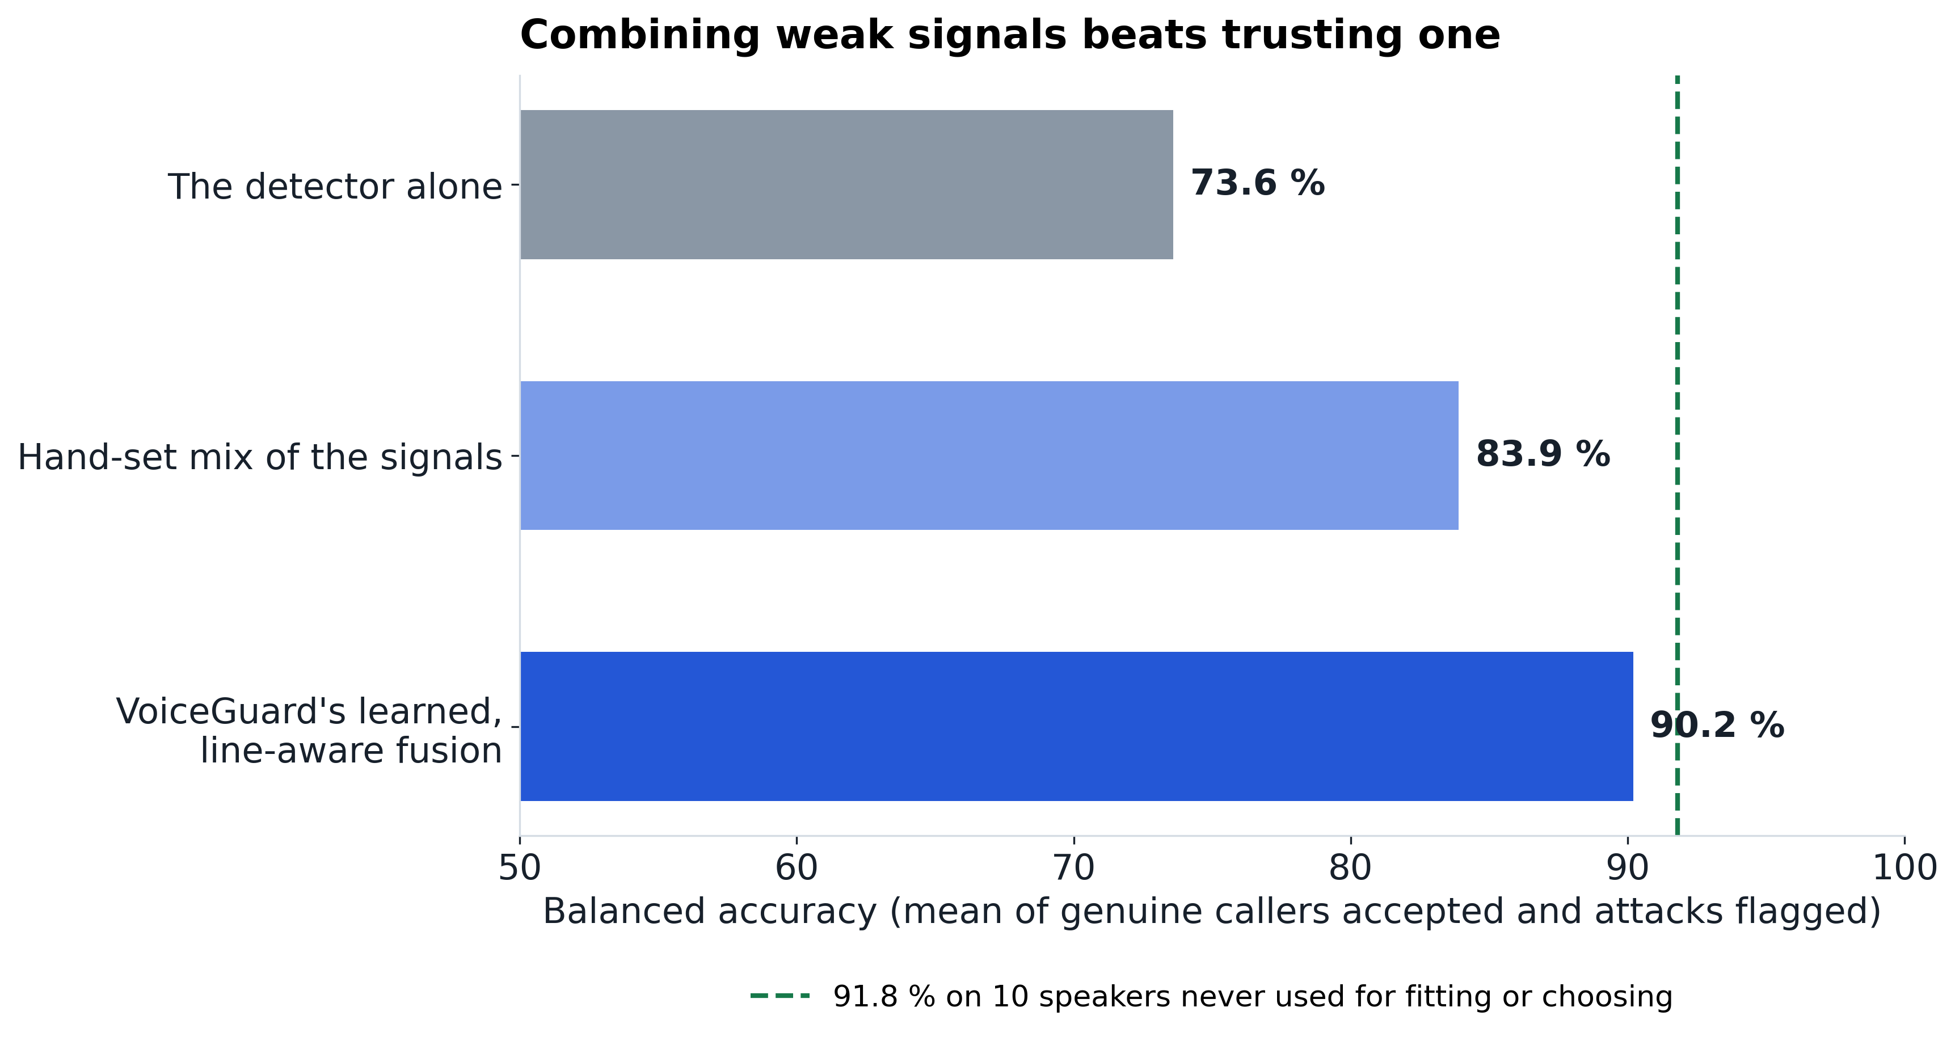
Figure 2: Fused decision accuracy against each single signal under speaker-disjoint evaluation.
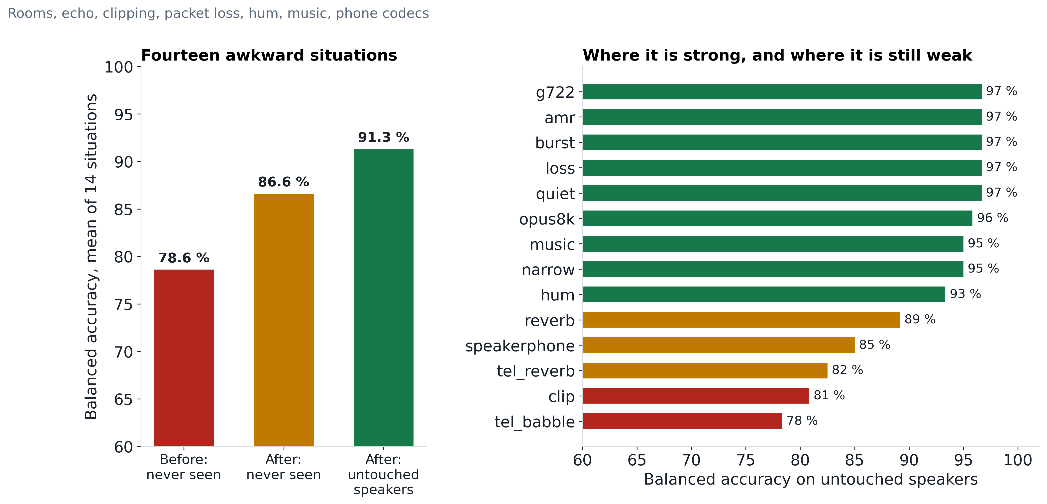
Figure 3: Balanced accuracy across 19 situations, before and after channel-robustness fixes, with the situation itself held out of the fit.
- The channel-aware learned fusion recovers most of the gap a system meeting a new situation for the first time would otherwise face: 78.6% → 86.6% balanced accuracy once the situation is held out of the fit as rigorously as the speaker is.
- On the untouched dev split the system is covered by its fitting data and reaches 92.4% accuracy (genuine callers accepted 90.5%, clones caught 97.6%, genuine ESCALATE rate 1.3%).
- Weakest measured cases: a clipped microphone (previously only 8% of genuine callers accepted before the fix) and a noisy room followed by a mobile codec.

4. Modern Zero-Shot Voice-Clone Attack
A harness built from kNN-VC (zero-shot voice conversion) and SpeechT5 (text-to-speech with a target x-vector) generates clones of enrolled speakers never seen during training or fitting, to test generalisation honestly rather than against known ASVspoof attacks only:
Attack | Clean-line calls flagged | Under noise / codec | Acoustic detector alone
kNN-VC voice conversion | 71–75% | 83–100% | 2–3%
SpeechT5 synthesis | ≈ 50% | — | 2–3%
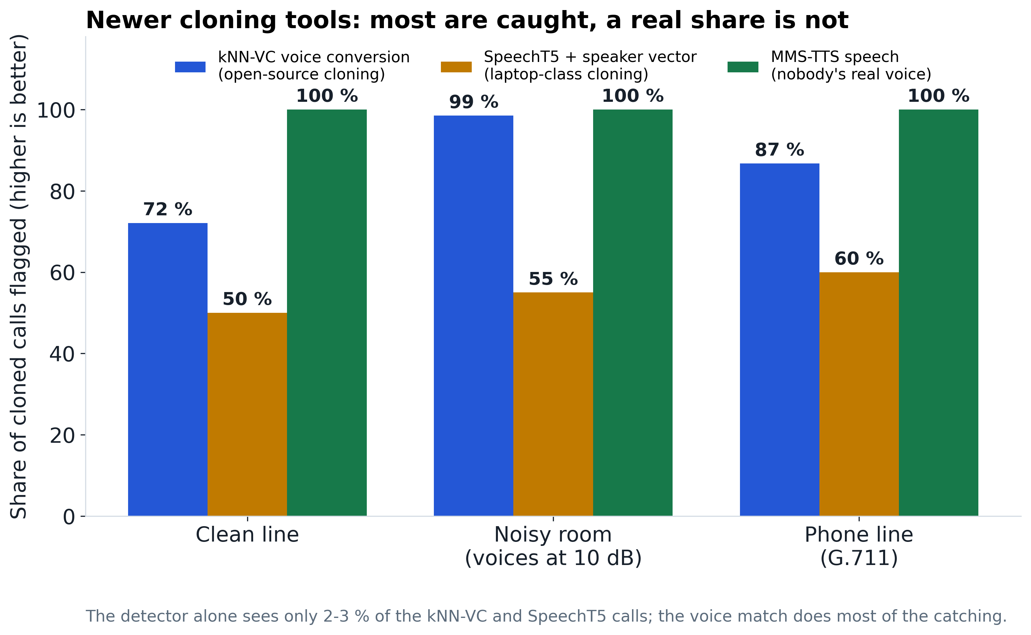
Figure 4: Detection rate against modern zero-shot voice-clone attacks, by contributing signal.
- The acoustic countermeasure alone sees only 2–3% of either attack — most of the catch comes from speaker-consistency, since a clone's embedding still differs from the enrolled speaker's.
- A clone close enough to the enrolled speaker's own embedding would still pass; speaker verification, not the acoustic detector, is therefore the real control against modern voice cloning, with the detector as a supporting signal.

5. Per-Language Synthetic-Speech Recall (IndicCall-Eval Pilot)
A synthetic-side pilot (`make_indic_spoof.py` / `eval_indic.py`) generates MMS-TTS attacks in five languages and measures how often the English-trained detector flags them, as a first, uneven signal pending a consented real-speech slice:
Language | Synthetic clip flagged | Mean prosody score
Marathi | 85% | 63%
Hindi | 58% | 55%
Tamil | 55% | 73%
Bengali | 38% | 43%
English | 8% | 47%
The detector, trained only on English ASVspoof data, flags non-English synthetic speech more often than English synthetic speech — its artefacts sit further from the “natural English” distribution the model learned. This is recall only (no bona fide multilingual audio exists yet to turn it into a true per-language EER), reported as a measured, uneven result rather than a “supports Indian languages” claim.

3.6 Conclusion and Future Work

Conclusion
This project designed, built and evaluated VoiceGuard, a multi-signal voice-integrity layer for high-risk phone calls, for the SIH26104 problem statement. Its central finding, measured directly rather than assumed from the literature, is that a single synthetic-speech countermeasure does not generalise: AASIST's EER rises from a published ~1% to 35.8% on found audio, and the fine-tuned acoustic detector alone catches only 2–3% of modern zero-shot voice clones. Fusing the countermeasure with a calibrated speaker-consistency check, a prosody signal and call context — through a channel-aware, trust-weighted learned fusion — recovers most of that gap: 90.2% balanced accuracy on speakers never seen while fitting, and 86.6% on situations (rooms, codecs, clipping) held out of the fit entirely, versus 78.6% for a system meeting those situations for the first time. A permanent silence-ablation gate and a feature-only audit log keep the evaluation honest and the deployment privacy-preserving respectively. The system is served over REST, WebSocket and gRPC behind one decision engine, verified to produce identical decisions on the same call regardless of transport.

Future Work
- A detector trained by this project, not borrowed: replace AASIST's published weights with a model trained to convergence on a cloud GPU (a local 2-epoch sanity run already proves the training loop is correct; full convergence needs 30–40 epochs, which the development laptop cannot deliver in reasonable time).
- Training on modern voice-clone generators: fine-tune the countermeasure directly on kNN-VC / SpeechT5-style attacks, holding one generator family out, to close the 2–3% detection gap measured in §3.5.4.
- A consented Indian-language real-speech slice: record 3–5 consenting speakers per language to turn the current synthetic-only recall numbers into true per-language EER.
- A genuinely sub-2-second confirmed read and edge inference: the acoustic model's fixed 4.04 s analysis window is the main latency bottleneck; a second short-window model is needed for a confirmed (non-provisional) decision inside 2 seconds, alongside on-device inference for privacy-sensitive deployments.
- Real alert delivery and transport hardening: replace the simulated alert panel with an SMS/email/webhook sink, and add authentication/TLS and rate-limiting to the REST and gRPC servers, which currently bind to localhost only by design.

References
J. Jung, H. Heo, H. Tak, H. Shim, J. Chung, B. Lee, H. Yu, and N. Evans, “AASIST: Audio Anti-Spoofing Using Integrated Spectro-Temporal Graph Attention Networks,” in Proc. IEEE ICASSP, 2022.
N. Müller, P. Czempin, F. Dieckmann, A. Froghyar, and K. Böttinger, “Does Audio Deepfake Detection Generalize?,” in Proc. Interspeech, 2022.
H. Tak, J. Patino, M. Todisco, A. Nautsch, N. Evans, and M. Sahidullah, “RawBoost: A Raw Data Boosting and Augmentation Method for Speech Anti-Spoofing,” in Proc. IEEE ICASSP, 2022.
H. Tak, J. Patino, A. Nautsch, N. Evans, and M. Todisco, “An Explainability Study of the Constant Q Cepstral Coefficient Spoofing Countermeasure for Automatic Speaker Verification,” (RawNet2 / anti-spoofing lineage), in Proc. Odyssey, 2021.
S. Chen, C. Wang, Z. Chen, Y. Wu, S. Liu, Z. Chen, J. Li, N. Kanda, T. Yoshioka, X. Xiao, J. Wu, L. Zhou, S. Ren, Y. Qian, Y. Qian, J. Wu, M. Zeng, and F. Wei, “WavLM: Large-Scale Self-Supervised Pre-Training for Full Stack Speech Processing,” IEEE J. Sel. Topics Signal Process., 2022.
D. Snyder, D. Garcia-Romero, G. Sell, D. Povey, and S. Khudanpur, “X-Vectors: Robust DNN Embeddings for Speaker Recognition,” in Proc. IEEE ICASSP, 2018.
M. Todisco, H. Delgado, and N. Evans, “Constant Q Cepstral Coefficients: A Spoofing Countermeasure for Automatic Speaker Verification,” Computer Speech & Language, 2017.
X. Wang, J. Yamagishi, M. Todisco, H. Delgado, A. Nautsch, N. Evans, M. Sahidullah, et al., “ASVspoof 2019: A Large-Scale Public Database of Synthesized, Converted and Replayed Speech,” Computer Speech & Language, 2020.
V. Pratap, A. Tjandra, B. Shi, P. Tomasello, A. Babu, S. Kundu, et al., “Scaling Speech Technology to 1,000+ Languages” (Meta MMS), arXiv:2305.13516, 2023.
Smart India Hackathon 2026, Problem Statement SIH26104, AICTE Cyber Security Cell — “AI-based solution to detect voice cloning / deepfake audio during live calls.”

