VoiceGuard: An Evaluation-Honest, Multi-Signal Decision Layer for Real-Time Voice-Clone Detection in High-Stakes Telephone Calls
Ghanshyam Kumavat, Sunil Saini, Vicky Pukale
Department of Computer Engineering, Vidyalankar Institute of Technology, Mumbai, India
{ghanshyam.kumavat@vit.edu.in, sunil.saini@vit.edu.in, vicky.pukale@vit.edu.in}
Abstract—Speech anti-spoofing countermeasures report sub-1% Equal Error Rate (EER) on ASVspoof 2019 LA, yet this accuracy does not carry over to unseen generators or found audio. We study that gap for telephone-based voice-clone fraud. First, we show that the standard LA evaluation pipeline contains a silence-duration/loudness shortcut: a classifier using only the non-speech regions of dev clips scored 13–15% EER (chance is 50%), and its apparent 1.83% EER was mostly artifact. We propose an anti-shortcut front-end and a permanent silence-ablation gate. Evaluated through them, the published AASIST weights score 9.6% (dev), 23.3% (eval) and 35.8% (In-the-Wild) EER, with an eval min-tDCF of 0.588. Second, because no single detector generalizes, we build VoiceGuard, a decision layer that fuses acoustic spoof detection, WavLM speaker consistency, prosody and call context into an ALLOW/VERIFY/ESCALATE recommendation with a feature-only audit log. In a worked case, a neural-TTS clone that the acoustic signal alone rates 29/100 is escalated (68/100) because speaker consistency fails. Third, a pilot across five Indian languages shows the English-trained detector’s synthetic recall ranging from 7.5% (English) to 85% (Marathi), so multilingual robustness must be measured, not assumed. All results carry provenance and limitations are stated explicitly.
Index Terms—audio anti-spoofing, voice-clone detection, speaker verification, sensor fusion, generalization, evaluation methodology, telephony fraud, multilingual speech, ASVspoof

I. INTRODUCTION
Modern text-to-speech (TTS) and voice-conversion (VC) systems need only a few seconds of someone’s voice, for example from a social-media post or a previous call, to imitate them convincingly over a phone line. Banks and call centers that lean on voice to confirm payments, add beneficiaries or reset credentials are therefore at direct risk. Smart India Hackathon 2026 statement SIH26104 (AICTE Cyber Security Cell) frames exactly this need: before a transaction goes through, a live, privacy-respecting system should flag synthetic speech, check whether the caller is the claimed person, look for unusual behavior and suggest what to do next, while handling Indian languages.
Published figures make detection look almost solved, since countermeasures on ASVspoof 2019 Logical Access (LA) regularly quote EER under 1% [2]. Independent testing paints a different picture: Müller et al. measured losses of up to ten times on audio collected outside the benchmark [1], and later traced this mainly to a mismatch between generators, not to harder attacks [5]. We reproduce this: AASIST, the strongest published model we tested, goes from ~1% published EER to 35.8% on In-the-Wild once evaluated honestly, and a current TTS model (Meta MMS-TTS, English) is flagged only 7.5% of the time. We also find that part of the in-domain accuracy is itself a corpus artifact.
We therefore do not propose a better single classifier. We (i) fix the evaluation so that every number can be trusted, and (ii) treat spoof detection as one of four weak, partly independent signals inside an auditable, policy-driven decision with a human in the loop. Contributions:
- Evaluation audit. A silence-duration/loudness shortcut in ASVspoof 2019 LA, closed by an anti-shortcut front-end and a permanent silence-ablation gate, with a fingerprint on every result (Sec. III-A).
- Honest re-evaluation of AASIST. Dev, eval, per-attack and In-the-Wild EER plus min-tDCF through that protocol (Sec. V).
- VoiceGuard. Four-signal fusion with a lone-signal floor, scenario-aware policy, feature-only audit log, REST/WebSocket/gRPC interfaces and an operator console, with a worked case where fusion recovers an acoustic miss (Secs. III, V-E).
- IndicCall-Eval. A five-language pilot showing uneven transfer of an English-trained detector (Sec. V-F).

II. LITERATURE SURVEY
We reviewed five works that define the state-of-the-art detector, the benchmark, and the generalization problem. Table I lists what each contributes, the shortcoming that matters for a deployable call-fraud system, and what VoiceGuard does about it.
Supporting work. ASVspoof 5 [4] is a larger, crowdsourced successor that includes about 2,000 speakers, 32 attack algorithms and adversarial attacks. The ADD challenge [12] focuses on noisy and partly fake audio. RawBoost [6] augments raw waveforms during training, and the survey by Pham et al. [11] concludes that generalization is what the field still lacks. For speaker evidence we use WavLM [7] embeddings with x-vector-style [8] scoring; for multilingual attacks, the open MMS-TTS model [9]. Sun et al. [13] take a complementary route, detecting neural-vocoder artifacts.
Gaps. Four gaps recur. G1 Generalization: in-domain EER does not predict behavior on unseen generators or found audio [1], [5]. G2 Evaluation honesty: to our knowledge, none of the reviewed works audits the corpus for shortcuts. G3 Single-signal framing: one acoustic classifier acts as the gate, with no fusion of speaker, behavioral or context evidence and no auditable human-in-the-loop decision. G4 Language coverage: corpora and detectors are English-centric and transfer unevenly [10]. VoiceGuard addresses G1–G3 through the front-end, honest cross-dataset evaluation and fusion (Secs. III–V), and makes a first measurement on G4 (Sec. V-F).

TABLE I. SURVEY OF REVIEWED WORKS, THEIR SHORTCOMINGS, AND THE VOICEGUARD RESPONSE
Work | Contribution | Shortcoming for our problem | What VoiceGuard does
AASIST [2] – ICASSP 2022 | Classifies raw waveforms with graph attention over both spectral and temporal structure in a single network. Reports EER under 1% on ASVspoof 2019 LA; a smaller AASIST-L variant keeps most of the accuracy. | Acts as the sole accept/reject decision. Numbers come from the standard in-domain protocol, and nothing else (speaker, behavior, call context) backs it up or explains the decision. | Takes the published weights as one of four signals and re-tests them through our front-end: 9.6% dev, 23.3% eval, 35.8% In-the-Wild EER, eval min-tDCF 0.588.
Müller et al. [1] – Interspeech 2022 | Trains twelve existing architectures under one common setup and collects a new set of in-the-wild celebrity and political audio used only for testing. Models near 1% EER on ASVspoof lose up to roughly tenfold accuracy there. | Shows that the problem exists but stops at diagnosis: no system-level answer, and the training corpus itself is taken as given. | Confirms the drop on AASIST (35.8%), keeps In-the-Wild out of training and threshold choice, and adds independent evidence instead of betting on one detector.
ASVspoof 2019 [3] – CSL 2020 | Public LA (TTS/VC) and PA (replay) corpora. Dev holds attacks A01–A06, eval holds different systems A07–A19. Also defines the tandem t-DCF cost. | Our audit finds that silence length and loudness alone separate the classes (13–15% EER from non-speech). Speech is English-centric and not call-center style. | Uses the official splits only, equalizes silence and loudness in a front-end, and reports per-attack EER and min-tDCF next to EER.
Müller et al. [5] – Interspeech 2024 | Tests whether the generalization gap comes from attacks being harder or merely different, and finds mismatch between training and test generators to be the main cause. | An analysis, not a system. It suggests that more data of the same kind will not help, yet no design is built around that. | Avoids dependence on one detector, shows the per-attack spread (0.7% to 52.1%), and fuses signals whose failures differ.
IndicSynth [10] – ACL 2025 | Synthetic-speech corpus covering twelve low-resource Indian languages with many synthetic speakers per language, motivated by uneven cross-language transfer. | It is a dataset. It does not combine speaker, behavioral and call-context evidence into a decision, and has no operator workflow. | IndicCall-Eval pilot: five languages, call-style clips with telephony codecs, recall per language; intended to grow toward [10].

III. THE VOICEGUARD SYSTEM
We consider a live or recorded call in which a caller requests an action of consequence. The defender sees the caller’s audio, an enrollment sample for the claimed identity and call metadata; the attacker presents a cloned or synthetic voice. Because no single detector is reliable (Sec. V), the system makes a bounded-risk decision in {ALLOW, VERIFY, ESCALATE} with human-readable reasons, scenario-dependent risk tolerance, and graceful degradation when a signal is weak or absent. It does not promise zero misses.

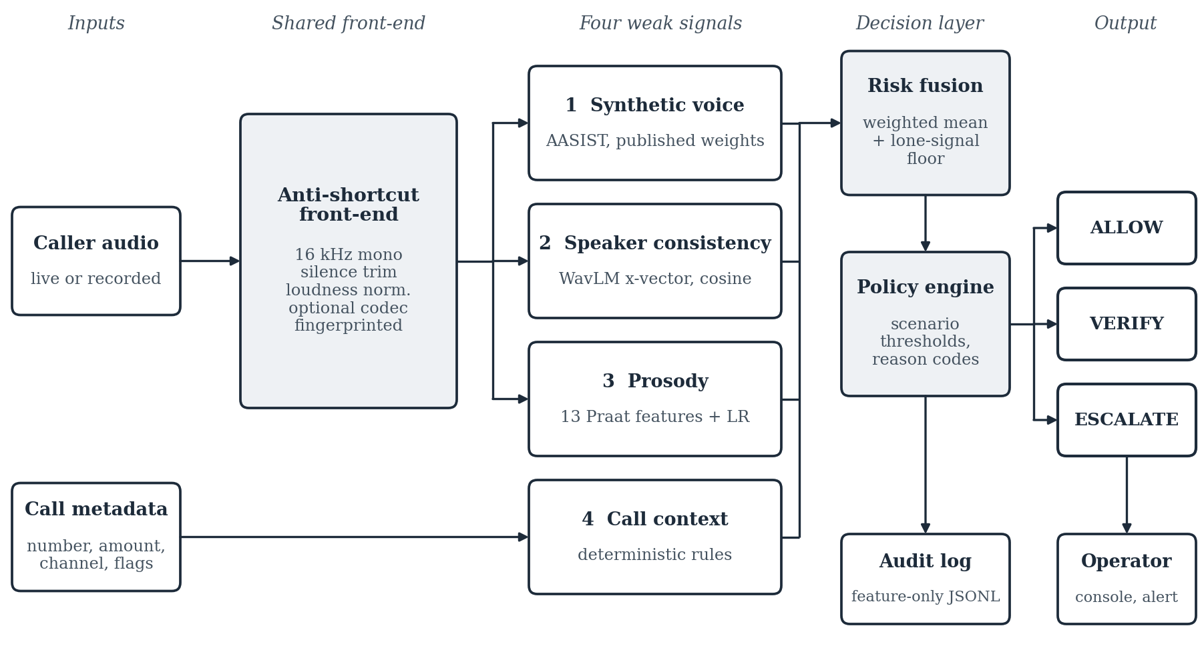
Fig. 1. VoiceGuard architecture. One anti-shortcut front-end feeds four signals (three from audio, one from call metadata). Fused risk is mapped by a scenario-aware policy to ALLOW/VERIFY/ESCALATE, logged feature-only, and shown to a human operator.

A. Anti-Shortcut Front-End
A classifier on handcrafted features scored 1.83% EER on the ASVspoof 2019 LA dev split. Re-scoring it on only the leading and trailing non-speech regions gave 13–15% EER, far below the ~50% expected of an uninformative input. Bona fide and spoof clips differ systematically in silence duration and loudness, probably a side effect of how the corpus was assembled, so a model can partly solve the task without learning anything about synthesis.
We close the shortcut with one front-end used for feature extraction, training and inference, identical for both classes: (1) resample to mono, 16 kHz; (2) trim leading/trailing silence uniformly and re-pad to a fixed margin; (3) EBU R128 loudness normalization and peak limiting; (4) optionally a telephony codec (via ffmpeg). Its settings hash to a 10-character fingerprint (640b0644ae for every result here), and results with different fingerprints are never tabulated together. After every model change a permanent gate re-runs the silence-only ablation: EER must lie within ~5 points of 50%, and below 40% means a leak and blocks trusting any other number from that run.

B. The Four Signals
Synthetic voice. AASIST [2] (vendored clovaai/aasist, published weights, not retrained by us) scores 4.04 s windows through the front-end; the streaming path smooths with an exponential moving average (EMA). The synthetic-voice threshold is 0.65.
Speaker consistency. The caller enrolls with ≈6 s of speech. Enrollment and each scoring window are embedded with a WavLM x-vector model (microsoft/wavlm-base-plus-sv [7]) and compared by cosine similarity; same-speaker similarity is ≈0.95 or higher on ≥6 s enrollments. A Platt calibrator maps similarity to mismatch risk and was verified on held-out speakers (ECE 0.389 → 0.181). Windows under 2.5 s are rejected, not scored, because short clips give spuriously high similarity.
Prosody/behavior. Thirteen Praat/Parselmouth features per window (F0 mean, SD, range and slope; voiced fraction; jitter local/RAP; shimmer local/APQ5; HNR; intensity variability; pause ratio; energy flux) feed a logistic regression trained on the ASVspoof 2019 LA training set. It is weak by design (26.3% dev EER) and contributes evidence partly independent of the acoustic detector’s failure modes.
Call context. A deterministic rule set scores caller-ID match with a known contact, banded transaction amount, channel and prior flags. It is the only non-acoustic signal, and one that an attacker with a perfect clone cannot easily control.

C. Risk Fusion
Let S be the signals present in a window (speaker is absent before enrollment or for short windows) and r_{s} ∈ [0,1] each signal’s risk. With base weights w_{spoof} = 0.45, w_{speaker} = 0.35, w_{prosody} = 0.25 and w_{context} = 0.20, the fused score is the weighted mean over present signals, renormalized:
F = Σ_{s∈S} [ w_{s} / Σ_{s′∈S} w_{s′} ] · r_{s} (1)
Lone-signal floor: if any present signal reaches τ_{alarm} = 0.80, F is floored at τ_{floor} = 0.68, so one strongly suspicious signal cannot be diluted by several reassuring ones. On the streaming path each signal has its own EMA constant, set by its volatility.

D. Policy Engine
Thresholds depend on the scenario, since the tolerable false-escalation rate differs between a support call and a privileged change (Table II). The engine also emits plain-language reason codes (e.g. “speaker mismatch: similarity 0.33 vs. enrolled voice”, “caller number not recognised”, “large transfer requested (INR 75,000)”) and a recommendation. Reads from a short or tiled window are marked provisional and capped at VERIFY, never a silent ESCALATE, until a full 4.04 s window confirms them; speech-onset VAD measures latency from when the caller starts talking. Weights and thresholds are documented operating points, not calibrated (Sec. VI).
TABLE II. POLICY THRESHOLDS BY CALL SCENARIO (FUSED SCORE, 0–1)
Scenario | Verify above | Escalate above
Routine support call | 0.55 | 0.75
Transaction / transfer | 0.40 | 0.65
Privileged change | 0.30 | 0.55

E. Audit Log and Interfaces
Every action change is appended to a JSONL log with per-signal scores, fused score, action, reasons, model and front-end version, git commit and timestamp, under a retention horizon with pruning. The write path rejects, recursively, any key carrying audio, waveform, transcript or embedding data, so privacy is enforced in code rather than by policy. A FastAPI session API (REST and WebSocket) and a gRPC transport share one SessionManager and were verified to give identical decisions on the same clip. A browser operator console shows the decision banner, fused-risk timeline, four signal meters, reason codes, editable call context, a simulated alert with acknowledge, and the audit trail. Servers bind to localhost only. 103 unit tests cover metrics, front-end, models, speaker, prosody, fusion, audit, API, VAD, calibration and min-tDCF.

IV. EXPERIMENTAL SETUP
Data. Official ASVspoof 2019 LA protocol files only: train for fitting, dev (known attacks A01–A06) for threshold selection, eval (unseen attacks A07–A19) as the in-domain test. In-the-Wild [1] is a cross-dataset test that is never trained on and never used to select a threshold. A random split is never used, since it leaks speakers and attacks. IndicCall-Eval attacks are generated with MMS-TTS [9]; no bona fide multilingual speech is included yet.
Systems. The Gen-1 baseline uses 61-dimensional handcrafted features with an XGBoost/LightGBM/CatBoost ensemble. The second system is AASIST with published weights. Both run through the same front-end. RawNet2, AASIST-L and SSL-AASIST (frozen wav2vec2/XLS-R with an AASIST back-end) are implemented and unit-tested but not trained at scale; a 2-epoch AASIST run (dev EER 34.1% → 26.6%) only confirms the training loop works and is used nowhere else.
Metrics. EER (higher score = more bona fide) is the headline, with per-attack EER on eval, scoring each attack’s spoof clips against all bona fide clips so one easy attack cannot mask failures elsewhere. We add min-tDCF using the organizers’ reference implementation and baseline ASV scores (0 = perfect, 1 = no better than no countermeasure). Accuracy is not reported because the class prior is roughly 9:1 bona fide to spoof. For the multilingual pilot we report synthetic recall, the fraction of clips scored above 0.65, since no bona fide set exists to compute EER.
Reproducibility. Python 3.11, seed 42, a single consumer 6 GB GPU. Every result row carries provenance (train and test set, model, seed, front-end fingerprint, score direction, git commit, timestamp) written by the evaluation harness.

V. RESULTS

A. Silence Shortcut and Detection Performance
After the fix, silence-only EER is near chance for the baseline (59.0%; 55–61% across runs) and AASIST (41.3%), so both models key on speech rather than the artifact; the unprotected pipeline scored 13–15%. AASIST’s dev EER is 9.6% against ~1% published because the front-end removes the artifact it had partly learned, and the higher figure is the honest one. The baseline is better on known attacks (7.0% vs. 9.6%) but the ranking reverses on unseen attacks (33.4% vs. 23.3%) and on In-the-Wild (58.2% vs. 35.8%). AASIST’s 35.8% is a clear gain but far from the < 15% we treat as a deployable target. Fig. 3a summarizes the comparison.
TABLE III. EER (%) THROUGH THE ANTI-SHORTCUT FRONT-END (FINGERPRINT 640B0644AE, SEED 42). SILENCE-ONLY CHANCE = 50%
System | Dev (known) | Eval (unseen) | In-the-Wild | Silence-only
Handcrafted 61-dim + GBM (Gen-1) | 7.0 | 33.4 | 58.2 | 59.0
AASIST, published weights | 9.6 | 23.3 | 35.8 | 41.3

B. Per-Attack Generalization
Fig. 2 splits the eval result by attack. AASIST is near-perfect on A08 and A09 (1.6% and 0.7%) but fails on A10 (52.1%, worse than chance), A12 (43.7%), A07 (40.0%) and A15 (39.0%); A10 and A12 use generators unlike those in its training set. A spread from 0.7% to 52.1% inside one partition shows that a single aggregate EER is not representative of real-world behavior.
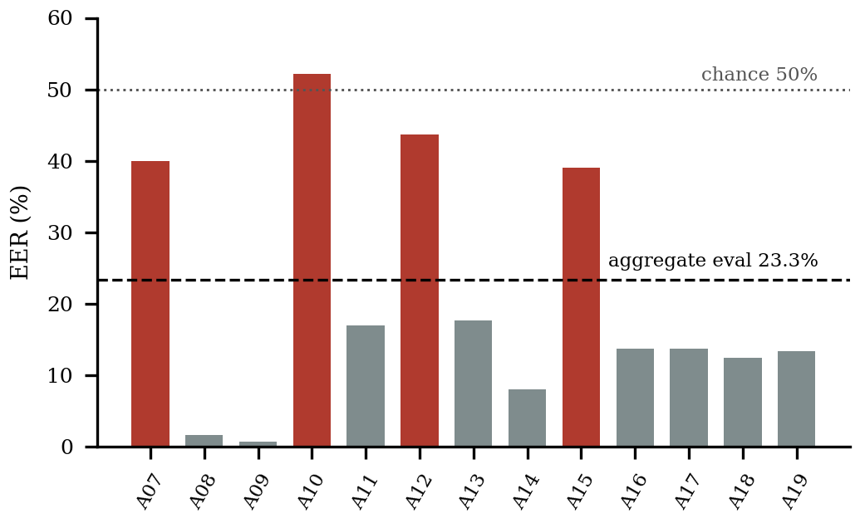
Fig. 2. AASIST per-attack EER on the eval partition (unseen attacks). Dark bars exceed 30%.

C. Deployment-Oriented Metric
AASIST’s min-tDCF is 0.288 on dev and 0.588 on eval. This independently computed metric tells the same story as EER: the countermeasure is usable on known attacks and loses a large share of its benefit on unseen ones.

D. Standalone Signal Performance
The prosody classifier scores 26.3% dev EER alone, weaker than the acoustic signal, and is kept as an independent fusion input. Speaker consistency supplied the decisive evidence in the worked case (Sec. V-E) and is the only signal whose calibrator held up on held-out data (Sec. VI).

E. System-Level Worked Example
A session is enrolled with a genuine speaker, a benign segment is scored, and then a different, modern neural-TTS voice is scored with call context set to an unrecognized caller and a requested INR 75,000 transfer (Table IV). The acoustic signal alone (29/100) is below the 65/100 synthetic-voice threshold and would not flag the call. Speaker cosine similarity is 0.33, mapping to risk 100/100 and triggering the lone-signal floor. The fused score is 68/100 and the transaction policy (escalate above 0.65) returns ESCALATE, with reason codes for the low similarity, the unrecognized number and the amount. Without the floor the weighted mean would be 53/100, only VERIFY. This is one case, not a detection rate.
TABLE IV. WORKED EXAMPLE: PER-SIGNAL RISK (0–100) AND DECISION
Call | Spoof | Spk. | Pros. | Ctx. | Decision (fused)
Benign | 0 | 0 | 49 | 0 | ALLOW (10)
Cloned voice† | 29 | 100 | 20 | 65 | ESCALATE (68)
†Modern neural-TTS clone, unrecognized caller, INR 75,000 transfer requested.
A second public deepfake-audio classifier, tried as an alternative acoustic signal, did worse than front-end-corrected AASIST and also missed this clone, so swapping one detector for another is no substitute for fusion.

F. IndicCall-Eval: Multilingual Pilot
We generated short bank-call-style synthetic attacks with MMS-TTS [9] in English, Hindi, Tamil, Bengali and Marathi (40 clips per language, native script, half passed through a randomly chosen telephony codec) and scored them with the same AASIST-based detector and 0.65 threshold (Table V).
TABLE V. INDICCALL-EVAL PILOT (N = 40 PER LANGUAGE, THRESHOLD 0.65)
Language | Synthetic recall (%) | Mean prosody score (%)
Marathi | 85.0 | 63
Hindi | 57.5 | 55
Tamil | 55.0 | 73
Bengali | 37.5 | 43
English | 7.5 | 47

The detector, trained only on English ASVspoof 2019, flags Indian-language synthesis more often than English synthesis from the same TTS system. A plausible reading is that non-English synthesis lies farther from the “natural English” distribution the model learned as bona fide, so its artifacts trip the detector more often. This is not evidence of multilingual robustness. Recall at one threshold says nothing about false accepts on genuine non-English speech; a consented bona fide slice recorded by the team (protocol in docs/indic_eval.md) is needed to turn Table V into per-language EER.

VI. DISCUSSION AND LIMITATIONS
The shortcut belongs to the corpus, not to our code. Any ASVspoof 2019 LA evaluation that does not equalize silence and loudness across classes risks the same inflation, so the front-end and gate are reusable independently of VoiceGuard.
Fusion compensates for a weak acoustic signal but does not fix it. The worked case depended on speaker mismatch being strong evidence. An attacker who evades the caller-ID check and uses a clone close enough to pass speaker verification would not be caught by this mechanism. We claim only that the fused system catches more than any single signal on the cases measured.
Calibration helped one signal of three. The speaker Platt calibrator generalized to held-out speakers (ECE 0.389 → 0.181). Spoof and prosody calibrators, fit and measured the same way, made unseen-attack and cross-dataset behavior worse and were not shipped; both stay on ad-hoc operating points. (Fig. 3b)
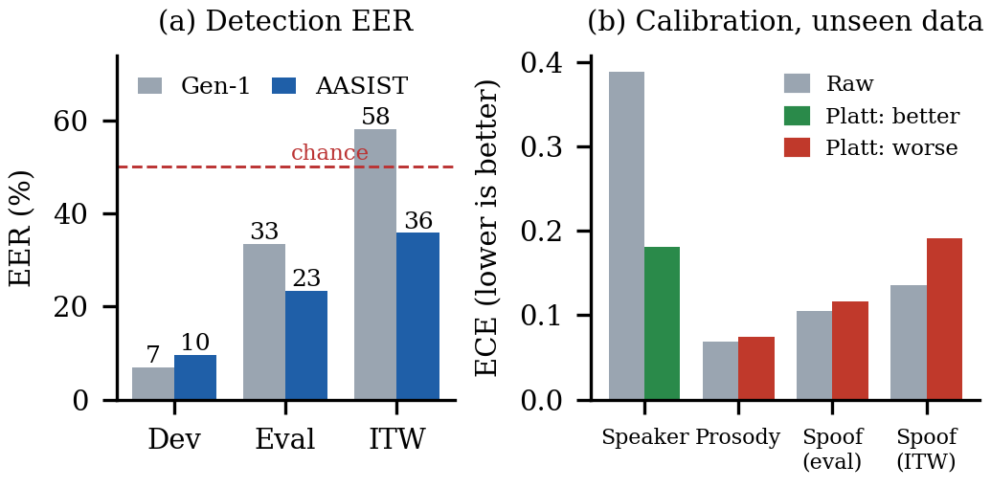
Fig. 3. (a) EER of the two systems on known (dev), unseen (eval) and found (In-the-Wild) audio. (b) Expected calibration error before and after Platt scaling on unseen data: only speaker consistency improves.
Limitations. (1) The detector is published, not self-trained; 35.8% In-the-Wild EER is not deployable, and full training (≈50 min per epoch, 30–40 epochs needed) does not fit our laptop GPU. (2) Fusion weights and policy thresholds are tuned by inspection, not calibrated on labeled risk data. (3) A confirmed acoustic read needs a 4.04 s window; VAD and provisional reads reduce but do not remove this latency. (4) Alerts are simulated, and the REST/gRPC servers have no auth or TLS (localhost only). (5) IndicCall-Eval uses synthetic attacks from one open TTS family, n = 40 per language, with no bona fide slice. (6) Adaptive attackers aware of the fusion logic are not evaluated. (7) min-tDCF covers AASIST only, and ASVspoof 2021 DF is not yet included.

VII. ENGINEERING LESSONS
- Silent checkpoint failure. A WavLM speaker-verification checkpoint stored in the older weight_g/weight_v format loaded without error but with randomly initialized positional-convolution weights under a newer transformers release, silently degrading same-speaker similarity. We now copy the raw weights into the parametrization API at load time; a same-speaker/different-speaker check catches this class of bug.
- Short clips lie. Below ≈2.5 s, x-vector similarity is unreliable, hence the minimum-duration gate.
- One smoothing constant destabilizes fusion. A single EMA constant made the fused decision oscillate between ALLOW and VERIFY on stable audio because prosody is more volatile; per-signal constants fixed it.
- Compute. One AASIST epoch takes ≈50 min on a 6 GB laptop GPU, so full training moves to a Kaggle T4 rather than reporting an under-trained model. A datasets-library release dropped script-based loaders and broke two planned data sources, so multilingual bona fide data awaits team recordings.

VIII. FUTURE WORK AND CONCLUSION
Future work. (1) Train AASIST (before SSL-AASIST) on a Kaggle T4, fine-tuned on modern neural-TTS output, and adopt it only if it beats the published-weights baseline under the identical protocol (target < 15% In-the-Wild EER). (2) Record the consented multilingual bona fide slice so Table V becomes per-language EER, then scale toward IndicSynth [10]. (3) Add ASVspoof 2021 DF and extend min-tDCF to every system. (4) Evaluate adaptive attackers who target the weakest present signal. (5) Production hardening: real alerts, auth/TLS, on-device inference.
Conclusion. A widely used benchmark can be partly solved by an artifact unrelated to synthesis, and even after removing it a strong published detector generalizes too poorly (35.8% In-the-Wild EER) to be deployed alone. VoiceGuard therefore treats detection as one of four weak signals fused into an auditable, policy-driven decision with a human in the loop, and in a worked case it escalates a clone that the acoustic signal alone rates 29/100. What transfers beyond our system is the front-end with its silence gate, per-attack, cross-dataset and min-tDCF reporting, and an honest record of what failed first.

ACKNOWLEDGMENT
Drafting, literature search and formatting were assisted by an AI writing assistant (Claude, Anthropic). Experiments, measurements, system design and conclusions are the authors' own and were checked against the project's code and logged results. We thank the SIH26104 problem-statement setters.

REFERENCES
[1] N. M. Müller, P. Czempin, F. Dieckmann, A. Froghyar, and K. Böttinger, “Does audio deepfake detection generalize?,” in Proc. Interspeech, 2022. arXiv:2203.16263.
[2] J. Jung, H.-S. Heo, H. Tak, H. Shim, J. S. Chung, B.-J. Lee, H.-J. Yu, and N. Evans, “AASIST: Audio anti-spoofing using integrated spectro-temporal graph attention networks,” in Proc. IEEE ICASSP, 2022. arXiv:2110.01200.
[3] X. Wang et al., “ASVspoof 2019: A large-scale public database of synthesized, converted and replayed speech,” Computer Speech & Language, vol. 64, 2020. arXiv:1911.01601.
[4] X. Wang, H. Delgado, H. Tak, J. Jung, H. Shim, M. Todisco, I. Kukanov, X. Liu, M. Sahidullah, T. Kinnunen, N. Evans, K. A. Lee, and J. Yamagishi, “ASVspoof 5: Crowdsourced speech data, deepfakes, and adversarial attacks at scale,” in Proc. ASVspoof 5 Workshop (Interspeech Satellite), 2024. arXiv:2408.08739.
[5] N. M. Müller, N. Evans, H. Tak, P. Sperl, and K. Böttinger, “Harder or different? Understanding generalization of audio deepfake detection,” in Proc. Interspeech, 2024. arXiv:2406.03512.
[6] H. Tak, M. Kamble, J. Patino, M. Todisco, and N. Evans, “RawBoost: A raw data boosting and augmentation method for speech anti-spoofing,” in Proc. IEEE ICASSP, 2022. arXiv:2111.04433.
[7] S. Chen et al., “WavLM: Large-scale self-supervised pre-training for full stack speech processing,” IEEE J. Sel. Topics Signal Process., vol. 16, no. 6, 2022. arXiv:2110.13900.
[8] D. Snyder, D. Garcia-Romero, G. Sell, D. Povey, and S. Khudanpur, “X-vectors: Robust DNN embeddings for speaker recognition,” in Proc. IEEE ICASSP, 2018.
[9] V. Pratap et al., “Scaling speech technology to 1,000+ languages,” 2023. arXiv:2305.13516.
[10] D. V. Sharma, V. Ekbote, and A. Gupta, “IndicSynth: A large-scale multilingual synthetic speech dataset for low-resource Indian languages,” in Proc. ACL, 2025.
[11] L. Pham, P. Lam, D. Tran, H. Tang, T. Nguyen, A. Schindler, F. Skopik, A. Polonsky, and C. Vu, “A comprehensive survey with critical analysis for deepfake speech detection,” 2024. arXiv:2409.15180.
[12] J. Yi, R. Fu, J. Tao, S. Nie et al., “ADD 2022: The first audio deep synthesis detection challenge,” in Proc. IEEE ICASSP, 2022. arXiv:2202.08433.
[13] C. Sun, S. Jia, S. Hou, and S. Lyu, “AI-synthesized voice detection using neural vocoder artifacts,” in Proc. IEEE/CVF CVPR Workshops, 2023. arXiv:2304.13085.

