**Atharva Phand – 111803092**

**Ghanshyam Patil – 111803091**

**PROJECT: HOTEL MANAGEMENT SYSTEM**

A Hotel Management System enables a hotel or a group of hotels to manage front-office capabilities; such as booking reservations, guest check-in/check-out, room assignment, managing room rates and billing.

The project contains an admin side and user side. The admin side manages every operation like room bookings, payment, managing rooms, etc. For the users, they can go through the homepage, book rooms, read about various services the hotel has to offer.

**Problem Statement** – To build a database management system for hotels which allows to handle all the operations like room bookings, payments and many others smoothly without any errors and loss of data.

**Relational Schemas**

1. Customer

* Customer ID, Name, Address, No of People, Check In, Check Out, Mobile Number
* Primary Key – Customer ID

1. Room

* Customer ID, Room ID
* Foreign Key – Customer ID

1. Room Status

* Room ID, Status, Type
* Primary Key – Room ID

1. Room Type

* Type, Price, Max Accommodation

1. Pays

* Customer ID, Bill ID, Payment Method
* Primary Key – Bill ID

1. Bill

* Bill ID, Check Out, Total Bill
* Foreign Key – Bill ID

1. Admin

* Admin ID, Username, Password
* Primary Key – Admin ID

1. Restaurant

* Customer ID, Name, Mobile Number, No of people, Total Bill, Date, Time
* Primary Key – Customer ID

1. Employee

* Employee Name, ID, Phone Number, Department, Salary
* Primary Key - ID

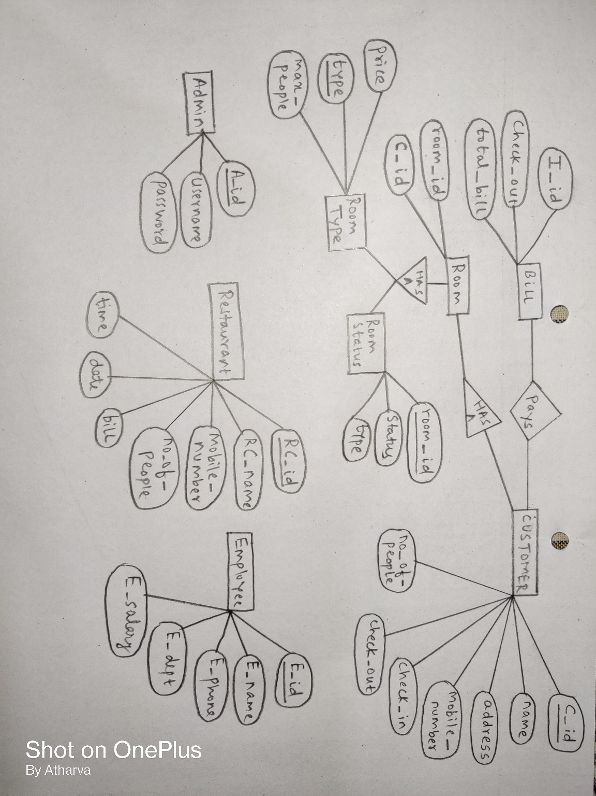

Normalization :

1 NF condition no multivalue attribute

2NF: A relation will be in 2NF if it is in 1NF and all non-key attributes are fully functional dependent on the primary key.

3NF :A relation will be in 3NF if it is in 2NF and no transition dependency exists.

1. Customer

Customer ID -> { Name, Address, No of People, Check In, Check Out, Mobile Number}

Primary Key – Customer ID

All normalization condition are satisfied by the above table

1. Room

Room table( Customer ID, Room ID, Status, Type ,Price, Max Accommodation)

Normalise form:-

**Room**

Customer ID, Room ID

Foreign Key – Customer ID

**Room Status**

Room ID, -> Status, Type

Primary Key – Room ID

**Room Type**

Type –> Price, Max Accommodation

Below all the table satisfies Normalization condition.

**Pays**

Customer ID, Bill ID, Payment Method

Primary Key – Bill ID

**Bill**

Bill ID, Check Out, Total Bill

Foreign Key – Bill ID

**Admin**

Admin ID, Username, Password

Primary Key – Admin ID

**Restaurant**

Customer ID, Name, Mobile Number, No of people, Total Bill, Date, Time

Primary Key – Customer ID

**Employee**

Employee Name, ID, Phone Number, Department, Salary

Primary Key - ID