# TravelBookingGraphQl

Grahql user information

query {

   userInformationById(userId: 1){

    username,

    email,

     busPhone,

        prov,

         postal,

         country

    city

  }

}

{

  "data": {

    "userInformationById": {

      "username": "johndoe",

      "email": "123",

      "busPhone": null,

      "prov": "",

      "postal": "123",

      "country": null,

      "city": "123"

    }

  }

}

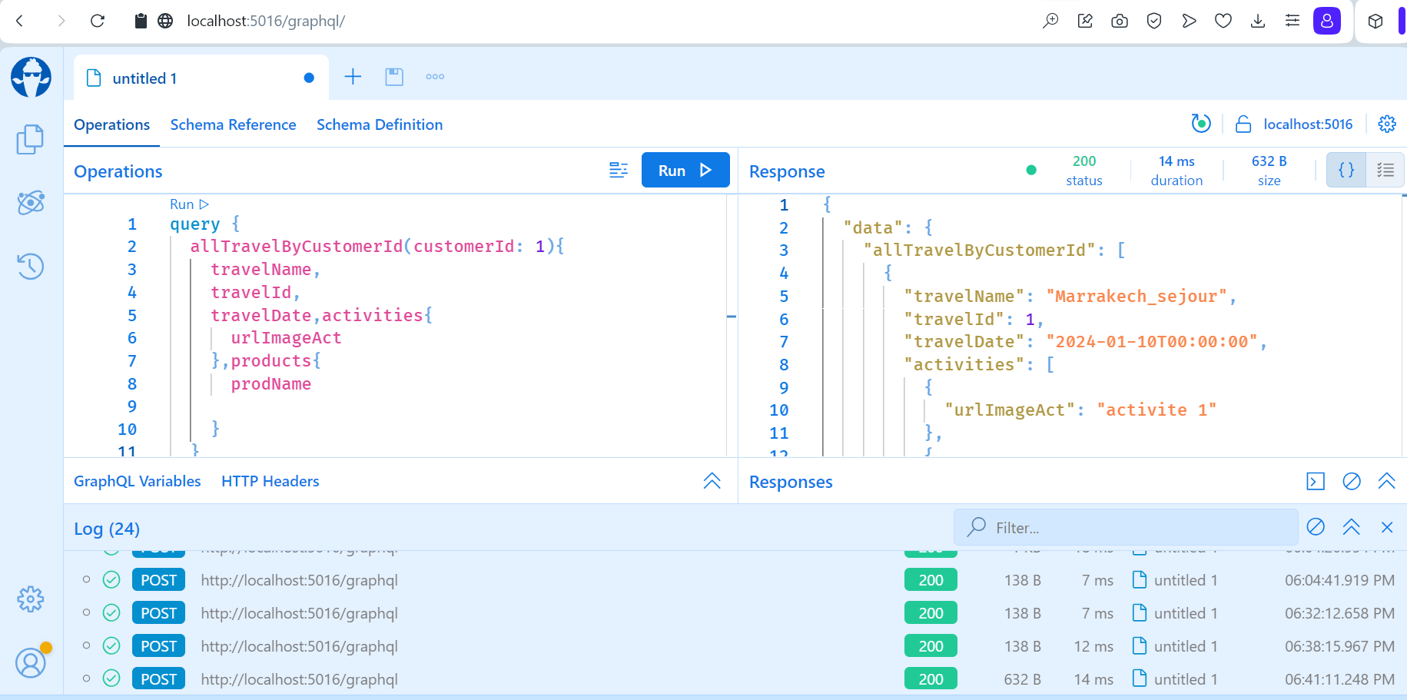

Graphql Travel with list <product(hotel,car)> ,list <activite> ,Aircraft

query {

  allTravelByCustomerId(customerId: 1){

    travelName,

    travelId,

    travelDate,activities{

      urlImageAct

    },products{

      prodName

    }

    ttname,

    activities{

      urlImageAct

    }

     companyName,

      flightNumber,

      seatNumber

  }

}

{

  "data": {

    "allTravelByCustomerId": [

      {

        "travelName": "Marrakech_sejour",

        "travelId": 1,

        "travelDate": "2024-01-10T00:00:00",

        "activities": [

          {

            "urlImageAct": "activite 1"

          },

          {

            "urlImageAct": "activite 1"

          },

          {

            "urlImageAct": "activite 1"

          }

        ],

        "products": [

          {

            "prodName": "Golden Tulip"

          },

          {

            "prodName": "BMW"

          },

          {

            "prodName": "Movenpick"

          }

        ],

        "ttname": "Trip Business",

        "companyName": "TUNISAIR",

        "flightNumber": "ABC123",

        "seatNumber": "12A"

      },

      {

        "travelName": "Tunis_Séjour",

        "travelId": 2,

        "travelDate": "2024-01-10T00:00:00",

        "activities": [],

        "products": [],

        "ttname": "Trip Business",

        "companyName": "AIRFRANCE",

        "flightNumber": "ABC123",

        "seatNumber": "12A"

      },

      {

        "travelName": "Cairo_Sejour",

        "travelId": 4,

        "travelDate": "2024-02-10T00:00:00",

        "activities": [],

        "products": [],

        "ttname": "Trip Business",

        "companyName": "TUNISAIR",

        "flightNumber": "ABC123",

        "seatNumber": "12A"

      },

      {

        "travelName": "Manhatan_Sejour",

        "travelId": 5,

        "travelDate": "2024-02-10T00:00:00",

        "activities": [],

        "products": [],

        "ttname": "Trip Business",

        "companyName": "TUNISAIR",

        "flightNumber": "ABC123",

        "seatNumber": "12A"

      }

    ]

  }

}

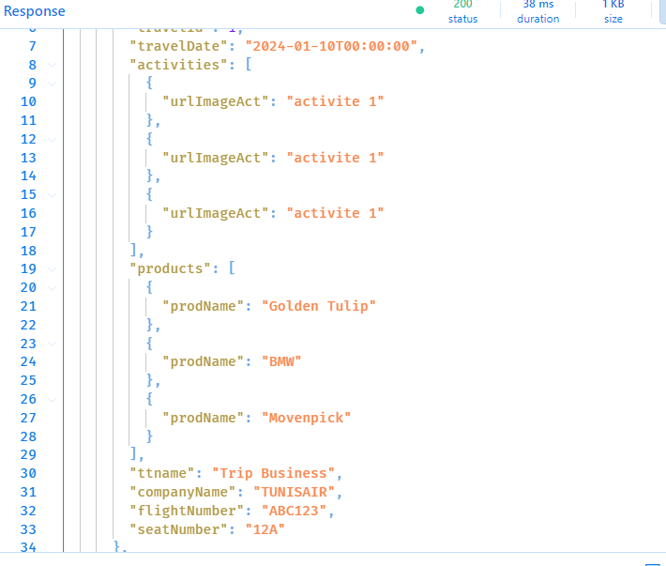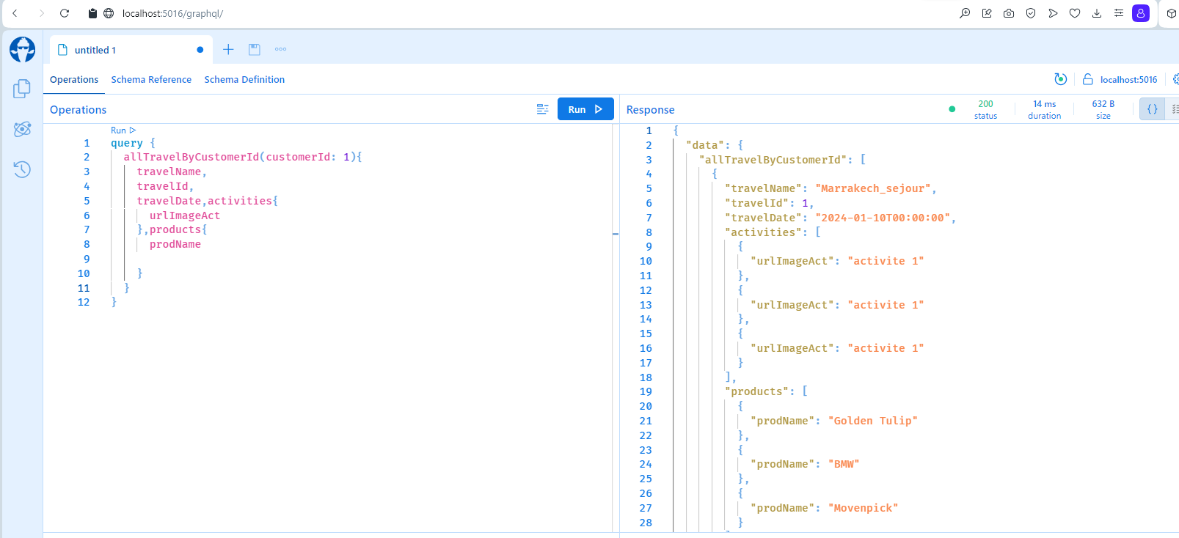

Graphql liste of product liee a un travel by id

query {

 allProductsByTravelId(travelId: 1){

    prodName,

    prodDescription,

  }

}

{

  "data": {

    "allProductsByTravelId": [

      {

        "prodName": "Golden Tulip",

        "prodDescription": "Hotel Description"

      },

      {

        "prodName": "Movenpick",

        "prodDescription": "Hotel Description"

      },

      {

        "prodName": "BMW",

        "prodDescription": "Car Description"

      }

    ]

  }

}

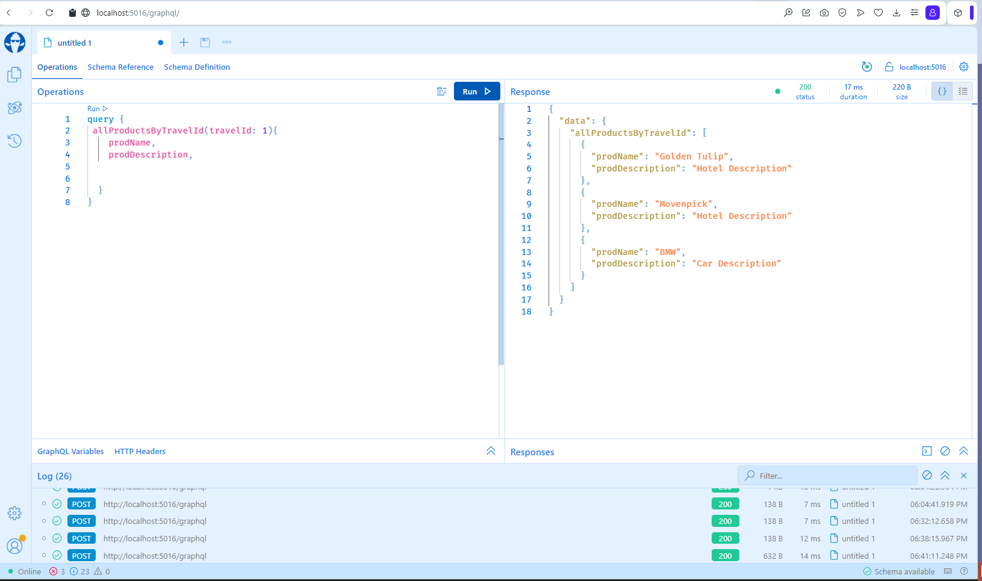

Graphql logn

query {

 login(username: "string",password: "string"){

    username,

    userId,

  }

}

{

  "data": {

    "login": {

      "username": "string",

      "userId": 6

    }

  }

}

