2.1 Scope
Item | Detail
Components tested | /login, the dashboards (/dashboard/*), the admin pages (/admin/*), /account-review, /reassignment and the REST API under /api/v1/*
Technology observed | Next.js 16.2.10 (React 19), FastAPI / uvicorn, nginx, AWS Application Load Balancer
Authorization | Confirmed in writing by the engagement owner: full active testing, including controlled brute force and injection tests
Test account | Dedicated ADMIN-role account supplied by the client (credentials stored only in local engagement evidence files)
Destructive tests | Brute force was capped at 45 attempts, and password-policy tests were reverted immediately. No data-integrity attacks were performed beyond the incident in section 2.5
Risk levels reported | High, Medium, Low, Informational

2.2 Approach
The assessment followed the OWASP WSTG checklist in the following phases: Information Gathering, Configuration and Deployment, Identity Management, Authentication, Authorization, Session Management, Injection, Error Handling, Cryptography, Business Logic, Client-side and API testing. Each test was run with the commands listed in the process screenshots, and all raw output was stored in the engagement evidence folder.
Active testing covered SQL, NoSQL, LDAP and command injection (sqlmap at level 3 and risk 2, plus manual payload batteries), cross-site scripting verified in a headless browser, controlled brute force, session and JWT attacks, authorization checks, and configuration review. The tools used are listed below.
Tool | Version / note | Used for
curl | system | HTTP and API requests, header analysis, payload batteries
nmap | 7.99 | Service, TLS and cipher enumeration
whatweb | system | Technology fingerprinting
ffuf | system | API endpoint and content discovery (2 wordlists, about 400 entries)
sqlmap | 1.10.9#stable | SQL-injection testing (level 3, risk 2, techniques BEUSTQ)
openssl | system | TLS and certificate analysis
Python 3 | 3.x | Brute-force harness, JWT cracking, payload encoding
rockyou.txt | 14,344,391 entries | JWT HS256 secret dictionary attack

2.3 Risk rating
Rating | Meaning
High | Directly exploitable weakness likely to cause significant compromise. Fix immediately.
Medium | Weakness that meaningfully reduces security or enables attacks in combination with other flaws. Fix in the near term.
Low | Minor weakness or information leakage with limited direct impact. Fix as part of routine hardening.
Informational | Observation or hardening recommendation with no direct security impact. No urgent fix required.

Each finding is mapped to the relevant WSTG test, a CWE identifier where one applies, and the OWASP Top 10 (2021) category.

2.4 Target and technology profile
Item | Detail
Public URL | https://coe.cuetrans.com:4000/login (plain HTTP on port 4000 returns 400)
Edge / server | awselb/2.0, then nginx, then uvicorn (Python FastAPI)
Frontend | Next.js 16.2.10 (App Router), React 19; X-Powered-By: Next.js is disclosed
TLS | Wildcard certificate CN=*.cuetrans.com (Amazon RSA 2048 M04), valid 9 August 2026 to 22 February 2027. TLS 1.0 and 1.1 rejected; TLS 1.2 and 1.3 only, cypher grade A
Authentication | LDAP / corporate identity (auth_type: password). An OneLogin SSO path is present but inactive. MFA fields exist but mfa_enrolled is false
Session | pg_session JWT (HS256), claims sub / iat / exp, lifetime 28,800 s (8 hours); HttpOnly, SameSite=Lax, no Secure flag
API | /api/v1/*, requires the X-API-Key header (value hardcoded in the JavaScript bundle) plus the session cookie for data endpoints
Roles discovered | ADMIN, CDO, ACCOUNT_MANAGER, GEO_HEAD, PROJECT_MANAGER, TEAM_MEMBER, DELIVERY_EXCELLENCE, PMO
API endpoints | /auth/{config,login,logout,me,change-password}, /auth/onelogin/login, /users, /roles, /accounts, /projects, /geos, /notifications, /dashboard/summary

2.5 Testing incident disclosure
During HTTP-method enumeration (WSTG 4.2.6), the command curl -X DELETE against /api/v1/users/{id} returned HTTP 204 and permanently deleted the user record hari.g@bahwancybertek.com. The API performs a hard delete with no confirmation, soft delete or trash. The incident is the direct evidence for VAPT-06.
Remediation performed immediately: the original record, captured minutes earlier in evidence/14_users_list.json, was re-created through POST /api/v1/users (HTTP 201). The account is active with the ADMIN role again. Two residual differences remain: the record has a new UUID (89df3c74-7133-4310-8951-3bd1258b4fee instead of 8dcc6aa3-...), and password_set is now false. If that user had a local password, it must be set again; LDAP and SSO login are unaffected. Verification: GET /users?limit=200 returned a total of 2 users.
After the incident, method enumeration was performed with OPTIONS first. The full log is stored in evidence/00_INCIDENT_LOG.txt.
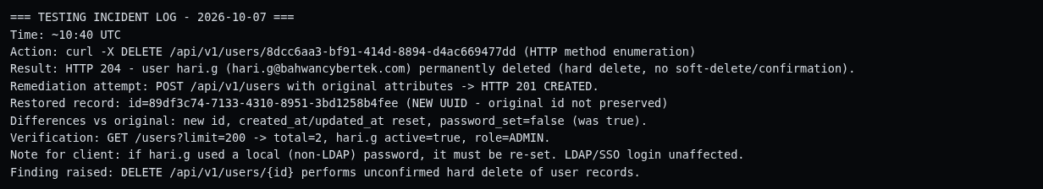
Process screenshot 30 - Testing incident: user delete and restore - WSTG 4.10.2/4.12.4

Summary of Findings
ID | Finding | Risk | WSTG | CWE
VAPT-01 | No Brute-Force, Rate-Limit or Account-Lockout Protection | High | 4.4.3, 4.10.5, 4.10.7 | CWE-307
VAPT-02 | Logout Does Not Invalidate the Session Token Server-Side | High | 4.6.6, 4.6.9 | CWE-613
VAPT-03 | Clickjacking: No X-Frame-Options or CSP frame-ancestors | Medium | 4.11.9, 4.2.12 | CWE-1021
VAPT-04 | Strict-Transport-Security (HSTS) Header Not Set | Medium | 4.2.7 | CWE-319
VAPT-05 | Hardcoded API Key in Client-Side JavaScript | Medium | 4.1.5, 4.12.1 | CWE-798
VAPT-06 | Unconfirmed Hard Delete of User Records (No Recovery) | Medium | 4.10.2, 4.10.6, 4.12.4 | CWE-841
VAPT-07 | Weak Password Policy (Length Only, No Complexity Check) | Medium | 4.4.7, 4.4.9 | CWE-521
VAPT-08 | Account Enumeration via Response Timing | Medium | 4.3.4 | CWE-208
VAPT-09 | Missing Ancillary Security Headers | Low | 4.2.14 | CWE-693
VAPT-10 | Technology and Validation-Schema Disclosure | Low | 4.1.2, 4.2.2, 4.8.1 | CWE-497
VAPT-11 | Session Cookie Missing the Secure Attribute | Low | 4.6.2 | CWE-614
VAPT-12 | Page-Route Authorization Enforced Only on the Client Side | Low | 4.5.2 | CWE-602
VAPT-13 | No Multi-Factor Authentication for Privileged Accounts | Informational | 4.4.11 | CWE-308
VAPT-14 | Static HS256 JWT Signing Secret | Informational | 4.6.10 | -
VAPT-15 | Inactive SSO Endpoint Exposed | Informational | 4.2.5, 4.12.1 | -

The WSTG column gives the OWASP Web Security Testing Guide test references on which each finding is based.

3.1 Security controls verified
- TLS 1.0 and 1.1 are disabled; TLS 1.2 and 1.3 are used with strong AEAD ciphers and a valid wildcard certificate.
- The session cookie is HttpOnly with SameSite=Lax, and Cache-Control: no-store is applied to all authenticated pages (the back button after logout shows no cached content).
- The login failure message is generic, so there is no message-based account enumeration.
- The API returns HTTP 401 for every data endpoint without a session, so no unauthenticated data is leaked.
- sqlmap at level 3 and risk 2 (all techniques) found zero injection points across the login JSON, query parameters, User-Agent and Referer. NoSQL, LDAP and command-injection payloads were rejected or returned generic errors.
- No cross-site scripting executed: payloads were JSON-escaped into the framework payload, and no browser dialog fired.
- No open redirect, host-header reflection, CORS origin reflection or cache-poisoning vector was found.
- Session fixation, JWT tampering, alg=none tokens and wrong or missing API keys were all rejected with HTTP 401.
- A default-credential spray with 8 common pairs was rejected, and no self-registration endpoints exist.
- Development and debug surfaces are closed: /.env, /package.json, /openapi.json, /docs, /redoc, /swagger and /graphql all return 404, and TRACE and DEBUG are blocked.
- Strict type validation on query and body parameters returns HTTP 422 before data is reached.
- The JWT HS256 secret resisted a dictionary attack of 14.3 million candidates.
Supporting screenshots for these checks are included in Appendix 7.3.

Detailed Findings

VAPT-01: No Brute-Force, Rate-Limit or Account-Lockout Protection
Risk rating | High
WSTG | 4.4.3, 4.10.5, 4.10.7
CWE | CWE-307
OWASP Top 10 | A07:2021 Identification and Authentication Failures
Affected URL | https://coe.cuetrans.com:4000/api/v1/auth/login (and the API generally)

Description
The login API accepts an unlimited number of failed authentication attempts. No rate limit, CAPTCHA, progressive delay or account lockout is applied, either per account or per IP address.
Evidence
A test harness sent 45 consecutive failed logins (30 sequential brute-force attempts and 15 rapid-fire requests with no delay) for a valid account. Every request returned HTTP 401, no HTTP 429 response was seen, and the correct password still returned HTTP 200 immediately afterwards, proving the account was never locked. No IP-based throttling was observed on any other API endpoint tested.
POST /api/v1/auth/login {"identifier":"<test account>","password":"<wrong>"}
-> 45 failed attempts, all HTTP 401, zero HTTP 429, no lockout
-> immediate correct-password login: HTTP 200 (account never locked)
Evidence files: evidence/17_bruteforce_results.json, tools/bruteforce.py

Impact
Online password guessing against any account, including ADMIN, is unbounded. Combined with LDAP-backed corporate accounts, this enables credential stuffing at line speed. At roughly 558 ms per request, a single connection can still make about 1,500 attempts per hour.
Recommendation
Implement per-account and per-IP sliding-window rate limits (for example 5 attempts per 15 minutes, followed by exponential back-off), progressive delays, and lockout or risk-based challenges after repeated failures. Add central WAF or API-gateway throttling with alerting, and require MFA for administrative actions.
References
- https://owasp.org/www-project-web-security-testing-guide/
- https://cheatsheetseries.owasp.org/cheatsheets/Authentication_Cheat_Sheet.html

VAPT-02: Logout Does Not Invalidate the Session Token Server-Side
Risk rating | High
WSTG | 4.6.6, 4.6.9
CWE | CWE-613
OWASP Top 10 | A07:2021 Identification and Authentication Failures
Affected URL | https://coe.cuetrans.com:4000/api/v1/auth/logout

Description
Logout returns HTTP 200 and clears the cookie in the browser (Max-Age=0), but the JSON Web Token (JWT) remains valid at the API. There is no server-side revocation list and no token versioning.
Evidence
Replaying the pre-logout token against /auth/me still returned HTTP 200 with the full user profile, and this remains possible until the token expires naturally (up to 8 hours). A fresh token could also be issued after logout, confirming that no server-side session state is revoked.
curl -X POST .../auth/logout -b "pg_session=$TOK" -> HTTP 200, Set-Cookie pg_session=""; Max-Age=0
curl .../auth/me -b "pg_session=$TOK" -> HTTP 200 (token STILL VALID; expected 401)
Evidence files: evidence/06_cookies.txt, evidence/27_evidence_session.html
Impact
Any stolen token (through XSS elsewhere, a shared device, proxy or log capture, or an unattended laptop) continues to grant full access for up to 8 hours after the user believes they have logged out. This is a direct violation of logout expectations and is especially problematic on shared or kiosk workstations.
Recommendation
Revoke tokens on the server at logout: add a jti claim and maintain a denylist until expiry, or switch to server-side sessions (opaque token and session store) with deletion on logout. Reduce the absolute lifetime and add an idle timeout for privileged roles.
References
- https://cheatsheetseries.owasp.org/cheatsheets/Session_Management_Cheat_Sheet.html
- https://cheatsheetseries.owasp.org/cheatsheets/JSON_Web_Token_for_Java_Cheat_Sheet.html

VAPT-03: Clickjacking: No X-Frame-Options or CSP frame-ancestors
Risk rating | Medium
WSTG | 4.11.9, 4.2.12
CWE | CWE-1021
OWASP Top 10 | A05:2021 Security Misconfiguration
Affected URL | https://coe.cuetrans.com:4000/login

Description
The application sends neither an X-Frame-Options header nor a Content-Security-Policy header with a frame-ancestors directive, so browsers allow the pages to be embedded in a frame on any other site.
Evidence
A local proof-of-concept page successfully framed the live /login page inside an attacker-controlled iframe (Screenshot 08). The header analysis confirms that both protections are absent (Screenshot 16).
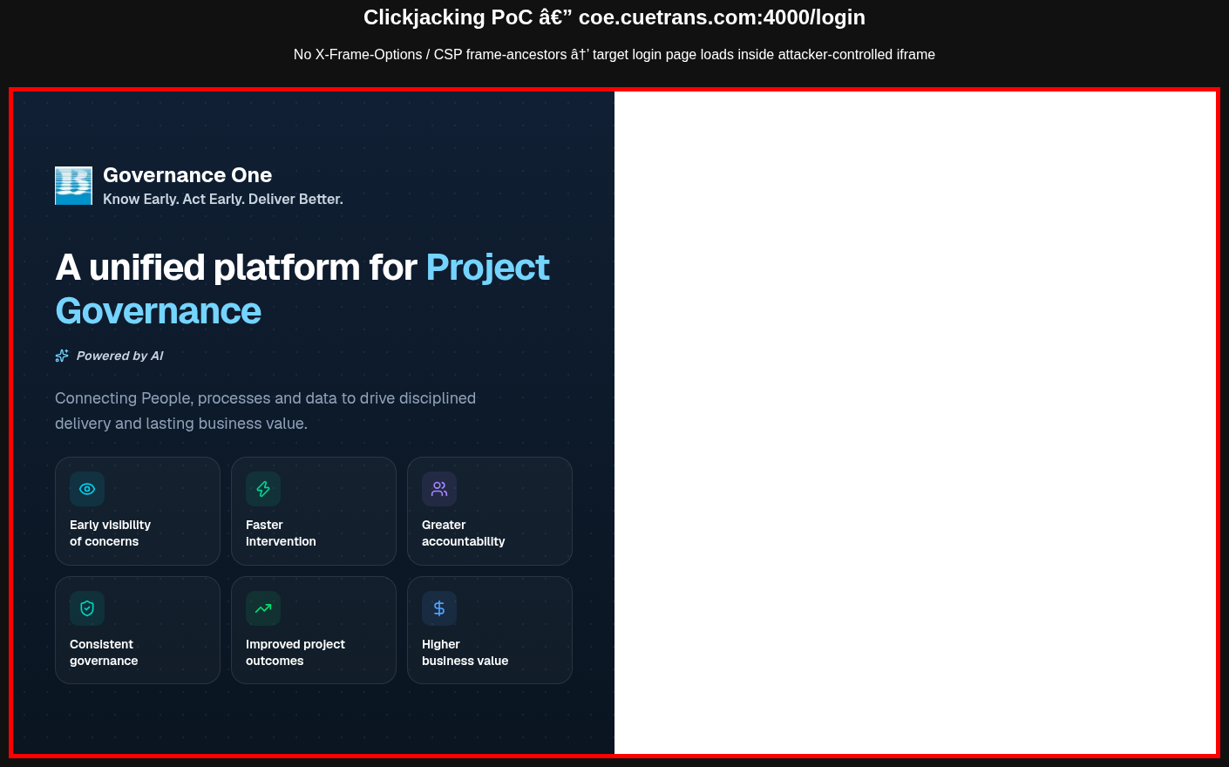
Screenshot 08 - Clickjacking PoC: /login rendered inside an attacker-controlled iframe (red border)
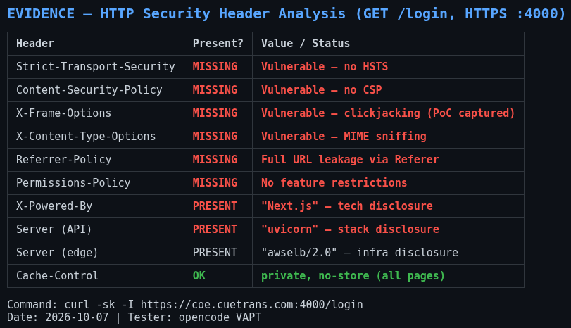
Screenshot 16 - HTTP security-header analysis (command: curl -sk -I https://coe.cuetrans.com:4000/login)
Impact
An attacker can overlay or disguise the login page and trick users into entering corporate credentials into attacker-controlled fields or clicking hidden buttons (UI redress).
Recommendation
Send Content-Security-Policy: frame-ancestors 'none' (or 'self' if same-origin framing is required), and add X-Frame-Options: DENY as a legacy fallback.
References
- https://cheatsheetseries.owasp.org/cheatsheets/Clickjacking_Defense_Cheat_Sheet.html
- https://developer.mozilla.org/en-US/docs/Web/HTTP/Reference/Headers/X-Frame-Options

VAPT-04: Strict-Transport-Security (HSTS) Header Not Set
Risk rating | Medium
WSTG | 4.2.7
CWE | CWE-319
OWASP Top 10 | A05:2021 Security Misconfiguration
Affected URL | https://coe.cuetrans.com:4000/login

Description
The application is served over HTTPS but does not return the Strict-Transport-Security header, so browsers are not instructed to use HTTPS exclusively for the site.
Evidence
curl -sk -I https://coe.cuetrans.com:4000/login -> no Strict-Transport-Security header in the response
Screenshot 16 - HTTP security-header analysis (command: curl -sk -I https://coe.cuetrans.com:4000/login)
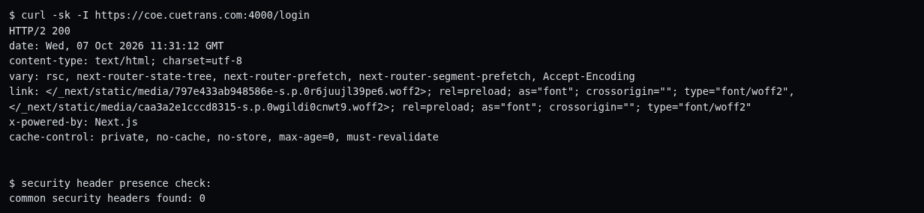
Process screenshot 05 - HTTP security header analysis - WSTG 4.2.7/4.2.12/4.2.14
Impact
On a first visit, or when a user types http://, a plain-HTTP request may be made. On a hostile network (for example an SSL-stripping attack on a corporate network), credentials could be exposed.
Recommendation
Send Strict-Transport-Security: max-age=31536000; includeSubDomains on all HTTPS responses. Add the preload directive only after confirming that all subdomains support HTTPS.
References
- https://cheatsheetseries.owasp.org/cheatsheets/HTTP_Strict_Transport_Security_Cheat_Sheet.html
- https://owasp.org/www-community/Security_Headers

VAPT-05: Hardcoded API Key in Client-Side JavaScript
Risk rating | Medium
WSTG | 4.1.5, 4.12.1
CWE | CWE-798
OWASP Top 10 | A07:2021 Identification and Authentication Failures
Affected URL | https://coe.cuetrans.com:4000/_next/static/chunks/073hm9zgjlwer.js

Description
The API is gated by a static shared key named local-dev-key that is shipped to every visitor inside the JavaScript bundle and sent as the X-API-Key header on every request. The name indicates a development default left in the deployed environment.
Evidence
Analysis of the downloaded JavaScript chunks exposed the key in plain text:
let r="/api/v1", n="local-dev-key" // sent as X-API-Key on every request
Endpoints protected only by this key (for example /auth/config and /auth/login) are therefore effectively public. Evidence file: evidence/chunks/073hm9zgjlwer.js
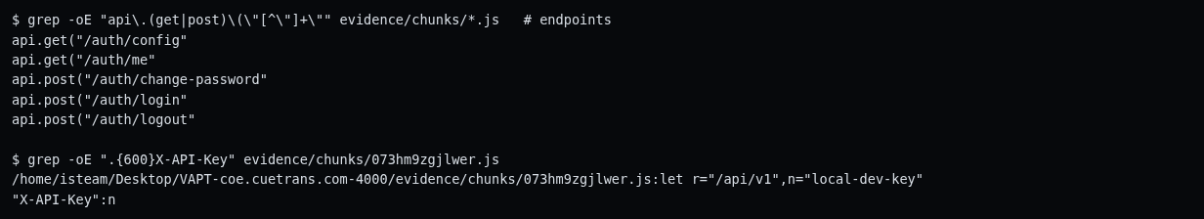
Process screenshot 06 - JS bundle analysis, hardcoded API key - WSTG 4.1.5
Impact
The key provides no meaningful authentication because anyone can extract it in seconds, and it creates a false sense of security. It also helps an attacker reach the unauthenticated API surface directly.
Recommendation
Remove client-side key checks, because the session cookie already authenticates users. If a key is required for anonymous endpoints, issue per-origin or per-instance keys on the server side. Rotate local-dev-key immediately and never embed shared secrets in front-end bundles.
References
- https://cheatsheetseries.owasp.org/cheatsheets/Secrets_Management_Cheat_Sheet.html
- https://cheatsheetseries.owasp.org/cheatsheets/REST_Security_Cheat_Sheet.html

VAPT-06: Unconfirmed Hard Delete of User Records (No Recovery)
Risk rating | Medium
WSTG | 4.10.2, 4.10.6, 4.12.4
CWE | CWE-841
OWASP Top 10 | A04:2021 Insecure Design
Affected URL | https://coe.cuetrans.com:4000/api/v1/users/{id}

Description
DELETE /api/v1/users/{id} performs an immediate hard delete (HTTP 204) with no confirmation step, no soft-delete flag, no grace period and no evidence of audit logging.
Evidence
During HTTP-method enumeration, a single DELETE request permanently removed a real user record. The record was re-created immediately through POST /api/v1/users (HTTP 201); see section 2.5 for the full incident disclosure.
curl -X DELETE https://coe.cuetrans.com:4000/api/v1/users/<uuid> -> HTTP 204 (record permanently deleted)
Evidence files: evidence/00_INCIDENT_LOG.txt, evidence/14_users_list.json
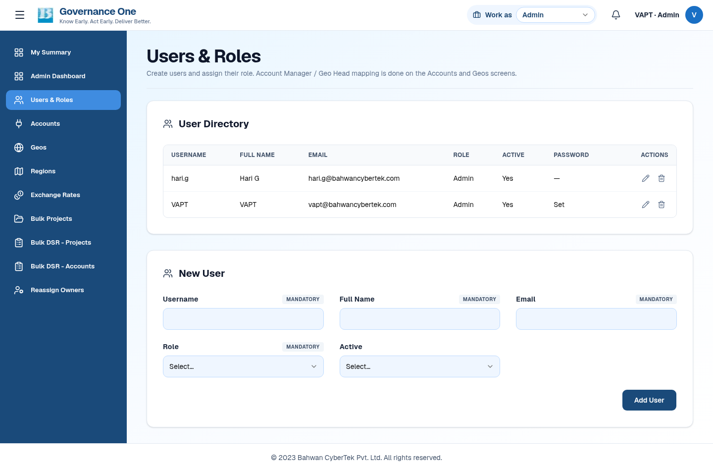
Screenshot 11 - Authenticated ADMIN user-management page (role-gated UI)
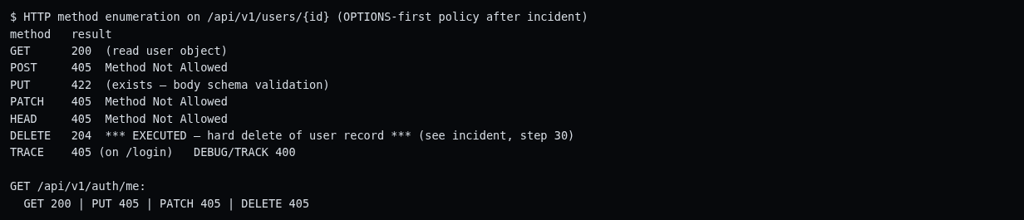
Process screenshot 11 - HTTP method enumeration (DELETE executed) - WSTG 4.2.6
Process screenshot 30 - Testing incident: user delete and restore - WSTG 4.10.2/4.12.4
Impact
An accidental or malicious call permanently destroys an account record with no way to undo it. Such a call was in fact made during this test and caused a real loss of data, which was then restored manually.
Recommendation
Switch to soft delete (is_active=false or deleted_at), require re-authentication and explicit confirmation (for example typing the username), enforce separation of duties, write immutable audit-log entries for all user mutations, and provide an administrator restore path. Review all other destructive methods in the API.
References
- https://cheatsheetseries.owasp.org/cheatsheets/REST_Security_Cheat_Sheet.html
- https://cheatsheetseries.owasp.org/cheatsheets/Logging_Cheat_Sheet.html

VAPT-07: Weak Password Policy (Length Only, No Complexity Check)
Risk rating | Medium
WSTG | 4.4.7, 4.4.9
CWE | CWE-521
OWASP Top 10 | A07:2021 Identification and Authentication Failures
Affected URL | https://coe.cuetrans.com:4000/api/v1/auth/change-password

Description
Server-side validation enforces only a minimum length of 8 characters. There is no complexity, dictionary or breached-password check.
Evidence
The password abcdefgh was accepted by POST /auth/change-password (HTTP 204) and was reverted immediately afterwards. A shorter password was correctly rejected with HTTP 422 (string_too_short, min_length 8).
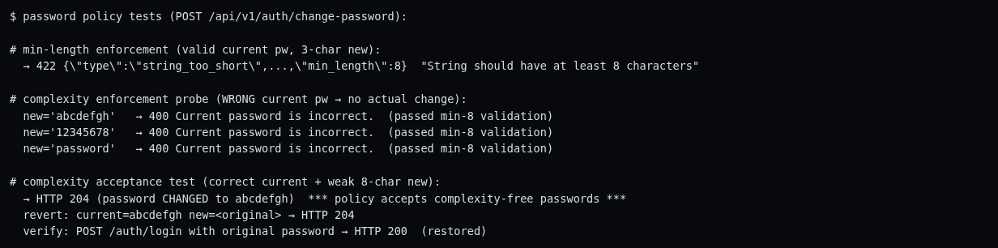
Process screenshot 14 - Password policy and complexity tests - WSTG 4.4.9
Impact
Users can set trivially guessable passwords. Together with the absence of rate limiting (VAPT-01), this makes online guessing of weak passwords practical.
Recommendation
Adopt a NIST SP 800-63B style policy: at least 12 characters, a blocklist of breached and common passwords, and rejection of user-name variants, without arbitrary composition rules. Combine with the rate limiting recommended for VAPT-01.
References
- https://pages.nist.gov/800-63-3/sp800-63b.html
- https://cheatsheetseries.owasp.org/cheatsheets/Authentication_Cheat_Sheet.html

VAPT-08: Account Enumeration via Response Timing
Risk rating | Medium
WSTG | 4.3.4
CWE | CWE-208
OWASP Top 10 | A07:2021 Identification and Authentication Failures
Affected URL | https://coe.cuetrans.com:4000/api/v1/auth/login

Description
The login error message is identical for existing and non-existing accounts, but the response time differs measurably. The back end performs the directory lookup and bind only for accounts that exist.
Evidence
Mean response time was 558.0 ms for an existing user and 446.1 ms for a non-existent user (8 samples each, low variance), a difference of about 112 ms. The generic message "Invalid email or password." was returned in both cases.
Evidence file: evidence/17_bruteforce_results.json (timing arrays)
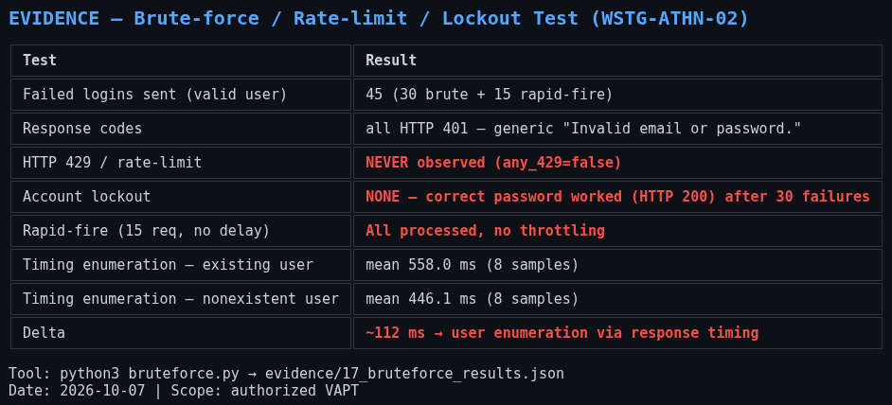
Screenshot 17 - Brute-force, lockout and timing-enumeration evidence
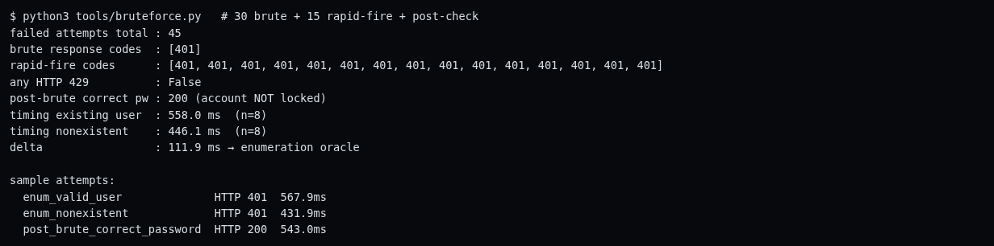
Process screenshot 13 - Brute-force, lockout and timing test - WSTG 4.4.3
Impact
Attackers can verify valid corporate e-mail addresses before launching credential stuffing, which raises the success rate of attacks described in VAPT-01.
Recommendation
Normalise the response time (a constant-time response floor) or perform an anonymous bind first, and keep the generic error messages, which are already correct.
References
- https://owasp.org/www-project-web-security-testing-guide/
- https://cheatsheetseries.owasp.org/cheatsheets/Authentication_Cheat_Sheet.html

VAPT-09: Missing Ancillary Security Headers
Risk rating | Low
WSTG | 4.2.14
CWE | CWE-693
OWASP Top 10 | A05:2021 Security Misconfiguration
Affected URL | https://coe.cuetrans.com:4000/login

Description
The responses do not include X-Content-Type-Options, Referrer-Policy or Permissions-Policy.
Evidence
curl -sk -I https://coe.cuetrans.com:4000/login -> X-Content-Type-Options, Referrer-Policy and Permissions-Policy are absent
Screenshot 16 - HTTP security-header analysis (command: curl -sk -I https://coe.cuetrans.com:4000/login)
Process screenshot 05 - HTTP security header analysis - WSTG 4.2.7/4.2.12/4.2.14
Impact
Without nosniff, browsers may MIME-sniff responses. Without a Referrer-Policy, full URLs may leak through the Referer header. Without a Permissions-Policy, no restrictions are placed on browser features.
Recommendation
Add the headers at nginx or the load balancer: X-Content-Type-Options: nosniff, Referrer-Policy: strict-origin-when-cross-origin, and a minimal Permissions-Policy.
References
- https://owasp.org/www-community/Security_Headers
- https://developer.mozilla.org/en-US/docs/Web/HTTP/Reference/Headers/Referrer-Policy

VAPT-10: Technology and Validation-Schema Disclosure
Risk rating | Low
WSTG | 4.1.2, 4.2.2, 4.8.1
CWE | CWE-497
OWASP Top 10 | A05:2021 Security Misconfiguration
Affected URL | https://coe.cuetrans.com:4000 (response headers and API error bodies)

Description
The application discloses its technology stack through response headers and verbose validation errors.
Evidence
The headers X-Powered-By: Next.js, Server: uvicorn and Server: awselb/2.0 are returned, and verbose pydantic 422 bodies expose internal field names and types (for example loc: ["body","current_password"]). No stack traces were observed.
Screenshot 16 - HTTP security-header analysis (command: curl -sk -I https://coe.cuetrans.com:4000/login)
Process screenshot 02 - Technology fingerprinting (WhatWeb) - WSTG 4.1.8/4.1.9
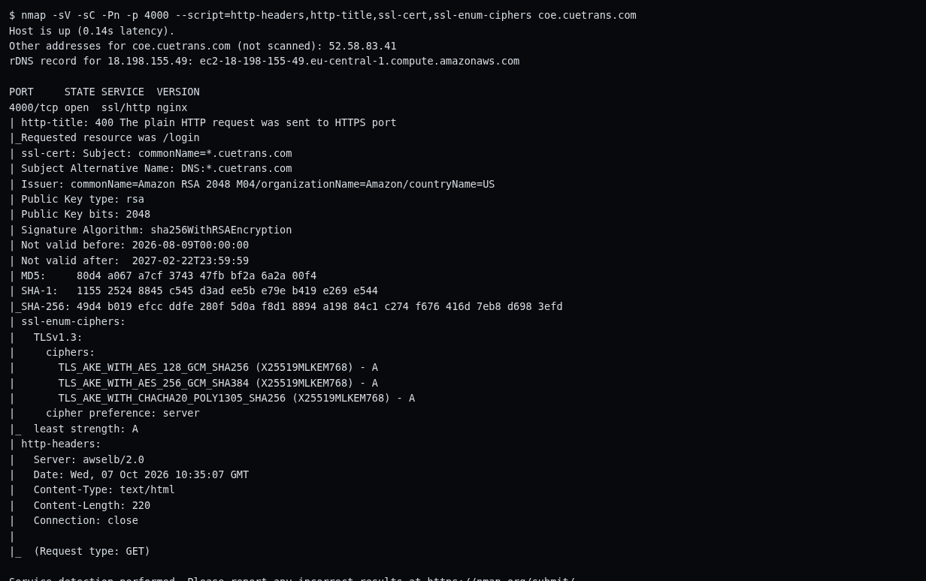
Process screenshot 03 - Nmap service and script scan - WSTG 4.1.2
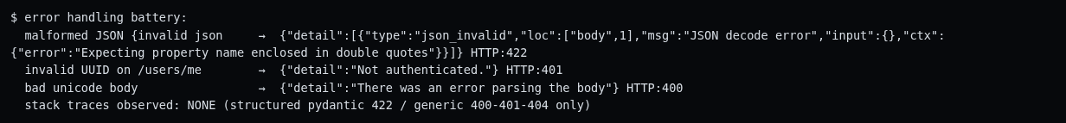
Process screenshot 27 - Verbose error-handling tests - WSTG 4.8.1/4.8.2
Impact
The information reduces the effort needed for reconnaissance and for targeting known vulnerabilities of the disclosed components.
Recommendation
Remove X-Powered-By (poweredByHeader: false in Next.js), normalise the Server headers, and map validation errors to generic messages in production.
References
- https://owasp.org/www-project-web-security-testing-guide/
- https://owasp.org/www-community/Security_Headers

VAPT-11: Session Cookie Missing the Secure Attribute
Risk rating | Low
WSTG | 4.6.2
CWE | CWE-614
OWASP Top 10 | A05:2021 Security Misconfiguration
Affected URL | https://coe.cuetrans.com:4000/api/v1/auth/login (Set-Cookie: pg_session)

Description
The pg_session cookie is set with HttpOnly, SameSite=Lax and Path=/, but without the Secure attribute.
Evidence
The login response sets: pg_session=<JWT>; HttpOnly; Max-Age=28800; Path=/; SameSite=lax. The Secure flag is absent (Screenshots 18 and process screenshot 08).
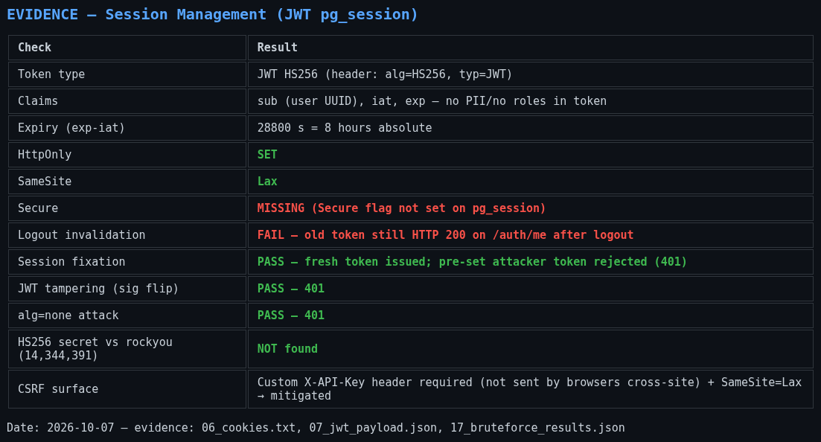
Screenshot 18 - Session and JWT test evidence
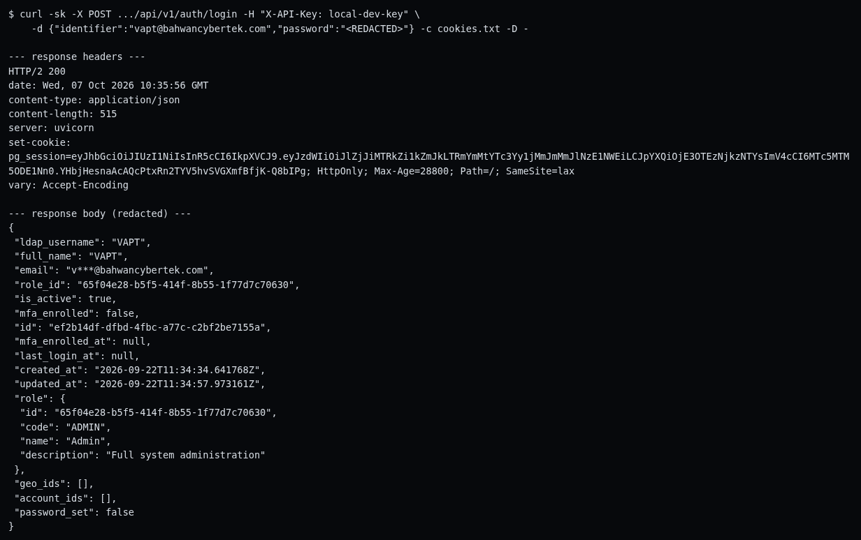
Process screenshot 08 - Authenticated login via API (response headers show the session cookie attributes) - WSTG 4.4.1
Impact
On any HTTP-reachable path, or in the event of a mixed-content misconfiguration, the cookie could be transmitted in clear text.
Recommendation
Add the Secure attribute to the Set-Cookie header, and keep plain HTTP rejected (currently HTTP 400).
References
- https://developer.mozilla.org/en-US/docs/Web/HTTP/Reference/Headers/Set-Cookie
- https://cheatsheetseries.owasp.org/cheatsheets/Session_Management_Cheat_Sheet.html

VAPT-12: Page-Route Authorization Enforced Only on the Client Side
Risk rating | Low
WSTG | 4.5.2
CWE | CWE-602
OWASP Top 10 | A01:2021 Broken Access Control
Affected URL | https://coe.cuetrans.com:4000/admin/*, /dashboard/*

Description
All HTML routes, including /admin/users, return an HTTP 200 shell to anonymous users. Protection relies on a client-side JavaScript redirect to /login.
Evidence
Headless visits to /admin/users and /dashboard/admin without a session were redirected to the login page by client-side code (Screenshots 09 and 10). All data endpoints still returned HTTP 401 without a session (process screenshot 12), which limits the real impact.
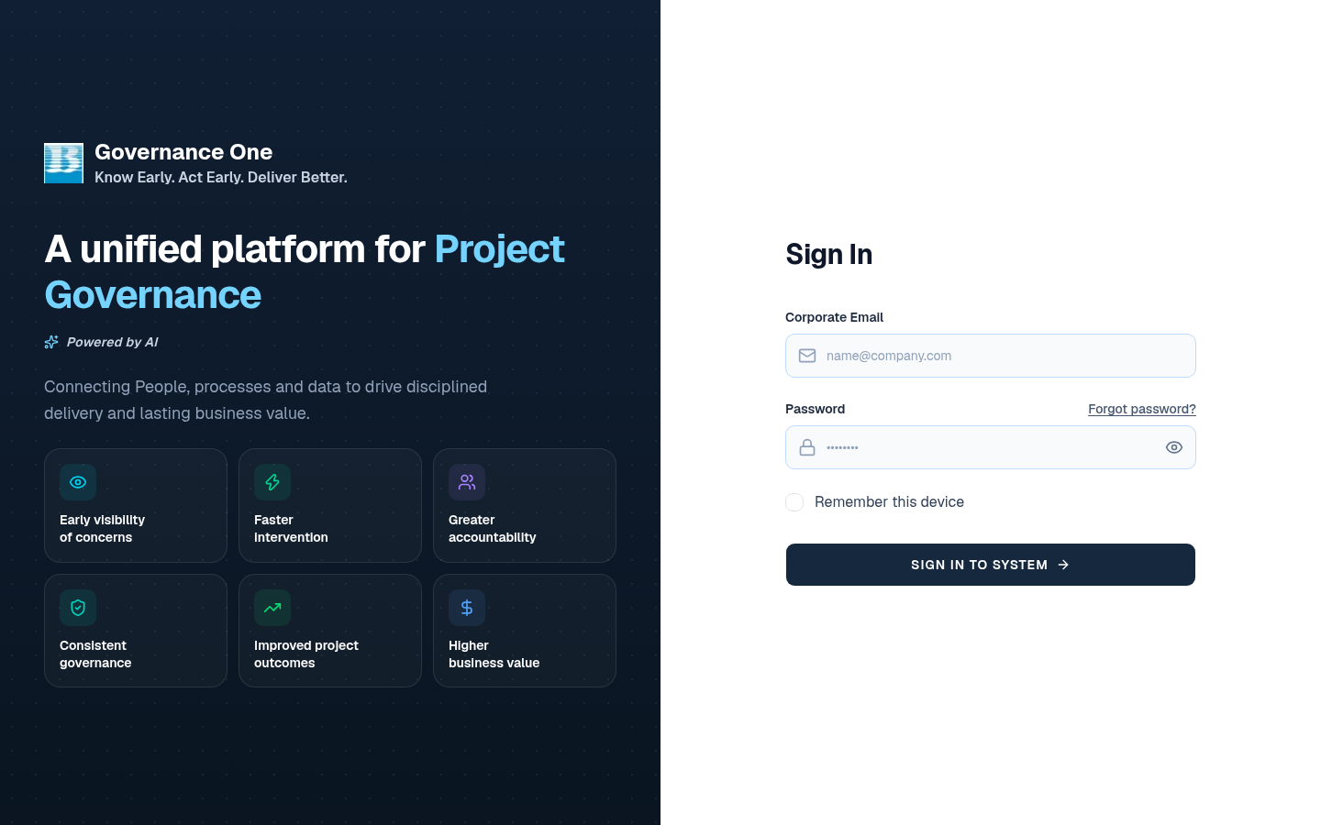
Screenshot 09 - Unauthenticated request to /admin/users is redirected to the login page
Screenshot 10 - Unauthenticated /dashboard/admin is redirected to the login page
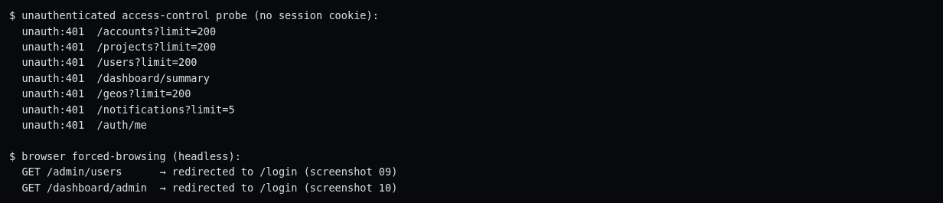
Process screenshot 12 - Unauthenticated access-control tests - WSTG 4.5.2
Impact
The page shell and role menus are delivered to unauthenticated users, which exposes application structure. Because the API enforces authentication, the direct impact is limited. This is a defence-in-depth gap.
Recommendation
Add server-side middleware authorization for page routes and return 302 or 401 from the server to unauthorised users. Retest per-role API authorization with a non-admin account.
References
- https://owasp.org/www-project-web-security-testing-guide/
- https://cheatsheetseries.owasp.org/cheatsheets/Authorization_Cheat_Sheet.html

VAPT-13: No Multi-Factor Authentication for Privileged Accounts
Risk rating | Informational
WSTG | 4.4.11
CWE | CWE-308
OWASP Top 10 | A07:2021 Identification and Authentication Failures
Affected URL | https://coe.cuetrans.com:4000/api/v1/auth/*

Description
The API schema supports MFA (mfa_enrolled, mfa_enrolled_at), but the ADMIN account has MFA disabled and no enrolment flow is exposed in the user interface.
Evidence
User objects returned by /auth/login and /auth/me show mfa_enrolled: false for the ADMIN test account (process screenshots 08 and 09).
Process screenshot 08 - Authenticated login via API (response headers show the session cookie attributes) - WSTG 4.4.1
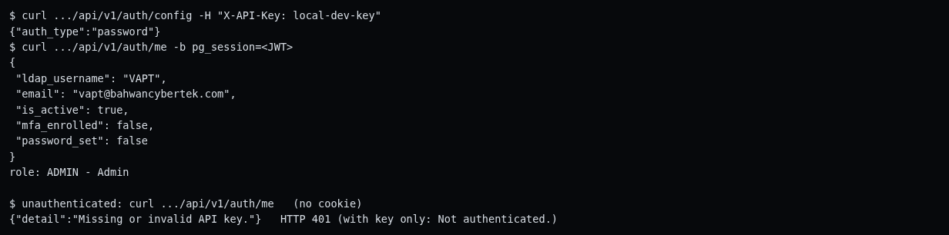
Process screenshot 09 - Session verification and auth configuration (/auth/config, /auth/me) - WSTG 4.4.4
Impact
Combined with VAPT-01, the lack of a second factor raises the risk of account takeover for administrative accounts.
Recommendation
Enforce MFA (TOTP or FIDO) for all administrative and remotely accessible roles.
References
- https://cheatsheetseries.owasp.org/cheatsheets/Multifactor_Authentication_Cheat_Sheet.html

VAPT-14: Static HS256 JWT Signing Secret
Risk rating | Informational
WSTG | 4.6.10
CWE | -
OWASP Top 10 | A02:2021 Cryptographic Failures
Affected URL | https://coe.cuetrans.com:4000 (pg_session token)

Description
Session tokens are signed with HS256 using one shared server-side secret. Tampering and alg=none attacks were rejected, and a dictionary attack did not recover the secret.
Evidence
A dictionary attack using rockyou.txt (14,344,391 candidates, 35 seconds) did not find the secret. Signature tampering and alg=none tokens were rejected with HTTP 401. This is recorded as a hardening recommendation rather than a defect.
Screenshot 18 - Session and JWT test evidence
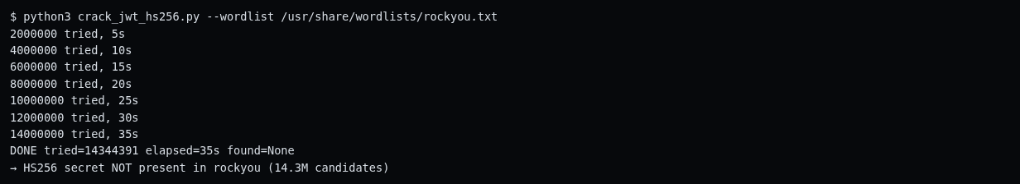
Process screenshot 18 - JWT HS256 secret dictionary attack - WSTG 4.6.10
Impact
HS256 shares a single secret across all instances. If the secret ever leaks (through a repository or an environment dump), every token can be forged.
Recommendation
Confirm that the secret is at least 256 bits of random data, rotate it periodically, or migrate to RS256 or EdDSA with key rotation. Add a jti claim to enable revocation (VAPT-02).
References
- https://cheatsheetseries.owasp.org/cheatsheets/JSON_Web_Token_for_Java_Cheat_Sheet.html

VAPT-15: Inactive SSO Endpoint Exposed
Risk rating | Informational
WSTG | 4.2.5, 4.12.1
CWE | -
OWASP Top 10 | A05:2021 Security Misconfiguration
Affected URL | https://coe.cuetrans.com:4000/api/v1/auth/onelogin/login

Description
The endpoint POST /api/v1/auth/onelogin/login exists (405 on GET) and is referenced in the JavaScript bundle, although the configured auth_type is password.
Evidence
The route was identified during JavaScript bundle and API analysis. The authentication configuration confirms that SSO is inactive (auth_type: "password"), as shown in process screenshot 09.
Process screenshot 09 - Session verification and auth configuration (/auth/config, /auth/me) - WSTG 4.4.4
Impact
Unused authentication paths enlarge the attack surface without providing any benefit.
Recommendation
Disable or remove authentication providers that are not in use in each environment.
References
- https://owasp.org/www-project-web-security-testing-guide/

Recommended Remediation
Many of the findings can be fixed together by adding response headers and by hardening the session and authentication configuration. For the Next.js front end, the header-related items can be set in next.config.js:
// next.config.js
module.exports = {
poweredByHeader: false,
async headers() {
return [{
source: '/(.*)',
headers: [
{ key: 'Strict-Transport-Security',
value: 'max-age=31536000; includeSubDomains' },
{ key: 'X-Content-Type-Options', value: 'nosniff' },
{ key: 'Referrer-Policy',
value: 'strict-origin-when-cross-origin' },
{ key: 'Permissions-Policy',
value: 'camera=(), microphone=(), geolocation=()' },
{ key: 'X-Frame-Options', value: 'DENY' },
{ key: 'Content-Security-Policy',
value: "default-src 'self'; frame-ancestors 'none'; " +
"object-src 'none'; base-uri 'self'" },
],
}];
},
};

Mapping: poweredByHeader removes the X-Powered-By header (VAPT-10); Strict-Transport-Security addresses VAPT-04; X-Content-Type-Options, Referrer-Policy and Permissions-Policy address VAPT-09; X-Frame-Options and the frame-ancestors directive address VAPT-03.
The Content-Security-Policy above is a starting point only. Next.js injects inline scripts, so the policy will likely need nonces or hashes (script-src) before it can be enforced without breaking the page; test with Content-Security-Policy-Report-Only first. If headers are set at nginx or the load balancer instead, apply the same values there. The remaining findings (rate limiting, token revocation, the API key, user deletion, password policy, timing, the Secure cookie flag and server-side route authorization) require changes in the FastAPI back end, the gateway or the application logic.

5.1 Priority plan
Priority | Action | Findings | Timeframe
P1 - Immediate | Deploy rate limiting and account lockout or back-off on /auth/login and sensitive API endpoints (WAF or API gateway) | VAPT-01 | 0-7 days
P1 | Revoke tokens on the server at logout (jti denylist or server-side sessions) | VAPT-02 | 0-7 days
P1 | Rotate or remove local-dev-key and stop shipping shared secrets in JavaScript | VAPT-05 | 0-7 days
P2 - Short term | Add CSP frame-ancestors and X-Frame-Options, and add HSTS | VAPT-03, 04 | 7-30 days
P2 | Soft delete, confirmation and audit logging for user deletion; review all destructive methods | VAPT-06 | 7-30 days
P2 | Harden the password policy (NIST style) with breached-password screening | VAPT-07 | 7-30 days
P2 | Constant-time authentication responses (normalise to a response-time floor) | VAPT-08 | 7-30 days
P3 - Next cycle | Add nosniff, Referrer-Policy and Permissions-Policy; strip technology headers; generic 422 errors; Secure cookie flag | VAPT-09, 10, 11 | Next cycle
P3 | Server-side middleware authorization for page routes; retest per-role API authorization with a non-admin account | VAPT-12 | Next cycle
P4 - Hardening | Enforce MFA for admin roles; JWT rotation, jti and asymmetric signing; remove the inactive SSO route | VAPT-13, 14, 15 | Hardening

Limitations and Next Steps
- Both seeded accounts carry the ADMIN role, so vertical privilege escalation and per-role API authorization could not be verified. A retest with a TEAM_MEMBER account is recommended.
- The 8-hour absolute session expiry was not awaited, and idle-timeout behaviour was inconclusive within the test window.
- Stored XSS was not injected into shared records because that would alter production-like data (rules of engagement). Profile-field injection testing is deferred.
- HTTP request smuggling was tested with a single CL.TE probe only. A full desync suite at the edge (nginx and ALB) is recommended.
- Concurrent-session behaviour was not tested, as it needs multi-device observation.
- Password-hash storage (LDAP, bcrypt or argon2) cannot be verified from a black-box position.
- SSRF, SSTI and mass assignment were not tested because no user-controlled URL or template vectors were identified in the explored features.
A re-test after the fixes for VAPT-01, VAPT-02 and VAPT-05, together with a role-separation test using a non-admin account, is recommended to complete the assessment. Raw evidence, tool scripts, screenshots and sqlmap logs accompany this report in the engagement folder.

Appendices

7.1 OWASP WSTG coverage matrix
WSTG | Test | Status | Outcome
4.1.2 | Fingerprint web server | Tested | nginx, uvicorn and awselb disclosed (VAPT-10)
4.1.4 | Attack surface identification | Tested | Routes and API fully mapped
4.1.5 | Web content information leakage | Tested | Hardcoded API key (VAPT-05)
4.1.6-4.1.7 | Entry points and execution paths | Tested | 40+ routes and endpoints mapped
4.1.8-4.1.9 | Framework and application fingerprint | Tested | Next.js 16.2.10, FastAPI, React 19
4.2.2 | Platform configuration | Tested | Technology disclosure (VAPT-10)
4.2.4 | Backup and unreferenced files | Tested | All probes returned 404
4.2.5 | Admin interfaces | Tested | Admin UI and API mapped (authentication required)
4.2.6 | HTTP methods | Tested | DELETE hard delete (VAPT-06); TRACE blocked
4.2.7 | HSTS | Tested | Missing (VAPT-04)
4.2.12 | Content Security Policy | Tested | Missing (VAPT-03)
4.2.14 | Other security headers | Tested | 3 headers missing (VAPT-09)
4.3.1 | Role definitions | Tested | 8 roles documented
4.3.4 | Account enumeration | Tested | Timing oracle (VAPT-08); message-based OK
4.4.1 | Credentials over an encrypted channel | Tested | PASS
4.4.2 | Default credentials | Tested | PASS - 8 pairs rejected
4.4.3 | Weak lockout mechanism | Tested | FAIL (VAPT-01)
4.4.4 | Bypass authentication schema | Tested | PASS - no bypass found
4.4.6 | Browser cache weaknesses | Tested | PASS - no-store everywhere
4.4.7 / 4.4.9 | Weak authentication methods / password change | Tested | Weak policy (VAPT-07)
4.4.11 | Multi-factor authentication | Tested | Not enforced (VAPT-13)
4.5.2 | Bypassing authorization schema | Tested | API 401 OK; client-side routes (VAPT-12)
4.5.4 | Insecure direct object references | Tested | Random UUIDs; 404 for unknown IDs
4.6.1-4.6.2 | Session schema and cookie attributes | Tested | Secure flag missing (VAPT-11)
4.6.3 | Session fixation | Tested | PASS
4.6.5 | Cross-site request forgery | Tested | Mitigated (custom header and SameSite)
4.6.6 | Logout functionality | Tested | FAIL (VAPT-02)
4.6.7 | Session timeout | Tested | 8 h absolute only; idle timeout not observable
4.6.10 | JSON Web Tokens | Tested | Attacks rejected; secret resisted rockyou (VAPT-14)
4.6.11 | Concurrent sessions | Not tested | Requires multi-device observation
4.7.1 / 4.11.1 | Reflected and DOM XSS | Tested | No execution (browser dialog capture)
4.7.2 | Stored XSS | Partial | Not injected into shared records (rules of engagement)
4.7.3 | HTTP verb tampering | Tested | DELETE abuse (VAPT-06)
4.7.5 | SQL and NoSQL injection | Tested | sqlmap level 3 / risk 2 and manual battery negative
4.7.6 | LDAP injection | Tested | No oracle
4.7.12 | Command injection | Tested | No oracle
4.7.16 | HTTP request smuggling | Partial | Light CL.TE probe, no anomaly
4.7.17 | Host header injection | Tested | No reflection
4.7.18-4.7.20 | SSTI / SSRF / mass assignment | Not tested | No URL or template input vectors discovered
4.8.1-4.8.2 | Error handling and stack traces | Tested | No stack traces; schema disclosure (VAPT-10)
4.9.1 | Weak transport layer security | Tested | TLS 1.2 / 1.3 only, grade A
4.9.3 | Sensitive information over unencrypted channels | Tested | All traffic uses HTTPS
4.10.2 / 4.10.6 | Forged requests / workflow circumvention | Tested | Destructive delete (VAPT-06)
4.10.5 / 4.10.7 | Usage limits / misuse defences | Tested | No rate limits (VAPT-01)
4.11.4 | Client-side URL redirect | Tested | Not vulnerable
4.11.7 | CORS | Tested | No origin reflection
4.11.9 | Clickjacking | Tested | Vulnerable (VAPT-03)
4.12.1-4.12.4 | API recon, BOLA, data exposure, function-level authorization | Tested | Authorization OK; function-level untestable with a single role

7.2 Evidence index
Finding | Screenshots attached in section 4
VAPT-01 | Screenshots 03 and 17; process screenshot 13
VAPT-02 | Screenshot 18; process screenshot 16
VAPT-03 | Screenshots 08 and 16
VAPT-04 | Screenshot 16; process screenshot 05
VAPT-05 | Process screenshot 06
VAPT-06 | Screenshot 11; process screenshots 11 and 30
VAPT-07 | Process screenshot 14
VAPT-08 | Screenshot 17; process screenshot 13
VAPT-09 | Screenshot 16; process screenshot 05
VAPT-10 | Screenshot 16; process screenshots 02, 03 and 27
VAPT-11 | Screenshot 18; process screenshot 08
VAPT-12 | Screenshots 09 and 10; process screenshot 12
VAPT-13 | Process screenshots 08 and 09
VAPT-14 | Screenshot 18; process screenshot 18
VAPT-15 | Process screenshot 09

7.3 Evidence for checks that passed
The following captures support the negative results (no vulnerability found) listed in section 3.1.
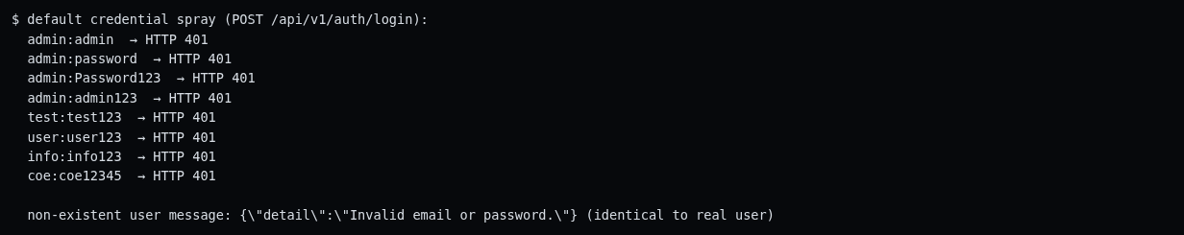
Process screenshot 15 - Default credential spray - WSTG 4.4.2
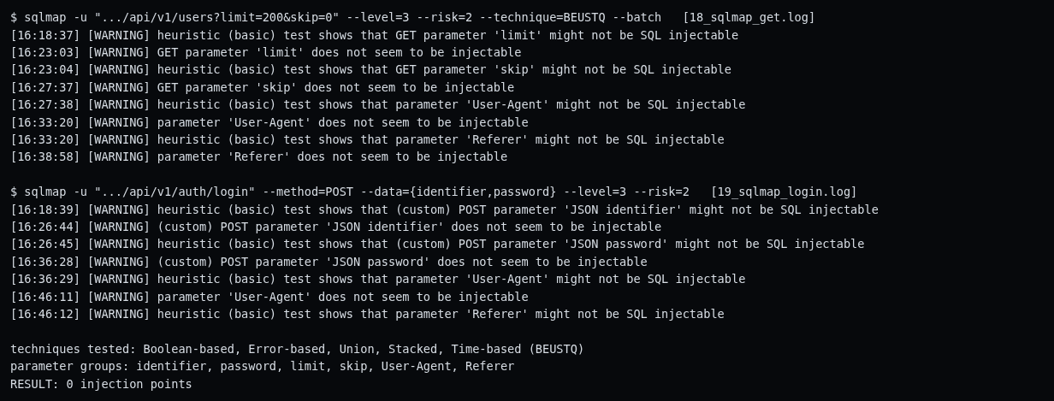
Process screenshot 19 - sqlmap automated SQL-injection scan (negative) - WSTG 4.7.5
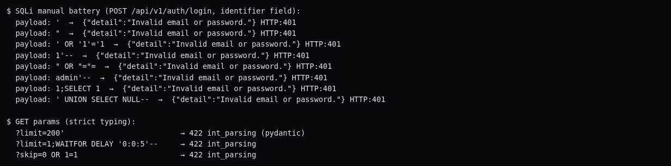
Process screenshot 20 - Manual SQL-injection battery (negative) - WSTG 4.7.5
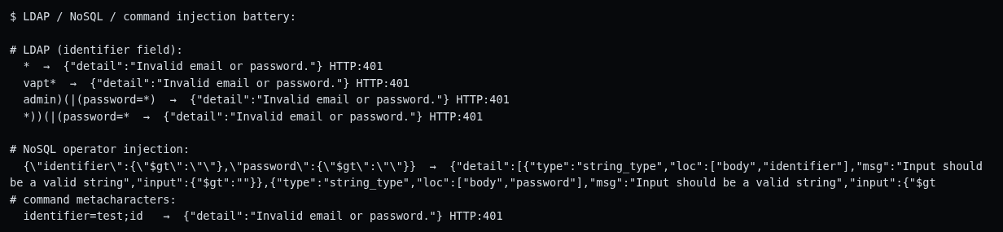
Process screenshot 21 - LDAP, NoSQL and command injection (negative) - WSTG 4.7.6/4.7.5.6
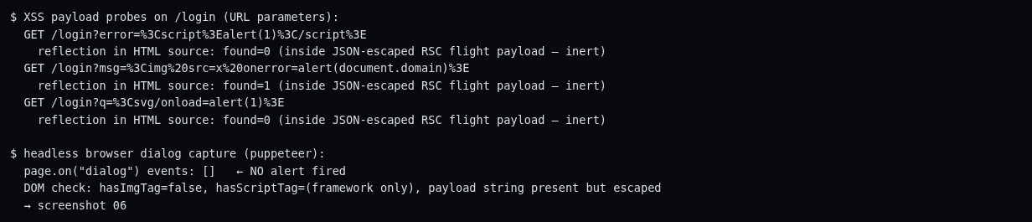
Process screenshot 22 - Reflected XSS, browser-verified (negative) - WSTG 4.7.1
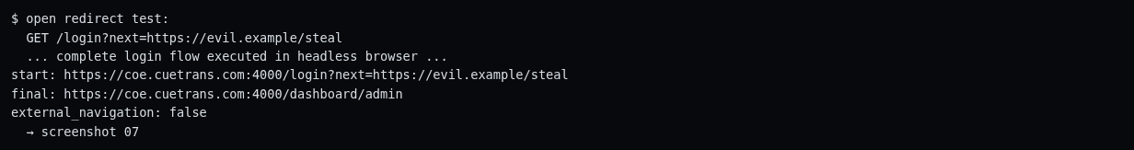
Process screenshot 24 - Open redirect test (negative) - WSTG 4.11.4
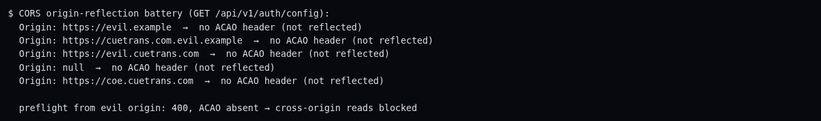
Process screenshot 25 - CORS origin-reflection tests (negative) - WSTG 4.11.7
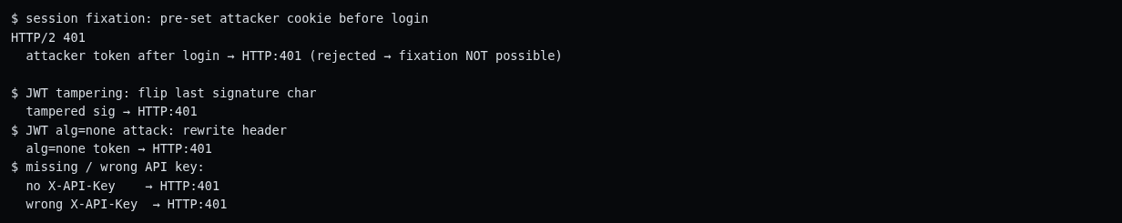
Process screenshot 29 - Session fixation and JWT attack suite (negative) - WSTG 4.6.3/4.6.10
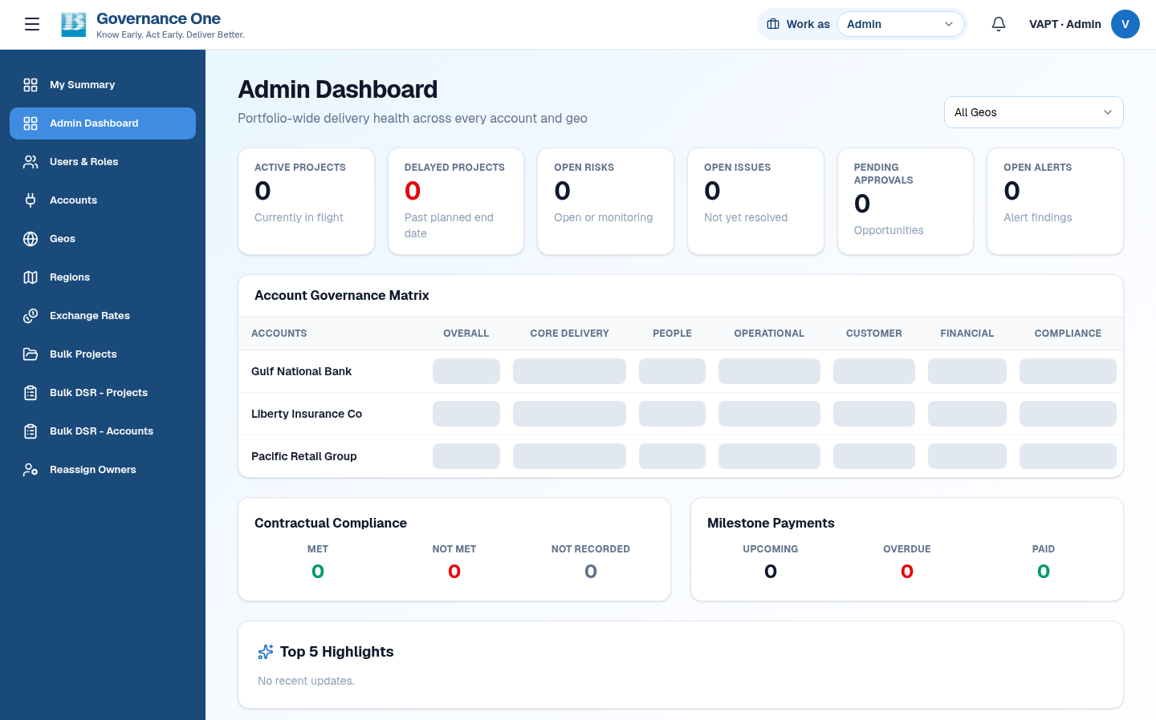
Screenshot 07 - Open-redirect test (?next=https://evil.example/steal) lands on the internal dashboard
Screenshot 15 - Browser back-button after logout shows the login page (no cached content; no-store confirmed)

