
Miracle Software Systems,Inc.

sap connectivity

Table of Contents

Table of Contents 2
1.Java Compute Node 3
1.1.Overview 3
1.2.What this lab is about 3
1.3.What you will do in this lab 3
2.Requirements, Prerequisites, and Planning 3
3.Scenario 4

1.Java Compute Node

1.1.Overview

1.2.What this lab is about

In this Lab, You will know how to make use of JavaCompute node for reading file contents.
We will use JavaCompute node to create and build a new output message that is totally independent of the input message.

1.3.What you will do in this lab

You will go through each step in the following sections. Each step might contain many subsets

Key Steps are
1) How to Create and Configure JavaCompute Node
- How to Build and Deploy Java Code used in message flow.

2.Requirements, Prerequisites, and Planning

Software Requirements | Network Requirements | Additional Requirements
All necessary software has been installed on the system. | None | None

Exercise

The steps involved are

Creating a Flow Using MQInpoutNode, FileOutputNode and JavaCompute node
Configuring a JavaCompute node
Writing java code to read file in JavaComputeNode
Test the flow

3.Scenario:

Step 1:- Create a Application “JavaComputeNodeSample”

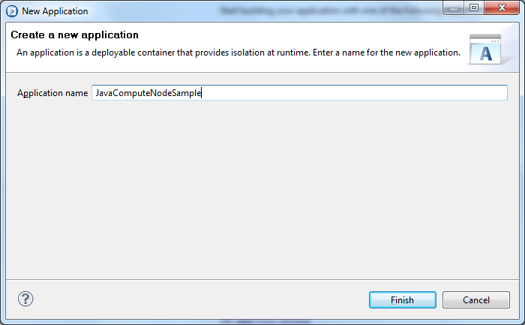

Step 2:- Create new message Flow “ReadFile”
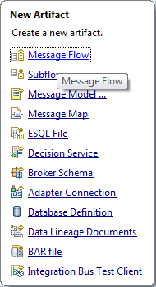
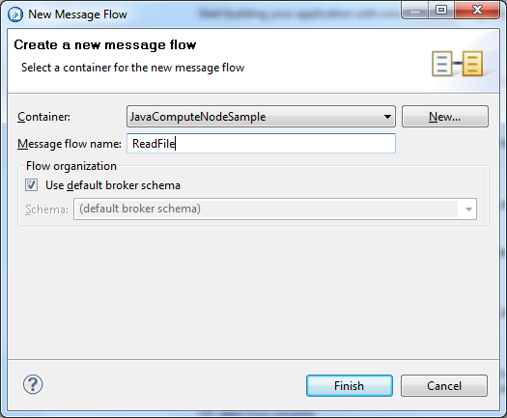

Step 3:- Create the flow using MQInputNode, JavaComputeNode,ComputeNode,FileOutputNode as shown in below.
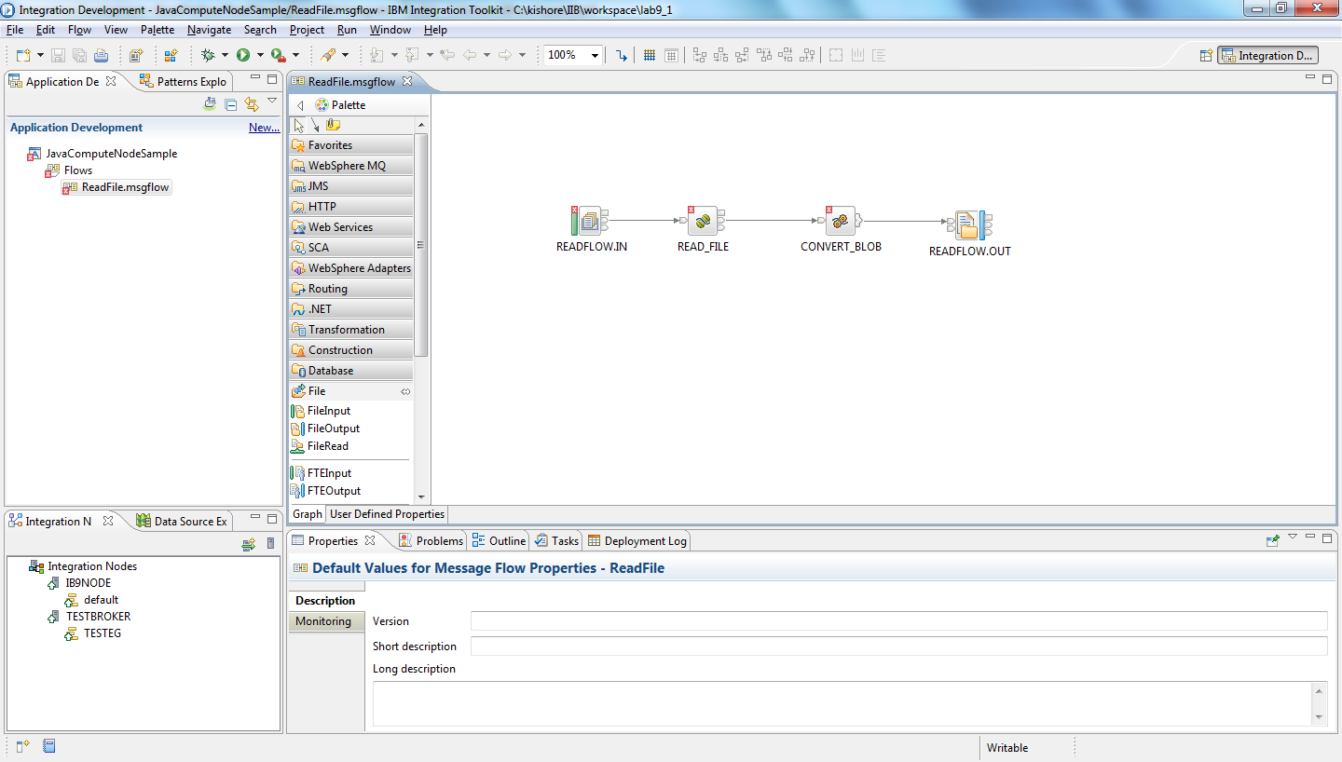

Step 4:- Right click on the MQInputNode and provide the Queue name “READFLOW.IN”

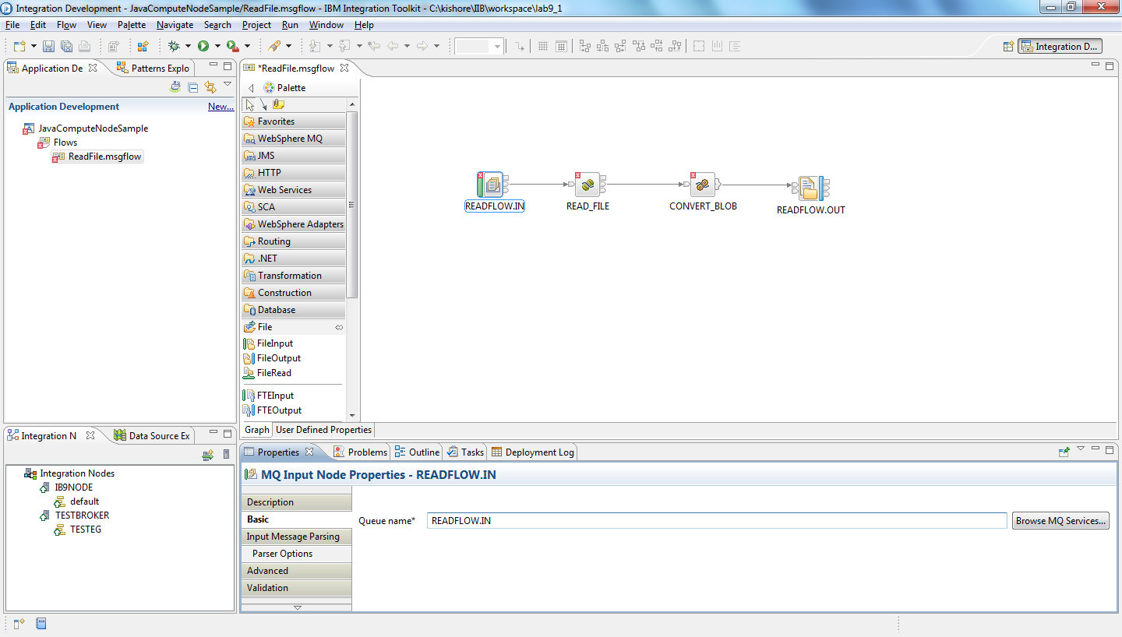

Select Input message parsing message Domain as XMLNSC

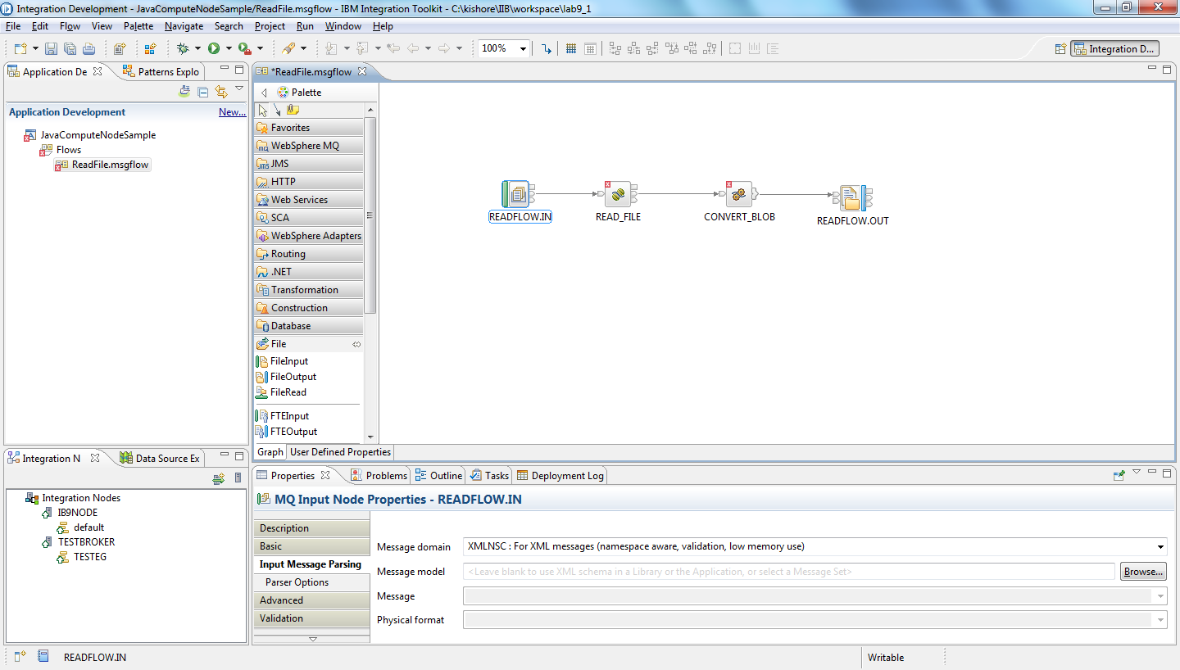

Step 5:- Configuring the JavaCompute Node.
Click on the JavaCompute Node and give the class name as “ReadFile_JavaCompute”
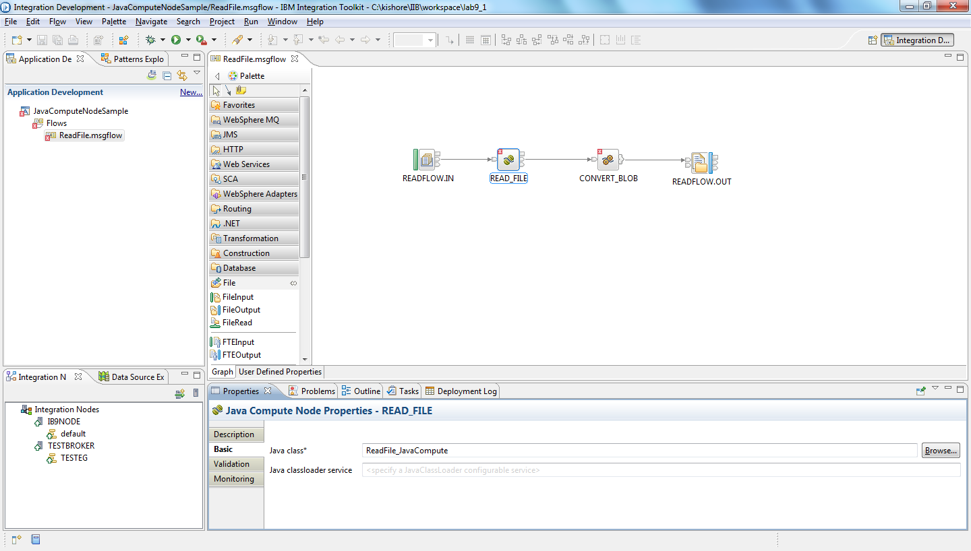

Double click on the JavaComputeNode. It opens the java class details window. Click Finish.
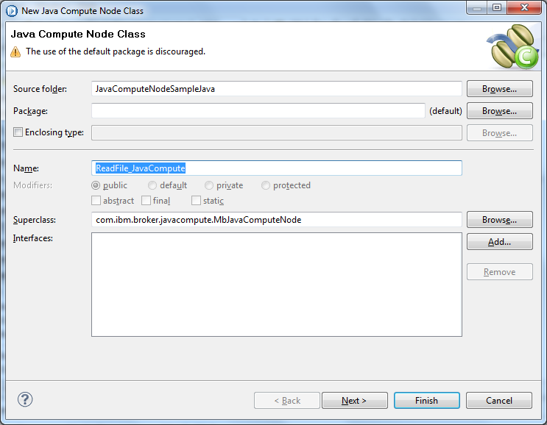

It opens the Java class file.

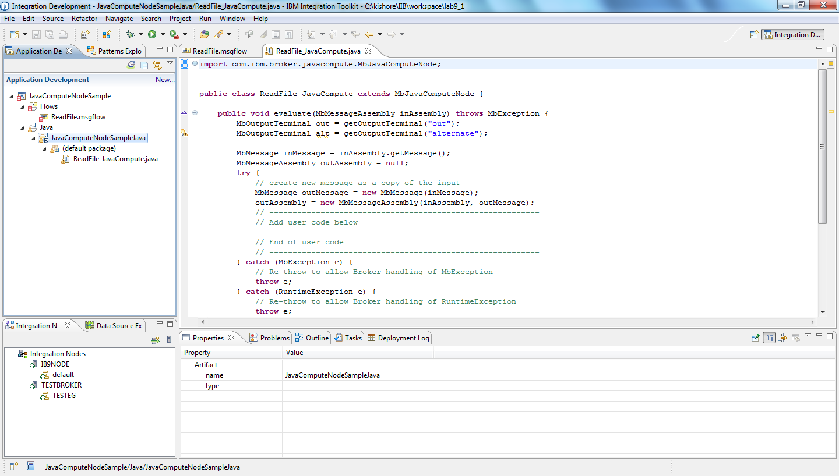

Copy the below code in between // Add user code and // End user code comments

MbElement mbElement = outAssembly.getMessage().getRootElement();
setAttribute("firstParserClassName", "XMLNSC");
MbElement mbElement1 = mbElement.getFirstElementByPath("/XMLNSC/FileStructure");
MbElement mbElement2 = mbElement.getFirstElementByPath("/XMLNSC/FileStructure/FileName");
String fileName = (String)mbElement2.getValue();
String data = null;
File file1=new File(fileName);
data=readTheFile(file1);
Object obj = mbElement1.createElementAsLastChild(0x1000000, "FileContent", data);

Copy the below method to the java class

public String readTheFile(File file) {

FileInputStream fis=null;
try {
fis = new FileInputStream(file);
} catch (FileNotFoundException e) {
throw new RuntimeException(e.toString());
}
String inputStreamString = new Scanner(fis,"UTF-8").useDelimiter("\\A").next();
try {
fis.close();
} catch (IOException e) {
throw new RuntimeException(e.toString());
}
return inputStreamString;

}

Right click on the source code and organize imports

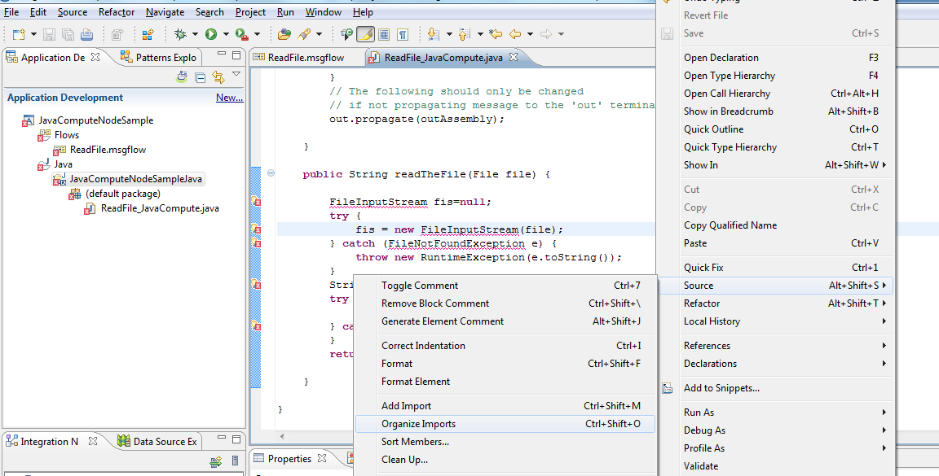

Step 6:- Double click on the compute node and copy the below ESQL

CREATE COMPUTE MODULE ReadFile_Compute
CREATE FUNCTION Main() RETURNS BOOLEAN
BEGIN
CALL CopyMessageHeaders();
-- CALL CopyEntireMessage();
DECLARE cData CHAR;
SET cData = InputRoot.XMLNSC.FileStructure.FileContent;
SET OutputRoot.BLOB.BLOB = CAST ( cData AS BLOB ccsid 1208 );

RETURN TRUE;
END;

CREATE PROCEDURE CopyMessageHeaders() BEGIN
DECLARE I INTEGER 1;
DECLARE J INTEGER;
SET J = CARDINALITY(InputRoot.*[]);
WHILE I < J DO
SET OutputRoot.*[I] = InputRoot.*[I];
SET I = I + 1;
END WHILE;
END;

CREATE PROCEDURE CopyEntireMessage() BEGIN
SET OutputRoot = InputRoot;
END;
END MODULE;

Step 7:- Click on the FileOutputNode properties. Provide the Directory as “C:\IIB\Lab9\output” and File Name as “OUTPUT.TXT”

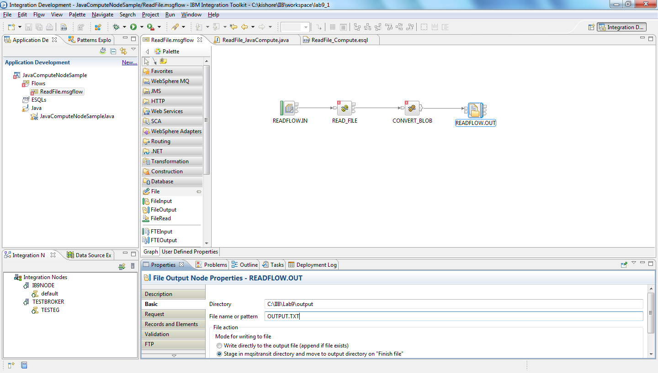

Build the project.

The flow should appear like this

Step 8:- Deploy the flow.

Right click on the flow and deploy to the execution group.

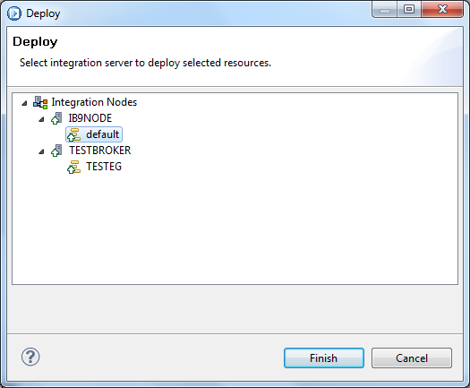

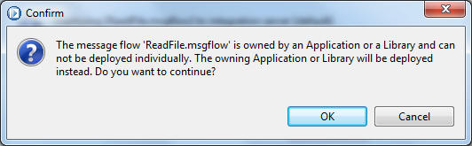

Click OK

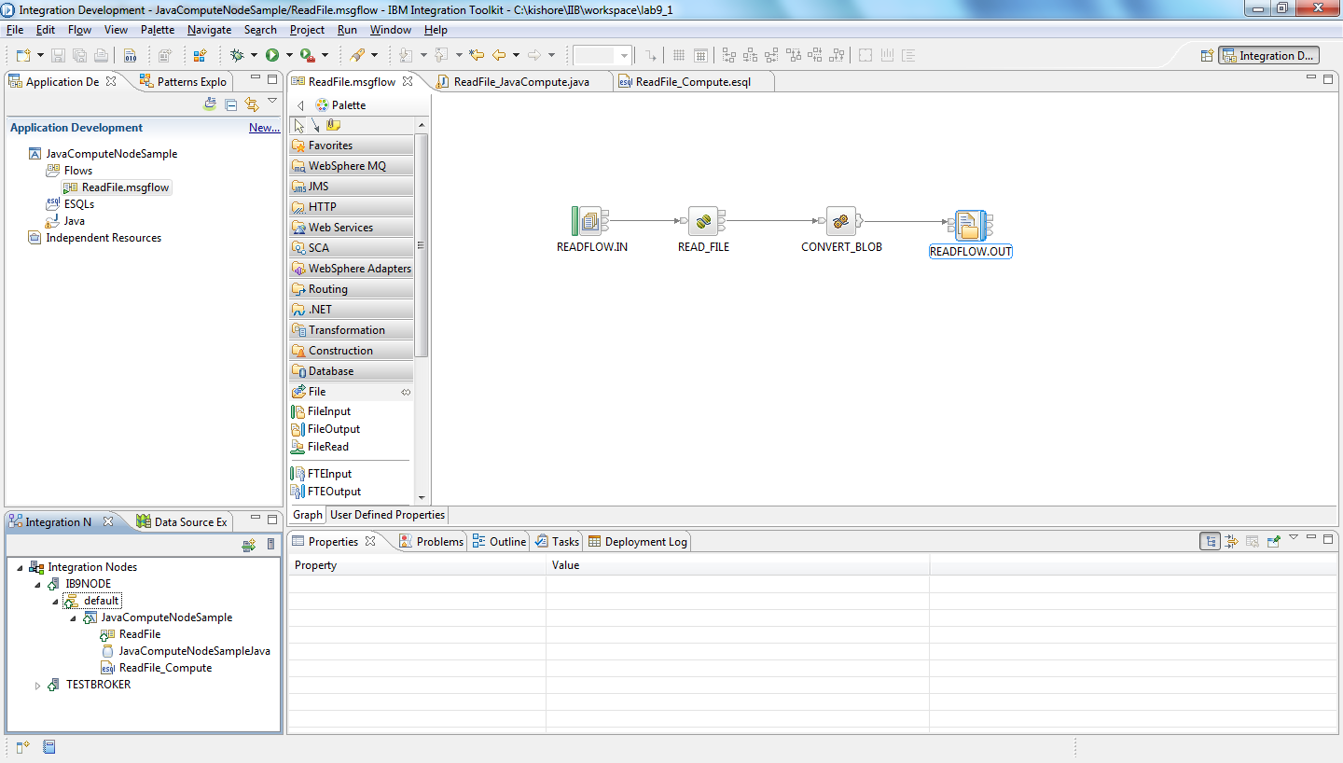

Step 9:- Testing.
Create the required Queue “READFLOW.IN” in MQ
Copy the test resources to the lab folders C:\IIB\Lab9\input

Using RFHUtil send the input message to READFLOW.IN Queue

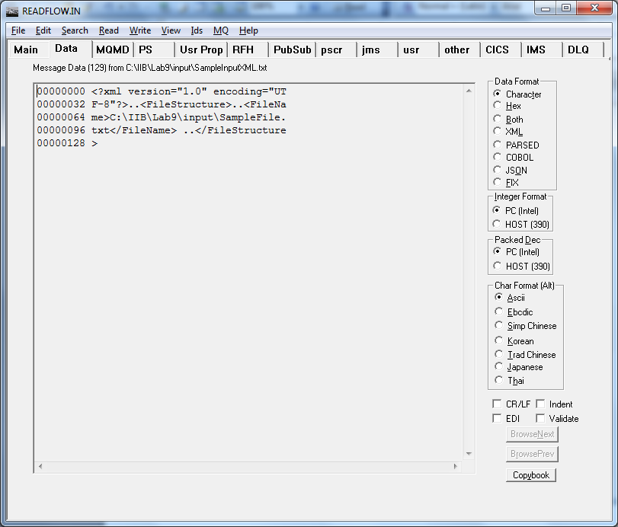
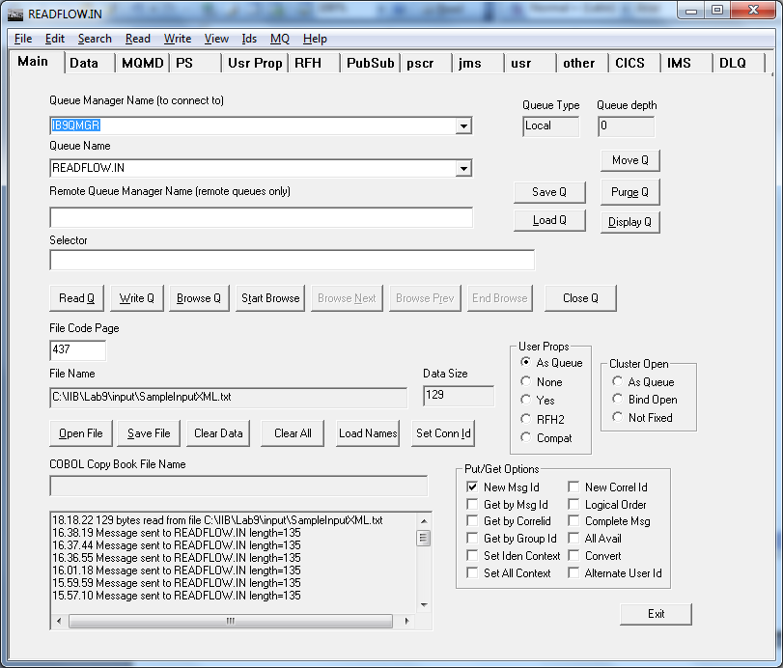

Click on Write Q to send the message.

Result:

Output file is generate in the specified directory C:\IIB\Lab9\output

