Lab7: Map Designer

Using Run Function

Objective

In this lab you will know how a main map can call an executable map from a map rule..
In this process the main map will call an executable map called the RUN Map using the RUN function from its map rule. You will create two executable maps and one calls the other.

By completing the exercise you will learn

1. What is a Run Map and Run function
2. Calling an executable map from a main map
3. Execute and Run the Map to obtain the output

Run Function

The RUN function allows you to execute another compiled map from a component or map rule.
You can use RUN to dynamically name source and/or destination files or to dynamically pass data to a map. You can also use the RUN function to split the output data into separate files based on some value in the input.
List of components

1. Input type tree – Employee.mtt
2. Output type tree – Employee.mtt
3. Input file name – EmployeeDetails.txt
4. Output file name – Report.txt
5. Map Source name – EMPLOYEE_REPORT.mms

Procedure

The EMPLOYEE is the main map which calls the compiled map GENERATE_REPORT. The main map has two output cards. The first output card does the actual mapping and generates the output. This output is sent as the input to the run map using the RUN function in the second output card, instead of writing to a file.

Step 1 :

Start menu->Programs-> WebSphere Transformation Extender 8.4 ->Design Studio

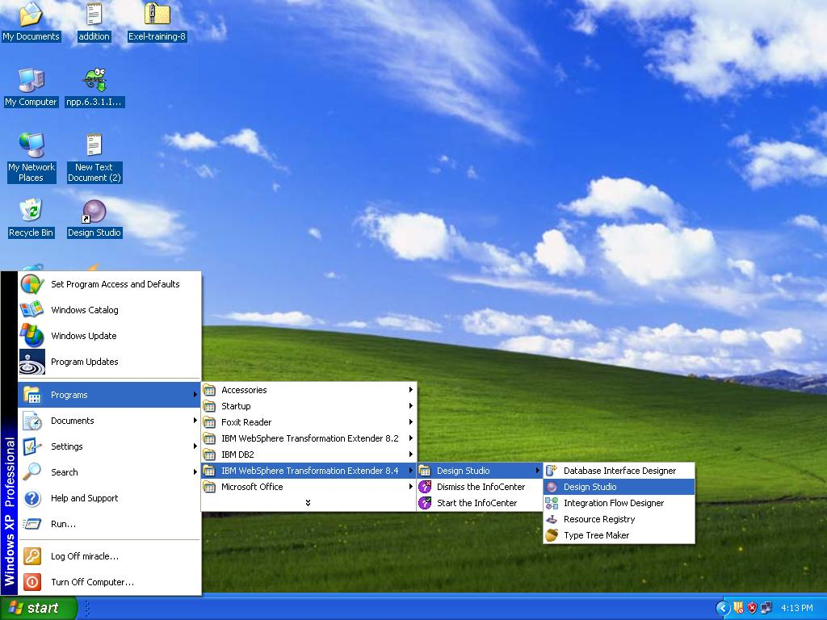

Step 2 :
Open the WebSphere Transformation Extender Design Studio and click the OK button to accept the default workspace location or you can browse your own location.
Here location C:\WTXTraining\WTX8.4 has been used.

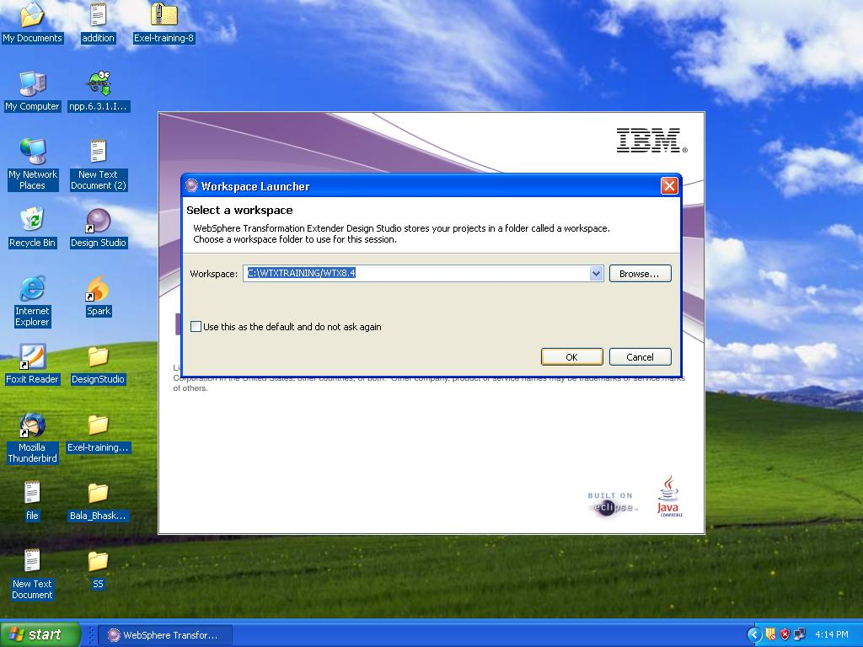

Step 3 :
Go to the file menu and select New->Extender Project to create a new project:

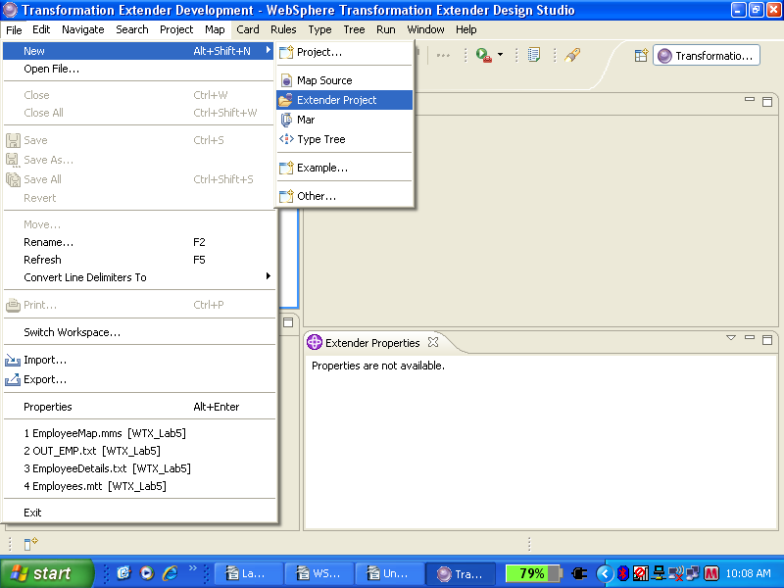

Step 4 :
Name this project WTX_Lab7 and accept the default location and click Finish.
You have created a subdirectory called WTX_Lab7 in your default workspace. You can use Windows Explorer to view it.

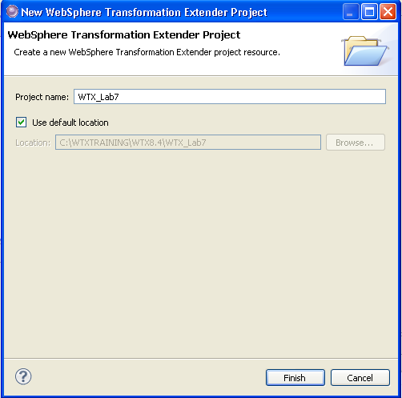

Step 5:

Open the type tree (Employee.mtt) provided in the Lab folder. Here we are going to use the same typetree for both source and target.

Analyze the type tree for any syntax errors.

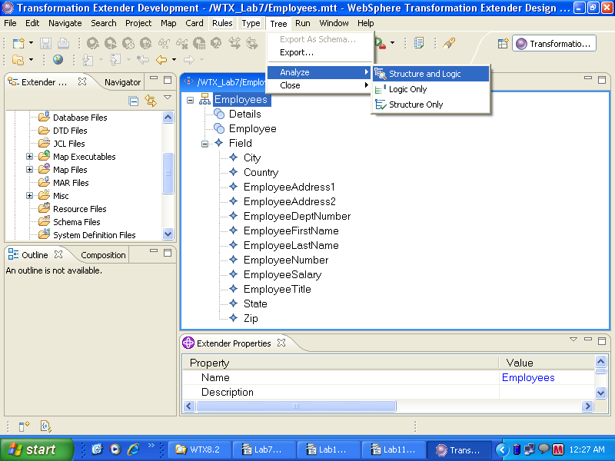

Step 6:

Open the type tree (Utility.mtt) provided in the Lab folder.

Analyze the type tree for any syntax errors and close the Analysis Results window

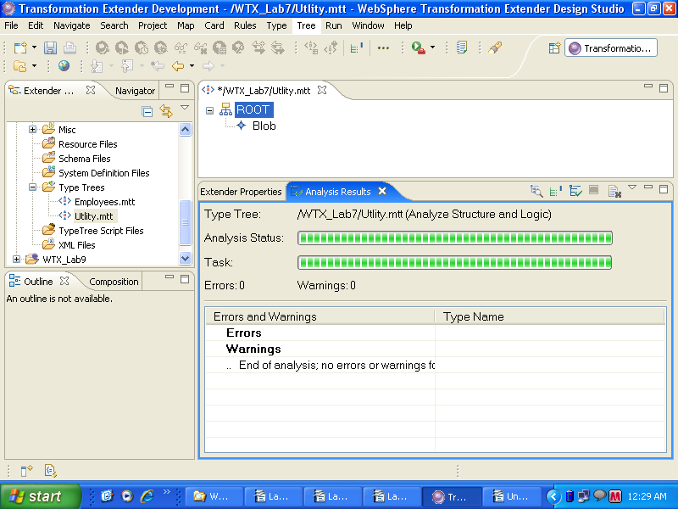

Step 7:

Create a map GENERATE_REPORT as shown below.

(Refer Lab_5 to create a map)

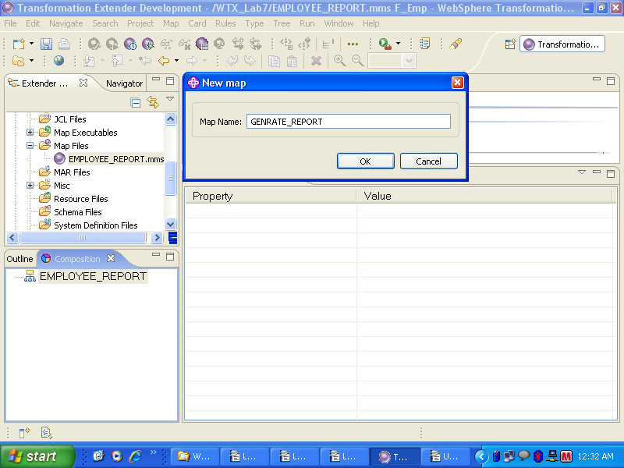

Step 8 :

Create an input card

- Go to menu Card>New.
- Name the Card as “blob1”.
- Add a type tree by Browsing / Locate the type tree. (Utility.mtt)
- Select Type as Blob by browsing the type tree (Utility.mtt) And click “OK”
- Add Source as File
- Specify the File path - dummyfile (Input Source file)
- Click OK, the Source Card is created.

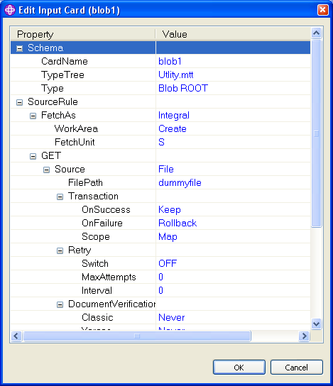

Step 9 :

Create an Output card

- Go to menu Card>New.
- Name the Card as “Blob”.
- Add a type tree by Browsing / Locate the type tree. (Utility.mtt)
- Select Type as Blob by browsing the type tree (Utility.mtt) And click “OK”
- Add Target as File
- Specify the File path – Report.txt (Target file)
- Click OK, the Source Card is created.
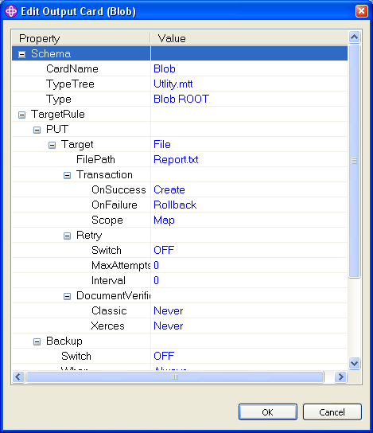

Step 10 :

Map the field Blob as shown below.

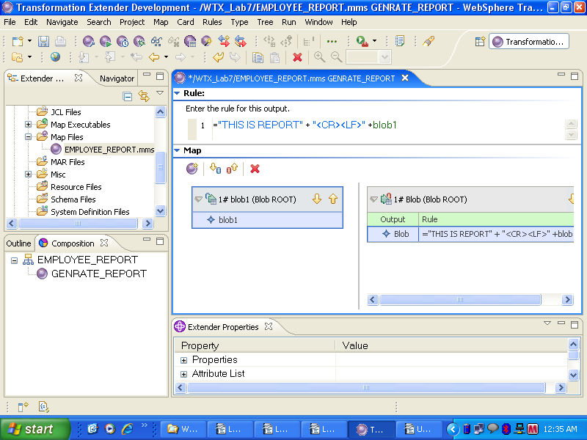

Step 11:

Create a Map EMPLOYEE which takes the file EmployeeDetails.txt as the input and calls the compiled map GENERATE_REPORT.mmc file.

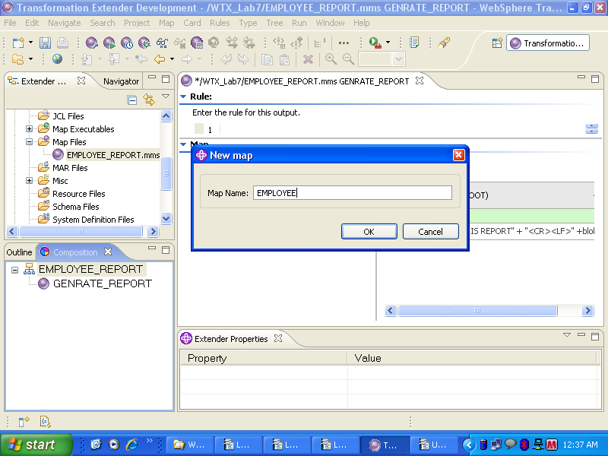

Step 12 :

Give the Input Card Settings as shown below

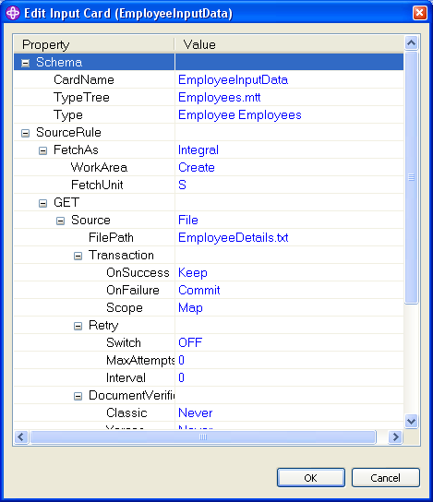

Step 13 :

Output Card Settings:

Number of output cards we have for this map is 2.

Output Card 1 settings:

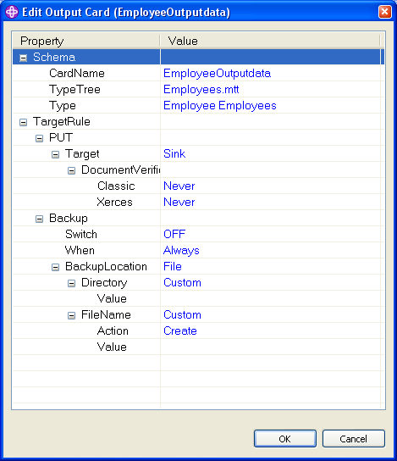

Step 14:

Output Card 2 settings:

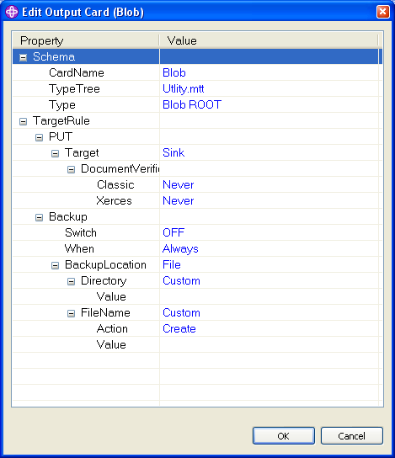

Creating a Functional map
Step 15:

Create a Functional map with name “F_Emp “ (For repeating data n number of times).The Arguments passed in the functional map are the source group Details(s) as shown below.

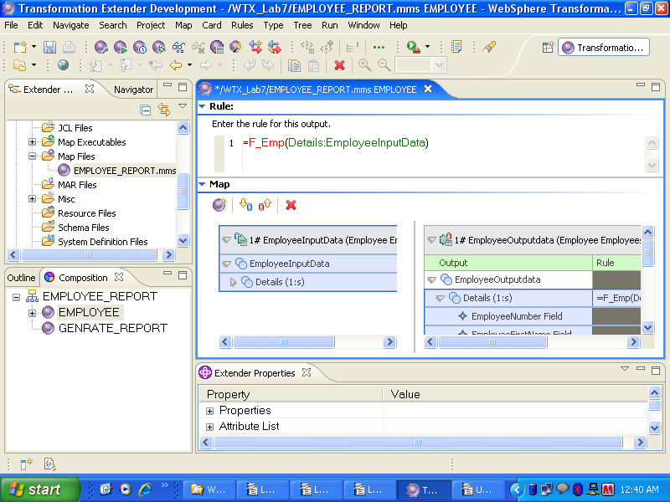

Step 16:

In the functional map wizard click create (The “F_Emp” map is created). And close it.

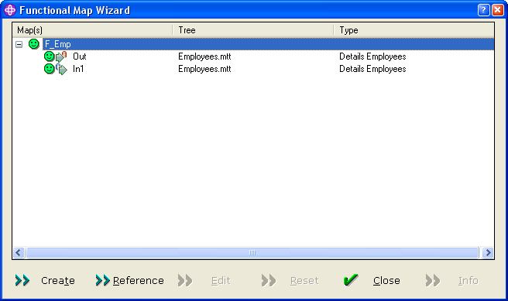

Step 17:

Map the “F_Emp” functional map source card and Target accordingly.

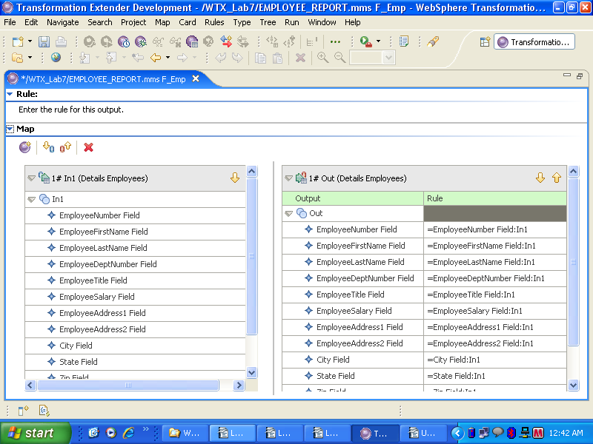

Step 18:

Click the Second Output card Blob and enter the following command in the rule bar as follows.

=VALID(RUN("GENERATE_REPORT.mmc", ECHOIN(1,PACKAGE(EmployeeOutputdata))),FAIL("FAIL IN RUN MAP" + LASTERRORMSG()))

This command invokes the compiled map GENERATE_REPORT.mmc file and gives the values of the first output card as the input using the ECHOIN function. If the map fails for any reason, the FAIL command gives the appropriate message using the LASTERRORMS”G() command.

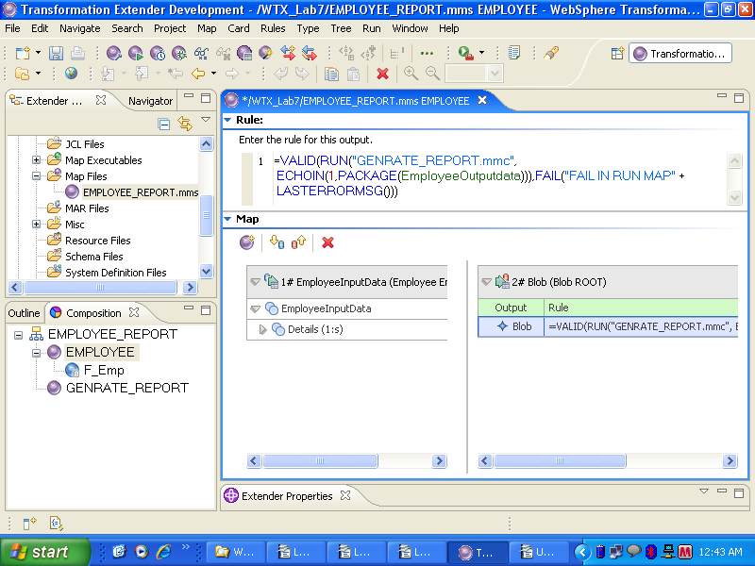

Step 19:

Compile the two maps ( First GENERATE_REPORT and then EMPLOYEE ) and run the EMPLOYEE map using the Map → Run from the File menu options.

The following message is seen on the screen.

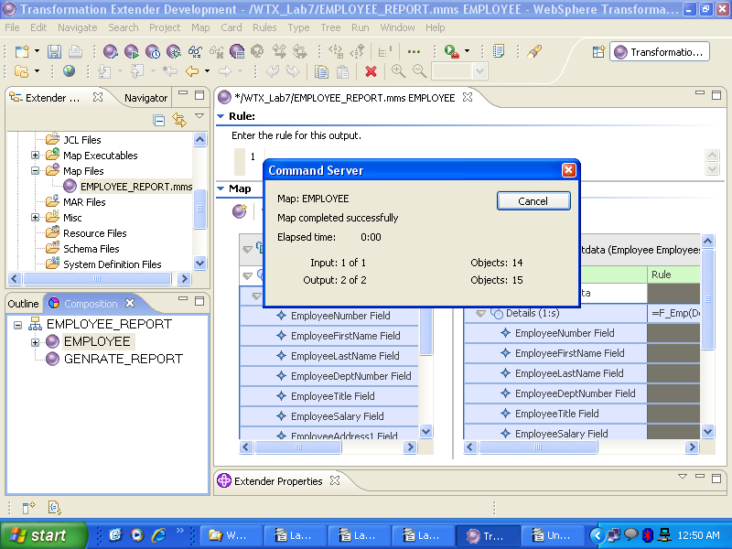

Points to remember

- The RUN function allows you to execute another compiled map from a component or map rule.
- Use RUN to dynamically name source and/or destination files or to dynamically pass data to a map.
- Use the RUN function to split the output data into separate files based on some value in the input.

LIMITATIONS & CONSTRAINTS

1. There are various methods of troubleshooting that can assist you in situations where when running a map, the following types of errors occur regarding input or output data
* Data is invalid
* Data contains invalid objects
* Unknown data exists
2. When you run a map, the first thing that happens is the input data is validated by comparing the data to its definition in the type tree. After validating data, the output card map rules are evaluated, and the output objects are built.
3. If you run a map and invalid or unknown input data is encountered, you can analyze what happened during the validation process. In addition, you can analyze the output data.
ECHO Command

- If you use the Echo command option for an output card, the data from that card will be passed back as a text item to the object in the map from which it was run.

- If you use the Echo command option for more than one output card, the data from all echoed cards will be concatenated together and passed back as a text-item to the object in the map from which it was run.

- If you do not use the Echo command option, the return code indicating the status of the map that was run will be passed back to the object in the map from which it was run.

