NCL Fall 2026:
Gymnasium Log Analysis, Custom File Format
CTF Walk-through & Technical Analysis Guide
Glenn R. Harshman
- Category: Forensics, Miscellaneous
- Difficulty: Hard
- Points: 100
- Core Concepts: Digital Forensics, Blue Team
Attack Pattern Recognition
Log Parsing and Data Manipulation
Timeline Analysis & Incident Reconstruction
Obfuscation and Decoding

1. Challenge Context & Initial Triage
Log analysis refers to the process of reviewing and interpreting system, network, or application logs to identify patterns, detect threats, and gain actionable insights. It plays a key role in security incident detection, troubleshooting, and compliance monitoring. CTF log files are often quite large, requiring players to use command-line tools or scripting to isolate the flag or malicious activity.
In this exercise, the log file was designed to record network traffic data in an efficient manner, utilizing raw binary data to save space compared to traditional text files. This was not done to intentionally obfuscate the data, but the effect on log analysis is the same, if you do not have a custom log reader for the file.
The exercise provides an example log file ('Custom File Format.sky'), and the specifications for the file's structure. We need to analyze this custom log file that was used to monitor data transfers on a secure network. Unfortunately, the log reader was not given to us; only the file specification was given. All date/time stamps provided as UTC. Answers should also be in UTC format. The final complication is that the file data is stored in "Big Endian" format, while most computer systems default to "Little Endian" format. What that means is that every two-byte group is reversed, but it is a simple matter to manage the byte order.
If we were going to analyze the log file format regularly and repeatedly, we would program a script or automated solution. Since this is a one-time analysis, we will use regular Linux command line tools.
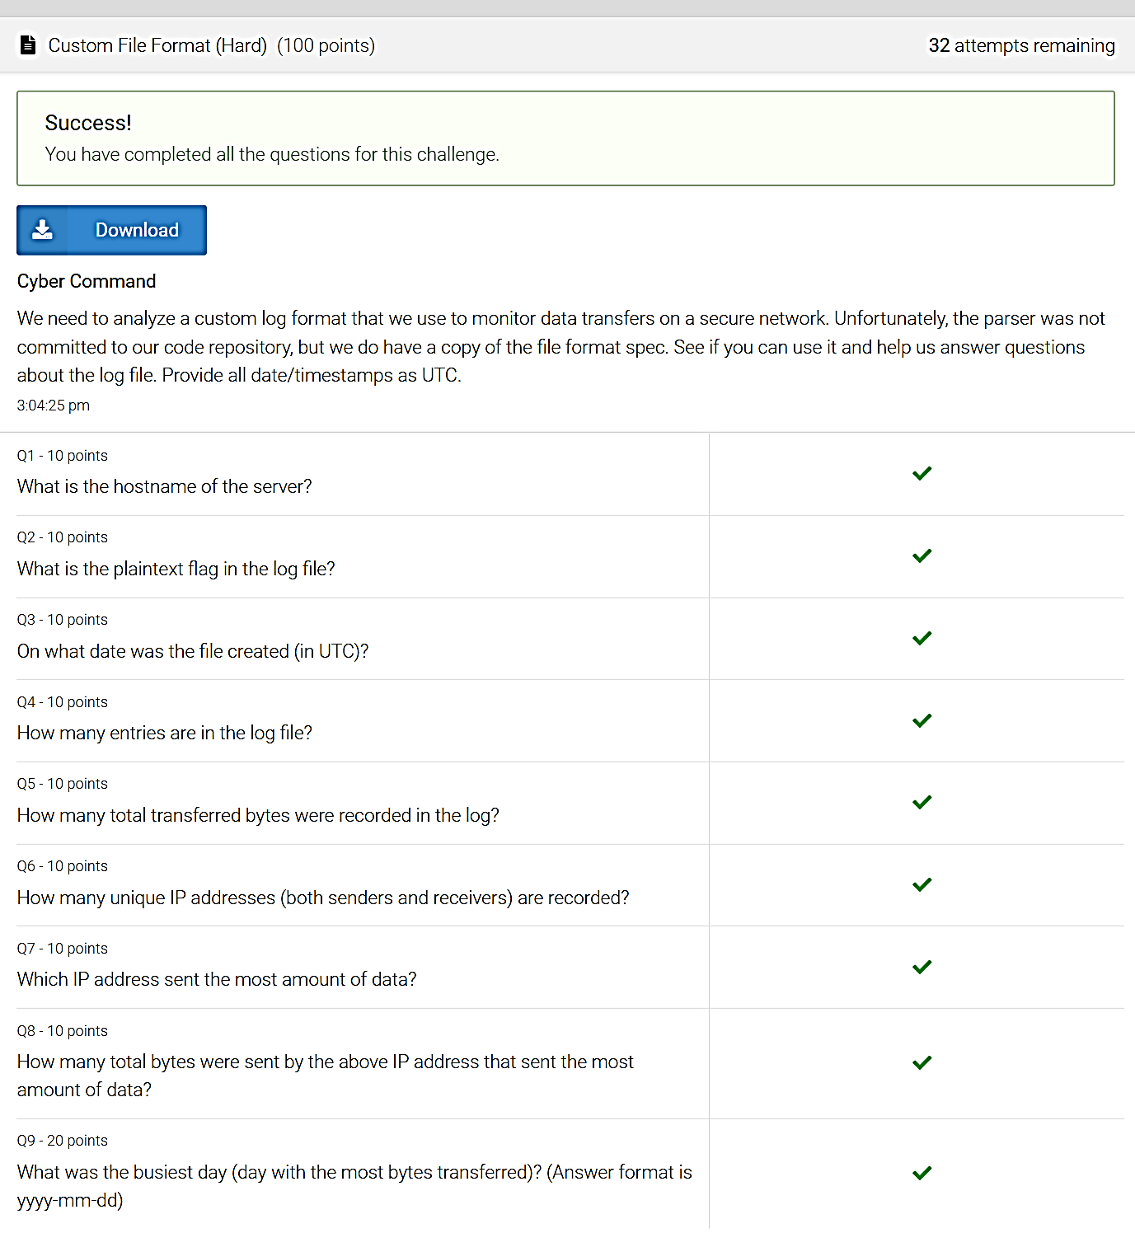
Specification For The File Header:
The SKY header begins at byte offset 0 and is comprised of the following fields in order with no padding. Because the file is saved in binary format, each field must be converted to its appropriate type, e.g., hex, decimal, or ASCII, depending on the individual fields' purposes.
- Magic Bytes = 8 bytes or 64 bits Hex
The magic bytes field is an 8-byte unique sequence used to identify the file as using the SKY format. All SKY files begin with the same hex ("0x") sequence: "91534B590D0A1A0A". We can see this signature in our example file using the Linux xxd command.
The Linux xxd command is a utility used to inspect files or standard input as binary bits, hex representations, and ASCII characters. It is widely used by system administrators, developers, and security analysts for debugging binaries, data analysis, and file patching. It has many flags to control the output, but in this example, we only use four:
  - -s Start byte (or "skip" bytes)
  - -l Length in bytes to output
  - -b Binary output
  - -c Columns to display per line
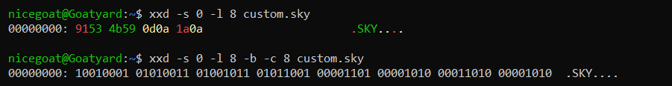
There is another Linux command, hexdump, which is also useful for this same type of analysis. However, hexdump defaults to reading bytes per the system default on which the command is run, which for most systems is "Little Endian" format. You can use it, but you have to manage the byte order by only reading one (1) byte at a time using the -e flag and a format string. The -v flag forces verbose mode, bypassing hexdump's desire to compress the output. The -s flag is the same as with xxd, but the length flag changes to -n.
The disadvantage of hexdump is that it does not natively display the ASCII conversion along with the byte readout. However, hexdump's output can be piped to xxd for conversion (use -b for binary and -r for ASCII). Notice the "unprintable" characters in the ASCII output.
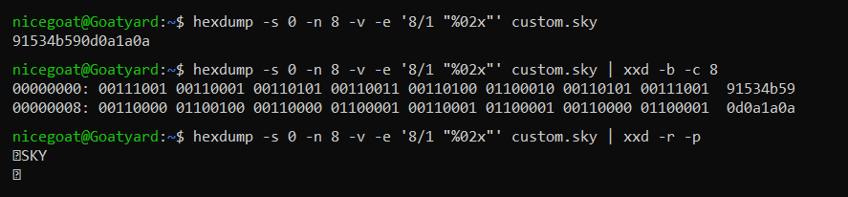
- Version Number = 1 byte or 8 bits Integer/Decimal
The version field is a single byte. The specification document says that all SKY files use version 1 at this time, so this field should be "0x00000001" in hex or "1" decimal. The field starts at byte 8 (i.e., skipping bytes 0 through 7), and the length of the field is one (1) byte.
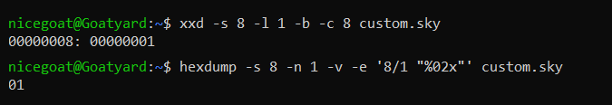
- Creation Time: = 4 bytes or 32 bits Timestamp
The creation timestamp is a single timestamp used to denote the start of data collection within the log file. It starts at byte 9, and the length is four (4) bytes. It is in standard Linux long integer format, which is the number of seconds since January 1st, 1970 at 12:00:00AM. The integer must be converted to UTC time to be understandable to humans. To do that, we put the hex value through an evaluation function $((x)) and echo it to the screen (there are other ways to convert hex to decimal, but this is the easiest). Then we put the decimal into the date command to convert it to a human-readable date & time. The -d flag tells the date command that the input is a string, but the '@' tells the command that the input is a decimal number. The -u flag tells the date command to convert to UTC time, not local time.
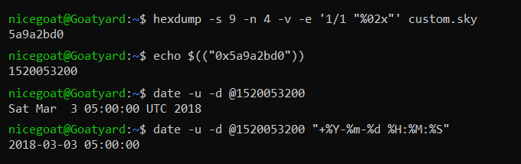
- Hostname Length = 4 bytes or 32 bits Integer/Decimal
The hostname length is a single decimal integer used to denote the number of bytes needed for the hostname. It starts at byte 13, and the length is four (4) bytes. If no host is specified, this value should be 0x00000000. In this case, the value is 0x0000000e, which converts to 14 bytes in decimal (base-10).
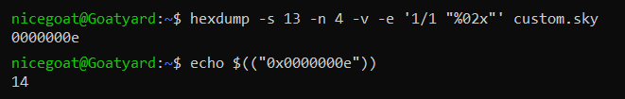
- Hostname = # Bytes in preceding value ASCII
The hostname is a dynamic length string used to identify the name of the host on which the log file was created. The byte-length of the hostname is the value from the previous field, in this case, 14 bytes. Therefore, the field starts at byte 17, and the length is 14 bytes. The server name needs to be converted to ASCII characters to be human-readable. In this case, xxd is the easier and shorter command to run.
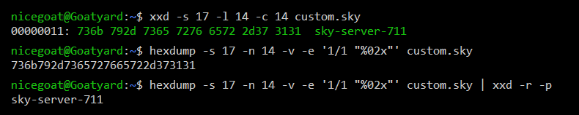
- Flag Length = 4 bytes or 32 bits Integer/Decimal
The flag length is a decimal integer used to denote how many bytes long is the flag value. This value is used to determine how many bytes to read for the following field. It starts at byte 31, and the length is four (4) bytes. If no flag is specified, this value should be 0x00000000. In this case, the value is 0x00000014, or 20 bytes.
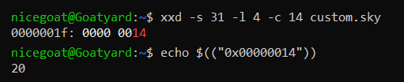
- Flag Value = # Bytes in preceding field ASCII Base64
The flag is a dynamic length string used to specify a flag value for the log file. The byte-length of the flag is the value from the previous field. It starts at byte 35, and for this file, the length is 20 bytes. This field can be used to store both encoded/encrypted flags as well as plaintext flags. If the flag appears to be encoded, you have to figure out how to decode it. In this case, I put the ASCII conversion in Google AI, and it suggested that it was encoded with base64.
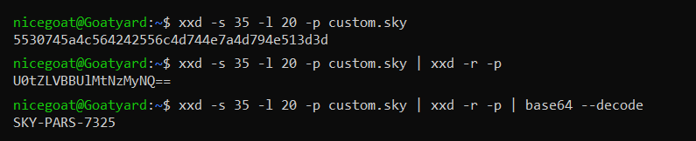
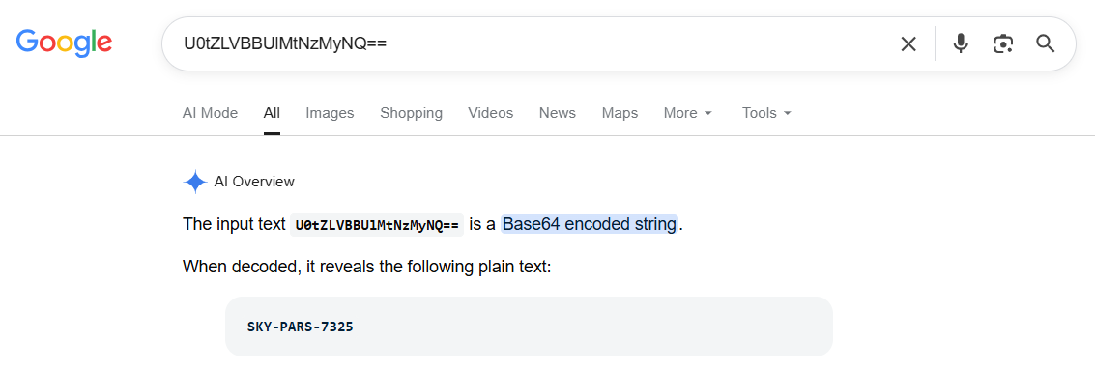
- Number of records = 4 bytes or 32 bits Integer/Decimal
The last header field is the number of log entries in the body. This field is a single decimal integer used to denote the number of records to follow. For this file, the field starts at byte 55, and the length is four (4) bytes. In this case, the value is 0x000000a2, or 162 log record entries.
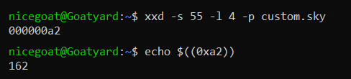
Specification For The File Body:
The body is a sequence of items, each with 4 required fields, and each field is four bytes long. All items are written in chronological order without any padding between items. Each item contains the following fields:
- Source IP Address = 4 bytes or 32 bits Four integers 0-255
The IPv4 address of the sender of the data stream. Represented as four short integers between 0 and 255, which means 8 bits each (2⁸ = 256). The decimal "." is not represented in the data. It is a convention to delimit the four integers, thus making the IP address more readable. For this file, the first body data record starts at byte 59, and the length is four (4) bytes. In this case, the value is 0x32c7ccb7, which must be broken into two-byte chunks as 0x(32 c7 cc b7). These values convert to decimal as 50, 199, 204, and 183.
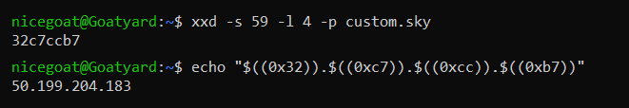
- Destination IP Address = 4 bytes or 32 bits Four integers 0-255
The IPv4 address of the destination of the data stream. Represented as four short integers between 0 and 255, just like the source IP address above. For this file, the second body data field starts at byte 63, and the length is four (4) bytes. In this case, the value is 0xe5d415d4, which must be broken into two-byte chunks as 0x(e5 d4 15 d4). These values convert to decimal as 229, 212, 21, and 212.
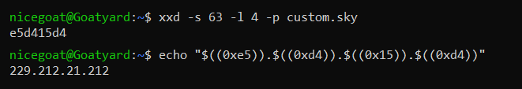
- Date/Time Stamp: = 4 bytes or 32 bits Timestamp
The timestamp when the data stream was initiated. Represented as one long integer. For this file, the third body data field starts at byte 67, and the length is four (4) bytes. In this case, the value is 0x5a9a44f5, which converts to decimal 1520059637. Again, this is the number of seconds since Jan. 1st, 1970 at 12:00:00AM.
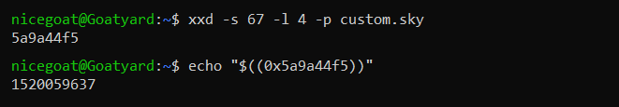
- Transferred Bytes: = 4 bytes or 32 bits Integer/Decimal
The number of bytes transferred in the data stream. Represented as one long integer. For this file, the fourth body data field starts at byte 71, and the length is four (4) bytes. In this case, the value is 0x000006c3, which converts to decimal 1731.
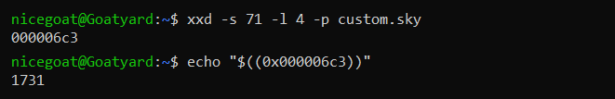
Converting The File Body To Facilitate Analysis:
Because the body is composed of records of fixed and predictable length, this makes it very easy to convert the entire body into human-readable format using simple Linux commands. We use the tail command because we want everything from after the header to the end of the file. The -c +60 flags mean to read every byte one at a time, starting with the 60th byte from the beginning (notice that this is different than saying start at byte 59). From there, we pipe the bytes to the hexdump command to convert the binary bytes to hex. Next, we pipe to the awk command to take advantage of its ability to create and use functions on the fly. We create a function to convert hex inputs to formatted IP addresses, and then we call that function as we convert columns 1 and 2. Columns 3 and 4 are simply converted to decimal numbers using the strtonum() function. The print command automatically puts a space delimiter between the fields. Finally, we redirect (>) the standard output to a new file called entries.txt.
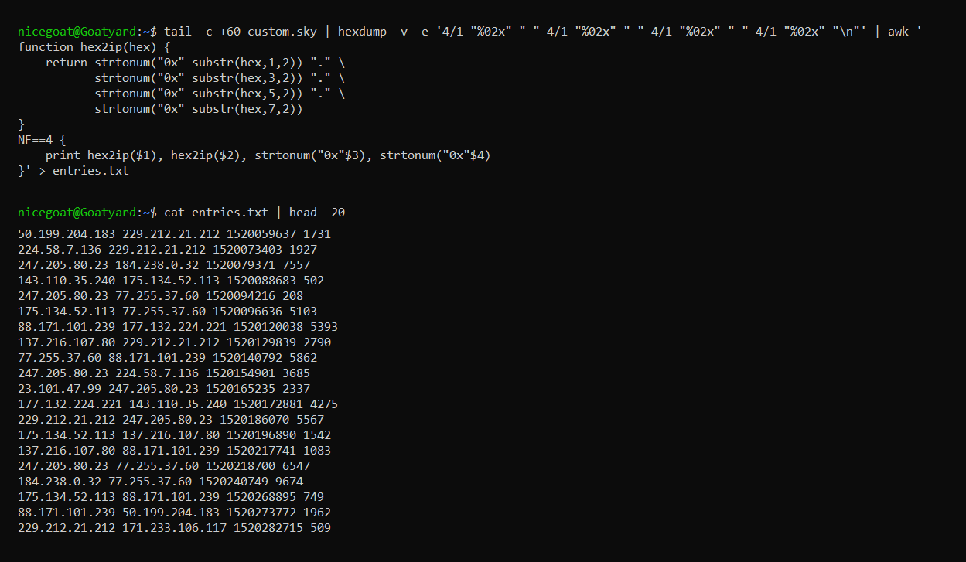

Now that we completely understand the structure of the file, have dissected the header and discovered the two missing field lengths, and we have created a new file which holds the individual log record entries --- we are ready to proceed with the CTF questions.

2. Challenge Question 1: What is the hostname of the server?
(10 Points)
This question was answered above in Section 1, at the top of page 4.
Verified Answer: "sky-server-711"

3. Challenge Question 2: What is the plaintext flag in the log file? (10 Points)
This question was answered above in Section 1, at the bottom of page 4 and the top of page 5.
Verified Answer: "SKY-PARS-7325"

4. Challenge Question 3: On what date was the file created (in UTC)? (10 Points)
This question was answered above in Section 1, in the middle of page 3.
Verified Answer: "2018-03-03"

5. Challenge Question 4: How many entries are in the log file?
(10 Points)
This question was answered above in Section 1, in the middle of page 5.
Verified Answer: "162"

6. Challenge Question 5: How many total transferred bytes were recorded in the log? (10 Points)
Finally, a question that was not answered while we were conducting initial triage!
In section 1, we recognized that the file body is very regular and repeatable. Each record is four (4) fields of four (4) bytes each, so we went ahead and extracted the records and saved them in text format for easier analysis.
Column 4 is the number of bytes transferred for each record. We simply need to pass our new text file through awk and sum the decimals in column 4.
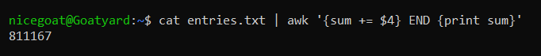
Verified Answer: "811167"

7. Challenge Question 6: How many unique IP addresses (both senders and receivers) are recorded? (10 Points)
We need the IP addresses from column 1 and from column 2 to be combined into a single column so that we can manipulate them as one group. The easiest way to do this is to write column 1 out to a new file, and then write column 2 out to the same file (i.e., an append operation). We do that using another redirection operator (>>), which appends the data to an existing file (or creates the file, if it does not yet exist). Then, we can run our new file through sort, uniq, and wc -l. This sorts the IP addresses, which is required by uniq to remove all duplicates, and then wc -l counts the number of lines remaining.
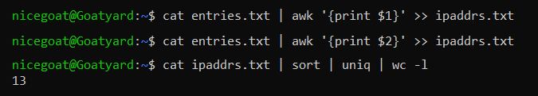
Verified Answer: "13"

8. Challenge Question 7: Which IP address sent the most amount of data? (10 Points)
In this question, we need to create an associative array (aka "dictionary" in Python or "map" in C++) in order to keep track of bytes per IP address. Associative arrays are known as "key-value pairs". In Excel, this would be like creating a Pivot Table to sum transferred bytes by IP address.
In order to do this, we need to isolate columns 1 (Source IP Address) and 4 (transferred bytes). Then we can have awk create our associative array. Each time that awk encounters a new IP address, it adds that IP address as a new key in the array. Then it adds the bytes to that key. If the key already exists, it adds the bytes to the value that was already present in the array. Then we have awk run a for loop to cycle through the array and send the key-value pairs to standard output. However, because we are interested in the largest number of bytes transferred, we need the values on the left and the keys on the right, so that our sort command will work properly. We include the -n and -r flags with sort so that the transferred bytes will be sorted numerically (not alpha-numerically) and arranged in descending order, placing our answer at the top of the list (answer = the key on the right side of the first line).
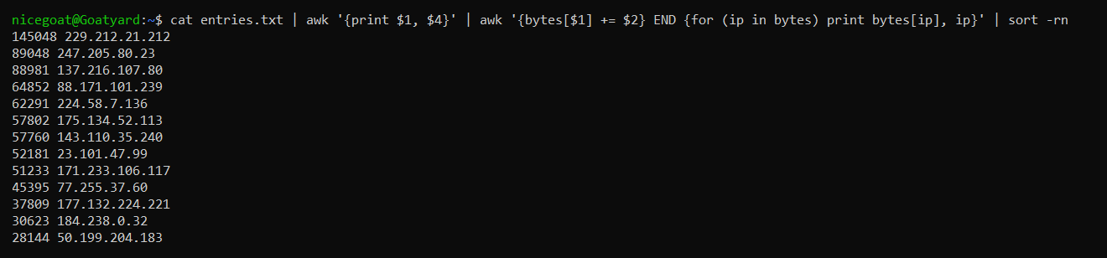
Verified Answer: "229.212.21.212"

9. Challenge Question 8: How many total bytes were sent by the above IP address that sent the most amount of data? (10 Points)
The same methodology and commands from the previous question also give us the answer to this question (answer = the value on the left side of the first line).
Verified Answer: "145048"

10. Challenge Question 9: What was the busiest day (day with the most bytes transferred)? (Answer format is yyyy-mm-dd)
(20 Points)
We are back to our entries.txt file that we created from the file body in section 1. Column 3 is the date/time stamp (in decimal format) and column 4 is the transferred bytes for each log entry. We need another associative array to sum up transferred bytes by date. But first we need to convert the integer timestamps to UTC dates.
When converting dates, you have to tell Linux if you want UTC dates/times vs local dates/times. It will often default to local dates/times, which would give the wrong answer to this question.
First, we cat the file to create a stream for piping commands. Then we use awk to pull out columns 3 and 4. At this point, for the next awk command, we only have two columns! Effectively, we screened out columns 1 and 2, so now column 3 becomes column 1 and column 4 becomes column 2.
However, the second awk command is processing data, not filtering it. It is reassigning the converted date string back to column 1, overwriting the integer decimal value. We still have our two columns, but we have transformed column 1. We use the strftime() function to convert the decimal date/time stamp to a string of text in YYYY-MM-DD format (we don't need or want the time portion). The $1 parameter is the data from column 1, and the other 1 parameter tells the strftime() function to convert to UTC, not local. Then we print the stream (both column 1 and column 2) to standard output and sort it. It will sort by date. Then we use the redirection operator > to send the data stream to a new file called dates.txt.
Finally, we run dates.txt through an associative array to set up our key-value pairs with dates for keys and bytes for values. We sum the bytes by date, just as we did with IP addresses in the previous two questions.
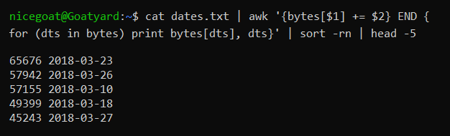
Verified Answer: "2018-03-23"

