

Black Monthly Statement |  |  |  | 
Anshu Bhati  Registered Email:  anshu.bhati@icloud.com  Registered Telephone Number (RTN): 8076031004  Your Plan:  Airtel 699 WiFi + TV 40 Mbps |  |  |  | Total Amount Payable: Due Date:  ₹856.68 4 Jul 2026  Pay via Airtel Thanks App i.airtel.in/digitalBills 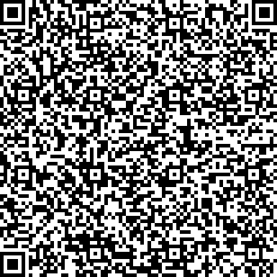  Scan and pay via any UPI apps  Powered by 
Airtel Black ID | Number of connections
10101029205226 |  | 2
Statement Date | Statement Period
24 Jun 2026 | 23 May 2026 - 22 Jun 2026
Last bill amount | Payment made |  | Payment Coupon | Credits | This Month's Charges | Total Amount | Amount after
due date (4 Jul)
₹856.68 | -₹856.68 | -₹0.00 | -₹0.00 | +₹856.68 | =₹856.68 | ₹1,074.68
This Month's Summary |  |  |  |  | (Amounts in ₹)
Services |  |  | Connections | Plan/Pack Charges | Other Charges |  | Total
Airtel Black Plan - 10101029205226 |  |  | 2 | 1049.0 | 27.00 | 1,076.00
Plan Discount |  |  | - | - | - | 350.00
Revised Charges |  |  | - | - | - | 726.00
Taxes |  |  | - | - | - | 130.68
This month's charges |  |  |  | 856.68
Last Bill Amount | - | - | - | 856.68
Last Payment Made | - | - | - | 856.68
TOTAL₹856.68
Total: Eight Hundred Fifty Six Rupees And Sixty Eight Paise Only
Other Charges in detail (excluding tax)
Services | Details | Amount (₹)
Recurring Charges
DTH : 3071869062-001 | DISNEY CHANNEL HD channel charges from 23 May 2026 to 22 Jun 2026 | 17.00
DTH : 3071869062-001 | & TV channel charges from 23 May 2026 to 22 Jun 2026 | 10.00
Total Recurring Charges (A) 27.00
Total Other Charges (A) 27.00
Detailed break-up of above charges can be found in bill

