AquaPure Smart Filters FZE
Dubai Smart Water Filtration Expansion Plan

Business Plan Financial Projection Report
Five-Year Projected Financial Study

Currency: AED
Scenario: Base Case
Projection period: 2026–2030
Prepared for: Prospective Investors
Prepared: 12 June 2026

CONFIDENTIAL

Table of Contents
Right-click the list below and choose 'Update Field' in Microsoft Word to refresh page numbers.
1. Executive Summary
2. Business Overview
3. Products and Revenue Model
4. Projection Assumptions
5. Operating Model
6. Capital Expenditure and Assets
7. Working Capital and Financing
8. Financial Statements
9. Financial Analysis
10. Scenario Comparison
11. Risks, Warnings and Reconciliations
12. Appendices

1. Executive Summary
AquaPure Smart Filters FZE imports high-quality water filtration components, assembles smart filtration systems locally, installs them for residential and commercial customers, and provides ongoing maintenance, filter replacement, and IoT-based water quality monitoring subscriptions.
This report presents a 2026–2030 projected financial study for AquaPure Smart Filters FZE under the Base Case, prepared in AED.

Key projected highlights
Total projected revenue | 20,627,338
Year 5 revenue | 6,893,373
Gross margin | 30.8%
EBITDA margin | (34.8%)
Net profit margin | (37.8%)
Closing cash (final year) | (8,069,249)
Total assets (final year) | (6,086,086)
Total borrowings (final year) | –
Total equity (final year) | (7,077,590)
Break-even target | 30 Jun 2027

Analytical commentary
- Revenue grows from 2,018,507 to 6,893,373 AED, a CAGR of 35.9%.
- Gross margin moves from 36.1% to 27.8% across the projection.
- Closing cash turns negative in Year 1, indicating a potential funding gap.
- Receivables rise as credit sales grow, increasing working capital requirements.

2. Business Overview
Business name | AquaPure Smart Filters FZE
Project | Dubai Smart Water Filtration Expansion Plan
Country / City | Dubai, United Arab Emirates
Industry | Water Treatment & Smart Home Services
Business model | Other
Tax jurisdiction | United Arab Emirates Corporate Tax
Reporting standard | Investor
Projection start | 01 Jan 2026
Projection period | 5 Years
Projection frequency | Monthly
Description | AquaPure Smart Filters FZE imports high-quality water filtration components, assembles smart filtration systems locally, installs them for residential and commercial customers, and provides ongoing maintenance, filter replacement, and IoT-based water quality monitoring subscriptions.

3. Products and Revenue Model

Products and services
Product / Service | Category | Revenue type | Unit | Price | Launch | Status
Residential Smart Filtration System | Product Sale | Unit Sales | System | 2,800 | 01 Jan 2026 | Active
Commercial Smart Filtration System | Product Sale | Unit Sales | System | 8,500 | 01 Feb 2026 | Active
Standard Installation Service | Service | Service Contract | Installation | 650 | 01 Jan 2026 | Active
Annual Maintenance Contract | Recurring Service | Subscription | Annual contract | 1,200 | 01 Mar 2026 | Active
Replacement Filter Pack | Consumables | Unit Sales | Filter pack | 480 | 01 Apr 2026 | Active
Smart Water Monitoring Subscription | SaaS / Monitoring | Subscription | Monthly subscription | 55 | 01 Jun 2026 | Active

Revenue by stream
Line item | Year 1 | Year 2 | Year 3 | Year 4 | Year 5 | Total
Product revenue | 1,709,471 | 2,414,202 | 3,255,824 | 4,411,301 | 6,007,050 | 17,797,848
Service revenue | 277,580 | 360,412 | 467,961 | 607,604 | 788,917 | 2,502,473
Subscription revenue | 31,456 | 53,801 | 65,058 | 79,295 | 97,406 | 327,017
Total revenue | 2,018,507 | 2,828,415 | 3,788,844 | 5,098,199 | 6,893,373 | 20,627,338

4. Projection Assumptions

Direct cost of sales
Line item | Year 1 | Year 2 | Year 3 | Year 4 | Year 5 | Total
Product direct costs | 893,793 | 1,301,906 | 1,816,406 | 2,544,281 | 3,579,296 | 10,135,682
Service delivery costs | 191,087 | 276,322 | 378,963 | 519,810 | 713,116 | 2,079,297
Subscription direct costs | 3,450 | 6,622 | 7,577 | 8,670 | 9,920 | 36,240
Payment gateway fees | 48,444 | 67,882 | 90,932 | 122,357 | 165,441 | 495,056
Sales commissions | 75,930 | 102,111 | 133,760 | 175,312 | 229,896 | 717,009
Warranty provision | 32,582 | 43,769 | 57,341 | 75,161 | 98,572 | 307,425
Import/customs costs | 44,690 | 65,095 | 90,820 | 127,214 | 178,965 | 506,784
Total cost of sales | 1,289,976 | 1,863,709 | 2,575,799 | 3,572,804 | 4,975,206 | 14,277,493

Operating expenses
Line item | Year 1 | Year 2 | Year 3 | Year 4 | Year 5 | Total
Selling and distribution expenses | 460,250 | 547,770 | 589,544 | 634,558 | 683,065 | 2,915,187
Administrative expenses | 413,800 | 467,360 | 488,891 | 511,440 | 535,056 | 2,416,548
Staff costs | 1,372,720 | 1,531,964 | 1,604,643 | 1,680,883 | 1,760,859 | 7,951,069
Technology and platform expenses | 45,600 | 47,424 | 49,321 | 51,294 | 53,346 | 246,984
Depreciation and amortisation | 99,229 | 112,250 | 112,250 | 99,250 | 81,021 | 504,000
Total operating expenses | 2,391,599 | 2,706,768 | 2,844,649 | 2,977,425 | 3,113,346 | 14,033,788

5. Operating Model

Staffing plan
Department | Role | Employees | Monthly salary | Start date
Management | General Manager | 1 | 24,000 | 01 Jan 2026
Sales | Sales Manager | 1 | 16,000 | 01 Jan 2026
Sales | Sales Executive | 2 | 8,000 | 01 Jan 2026
Operations | Installation & Maintenance Technician | 3 | 6,500 | 01 Jan 2026
Customer Support | Customer Support Coordinator | 1 | 6,000 | 01 Mar 2026
Finance | Accountant / Admin Officer | 1 | 7,500 | 01 Jan 2026
Technology | IoT Platform Specialist | 1 | 14,000 | 01 Jun 2026

Total staff cost by year
Line item | Year 1 | Year 2 | Year 3 | Year 4 | Year 5 | Total
Customer support | 64,800 | 80,870 | 84,105 | 87,469 | 90,968 | 408,213
Finance & administration | 97,200 | 101,088 | 105,132 | 109,337 | 113,710 | 526,467
Management | 379,260 | 397,548 | 416,750 | 436,913 | 458,084 | 2,088,555
Operations | 285,900 | 298,770 | 312,284 | 326,473 | 341,371 | 1,564,797
Sales | 437,760 | 459,648 | 482,630 | 506,762 | 532,100 | 2,418,900
Technology | 107,800 | 194,040 | 203,742 | 213,929 | 224,626 | 944,137
Total staff cost | 1,372,720 | 1,531,964 | 1,604,643 | 1,680,883 | 1,760,859 | 7,951,069

6. Capital Expenditure and Assets
Asset | Category | Cost | Life (yrs) | Method | NBV (final year)
Assembly Tools and Workbench Equipment | Equipment | 85,000 | 5 | Straight Line | 5,000
Delivery and Service Van | Vehicle | 145,000 | 5 | Straight Line | 25,000
Office Furniture and Fit-out | Furniture | 95,000 | 5 | Straight Line | 10,000
Computers and Devices | Computers | 42,000 | 3 | Straight Line | 3,000
IoT Monitoring Platform Development | Software Development | 125,000 | 4 | Straight Line | –
Warehouse Shelving and Storage System | Leasehold Improvements | 60,000 | 5 | Straight Line | 5,000

7. Working Capital and Financing

Working capital assumptions
Accounts receivable days | 35
% sales on credit | 55
Accounts payable days | 40
Inventory days | 70
Minimum cash balance | 150,000
Bad debt % | 2
Customer deposit % | 15
Supplier advance % | 20
Safety stock % | 15
Stock purchase cycle | Monthly

Equity funding
Founder capital | 650,000
Investor equity | 350,000
Investor name | Gulf Seed Growth Investor
Shareholding % | 25
Use of funds | Inventory purchase, marketing launch, IoT platform development, working capital buffer, and hiring.
Dividend policy % | 20

Loans
Loan | Amount | Rate | Term (m) | Grace (m) | Repayment
Vehicle and Equipment Finance | 250,000 | 8.5% | 48 | 3 | Equal Installments
Working Capital Facility | 300,000 | 10.0% | 36 | 6 | Interest Only Then Principal

Grants
Grant | Amount | Expected date | Restrictions
Sustainability Innovation Support Grant | 100,000 | 01 Sep 2026 | Must be used for smart monitoring, water-efficiency awareness, and customer education.

Tax and VAT
Corporate tax rate | 9.0%
VAT / sales tax rate | 5.0%
VAT registration threshold | 375,000
Customs duty rate | 5.0%
Withholding tax rate | 0.0%
Tax payment frequency | Yearly
VAT payment frequency | Quarterly
Tax loss carryforward | Enabled

KPI targets
Target gross margin | 45.0%
Target EBITDA margin | 18.0%
Target net margin | 10.0%
Break-even target | 30 Jun 2027
Min. monthly revenue | 350,000
CAC target | 650
LTV target | 4,500
ROI target | 25.0%

8. Financial Statements
All figures in AED. Negative amounts are shown in parentheses; a dash indicates a nil balance.

Statement of Profit or Loss
Line item | Year 1 | Year 2 | Year 3 | Year 4 | Year 5
Revenue
Product revenue | 1,709,471 | 2,414,202 | 3,255,824 | 4,411,301 | 6,007,050
Service revenue | 277,580 | 360,412 | 467,961 | 607,604 | 788,917
Subscription revenue | 31,456 | 53,801 | 65,058 | 79,295 | 97,406
Total revenue | 2,018,507 | 2,828,415 | 3,788,844 | 5,098,199 | 6,893,373
Cost of sales
Product direct costs | 893,793 | 1,301,906 | 1,816,406 | 2,544,281 | 3,579,296
Service delivery costs | 191,087 | 276,322 | 378,963 | 519,810 | 713,116
Subscription direct costs | 3,450 | 6,622 | 7,577 | 8,670 | 9,920
Payment gateway fees | 48,444 | 67,882 | 90,932 | 122,357 | 165,441
Sales commissions | 75,930 | 102,111 | 133,760 | 175,312 | 229,896
Warranty provision | 32,582 | 43,769 | 57,341 | 75,161 | 98,572
Import/customs costs | 44,690 | 65,095 | 90,820 | 127,214 | 178,965
Total cost of sales | 1,289,976 | 1,863,709 | 2,575,799 | 3,572,804 | 4,975,206
Gross profit | 728,530 | 964,706 | 1,213,045 | 1,525,396 | 1,918,167
Operating expenses
Selling and distribution expenses | 460,250 | 547,770 | 589,544 | 634,558 | 683,065
Administrative expenses | 413,800 | 467,360 | 488,891 | 511,440 | 535,056
Staff costs | 1,372,720 | 1,531,964 | 1,604,643 | 1,680,883 | 1,760,859
Technology and platform expenses | 45,600 | 47,424 | 49,321 | 51,294 | 53,346
Depreciation and amortisation | 99,229 | 112,250 | 112,250 | 99,250 | 81,021
Total operating expenses | 2,391,599 | 2,706,768 | 2,844,649 | 2,977,425 | 3,113,346
Operating profit / (loss) | (1,663,069) | (1,742,062) | (1,631,605) | (1,452,029) | (1,195,179)
Finance costs
Vehicle and Equipment Finance | 20,959 | 16,043 | 10,476 | 4,417 | –
Working Capital Facility | 23,750 | 23,500 | 11,500 | 1,000 | –
Total finance costs | 44,709 | 39,543 | 21,976 | 5,417 | –
Profit / (loss) before tax | (1,707,778) | (1,781,606) | (1,653,581) | (1,457,446) | (1,195,179)
Income tax expense | – | – | – | – | –
Profit / (loss) for the period | (1,707,778) | (1,781,606) | (1,653,581) | (1,457,446) | (1,195,179)

Statement of Financial Position
Line item | Year 1 | Year 2 | Year 3 | Year 4 | Year 5
ASSETS
Non-current assets
Property, plant and equipment | 346,000 | 265,000 | 184,000 | 116,000 | 48,000
Intangible assets | 106,771 | 75,521 | 44,271 | 13,021 | –
Other non-current assets | 168,000 | 168,000 | 168,000 | 168,000 | 168,000
Total non-current assets | 620,771 | 508,521 | 396,271 | 297,021 | 216,000
Current assets
Inventories | 662,242 | 747,070 | 866,508 | 1,035,460 | 1,275,655
Trade and other receivables | 134,378 | 179,354 | 240,351 | 323,508 | 437,509
Prepayments and deposits | 54,000 | 54,000 | 54,000 | 54,000 | 54,000
VAT receivable | 326 | – | – | – | –
Cash and cash equivalents | (1,652,681) | (3,532,931) | (5,308,708) | (6,843,966) | (8,069,249)
Total current assets | (801,735) | (2,552,508) | (4,147,850) | (5,430,998) | (6,302,086)
Total assets | (180,964) | (2,043,987) | (3,751,579) | (5,133,977) | (6,086,086)
EQUITY AND LIABILITIES
Equity
Share capital | 650,000 | 650,000 | 650,000 | 650,000 | 650,000
Additional paid-in capital / investor contribution | 350,000 | 350,000 | 350,000 | 350,000 | 350,000
Retained earnings / (accumulated losses) | (1,989,778) | (3,771,384) | (5,424,965) | (6,882,411) | (8,077,590)
Total equity | (989,778) | (2,771,384) | (4,424,965) | (5,882,411) | (7,077,590)
Non-current liabilities
Long-term borrowings | 293,160 | 104,609 | – | – | –
End-of-service benefit provision | 14,400 | 29,520 | 45,396 | 62,066 | 79,569
Total non-current liabilities | 307,560 | 134,129 | 45,396 | 62,066 | 79,569
Current liabilities
Trade and other payables | 285,811 | 359,715 | 460,602 | 599,521 | 792,384
Current portion of long-term borrowings | 182,983 | 188,550 | 104,609 | – | –
VAT payable | – | 1,678 | 4,720 | 8,701 | 13,868
Tax payable | – | – | – | – | –
Accrued expenses | – | – | – | – | –
Customer deposits / contract liabilities | 32,460 | 43,324 | 58,059 | 78,146 | 105,684
Total current liabilities | 501,254 | 593,267 | 627,990 | 686,368 | 911,935
Total liabilities | 808,814 | 727,397 | 673,386 | 748,434 | 991,504
Total equity and liabilities | (180,964) | (2,043,987) | (3,751,579) | (5,133,977) | (6,086,086)
Balance check (Assets - Equity & Liabilities) | – | – | – | – | –

Statement of Cash Flows (indirect method)
Line item | Year 1 | Year 2 | Year 3 | Year 4 | Year 5
Cash flows from operating activities
Profit / (loss) before tax | (1,707,778) | (1,781,606) | (1,653,581) | (1,457,446) | (1,195,179)
Adjustments for:
Depreciation and amortisation | 99,229 | 112,250 | 112,250 | 99,250 | 81,021
Finance costs | 44,709 | 39,543 | 21,976 | 5,417 | –
End-of-service benefit provision | 14,400 | 15,120 | 15,876 | 16,670 | 17,503
Operating cash flows before working capital changes | (1,549,440) | (1,614,692) | (1,503,479) | (1,336,109) | (1,096,655)
Changes in working capital:
(Increase) / decrease in inventories | (217,242) | (84,828) | (119,438) | (168,952) | (240,195)
(Increase) / decrease in trade and other receivables | (134,378) | (44,975) | (60,997) | (83,157) | (114,001)
(Increase) / decrease in prepayments and deposits | – | – | – | – | –
Increase / (decrease) in trade and other payables | 285,811 | 73,904 | 100,887 | 138,920 | 192,862
Increase / (decrease) in accrued expenses | – | – | – | – | –
Increase / (decrease) in customer deposits | 32,460 | 10,864 | 14,734 | 20,087 | 27,538
Increase / (decrease) in VAT payable / receivable | (326) | 2,003 | 3,042 | 3,980 | 5,167
Pre-operating / startup costs paid | (282,000) | – | – | – | –
Cash generated from / (used in) operations | (1,865,114) | (1,657,724) | (1,565,250) | (1,425,231) | (1,225,283)
Income tax paid | – | – | – | – | –
Net cash from / (used in) operating activities | (1,865,114) | (1,657,724) | (1,565,250) | (1,425,231) | (1,225,283)
Cash flows from investing activities
Purchase of property, plant and equipment | (427,000) | – | – | – | –
Purchase / development of intangible assets | (125,000) | – | – | – | –
Capitalized startup costs | (667,000) | – | – | – | –
Proceeds from disposal of assets | – | – | – | – | –
Net cash used in investing activities | (1,219,000) | – | – | – | –
Cash flows from financing activities
Proceeds from founder capital | 650,000 | – | – | – | –
Proceeds from investor equity | 350,000 | – | – | – | –
Proceeds from borrowings | 550,000 | – | – | – | –
Repayment of borrowings | (73,857) | (182,983) | (188,550) | (104,609) | –
Interest and finance charges paid | (44,709) | (39,543) | (21,976) | (5,417) | –
Grants received | – | – | – | – | –
Dividends paid | – | – | – | – | –
Net cash from / (used in) financing activities | 1,431,433 | (222,527) | (210,527) | (110,027) | –
Net increase / (decrease) in cash and cash equivalents | (1,652,681) | (1,880,250) | (1,775,777) | (1,535,258) | (1,225,283)
Cash and cash equivalents at beginning of period | – | (1,652,681) | (3,532,931) | (5,308,708) | (6,843,966)
Cash and cash equivalents at end of period | (1,652,681) | (3,532,931) | (5,308,708) | (6,843,966) | (8,069,249)
Cash reconciliation to Statement of Financial Position | – | – | – | – | –

9. Financial Analysis

Key performance indicators
Gross margin | 30.8%
EBITDA margin | (34.8%)
Net profit margin | (37.8%)
Return on assets | 128.1%
Return on equity | 110.1%
Current ratio | (6.91x)
Quick ratio | (8.31x)
Closing cash | (8,069,249)
Net working capital | (7,214,021)
Debt-to-equity | -0.00x
Debt-to-assets | -0.00x
Interest coverage | (64.31x)
Receivable days | 35
Inventory days | 70
Payable days | 40
Cash conversion cycle | 65
Operating cash flow | (7,738,603)
Free cash flow | (8,290,603)
The charts below are generated from the projected financial statements and mirror the application's Financial Analysis dashboard.

Executive Overview
Headline growth, profitability and how revenue converts to profit.
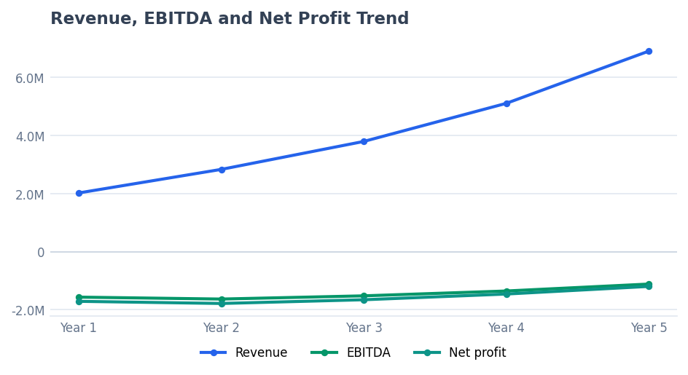
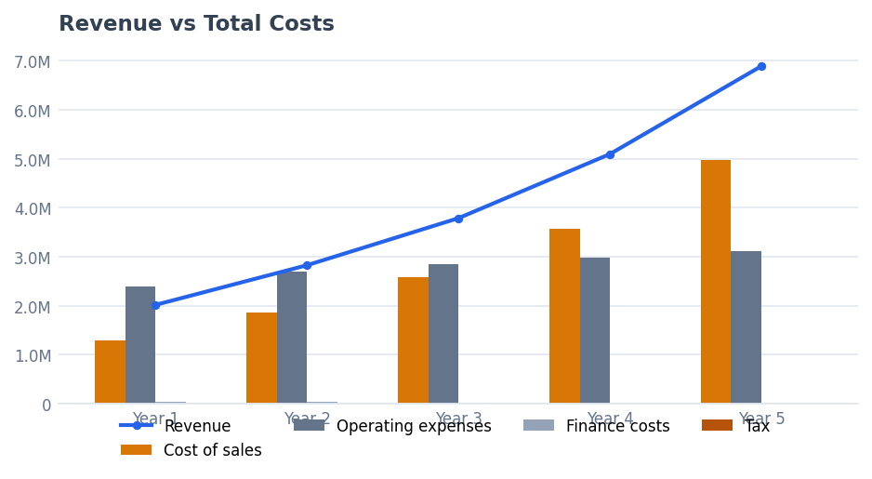
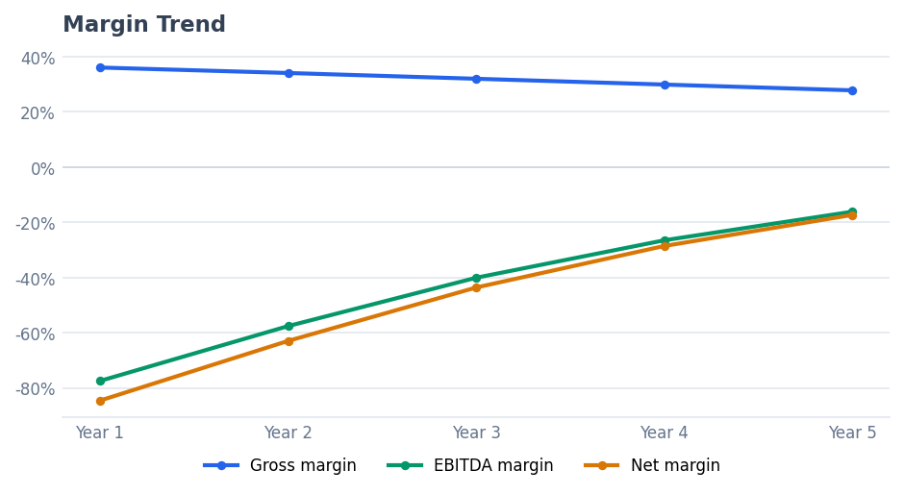
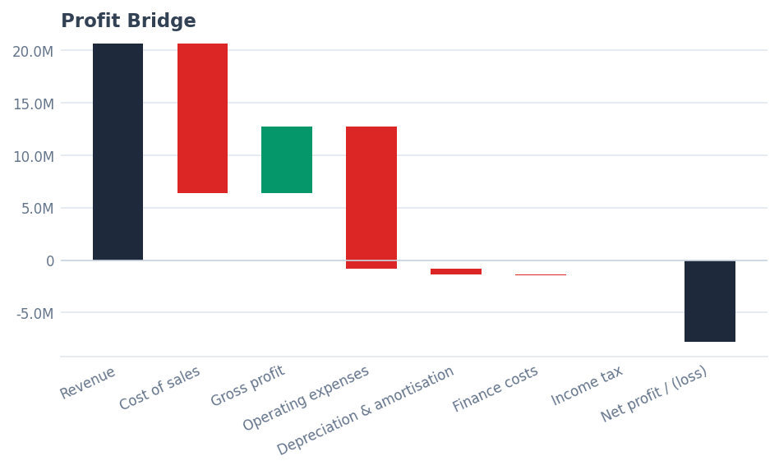

Revenue Analysis
Revenue composition, concentration and growth.
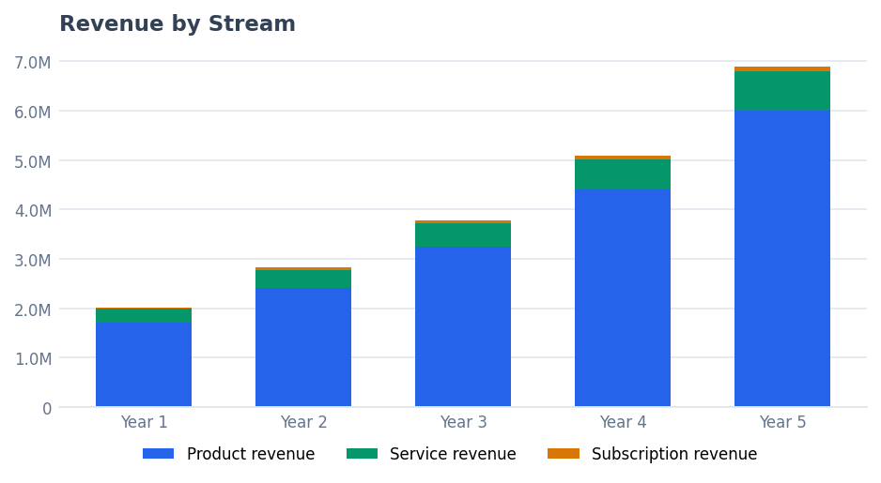
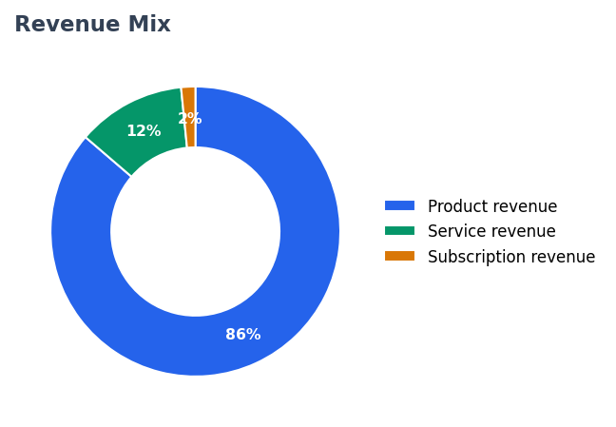
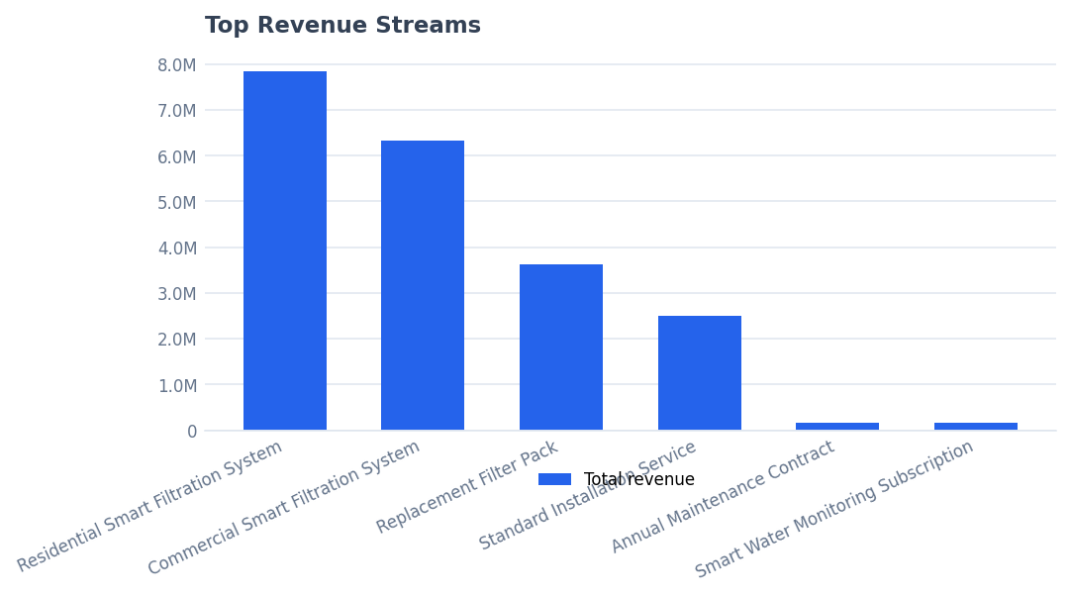
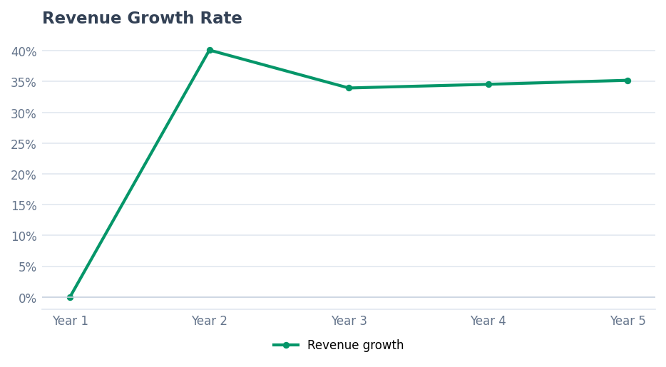

Cost & Profitability Analysis
Cost structure and gross profitability.
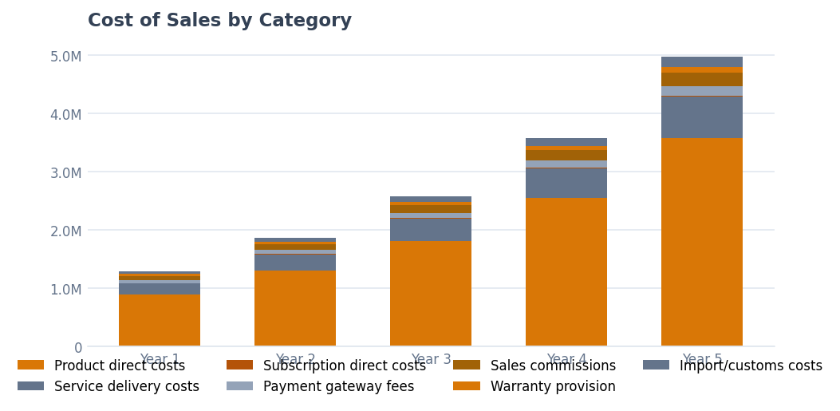
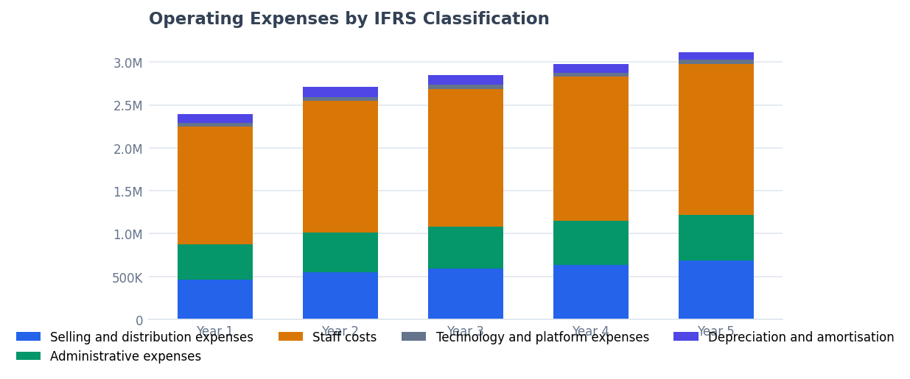
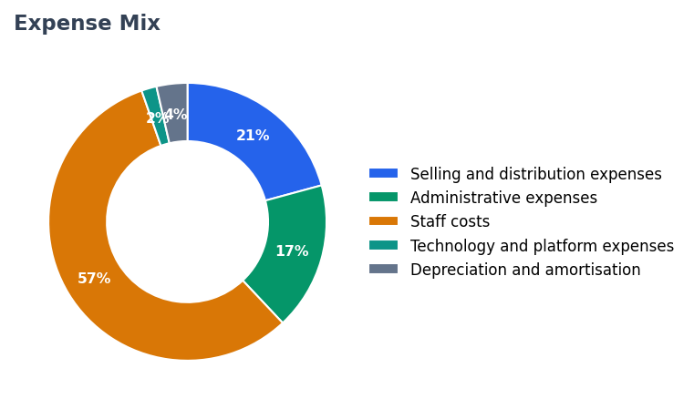
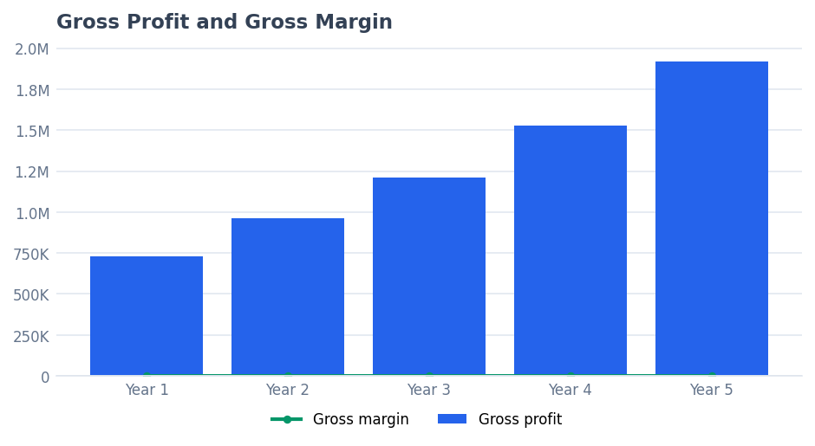

Cash Flow Analysis
Cash generation, free cash flow and funding adequacy.
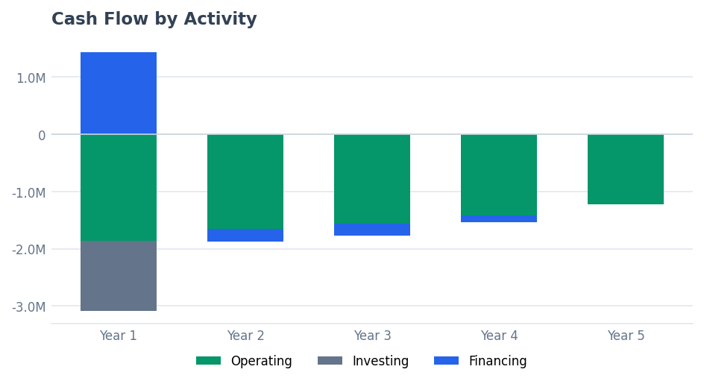
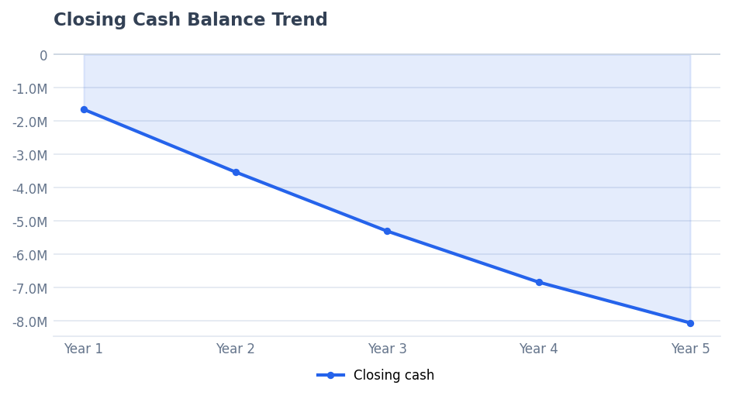
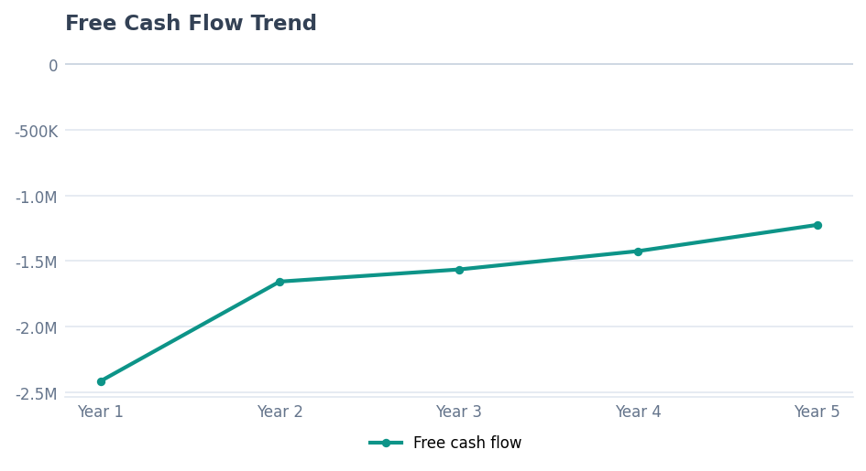
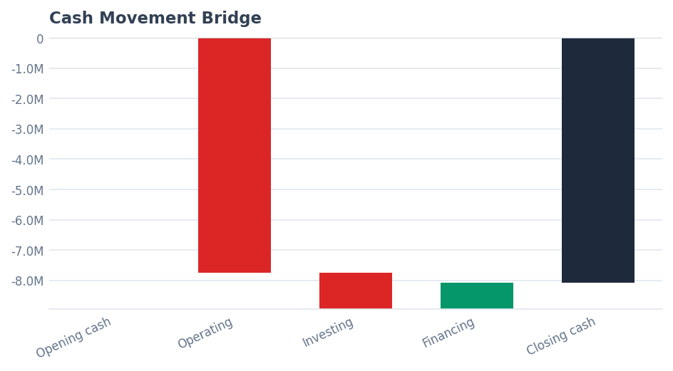
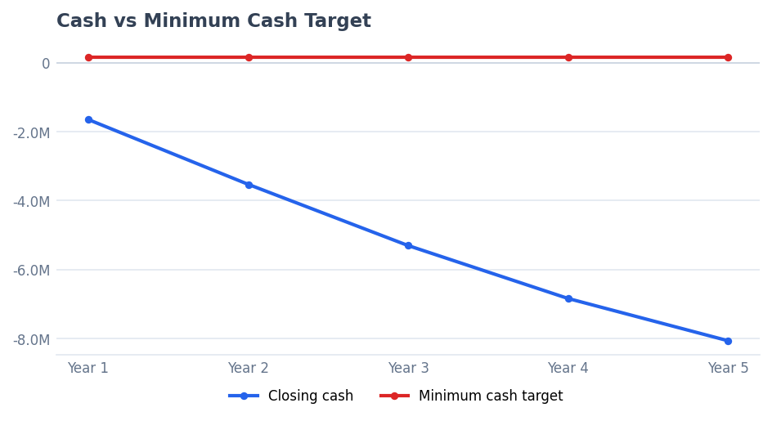

Balance Sheet Analysis
Asset composition, capital structure and liquidity.
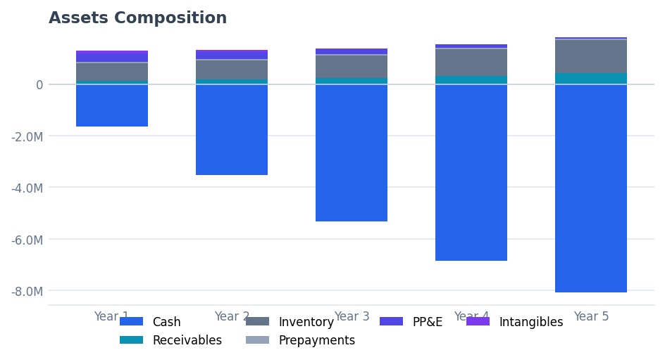
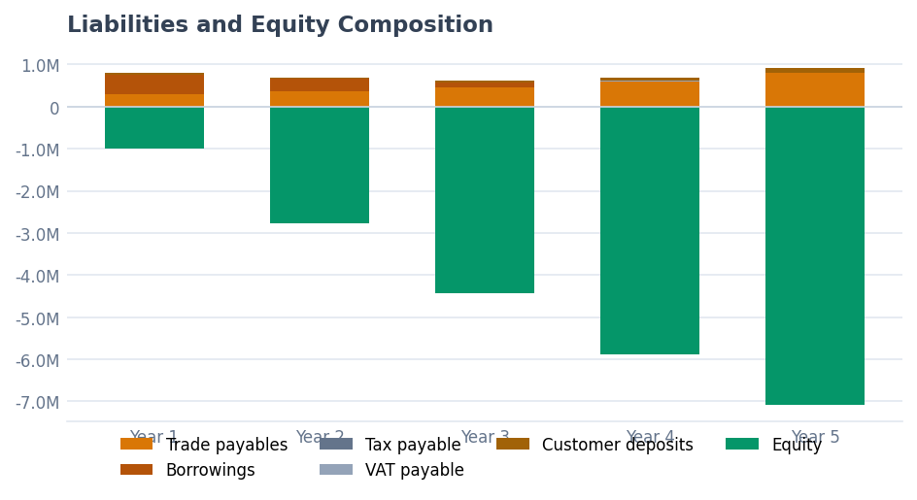
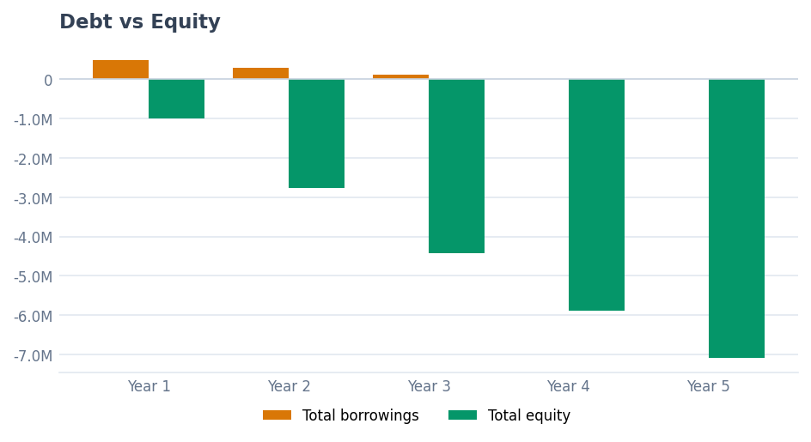
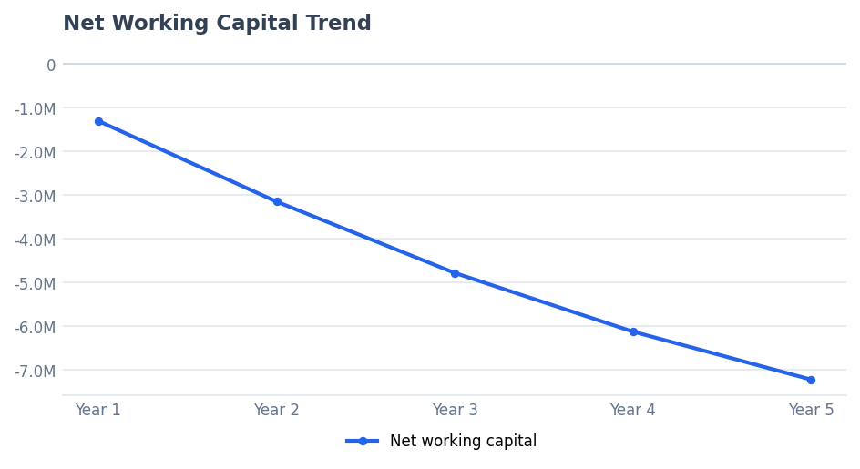
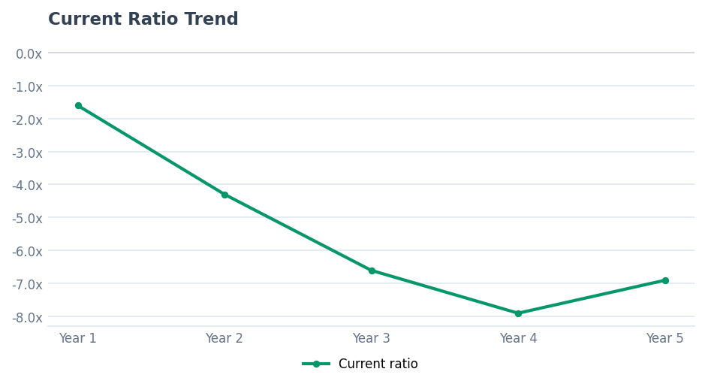

Working Capital Analysis
Receivables, inventory, payables and the cash cycle.
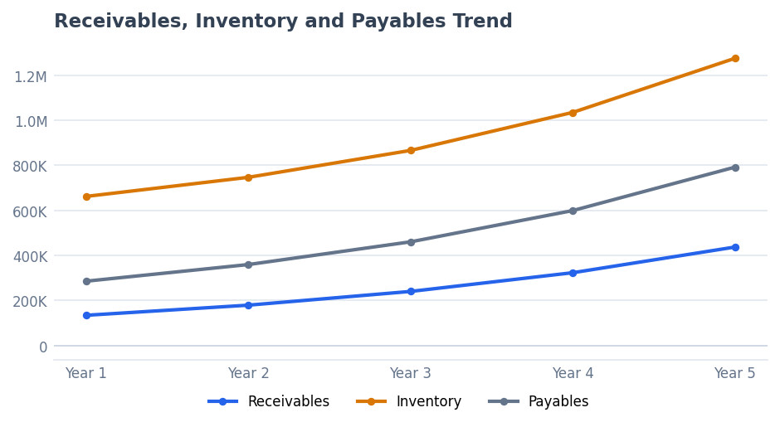
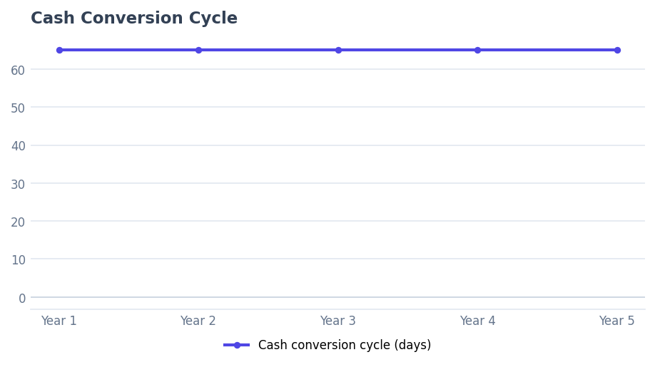
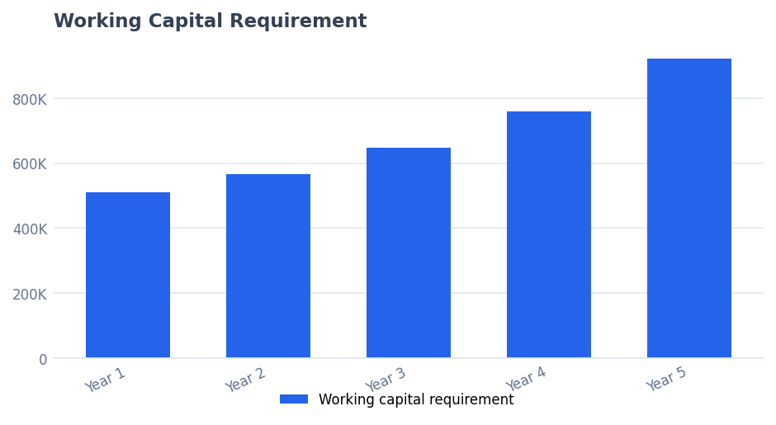
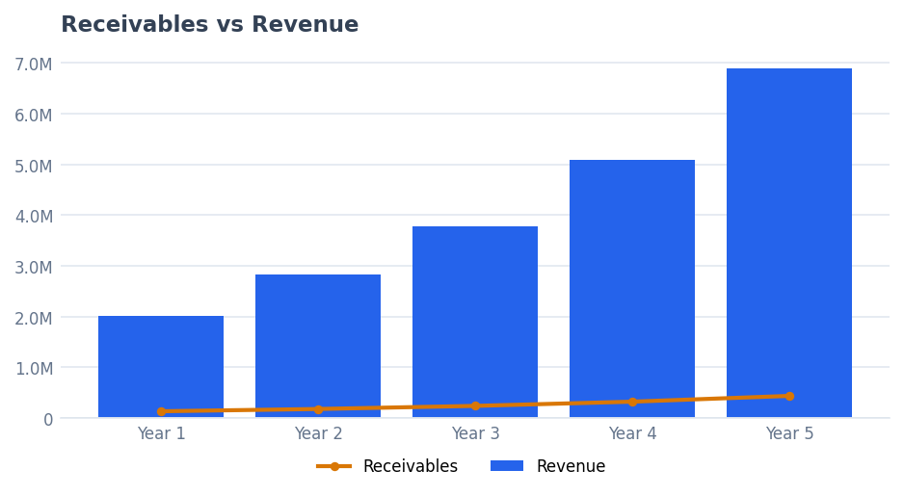

10. Scenario Comparison
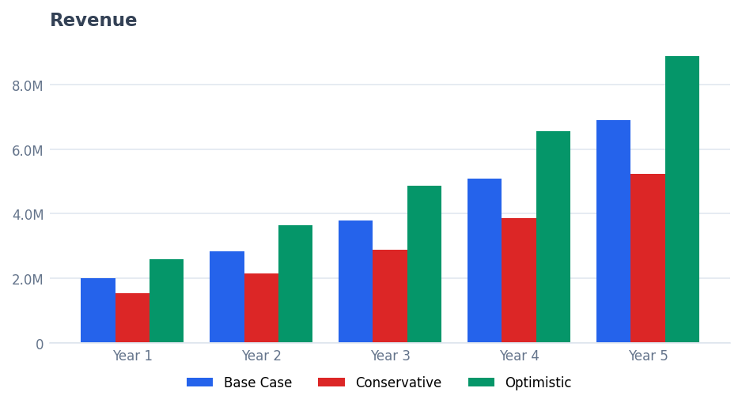
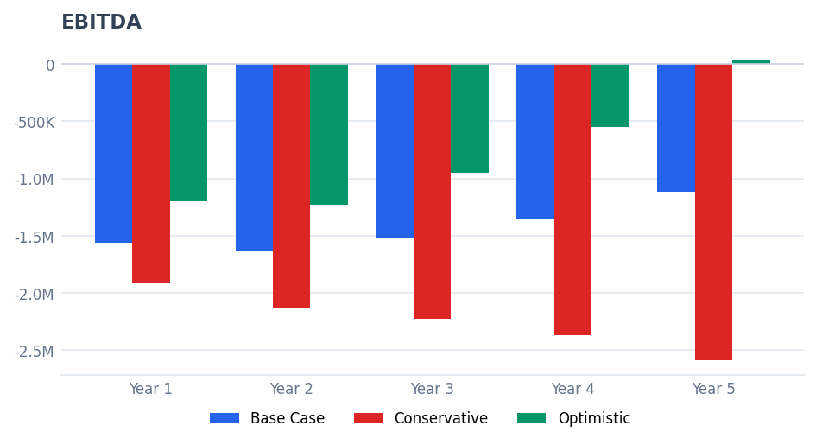
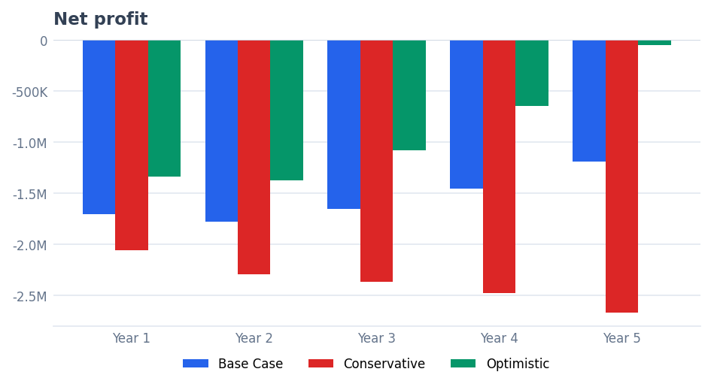
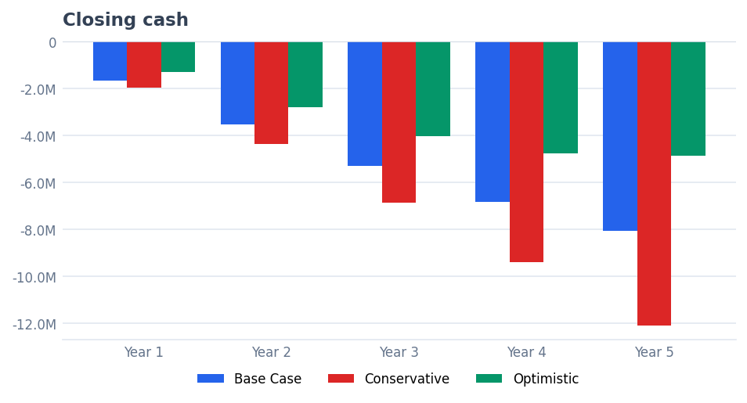
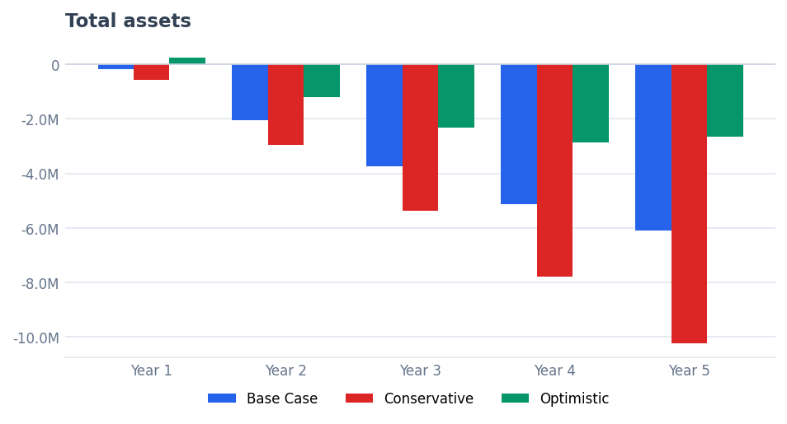
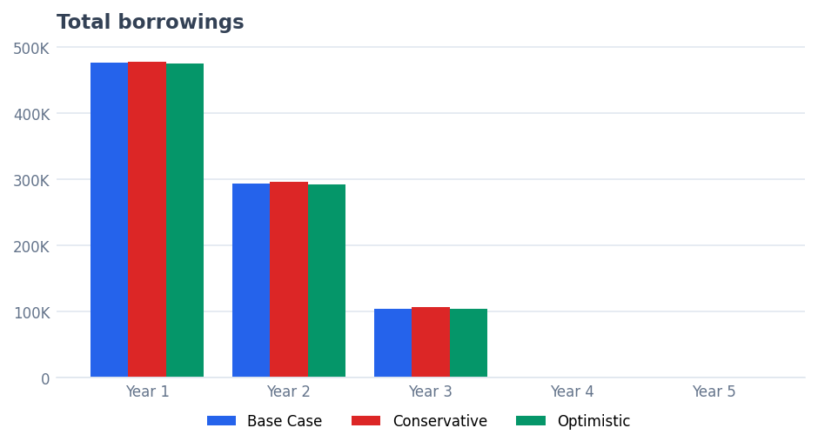
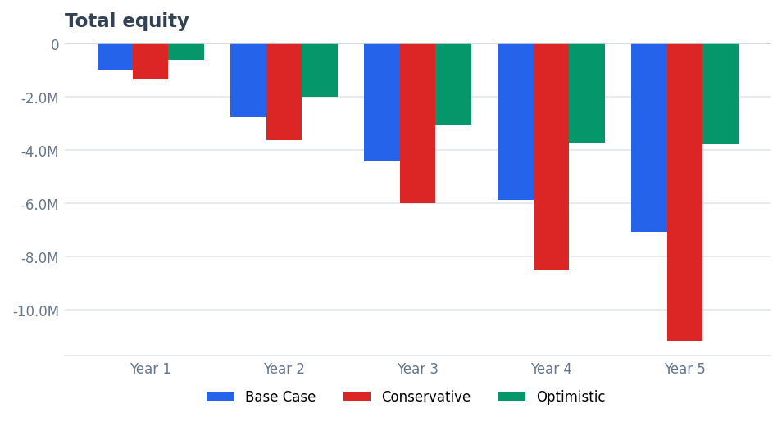
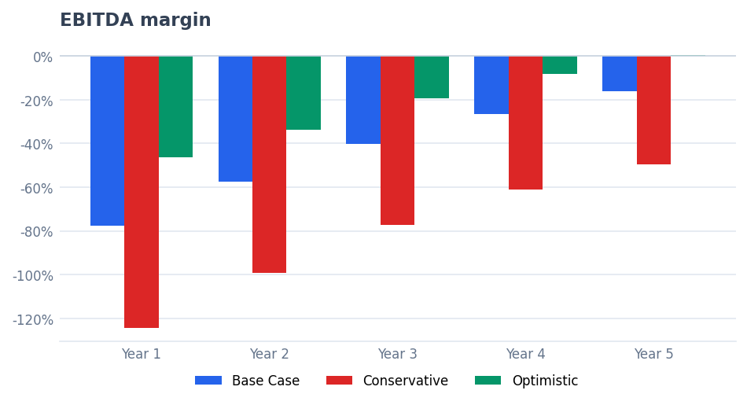
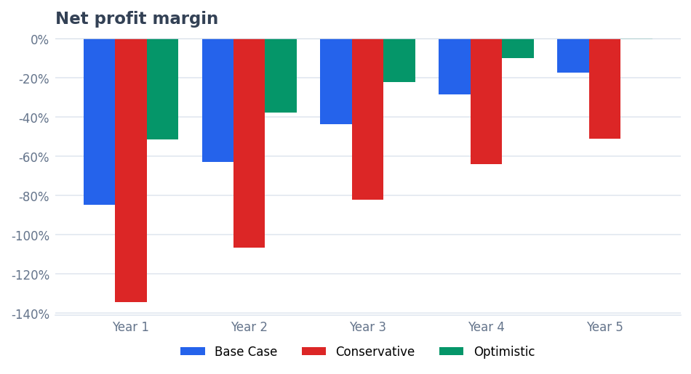

Scenario summary
Metric | Base Case | Conservative Case | Optimistic Case
Revenue | 20,627,338 | 15,676,777 | 26,557,697
EBITDA | (7,179,944) | (11,230,708) | (3,897,335)
Net profit | (7,795,590) | (11,869,039) | (4,501,724)
Closing cash | (8,069,249) | (12,086,768) | (4,867,378)
Total assets | (6,086,086) | (10,226,994) | (2,640,094)
Total borrowings | – | – | –
Total equity | (7,077,590) | (11,151,039) | (3,783,724)
EBITDA margin | (16.2%) | (49.4%) | 0.3%
Net profit margin | (17.3%) | (51.0%) | (0.6%)

11. Risks, Warnings and Reconciliations

Reconciliation checks
[INFO] Balance sheet balances (Assets = Equity + Liabilities): PASS
[INFO] Cash flow reconciles to balance sheet cash: PASS

Warnings
[WARNING] One or more direct cost items are unassigned and excluded from cost of sales.
[INFO] Grant 'Sustainability Innovation Support Grant' is scenario-dependent and recognised only in the optimistic case.
[INFO] Sales commissions are recognised in cost of sales; excluded from staff costs to avoid double-counting.
[CRITICAL] Projected cash balance is negative — this indicates a funding gap.
[CRITICAL] Projected closing cash balance is negative.
[INFO] Interest paid is presented under financing activities (default policy).
[CRITICAL] Projected cash balance is negative in one or more periods.
[WARNING] Projected EBITDA is negative over the projection.
[WARNING] Current ratio is below 1.0 — short-term liquidity pressure.

12. Appendices

Appendix A — Revenue by stream
Line item | Year 1 | Year 2 | Year 3 | Year 4 | Year 5 | Total
Product revenue | 1,709,471 | 2,414,202 | 3,255,824 | 4,411,301 | 6,007,050 | 17,797,848
Service revenue | 277,580 | 360,412 | 467,961 | 607,604 | 788,917 | 2,502,473
Subscription revenue | 31,456 | 53,801 | 65,058 | 79,295 | 97,406 | 327,017
Total revenue | 2,018,507 | 2,828,415 | 3,788,844 | 5,098,199 | 6,893,373 | 20,627,338

Appendix E — Fixed asset register
Asset | Category | Cost | Life | Residual | NBV
Assembly Tools and Workbench Equipment | Equipment | 85,000 | 5.0 | 5,000 | 5,000
Delivery and Service Van | Vehicle | 145,000 | 5.0 | 25,000 | 25,000
Office Furniture and Fit-out | Furniture | 95,000 | 5.0 | 10,000 | 10,000
Computers and Devices | Computers | 42,000 | 3.0 | 3,000 | 3,000
IoT Monitoring Platform Development | Software Development | 125,000 | 4.0 | – | –
Warehouse Shelving and Storage System | Leasehold Improvements | 60,000 | 5.0 | 5,000 | 5,000

Appendix F — Loan schedule
Loan | Lender | Amount | Rate | Term | Repayment
Vehicle and Equipment Finance | Emirates Commercial Bank | 250,000 | 8.5% | 48 | Equal Installments
Working Capital Facility | UAE SME Finance Partner | 300,000 | 10.0% | 36 | Interest Only Then Principal

Appendix I — Reconciliation checks
• Balance sheet balances (Assets = Equity + Liabilities): PASS
• Cash flow reconciles to balance sheet cash: PASS

