ARCHITECTURE FIELD STUDY
OpenClaw Architecture
and Agent Patterns
Evidence-based analysis • pattern catalog • agent-only clone blueprint
Senior-architect report | Agent execution scope; channels and product peripherals excluded from the clone
Prepared for Ghassan Alhamoud
AI Agent Architecture Patterns Handbook • ghassan-alhamoud.com
Evidence snapshot: 17 July 2026

Document status and evidence contract
SCOPE This is an architectural study of the public OpenClaw agent execution system and a clean agent-only reference design. It deliberately excludes channel adapters, device nodes, Control UI, voice, canvas, and other product-shell capabilities from the proposed clone.
OpenClaw changes quickly. This report analyzes the public main branch and official documentation as they existed on 17 July 2026, with stable release v2026.7.1 and the v2026.7.2-beta.1 prerelease visible in the release feed. Statements marked Implemented are directly supported by official documentation or source layout. Statements marked Architectural inference describe a senior-architect interpretation of those mechanisms; they are not maintainer-assigned labels. [S1, S2, S31]
The report is not a line-by-line code audit and does not claim that every source path is equally mature. It studies the runtime contracts, dominant flows, state model, extension boundaries, safety mechanisms, and patterns most relevant to building a smaller agent core.

How to read this report
Reader | Recommended path | Outcome
Handbook author | Executive summary → Pattern catalog → Handbook mapping | Accurate pattern language and chapter cross-references
Software architect | System context → Runtime → State → Security → Clone architecture | Boundaries, invariants, and trade-offs
Implementer | Clone scope → Contracts → Data model → Roadmap → Tests | Build sequence and acceptance criteria
Reviewer | Evidence method → Pattern evidence matrix → Sources | Traceability and confidence labels

Contents
- Executive summary
- 1. Scope, method, and evidence
- 2. OpenClaw system context
- 3. Agent runtime decomposition
- 4. End-to-end turn lifecycle
- 5. Prompt, context, workspace, and skills
- 6. Tools and execution policy
- 7. Sessions, transcript, memory, and compaction
- 8. Concurrency, resilience, and recovery
- 9. Extension and runtime architecture
- 10. Multi-agent and subagent design
- 11. Security and trust boundaries
- 12. Pattern catalog and interpretation
- 13. Mapping to the AI Agent Architecture Patterns Handbook
- 14. Agent-only clone: scope and requirements
- 15. Target architecture and contracts
- 16. Persistence, observability, testing, and operations
- 17. Delivery roadmap and decisions
- 18. Fork versus clean-room reimplementation
- 19. Conclusions
- Appendices: evidence matrix, source-code map, handbook extensions, and references

Executive summary
ARCHITECTURAL VERDICT OpenClaw is best understood as a local-first assistant platform whose core is a serialized, event-streaming, tool-using agent runtime. The most reusable idea is not its channel surface; it is the disciplined turn kernel around context assembly, typed tools, durable sessions, per-session concurrency, compaction, failover, and explicit policy boundaries.
The full product uses a long-lived Gateway as the control plane and source of truth for sessions, routing, clients, nodes, and delivery. Inside that platform, a built-in runtime owns a prepared model loop, while provider and plugin abstractions let other harnesses participate. For an agent-only clone, the Gateway can be collapsed into a thin in-process run coordinator or local API without carrying channels or device orchestration. [S2, S23, S24]
The ordinary turn is a structured ReAct-style loop: accept a run, serialize it within a session, assemble bounded context, call a model, execute authorized tools, append observations, and continue until a final answer or terminal condition. OpenClaw adds production controls around the familiar loop: lifecycle events, queues, file-aware write locks, compaction and retry, auth/model failover, loop detection, timeouts, cancellation, and reply normalization. [S3, S10–S13, S18]
OpenClaw does not require a Plan-and-Execute planner for every turn, and it does not impose a universal Generator–Critic reflection pass. Those patterns are supported at a higher level through skills, task structures, plugins, or critic subagents. This distinction matters: describing optional orchestration as the kernel would make the handbook less precise. [H2, H3, S19]
State is intentionally layered. Session metadata is mutable; transcript events are append-only and parent-linked; context is a bounded projection of that history; compaction creates persistent summaries; memory remains a distinct durable knowledge layer. This separation prevents the common error of treating context, memory, and transcript as synonyms. [S5, S7–S10]
Security follows a defense-in-depth model but assumes one trusted operator per Gateway rather than hostile multi-tenancy. Prompt instructions are advisory; enforceable controls live in identity/pairing, allowlists, tool policy, approvals, sandboxing, and OS/container boundaries. An educational clone should preserve that ordering and should never use memory or the system prompt as the only authorization mechanism. [S15–S17]

Primary recommendations
- Build a small modular monolith first: one process, one SQLite database, a local CLI/library API, and a single model/tool loop.
- Make Run, Attempt, Session, TranscriptEvent, ToolCall, ToolResult, and TerminalOutcome explicit domain concepts before adding features.
- Separate model context from durable transcript and memory from both; define projection and compaction contracts early.
- Treat tool policy as a reference monitor: filter schemas before inference and re-check permission at execution time.
- Serialize runs per session; add bounded global concurrency, cancellation, and idempotent run acceptance before subagents.
- Implement observable lifecycle events from day one so every state transition, model call, tool call, retry, and compaction is explainable.
- Add Plan-and-Execute and reflection as composable orchestration modules after the reactive kernel is stable, not inside the minimum loop.
- If forking OpenClaw, preserve MIT and third-party notices. If reimplementing, publish a compatibility boundary and avoid implying official affiliation.

1. Scope, method, and evidence

1.1 Questions this study answers
- What is the architectural role of the Gateway, built-in runtime, reusable agent core, provider layer, session store, and plugin SDK?
- How does one user turn move through queues, locks, context assembly, model inference, tools, persistence, streaming, and completion?
- Which agentic, software-design, state-management, reliability, and security patterns are implemented?
- Which handbook patterns are core, optional, merely enabled, or absent by default?
- What is the smallest credible architecture for cloning only the agent execution capability?

1.2 Evidence method
The study triangulates three primary source classes: official conceptual/technical documentation, public repository structure and maintainer rules, and current release metadata. The author’s handbook is used only to align vocabulary and teaching structure; it is not evidence for OpenClaw internals. [S1–S31, H0–H4]
Evidence label | Meaning | How to use it
Implemented | Directly described by official docs or visible source organization | Safe to teach as an OpenClaw mechanism within the snapshot
Architectural inference | A recognized pattern inferred from multiple mechanisms | Teach as an interpretation, not an official OpenClaw label
Supported, not default | The platform enables the pattern, but the base loop does not require it | Explain the extension path and avoid implying universality
Out of clone scope | A real product feature intentionally excluded | Keep only a port or future extension seam when necessary

1.3 Important limitations
Documentation and main-branch source can diverge temporarily. A public architecture study also cannot establish production deployment topology, hidden operational practices, or the behavior of every third-party plugin. Exact defaults should be rechecked before implementation because queue limits, timeouts, filenames, and schemas are version-sensitive.
DO NOT COPY THE WRONG BOUNDARY A clone of the agent is not a clone of OpenClaw’s product. Preserve the execution contracts and architectural lessons; omit channel docking, mobile/desktop nodes, control UI, media delivery, voice/canvas, and remote product operations unless a later requirement explicitly needs them.

2. OpenClaw system context
OpenClaw presents itself as a personal AI assistant running on the operator’s devices. The Gateway is the long-lived control plane and authoritative coordination point; clients and channels connect to it, while the agent runtime performs model/tool execution. Official architecture documentation describes a mandatory handshake, typed protocol generation, a local-first operational posture, and exactly one relevant Gateway-owned channel session per host for certain transports. [S1, S24]
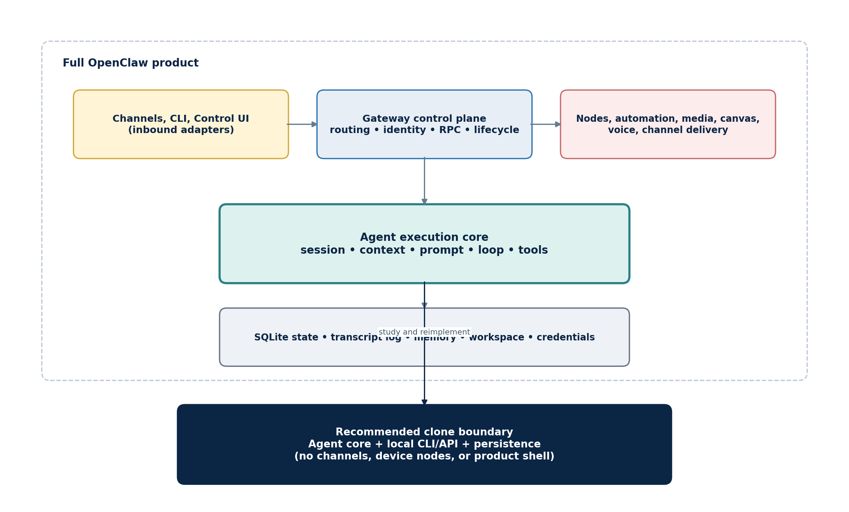
Figure 1. OpenClaw product boundary and the recommended agent-only clone boundary.

2.1 Product control plane
The Gateway’s responsibilities include run admission, session identity, routing, connection lifecycle, events, and coordination with peripheral capabilities. From an architectural standpoint it resembles a control plane, while the embedded runtime is the execution plane for a prepared turn. The distinction also explains why provider and runtime are different: a provider transports model requests; a runtime owns the loop around them. [S23, S24]

2.2 Agent execution core
The agent core is the reusable center of gravity: session context, prompt composition, messages, tool calls, compaction, and harness contracts. The public layout places built-in orchestration under src/agents, provider transport under src/llm, reusable contracts under packages/agent-core, and plugin-facing contracts behind SDK barrels. Plugins are instructed not to import internal src paths. [S2, S25–S28]

2.3 Recommended clone interpretation
For the proposed clone, keep the semantic responsibilities of admission, session serialization, execution, persistence, and eventing, but collapse them into a modular monolith. A local CLI or library call can replace channel ingress. A small RunCoordinator can replace the public Gateway protocol. This preserves future extensibility without importing product complexity.

3. Agent runtime decomposition
OpenClaw area | Observed responsibility | Clone interpretation
src/agents/embedded-agent-runner | Attempt loop, model selection, provider normalization, compaction, transcript/session wiring | application/run + application/attempt
src/agents/sessions | Session persistence, resources, prompts, skills, renderers | session service + resource catalog
packages/agent-core | Reusable loop and harness contracts, messages, compaction, prompts, skills, storage contracts | domain kernel + ports
src/agents/runtime | Facade from reusable core to provider/plugin runtime | runtime facade
src/agents/agent-tools* | Typed tool definitions, schemas, policy, adapters, sandbox/host edit tools | tool registry + policy + executor
src/agents/agent-hooks | Compaction safeguards/instructions and context pruning | interceptor pipeline
src/agents/harness | Harness registry, selection, lifecycle | runtime strategy registry
src/llm | Provider/model registry and streaming transports | model port adapters

Source: official runtime architecture and public repository layout. [S2, S25–S27]

3.1 Domain concepts
A useful domain model separates a Run—the accepted unit visible to callers—from an Attempt, which is one execution try under a selected model/auth/runtime combination. A run may survive compaction retry, transient retry, or model failover, so conflating run and attempt makes observability and idempotency harder. Session is the durable conversation identity; TranscriptEvent is immutable history; ContextView is a bounded projection prepared for one attempt.

3.2 Application services
The runtime behavior is naturally decomposed into a RunCoordinator, SessionLaneScheduler, ContextEngine, PromptAssembler, RuntimeHarness, ToolService, Compactor, MemoryService, SessionRepository, and EventSink. OpenClaw’s source is more granular and product-aware, but these roles capture the stable architectural responsibilities needed by a clone.

3.3 Boundary discipline
The most important structural rule is dependency direction: the domain and application loop depend on ports, never on a specific model SDK, database driver, sandbox backend, or channel. Provider normalization belongs in adapters. Policy decisions belong in an application/domain service. UI and transport formatting belong outside the kernel. This is the core of the ports-and-adapters interpretation.

4. End-to-end turn lifecycle
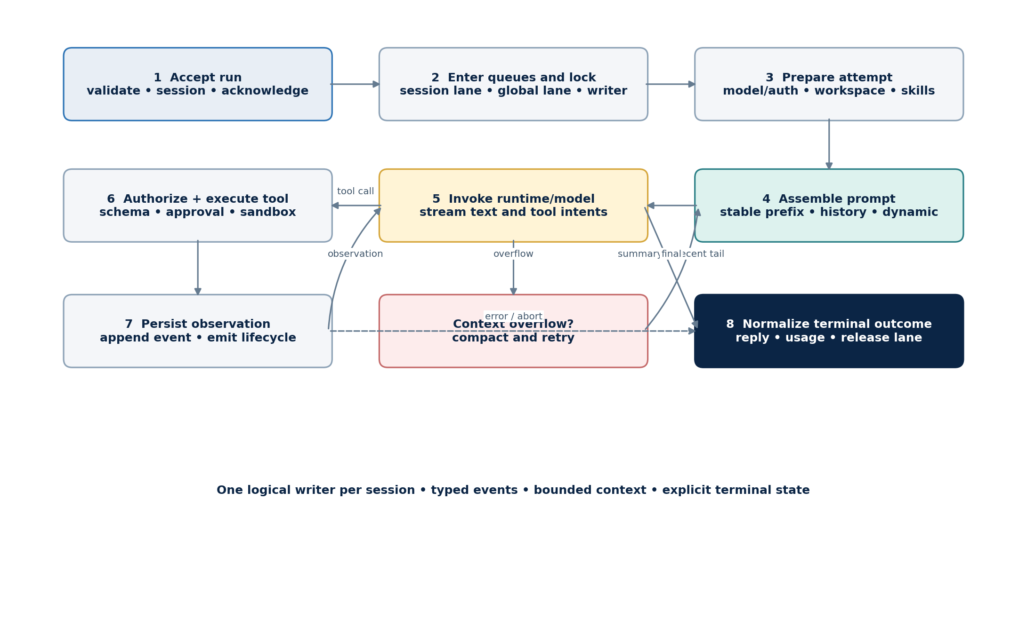
Figure 2. One OpenClaw agent turn as a serialized, event-streaming tool loop with compaction and terminal normalization.

4.1 Admission and immediate acknowledgement
The agent RPC validates parameters, resolves a session, persists session metadata, and immediately returns a run identifier and acceptance time. Completion is separate: callers can observe lifecycle streams or wait on the run. This is asynchronous command admission, not a single blocking request/response transaction. [S3]

4.2 Queueing and write ownership
Runs enter a per-session lane and may also pass through a global lane. The session lane guarantees one active run for a session, which prevents model/tool turns from racing over the same transcript. A process-aware, file-aware write lock protects transcript mutation even if a writer bypasses the in-process lane. The default documented acquisition wait is 60 seconds. [S3, S11]

4.3 Preparation
The coordinator resolves model and auth profile, workspace and sandbox root, skills snapshot, bootstrap files, session transcript, context limits, and compaction reserve. This is the deterministic setup stage where most configuration is converted into an effective run policy. [S3–S5, S21]

4.4 Model/tool cycle
The runtime calls the selected model with the assembled system prompt, context, and only the allowed tool schemas. When the model emits a tool intent, the tool service validates arguments, runs hooks and policy checks, applies approvals/sandbox decisions, executes the tool, records the result, and resumes inference. Assistant, tool, and lifecycle changes stream as distinct event classes. [S3, S14, S15]

4.5 Recovery and completion
Context overflow can trigger compaction followed by a retry with buffers reset. Transient provider failures may retry; exhausted auth can rotate profiles; configured model fallbacks can move to another model. Timeouts and aborts converge on a normalized terminal outcome. The turn then persists final state, releases locks/lanes, and emits end or error. [S3, S10–S13]
KEY INVARIANT Exactly one logical writer mutates a session transcript at a time. Preserve this invariant before optimizing concurrency; otherwise tool results, compaction, branch selection, and final responses can be reordered or lost.

5. Prompt, context, workspace, and skills

5.1 Prompt assembly is a pipeline
OpenClaw rebuilds the system prompt for every run. Official documentation describes a pure renderer, a configuration resolver, and runtime adapters. Core sections cover tools, execution guidance, safety, skills, workspace and files, sandbox, time, output behavior, heartbeats, runtime metadata, and reasoning guidance. Providers may replace named sections and contribute stable or dynamic material. [S4]
The prompt is deliberately cache-aware: deterministic stable content belongs above the prompt-cache boundary, while volatile per-turn material belongs below it. This is both a cost/latency optimization and a reproducibility pattern. The maintainer rules emphasize deterministic ordering so semantically identical runs produce cache-compatible prefixes. [S4, S28]

5.2 Context is not memory
Context is the complete bounded input sent to a model for one run: system prompt, conversation history, tool calls/results, and attachments. Memory is stored knowledge that may be loaded, searched, or injected. Transcript is durable conversation history. Compaction is a persistent representation of older transcript spans. Keeping the four concepts distinct makes budgets and lifecycle ownership explicit. [S5, S7–S10]
Concept | Durability | Primary owner | Purpose
Transcript | Durable | Session store | Canonical event history and branches
Context view | Ephemeral per attempt | Context engine | Bounded input for the model
Compaction | Durable summary event | Compactor/session store | Represent older history within token budget
Memory | Durable knowledge | Memory service/plugin | Recall facts and working knowledge across turns
Prompt | Rebuilt per run | Prompt assembler | Rules, capabilities, workspace, and run metadata

5.3 Workspace and bootstrap resources
Each agent has a workspace that acts as its default working directory and contextual home. Files such as AGENTS.md, SOUL.md, TOOLS.md, IDENTITY.md, USER.md, HEARTBEAT.md, BOOTSTRAP.md, and MEMORY.md can shape behavior. Bootstrap files are injected under size limits and may be skipped when blank or truncated when large. The workspace is not itself a security boundary; without sandboxing, absolute paths may reach outside it. [S4, S21]

5.4 Skills as progressive disclosure
Skills are resource packages with metadata and instructions. Their compact catalog appears in context; the model reads full skill content only when the task requires it. Multiple discovery locations have precedence, and package manifests can declare skills explicitly. This is a progressive-disclosure pattern that keeps the base prompt small while retaining a broad capability catalog. [S2, S4, S5]
CLONE RULE Implement a ContextBudget object that reports token allocations for system prompt, transcript tail, tool schemas, retrieved memory, reserved output, and compaction reserve. Context assembly should fail with an explainable budget report, not silently truncate arbitrary material.

6. Tools and execution policy

6.1 Typed capability surface
OpenClaw tools are typed callable capabilities. The model receives schemas only after profiles, allow/deny rules, provider restrictions, sandbox policy, channel policy, and plugin filters are applied. Tools, skills, and plugins are distinct: tools execute; skills provide task guidance; plugins extend runtime behavior and can register tools or hooks. [S14]

6.2 Policy before inference and before execution
Removing disallowed tool schemas before the model call reduces accidental selection and limits the apparent capability surface. Rechecking policy when executing a call handles state changes, malformed calls, hook decisions, and bypass attempts. In classic security terminology, the ToolService acts like a reference monitor at the capability boundary. This label is an architectural inference; the enforcement behavior is documented. [S14, S15]

6.3 Sandbox is location, policy is permission
The sandbox decides where execution occurs; tool policy decides which tools are available; elevated execution is a controlled escape path. These controls are orthogonal. Denying a dedicated write tool does not prevent a permitted command-execution tool from modifying files, so policy must consider semantic capabilities rather than tool names alone. [S15]

6.4 Tool search and schema virtualization
Large tool catalogs can be exposed through a discovery mechanism without injecting every schema into every request. This is schema virtualization: the model first searches the catalog, then receives detailed schemas for relevant tools. The result is lower context cost and a narrower effective attack surface. [S14]

6.5 Execution contract for a clone
interface ToolDefinition<I, O> {
name: string; schema: JsonSchema<I>; effect: 'read' | 'write' | 'external';
authorize(ctx: PolicyContext, input: I): Decision;
execute(ctx: ExecutionContext, input: I, signal: AbortSignal): Promise<O>;
}
ToolResult = { callId, status, output, redactions, startedAt, endedAt, auditRef }
The effect classification enables default approval and sandbox policy. Execution receives a cancellation signal. Results carry stable call identifiers and redaction/audit references. The runtime should never persist secrets or uncontrolled binary data directly into the transcript; store an artifact reference and a bounded textual observation instead.

7. Sessions, transcript, memory, and compaction
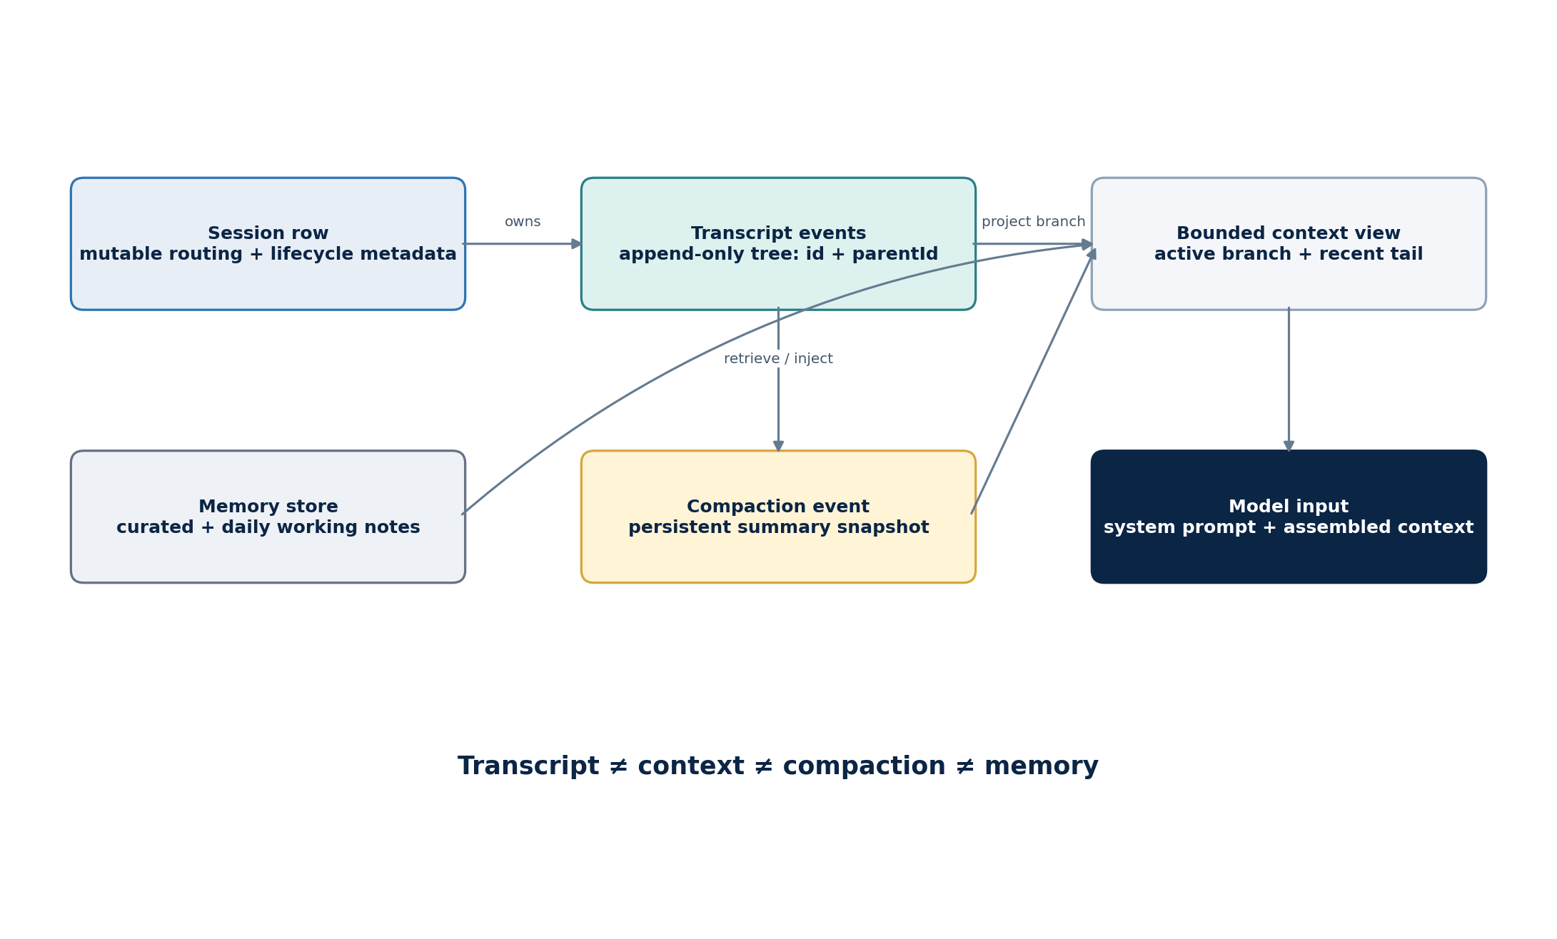
Figure 3. State separation: mutable session metadata, append-only transcript events, context projections, compaction snapshots, and independent memory.

7.1 Session identity and lifecycle
The Gateway owns session state. Session keys are routing selectors, not authentication credentials. Direct messages may share a session by default for a single-user assistant, while groups and rooms isolate state; reset can occur manually, daily, or after idle limits. For an agent-only clone, use opaque session IDs and require caller identity separately if a remote API is added. [S7, S16]

7.2 Two persistence layers
Official deep-dive documentation separates mutable session rows from append-only, tree-structured transcript events identified by id and parentId. Event types include messages, custom content, compaction, and branch summaries. A bounded tail is read for interactive work; full scans use an asynchronous index. This resembles event sourcing, but the report uses the narrower term append-only event log because not every system state is necessarily rebuilt exclusively from events. [S8]

7.3 Memory tiers
Memory uses plain Markdown for durable curated facts and daily working notes, with optional additional stores and retrieval plugins. Distillation promotes useful working knowledge to durable memory. Action-sensitive memory can record permissions or commitments, but memory is explicitly not policy; authorization must be checked against current enforceable state. [S9]

7.4 Compaction versus pruning
Compaction summarizes an older transcript span into a persistent event and retains recent turns verbatim. It preserves assistant tool-call/tool-result pairings and can run automatically near the context limit or after overflow, then retry the attempt. Pruning trims large tool outputs only in the current assembled context and does not rewrite durable history. [S10]

7.5 Suggested minimal schema
sessions(id PK, agent_id, created_at, started_at, last_interaction_at, updated_at, active_leaf_id, status, version)
transcript_events(id PK, session_id FK, parent_id FK?, kind, payload_json, created_at, run_id, attempt_id)
runs(id PK, session_id FK, idempotency_key UNIQUE, status, accepted_at, started_at, ended_at, terminal_json)
attempts(id PK, run_id FK, ordinal, runtime_id, provider_id, model_id, auth_profile_id, status, usage_json)
memory_items(id PK, agent_id, scope, content, source_ref, sensitivity, valid_until, embedding_ref)
audit_events(id PK, run_id, attempt_id, category, metadata_json, created_at)
Use optimistic versioning on the session row, but enforce a single writer so conflicts are exceptional. Transcript events should be immutable; corrections become new events. Large artifacts belong in an artifact store. Memory indexes can be rebuilt from canonical memory items.

8. Concurrency, resilience, and recovery

8.1 Lane-aware concurrency and bulkheads
OpenClaw combines a one-at-a-time session lane with broader global and subagent limits. This is a bulkhead pattern: a busy session cannot corrupt itself, and bounded pools prevent one workload class from consuming all capacity. Queue modes determine whether new user input steers the active turn, follows it, collects with other input, or interrupts it. [S3, S11, S19]

8.2 Backpressure
Queue debounce, pending caps, and drop/summarize behavior bound load. Steering waits for a safe model boundary after current tool work rather than aborting an in-flight tool; interrupt is the explicit cancellation mode. A clone should make those semantics visible to callers because steering, follow-up, and interrupt have materially different guarantees. [S11]

8.3 Retry and idempotency
Request-level retries use bounded attempts, backoff, and jitter while preserving ordering and avoiding duplicate non-idempotent effects. The safe rule is: retry model transport before any externally visible tool effect, or retry a tool only when it declares an idempotency key/contract. Run admission should accept an idempotency key so reconnecting clients cannot create duplicate turns. [S12]

8.4 Auth and model failover
Failover is staged: rotate authentication profiles within a provider, then move through configured model fallbacks. Explicit per-session model choice is treated more strictly than a default that permits fallback. The selected session model remains unchanged when fallback is only for the current turn, and visible notices preserve operator understanding. [S13]

8.5 Loop detection and circuit breaking
Tool-loop detection uses rolling signatures to recognize repeated calls, known polling patterns, and ping-pong behavior. A post-compaction guard detects the same tool/arguments/result triple after a summary reset. These are circuit breakers around agent behavior rather than network endpoints. [S18]

8.6 Failure policy matrix
Failure | Preferred policy | Why
Transient provider error before output | Bounded retry, then auth/model failover | No external effect has occurred
Tool effect uncertain | Do not retry automatically; reconcile by idempotency key | Avoid duplicate side effects
Context overflow | Compact, reset attempt buffers, retry once | Preserves run identity while changing representation
Optional context plugin failure | Quarantine plugin; degrade to legacy engine | Maintains availability with explicit notice
Required capability mismatch | Fail closed | Silent fallback would violate intent or safety
Repeated tool cycle | Warn, then abort with diagnostic | Bounds cost and unproductive behavior
Session lock timeout | Report busy; caller retries later | Preserves single-writer invariant

9. Extension and runtime architecture

9.1 Runtime is not provider
A runtime owns a prepared model loop: it accepts prompt/context, drives model output and tool calls, and returns the finished turn. A provider is the transport/API route used to reach a model. OpenClaw’s built-in runtime id is openclaw; plugin harnesses can register alternatives such as codex. Model-scoped configuration wins over provider-scoped selection. [S2, S23]

9.2 Harness registry and selection
Auto selection chooses a compatible registered harness or the built-in runtime. Explicit plugin runtime selection fails when unavailable rather than silently switching semantics. This combines Strategy, Registry, and fail-closed explicit configuration. The clone can initially ship one runtime but should retain a RuntimePort so an alternative harness does not require rewriting session and tool services. [S2]

9.3 Hook/interceptor pipeline
Plugin hooks span model resolution, prompt construction, reply generation, agent completion, compaction, tool invocation, tool-result persistence, message lifecycle, sessions, and Gateway lifecycle. Blocking decisions are terminal at the relevant point. Hooks are powerful but create ordering and fault-isolation risks; publish a deterministic order and never let optional telemetry hooks block core completion. [S3]

9.4 Context engine plugin slot
The context engine has an exclusive ownership contract for ingest, assemble, compact, and optional lifecycle stages. A plugin can declare that it owns compaction. Failure isolation allows a bad optional engine to be quarantined for the process and downgraded, while an explicit host capability mismatch fails closed. This is a strong example of a replaceable Strategy with capability negotiation and graceful degradation. [S6]

9.5 Resource discovery
Packages can declare extensions, skills, prompts, and themes in metadata, with conventional directories as fallback. This combines manifest-driven discovery with convention over configuration. For the clone, use manifests for distributable packages and a single explicit local directory for development; avoid supporting many precedence layers until real use cases demand them. [S2]

10. Multi-agent and subagent design

10.1 Multi-agent routing versus subagents
OpenClaw uses agent in two different senses. Multi-agent routing hosts multiple isolated persona/workspace/session scopes in one Gateway and binds inbound traffic to them. Subagents are child execution sessions spawned by a parent for delegated work. The proposed clone needs subagents only; multi-agent routing and channel bindings are product concerns. [S19, S20]

10.2 Orchestrator–worker mechanics
A parent uses a non-blocking spawn tool and receives a run identifier. The child runs in an isolated or forked context, under depth and child-count limits, with a restricted tool surface. Completion is push-based and announces back to the parent; the parent yields instead of polling. Cascade stop and depth-based policies bound the delegation tree. [S19]

10.3 Trust and information flow
Child output is data/evidence, not policy. It cannot override the parent’s governing instructions or the host’s tool policy. A production clone should mark provenance on child results, limit payload size, and require the parent to integrate or verify high-impact claims before external side effects.

10.4 When subagents are justified
- Independent research or implementation tasks can run in parallel without shared mutable state.
- A specialist needs a narrower prompt, model, tool policy, or context budget.
- A critic or verifier should be separated from the generator to reduce correlated errors.
- The parent can define an explicit output contract and acceptance test.
Do not use a subagent merely to hide a long function. Delegation introduces queueing, cost, provenance, cancellation, completion delivery, and reconciliation. For the first clone release, defer subagents until single-agent lifecycle and observability are stable.

11. Security and trust boundaries

11.1 Trust model
OpenClaw’s documented security model assumes a single trusted operator per Gateway, not hostile multi-tenancy. Separate Gateways and OS users are recommended when principals are mutually untrusted. An agent-only clone should state the same boundary explicitly. If exposed as a service, authentication, tenant isolation, secrets isolation, per-tenant encryption, and resource quotas become new architecture—not a small configuration change. [S16]

11.2 Control hierarchy
- Establish caller and operator identity; never treat a session key as authentication.
- Determine effective scope through allowlists, tool policy, resource policy, and approval requirements.
- Constrain execution location using sandbox/OS/container boundaries.
- Only then ask the model to act; assume prompt content and model output are manipulable.

11.3 Sandbox boundary
Sandbox modes decide which sessions run isolated and how sandboxes are shared. Backends include container and remote isolation mechanisms; documented Docker defaults can disable network, use a read-only root, and drop capabilities. Workspace access can be none, read-only, or read-write, and bind mounts require careful validation. [S17]

11.4 Clone threat model
Threat | Control | Acceptance evidence
Prompt injection requests a forbidden tool | Schema filtering + execution-time policy | Tool absent from model input and denied if forged
Command tool escapes workspace | Sandbox filesystem boundary + canonical path checks | Escape corpus fails; symlink and bind-mount tests pass
Secret enters transcript | Secret references, redaction, bounded observations | Automated secret scanner on events and logs
Duplicate external side effect | Idempotency keys + no blind retries | Replay test produces one effect
Malicious child result changes policy | Provenance + parent policy dominance | Child payload treated as untrusted data
Runaway cost/tool loop | Budgets, watchdog, loop breaker, queue limits | Deterministic abort with diagnostic

NON-NEGOTIABLE Safety text in the system prompt is guidance, not enforcement. A clone is not safe until authorization, sandbox, idempotency, cancellation, redaction, and audit behavior are implemented outside the model.

12. Pattern catalog and interpretation
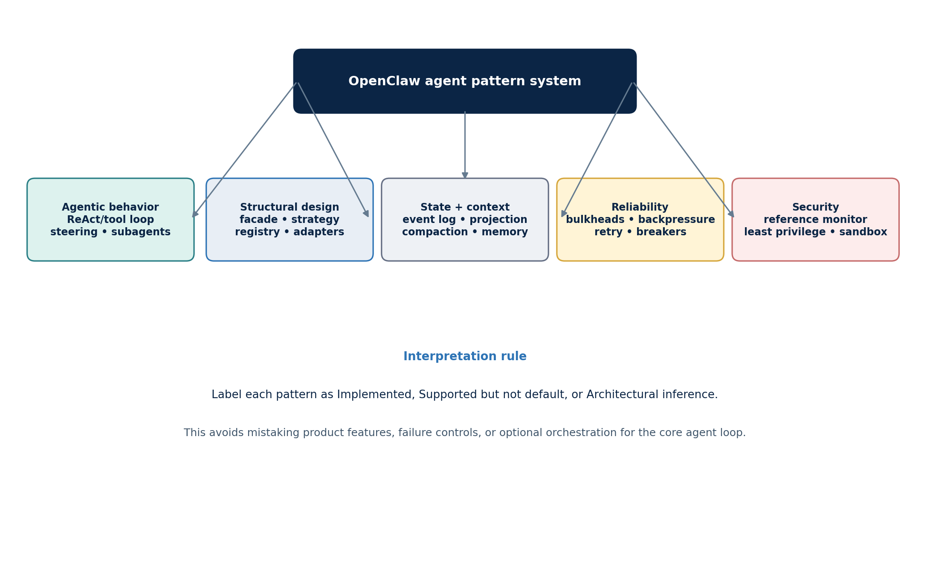
Figure 4. Pattern taxonomy used in this study: agentic, structural, state/context, reliability, and security patterns.

12.1 Pattern status summary
The catalog contains 38 patterns: 32 directly implemented, 4 architectural inferences, and 2 supported but non-default agentic patterns. The classification prevents marketing-level feature lists from being mistaken for architectural patterns.
ID | Pattern | Family | Status | Clone
P01 | Structured ReAct / tool loop | Agentic | Implemented | Core
P02 | Event-driven orchestration | Agentic | Implemented | Core
P03 | Steering / interruptible interaction | Agentic | Implemented | Core
P04 | Orchestrator–worker subagents | Agentic | Implemented | Optional
P05 | Plan-and-Execute | Agentic | Supported, not default | Extension
P06 | Generator–Critic reflection | Agentic | Supported, not default | Extension
P07 | Progressive disclosure | Context | Implemented | Core
P08 | Prompt pipeline and cache boundary | Context | Implemented | Core
P09 | Context engine strategy | Context | Implemented | Core
P10 | Tiered memory | Context | Implemented | Core
P11 | Hybrid retrieval | Context | Implemented | Optional
P12 | Summarization compaction | Context | Implemented | Core
P13 | In-memory pruning | Context | Implemented | Core
P14 | Control plane / execution plane | Structural | Implemented | Product
P15 | Facade | Structural | Implemented | Core
P16 | Ports and adapters | Structural | Architectural inference | Core
P17 | Strategy | Structural | Implemented | Core
P18 | Registry / factory | Structural | Implemented | Core
P19 | Adapter / anti-corruption layer | Structural | Implemented | Core
P20 | Phase-oriented pipeline | Structural | Architectural inference | Core
P21 | Plugin hook/interceptor chain | Structural | Implemented | Core
P22 | Manifest + convention discovery | Structural | Implemented | Extension
P23 | Append-only event log | Data | Implemented | Core
P24 | Projection / read model | Data | Architectural inference | Core
P25 | Snapshot | Data | Implemented | Core
P26 | Single writer / unit of work | Concurrency | Implemented | Core
P27 | Bulkhead isolation | Reliability | Implemented | Core
P28 | Backpressure | Reliability | Implemented | Core
P29 | Retry with backoff and jitter | Reliability | Implemented | Core
P30 | Circuit breaker | Reliability | Implemented | Core
P31 | Two-stage failover | Reliability | Implemented | Core
P32 | Timeout / watchdog / cooperative cancellation | Reliability | Implemented | Core
P33 | Graceful degradation with quarantine | Reliability | Implemented | Core
P34 | Reference monitor | Security | Architectural inference | Core
P35 | Least privilege / capability filtering | Security | Implemented | Core
P36 | Defense in depth | Security | Implemented | Core
P37 | Fail-closed explicit selection | Security | Implemented | Core
P38 | Audit and observability events | Operations | Implemented | Core

Status is the report’s classification based on the evidence column in Appendix A; it is not official OpenClaw maturity terminology.

12.2 Agentic patterns

Structured ReAct / native tool loop
The base loop matches the operational essence of ReAct: the model chooses an action, a typed tool executes it, the observation is appended, and the model continues. Modern provider APIs may hide chain-of-thought and express action as a structured tool call, so Thought–Action–Observation is best taught as a control-flow abstraction rather than a requirement to expose internal reasoning. [S3, S23, H1]

Plan-and-Execute
OpenClaw can host explicit plans, task graphs, or delegated workers, but the default run does not require a planner that produces a complete plan before execution. The correct classification is supported, not default. A clone should implement planning as an orchestration policy over the same runtime and tool contracts. [S19, H2]

Reflection
Compaction safeguards, loop detection, retries, and terminal normalization are corrective mechanisms, but they are not a generic Generator–Critic architecture. True reflection requires a separate evaluation step against criteria and a revision loop. It can be built with a critic subagent, a plugin hook, or a skill. Teach the difference between deterministic runtime safeguards and model-based self-critique. [S18, S19, H3]

Multi-agent collaboration
The subagent subsystem implements orchestrator–worker delegation with isolation, bounded nesting, tool restrictions, cancellation, and push completion. It avoids a common anti-pattern—polling workers in a tight loop—by delivering completion as an event. [S19, H4]

12.3 Structural patterns
The dominant structural family combines Facade, Strategy, Registry, Adapter, and Pipeline patterns. The facade stabilizes entry points. Strategies select runtimes, context engines, providers, memory, and compaction behavior. Registries discover harnesses, tools, and resources. Adapters normalize provider and external runtime protocols. The attempt runner decomposes execution into ordered phases. Together they create an extensible modular monolith rather than a microservice system. [S2, S25–S27]

12.4 State and context patterns
The transcript is an append-only event tree with derived active-branch views, while compaction acts as a durable summary snapshot. This is event-sourcing-like, but the safer description is append-only log plus projections because mutable session rows remain authoritative for lifecycle metadata. Context assembly is a projection, and memory retrieval is a separate enrichment pipeline. [S6–S10]

12.5 Reliability patterns
Per-session lanes and separate concurrency pools provide bulkheads; queue bounds provide backpressure; retries use backoff and jitter; auth cooldowns and tool-loop guards behave as circuit breakers; model chains provide failover; abort signals and timeouts provide cooperative cancellation. These patterns turn a probabilistic model loop into an operable runtime. [S3, S11–S13, S18]

12.6 Security patterns
Capability filtering implements least privilege. The tool policy boundary resembles a reference monitor. Identity, pairing, policy, approvals, sandboxing, and OS/container boundaries form defense in depth. Explicit selections fail closed when silent fallback would alter meaning. These controls are deliberately outside the model. [S2, S6, S14–S17]

13. Mapping to the AI Agent Architecture Patterns Handbook
Handbook topic | OpenClaw mapping | Recommended wording
ReAct | Direct match at control-flow level through native tool calls and observations | OpenClaw operationalizes a structured ReAct-style loop, with reasoning often implicit or provider-managed.
Plan-and-Execute | Available via tasks/skills/subagents; not mandatory in an ordinary turn | OpenClaw supports plan-and-execute orchestration above its reactive kernel.
Reflection | Can be implemented by critic skill/plugin/subagent; safeguards are deterministic, not a critic | Reflection is composable, not a universal default pass.
Multi-Agent Collaboration | Subagent orchestrator–worker plus separate multi-agent routing | Distinguish delegated child runs from multiple persistent agent identities.
Tool / Skill Registry | Typed tools + layered policy; skill metadata + on-demand instructions; plugin registration | Separate executable capability, procedural guidance, and extension packaging.
Memory and Context | Transcript, context view, compaction, and memory are separate layers | Use a four-layer model instead of treating context and memory as synonyms.
Human in the Loop | Approvals, pairing, allowlists, interrupt/steer, and explicit policy | Place human gates at side-effect boundaries, not only at final response.
Observability | Assistant/tool/lifecycle streams, run IDs, diagnostics, usage, audit metadata | Trace the lifecycle from acceptance through every attempt and tool effect.
Safety | Identity → scope → sandbox/OS → model; prompt safeguards are advisory | Teach enforceable controls outside the model and state the trust model.
Agent Platform | Gateway control plane + embedded runtime + providers/plugins + durable state | Show how the agent loop becomes a product platform without making channels part of the kernel.

13.1 Suggested case-study framing
Present OpenClaw as a production case study after the foundational patterns. Begin with the structured ReAct loop, then show how session serialization, context engineering, compaction, tool policy, and eventing address real operational failure modes. Finally show where Plan-and-Execute, Reflection, and subagents sit above the kernel. This ordering reinforces that patterns compose rather than replace one another.

13.2 Patterns worth adding to the handbook
- Agent Run Lifecycle: accepted run, attempts, events, cancellation, and terminal outcome.
- Context Engine: ingest, assemble, compact, prune, and post-turn maintenance as a replaceable strategy.
- Session Lane / Single Writer: serialization as the antidote to transcript and tool races.
- Tool Reference Monitor: capability discovery, schema filtering, approval, execution, and audit.
- Compaction Snapshot: durable summaries plus recent verbatim tail, contrasted with ephemeral pruning.
- Agent Reliability: retry, failover, circuit breakers, backpressure, budgets, and watchdogs.

14. Agent-only clone: scope and requirements
PRODUCT DEFINITION A local-first, single-operator agent runtime that accepts a turn through a CLI or library/local API, maintains durable sessions, assembles bounded context, calls configurable models, executes authorized tools, streams lifecycle events, and returns a normalized outcome.

14.1 In scope
- One agent identity and workspace; multiple durable sessions.
- Local CLI and embeddable library API; optional loopback-only HTTP/SSE adapter.
- Model provider port with at least one streaming adapter and deterministic fake model for tests.
- Typed tool registry, policy engine, approvals contract, executor, and optional sandbox port.
- Prompt assembler, skills catalog, context budgeting, transcript projection, compaction, and memory retrieval.
- Per-session serialization, bounded global concurrency, cancellation, retry, failover, and loop detection.
- SQLite state, append-only transcript events, lifecycle event stream, structured logs, traces, and usage accounting.
- Subagent delegation as a later phase after single-agent correctness.

14.2 Explicitly out of scope
- Messaging channels, channel accounts, docking, group routing, and outbound delivery shaping.
- Desktop/mobile nodes, device pairing, voice wake, canvas, media pipelines, and remote-control features.
- Control UI, public WebSocket Gateway protocol, automation/cron, webhooks, and marketplace packaging.
- Hostile multi-tenancy, organization-wide delegation, fleet management, and cloud worker placement.
- Compatibility with every OpenClaw plugin or configuration file.

14.3 Quality attributes
Attribute | Target | Architectural consequence
Correctness | No reordered transcript events or duplicate tool effects | Single writer, idempotency, immutable events
Explainability | Every run reconstructable from lifecycle metadata | Run/attempt/event model and correlation IDs
Safety | Model cannot exceed effective capability policy | Pre-inference filtering and execution-time authorization
Resilience | Transient model failures do not corrupt sessions | Attempt isolation, retry/failover, transactional settlement
Context efficiency | Budgets visible and deterministic | Context report, progressive skills, compaction/pruning
Portability | Provider/database/sandbox replaceable | Ports and adapters; canonical domain contracts
Operability | Bounded queues, cancellation, budgets, useful diagnostics | Bulkheads, backpressure, watchdogs, metrics

15. Target architecture and contracts
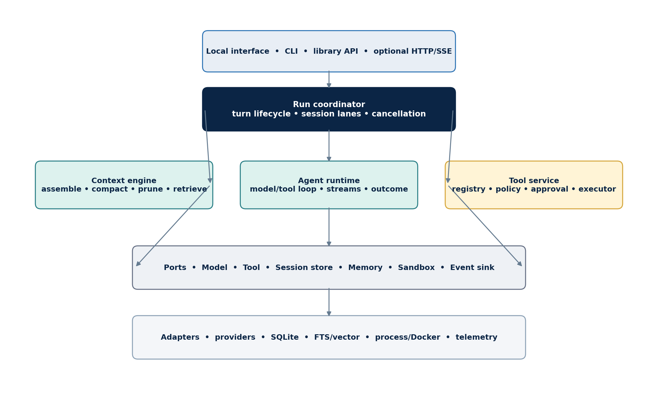
Figure 5. Recommended modular-monolith architecture for the agent-only clone.

15.1 Module boundaries
Module | Owns | Must not own
domain | Run/session/event/tool/outcome types and invariants | SDKs, SQL, HTTP, filesystem
application/run | Admission, scheduling, attempts, settlement, cancellation | Provider-specific request shapes
application/context | Budget, projection, retrieval, compaction, pruning | Transcript storage implementation
application/tools | Registry, effective policy, approval, execution, observation shaping | Model dialogue
ports | Model, store, memory, sandbox, clock, event sink contracts | Business orchestration
adapters | Provider SDKs, SQLite, FTS/vector, process/Docker, telemetry | Cross-adapter coordination
interfaces | CLI/library/local HTTP mapping | Session or tool policy rules

15.2 Run state machine
ACCEPTED → QUEUED → PREPARING → RUNNING ⇄ TOOL_EXECUTING
↘ COMPACTING → RUNNING
↘ RETRY_WAIT → RUNNING
↘ CANCELLING → CANCELLED
↘ SUCCEEDED | FAILED | TIMED_OUT
All terminal states are immutable. An Attempt has its own narrower lifecycle and always belongs to one Run. A model fallback creates a new attempt. Compaction may either continue the attempt or create a new attempt; choose one rule and keep telemetry consistent. External callers observe only documented run events, not internal object mutations.

15.3 Runtime port
interface AgentRuntime {
run(input: PreparedTurn, sink: RuntimeEventSink, signal: AbortSignal): Promise<RuntimeOutcome>;
}
type RuntimeEvent =
| { type: 'assistant.delta'; text: string }
| { type: 'tool.intent'; call: ToolCall }
| { type: 'tool.result'; result: ToolResult }
| { type: 'usage'; usage: Usage }
| { type: 'lifecycle'; phase: 'start' | 'end' | 'error' };

15.4 Context engine port
interface ContextEngine {
ingest(event: TranscriptEvent): Promise<void>;
assemble(req: AssembleRequest): Promise<ContextView>;
compact(req: CompactRequest): Promise<CompactionResult>;
afterTurn?(outcome: TerminalOutcome): Promise<void>;
}
ContextView = { messages, tools, memoryRefs, budgetReport, projectionRef }

15.5 Terminal outcome
type TerminalOutcome =
| { status: 'ok'; final: AssistantMessage; usage: Usage; artifacts: ArtifactRef[] }
| { status: 'cancelled'; reason: string }
| { status: 'timeout'; phase: string }
| { status: 'error'; category: ErrorCategory; retryable: boolean; diagnosticRef: string };
Normalize provider and tool errors into stable categories. Do not expose provider exception strings as API contracts. Store raw diagnostics behind a reference with secret redaction.

16. Persistence, observability, testing, and operations

16.1 Transaction boundaries
Run acceptance should atomically create or retrieve the idempotent run and update session metadata. Appending a transcript event and advancing the active leaf should be one transaction. Tool results must be durably recorded before the runtime uses them as observations. Final settlement should persist the terminal outcome and emit a completion event through an outbox-style mechanism if a durable external event bus is later added.

16.2 Observability model
Signal | Minimum fields | Purpose
Run span | runId, sessionId, accepted/start/end, status | End-to-end latency and terminal outcomes
Attempt span | attemptId, runtime/provider/model/auth profile, ordinal | Retry and failover analysis
Model span | request hash, tokens, latency, finish reason | Cost, performance, context regressions
Tool span | callId, tool, policy decision, effect, latency, status | Safety and side-effect diagnosis
Context event | budget report, projection, memory refs, compaction ref | Why the model saw what it saw
Queue metric | lane, depth, wait time, dropped/collected count | Backpressure and capacity

16.3 Test pyramid
- Domain property tests: legal state transitions, event immutability, active-leaf consistency, token-budget arithmetic.
- Policy tests: deny precedence, schema filtering, approval rules, forged tool call rejection, path canonicalization.
- Deterministic runtime tests: scripted fake model emits deltas/tool calls/errors; fake tools record effects.
- Persistence tests: crash between event append and leaf update, migration compatibility, lock contention, replay.
- Resilience tests: transient error, Retry-After, auth rotation, model fallback, timeout, cancellation, loop breaker.
- Security tests: prompt-injection corpus, symlink escapes, secret redaction, untrusted child payloads, sandbox network policy.
- Evaluation tests: task success, unnecessary tool calls, context precision, compaction fidelity, cost and latency budgets.

16.4 Golden turn record
For each end-to-end test, persist a golden record containing input, effective policy, context budget report, ordered runtime events, normalized tool observations, final outcome, and expected transcript tree. Golden records make architectural regressions visible even when model wording changes; use the fake model for deterministic CI and a small live-provider smoke suite outside the main build.

16.5 Operational defaults
Start conservative: one active run per session, a small global limit, bounded queue, explicit timeout, no automatic retry after tool side effects, sandbox off only for trusted local development, and read-only tools by default for remote callers. Publish every default in configuration output and record the effective values with each run.

17. Delivery roadmap and decisions
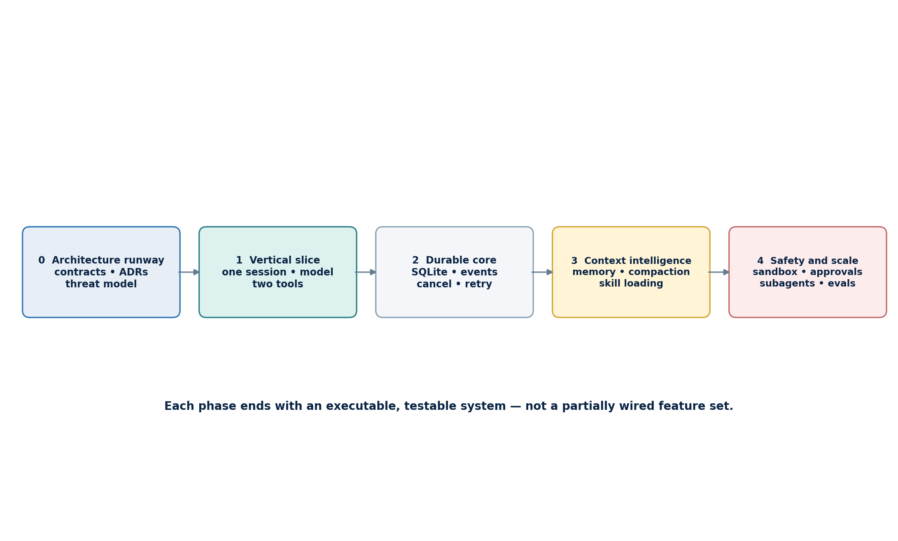
Figure 6. Incremental implementation roadmap: establish contracts, then one vertical slice, durability, context intelligence, and advanced safety/scale.

17.1 Phase 0 — architecture runway
- Write ADRs for state ownership, runtime/provider distinction, event schema, tool policy, and sandbox assumptions.
- Define the single-operator trust model and local-only network boundary.
- Implement types and state machines with a deterministic fake clock/model/tool set.

17.2 Phase 1 — executable vertical slice
- CLI accepts one turn and streams lifecycle events.
- One model adapter supports text plus native tool calls.
- Two tools demonstrate read-only and write/approval behavior.
- In-memory session transcript proves the tool loop and outcome contract.

17.3 Phase 2 — durable core
- SQLite session/run/attempt/event schema and migrations.
- Per-session lane, global limit, idempotent admission, cancellation, timeout, and structured errors.
- Observability spans and deterministic crash/recovery tests.

17.4 Phase 3 — context intelligence
- Prompt pipeline, workspace bootstrap, skill metadata and lazy instruction loading.
- Context budget report, bounded projections, compaction snapshot, tool-output pruning.
- Durable memory plus keyword search; add embeddings only after retrieval evaluation proves value.

17.5 Phase 4 — safety and scale
- Sandbox adapter, approval workflow, loop detection, auth/model failover, and redaction audits.
- Subagent orchestrator with push completion and depth/tool limits.
- Plan-and-Execute and critic/reflection modules, evaluated independently of the base loop.

17.6 Architecture decision backlog
Decision | Recommended default | Revisit when
Language | TypeScript for conceptual proximity and ecosystem | Team strengths or embedded constraints favor another language
Deployment | Single local process | Remote multi-user access becomes a requirement
Database | SQLite with WAL and explicit migrations | Write scale or tenancy exceeds single-node boundary
Event delivery | In-process async stream | External consumers require durable replay
Memory search | FTS/keyword first | Evaluation demonstrates semantic recall gap
Sandbox | Port with Docker implementation in safety phase | Untrusted tool execution is required earlier
Subagents | Deferred | Single-agent correctness and telemetry are stable

18. Fork versus clean-room reimplementation
OpenClaw is published under the MIT License, which permits use, modification, distribution, sublicensing, and sale provided the copyright and permission notice is included in copies or substantial portions. The repository also publishes third-party notices, including adapted Pi/pi-mono portions. This section is architectural guidance, not legal advice. [S29, S30]
Approach | Advantages | Costs / risks | Best fit
Focused fork | Fastest path; proven runtime behavior; upstream fixes | Large product surface; upstream churn; notice obligations; harder to create a small teaching codebase | You want compatibility and can continually rebase
Extract packages | Reuses agent-core contracts while excluding some product code | Internal dependencies may still pull product assumptions; extraction boundary can drift | Upstream packages are stable and explicitly reusable
Clean agent-only reimplementation | Small, teachable architecture; deliberate contracts; no accidental channel scope | More engineering and validation; behavioral gaps; must avoid claiming compatibility | Your goal is education, experimentation, and a reference clone

RECOMMENDATION Build a clean agent-only reimplementation informed by public behavior and architecture, with independent module names and tests. Preserve a source-attribution document and link to OpenClaw, but do not use OpenClaw branding in a way that implies endorsement. If any source code is copied or substantially adapted, carry the MIT and relevant third-party notices.

18.1 Compatibility position
Choose one explicit position: concept-compatible, protocol-compatible, or source-compatible. For this project, concept-compatible is sufficient: preserve architectural ideas and user-visible semantics without promising OpenClaw configuration, plugin, transcript, or Gateway protocol compatibility. This keeps the codebase small and makes the handbook examples easier to understand.

19. Conclusions
OpenClaw’s most instructive contribution is the production envelope around a tool-using model loop. The kernel is simple enough to explain, but the surrounding invariants—single-writer sessions, bounded context projections, typed policy-filtered tools, persistent compaction, lifecycle events, failover, cancellation, and sandbox separation—are what make the agent operable.
For the handbook, use OpenClaw to show pattern composition. ReAct explains the inner dialogue with tools. Context, memory, and compaction explain continuity under limits. Queues, bulkheads, retries, and breakers explain reliability. Tool policy, approvals, and sandboxing explain safety. Subagents demonstrate orchestrator–worker collaboration. Plan-and-Execute and Reflection remain optional policies above the base runtime.
For the clone, resist product imitation. Build one durable, observable, policy-aware turn from end to end. Once that vertical slice is correct, add context intelligence, resilience, and delegated work incrementally. A small architecture with explicit contracts will be more valuable to readers than a superficial copy of a large assistant platform.

Appendix A — Pattern evidence matrix
ID | Pattern | Status | Mechanism / interpretation | Evidence
P01 | Structured ReAct / tool loop | Implemented | Model emits native tool calls; observations return to the same serialized turn until final output. | S3, S23
P02 | Event-driven orchestration | Implemented | Assistant, tool, and lifecycle deltas are streamed as events; run acceptance is asynchronous. | S3
P03 | Steering / interruptible interaction | Implemented | Queue modes steer, follow up, collect, or interrupt while preserving per-session ordering. | S11
P04 | Orchestrator–worker subagents | Implemented | Non-blocking spawn, isolated child sessions, bounded nesting, push-based completion. | S19
P05 | Plan-and-Execute | Supported, not default | Can be expressed through skills, task tools, or subagents; not the mandatory ordinary-turn kernel. | S3, S19, H2
P06 | Generator–Critic reflection | Supported, not default | Can be added as a skill, plugin, or critic subagent; base loop does not require a separate critic pass. | S19, H3
P07 | Progressive disclosure | Implemented | System prompt lists skill metadata; full instructions are read only when relevant. | S4, S5
P08 | Prompt pipeline and cache boundary | Implemented | Stable prompt content is separated from volatile per-run suffixes for deterministic caching. | S4, S28
P09 | Context engine strategy | Implemented | Exclusive engine slot owns ingest, assemble, compact, and optional lifecycle stages. | S6
P10 | Tiered memory | Implemented | Curated durable memory, daily working notes, and optional retrieval/indexing serve different time horizons. | S9
P11 | Hybrid retrieval | Implemented | Memory can combine semantic/vector and keyword search through the active memory plugin. | S9
P12 | Summarization compaction | Implemented | Older history becomes a persistent summary while recent turns remain verbatim; overflow can retry. | S10
P13 | In-memory pruning | Implemented | Large tool outputs can be trimmed in the assembled context without rewriting the durable transcript. | S10
P14 | Control plane / execution plane | Implemented | Gateway coordinates identity, sessions, and RPC; runtime owns one prepared model/tool loop. | S23, S24
P15 | Facade | Implemented | The runtime facade connects reusable agent-core contracts to OpenClaw’s provider/plugin runtime. | S2
P16 | Ports and adapters | Architectural inference | Provider, runtime, store, tool, hook, and plugin boundaries isolate external mechanisms. | S2, S23
P17 | Strategy | Implemented | Runtime selection, context engines, providers, memory, and compaction are replaceable strategies. | S2, S6, S23
P18 | Registry / factory | Implemented | Harnesses, tools, providers, plugins, and resources are registered and selected at runtime. | S2, S14
P19 | Adapter / anti-corruption layer | Implemented | Provider normalization and harness adapters prevent provider-specific protocols leaking into the kernel. | S2
P20 | Phase-oriented pipeline | Architectural inference | The attempt runner is decomposed into preparation, prompt, execution, streaming, recovery, and settlement phases. | S25, S26
P21 | Plugin hook/interceptor chain | Implemented | Before/after hooks can inspect or alter model, prompt, tool, compaction, message, session, and gateway lifecycles. | S3
P22 | Manifest + convention discovery | Implemented | Resource manifests declare extensions/skills/prompts/themes; conventional directories are fallback discovery. | S2
P23 | Append-only event log | Implemented | Transcript events form an append-only parent-linked tree; mutable session metadata is separate. | S7, S8
P24 | Projection / read model | Architectural inference | Active branch and bounded tail are derived views over the durable event history. | S8
P25 | Snapshot | Implemented | Compaction entries summarize a prior span and act as durable context snapshots. | S8, S10
P26 | Single writer / unit of work | Implemented | Per-session lanes plus process/file-aware write locks serialize transcript mutation. | S3
P27 | Bulkhead isolation | Implemented | Session lanes, global limits, and a separate subagent lane contain concurrency pressure. | S3, S11, S19
P28 | Backpressure | Implemented | Queue caps, debounce, collection, and drop/summarize policy bound pending work. | S11
P29 | Retry with backoff and jitter | Implemented | Transient requests retry with bounded exponential delay while preserving operation ordering. | S12
P30 | Circuit breaker | Implemented | Auth cooldowns and tool-loop detection stop repeated failing or unproductive work. | S13, S18
P31 | Two-stage failover | Implemented | Auth profiles rotate within a provider before model fallback progresses across configured models. | S13
P32 | Timeout / watchdog / cooperative cancellation | Implemented | Run timeouts, idle diagnostics, abort signals, and queue cancellation normalize termination. | S3
P33 | Graceful degradation with quarantine | Implemented | A failing optional context engine can be quarantined and downgraded; declared capability mismatch fails closed. | S6
P34 | Reference monitor | Architectural inference | Tool schemas are removed before model invocation and policy is checked again at execution boundaries. | S14, S15
P35 | Least privilege / capability filtering | Implemented | Allow/deny, provider, sandbox, channel, and plugin filters reduce the model’s available capabilities. | S14, S15
P36 | Defense in depth | Implemented | Identity, pairing, allowlists, tool policy, approvals, sandbox, and OS/container boundaries layer controls. | S16, S17
P37 | Fail-closed explicit selection | Implemented | Explicit unavailable runtimes and required host capabilities error rather than silently changing semantics. | S2, S6
P38 | Audit and observability events | Implemented | Lifecycle streams, tool events, session metadata, traces, and diagnostics expose run behavior. | S3, S8

Evidence keys resolve to the primary-source list in Appendix D.

Appendix B — Source-code orientation map
Path | Responsibility | Review focus
packages/agent-core | Reusable loop, harness/message/compaction/prompt/skill/session contracts | Read first for stable concepts
src/agents/embedded-agent-runner | OpenClaw-owned attempt orchestration and recovery | Trace one turn and failure paths
src/agents/embedded-agent-runner/run | Phase-oriented preparation, prompt, execution, stream, timeout, settlement helpers | Identify pipeline boundaries
src/agents/runtime | Facade connecting reusable core and plugin/provider runtime | Study dependency direction
src/agents/harness | Runtime registry, selection, and lifecycle | Study strategy/factory behavior
src/agents/sessions | Persistence, resource loading, prompt/skill/session utilities | Study state/resource ownership
src/agents/agent-tools* | Schemas, policy, adapters, host/sandbox tools | Study capability enforcement
src/agents/agent-hooks | Compaction safeguards and context pruning | Study lifecycle interceptors
src/llm | Models/providers/transports/streams | Study anti-corruption adapters
src/context-engine | Context lifecycle integration | Study context strategy
src/sessions and src/transcripts | Session/transcript infrastructure | Study event and projection model
AGENTS.md | Maintainer invariants and contribution rules | Treat as design intent and guardrails

SUGGESTED TRACE Start at the documented agent RPC, follow agentCommand into runEmbeddedAgent, then into the selected harness and tool loop. On the way back, follow stream bridging, transcript persistence, terminal normalization, and lock release. Repeat the trace for context overflow, cancellation, a transient provider error, and a tool denial.

Appendix C — Suggested handbook case-study outline
Unit | Title | Patterns
Case study 1 | The smallest reliable agent turn | ReAct loop + run/attempt distinction + lifecycle events
Case study 2 | Context is a projection, not a database | Context budget + transcript + memory + compaction + pruning
Case study 3 | Tools are capabilities | Registry + schema virtualization + reference monitor + sandbox
Case study 4 | One session, one writer | Queue lane + lock + idempotency + cancellation
Case study 5 | Resilience around probabilistic execution | Retry + auth rotation + model fallback + breakers
Case study 6 | Delegation without losing control | Subagents + tool limits + push completion + provenance
Case study 7 | Optional planning and reflection | Planner/critic modules above the same runtime contracts
Capstone | Build an agent-only OpenClaw-inspired core | Modular monolith + SQLite + tests + observability

Appendix D — Primary sources
All web sources were accessed for the 17 July 2026 evidence snapshot. OpenClaw documentation and repository links are primary sources. Handbook links are included for terminology alignment.
[S1] OpenClaw repository and README — https://github.com/openclaw/openclaw
[S2] Agent runtime architecture — https://docs.openclaw.ai/agent-runtime-architecture
[S3] Agent loop — https://docs.openclaw.ai/concepts/agent-loop
[S4] System prompt — https://docs.openclaw.ai/concepts/system-prompt
[S5] Context — https://docs.openclaw.ai/concepts/context
[S6] Context engine — https://docs.openclaw.ai/concepts/context-engine
[S7] Session management — https://docs.openclaw.ai/concepts/session
[S8] Session management and compaction deep dive — https://docs.openclaw.ai/reference/session-management-compaction
[S9] Memory — https://docs.openclaw.ai/concepts/memory
[S10] Compaction — https://docs.openclaw.ai/concepts/compaction
[S11] Command queue — https://docs.openclaw.ai/concepts/queue
[S12] Retry policy — https://docs.openclaw.ai/concepts/retry
[S13] Model failover — https://docs.openclaw.ai/concepts/model-failover
[S14] Tool system — https://docs.openclaw.ai/tools
[S15] Sandbox, tool policy, and elevated execution — https://docs.openclaw.ai/gateway/sandbox-vs-tool-policy-vs-elevated
[S16] Security model — https://docs.openclaw.ai/gateway/security
[S17] Sandboxing — https://docs.openclaw.ai/gateway/sandboxing
[S18] Tool loop detection — https://docs.openclaw.ai/tools/loop-detection
[S19] Subagents — https://docs.openclaw.ai/tools/subagents
[S20] Multi-agent routing — https://docs.openclaw.ai/concepts/multi-agent
[S21] Agent workspace — https://docs.openclaw.ai/concepts/agent-workspace
[S22] Agent runtime — https://docs.openclaw.ai/concepts/agent
[S23] Agent runtimes — https://docs.openclaw.ai/concepts/agent-runtimes
[S24] Gateway architecture — https://docs.openclaw.ai/concepts/architecture
[S25] OpenClaw source: agent modules — https://github.com/openclaw/openclaw/tree/main/src/agents
[S26] OpenClaw source: embedded agent runner — https://github.com/openclaw/openclaw/tree/main/src/agents/embedded-agent-runner
[S27] OpenClaw source: reusable agent core — https://github.com/openclaw/openclaw/tree/main/packages/agent-core
[S28] OpenClaw maintainer architecture rules (AGENTS.md) — https://github.com/openclaw/openclaw/blob/main/AGENTS.md
[S29] OpenClaw MIT license — https://github.com/openclaw/openclaw/blob/main/LICENSE
[S30] OpenClaw third-party notices — https://github.com/openclaw/openclaw/blob/main/THIRD_PARTY_NOTICES.md
[S31] OpenClaw releases — https://github.com/openclaw/openclaw/releases
[H0] AI Agent Architecture Patterns Handbook — https://ghassan-alhamoud.com/handbook/
[H1] Handbook Chapter 1: ReAct — https://ghassan-alhamoud.com/handbook/chapter-01-react-pattern.html
[H2] Handbook Chapter 2: Plan-and-Execute — https://ghassan-alhamoud.com/handbook/chapter-02-plan-and-execute.html
[H3] Handbook Chapter 3: Reflection — https://ghassan-alhamoud.com/handbook/chapter-03-reflection.html
[H4] Handbook Chapter 4: Multi-Agent Collaboration — https://ghassan-alhamoud.com/handbook/chapter-04-multi-agent-collaboration.html

Appendix E — Senior-architect review checklist
- Can every terminal outcome be reconstructed from durable state without reading unstructured logs?
- Can a caller safely retry run admission without creating a duplicate turn?
- Can two runs ever mutate the same session concurrently? If not, where is the invariant enforced?
- Can the model see or invoke a tool that policy denies? Test both schema filtering and forged execution.
- Can a tool be retried after an uncertain external effect? Require idempotency or reconciliation.
- Can context assembly explain every included and excluded item with token counts?
- Can compaction preserve identifiers, tool-call/result pairing, commitments, and unresolved work?
- Can cancellation stop model streaming, queued work, and child runs without corrupting persistence?
- Can a plugin/provider failure change semantics silently? Define fail-open versus fail-closed per boundary.
- Can secrets, raw binary output, or unbounded tool results enter transcript, logs, or prompts?
- Does the sandbox boundary match the threat model, including absolute paths, symlinks, mounts, and network?
- Are Plan-and-Execute and Reflection independently testable modules rather than hidden prompt conventions?

