ARCHITECTURE STUDY
Streaming-Native
Agent Runtime
Architecture, semantics, and open-source project blueprint
Continuously aware, episodically reasoning: temporal truth in the stream plane, bounded cognition in the agent plane, and governed effects in the action plane.
Prepared for Ghassan Alhamoud
Senior architecture study
Research snapshot: 28 July 2026

REPORT MAP
How to use this study
I | Problem and position | Sections 1–4: category boundary, market gap, principles
II | Runtime architecture | Sections 5–13: Situation model, time, cognition, correctness
III | Production design | Sections 14–18: safety, replay, deployment, implementation
IV | Open-source execution | Sections 19–24: use cases, risks, roadmap, recommendation
V | Reference material | Contracts, ADRs, research sources, and glossary
Working project label
Streaming Agent Runtime (SAR). The architecture is intentionally independent of the final repository name.

ARCHITECTURE STUDY

Executive summary
OpenClaw, Hermes Agent, and LangGraph are strong at turn-based or episode-based work. They can stream model tokens, execution updates, tool output, and graph-state changes, but that is not the same as processing an unbounded external data stream. A sensor stream introduces requirements that an ordinary agent loop does not natively own: event time, out-of-order arrival, windows, watermarks, stateful temporal joins, silence detection, backpressure, replay, partitioning, late corrections, and explicit processing guarantees.
The right design is therefore not “put Kafka in front of an agent.” It is a two-runtime architecture:
- A continuous deterministic runtime ingests events, normalizes them, manages event-time state, computes features, recognizes patterns, and maintains versioned situations.
- An episodic cognitive runtime wakes agents on carefully governed triggers, gives each episode an immutable situation snapshot and a strict budget, accepts structured decisions, and routes proposed actions through deterministic policy and idempotent execution.
The system is continuously sensing, but only intermittently reasoning. This distinction controls cost, latency, failure amplification, and action safety.
The project’s primary abstraction should be the Situation, not the message, prompt, thread, or graph node. A Situation is a keyed, durable, versioned interpretation of what is happening around an entity: a machine, vehicle, account, patient, building, shipment, service, or market instrument. It includes evidence, temporal features, baselines, anomalies, confidence, lifecycle, provenance, and a validity interval. Agent episodes operate on Situation Snapshots, never on an unbounded raw stream.
The proposed runtime has seven defining ideas:
- Raw events are evidence, not prompts.
- Event time establishes temporal truth; processing time only describes system behavior.
- Situation reducers convert continuous observations into stable, inspectable state.
- Cognitive triggers decide when thinking is worth its latency and cost.
- Agent episodes are bounded, version-aware, cancelable, and replayable.
- Agents propose intents; a separate policy-and-action plane applies effects.
- Replay is a first-class development and evaluation mode, not a debugging afterthought.
The open-source opportunity is real but time-sensitive. Confluent now offers Streaming Agents running on Flink in Confluent Cloud, and StreamNative has described an Agent Engine based on Pulsar Functions. These products validate the category. They also sharpen the gap: a vendor-neutral, open, situation-centric runtime that runs locally, at the edge, or on existing brokers; integrates with existing agent frameworks; and makes temporal semantics, cognition budgets, evidence lineage, and safe replay portable.
The recommended implementation is a modular monolith first, written in Go for the control plane and embedded runtime, with process-isolated Python model workers and protocol-level SDKs for other languages. It should not attempt to rebuild Flink. The first release should provide a correct single-node event-time engine, durable situation state, cognitive scheduling, action policy, replay, and adapters for MQTT plus one durable log. Later releases can add distributed execution and adapters that compile or map the same Situation specification onto Kafka Streams, Flink, or Pulsar.
The best first demonstration is predictive maintenance using simulated temperature, vibration, power, and maintenance events. It is safe, visually understandable, replayable, and rich enough to prove slow trends, correlated signals, missing heartbeats, late data, bounded reasoning, human approval, and outcome learning.
ARCHITECTURE STUDY

1. Problem definition

1.1 “Streaming” currently means two different things
Agent frameworks use streaming to mean incremental delivery from an execution that has already started: model token deltas, tool-call events, state updates, or progress messages. Stream processors use streaming to mean continuous computation over an unbounded dataset whose events may arrive late, out of order, in bursts, or not at all.
Both uses are valid, but they solve different problems.
Capability | Agent execution streaming | Data stream processing
Primary unit | Turn, run, thread, node | Event, key, window, partition
Main clock | Request/execution time | Event time plus processing time
State | Conversation or graph state | Keyed operator state over unbounded input
Ordering | Usually local execution order | Partition ordering; cross-partition uncertainty
Completeness | Run completes | Stream may never complete
Late data | Usually a new input | Explicit lateness and correction semantics
Flow control | Run queues and concurrency | End-to-end backpressure and lag
Recovery | Resume a workflow/checkpoint | Replay source offsets plus operator state
Output | Answer, tool result, graph update | Continuous derived streams and materialized views

LangGraph is correctly described by its own documentation as an orchestration runtime for long-running, stateful agents with persistence, streaming, and human-in-the-loop control. Its streaming is valuable, but its primary abstraction remains a graph invocation and thread state. It does not present itself as an event-time stream processor with windows and watermarks. OpenClaw’s runtime is organized around agent attempts, provider streams, tool calls, compaction, and sessions. Hermes Agent is organized around persistent personal-agent memory, channels, skills, schedules, and delegated work. None of this is a weakness; it is a scope boundary.

1.2 Why a sensor stream changes the architecture
Assume a machine sends four readings per minute. That is a slow stream by infrastructure standards, but it is still not naturally a sequence of chat turns.
The system must answer questions such as:
- Is the temperature high relative to this machine’s own baseline, or only high in absolute terms?
- Did vibration rise before current consumption, or after it?
- Is the last sample missing because the machine stopped, the sensor failed, or the network disconnected?
- Did a late reading revise a previously stable interpretation?
- Should a new observation update an existing incident, create a new incident, or be ignored as duplicate evidence?
- If the agent is still reasoning, should newer evidence cancel it, amend its context, or wait for the next episode?
- If the same event is replayed after a crash, how are duplicate physical actions prevented?
- If 10,000 devices cross a warning threshold together, which situations receive scarce LLM capacity?
These are temporal, distributed-systems, and control problems before they are language-model problems.

1.3 The product thesis
The project should make this promise:
KEY CONCLUSION Define how continuous evidence becomes a governed situation, when that situation deserves cognition, and how a decision becomes a safe, traceable action.

That promise is narrower and more defensible than “a new agent framework.” Existing agent frameworks can be used inside an episode. Existing stream engines can be used below the Situation layer. The project owns the missing semantic and runtime boundary between them.
ARCHITECTURE STUDY

2. Goals, scope, and non-goals

2.1 Goals
The runtime should:
- Treat unbounded streams, slow streams, bursty streams, and silence as first-class inputs.
- Preserve event-time semantics and explicitly handle late or out-of-order observations.
- Maintain keyed, durable, inspectable state for each monitored entity or relationship.
- Support deterministic rules, signal processing, statistical models, time-series models, and LLM agents in an escalation ladder.
- Wake cognitive workers on semantic changes rather than on every event.
- Bound every agent episode by time, tokens, tool calls, retries, and action permissions.
- Separate decision generation from side-effect execution.
- Provide safe replay, shadow evaluation, and counterfactual comparison.
- Remain broker-neutral and model-provider-neutral.
- Run as a useful single binary for development and small deployments.
- Scale by partitioning situations by key and by independently scaling stream and cognitive workers.

2.2 Non-goals
The project should not initially:
- Replace Kafka, Pulsar, NATS, MQTT brokers, Flink, Beam, or Kafka Streams.
- Build a general-purpose distributed stream processor in version 1.
- Put an LLM in the per-event hot path.
- Promise universal exactly-once physical side effects.
- Treat free-form natural language as the source of truth for state.
- Allow agents to call actuators or privileged external systems directly.
- Start as a multi-agent mesh, visual workflow builder, or Kubernetes platform.
- Optimize for video-rate or sub-millisecond control loops. Those remain in dedicated signal-processing, robotics, or real-time control systems.

2.3 Supported latency envelope
The architecture should support several cognitive lanes:
Lane | Typical latency | Technique | Example
L0 safety | microseconds–milliseconds | PLC, rule, deterministic code | Emergency motor shutdown
L1 stream | milliseconds–seconds | windows, CEP, anomaly model | Detect correlated temperature/vibration rise
L2 fast cognition | seconds | small/local model or compact LLM episode | Classify incident and select playbook
L3 deep cognition | tens of seconds–minutes | full agent, retrieval, tools, verification | Diagnose likely cause and propose maintenance plan
L4 learning | minutes–days | offline replay, evaluation, threshold/model update | Improve trigger policy from outcomes

An LLM must never be responsible for the L0 safety lane. The runtime may observe and explain L0 actions, but it must not replace them.
ARCHITECTURE STUDY

3. Current landscape and the real gap

3.1 What existing agent frameworks already solve
LangGraph provides durable graph execution, thread-scoped checkpoints, long-term stores, interrupts, and incremental execution output. OpenClaw provides a mature session-based tool loop, provider normalization, compaction, policy boundaries, channels, and automation. Hermes provides a persistent self-improving personal agent, schedules, skills, memory, multiple communication channels, and subagents.
These are valuable episode engines. The new project should integrate them behind an EpisodeExecutor port rather than copy their complete surfaces.

3.2 What stream systems already solve
Apache Flink combines replayable inputs with operator checkpoints so state can recover consistently. Its event-time model uses watermarks to estimate progress and classify later arrivals. Apache Beam provides a portable model for windows, triggers, allowed lateness, state, and timers. Kafka Streams provides partitioned processing with local state stores and configurable at-least-once or exactly-once-v2 semantics. Reactive Streams defines non-blocking backpressure so asynchronous boundaries do not require unbounded buffers.
These systems solve the mechanics of unbounded computation. They do not define when an LLM should think, what a cognitive snapshot contains, how a situation supersedes an in-flight decision, or how non-deterministic decisions are replayed safely.

3.3 Direct category competitors
By July 2026, two offerings directly validate streaming agents:
- Confluent Streaming Agents run on Flink in Confluent Cloud and advertise tool calling, MCP integration, reflection, replayability, monitoring, and agent definitions through SQL DDL.
- StreamNative Agent Engine was introduced as an early-access, event-driven runtime based on Pulsar Functions, with persistent agent state, an event bus, agent registry, observability, and agent-framework compatibility.
Apache Pulsar also has a 2026 proposal to add native MCP, agent-runtime, and communication patterns using Pulsar Functions and compacted topics.
This means the project should not claim that “streaming agents” are an empty category. The stronger open-source position is:
Dimension | Proposed project position
Infrastructure | Broker-neutral; embedded locally; adapters for Kafka, Pulsar, NATS, and MQTT
Core abstraction | Situation and cognitive trigger, not topic-to-agent invocation
Runtime boundary | Deterministic continuous topology plus bounded episodic cognition
Deployment | Laptop, edge gateway, single server, or external stream engine
Agent framework | Pluggable episode engines; no mandatory agent SDK
Correctness | Explicit event-time, lateness, supersession, replay, and side-effect semantics
Safety | Intent ledger and policy gateway between model and effectors
Testing | Deterministic stream replay plus recorded-model and live-model comparison
Openness | Apache-2.0 core, open contracts, compatibility suite, no cloud dependency

3.4 The category name
“Streaming agent” is understandable but overloaded. Internally, use more precise terms:
- Streaming-native agent system: the complete product category.
- Situation runtime: the continuous semantic layer.
- Cognitive scheduler: the admission and wake-up layer.
- Agent episode: one bounded reasoning execution.
- Action plane: policy, approval, dispatch, and reconciliation.
The name of the eventual repository can change. The architecture should not depend on branding.
ARCHITECTURE STUDY

4. Core architectural principles

4.1 Continuous awareness, episodic reasoning
The system is always updating state but rarely invoking an expensive reasoning model. Continuous LLM calls create cost explosions, queue instability, contradictory decisions, and action oscillation. Awareness comes from stream state; cognition is an exception path.

4.2 Raw events are evidence, not prompts
Raw sensor payloads should be validated, timestamped, normalized, deduplicated, and stored before any model sees them. The model receives a compact, typed projection with provenance. This preserves auditability and reduces prompt-injection and malformed-input risk.

4.3 Temporal truth belongs to the stream plane
Window membership, ordering, duration, correlation, rate of change, missingness, and allowed lateness must be computed deterministically. The LLM may interpret these facts but must not reconstruct them from an arbitrary text dump.

4.4 Situations, not messages
A message is a transport occurrence. A Situation is a meaningful, evolving domain state. The same Situation may be supported by thousands of events, multiple windows, and several models. The Situation remains stable enough for humans and agents to discuss.

4.5 One append-only evidence truth, many projections
Raw and derived events should form an append-only audit trail. Situation state, prompts, dashboards, embeddings, and summaries are projections. Compaction can reduce a model’s context, but it must not erase the evidence needed for replay and audit.

4.6 Agents propose; deterministic policy disposes
The agent produces a typed decision and one or more Action Intents. A separate policy engine validates permissions, evidence freshness, risk, budgets, human-approval requirements, and idempotency. The action executor never receives unconstrained model text.

4.7 Backpressure includes cognition
Traditional backpressure protects memory and queues. A streaming agent also needs cognitive backpressure: priority, coalescing, cooldown, quotas, stale-episode cancellation, overload modes, and model-tier selection.

4.8 Replay before autonomy
Every feature should be testable against a recorded stream with actions disabled. Autonomy should be earned through replay accuracy, shadow performance, and safe staged permissions.

4.9 Explicit contracts at every boundary
Transport events, situations, episode requests, decisions, intents, commands, and outcomes all require versioned schemas. Free-form text is allowed inside controlled fields, never as the entire protocol.

4.10 Start as a modular monolith
The first release should contain one coherent engine with explicit ports. Components can later be split by load or trust boundary. Beginning with a distributed agent mesh would make temporal correctness, replay, and debugging much harder.
ARCHITECTURE STUDY

5. Reference architecture
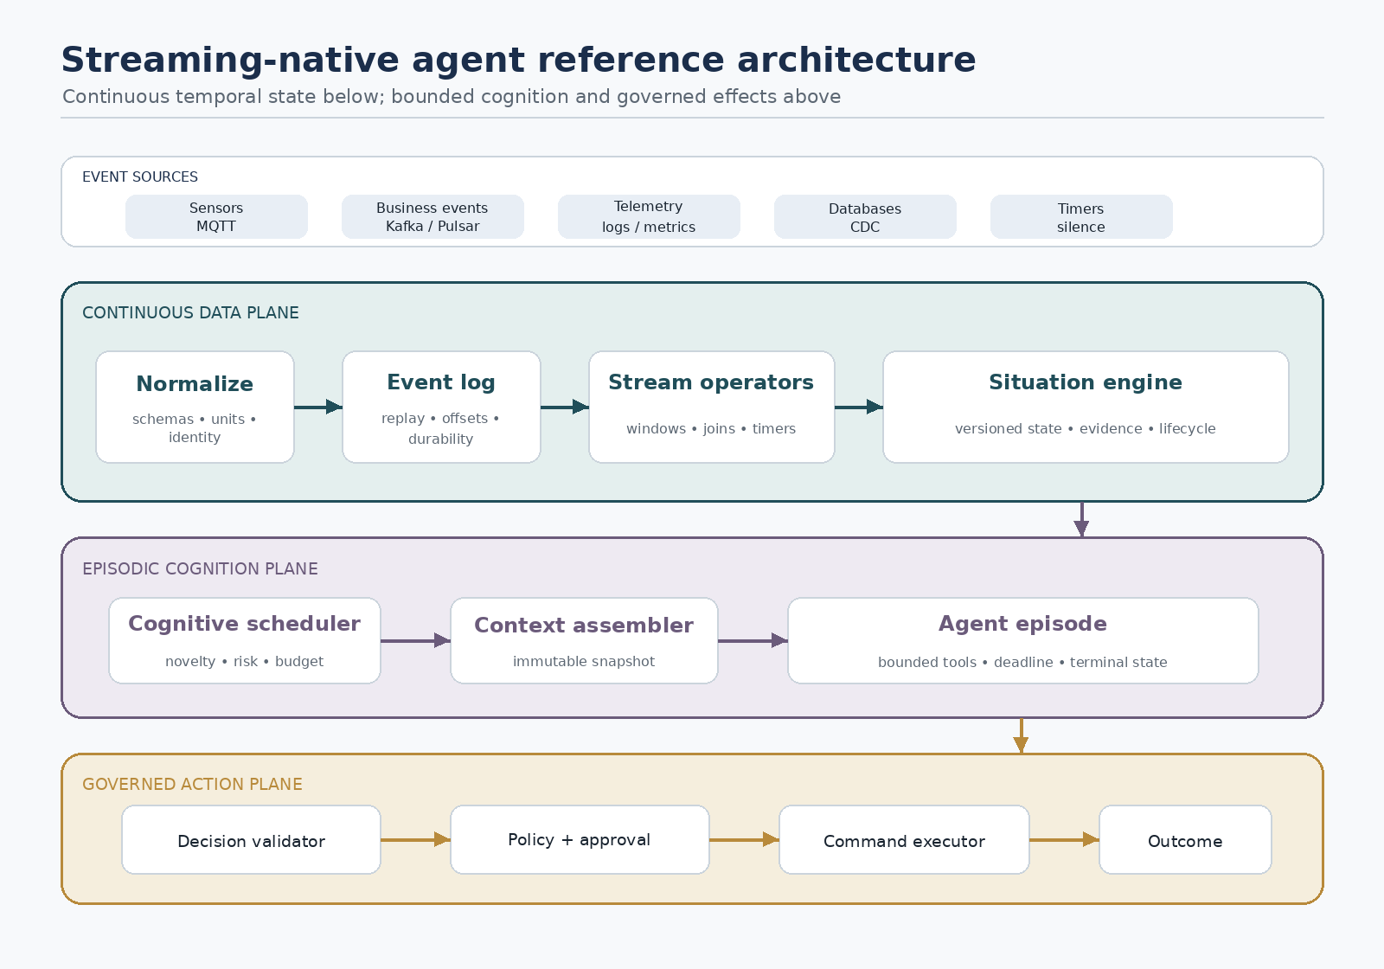
Figure 1. Streaming-native agent reference architecture.
The design is divided into a continuous data plane, an episodic cognition plane, an action plane, and a control plane.

5.1 Ingress and normalization
Ingress adapters accept MQTT, Kafka, Pulsar, NATS, HTTP, files, databases, or test generators. They map provider-specific messages into one Event Envelope. The normalization layer:
- validates schema and units;
- assigns source, entity, and correlation identities;
- preserves original event and ingestion timestamps;
- rejects or quarantines malformed data;
- deduplicates when the source offers stable identifiers;
- records schema version, tenant, security classification, and trace context;
- converts units without losing the original value;
- publishes accepted observations and data-quality events.
The agent layer never parses arbitrary broker payloads directly.

5.2 Durable event log
The log provides replay, offset management, fan-out, and recovery. In local mode it may be an embedded append-only log. In production it may be Kafka, Pulsar, Redpanda, or JetStream. The runtime should depend on a small Log port:
- append;
- subscribe from offset or time;
- acknowledge/checkpoint;
- seek/replay;
- query partition lag;
- publish transactionally where supported.
Broker-specific guarantees must be surfaced, not hidden.

5.3 Stateful stream operators
Operators perform deterministic transformations:
- filter, map, validate, and enrich;
- key and partition by entity;
- tumbling, sliding, session, count, and decay windows;
- aggregates, rates, deltas, derivatives, quantiles, and baselines;
- temporal joins and correlation;
- timers, duration conditions, and missing-heartbeat detection;
- change-point, anomaly, forecast, and classification calls;
- complex-event patterns;
- field-specific state reduction.
Operators emit typed Feature Events and Pattern Events. They should be deterministic for a fixed input sequence, operator version, configuration, and model artifact.

5.4 Situation engine
The Situation engine is the architectural center. For each key, a reducer combines evidence and derived features into a versioned Situation:
- current phase: normal, watch, warning, incident, recovering, resolved;
- severity and confidence;
- first observed, last updated, event-time range, and validity;
- active hypotheses and disconfirming evidence;
- baselines, deviations, trends, forecasts, and uncertainty;
- supporting evidence references;
- related entities and upstream situations;
- previous decision and action status;
- lifecycle timers and cooldown;
- provenance for every derived field.
Reducers are domain-defined and field-specific. Lists may append or de-duplicate; scores may take maximum or weighted updates; phase may follow an explicit state machine; evidence sets use stable identities; human annotations may override model projections but never erase original evidence.
Every change creates a new situation_version. A version is immutable after publication.

5.5 Cognitive scheduler
The scheduler decides whether a Situation version deserves an episode. It evaluates:
- novelty relative to the last reasoned version;
- severity and risk;
- uncertainty or hypothesis conflict;
- opportunity value;
- time since last reasoning;
- whether deterministic policy already knows the answer;
- current evidence completeness and watermark;
- episode cost estimate;
- queue capacity and tenant budget;
- whether a newer version supersedes an in-flight episode;
- action urgency and decision deadline.
The scheduler may ignore, debounce, coalesce, defer, downgrade, upgrade, cancel, or start an episode.

5.6 Context assembler
The context assembler builds an immutable Situation Snapshot. It includes only bounded, relevant material:
- Situation fields and version;
- important recent features and their event-time ranges;
- baseline and historical comparison;
- top supporting and contradicting evidence;
- related incidents and previous outcomes;
- available tools and action policy;
- freshness, lateness, and confidence markers;
- domain instructions and decision schema.
Large raw windows remain accessible through typed query tools. They are not embedded in the initial prompt.

5.7 Episode workers
Episode workers execute one bounded reasoning task. The engine may be a native loop or an adapter for LangGraph, OpenClaw, Hermes, another agent SDK, or a direct model call. Each worker receives:
- immutable episode request;
- explicit objective;
- situation snapshot version;
- deadline and cancellation channel;
- token, tool, retry, and monetary budgets;
- allowlisted read tools;
- structured output contract;
- action permissions limited to proposing intents.
The worker emits trace events and ends in a named terminal state: decided, no_action, needs_human, superseded, timed_out, budget_exhausted, failed, or canceled.

5.8 Decision and action plane
The decision validator checks schema, evidence references, freshness, and internal consistency. The policy gateway then evaluates Action Intents. Depending on risk, an intent may be:
- automatically approved;
- rate-limited or delayed;
- simulated;
- sent for human approval;
- rejected;
- split into a safe immediate action and a reviewed follow-up;
- converted into a notification only.
Approved intents become Commands with an idempotency key. Effectors execute commands through narrow credentials. Results return as Outcome Events, which close the loop.

5.9 Control plane
The control plane manages:
- Situation specifications and schema versions;
- connectors and secrets references;
- operator and model registries;
- deployment versions;
- trigger policies and budgets;
- agent and tool capabilities;
- action permissions and approval rules;
- replay jobs and experiment definitions;
- tenants, quotas, and retention;
- dashboards, audit access, and lifecycle operations.
The control plane must never become the per-event bottleneck.
ARCHITECTURE STUDY

6. The end-to-end lifecycle
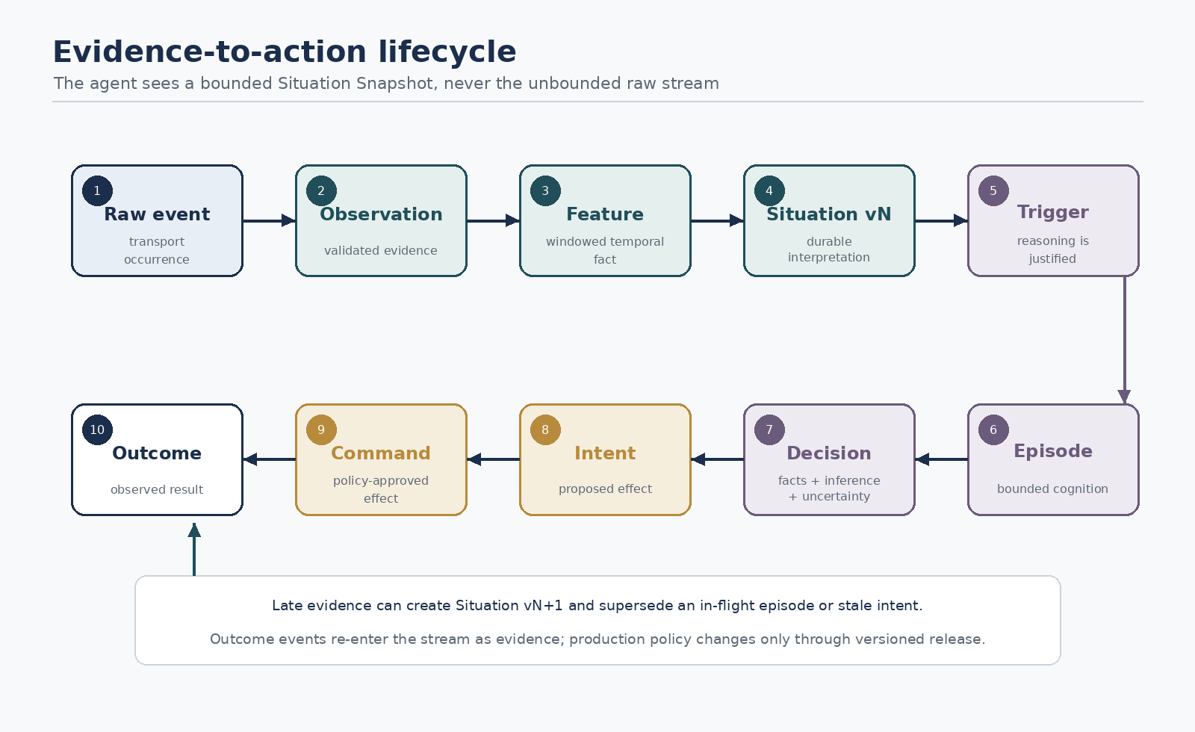
Figure 2. Evidence-to-action lifecycle and feedback.

6.1 Event to observation
A source message becomes an accepted Observation only after validation and normalization. Rejected input becomes a Data Quality Event with enough context for diagnosis. The original payload is retained according to policy.

6.2 Observation to feature
Keyed operators update time-aware state and emit meaningful features such as:
- 15-minute vibration RMS;
- 24-hour deviation from weekday baseline;
- temperature slope;
- correlation between current draw and vibration;
- predicted failure probability;
- heartbeat missing for 12 minutes.
Feature events contain the exact window, watermark, model/operator version, and input lineage.

6.3 Feature to Situation version
The Situation reducer applies domain rules. A machine may transition from normal to watch when a trend persists across three windows, then to warning when two independent indicators agree. Hysteresis prevents immediate reversal when one reading returns to normal.

6.4 Situation to episode
A cognitive trigger compares the new version with the last reasoned version. A small change may be absorbed without cognition. A new failure hypothesis, higher severity, contradictory evidence, long unresolved duration, or meaningful forecast shift may start an episode.

6.5 Episode to decision
The agent interprets the snapshot, queries bounded evidence, consults manuals or prior incidents, and returns a typed Decision Record. The record distinguishes facts, inferences, uncertainty, proposed actions, and required approvals.

6.6 Intent to command
The policy gateway validates the intent against current Situation state. If the Situation has already changed, the intent may be stale and rejected. Approved intents receive an idempotency identity and become Commands.

6.7 Outcome to learning
Command results, human decisions, later sensor behavior, and eventual incident resolution become Outcome Events. Offline evaluation compares the decision with reality and may propose changes to detectors, triggers, prompts, or policies. Production policies change only through versioned deployment, not through uncontrolled self-modification.
ARCHITECTURE STUDY

7. Time semantics
Time is the hardest part of a streaming agent and must be visible in every contract.

7.1 Four relevant times
Time | Meaning | Why it matters
Event time | When the physical or business event occurred | Correct windows and causality
Ingestion time | When the platform accepted it | Source/network delay and data quality
Processing time | When an operator handled it | Runtime latency and queue behavior
Decision/action time | When cognition froze context and an effect occurred | Freshness, validity, and audit

A decision should state both the Situation version and the event-time horizon it considered.

7.2 Watermarks and completeness
A watermark is an estimate that events earlier than a point are unlikely to arrive. It is not proof. Each connector should declare a watermark strategy and idle-source policy.
Situation versions should expose a completeness state:
- provisional: window emitted early; more on-time evidence expected;
- on-time: watermark passed the decision horizon;
- corrected: late evidence revised an earlier result;
- final-by-policy: lateness allowance expired;
- uncertain: source or clock quality prevents a strong claim.
The cognitive trigger may reason early for urgency and then schedule a confirmation episode after the watermark.

7.3 Late data policy
Late evidence can:
- update only historical analytics;
- revise the current Situation;
- create a corrected Situation version;
- retract or downgrade a hypothesis;
- supersede an in-flight episode;
- trigger action reconciliation if a decision would have differed.
The policy must be configured per Situation type. A late room-temperature sample may be low risk; a late financial transaction may materially change fraud analysis.

7.4 Silence is an event
Slow streams make absence important. Timers should produce explicit facts:
- heartbeat missing;
- expected process phase did not start;
- value unchanged suspiciously long;
- recovery condition not observed before deadline;
- no confirming evidence arrived within the decision window.
Silence cannot be detected by waiting for the next event. It requires durable timers tied to event or processing time.

7.5 Windowing
The runtime should support:
- tumbling windows for periodic summaries;
- sliding windows for smooth trend detection;
- session windows for bursts separated by inactivity;
- count windows where rate varies;
- decayed state for long-lived context without hard boundaries;
- calendar windows for business schedules;
- multi-resolution windows such as 1 minute, 15 minutes, 6 hours, and 30 days.
Agents should see named features across resolutions, not one giant list of samples.
ARCHITECTURE STUDY

8. The Situation model

8.1 Situation identity
A Situation ID identifies one domain episode such as machine-17/bearing-degradation/2026-07-28. The entity key identifies the monitored object. A situation may close and a later recurrence should usually receive a new ID so outcomes remain distinct.

8.2 Situation lifecycle
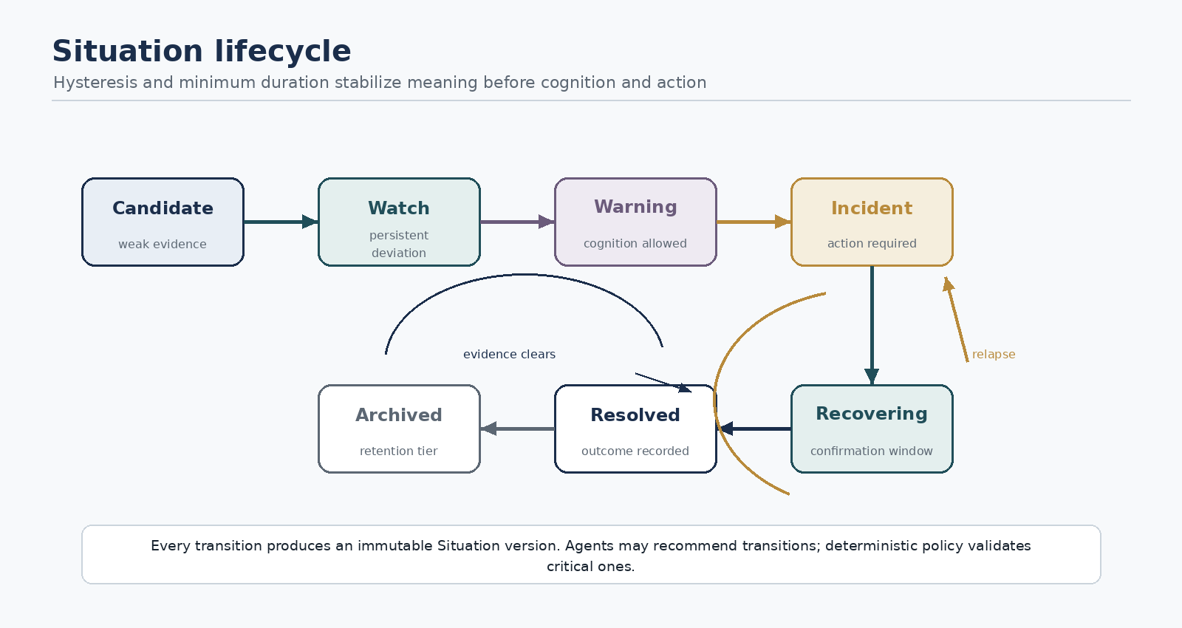
Figure 3. Recommended Situation lifecycle.
Recommended lifecycle:
- candidate — weak signal; state retained, no external visibility required.
- watch — persistent deviation; low-cost monitoring or local model.
- warning — meaningful risk; agent episode allowed.
- incident — action or human coordination required.
- recovering — intervention occurred; confirmation window active.
- resolved — exit criteria met and outcome recorded.
- archived — retention policy moved it from active state.
Transitions are domain-defined and should include hysteresis and minimum duration. An agent may recommend a transition, but critical transitions should be validated by deterministic policy.

8.3 Situation contract
Field group | Required content
Identity | tenant, situation ID, type, entity key, version
Time | first event, latest event, watermark, decision horizon, validity
Lifecycle | phase, severity, status, previous phase
Interpretation | concise summary, hypotheses, confidence, uncertainty
Evidence | references, features, contradictions, data-quality flags
Context | baselines, related entities, previous incidents
Cognition | last episode, last reasoned version, cooldown, priority
Action | active intents, commands, approvals, outcome state
Provenance | reducer, operator, model, prompt, policy, schema versions

The concise summary is a projection. Structured fields and evidence references remain authoritative.

8.4 Situation reducers
Reducers must be explicit per field:
- append with bounded retention;
- set union by evidence ID;
- latest by event time;
- maximum severity with controlled decay;
- Bayesian or weighted confidence update;
- state-machine transition;
- human override;
- replace only if source priority is higher;
- merge related sub-situations.
This follows the same principle as field-specific reducers in durable agent state, but applies it to temporal domain truth.

8.5 Situation graphs
Some domains require relationships:
- machine → production line → factory;
- account → device → IP address → merchant;
- service → dependency → region;
- patient → device → medication → care team.
The first version should keep a keyed Situation model and allow explicit related IDs. A full graph engine can come later. Early graph complexity would distract from event-time and cognition semantics.
ARCHITECTURE STUDY

9. Cognitive scheduling

9.1 Why the scheduler is a product, not a queue
An ordinary task queue asks, “Which pending task runs next?” The cognitive scheduler asks:
- Is reasoning required at all?
- Which model tier is sufficient?
- Is the Situation stable enough to reason about?
- Has a newer version made the request obsolete?
- Can several changes be coalesced?
- What is the value of this decision relative to its cost?
- What happens when model capacity is unavailable?
This logic is central to the runtime’s value.

9.2 Trigger types
Triggers can be combined:
- threshold crossing;
- duration above or below condition;
- trend break or change point;
- anomaly score;
- forecast crossing a future risk boundary;
- correlation or sequence pattern;
- novelty relative to last reasoned version;
- contradiction between models or evidence;
- uncertainty above a decision threshold;
- missing expected event;
- scheduled review;
- human request;
- outcome mismatch;
- policy escalation.

9.3 Trigger policy
A trigger should produce a score and reasons, not a Boolean only:
priority = expected impact × urgency × uncertainty value × novelty ÷ estimated cognitive cost
The exact formula is domain-specific, but the factors should be inspectable.

9.4 Debounce, hysteresis, and coalescing
Without temporal dampening, a noisy boundary can start many contradictory episodes. The scheduler needs:
- debounce: wait briefly for a burst to settle;
- hysteresis: require a stronger condition to enter than to remain;
- cooldown: suppress repeated reasoning after a recent decision;
- coalescing: combine several compatible Situation versions;
- supersession: cancel an episode whose snapshot is no longer current;
- minimum meaningful delta: ignore changes that do not alter likely action;
- confirmation trigger: reason provisionally, then verify after watermark.

9.5 Overload modes
When cognitive capacity is constrained:
- preserve deterministic safety processing;
- reject or defer low-impact episodes;
- coalesce by entity and Situation;
- use a smaller model for classification;
- reduce retrieval and tool budgets;
- send notification-only outcomes;
- keep durable backlog with expiration;
- surface dropped or expired cognitive opportunities as metrics.
Raw evidence should continue to be retained even when cognition is degraded.

9.6 Cognitive service-level objectives
Useful SLOs include:
- time from event horizon to Situation update;
- time from trigger to episode start;
- time from trigger to validated decision;
- percentage of episodes superseded before completion;
- percentage of situations that trigger unnecessarily;
- queue age by severity;
- token and currency cost per resolved Situation;
- percentage of decisions made with provisional evidence.
ARCHITECTURE STUDY

10. Agent episode runtime

10.1 Episode contract
Field group | Content
Identity | episode ID, Situation ID/version, trigger ID
Objective | decision question and expected output
Snapshot | immutable context reference and evidence horizon
Budgets | deadline, tokens, tools, retries, cost
Capabilities | read tools, proposal types, prohibited operations
Policy | model tier, verification rule, human-approval rule
Cancellation | supersession key and cancellation channel
Trace | correlation, deployment, model, prompt, tool versions

10.2 Episode phases
A robust default episode is:
- validate snapshot and objective;
- classify whether deterministic resolution is possible;
- form or update hypotheses;
- request only necessary evidence through typed tools;
- evaluate alternatives and uncertainty;
- produce a structured decision;
- run independent validation for high-risk decisions;
- emit Action Intents or no_action;
- terminate with a named state.
The agent does not remain alive waiting for the next sensor event. A later meaningful change creates a new episode.

10.3 Tools
Read tools should include:
- query features over a bounded time range;
- compare with baseline or peer cohort;
- retrieve raw evidence by ID;
- run a forecast or anomaly model;
- retrieve manuals, procedures, and prior incidents;
- inspect related Situations;
- estimate action impact;
- request human input.
Write tools should be limited to producing typed Intents, annotations, or requests. Direct actuator access violates the trust boundary.

10.4 Model escalation ladder
Use the cheapest reliable technique:
- deterministic rule or lookup;
- statistical detector or control chart;
- specialized classifier, anomaly model, or time-series foundation model;
- compact language model for classification or summarization;
- full agent with retrieval and tools;
- multi-model or human review for high stakes.
Chronos, TimesFM, and Moirai illustrate why forecasting should be a pluggable time-series tool, not simulated by a general LLM. The agent interprets forecasts in domain context and decides what additional evidence or action is appropriate.

10.5 Existing frameworks as adapters
The runtime should define a narrow executor interface so an episode can run through:
- native direct-model executor;
- LangGraph graph;
- OpenClaw runtime;
- Hermes Agent task;
- Temporal workflow;
- remote agent service.
This preserves ecosystem compatibility without importing another framework’s thread or memory semantics into the stream core.

10.6 Non-determinism
Episode output is not deterministic even with a fixed prompt. Therefore the audit record must preserve:
- model provider and exact model identifier;
- sampling and reasoning parameters;
- system and task prompt versions;
- input snapshot hash;
- tool schemas and results;
- retrieved document identities and versions;
- raw structured output;
- validation and repair steps;
- final accepted decision.
Replay can then choose recorded output or re-execution.
ARCHITECTURE STUDY

11. Memory and context

11.1 Five memory layers
Layer | Purpose | Retention
Event log | Raw and normalized evidence | Policy-based, append-only
Feature state | Windows, aggregates, baselines, timers | Operational
Situation store | Current and versioned semantic state | Long-lived
Episode ledger | Prompts, tools, decisions, terminal states | Audit
Knowledge store | Manuals, incident patterns, approved lessons | Curated

These layers must not collapse into a chat transcript.

11.2 Context projection
The prompt projection should contain:
- the current Situation version;
- the delta since last reasoned version;
- a small multi-resolution feature summary;
- top evidence and contradictions;
- relevant prior decisions and outcomes;
- policy and tool capabilities.
Context assembly should be deterministic and versioned. Any model-generated summary must carry evidence references and may be regenerated.

11.3 Long-term learning
The runtime may propose lessons such as:
- a recurring sensor combination predicts a specific failure;
- a trigger is too sensitive;
- one action works better under certain conditions;
- a manual section is frequently relevant.
However, production memory and policy should change through a governed promotion flow:
outcomes → candidate lesson → offline validation → human/automated review → versioned knowledge release
Self-improvement should not silently rewrite live control policy.

11.4 Data retention
Retention should vary by layer and classification. Raw high-frequency evidence may be tiered to object storage while derived features and decision evidence remain online. Deletion must account for legal, safety, privacy, and reproducibility needs.
ARCHITECTURE STUDY

12. Correctness and failure semantics

12.1 Processing guarantees
The system should state guarantees per boundary:
Boundary | Recommended semantics
Broker to stream state | Exactly-once state effect where supported; otherwise at-least-once plus deduplication
Situation publication | Transactional with state update or recoverable outbox
Episode request | At-least-once delivery, idempotent by Situation version and trigger
Model invocation | May repeat; ledger prevents multiple accepted decisions
Intent creation | Idempotent by decision and intent identity
Command dispatch | Transactional outbox; idempotency key
Physical effect | Provider-specific; reconcile rather than promise universal exactly once

Flink correctly distinguishes exactly-once state semantics from end-to-end effects: replayable sources and transactional or idempotent sinks are required for end-to-end guarantees. The same caution is essential here because an LLM API call or physical actuator cannot be rolled back with an operator checkpoint.

12.2 Inbox and outbox
Each boundary that crosses from durable state to external work should use:
- an inbox to record received identity and status;
- a state transition;
- an outbox record created atomically with the state change;
- a dispatcher that retries safely;
- an outcome or reconciliation event.
This prevents “state says sent, message missing” and “message sent twice, state missing” failure gaps.

12.3 Supersession
Every episode and intent references a Situation version. Before accepting a decision or applying an action, the runtime compares it with the current version:
- unchanged: continue;
- compatible newer version: revalidate against delta;
- materially superseded: cancel or reject;
- resolved: close as stale;
- escalated: start higher-priority episode.
Supersession is more appropriate than letting concurrent agents race to update shared state.

12.4 Recovery
After restart:
- restore stream offsets and state checkpoint;
- restore timers and watermark state;
- rebuild materialized Situation views if needed;
- resume or reissue pending episodes from the ledger;
- reconcile approved but incomplete commands;
- never blindly repeat an external action;
- emit a recovery audit event.

12.5 Schema evolution
Every event and contract includes a schema version. Compatibility rules should be tested in CI:
- additive optional fields are generally safe;
- semantic changes require a new event type or major version;
- unit changes require explicit conversion;
- reducers must declare supported versions;
- replay must be able to use historical decoders.
AsyncAPI can document channels and messages; CloudEvents can supply the portable envelope. Neither replaces domain schema governance.
ARCHITECTURE STUDY

13. Backpressure and resource control

13.1 Three pressure domains
- Transport pressure: producer rate versus broker and consumer capacity.
- State pressure: key cardinality, window retention, timers, and checkpoint size.
- Cognitive pressure: episode arrival versus model/tool capacity and budget.
Each needs independent metrics and controls.

13.2 Stream-plane controls
- bounded queues and non-blocking backpressure;
- partition lag measurement;
- per-key hot-spot detection;
- batching where latency allows;
- load shedding only through explicit policy;
- state TTL and tiering;
- checkpoint tuning;
- isolated dead-letter/quarantine paths.

13.3 Cognitive-plane controls
- tenant and Situation quotas;
- priority queues;
- maximum in-flight episodes per entity;
- episode expiration;
- coalescing and cancellation;
- model-tier routing;
- circuit breakers around providers and tools;
- cost budgets;
- admission decisions recorded as events.

13.4 Slow streams
Slow streams can create large timer and idle-state populations even with low throughput. The runtime must optimize for:
- millions of mostly idle keys;
- sparse updates;
- long windows;
- durable scheduled timers;
- efficient cold-state tiering;
- wake-on-change behavior;
- heartbeat and expected-event models.
Throughput is not the only scaling dimension; active state cardinality often dominates.
ARCHITECTURE STUDY

14. Safety, security, and governance

14.1 Trust boundaries
Treat all incoming event content as untrusted, even when it originates from an internal sensor. A compromised device can inject text, malformed values, adversarial patterns, or false timestamps.
Trust zones:
- ingress normalization;
- deterministic stream core;
- model/context zone;
- action policy zone;
- effector credentials;
- human approval surface.
Models should receive normalized typed fields, not uncontrolled instructions hidden in sensor metadata.

14.2 Capability security
Each episode receives a short-lived capability set:
- allowed tools;
- permitted entity and time ranges;
- maximum query volume;
- allowed intent types;
- data-classification boundary;
- expiry;
- tenant identity.
Effectors use separate narrow credentials. Model workers never receive general broker, cloud, or actuator credentials.

14.3 Action risk classes
Class | Example | Default policy
R0 observe | Query state or evidence | Automatic
R1 inform | Notification or ticket draft | Automatic with rate limits
R2 reversible | Adjust non-critical setpoint within safe envelope | Policy validation; optional approval
R3 consequential | Stop production line, block account | Human approval or pre-approved deterministic rule
R4 safety/regulated | Medical dose, emergency control, financial transfer | External certified control; agent advisory only

14.4 Prompt injection and data poisoning
Mitigations:
- strict schema and field typing;
- content/non-instruction separation;
- allowlisted retrieval sources;
- provenance and source reputation;
- cross-sensor confirmation;
- anomaly detection on device behavior;
- immutable prompt policy;
- independent decision validation;
- never using free-form event text as a system instruction.

14.5 Audit and observability
Use OpenTelemetry traces across producer, consumer, Situation update, episode, tool, decision, policy, command, and outcome. Preserve causal links even when asynchronous messaging makes a single parent-child trace insufficient. Metrics should include data freshness, watermark lag, late-event rate, state size, trigger reasons, episode cost, supersession, policy rejection, duplicate suppression, and action reconciliation.
OpenLineage-style metadata is useful for tracing which datasets, operator versions, and model artifacts produced a decision.
ARCHITECTURE STUDY

15. Replay and evaluation

15.1 Replay modes
The runtime should support four modes:
- Deterministic replay: re-run normalization, operators, and Situation reducers with actions disabled.
- Recorded-cognition replay: reuse captured model/tool outputs to reproduce the accepted decision path.
- Live-model shadow replay: invoke a new model, prompt, or policy on historical Situations without effects.
- Counterfactual action replay: compare proposed actions with recorded outcomes or a simulator.

15.2 Why recorded cognition matters
Re-running the same model is not a deterministic replay. Provider models change, tool data changes, and sampling varies. A faithful incident reproduction uses recorded outputs. A comparative experiment deliberately re-executes.

15.3 Evaluation dimensions
Layer | Measures
Ingress | validation rate, duplicate rate, clock skew, missing fields
Stream | throughput, lag, state size, recovery time, late corrections
Situation | detection precision/recall, time-to-situation, phase stability
Trigger | useful wake-up rate, missed cognition, coalescing ratio
Episode | latency, token/tool cost, evidence use, uncertainty calibration
Decision | factuality, policy compliance, utility, human acceptance
Action | duplicate effects, completion, reversal, safety incidents
Outcome | resolution time, avoided loss, energy/maintenance savings

15.4 Golden stream scenarios
The repository should include deterministic fixtures:
- ordered normal data;
- bounded out-of-order data;
- late correction after provisional decision;
- duplicate events;
- missing heartbeat;
- burst overload;
- hot key;
- provider outage;
- tool timeout;
- episode supersession;
- crash between intent and command;
- replay with actions disabled;
- schema upgrade.
The compatibility suite is one of the most valuable open-source assets.
ARCHITECTURE STUDY

16. Deployment architecture
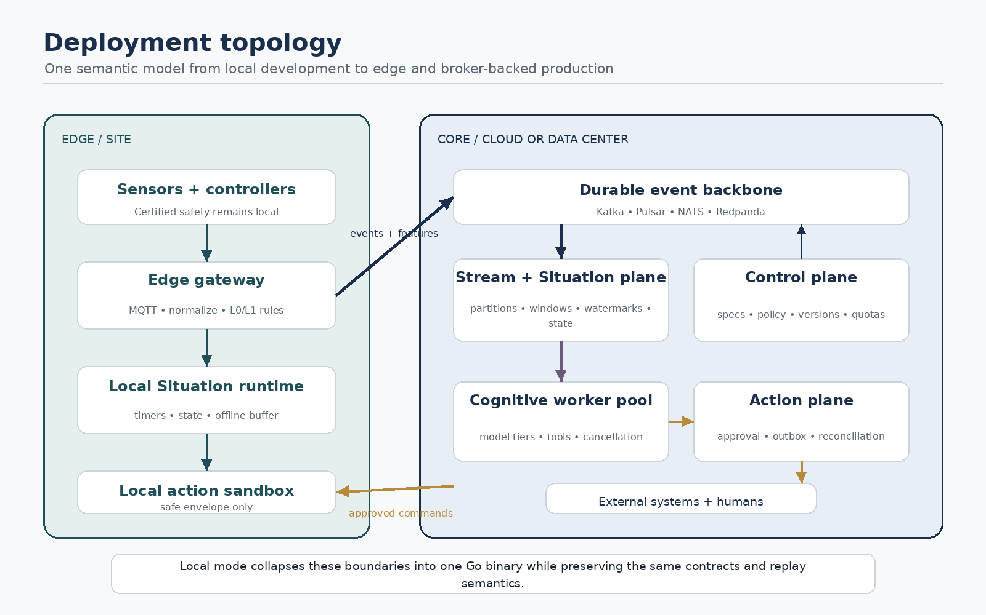
Figure 4. Local, edge, and broker-backed deployment topology.

16.1 Local mode
One binary provides:
- embedded log;
- connectors;
- single-node stream operators;
- durable state;
- scheduler;
- replay CLI;
- action sandbox;
- local dashboard API.
Model workers run in separate processes. This mode supports development, home automation, lab sensors, and small installations.

16.2 Edge mode
An edge gateway handles MQTT, normalization, low-latency rules, compact features, local Situation state, and offline buffering. Only meaningful features or Situations travel to the cloud. Critical safety stays in local certified control.
The edge can use a local model for L2 cognition and escalate complex episodes when connectivity returns.

16.3 Broker-backed mode
The runtime uses Kafka, Pulsar, NATS JetStream, or Redpanda for durable input/output. Situation partitions are assigned by entity key. Stateless connectors and cognitive workers scale independently.

16.4 External stream-engine mode
Flink or Kafka Streams computes features and may maintain Situations. The project supplies:
- schema contracts;
- Situation reducer libraries;
- cognitive-trigger operator or connector;
- episode scheduler;
- action plane;
- replay and audit conventions.
This avoids competing with mature distributed stream engines while preserving the project’s semantic model.

16.5 Partitioning
Partition by the identity that requires serial Situation updates. Cross-entity relationships use derived streams, explicit joins, or higher-level aggregate Situations. Global locks should be avoided.
Hot entities may need sub-key aggregation followed by a single ordered reducer. Repartitioning must preserve state migration and Situation version order.
ARCHITECTURE STUDY

17. Recommended implementation strategy

17.1 Language choice
Option | Strengths | Risks | Role
Go | Concurrency, single binary, broker clients, operational simplicity, strong fit with Ghassan’s Go work | Smaller AI-model ecosystem | Recommended core and CLI
Python | Agent and ML ecosystem, fast experiments | Hot-path performance and packaging | Model workers and SDK
Java/Kotlin | Best Flink/Kafka affinity, mature stream libraries | Heavier local distribution | Later stream-engine adapter
Rust | Excellent safety and performance | Slower contributor onboarding | Optional edge/high-performance components
Ruby | Elegant DSL and Ghassan’s possible framework work | Limited streaming/ML ecosystem | Optional SDK, not initial runtime core

Recommendation: Go core plus Python worker protocol, with contracts independent of language.

17.2 Do not build Flink
Version 1 needs correct single-node semantics, not distributed claims. Implement:
- keyed event-time state;
- watermarks;
- a small set of windows;
- timers;
- deterministic reducers;
- durable checkpoints;
- append-only replay;
- clear processing guarantees.
For large distributed jobs, adapt to Flink or Kafka Streams.

17.3 Process boundaries
Keep these boundaries explicit even in a modular monolith:
- connectors;
- log;
- operator runtime;
- state store;
- Situation engine;
- cognitive scheduler;
- episode executor;
- model provider;
- tool gateway;
- policy engine;
- action dispatcher;
- audit/telemetry.
Model execution should be process-isolated so Python dependencies, crashes, GPUs, and provider SDKs cannot destabilize the stream core.

17.4 Storage
The first release can use:
- embedded append-only log for events;
- embedded transactional key-value store for operator and Situation state;
- object/file storage for large evidence;
- relational metadata for deployments and policy;
- optional vector index only for curated knowledge.
Do not use a vector database as the primary memory model.

17.5 Protocols and standards
- CloudEvents-compatible envelope for interoperability;
- JSON Schema or Protobuf for payload contracts;
- AsyncAPI for channel documentation;
- OpenTelemetry for traces, metrics, and logs;
- MCP only for typed tools, not for the streaming transport;
- optional OpenLineage-compatible decision lineage.
MCP is request/tool oriented. It should not be stretched into the event bus.
ARCHITECTURE STUDY

18. Project model and repository structure

18.1 Primary developer artifact: SituationSpec
A developer should define one versioned specification containing:
- input streams and schemas;
- entity key;
- watermark and lateness policy;
- windows and features;
- detectors and model artifacts;
- Situation reducer and lifecycle;
- cognitive triggers and budgets;
- episode executor and output schema;
- action types and risk classes;
- retention, replay, and observability policy.
The same specification should run locally and later map onto external engines.

18.2 Suggested repository
Module | Responsibility
contracts | Event, Situation, Episode, Decision, Intent, Command, Outcome schemas
runtime | Lifecycle, partitions, checkpoints, timers, backpressure
connectors | MQTT, Kafka, Pulsar, NATS, HTTP, file, simulator
operators | Windows, joins, features, detectors
situations | Reducers, lifecycle, provenance
cognition | Triggers, scheduler, admission, budgets
episodes | Executor interface and native loop
models | Provider and time-series model adapters
tools | Evidence queries and controlled integrations
actions | Policy, approvals, outbox, effectors, reconciliation
replay | Deterministic, recorded, shadow, counterfactual modes
telemetry | OpenTelemetry and audit events
sdk | Go and Python authoring SDKs
examples | Predictive maintenance, smart building, incident response
specs | Architecture decisions and semantic RFCs

18.3 CLI experience
The CLI should prioritize architecture visibility:
- validate a SituationSpec;
- run locally;
- publish simulated events;
- inspect entity and Situation state;
- explain why cognition did or did not trigger;
- replay a time range;
- compare two agent/policy versions;
- approve or reject an Intent;
- inspect decision lineage;
- export an AsyncAPI description.
“Explain why the agent did not wake” is as important as “show what the agent did.”

18.4 License and governance
Apache-2.0 is the recommended license for an infrastructure project because it is permissive and includes an explicit patent grant. Use:
- public RFCs for semantic changes;
- semantic versioning for contracts;
- architecture decision records;
- a compatibility test suite;
- documented security model;
- contributor-friendly local mode;
- no required cloud service.
Avoid an open-core split until the core semantics and community are established.
ARCHITECTURE STUDY

19. MVP use case: predictive maintenance

19.1 Why this is the right first example
Predictive maintenance demonstrates:
- multiple sensor types;
- multi-resolution windows;
- slow drift and sudden anomalies;
- missing data;
- correlated evidence;
- domain retrieval;
- safe, non-physical actions;
- human approval;
- measurable outcomes;
- replay with a simulator.

19.2 Scenario
A simulated motor emits temperature, vibration, current, rotation speed, and heartbeat events. Maintenance records and operating mode changes arrive on separate streams.
Deterministic operators compute:
- vibration RMS and kurtosis;
- temperature slope;
- current deviation by operating mode;
- correlation across signals;
- peer and historical baselines;
- missing-heartbeat duration.
The Situation engine maintains bearing_degradation and sensor_health Situations separately. A cognitive trigger starts an episode only when evidence persists, multiple features agree, uncertainty is high, or maintenance urgency changes.
The agent can:
- retrieve relevant manual sections;
- inspect prior incidents;
- compare hypotheses such as bearing wear, overload, misalignment, or sensor failure;
- propose inspection steps;
- draft a maintenance ticket;
- recommend operating limits.
It cannot stop the machine. A deterministic safety system remains responsible for emergency shutdown.

19.3 Acceptance criteria
The MVP is credible when it can:
- correctly handle a deliberately out-of-order trace;
- revise a provisional Situation after late evidence;
- detect missing heartbeat without a new event;
- avoid repeated episodes during noisy oscillation;
- cancel an episode after material supersession;
- prevent duplicate ticket creation after crash/replay;
- reproduce a decision using recorded cognition;
- compare a new prompt/model in shadow mode;
- explain every Situation field through provenance;
- run locally with one command.
ARCHITECTURE STUDY

20. Additional reference use cases

20.1 Smart building and energy
Slow streams from temperature, humidity, CO₂, occupancy, weather, and energy meters create Situations such as ventilation inefficiency, mold risk, abnormal night consumption, or equipment degradation. The action plane may recommend schedules or create facility tickets. This is an excellent second demo because silence, seasonality, long windows, and low event rates matter.

20.2 Production incident response
Logs, metrics, traces, deploy events, feature flags, and dependency health create service Situations. Deterministic operators recognize SLO burn, correlated failures, and change points. The agent retrieves runbooks and change history, proposes a diagnosis and rollback, while policy controls execution.

20.3 Fraud and account risk
Transactions, devices, locations, identity signals, and historical behavior create account Situations. Fast rules can block known attacks; cognition handles ambiguous cases. Strong versioning and stale-decision checks are essential because new transactions continue during reasoning.

20.4 Logistics
Vehicle telemetry, route progress, weather, warehouse events, and delivery commitments create shipment Situations. Agents reason about exceptions and propose rerouting or customer communication; deterministic systems retain control of safety and dispatch constraints.

20.5 Healthcare monitoring
The architecture can support advisory monitoring, but healthcare is not a suitable first autonomous demo. Clinical decisions require validated models, regulated data handling, explicit human authority, and domain-specific safety cases. The agent should remain advisory unless deployed inside an approved medical system.
ARCHITECTURE STUDY

21. Risks and design traps

21.1 Calling the agent for each event
This is the most likely naive design. It creates runaway cost, backlogs, repeated context, and contradictory actions. Use situations and cognitive triggers.

21.2 Treating the broker as the architecture
Kafka or Pulsar solves transport and durability, not temporal interpretation, cognition admission, context projection, or action safety.

21.3 Hiding lateness
If the agent cannot see whether evidence is provisional or corrected, it may overstate confidence. Completeness belongs in the Situation contract.

21.4 Letting model output mutate state directly
Direct writes make replay, validation, and provenance weak. Accept a typed decision, validate it, then apply a deterministic reducer or policy.

21.5 Mixing continuous and reasoning loops
An agent waiting indefinitely for events becomes hard to checkpoint, upgrade, cancel, and budget. Keep the stream loop continuous and episodes finite.

21.6 Exactly-once marketing
Exactly-once stream state does not make email, tickets, payments, or physical actions exactly once. Use idempotency and reconciliation, and document limits.

21.7 Oscillation
Noisy evidence can cause repeated phase and action reversals. Use hysteresis, minimum duration, cooldown, and action stability policy.

21.8 Context dumping
Putting thousands of readings into a prompt wastes tokens and encourages arithmetic mistakes. Provide computed features and query tools.

21.9 Uncontrolled self-learning
Automatically changing production triggers or policies from one outcome can create drift and unsafe feedback. Promote learned changes through offline evaluation and versioned release.

21.10 Rebuilding too much infrastructure
A new distributed broker, stream engine, vector database, workflow engine, and agent SDK in one repository would be unfinishable. Own the Situation-to-Cognition boundary and integrate the rest.

21.11 Weak open-source differentiation
An open Kafka consumer that calls an LLM will be eclipsed by vendor offerings. The project needs explicit semantics, a portable SituationSpec, replay, and a compatibility suite.
ARCHITECTURE STUDY

22. Delivery roadmap

Phase 0 — Semantics and simulator
Duration target: 2–3 weeks.
- Publish architecture RFC and glossary.
- Define versioned contracts.
- Build sensor simulator and golden traces.
- Define event-time, watermark, lateness, supersession, and action semantics.
- Produce a deterministic replay command.
Exit condition: the same trace always creates the same Situation history.

Phase 1 — Single-node useful runtime
Duration target: 6–8 weeks.
- Go modular monolith.
- MQTT plus embedded log.
- keyed state, windows, timers, and checkpoints;
- Situation reducer and lifecycle;
- cognitive scheduler;
- one direct-model executor and Python worker protocol;
- typed evidence tools;
- intent policy and ticket/notification effector;
- OpenTelemetry;
- predictive-maintenance example.
Exit condition: complete local demo with crash recovery and safe replay.

Phase 2 — Production semantics
Duration target: 6–10 weeks.
- Kafka and NATS/Pulsar adapters;
- schema registry integration;
- inbox/outbox and reconciliation;
- multi-tenant quotas;
- approval workflow;
- recorded and live-model replay;
- compatibility suite;
- deployment and model version comparison.
Exit condition: a broker-backed deployment survives restarts and prevents duplicate effects.

Phase 3 — Scale and ecosystem
- partition assignment and distributed workers;
- external Flink/Kafka Streams Situation adapters;
- LangGraph/OpenClaw/Hermes episode executors;
- time-series model adapters;
- edge gateway profile;
- web inspection UI;
- more examples and SDKs.
Exit condition: the same SituationSpec semantics operate across local and external-engine modes.

Phase 4 — Learning and community
- outcome-based evaluation service;
- trigger-policy optimization in shadow mode;
- reusable Situation packs;
- benchmark corpus;
- governance and plugin registry;
- CNCF-style interoperability work if adoption warrants it.
ARCHITECTURE STUDY

23. Project success measures
The project should not measure success by “number of agents” or “events sent to an LLM.” Better measures are:
- percentage of raw events absorbed without cognition;
- trigger precision and missed-important-situation rate;
- time from meaningful evidence to validated Situation;
- time from Situation to useful decision;
- cognitive cost per resolved Situation;
- percentage of episodes superseded;
- duplicate external effects;
- replay reproducibility;
- action acceptance and outcome utility;
- number of brokers and episode engines passing compatibility tests;
- local setup time;
- community-created Situation packs.
A strong runtime makes agents think less often and act more reliably.
ARCHITECTURE STUDY

24. Final recommendation
Build the project, but frame it correctly.
Do not build “LangGraph for sensor messages.” Do not build “OpenClaw connected to MQTT.” Do not build a thin Kafka-to-LLM function. Those approaches preserve the wrong unit of work.
Build an open Situation Runtime for streaming-native agents:
- event-time aware;
- stateful and replayable;
- continuously sensing;
- episodically reasoning;
- model- and broker-neutral;
- explicit about uncertainty and lateness;
- safe by construction around side effects;
- small enough to run locally;
- compatible with mature stream engines at scale.
Its most important innovation is not the agent loop. It is the contract and scheduler between continuous temporal state and bounded cognition.
If executed well, the project can become the missing infrastructure layer between the data-streaming ecosystem and the agent ecosystem: stream processors determine what is happening, agent episodes reason about what it means, and the action plane decides what is allowed to happen next.
ARCHITECTURE STUDY

Appendix A — Core contracts

A.1 Event Envelope
Required concepts:
- stable event identity;
- source and type;
- schema version;
- tenant and entity key;
- event, ingestion, and processing timestamps;
- correlation and causation identities;
- trace context;
- security classification;
- payload and unit metadata;
- original payload reference;
- quality flags.
Use a CloudEvents-compatible envelope while preserving domain-specific fields.

A.2 Feature Event
- feature name and type;
- entity key;
- value and uncertainty;
- window start/end;
- watermark and completeness;
- operator/model artifact and version;
- input evidence references;
- calculation timestamp.

A.3 Situation Snapshot
- immutable Situation ID and version;
- lifecycle, severity, confidence;
- event-time horizon and validity;
- meaningful delta;
- feature summary;
- hypotheses and contradictions;
- evidence references;
- previous decision and outcome;
- policy and action state;
- provenance hash.

A.4 Decision Record
- episode and Situation version;
- decision type;
- facts used;
- inferences;
- uncertainty and alternatives;
- requested evidence;
- Action Intents;
- human-review need;
- validity condition and expiry;
- model/tool trace.

A.5 Action Intent and Command
An Intent describes the desired effect and reasoning. A Command is policy-approved and executable. Both include stable identity, entity target, preconditions, risk class, expiry, and idempotency. Commands additionally include approval and effector route.

A.6 Outcome Event
- command and intent identity;
- execution status;
- provider result;
- observed effect;
- reconciliation status;
- human feedback;
- eventual Situation resolution;
- evaluation labels.
ARCHITECTURE STUDY

Appendix B — Architecture decisions to write first
- ADR-001: Situation is the primary semantic unit.
- ADR-002: Continuous stream loop and episodic agent loop are separate.
- ADR-003: Event time, watermarks, and allowed lateness are explicit.
- ADR-004: Raw evidence is append-only; summaries are projections.
- ADR-005: Agents return typed Decisions and cannot execute effects directly.
- ADR-006: Every episode is version-bound, bounded, cancelable, and terminal.
- ADR-007: Replay has deterministic, recorded, shadow, and counterfactual modes.
- ADR-008: Version 1 is a modular monolith in Go with process-isolated model workers.
- ADR-009: The core is broker-neutral and does not rebuild a distributed stream engine.
- ADR-010: Apache-2.0 license and public compatibility suite.
ARCHITECTURE STUDY

Appendix C — Research basis and sources
Research snapshot: 28 July 2026. The architecture is a synthesis; sources support the capabilities and market observations, not every design recommendation.
- Apache Flink, “Stateful Stream Processing.”
https://nightlies.apache.org/flink/flink-docs-stable/docs/concepts/stateful-stream-processing/
- Apache Flink, “Timely Stream Processing.”
https://nightlies.apache.org/flink/flink-docs-stable/docs/concepts/time/
- Apache Flink, “Fault Tolerance.”
https://nightlies.apache.org/flink/flink-docs-stable/docs/learn-flink/fault_tolerance/
- Apache Beam, “Programming Guide,” especially windows, watermarks, triggers, state, and timers.
https://beam.apache.org/documentation/programming-guide/
- Apache Kafka, “Kafka Streams Core Concepts.”
https://kafka.apache.org/41/streams/core-concepts/
- Apache Kafka, “Configuring a Streams Application,” processing guarantees.
https://kafka.apache.org/40/streams/developer-guide/config-streams/
- Reactive Streams, “Reactive Streams Specification for the JVM.”
https://github.com/reactive-streams/reactive-streams-jvm
- OASIS, “MQTT Version 5.0.”
https://docs.oasis-open.org/mqtt/mqtt/v5.0/mqtt-v5.0.html
- Temporal, “How Temporal Works” and workflow message passing.
https://docs.temporal.io/encyclopedia/architecture/how-temporal-works https://docs.temporal.io/handling-messages
- CloudEvents specification.
https://github.com/cloudevents/spec/blob/main/cloudevents/spec.md
- AsyncAPI Specification 3.1.0.
https://www.asyncapi.com/docs/reference/specification/latest
- OpenTelemetry, messaging semantic conventions.
https://opentelemetry.io/docs/specs/semconv/messaging/
- OpenLineage, project overview.
https://openlineage.io/
- LangChain, “LangGraph Overview.”
https://docs.langchain.com/oss/python/langgraph/overview
- OpenClaw, “Agent Runtime Architecture.”
https://docs.openclaw.ai/agent-runtime-architecture
- Nous Research, “Hermes Agent.”
https://github.com/nousresearch/hermes-agent
- Confluent, “Streaming Agents with Confluent Intelligence.”
https://docs.confluent.io/cloud/current/ai/streaming-agents/overview.html
- StreamNative, “Introducing the StreamNative Agent Engine.”
https://streamnative.io/blog/introducing-the-streamnative-agent-engine
- Apache Pulsar issue 25881, native support for the agent ecosystem.
https://github.com/apache/pulsar/issues/25881
- Ansari et al., “Chronos: Learning the Language of Time Series.”
https://arxiv.org/abs/2403.07815
- Das et al., “A Decoder-Only Foundation Model for Time-Series Forecasting” (TimesFM).
https://arxiv.org/abs/2310.10688
- Liu et al., “Moirai 2.0: When Less Is More for Time Series Forecasting.”
https://arxiv.org/abs/2511.11698
ARCHITECTURE STUDY

Appendix D — Glossary
Cognitive trigger — Policy that decides whether and how a Situation version starts an agent episode.
Command — An approved, executable action with preconditions and idempotency.
Completeness — The runtime’s current belief about whether more relevant events may arrive for a time horizon.
Episode — One bounded, version-specific reasoning execution.
Event time — Time at which the source-domain event occurred.
Feature — A deterministic or model-derived value over bounded evidence.
Intent — A proposed effect that has not yet passed action policy.
Outcome — The observed result of a Command or decision.
Situation — Durable, versioned, evidence-backed semantic state around an entity or relationship.
Situation reducer — Deterministic logic that applies evidence and features to Situation state.
Supersession — Replacement of an episode or decision because a newer Situation version materially changes its validity.
Watermark — Estimate of event-time progress used to reason about completeness and late data.

