**M/M/1**

**The code’s output:**

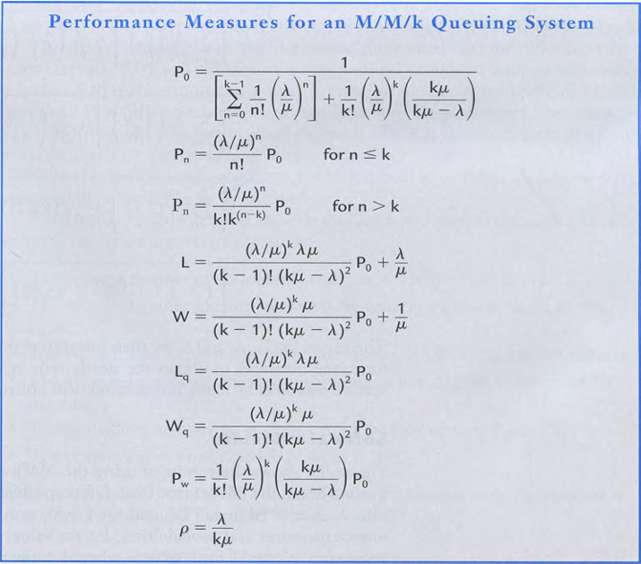**M/M/K**

**From the book** 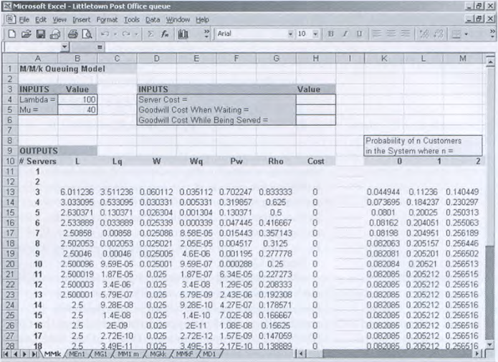

MM1m

