

***King Abdullah II School of Engineering***

***Embedded Systems***

***Dr. Belal Sababha***

***Project Report***

***Ghassan Haddadin 20190410***

***Issam Al-Samardali 20200541***

***Zeina Haddadin 20190238***

**Table of Contents**

Abstract 3

Introduction 3

Components 3

Design 6

Problems and Recommendations 8

Problems 8

Recommendations 8

Conclusion 8

References 9

Source Code 10

**Table of Figures**

Figure 1: PIC16F877A 3

Figure 2: IR Sensor 4

Figure 3: Digital LDR 4

Figure 4: Resistors 4

Figure 5: Traffic Lights 5

Figure 6: DC Power Supply 5

Figure 7: NMOS Transistor 5

Figure 8: DC Motor 6

Figure 9: Schematic Diagram 6

Figure 10: Flowchart 7

Figure 11: Final Prototype 8

**Smart Traffic Lights**

# Abstract

*Street traffic is one of the most common problems faced worldwide. With the rapid increase in population, this problem is only growing. Lights at intersections to control traffic, although reduce accidents, cause congestion to form where it might be unnecessary. The traffic light system can be improved to smartly and efficiently navigate traffic to decrease the effect of this issue on our everyday life.*

# Introduction

This project aims to reduce traffic congestion, improve the road experience, and save a lot of time wasted on the road. This will also increase the efficiency of the public transport system which will further contribute to resolving the issue. Also, this solution will affect the medical and public safety sectors by prioritizing the lanes of ambulances and police vehicles.

Normal traffic lights with fixed time intervals disregard the traffic situation at each intersection. The proposed system provides dynamic time intervals for traffic lights according to the number of vehicles present and the urgency of each lane. More cars will lead to a longer green light time, and in the case of an emergency, the lane will be prioritized over the others.

# Components

1. **PIC16F877A:**

It has a total number of 40 pins, 33 pins of which are for input and output. There are 5 ports (PORTA, PORTB, PORTC, PORTD, and PORTE). Ports A&E are the only ones that can take an analog signal, which means they use an internal ATD converter. The external interrupt is on RB0. There are 2 comparators, 3 timers (TMR0, TMR1, TMR2), and an EEPROM of 256 bytes. It can operate at a voltage between (2-5.5) V.

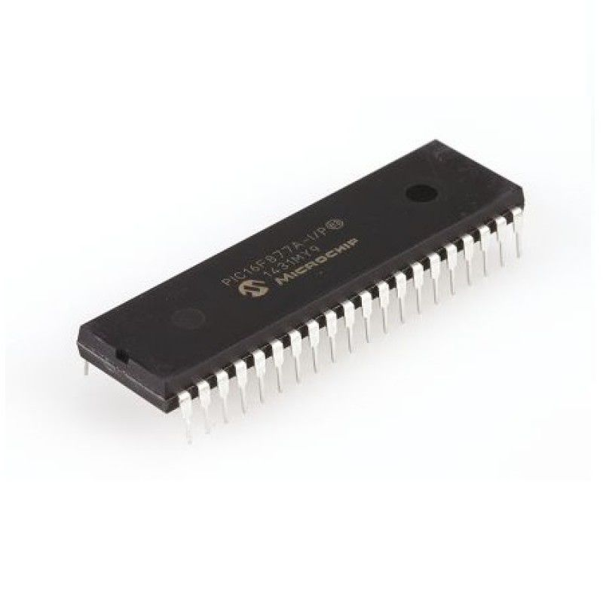

Figure 1: PIC16F877A

1. **IR Sensors:**

An infrared (IR) sensor is an electronic device that detects infrared radiation in its surrounding environment. We used four IR sensors to detect the presence of cars.

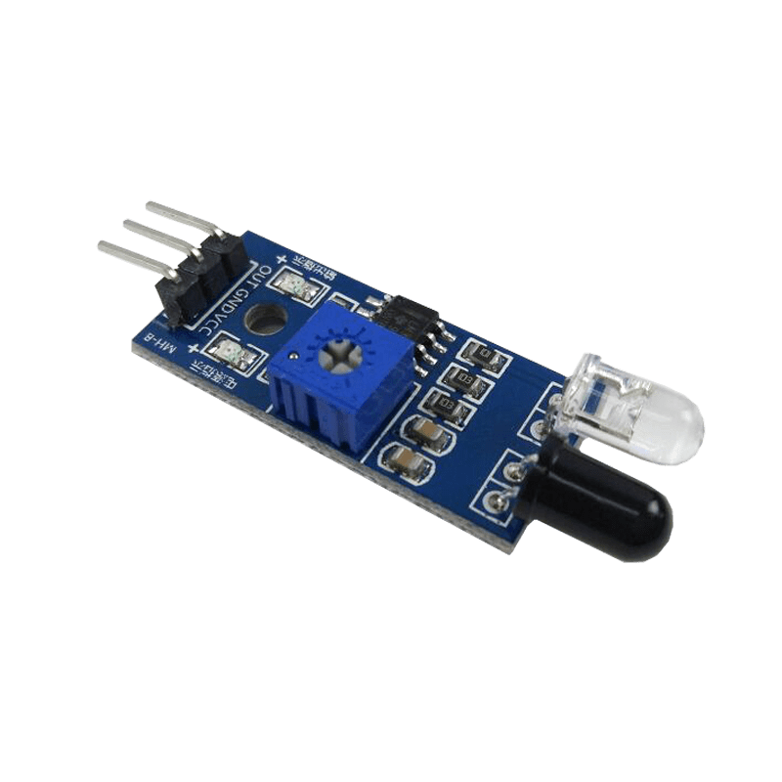

Figure 2: IR Sensor

1. **Digital LDR:**

The Digital LDR Module is used to detect the presence of light / measuring the intensity of light. The output of the module goes high in the presence of light and it becomes low in the absence of light.

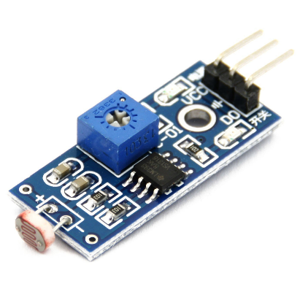

Figure 3: Digital LDR

1. **Resistors:**

350 Ohms resistors were used in the circuit. A 10k Ohms resistor was used with the push button.

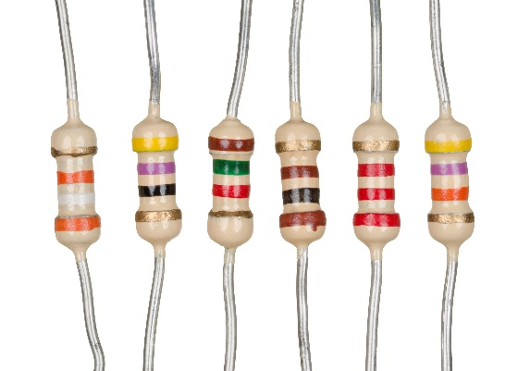

Figure 4: Resistors

1. **Traffic Lights LEDs:**

Voltage: 5 Volts.

Interface: common cathode red yellow green control.

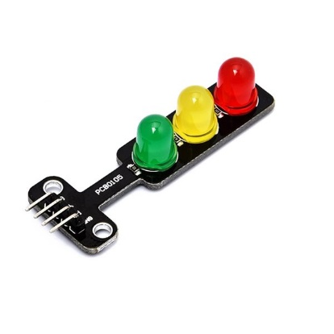

Figure 5: Traffic Lights

1. **DC Power Supply:**

Used as a voltage source.

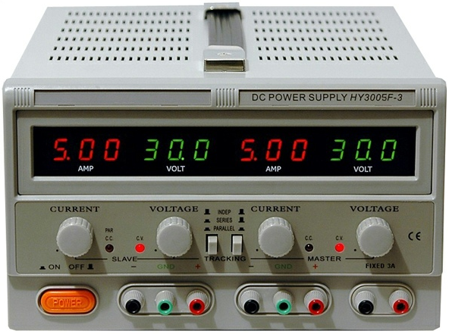

Figure 6: DC Power Supply

1. **NMOS Transistors:**

It has three terminals: gate, source, and drain. The current flowing through one of its terminals can be controlled by the voltage between the other two terminals.

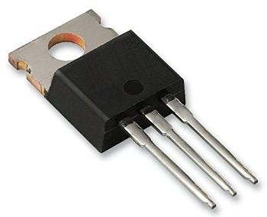

Figure 7: NMOS Transistor

1. **DC Motors:**

It is a type of rotary electrical motor that converts direct current (DC) electrical energy into mechanical energy. We used two DC motors in our project that rotate in the same direction, acting as a crosswalk.

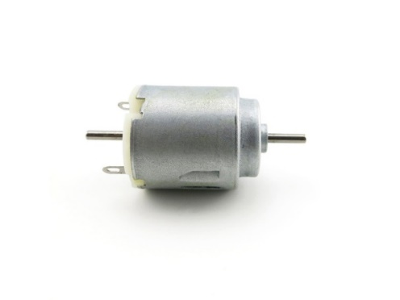

Figure 8: DC Motor

# Design

The infrared and light sensors are mounted on the sidewalk to detect the vehicle on the road. These sensors will sense the presence of a car or a flashing light passing by. The unit generates an output signal for red, green, and yellow signals and monitors their timings taking into consideration the number of vehicles on each road. A schematic diagram was designed using Proteus software as shown below.

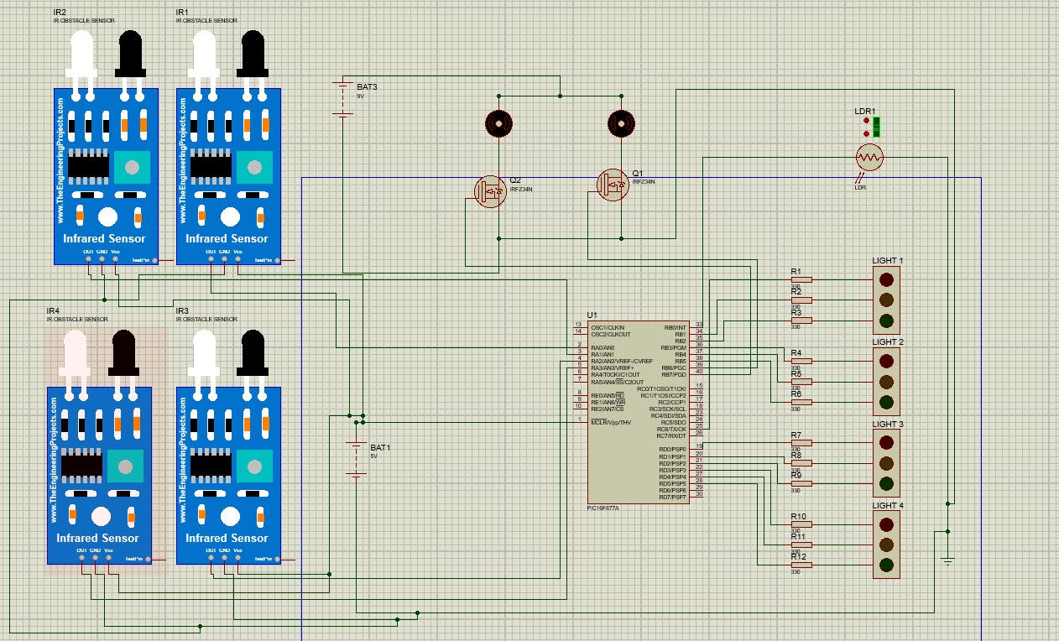

Figure 9: Schematic Diagram

The below flowchart was produced using the code written for programming the PIC16F877A.

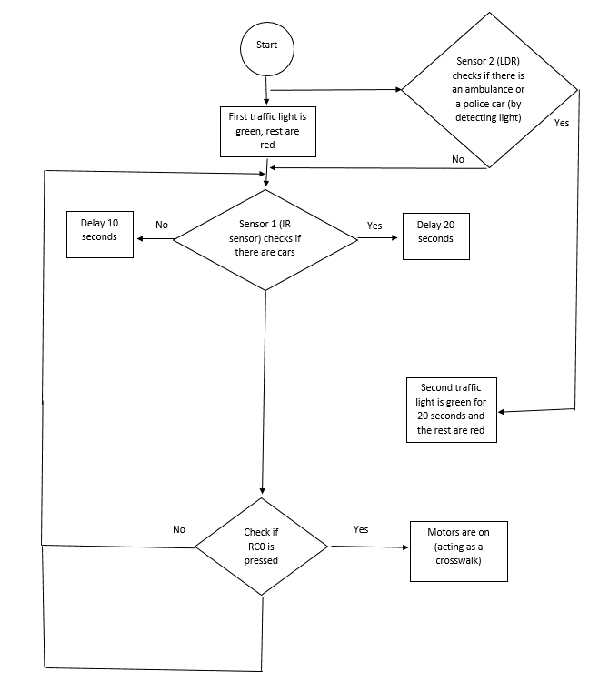

Figure 10: Flowchart

# Problems and Recommendations

## Problems

1. We tried to use the color sensor TCS3200 to detect a blue flashing light coming from the ambulance, but the noise was very high and it couldn't detect it due to the varying frequency range for every color.
2. We replaced it with an LDR to detect the light of the ambulance or a police car.
3. One of the pins on the PIC was broken during the process.
4. The two DC motors acting as a crosswalk were difficult to place on the wood board.

## Recommendations

1. Use a sound sensor instead that is programmed to detect the sirens of the ambulance and/or police car.
2. Could try to use a more accurate color sensor with higher accuracy, and write a code for it with the correct frequency range for the color needed.
3. Replace the broken PIC with a new one.
4. Drill a hole for the motors on the board.

# Conclusion

To conclude, the main purpose of our project is to help avoid congestion and traffic on the road by using IR sensors that detect objects to help speed up the process. A push button was used to help people cross the road safely and efficiently. Also, once there is an emergency, the ambulance or police car will be able to move faster as all other traffic lights on the road will be red except the one that detected the emergency lights, this will enable it to reach its destination on time without any delays. Such a system can be applied in cities like Amman to solve the problem of increased traffic that we have been facing recently due to our growing population.

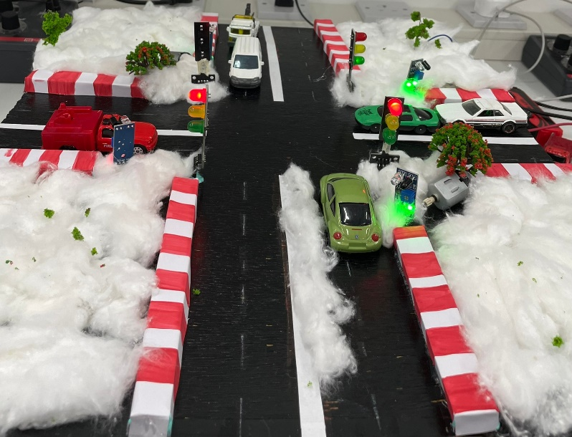

Figure : Final Prototype

# References

1. Utmel. (2021, September 8). PIC16F877A microcontroller: Datasheet, Pinout, and features. Utmel. Retrieved January 17, 2023, from <https://www.utmel.com/components/pic16f877a-microcontroller-datasheet-pinout-and-features?id=522>
2. Jost, D. (2019, July 30). What is an IR sensor? Fierce Electronics. Retrieved January 17, 2023, from <https://www.fierceelectronics.com/sensors/what-ir-sensor>
3. Introduction to NMOS and PMOS transistors. AnySilicon. (2022, July 3). Retrieved January 17, 2023, from <https://anysilicon.com/introduction-to-nmos-and-pmos-transistors/>

# Source Code

void myDelay(unsigned int x);

void myFunction();

unsigned int ctr1;

unsigned int motor;

unsigned int light_time;

void nop_Delay(unsigned int count);

void interrupt(){

if(INTCON & 0x04)// tmr0

{

TMR0=248;

ctr1++;

INTCON = INTCON & 0xFB;

if (PORTC & 0x01 ) //RC0 1st push button

{

motor = 1;

}

if (INTCON & 0x02 ) //RB0 int flag

{

// 1st light:

if (PORTB & 0X04){

asm BCF 0x06,2 // 1st light green off

asm BSF 0x06,1 // 1st light yellow on

nop_Delay(500); /// 1 second delay

asm BCF 0x06,1 // 1st light yellow off

asm BSF 0x07,6 // 1st light red on

} else if (PORTB & 0X02){

asm BCF 0x06,1 // 1st light yellow off

asm BSF 0x07,6 // 1st light red on

}

// 3rd light:

else if (PORTD & 0X04){

asm BCF 0x08,2 // similar to previous light

asm BSF 0x08,1

nop_Delay(500);

asm BCF 0x08,1

asm BSF 0x08,0

} else if (PORTD & 0X02){

asm BCF 0x08,1

asm BSF 0x08,0

}

// 4th light:

else if (PORTD & 0X20){

asm BCF 0x08,5 // similar to previous light

asm BSF 0x08,4

nop_Delay(500);

asm BCF 0x08,4

asm BSF 0x08,3

} else if (PORTD & 0X10){

asm BCF 0x08,4

asm BSF 0x08,3

}

PORTB = 0X20; // 2nd light green on

nop_Delay(6000);

PORTB = 0X10; // 2nd light yellow on

nop_Delay(500);

PORTB = 0X08; // 2nd light red on

INTCON = INTCON & 0xFD;

asm GOTO 0x00

}

}

}

void main() {

ADCON1 = 0x06; // convert all portA to digital

OPTION_REG = 0x87;

TMR0=248;

INTCON =0xB0;

TRISD = 0x00;

TRISB = 0x01; //RB0 Input

PORTB = 0x00 ;

TRISC = 0xA1 ; // 1010 0001 in decimal -- motor PB RC0 --- for color sensor(not accurate)

PORTC = 0x16; // for color sensor(not accurate)

TRISA = 0xFF; // 1111 1111 in decimal.

while(1){

myFunction();

}

}

void myDelay(unsigned int x){

ctr1=0;

while(ctr1<x);

}

void myFunction(){

light_time = 0x02;

while(light_time) {

if(PORTA & 0x02) // RA1 -- true when no cars

{

light_time = 0x00;

}

else

{

light_time -- ; // 0x01

}

PORTB = 0x0C; //Green ON for the 1st & Red ON for the 2nd traffic light.

PORTC = PORTC & 0xBF; // Red off for first

PORTD = 0x09; // Both 2nd & 3rd traffic lights are Red.

myDelay(10000); //means 10s

}

PORTB = 0x0A; // yellow ON for 1st & red ON for 2nd

myDelay(1000);

light_time = 0x02;

while(light_time) {

if(PORTA & 0x04) // RA2 -- true when when no cars

{

light_time = 0x00;

}

else

{

light_time -- ; // 0x01

}

//2nd Case:

PORTB = 0x21; //Second is green

PORTC = PORTC | 0x40; // First is red

PORTD = 0x09; //Both 2nd & 3rd traffic lights are Red.

myDelay(10000);

}

PORTB = 0x11; // 2nd yellow ON

PORTC = PORTC | 0x40; // First is red

myDelay(1000);

light_time = 0x02;

while(light_time) {

if(PORTA & 0x08) // RA3 -- true when no cars

{

light_time = 0x00;

}

else

{

light_time -- ; // 0x02

}

//3rd Case:

PORTB = 0x08; // 2nd is Red

PORTC = PORTC | 0x40; // First is red

PORTD = 0x0C; //3rd is green & 4th is Red

myDelay(10000);

}

PORTD = 0x0A; // 3rd is yellow & 4th is Red.

myDelay(1000);

light_time = 0x02;

while(light_time) {

if(PORTA & 0x10) // RA4 -- true when no cars

{

light_time = 0x00;

}

else

{

light_time -- ; // 0x02

}

//4th case

PORTB = 0x08; //2nd is Red

PORTC = PORTC | 0x40; // First is red

PORTD = 0x21; //4th is green & 3rd is Red

myDelay(10000);

}

PORTD = 0x11; // 4th is yellow & 3rd is red

myDelay(1000);

PORTD = 0x09; // Both 3rd & 4th traffic lights are Red.

if (motor) //RC0 push button

{

PORTB = PORTB | 0xC8; // both motors are on -- 1st red light is on

myDelay(10000);

motor = 0;

}

}

void nop_Delay(unsigned int count)

{

unsigned int i,j;

for(i=0;i<count;i++)

{

for(j=0;j<500;j++){

j=j;

}

}

}