
Department of CSE

B.Tech. CSE Trimester -5

Roll No:- 2520030213
Name:- G.kevin josh

Cloud Infrastructure and Services
25CS2206E

LAB RECORD
2026

Experiment -2(B)

AIM: Add MFA Authentication to IAM User.

Description:
Multi-Factor Authentication (MFA) is a security feature used to protect an AWS account from unauthorized access. It adds an extra layer of protection by requiring a password and a temporary 6-digit verification code generated through an authenticator app. Enabling MFA for the IAM user helps keep the AWS account secure and prevents unauthorized users from accessing important account settings and resources.
Steps:
- Sign in to the AWS Console as the IAM user (your account email and password).
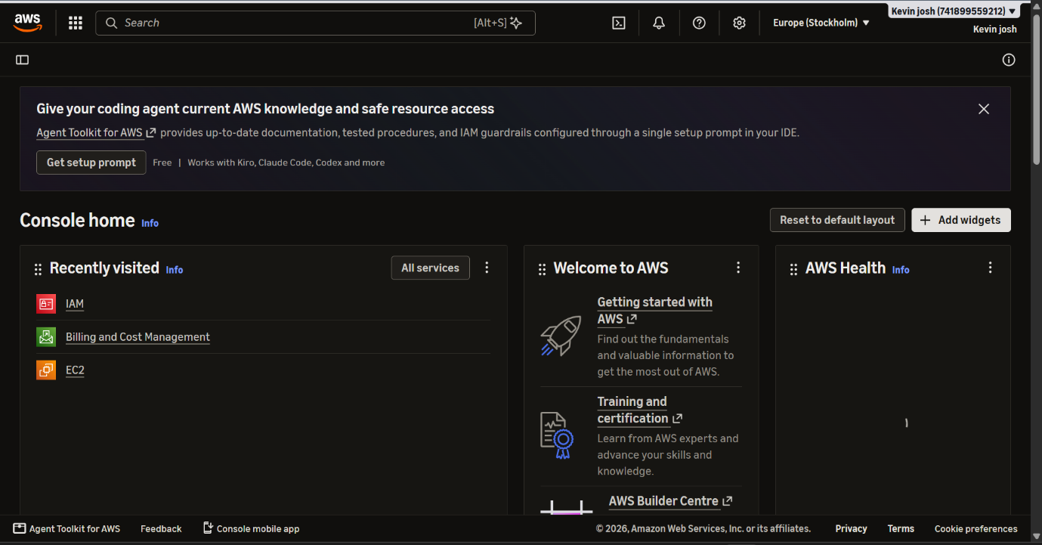
2 Click your account name (top right) → Security credentials.
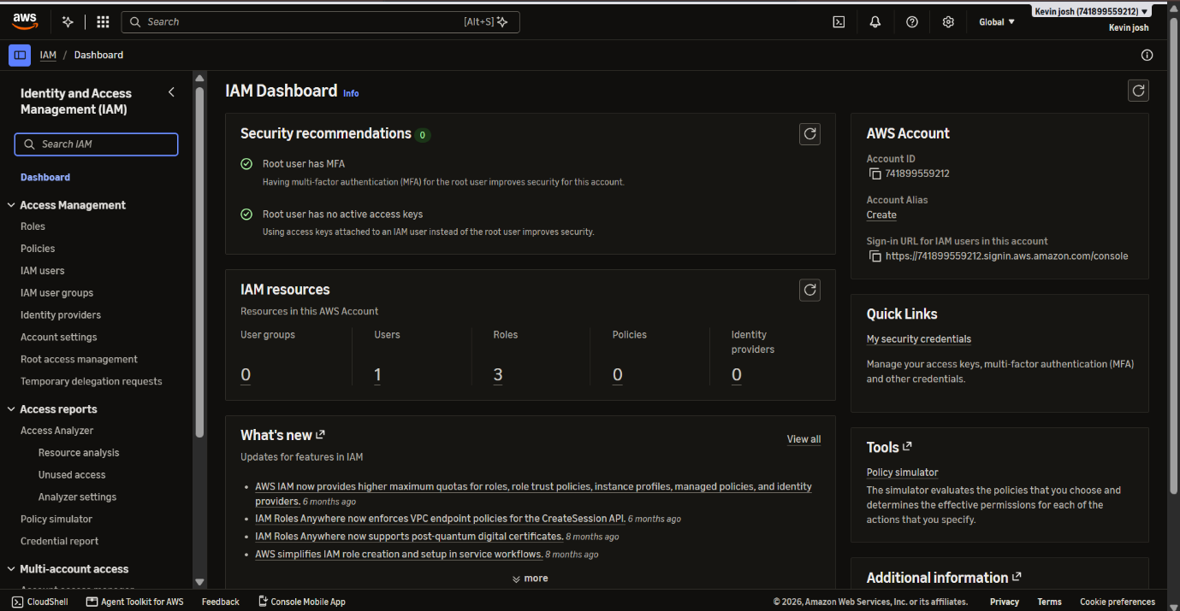

3. Find Multi-factor authentication (MFA) → click Assign MFA device.
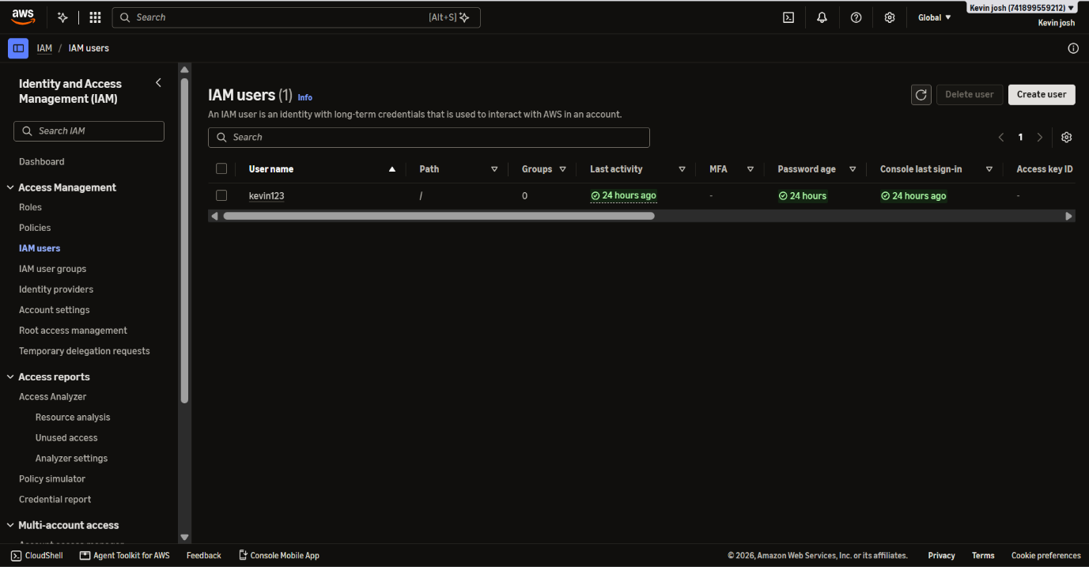
4. Enter a Device name, for example IAM-phone.
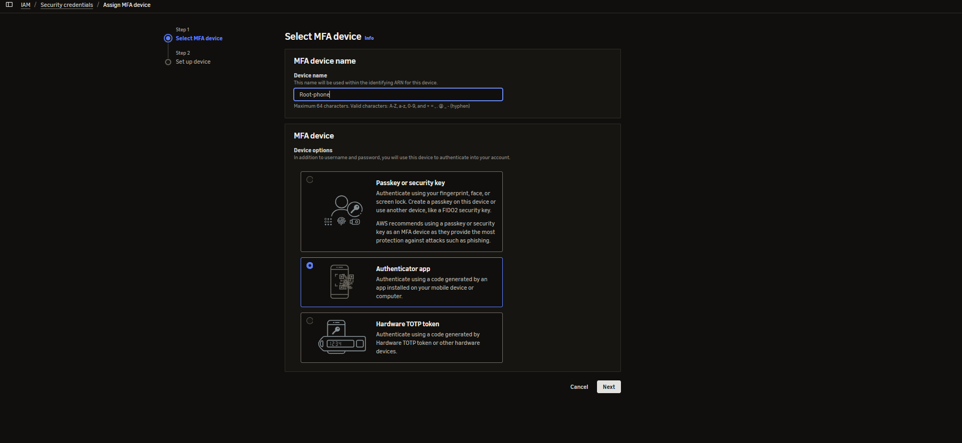
5. Select Authenticator app → click Next.
6. Click Show QR code.
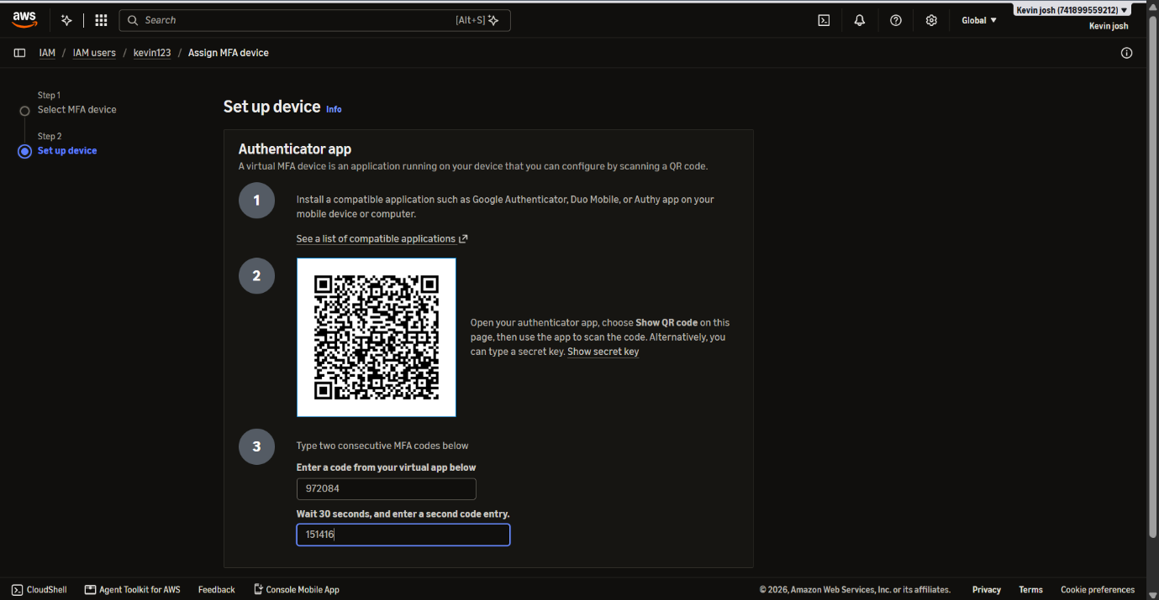
7. On your phone, open the authenticator app → Add account → Scan QR code → scan the code on the screen.
8. The app now shows a 6-digit code that changes every 30 seconds. In AWS, type MFA code 1 with the current code.
9. Wait for the code to change (about 30 seconds), then type the new code in MFA code 2.
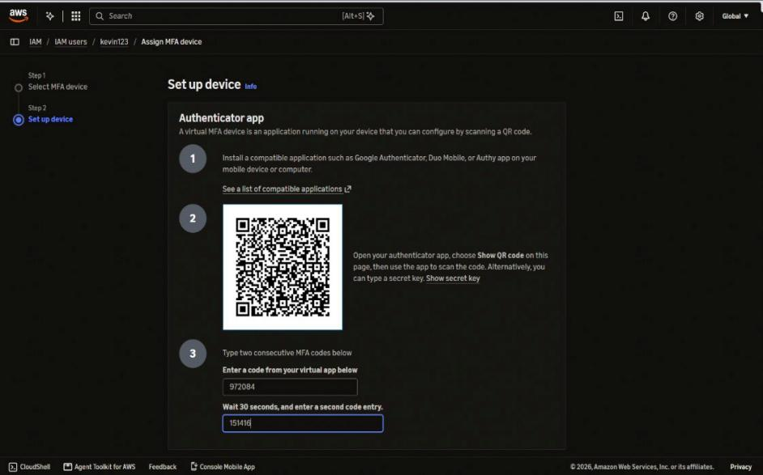
10. Click Add MFA.

Output:


