SANJIVANI COLLEGE OF ENGINEERING,
KOPARGAON
(An autonomous Institute affiliated to SPPU Pune)
Department of Information Technology Academic Year 2025-26 Sem-II

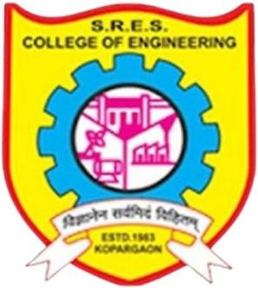

Web Technology Laboratory CIA Case Study
Topic- “Evaluation of Websites”

Roll. No. PRN Name
53 UIT23M1053 Siddharth Ramnath Ghawate

Course Incharge – Dr. Y. S. Deshmukh

1

