Pre-Processing – 2018

# Overview

The quality of skin lesion images taken in labs are crucial to detect a particular type of skin cancer. The ISIC-2018 dataset of dermatoscopic images contain skin lesion images of different classes however, many images contain a lot of noisy artefacts that can hinder performance of any kind of prediction model. This document aims to describe in detail various steps taken to improve image quality by applying various techniques in an attempt to build a robust model.

# Data Description

The ISIC – 2018 training dataset consists of 10,015 dermatoscopic images of skin lesions belonging to different cases of skin cancers. The ground truth of these images is stored in another dataset which consists mapping of these images to their corresponding labels(skin lesion class). There are 7 cases namely :

* MEL - Melanoma
* NV - Melanocytic Nevus
* BCC -  Basal Cell Carcinoma
* AKIEC -  Actinic Keratosis
* BKL - Benign Keratosis Lesion
* DF - Dermatofibroma
* VASC - Vascular Lesions

# Pre- Processing Steps

The goal of the pre-processing is to improve the training data for CNN model by removing undesirable noise and enhancing the images to improve the performance of the model. The following steps were taken in the pre-processing stage:

1. Mapping – Organize images for efficient importing
2. Hair Removal – Eliminate element of noise that might be learned as a feature by model
3. Resizing – Reduces time taken at each epoch of training CNN model.
4. Cropping – Avoid unwanted areas of image(dark corners, ruler marks, normal skin area)
5. Augmentation – Balance the amount of data in each class and increase the training data.
6. Normalization – Ensure each pixel has similar distribution making convergence of CNN faster.

## Step 1: Mapping

With the help of python script all the 10,015 training set images which were contained in a single folder were moved to their respective directories according to the mapping present in the ground-truth dataset. The counts of images in each class after mapping are shown below:

|  |  |
| --- | --- |
| Class | COUNT |
| NV | 6705 |
| MEL | 1113 |
| BKL | 1099 |
| BCC | 514 |
| AKIEC | 327 |
| VASC | 142 |
| DF | 115 |
| Total | 10015 |

## Step 2 : Digital Hair Removal

Artifacts such as hair especially dark coloured hair are the major obstacles for creating a robust model. A CNN model is capable of learning every feature of image given to it as training data. Hair in images is processed as a feature of skin lesion itself resulting in poor model performance.

Hence, it becomes essential to eliminate any such noise. We have implemented the most popular

The following methodology has been employed to tackle this problem:

* As we know any kind of pre-processing/filter reduces the quality of image, hence applying it to all images is not optimal. We tried to find pattern of the presence of hair in different classes, but it turned out that all the classes have significant number of images with hair. Even if a class has a smaller number of images with hair, we cannot ignore them as during augmentation those numbers can increase. Generalizing classes with hair or without hair might result in degrading quality of non-noisy images and leaving some images with hair, unprocessed, thereby affecting the accuracy.
* Therefore, we manually looked at all the 10,015 images and selected the images with dark coloured hair for hair removal. The count of images with hair selected from each class is shown below:

|  |  |
| --- | --- |
| Class | COUNT of IMAGES WITH HAIR |
| NV | 727 |
| MEL | 339 |
| BKL | 215 |
| BCC | 165 |
| AKIEC | 103 |
| VASC | 13 |
| DF | 57 |
| TOTAL | 1619 |

Hence, 16% of images are considered for hair removal processing.

* The techniques used for hair removal is called Dullrazor which is a well-known mechanism for removing hair from dermatoscopic images. The algorithm has been developed after research and is efficient especially for skin cancer images. It performs better on especially dark thick hair as they are the main culprit that confuses the CNN model resulting in unsatisfactory results. The Dullrazor[1] algorithm and its working are described briefly :
  + The hair regions are initially detected through the morphological closing operator on each RGB color channel separately and with three structuring elements having different directions .
  + To generate the binary mask, a thresholding process is applied to the absolute difference between the original color channel and the image generated by the closing .
  + The mask pixels undergo a bilinear interpolation between two nearby not-mask pixels.
  + Finally, to the resulting image, an adaptive median filter is applied.

We have implemented this algorithm in Python using OPENCV library.

* Results after applying the hair removal pre-processing is shown below:

**AKIEC:**

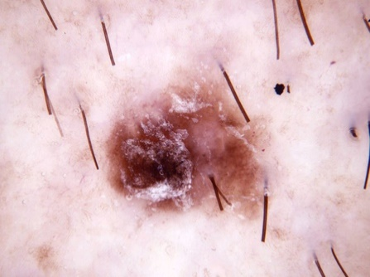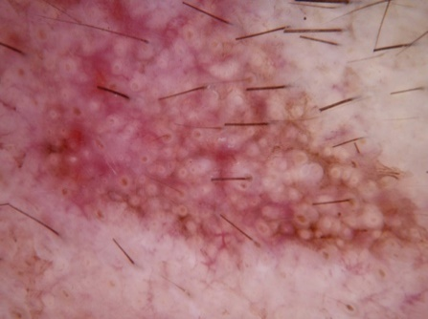

**BCC:**

**BKL:**

**DF:**

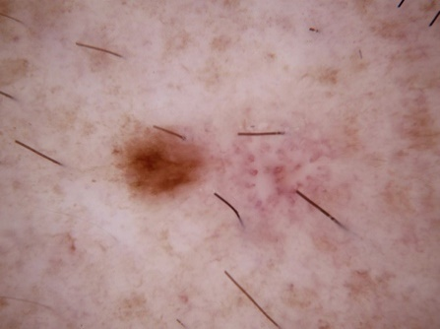

**MEL:**

**NV:**

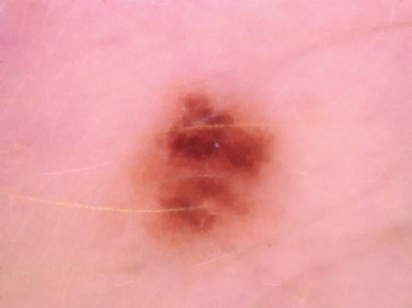

**VASC:**

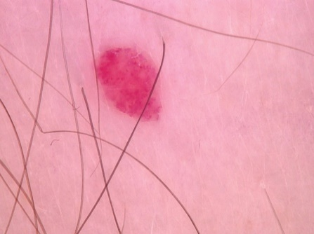

**Note** : Dull razor algorithm does not work efficiently with white or light-coloured hair. But they are automatically handled by the CNN and are not as much a hinderance as compared to dark thick hair.

## Step 3 : Resizing

Resizing images is a critical step in Image pre-processing as CNN models run faster on smaller images. In our dataset all the images have size of 600 x 490. Hence before Image Cropping and Augmentation we have resized all the images to 128 x 128. We consider square dimensions as the Tensor Flow library which we are using to create our model, expects that dimension.

## Step 4 : Image Cropping

Some images have dark borders(Vignette) and Ink/Ruler marks which can affect the training efficiency of the model; hence we need to crop the images to make the lesion prominent. We have followed the following steps:

* Identified the classes which needs the images to be cropped by manually checking the location of the lesion in the images – **BKL, MEL, VASC**.
* According to our observations, we selected the images from each class on which central crop can be applied. We filtered out **124** images from BKL, **194** images from MEL, and **119** images from VASC class.
* We also noticed that 2 images from AKIEC, 2 images from BCC, need to be centrally cropped as they contain ink marks on the sides.

Image Cropping Results:

**BKL**:

MEL:

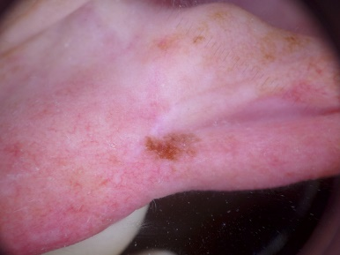 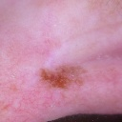

VASC:

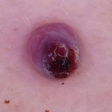

AKIEC:

BCC:

## Step 5 : Augmentation

Augmentation of images is done to deal with the problem of skewed classes ,overfitting, and training image scarcity. As can be seen from the frequency table of classes, the NV class dominates with approximately 67% of images in training data. Hence, to balance the distribution various augmentation techniques are implemented to increase the size of each class. The below table summarizes the Augmentations applied on different classes:

|  |  |  |  |  |  |  |  |  |
| --- | --- | --- | --- | --- | --- | --- | --- | --- |
| Sl. No | 1 | 2 | 3 | 4 | 5 | 7 | 8 |  |
| CLASS | Actinic Keratosis | Basal Cell Carcinoma | Benign Keratosis | Dermatofibroma | Melanoma | Vascular Lesion | Melanocytic Nevus |  |
| Notation | AKIEC | BCC | BKL | DF | MEL | VASC | NV | Total |
| Images before Aug | 327 | 514 | 1099 | 115 | 1113 | 142 | 6705 | 10015 |
| Aug_1 | ShiftScaleRotate. shift_limit=0.0625 (default), scale_limit=0.2 (default), rotate_limit=(-40,40) degrees | ShiftScaleRotate. shift_limit=0.0625 (default), scale_limit=0.2 (default), rotate_limit=(-40,40) degrees | ShiftScaleRotate. shift_limit=0.0625 (default), scale_limit=0.2 (default), rotate_limit=(-40,40) degrees | ShiftScaleRotate. shift_limit=0.0625 (default), scale_limit=0.2 (default), rotate_limit=(-40,40) degrees | Vertical flip: Flip the input vertically around the x-axis. | ShiftScaleRotate. shift_limit=0.0625 (default), scale_limit=0.2 (default), rotate_limit=(-40,40) degrees | No Augmentations were applied as the training input is 6705 images. 70% of this size i.e near to 4693 images will be chosen for model building | TOTAL |
| Aug_2 | Horizontal flip: Flip the input horizontally around the y-axis | Horizontal flip: Flip the input horizontally around the y-axis | Vertical flip: Flip the input vertically around the x-axis. | Horizontal flip: Flip the input horizontally around the y-axis | Bright Contrast : Adjusts the brightness and contrast of the images, brightness=0.2, contrast=0.2 | Horizontal flip: Flip the input horizontally around the y-axis |
| Aug_3 | Vertical flip: Flip the input vertically around the x-axis. | Vertical flip: Flip the input vertically around the x-axis. |  | Vertical flip: Flip the input vertically around the x-axis. |  | Vertical flip: Flip the input vertically around the x-axis. |
| Aug_4 | Bright Contrast : Adjusts the brightness and contrast of the images, brightness=0.2, contrast=0.2 |  |  | Bright Contrast : Adjusts the brightness and contrast of the images, brightness=0.2, contrast=0.2 |  | Bright Contrast : Adjusts the brightness and contrast of the images, brightness=0.2, contrast=0.2 |

|  |  |  |  |  |  |  |  |  |
| --- | --- | --- | --- | --- | --- | --- | --- | --- |
| Aug_5 |  |  |  | Rotate, without shear shifting (40 degrees) on randomly chosen 1010 images from last augmentation |  | Rotate, without shear shifting (40 degrees) |  |  |
| Training input after Aug | 5232 | 4112 | 4396 | 4611 | 4452 | 4544 | 4693 | 32040 |

**Notes:**

1. Augmentations are applied to match the training size of the biggest class NV, size = 6705. Training input of 70% = 0.7x6705 = 4700(approx). Therefore, target training size range of other classes - (4100, 5200).
2. All augmentations are applied using the 'Albumentations' library.
3. The final resolution of images after all augmentations was maintained to 128 x 128 .
4. Effort was made to make augmented images as natural as possible by choosing the sequence of augmentations functions as well as the augmenting parameters to avoid duplications from repeated augmentations.
5. Augmentations are applied to all the resulting images from the previous augmentation of a class except the last augmentation of DF class wherein it was applied on a selected number of randomly chosen and shuffled images to match the final training size.

***Augmentation Results***

**AKIEC**:

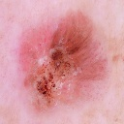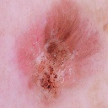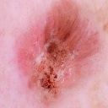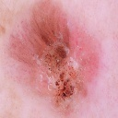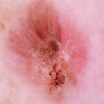

**DF**:

**VASC**:

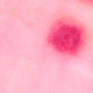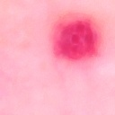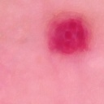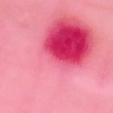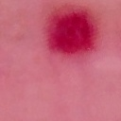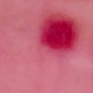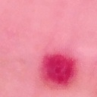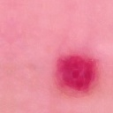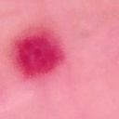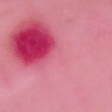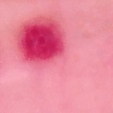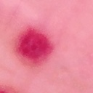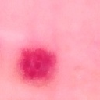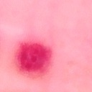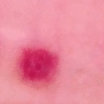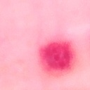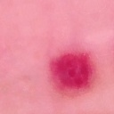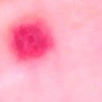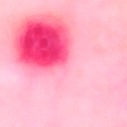

**BCC**:

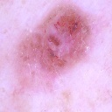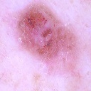

**BKL**:

**MEL** :

## Step 6 : Normalization

The final step of pre-processing is standardizing each pixel value of image from 0-255 to 0-1 called Normalization. The main objective of performing normalization is to achieve consistency in dynamic range of pixel intensity of images of different skin lesions. Furthermore, it will help CNN model converge faster. Normalization will be applied while developing the model as it comes as a built-in feature of ImageDataGenerator class in Tensorflow library of python.

1. Lee, T.; Ng, V.; Gallagher, R.; Coldman, A.; McLean, D. Dullrazor: A software approach to hair removal from images. *Comput. Biol. Med.* **1997**, *27*, 533–543.