Home Code:

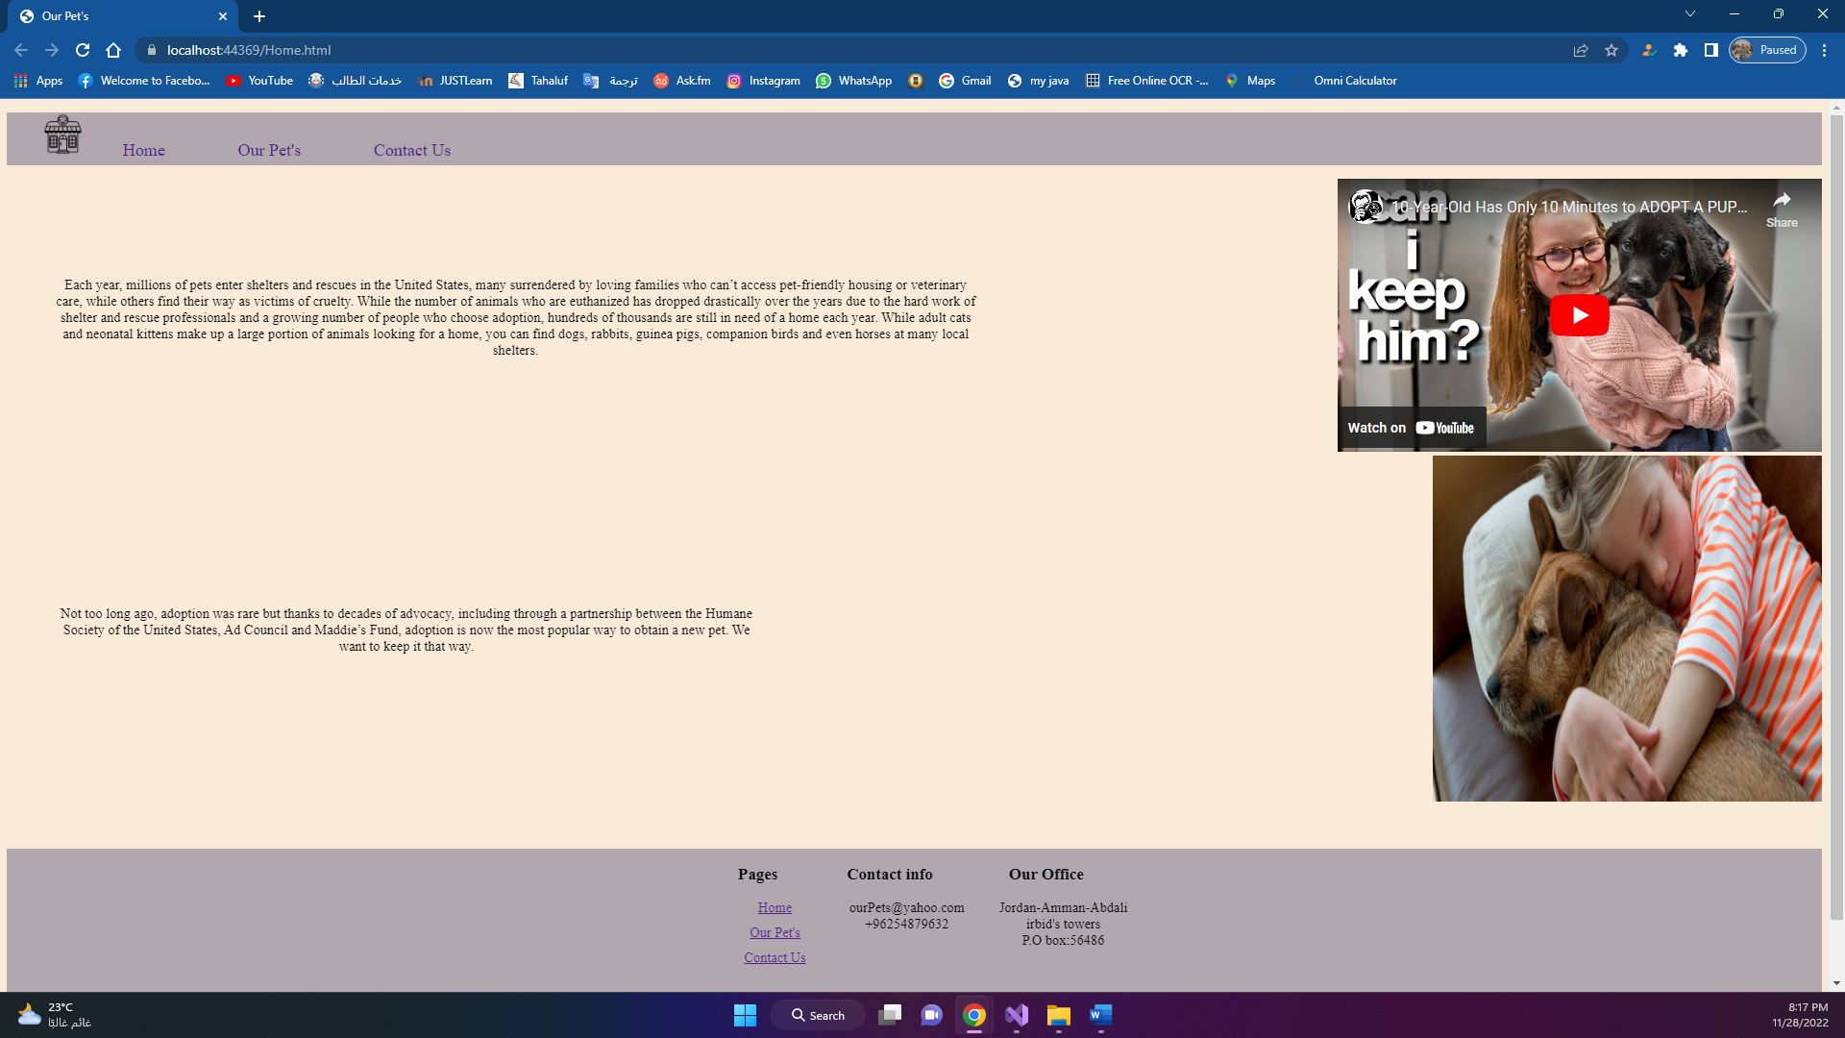

<!DOCTYPE html>

<html>

<head>

<meta charset="utf-8" />

<title>Our Pet's</title>

<link href="Style.css" rel="stylesheet" />

</head>

<body>

<header>

<nav>

<div class="navB">

<ul>

<li class="navB"><img src="images/1173553-200.png" /></li>

<li class="navB"><a href="Home.html">Home</a></li>

<li class="navB"><a href="OurPets.html">Our Pet's</a></li>

<li class="navB"><a href="ContactUs.html">Contact Us</a></li>

</ul>

</div>

</nav>

</header>

<main>

<div class="containerr">

<div>

<iframe width="560" height="315" src="https://www.youtube.com/embed/kzpW0Y7A8F4" title="YouTube video player" frameborder="0" allow="accelerometer; autoplay; clipboard-write; encrypted-media; gyroscope; picture-in-picture" allowfullscreen></iframe>

</div>

<div>

<p>

Each year, millions of pets enter shelters and rescues in the United States, many surrendered by loving families who can’t access pet-friendly housing or veterinary care, while others find their way as victims of cruelty.

While the number of animals who are euthanized has dropped drastically over the years due to the hard work of shelter and rescue professionals and a growing number of people who choose adoption, hundreds of thousands are still in need of a home each year.

While adult cats and neonatal kittens make up a large portion of animals looking for a home, you can find dogs, rabbits, guinea pigs, companion birds and even horses at many local shelters.

</p>

</div>

</div>

<div class="container1">

<div>

<img src="images/dog-girl-440625.jpg" width="450px" height="400px" />

</div>

<div>

<p>

Not too long ago, adoption was rare but thanks to decades of advocacy, including through a partnership between the Humane Society of the United States,

Ad Council and Maddie’s Fund, adoption is now the most popular way to obtain a new pet. We want to keep it that way.

</p>

</div>

</div>

</main>

<footer>

<div class="flexFooter">

<div class="listClass">

<h3>Pages</h3>

<ul>

<li><a href="Home.html">Home</a></li>

<li><a href="OurPets.html">Our Pet's</a></li>

<li><a href="ContactUs.html">Contact Us</a></li>

</ul>

</div>

<div>

<h3>Contact info</h3>

<ul>

<li>ourPets@yahoo.com</li>

<li>+96254879632</li>

</ul>

</div>

<div>

<h3>Our Office</h3>

<ul>

<li>Jordan-Amman-Abdali</li>

<li>irbid's towers</li>

<li>P.O box:56486</li>

</ul>

</div>

</div>

<div>

<p style="text-align:center">

&copy; 2022 Our Pets store, all rights reserved.

</p>

</div>

</footer>

</body>

</html>

Our pets code:

<!DOCTYPE html>

<html>

<head>

<meta charset="utf-8" />

<title>Our Pet's</title>

<link href="Style.css" rel="stylesheet" />

<style>

main h1{

text-align:center;

}

.alld {

margin-left:15%;

display:inline-block;

}

#zoomA {

width: 600px;

height: auto;

transition: transform ease-in-out 1s;

}

#zoomA:hover {

transform: scale(1.2);

}

</style>

</head>

<body>

<header>

<nav>

<div class="navB">

<ul>

<li class="navB"><img src="images/1173553-200.png" /></li>

<li class="navB"><a href="Home.html">Home</a></li>

<li class="navB"><a href="OurPets.html">Our Pet's</a></li>

<li class="navB"><a href="ContactUs.html">Contact Us</a></li>

</ul>

</div>

</nav>

</header>

<main>

<h1>My Gallery</h1>

<div class="alld">

<div>

<img src="images/dog-girl-440625.jpg" id="zoomA" />

</div>

<div>

<h1>Raugh</h1>

</div>

</div>

<div class="alld">

<div>

<img src="images/png-transparent-chinese-beagle-chinese-crested-dog-puppy-maltese-dog-pet-sitting-bark-dog-walking.png" />

</div>

<div>

<h1>

joy

</h1>

</div>

</div>

</main>

<footer>

<div class="flexFooter">

<div class="listClass">

<h3>Pages</h3>

<ul>

<li><a href="Home.html">Home</a></li>

<li><a href="OurPets.html">Our Pet's</a></li>

<li><a href="ContactUs.html">Contact Us</a></li>

</ul>

</div>

<div>

<h3>Contact info</h3>

<ul>

<li>ourPets@yahoo.com</li>

<li>+96254879632</li>

</ul>

</div>

<div>

<h3>Our Office</h3>

<ul>

<li>Jordan-Amman-Abdali</li>

<li>irbid's towers</li>

<li>P.O box:56486</li>

</ul>

</div>

</div>

<div>

<p style="text-align:center">

&copy; 2022 Our Pets store, all rights reserved.

</p>

</div>

</footer>

</body>

</html>

Contact us code:

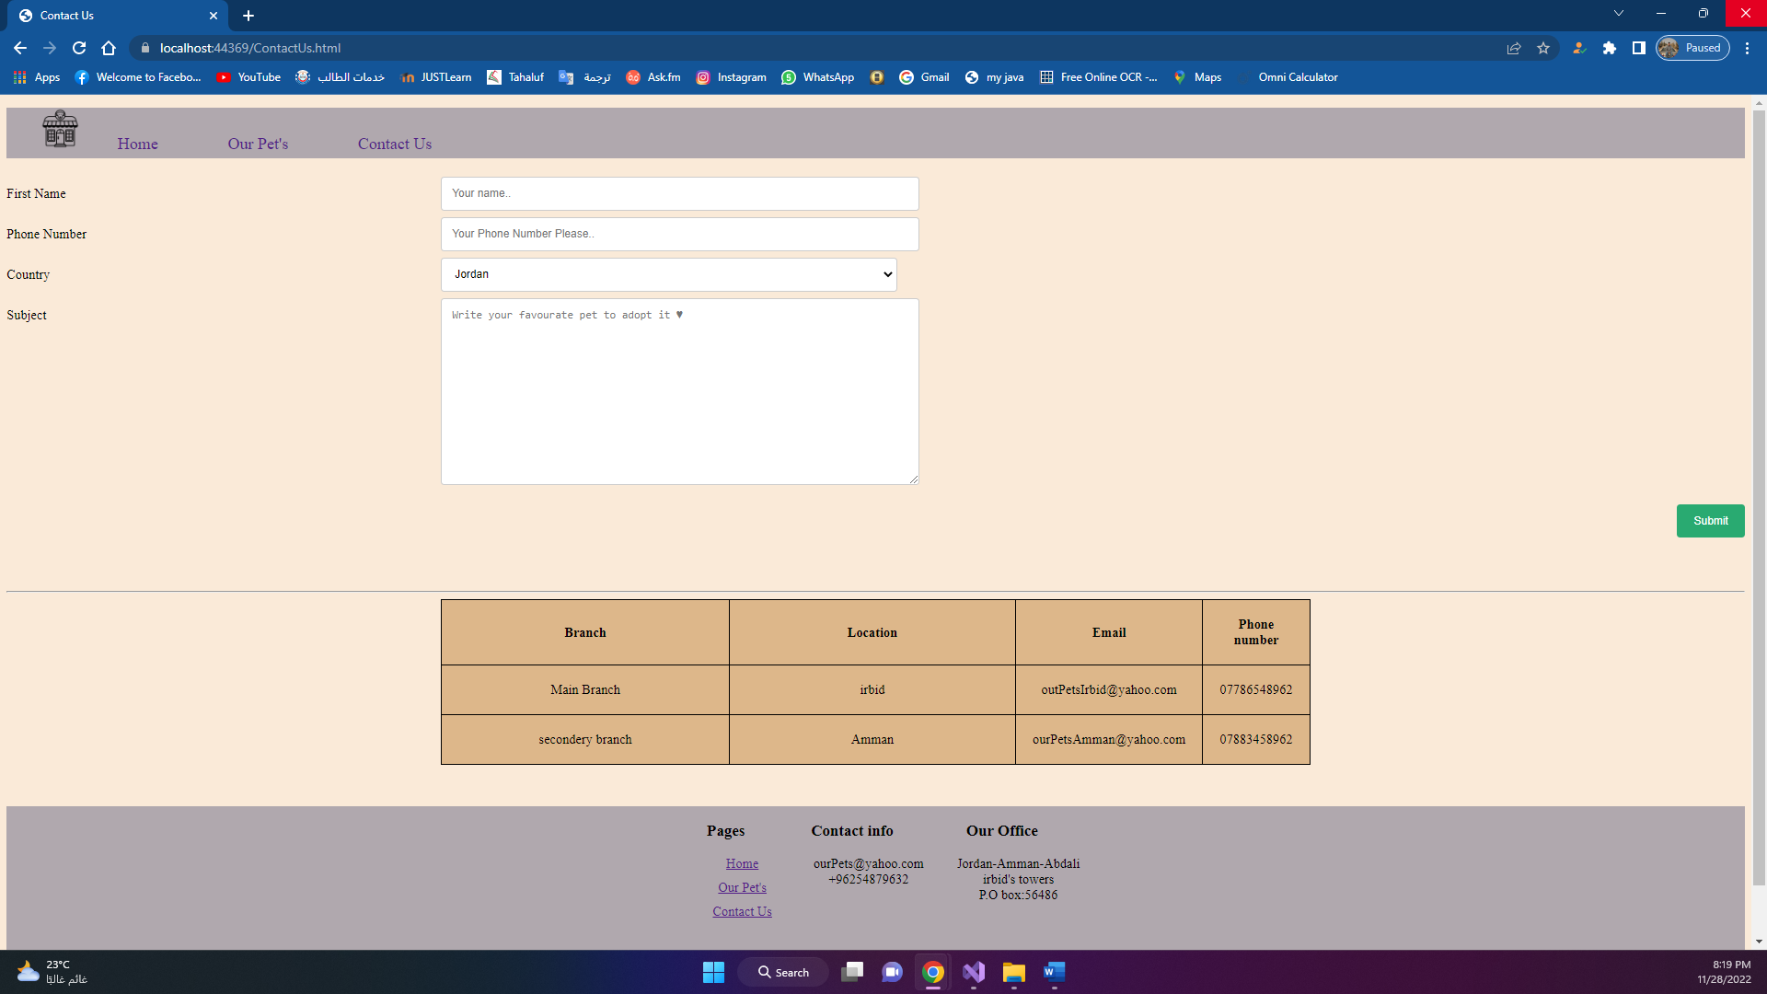

<!DOCTYPE html>

<html>

<head>

<meta charset="utf-8" />

<link href="Style.css" rel="stylesheet" />

<title>Contact Us</title>

</head>

<body>

<header>

<nav>

<div class="navB">

<ul>

<li class="navB"><img src="images/1173553-200.png" /></li>

<li class="navB"><a href="Home.html">Home</a></li>

<li class="navB"><a href="OurPets.html">Our Pet's</a></li>

<li class="navB"><a href="ContactUs.html">Contact Us</a></li>

</ul>

</div>

</nav>

</header>

<main>

<div class="containerrr">

<form>

<div class="row">

<div class="col-25">

<label for="fname">First Name</label>

</div>

<div class="col-75">

<input type="text" id="fname" name="firstname" placeholder="Your name..">

</div>

</div>

<div class="row">

<div class="col-25">

<label for="Phone_Number">Phone Number</label>

</div>

<div class="col-75">

<input type="text" id="Phone_Number" name="PhoneNumber" placeholder="Your Phone Number Please..">

</div>

</div>

<div class="row">

<div class="col-25">

<label for="country">Country</label>

</div>

<div class="col-75">

<select id="country" name="country">

<option value="Jordan">Jordan</option>

<option value="Emirates">UAE</option>

<option value="Saudi">SAR</option>

</select>

</div>

</div>

<div class="row">

<div class="col-25">

<label for="subject">Subject</label>

</div>

<div class="col-75">

<textarea id="subject" name="subject" placeholder="Write your favourate pet to adopt it ♥" style="height:200px"></textarea>

</div>

</div>

<br />

<div class="row">

<input type="submit" value="Submit">

</div>

<br />

</form>

</div>

<br /><br /><hr />

<table>

<tr>

<th> Branch</th>

<th> Location</th>

<th> Email</th>

<th> Phone number</th>

</tr>

<tr>

<td> Main Branch</td>

<td>

irbid

</td>

<td>

outPetsIrbid@yahoo.com

</td>

<td>

07786548962

</td>

</tr>

<tr>

<td> secondery branch</td>

<td>

Amman

</td>

<td>

ourPetsAmman@yahoo.com

</td>

<td>

07883458962

</td>

</tr>

</table>

</main>

<footer>

<div class="flexFooter">

<div class="listClass">

<h3>Pages</h3>

<ul>

<li><a href="Home.html">Home</a></li>

<li><a href="OurPets.html">Our Pet's</a></li>

<li><a href="ContactUs.html">Contact Us</a></li>

</ul>

</div>

<div>

<h3>Contact info</h3>

<ul>

<li>ourPets@yahoo.com</li>

<li>+96254879632</li>

</ul>

</div>

<div>

<h3>Our Office</h3>

<ul>

<li>Jordan-Amman-Abdali</li>

<li>irbid's towers</li>

<li>P.O box:56486</li>

</ul>

</div>

</div>

<div>

<p style="text-align:center">

&copy; 2022 Our Pets store, all rights reserved.

</p>

</div>

</footer>

</body>

</html>

Styles code:

body {

background-color: antiquewhite;

}

.navB {

background-color: #b0a8ae;

}

.navB a {

list-style-type: none;

display: inline-block;

padding: 10px 20px 5px 20px;

text-decoration: none;

font-size: 20px;

margin: 0px 20px;

}

.navB a:hover {

background-color: #fe7676;

color: black;

}

.navB li {

list-style-type: none;

display: inline-block;

}

.navB img {

width: 50px;

height: 50px;

}

.containerr {

display: flex;

align-items: center;

flex-direction: row-reverse;

}

.containerr p {

margin-left: 50px;

width: 70%;

text-align: center;

}

.sora {

width: 200px;

height: 200px;

object-fit: contain;

}

.container1 {

display: flex;

align-items: center;

flex-direction: row-reverse;

}

.container1 p {

margin-left: 50px;

width: 50%;

text-align: center;

}

footer {

background-color: #b0a8ae;

}

.flexFooter {

display: flex;

margin: 50px;

justify-content: center;

text-align: center;

}

.flexFooter li {

list-style-type: none;

}

.listClass li {

margin: 10px;

list-style-type: none;

}

table, table td, table th {

border: 1px solid;

margin: auto;

background-color: burlywood;

border-collapse: collapse;

width: 50%;

text-align: center;

padding: 20px;

}

input[type=text], select, textarea {

width: 35%;

padding: 12px;

border: 1px solid #ccc;

border-radius: 4px;

resize: vertical;

}

label {

padding: 12px 12px 12px 0;

display: inline-block;

}

input[type=submit] {

background-color: #04AA6D;

color: white;

padding: 12px 20px;

border: none;

border-radius: 4px;

cursor: pointer;

float: right;

}

input[type=submit]:hover {

background-color: #45a049;

}

.container {

border-radius: 5px;

background-color: #f2f2f2;

padding: 20px;

}

.col-25 {

float: left;

width: 25%;

margin-top: 6px;

}

.col-75 {

float: left;

width: 75%;

margin-top: 6px;

}

/* Clear floats after the columns */

.row:after {

content: "";

display: table;

clear: both;

}

/* Responsive layout - when the screen is less than 600px wide, make the two columns stack on top of each other instead of next to each other */

@media screen and (max-width: 600px) {

.col-25, .col-75, input[type=submit] {

width: 100%;

margin-top: 0;

}

}

Photos

