Data Science Lab

Legal Document Authenticity Verifier

Project Report

Submitted to: Course Instructor
Semester: Spring 2026

Group Members
Name | Roll Number
Ghayur | 231570
Syed Ali Adan | 231663

1. Introduction
Manual verification of legal contracts is a slow, error-prone, and high-risk process in the modern legal and corporate landscape. Attorneys and compliance officers spend considerable time reviewing signature authenticity and screening for predatory or unfair clauses embedded in dense legal prose. This project addresses these bottlenecks by developing an AI-driven multi-agent forensic verification system that automates both signature authentication and clause risk detection, delivering results through an intuitive web interface complete with explainability outputs.

2. Problem Statement
Autonomous legal document verification requires addressing three core vulnerabilities simultaneously:
• Signature Forgery: Skilled forgers can replicate handwriting patterns closely enough to defeat naive visual inspection.
• Predatory Clauses: Contractual language that disproportionately disadvantages one party is often buried in technical legalese, making manual detection unreliable.
• Lack of Explainability: Purely black-box AI outputs are insufficient in legal contexts, where human auditors must understand and validate algorithmic decisions.

3. Proposed Solution
We implement a multi-modal multi-agent forensic verification system served via FastAPI backend and React/Vite frontend. The system decomposes the verification problem into specialized agents: a Computer Vision (CV) Agent for signature analysis using a Siamese Convolutional Neural Network with VGG16 backbone, and a Natural Language Processing (NLP) Agent for clause risk detection using a fine-tuned RoBERTa transformer. A Supervisor Agent fuses the risk scores using a weighted decision rule and invokes Explainable AI (XAI) modules (Grad-CAM for visual heatmaps, SHAP for token-level attributions) to produce interpretable outputs.

4. Dataset Collection and Challenges
The models are trained and evaluated on two peer-reviewed research datasets:
• CEDAR Signatures: A benchmark computer vision dataset containing 55 writers, each providing 24 genuine and 24 skilled-forgery signatures (2,640 total images). Challenges include high intra-class variation (a signer's own signatures differ) and low inter-class variation (skilled forgeries deliberately mimic the genuine style).
• LexGLUE UNFAIR-ToS: A natural language understanding dataset of annotated Terms of Service clauses spanning eight legal category labels. Challenges include severe class imbalance (some unfair categories are rare) and ambiguous boundary cases between fair and unfair clauses.

Table 1: Dataset Summary
Dataset Name | Modality | Size / Splits | Primary Metrics | Target Task
CEDAR Signatures | Visual  (Signature Images) | 55 writers; 24 genuine +  24 forgery each  (2,640 total images) | 80.21% Accuracy  0.9209 AUC | Detecting skilled forgeries  (binary classification)
LexGLUE UNFAIR-ToS | Semantic  (Contract Text) | Terms of Service clauses,  8 label categories;  train/val/test splits | 95.83% Accuracy  89.65% Macro F1 | Identifying predatory  clauses (multi-class)

5. Methodology
Our methodology implements a multi-agent pipeline. The user uploads a scanned legal document or PDF via the React frontend. The backend orchestrates the following agents in sequence:
• Document Parsing Agent: Extracts signature crops and raw contract text from the uploaded PDF/image.
• CV Agent (Siamese CNN): Compares the extracted signature region against a reference signature to produce a forgery probability score.
• NLP Agent (RoBERTa): Tokenizes and classifies each contract clause into fair or unfair categories, computing a weighted clause risk score.
• Supervisor Agent: Fuses both risk scores using a weighted linear combination rule and determines a final authenticity verdict.
• XAI Agent: Generates Grad-CAM visual heatmaps overlaid on the signature image and SHAP token-level attributions for the highest-risk clauses.

Figure 1 illustrates the complete system workflow from document upload through final report generation:

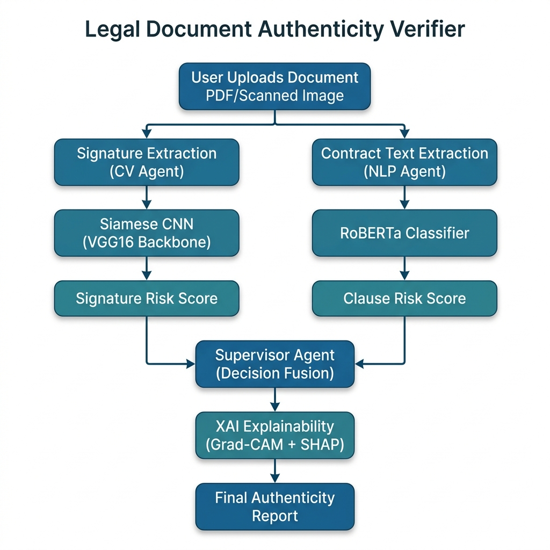
Figure 1: Complete System Workflow – Multi-Agent Legal Document Verification Pipeline

Figure 2 shows the layered system architecture across frontend, backend, and AI model components:

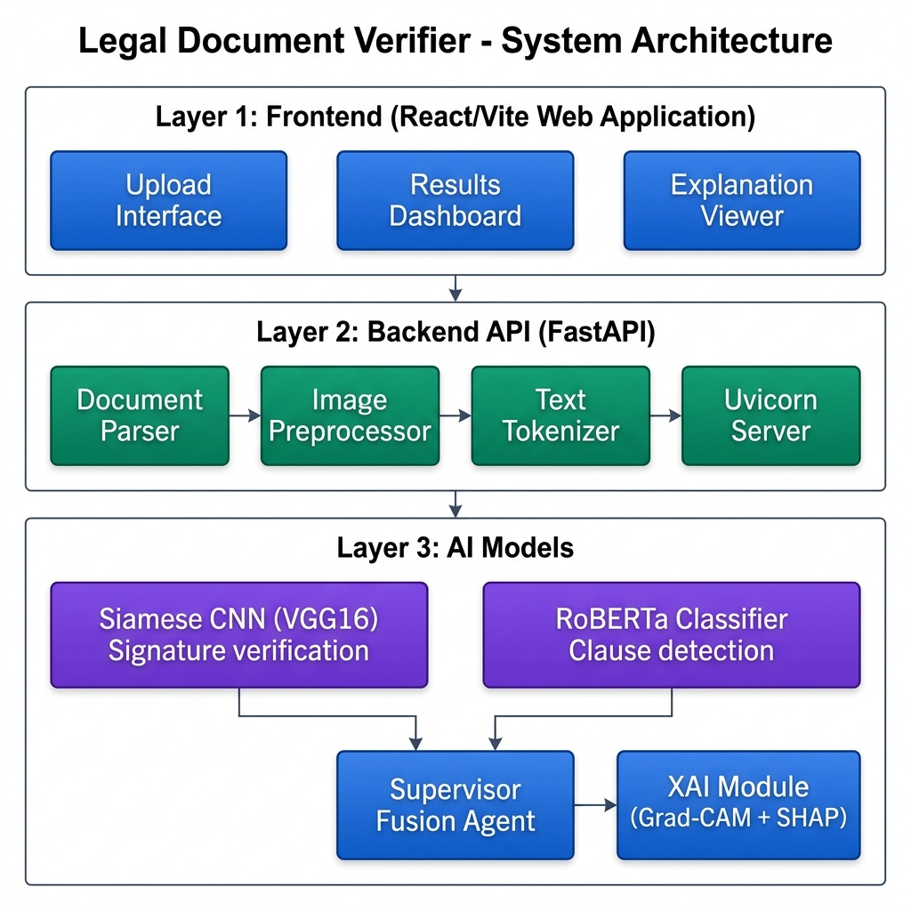
Figure 2: System Architecture – Frontend, Backend API, and AI Model Layers

6. Technical Details
The system achieves competitive, robust benchmarks on the standard research datasets. Detailed technical specifications for each pipeline component are provided below.

6.1 Computer Vision Pipeline (Siamese CNN)
• Model Architecture: VGG16 backbone pre-trained on ImageNet. The final block is fine-tuned; a custom contrastive head computes L1-distance between twin embeddings to yield a forgery probability score.
• Training: Contrastive loss with margin=1.0; SGD optimizer (lr=0.001, momentum=0.9); 35 epochs; data augmentation (random flips, rotations, brightness jitter).
• Test Accuracy: 80.21% | AUC: 0.9209 | Equal Error Rate (EER): 14.7%
• Explainability: Grad-CAM heatmaps highlight which stroke regions triggered the forgery flag.

6.2 Natural Language Processing Pipeline (RoBERTa Classifier)
• Model Architecture: roberta-base (125M parameters) pre-trained model. A linear classification head (hidden→8 classes) is added and fine-tuned end-to-end on the LexGLUE UNFAIR-ToS dataset.
• Training: AdamW optimizer (lr=2e-5, weight_decay=0.01); 5 epochs; weighted cross-entropy to handle class imbalance; maximum sequence length 512 tokens.
• Test Accuracy: 95.83% | Macro F1: 89.65%
• Explainability: SHAP token-level attributions highlight which contract terms elevated the risk score.

6.3 Supervisor Decision Fusion & Explainability (XAI)
• Fusion Rule: combined_risk = (0.6 × sig_risk) + (0.4 × nlp_risk). If combined_risk > 0.5, the document is flagged as SUSPICIOUS.
• The 60/40 weight split reflects the higher legal consequence of a forged signature vs. a single unfair clause; this threshold can be adjusted via a configuration parameter.
• Output: JSON report with per-component risk scores, final verdict, Grad-CAM PNG overlay, and ranked SHAP attribution list – all returned to the React frontend for display.

7. Libraries & Tools
Table 2: Libraries and Frameworks Used
Library / Tool | Purpose
PyTorch | Model implementation, Siamese CNN training loop, contrastive loss computation
Transformers (HuggingFace) | Tokenization and fine-tuning of RoBERTa-base for clause classification
FastAPI | Building the backend REST API; async endpoints for model inference
React (Vite) | Developing the interactive web frontend – upload, results, and XAI display
Grad-CAM (OpenCV) | Generating visual explainability heatmaps overlaid on signature images
SHAP | Computing token-level attribution scores for RoBERTa NLP decisions
Uvicorn | Asynchronous ASGI gateway server interfacing between FastAPI and the web
python-docx | Automated report generation for final authenticity audit documents

Note: The above sections represent the minimum requirements that must be included in your final report. You are encouraged to elaborate further on your experimental results, ablation studies, limitations, and future work as appropriate for a complete academic submission.

