Outfit Recommender using AI

Saalim Abdullah Muhammad
Department of Computer Science
Air University Islamabad
Islamabad, Pakistan
231585@students.au.edu.pk
Syed Ghayur Hussain
Department of Computer Science
Air University Islamabad
Islamabad, Pakistan
231570@students.au.edu.pk

Abstract—Choosing an outfit on the daily is an arduous task and repetitive task. To deal with this problem, we created an outfit recommendation system that uses a fuzzy logic system along with supervised machine learning. The contribution is a demonstration of rule based vs. learned scoring (Abstract)
Keywords—outfit recommender, fuzzy logic, supervised learing, neural network, regression, Flask, React.

Introduction (Heading 1)
Many people often struggle with creating an outfit for the day regularly, with many combinations feeling disjointed. The changing conditions, such as the weather or formality of the the occasion. This calls for a system that can automatically generate and rank outfits for us constrained by set rules and give an estimate of how good the combination seems. This recommender uses a fuzzy logic scoring engine for scoring based on suitability of the rules applied (such as weather, formality, color harmony, etc.). Secondly, a supervised machine learning pipeline that learns to give its own score based on categorical features (useful for future developments).

Ease of Use

System Usability
Clone the repository from github via git clone. In the backend directory, create a virtual environment (venv), activate it, and install dependencies from requirements.txt via pip. In the frontend directory, install dependencies via npm install, then run via npm start. The use side should be running on localhost:3000.

Methodology & System Design
This project uses react via create-react-app for the front-end and python/flask for the backend.

Abbreviations and Acronyms
AI: Artificial Intelligence
MLP: Multi-Layer Perceptron
API: Application Programming Interface
CSP: Constraint Satisfaction Problem
ML: Machine Learning

Equations
- $Weather fit: μ_{\left\{warmth\right\}\left(weather, warmth\right)}∈\left[0,1\right]$
- $Style fit: μ_{\left\{style\right\}\left(event, item\right)}∈\left[0,1\right]$
- $Formality fit: μ_{\left\{formality\right\}\left(event, items\right)}∈\left[0,1\right]$
- $Color harmony: μ_{\left\{color\right\}\left(items\right)}∈\left[0,1\right]$
- $eventSuitability = min\left(styleMatch, formalityFit\right)$

Some Common Mistakes
- The word “data” is plural, not singular.
- The expert score is not the same as ML Prediction

Implementation

CSP
The outfit recommendation is modeled as a csp. Each clothing category is a variable, and eachall the clothing items are their domains. The hard constraints are:

All clothing categories must be selected (e.g. no shoes not allowed).

Chosen items must be suitable for the weather.

Optional categories may be skipped (such as jackets).

Beam Search
Outfit generation is done by going category to category. Partial outfits are expanded and then evaluated using the heuristic score generated by the fuzzy logic. Only the top k outfits are retained. This continues until complete outfits are formed. This reduces the load caused by complete expansion of all possible combinations.

Fuzzy Logic

Fuzzification: discrete attributes (warmth, style, formality, color harmony) are converted into membership values between 0 and 1.

Fuzzy inference: weather suitability, event suitability, and color harmony are combined using weighted aggregation

Defuzzification: the aggregated fuzzy values are converted into a single numeric score for ranking.

MLP
The backend implements an MLP Regressor using scikit-learn to predictoutfit scores, as a dual-scoring alternative. It takes 18 features as input (weather, event, and 4 attributes × 4 clothing pieces) and generates approximately 67 binary input neurons after encoding. There are two hidden layers, both of which have Rectified Linear Unit as the activation function to capture broad patterns and then refine them. The score is output as a prediction on a scale between 0 and 10.

Data Representation
Clothing items are represented as objects containing attributes like warmth, formality, and style tags.

Figures and Tables

Semantic Network

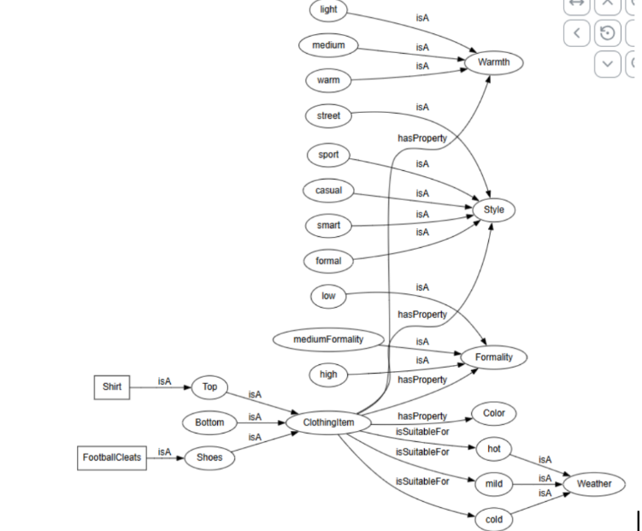
- Semantic Network of our data

Frames.
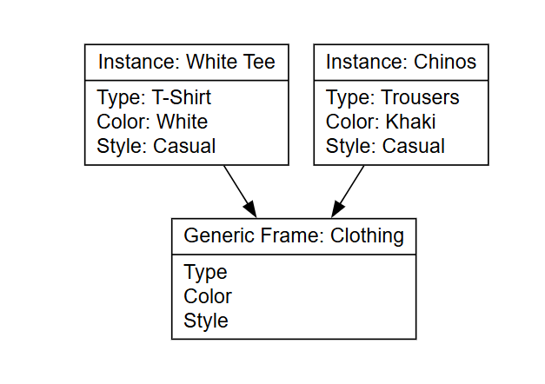
- Frames of our data.

Results
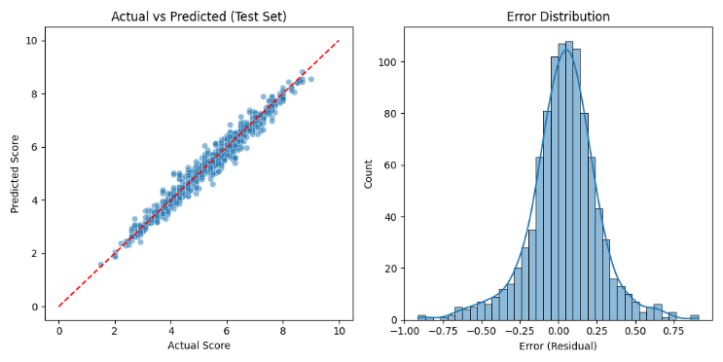

- Results

Conclusion
This project combined multiple AI Paradigms such as Fuzzy Logic and ML to produce an outfit recommender that ranks outfits in a logical way.
Future improvements includes creating a form for users to enter their own data rather than going into program files and changing it

