Ghazal Arbabzadeh  Computer Science Student · FH Campus Wien · Vienna, Austria | 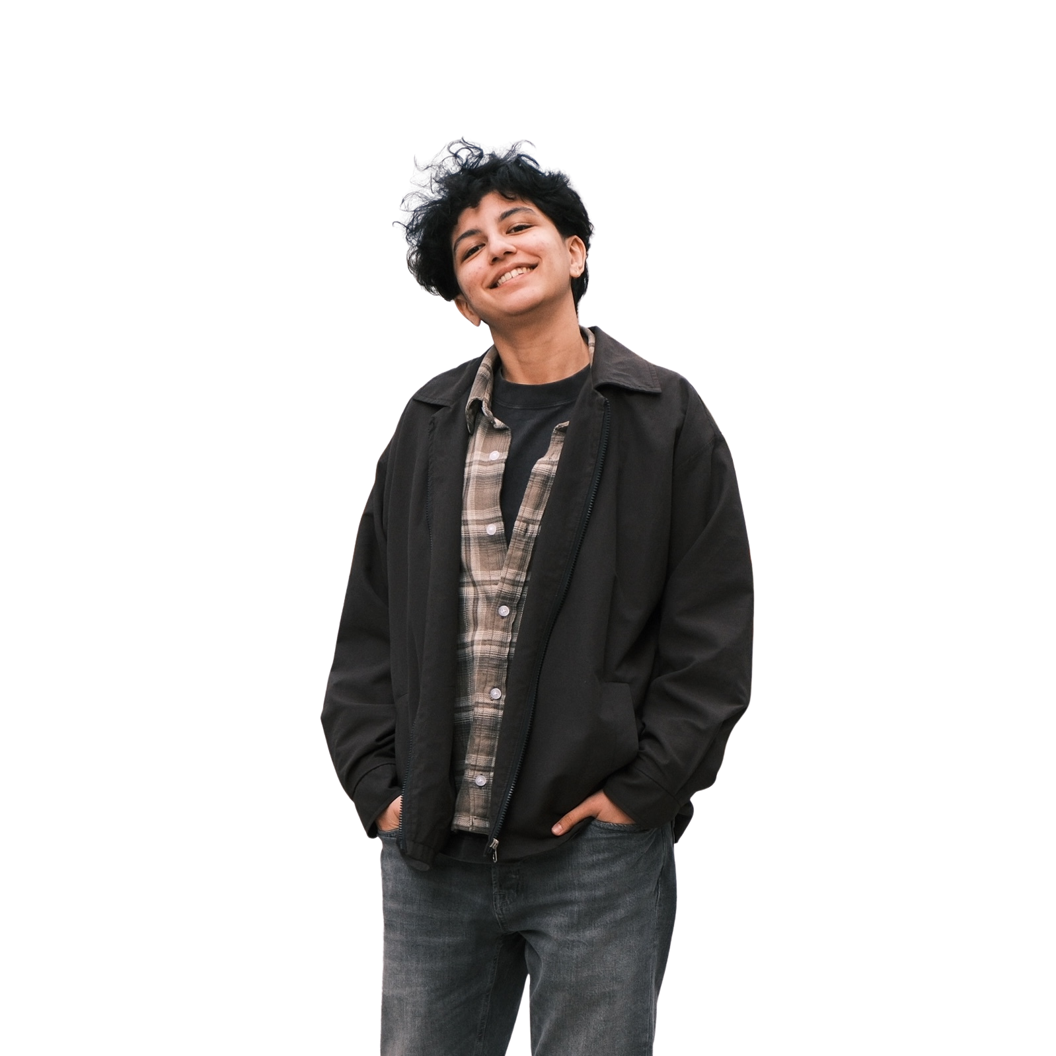

Contact  Vienna, Austria  +43 660 946 7406  ghazalab96@gmail.com  LinkedIn ↗  github.com/ghazalab96 ↗  Technical Skills  Languages: Python · Java · JavaScript · SQL  Web: HTML · CSS · Node.js · Express.js  Data: Pandas · NumPy · Matplotlib · Seaborn  ML / DL: Scikit-learn · Neural Networks · Deep Learning  Tools: Git · Linux · MS Office · Power BI  Concepts: Algorithms · Statistics · Networking · OOP  Languages  English: Fluent  German: C1 – EPD Certificate  Persian: Native  Certifications  ▸ AI Programming with Python Nanodegree — Udacity / AWS (2024)  ▸ Machine Learning – 70h — Pytopia  ▸ Python for Data Science, AI & Dev — Coursera (25h)  ▸ Exploratory Data Analysis in Python — DataCamp | Profile  Computer Science student at FH Campus Wien, combining a strong technical background with a professional history in medicine. Experienced in full-stack web development, data analysis, and machine learning. Analytical, detail-oriented, and a clear communicator — I bring both precision and adaptability to every project I work on.  Education  BSc Computer Science & Digital Communications · FH Campus Wien Sep 2025 – Jun 2028  – University of Applied Sciences, Vienna  Doctor of Dental Surgery (DDS) · Azad University of Isfahan, Iran 2015 – 2021  Work Experience  Sales Assistant (Part-time) · Julius Meinl am Graben, Vienna 2024 – Present  – Customer service in a multilingual, multicultural environment (DE / EN)  – Structured, reliable work execution under pressure  General Dentist · Private Practice, Iran 2021 – 2024  – High-precision work with strict documentation and data handling  – Complex problem-solving and responsibility for patient outcomes  Projects  Austrian Immigration Platform · Full-Stack · HTML, CSS, JS, Node.js, Express.js 2026  – Auth, user flows, data handling, frontend-backend communication  Java Chatroom Application · OOP · Client-Server · Networking 2026  – Multi-user chat system with socket programming in Java  Image Classifier · Deep Learning · Python · Neural Networks 2024  – Transfer learning model trained and evaluated as Udacity Nanodegree final project  All projects: github.com/ghazalab96

