INSTITUTE OF MANAGEMENT SCIENCES
HAYATABAD, PESHAWAR

Database Management Systems Lab — Semester IV
Travel Itinerary Planner — Schema, ERD, Normalization & Dataset
Student 1 | Muhammad Meher Ali
Student 2 | Ghazal Khan
Submitted To | Ali Hassan
Subject | Database Management Systems Lab
Semester | IV
Session | 2024–2028 (Fall)
Project Title | Travel Itinerary Planner

Project Milestone Tracker/ Version Control:
Milestone | Version
ERD & Schema | 1.0

MILESTONE 1 :

Entity Relationship Diagram (ERD):
The following ERD illustrates all tables, attributes, and relationships of the Travel Itinerary Planner database system. Created using Draw.io.

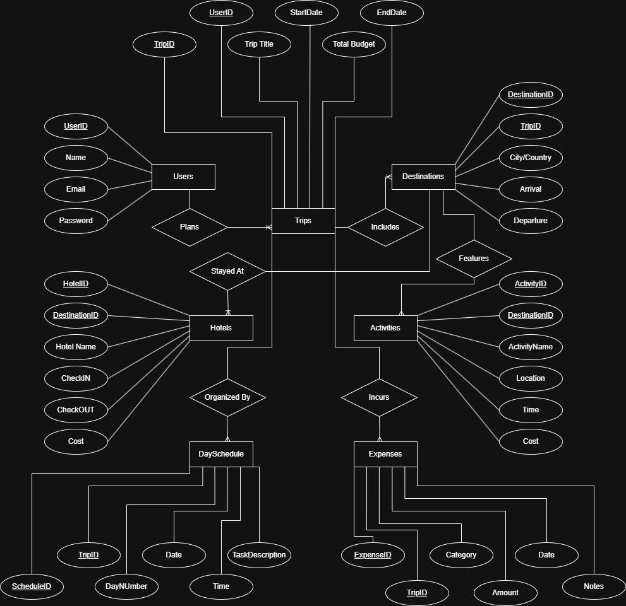

Database Schema (MySQL Workbench):
The CREATE TABLE statements below define the complete relational schema. All tables use primary keys, foreign keys, NOT NULL constraints, and CHECK constraints.

1. Users Table:
CREATE TABLE Users (
UserID INT PRIMARY KEY AUTO_INCREMENT,
Name VARCHAR(100) NOT NULL,
Email VARCHAR(150) NOT NULL UNIQUE,
Password VARCHAR(255) NOT NULL
);

2. Trips Table:
CREATE TABLE Trips (
TripID INT PRIMARY KEY AUTO_INCREMENT,
UserID INT NOT NULL,
TripTitle VARCHAR(200) NOT NULL,
StartDate DATE NOT NULL,
EndDate DATE NOT NULL,
TotalBudget DECIMAL(10,2) NOT NULL CHECK (TotalBudget >= 0),
CONSTRAINT FK_Trips_Users FOREIGN KEY (UserID) REFERENCES Users(UserID),
CONSTRAINT CHK_Trips_Dates CHECK (EndDate > StartDate)
);

3. Destinations Table:
CREATE TABLE Destinations (
DestinationID INT PRIMARY KEY AUTO_INCREMENT,
TripID INT NOT NULL,
City VARCHAR(100) NOT NULL,
Country VARCHAR(100) NOT NULL,
ArrivalDate DATE NOT NULL,
DepartureDate DATE NOT NULL,
CONSTRAINT FK_Dest_Trips FOREIGN KEY (TripID) REFERENCES Trips(TripID),
CONSTRAINT CHK_Dest_Dates CHECK (DepartureDate > ArrivalDate)
);

4. Hotels Table:
CREATE TABLE Hotels (
HotelID INT PRIMARY KEY AUTO_INCREMENT,
DestinationID INT NOT NULL,
HotelName VARCHAR(200) NOT NULL,
CheckIn DATE NOT NULL,
CheckOut DATE NOT NULL,
CostPerNight DECIMAL(10,2) NOT NULL CHECK (CostPerNight >= 0),
CONSTRAINT FK_Hotels_Dest FOREIGN KEY (DestinationID) REFERENCES Destinations(DestinationID),
CONSTRAINT CHK_Hotel_Dates CHECK (CheckOut > CheckIn)
);

5. Activities Table:
CREATE TABLE Activities (
ActivityID INT PRIMARY KEY AUTO_INCREMENT,
DestinationID INT NOT NULL,
ActivityName VARCHAR(200) NOT NULL,
Location VARCHAR(200) NOT NULL,
ActivityTime TIME NOT NULL,
Cost DECIMAL(10,2) NOT NULL CHECK (Cost >= 0),
CONSTRAINT FK_Activities_Dest FOREIGN KEY (DestinationID) REFERENCES Destinations(DestinationID)
);

6. DaySchedule Table:
CREATE TABLE DaySchedule (
ScheduleID INT PRIMARY KEY AUTO_INCREMENT,
TripID INT NOT NULL,
DayNumber INT NOT NULL CHECK (DayNumber >= 1),
ScheduleDate DATE NOT NULL,
ScheduleTime TIME NOT NULL,
TaskDescription VARCHAR(500) NOT NULL,
CONSTRAINT FK_DaySched_Trips FOREIGN KEY (TripID) REFERENCES Trips(TripID)
);

7. Expenses Table:
CREATE TABLE Expenses (
ExpenseID INT PRIMARY KEY AUTO_INCREMENT,
TripID INT NOT NULL,
Category VARCHAR(100) NOT NULL
CHECK (Category IN ('Hotel','Transport','Food','Activities','Shopping','Other')),
Amount DECIMAL(10,2) NOT NULL CHECK (Amount >= 0),
ExpenseDate DATE NOT NULL,
Notes VARCHAR(500),
CONSTRAINT FK_Expenses_Trips FOREIGN KEY (TripID) REFERENCES Trips(TripID)
);

Table Relationships Summary:
Relationship | Type | Foreign Key
Users → Trips | One-to-Many | Users.UserID → Trips.UserID
Trips → Destinations | One-to-Many | Trips.TripID → Destinations.TripID
Destinations → Hotels | One-to-Many | Destinations.DestinationID → Hotels.DestinationID
Destinations → Activities | One-to-Many | Destinations.DestinationID → Activities.DestinationID
Trips → DaySchedule | One-to-Many | Trips.TripID → DaySchedule.TripID
Trips → Expenses | One-to-Many | Trips.TripID → Expenses.TripID

