INSTITUTE OF MANAGEMENT SCIENCES
HAYATABAD, PESHAWAR

Database Management Systems Lab — Semester IV
Travel Itinerary Planner — Schema, ERD, Normalization & Dataset
Student 1 | Muhammad Meher Ali
Student 2 | Ghazal Khan
Submitted To | Ali Hassan
Subject | Database Management Systems Lab
Semester | IV
Session | 2024–2028 (Fall)
Project Title | Travel Itinerary Planner

Project Milestone Tracker/ Version Control:
Milestone | Version
ERD & Schema | 1.0
Normalization & Updated ERD | 1.1

MILESTONE 1 :

Entity Relationship Diagram (ERD):
The following ERD illustrates all tables, attributes, and relationships of the Travel Itinerary Planner database system. Created using Draw.io.

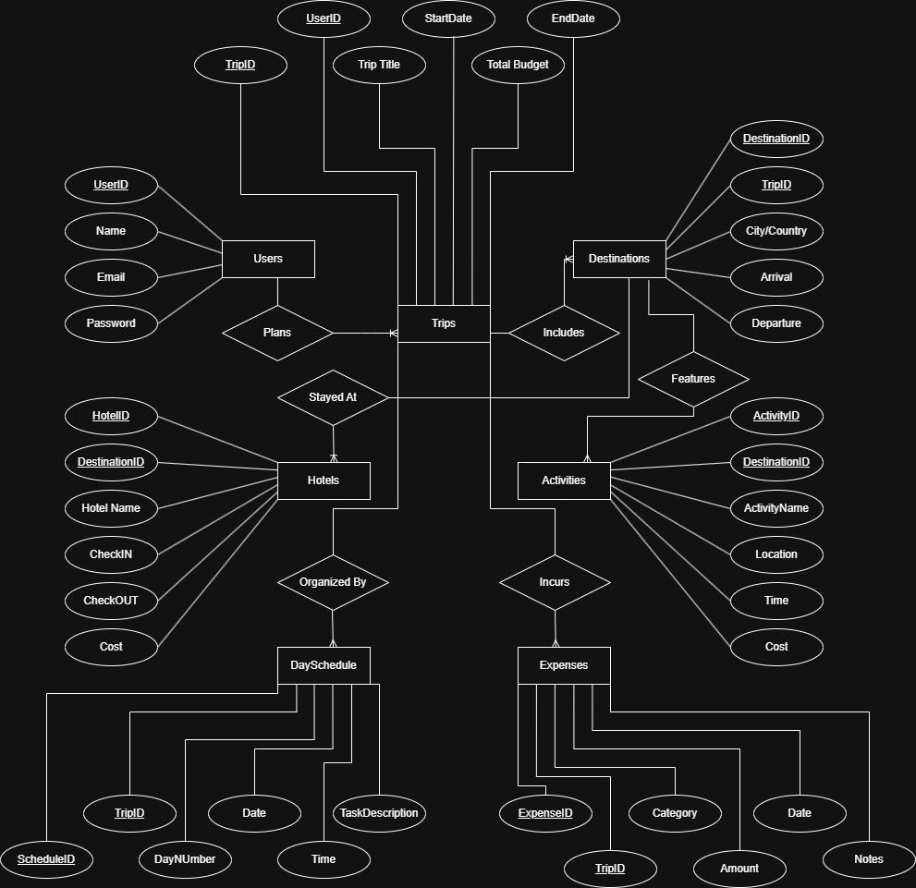

Database Schema (MySQL Workbench):
The CREATE TABLE statements below define the complete relational schema. All tables use primary keys, foreign keys, NOT NULL constraints, and CHECK constraints.

1. Users Table:
CREATE TABLE Users (
UserID INT PRIMARY KEY AUTO_INCREMENT,
Name VARCHAR(100) NOT NULL,
Email VARCHAR(150) NOT NULL UNIQUE,
Password VARCHAR(255) NOT NULL
);

2. Trips Table:
CREATE TABLE Trips (
TripID INT PRIMARY KEY AUTO_INCREMENT,
UserID INT NOT NULL,
TripTitle VARCHAR(200) NOT NULL,
StartDate DATE NOT NULL,
EndDate DATE NOT NULL,
TotalBudget DECIMAL(10,2) NOT NULL CHECK (TotalBudget >= 0),
CONSTRAINT FK_Trips_Users FOREIGN KEY (UserID) REFERENCES Users(UserID),
CONSTRAINT CHK_Trips_Dates CHECK (EndDate > StartDate)
);

3. Destinations Table:
CREATE TABLE Destinations (
DestinationID INT PRIMARY KEY AUTO_INCREMENT,
TripID INT NOT NULL,
City VARCHAR(100) NOT NULL,
Country VARCHAR(100) NOT NULL,
ArrivalDate DATE NOT NULL,
DepartureDate DATE NOT NULL,
CONSTRAINT FK_Dest_Trips FOREIGN KEY (TripID) REFERENCES Trips(TripID),
CONSTRAINT CHK_Dest_Dates CHECK (DepartureDate > ArrivalDate)
);

4. Hotels Table:
CREATE TABLE Hotels (
HotelID INT PRIMARY KEY AUTO_INCREMENT,
DestinationID INT NOT NULL,
HotelName VARCHAR(200) NOT NULL,
CheckIn DATE NOT NULL,
CheckOut DATE NOT NULL,
CostPerNight DECIMAL(10,2) NOT NULL CHECK (CostPerNight >= 0),
CONSTRAINT FK_Hotels_Dest FOREIGN KEY (DestinationID) REFERENCES Destinations(DestinationID),
CONSTRAINT CHK_Hotel_Dates CHECK (CheckOut > CheckIn)
);

5. Activities Table:
CREATE TABLE Activities (
ActivityID INT PRIMARY KEY AUTO_INCREMENT,
DestinationID INT NOT NULL,
ActivityName VARCHAR(200) NOT NULL,
Location VARCHAR(200) NOT NULL,
ActivityTime TIME NOT NULL,
Cost DECIMAL(10,2) NOT NULL CHECK (Cost >= 0),
CONSTRAINT FK_Activities_Dest FOREIGN KEY (DestinationID) REFERENCES Destinations(DestinationID)
);

6. DaySchedule Table:
CREATE TABLE DaySchedule (
ScheduleID INT PRIMARY KEY AUTO_INCREMENT,
TripID INT NOT NULL,
DayNumber INT NOT NULL CHECK (DayNumber >= 1),
ScheduleDate DATE NOT NULL,
ScheduleTime TIME NOT NULL,
TaskDescription VARCHAR(500) NOT NULL,
CONSTRAINT FK_DaySched_Trips FOREIGN KEY (TripID) REFERENCES Trips(TripID)
);

7. Expenses Table:
CREATE TABLE Expenses (
ExpenseID INT PRIMARY KEY AUTO_INCREMENT,
TripID INT NOT NULL,
Category VARCHAR(100) NOT NULL
CHECK (Category IN ('Hotel','Transport','Food','Activities','Shopping','Other')),
Amount DECIMAL(10,2) NOT NULL CHECK (Amount >= 0),
ExpenseDate DATE NOT NULL,
Notes VARCHAR(500),
CONSTRAINT FK_Expenses_Trips FOREIGN KEY (TripID) REFERENCES Trips(TripID)
);

Table Relationships Summary:
Relationship | Type | Foreign Key
Users → Trips | One-to-Many | Users.UserID → Trips.UserID
Trips → Destinations | One-to-Many | Trips.TripID → Destinations.TripID
Destinations → Hotels | One-to-Many | Destinations.DestinationID → Hotels.DestinationID
Destinations → Activities | One-to-Many | Destinations.DestinationID → Activities.DestinationID
Trips → DaySchedule | One-to-Many | Trips.TripID → DaySchedule.TripID
Trips → Expenses | One-to-Many | Trips.TripID → Expenses.TripID

MILESTONE 2

Normalization — Formal Analysis:
This section documents the complete normalization of the Travel Itinerary Planner schema from 1NF through 3NF. Each table is analyzed individually with issue, change, and justification recorded.

Step 1 — Normalization Process:

First Normal Form (1NF):
Rule: All columns hold atomic (single, indivisible) values. Each table has a primary key. No repeating groups or multi-valued columns.
Users — 1NF:
Table | Users
Issue / Check | Check: atomic values, primary key, no repeating groups.
Change Made | No change required.
Justification | UserID is the primary key. Name, Email, Password are all single-valued atomic strings. Email is UNIQUE. No multi-valued attributes or repeating groups. Satisfies 1NF.

Trips — 1NF:
Table | Trips
Issue / Check | Check: atomic values, no repeating groups. Verify ERD City/Country label not carried into Trips.
Change Made | No change required to Trips. City/Country label was in Destinations ERD only.
Justification | TripID is PK. TripTitle, StartDate, EndDate, TotalBudget are all atomic. UserID is a single FK integer per row. Satisfies 1NF.

Destinations — 1NF:
Table | Destinations
Issue / Check | Issue: ERD shows 'City/Country' as one combined oval — possible 1NF violation if stored as one concatenated column.
Change Made | Confirmed: SQL schema already uses separate City VARCHAR(100) and Country VARCHAR(100) columns. ERD label updated to show two distinct ovals.
Justification | DestinationID is PK. City and Country are separate atomic columns. ArrivalDate and DepartureDate are individual DATE fields. Satisfies 1NF. ERD corrected in Step 3.

Hotels — 1NF:
Table | Hotels
Issue / Check | Check: no repeating amenity lists or multi-valued fields.
Change Made | No change required.
Justification | HotelID is PK. All columns single-valued and atomic. Satisfies 1NF.

Activities — 1NF:
Table | Activities
Issue / Check | Check: ActivityName, Location, ActivityTime, Cost — all atomic?
Change Made | No change required.
Justification | ActivityID is PK. Every attribute holds exactly one value per row. Satisfies 1NF.

DaySchedule — 1NF:
Table | DaySchedule
Issue / Check | Check: TaskDescription — could it store multiple tasks in one cell?
Change Made | No change required. TaskDescription holds one task per row. Multiple tasks on same day = multiple rows with different ScheduleIDs.
Justification | ScheduleID is PK. All columns atomic. Satisfies 1NF.

Expenses — 1NF:
Table | Expenses
Issue / Check | Check: Category CHECK constraint — is it storing a set in one cell?
Change Made | No change required. CHECK is a validation rule, not multi-value storage. Each row holds one category.
Justification | ExpenseID is PK. All columns single-valued. Satisfies 1NF.

Second Normal Form (2NF):
Rule: In 2NF AND every non-key attribute fully depends on the entire primary key. Partial dependency only possible with composite primary keys.

All 7 Tables — 2NF:
Table | All 7 Tables
Issue / Check | Do any non-key columns depend on only part of the primary key?
Change Made | No change required for any table.
Justification | Every table uses a single-column surrogate primary key (AUTO_INCREMENT INT). With a single-column PK, partial functional dependency is mathematically impossible — there is no 'part of the key' to partially depend on. All 7 tables satisfy 2NF.

Third Normal Form (3NF):
Rule: In 2NF AND no non-key attribute is transitively dependent on the primary key via another non-key attribute.
Users — 3NF:
Table | Users
Issue / Check | Does Email → Name or Password? Transitive chain via non-key columns?
Change Made | No change required.
Justification | Email has a UNIQUE constraint but does not functionally determine Name or Password in a database transitive sense. All non-key attributes are independent facts about UserID. Satisfies 3NF.

Trips — 3NF:
Table | Trips
Issue / Check | Does TotalBudget derive from StartDate + EndDate? Does TripTitle determine other columns?
Change Made | No change required.
Justification | TotalBudget is user-entered, not computed. TripTitle is descriptive only. No transitive dependencies. Satisfies 3NF.

Destinations — 3NF:
Table | Destinations
Issue / Check | Could Country → City create transitive dependency?
Change Made | No change required.
Justification | City does not determine Country or vice versa in a travel context. Both are direct properties of DestinationID. Satisfies 3NF.

Hotels — 3NF:
Table | Hotels
Issue / Check | Could HotelName → DestinationID? Could CheckIn/CheckOut determine CostPerNight?
Change Made | No change required.
Justification | HotelName does not determine DestinationID (same chain name could appear at multiple destinations). CostPerNight is user-entered, not computed from dates. Satisfies 3NF.

Activities — 3NF:
Table | Activities
Issue / Check | Does Location → DestinationID transitively? Could ActivityName determine Cost?
Change Made | No change required.
Justification | Location is a descriptive string, not a deterministic FK. ActivityName does not determine Cost. All non-key attributes depend solely on ActivityID. Satisfies 3NF.

DaySchedule — 3NF:
Table | DaySchedule
Issue / Check | Potential issue: TripID + DayNumber could determine ScheduleDate transitively.
Change Made | Identified and evaluated. ScheduleDate retained by design decision. See justification.
Justification | TripID + DayNumber could theoretically derive ScheduleDate (Day 1 = StartDate + 0). However, ScheduleDate is kept as an explicit column to allow flexible scheduling (pre/post-trip tasks) and avoid mandatory JOINs to Trips. Documented design decision — not a violation under this rationale.

Expenses — 3NF:
Table | Expenses
Issue / Check | Does Category → Amount? Does ExpenseDate → TripID?
Change Made | No change required.
Justification | Category does not determine Amount (same category has varying amounts). ExpenseDate does not determine TripID. All non-key attributes depend only on ExpenseID. Satisfies 3NF.

Step 2 — Duplicate & Redundancy Check
All tables reviewed for redundant columns, repeated data, and overlapping attributes.
Table | Issue Found | Action Taken
Destinations | City/Country combined ERD label | Confirmed two separate DB columns. ERD updated to show City and Country as distinct ovals.
Hotels | Cost column — ambiguous (per night vs total?) | Renamed to CostPerNight for semantic clarity.
Activities | Cost column — similar ambiguity | Retained as Cost (flat per-activity fee). No overlap with Hotels.
DaySchedule | ScheduleDate could overlap trip date logic | Retained — independently entered date for flexible planning.
All Tables | No cross-table column duplication found | No structural changes required.

Step 3 — Updated ERD:
Changes reflected: City/Country split into two attribute ovals. Hotels.Cost renamed to CostPerNight. All PKs underlined, all FK cardinalities confirmed.
