INSTITUTE OF MANAGEMENT SCIENCES
HAYATABAD, PESHAWAR

Database Management Systems Lab — Semester IV
Travel Itinerary Planner
Student 1 | Muhammad Meher Ali
Student 2 | Ghazal Khan
Submitted To | Ali Hassan
Subject | Database Management Systems Lab
Semester | IV
Session | 2024–2028 (Fall)
Project Title | Travel Itinerary Planner

Project Milestone Tracker/ Version Control:
Milestone | Version
ERD & Schema | 1.0
Normalization & Updated ERD | 1.1
Dataset Preprocessing & Dataflow | 1.2
DDL scripts added, EER diagram verified | 1.3
Data populated validation queries added | 1.4

MILESTONE 1:

Entity Relationship Diagram (ERD):
The following ERD illustrates all tables, attributes, and relationships of the Travel Itinerary Planner database system. Created using Draw.io.

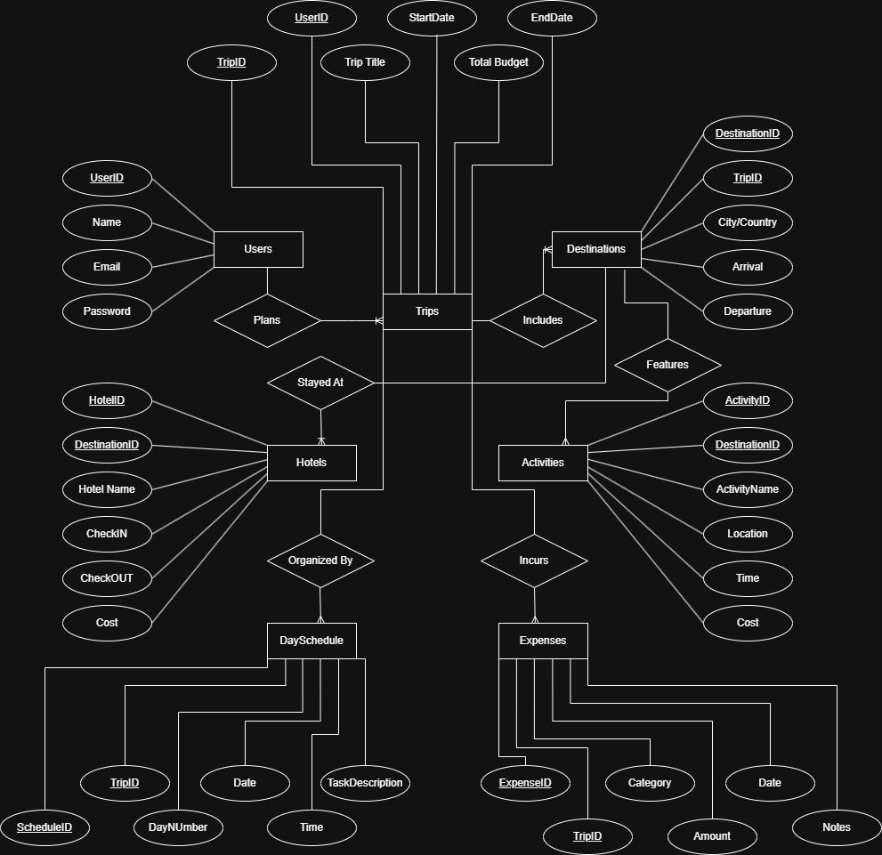

Database Schema (MySQL Workbench):
The CREATE TABLE statements below define the complete relational schema. All tables use primary keys, foreign keys, NOT NULL constraints, and CHECK constraints.

1. Users Table:
CREATE TABLE Users (
UserID INT PRIMARY KEY AUTO_INCREMENT,
Name VARCHAR(100) NOT NULL,
Email VARCHAR(150) NOT NULL UNIQUE,
Password VARCHAR(255) NOT NULL
);

2. Trips Table:
CREATE TABLE Trips (
TripID INT PRIMARY KEY AUTO_INCREMENT,
UserID INT NOT NULL,
TripTitleVARCHAR(200) NOT NULL,
StartDate DATE NOT NULL,
EndDate DATE NOT NULL,
TotalBudgetDECIMAL(10,2) NOT NULL CHECK (TotalBudget>= 0),
CONSTRAINT FK_Trips_Users FOREIGN KEY (UserID) REFERENCES Users(UserID),
CONSTRAINT CHK_Trips_Dates CHECK (EndDate>StartDate)
);

3. Destinations Table:
CREATE TABLE Destinations (
DestinationID INT PRIMARY KEY AUTO_INCREMENT,
TripID INT NOT NULL,
City VARCHAR(100) NOT NULL,
Country VARCHAR(100) NOT NULL,
ArrivalDate DATE NOT NULL,
DepartureDate DATE NOT NULL,
CONSTRAINT FK_Dest_Trips FOREIGN KEY (TripID) REFERENCES Trips(TripID),
CONSTRAINT CHK_Dest_Dates CHECK (DepartureDate>ArrivalDate)
);

4. Hotels Table:
CREATE TABLE Hotels (
HotelID INT PRIMARY KEY AUTO_INCREMENT,
DestinationID INT NOT NULL,
HotelNameVARCHAR(200) NOT NULL,
CheckIn DATE NOT NULL,
CheckOut DATE NOT NULL,
CostPerNight DECIMAL(10,2) NOT NULL CHECK (CostPerNight>= 0),
CONSTRAINT FK_Hotels_Dest FOREIGN KEY (DestinationID) REFERENCES Destinations(DestinationID),
CONSTRAINT CHK_Hotel_Dates CHECK (CheckOut>CheckIn)
);

5. Activities Table:
CREATE TABLE Activities (
ActivityID INT PRIMARY KEY AUTO_INCREMENT,
DestinationID INT NOT NULL,
ActivityName VARCHAR(200) NOT NULL,
Location VARCHAR(200) NOT NULL,
ActivityTime TIME NOT NULL,
Cost DECIMAL(10,2) NOT NULL CHECK (Cost >= 0),
CONSTRAINT FK_Activities_Dest FOREIGN KEY (DestinationID) REFERENCES Destinations(DestinationID)
);

6. DaySchedule Table:
CREATE TABLE DaySchedule (
ScheduleID INT PRIMARY KEY AUTO_INCREMENT,
TripID INT NOT NULL,
DayNumber INT NOT NULL CHECK (DayNumber>= 1),
ScheduleDate DATE NOT NULL,
ScheduleTime TIME NOT NULL,
TaskDescriptionVARCHAR(500) NOT NULL,
CONSTRAINT FK_DaySched_Trips FOREIGN KEY (TripID) REFERENCES Trips(TripID)
);

7. Expenses Table:
CREATE TABLE Expenses (
ExpenseID INT PRIMARY KEY AUTO_INCREMENT,
TripID INT NOT NULL,
Category VARCHAR(100) NOT NULL
CHECK (Category IN ('Hotel','Transport','Food','Activities','Shopping','Other')),
Amount DECIMAL(10,2) NOT NULL CHECK (Amount >= 0),
ExpenseDate DATE NOT NULL,
Notes VARCHAR(500),
CONSTRAINT FK_Expenses_Trips FOREIGN KEY (TripID) REFERENCES Trips(TripID)
);

Table Relationships Summary:
Relationship | Type | Foreign Key
Users → Trips | One-to-Many | Users.UserID → Trips.UserID
Trips → Destinations | One-to-Many | Trips.TripID → Destinations.TripID
Destinations → Hotels | One-to-Many | Destinations.DestinationID → Hotels.DestinationID
Destinations → Activities | One-to-Many | Destinations.DestinationID → Activities.DestinationID
Trips → DaySchedule | One-to-Many | Trips.TripID → DaySchedule.TripID
Trips → Expenses | One-to-Many | Trips.TripID → Expenses.TripID

MILESTONE 2:

Normalization — Formal Analysis:
This section documents the complete normalization of the Travel Itinerary Planner schema from 1NF through 3NF. Each table is analyzed individually with issue, change, and justification recorded.

Step 1 — Normalization Process:

First Normal Form (1NF):
Rule: All columns hold atomic (single, indivisible) values. Each table has a primary key. No repeating groups or multi-valued columns.
Users — 1NF:
Table | Users
Issue / Check | Check: atomic values, primary key, no repeating groups.
Change Made | No change required.
Justification | UserID is the primary key. Name, Email, Password are all single-valued atomic strings. Email is UNIQUE. No multi-valued attributes or repeating groups. Satisfies 1NF.

Trips — 1NF:
Table | Trips
Issue / Check | Check: atomic values, no repeating groups. Verify ERD City/Country label not carried into Trips.
Change Made | No change required to Trips. City/Country label was in Destinations ERD only.
Justification | TripID is PK. TripTitle, StartDate, EndDate, TotalBudget are all atomic. UserID is a single FK integer per row. Satisfies 1NF.

Destinations — 1NF:
Table | Destinations
Issue / Check | Issue: ERD shows 'City/Country' as one combined oval — possible 1NF violation if stored as one concatenated column.
Change Made | Confirmed: SQL schema already uses separate City VARCHAR(100) and Country VARCHAR(100) columns. ERD label updated to show two distinct ovals.
Justification | DestinationID is PK. City and Country are separate atomic columns. ArrivalDate and DepartureDate are individual DATE fields. Satisfies 1NF. ERD corrected in Step 3.

Hotels — 1NF:
Table | Hotels
Issue / Check | Check: no repeating amenity lists or multi-valued fields.
Change Made | No change required.
Justification | HotelID is PK. All columns single-valued and atomic. Satisfies 1NF.

Activities — 1NF:
Table | Activities
Issue / Check | Check: ActivityName, Location, ActivityTime, Cost — all atomic?
Change Made | No change required.
Justification | ActivityID is PK. Every attribute holds exactly one value per row. Satisfies 1NF.

DaySchedule — 1NF:
Table | DaySchedule
Issue / Check | Check: TaskDescription — could it store multiple tasks in one cell?
Change Made | No change required. TaskDescription holds one task per row. Multiple tasks on same day = multiple rows with different ScheduleIDs.
Justification | ScheduleID is PK. All columns atomic. Satisfies 1NF.

Expenses — 1NF:
Table | Expenses
Issue / Check | Check: Category CHECK constraint — is it storing a set in one cell?
Change Made | No change required. CHECK is a validation rule, not multi-value storage. Each row holds one category.
Justification | ExpenseID is PK. All columns single-valued. Satisfies 1NF.

Second Normal Form (2NF):
Rule: In 2NF AND every non-key attribute fully depends on the entire primary key. Partial dependency only possible with composite primary keys.

All 7 Tables — 2NF:
Table | All 7 Tables
Issue / Check | Do any non-key columns depend on only part of the primary key?
Change Made | No change required for any table.
Justification | Every table uses a single-column surrogate primary key (AUTO_INCREMENT INT). With a single-column PK, partial functional dependency is mathematically impossible — there is no 'part of the key' to partially depend on. All 7 tables satisfy 2NF.

Third Normal Form (3NF):
Rule: In 2NF AND no non-key attribute is transitively dependent on the primary key via another non-key attribute.
Users — 3NF:
Table | Users
Issue / Check | Does Email → Name or Password? Transitive chain via non-key columns?
Change Made | No change required.
Justification | Email has a UNIQUE constraint but does not functionally determine Name or Password in a database transitive sense. All non-key attributes are independent facts about UserID. Satisfies 3NF.

Trips — 3NF:
Table | Trips
Issue / Check | Does TotalBudget derive from StartDate + EndDate? Does TripTitle determine other columns?
Change Made | No change required.
Justification | TotalBudget is user-entered, not computed. TripTitle is descriptive only. No transitive dependencies. Satisfies 3NF.

Destinations — 3NF:
Table | Destinations
Issue / Check | Could Country → City create transitive dependency?
Change Made | No change required.
Justification | City does not determine Country or vice versa in a travel context. Both are direct properties of DestinationID. Satisfies 3NF.

Hotels — 3NF:
Table | Hotels
Issue / Check | Could HotelName → DestinationID? Could CheckIn/CheckOut determine CostPerNight?
Change Made | No change required.
Justification | HotelName does not determine DestinationID (same chain name could appear at multiple destinations). CostPerNight is user-entered, not computed from dates. Satisfies 3NF.

Activities — 3NF:
Table | Activities
Issue / Check | Does Location → DestinationID transitively? Could ActivityName determine Cost?
Change Made | No change required.
Justification | Location is a descriptive string, not a deterministic FK. ActivityName does not determine Cost. All non-key attributes depend solely on ActivityID. Satisfies 3NF.

DaySchedule — 3NF:
Table | DaySchedule
Issue / Check | Potential issue: TripID + DayNumber could determine ScheduleDate transitively.
Change Made | Identified and evaluated. ScheduleDate retained by design decision. See justification.
Justification | TripID + DayNumber could theoretically derive ScheduleDate (Day 1 = StartDate + 0). However, ScheduleDate is kept as an explicit column to allow flexible scheduling (pre/post-trip tasks) and avoid mandatory JOINs to Trips. Documented design decision — not a violation under this rationale.

Expenses — 3NF:
Table | Expenses
Issue / Check | Does Category → Amount? Does ExpenseDate → TripID?
Change Made | No change required.
Justification | Category does not determine Amount (same category has varying amounts). ExpenseDate does not determine TripID. All non-key attributes depend only on ExpenseID. Satisfies 3NF.

Step 2 — Duplicate & Redundancy Check
All tables reviewed for redundant columns, repeated data, and overlapping attributes.
Table | Issue Found | Action Taken
Destinations | City/Country combined ERD label | Confirmed two separate DB columns. ERD updated to show City and Country as distinct ovals.
Hotels | Cost column — ambiguous (per night vs total?) | Renamed to CostPerNight for semantic clarity.
Activities | Cost column — similar ambiguity | Retained as Cost (flat per-activity fee). No overlap with Hotels.
DaySchedule | ScheduleDate could overlap trip date logic | Retained — independently entered date for flexible planning.
All Tables | No cross-table column duplication found | No structural changes required.

Step 3 — Updated ERD:
Changes reflected: City/Country split into two attribute ovals. Hotels.Cost renamed to CostPerNight. All PKs underlined, all FK cardinalities confirmed.
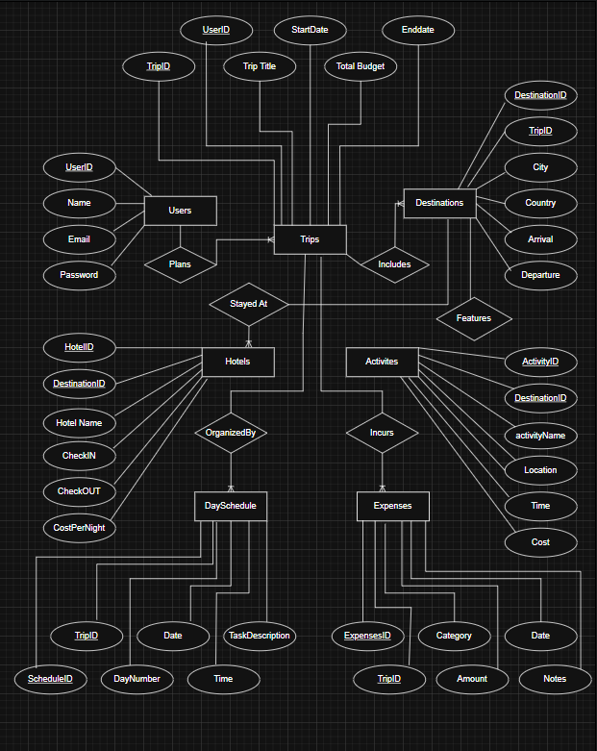

MILESTONE 3:

Dataset Preprocessing:
This section documents the complete dataset preparation for the Travel Itinerary Planner database. Since this project is built on a custom schema (not sourced from a real-world CSV dataset), structured synthetic data was generated using Python with the Faker library. All data is realistic, referentially consistent, and sufficient to populate every core table.

Step 1 — Dataset Preparation:

Approach: Synthetic Data Generation with Python Faker:
The Faker library was used to generate realistic names, emails, dates, and other values. A fixed random seed (seed=42) was applied to both Python's random module and Faker to make the dataset fully reproducible. Real-world city/country pairs (e.g., Istanbul/Turkey, Paris/France, Tokyo/Japan) and curated activity lists were used to make the data meaningful rather than purely random.

Dataset Volume Summary:
Table | Rows Generated | Source | Min Req. | Status
Users | 75 | Faker (Python) | 50 | ✓ Meets requirement
Trips | 90 | Faker (Python) | 50 | ✓ Meets requirement
Destinations | 100 | Faker + Real Cities | 50 | ✓ Meets requirement
Hotels | 100 | Faker + Real Cities | 50 | ✓ Meets requirement
Activities | 100 | Curated Activity List | 50 | ✓ Meets requirement
DaySchedule | 100 | Faker (Python) | 50 | ✓ Meets requirement
Expenses | 100 | Faker (Python) | 50 | ✓ Meets requirement

Preprocessing Steps Applied:
The following preprocessing steps were applied during generation to ensure clean, consistent, and database-ready data:
Preprocessing Step | Table(s) Affected | Action Taken
Duplicate Removal | All tables | Each table uses AUTO_INCREMENT primary keys (UserID, TripID, etc.). The Python generator tracks used email addresses in a set to guarantee uniqueness. No duplicate rows exist in any CSV.
Email Uniqueness | Users | A Python set() tracks all generated emails. If a collision occurs, a new email is regenerated until unique. The UNIQUE constraint in MySQL will enforce this at load time.
Date Consistency | Trips, Destinations, Hotels | All EndDate>StartDate, DepartureDate>ArrivalDate, and CheckOut>CheckIn constraints are enforced in the generator logic before writing rows. No date-inverted rows exist in the CSVs.
Data Type Consistency | All tables | All IDs are integers. All dates are ISO-8601 (YYYY-MM-DD). All times are HH:MM:SS. All monetary values are decimal with 2 decimal places. All string fields are non-empty where NOT NULL is required.
Null / Missing Values | Expenses.Notes | Notes is the only nullable column in the schema. The generator intentionally leaves it blank for ~37% of rows to reflect realistic data (not all expenses need a note). All other columns are always populated.
Referential Integrity | All FK columns | FK values are assigned directly from parent-table IDs during generation (e.g., Trips.UserID is always drawn from the Users list). No orphaned foreign keys exist in any CSV.
Category Validation | Expenses.Category | Only the six allowed values — Hotel, Transport, Food, Activities, Shopping, Other — are used. The generator draws from this exact list, matching the CHECK constraint in the schema.
Realistic Data Values | Hotels, Activities | Hotel names use a real city name combined with random prefix/suffix (e.g., 'Grand Istanbul Resort'). Activities are drawn from a curated list of 20 real travel activities. Cost ranges are realistic (hotel: $40–$450/night, activities: $10–$200).

Step 2 — Dataflow Definition:
This section explains exactly how data enters the Travel Itinerary Planner system, how it flows through the tables, and what comes out at the end. This is specific to this project — the flow is driven by the hierarchical nature of trip planning.

Data Entry Point:
All data entry begins with the Users table. A user must exist before any trip, destination, hotel, activity, schedule, or expense can be created. This is because every trip is linked to a UserID via a foreign key, and all downstream tables link through trips or destinations.

Dataflow Through the System — Stage by Stage:
Stage | Table(s) | Data Direction | Description
1 — Entry | Users | INSERT | A new user registers with Name, Email, and Password. This is the starting point of all data in the system. No trip can exist without a valid user.
2 — Trip Creation | Trips | INSERT (depends on Users) | The user creates a trip by entering a title, start/end dates, and a total budget. The UserID foreign key links it to the registered user.
3 — Destination Planning | Destinations | INSERT (depends on Trips) | For each trip, one or more destinations are added with city, country, arrival, and departure dates. A trip can include multiple destinations (e.g., Dubai then Paris).
4 — Hotel Booking | Hotels | INSERT (depends on Destinations) | Each destination gets a hotel assigned — with name, check-in/out dates, and cost per night. Hotels are scoped to a specific destination, not the trip directly.
5 — Activity Scheduling | Activities | INSERT (depends on Destinations) | Activities (tours, safaris, cruises, etc.) are attached to a destination, with time and cost. Multiple activities can exist per destination.
6 — Day Planning | DaySchedule | INSERT (depends on Trips) | Day-by-day task scheduling is added for the trip — each row represents one time slot on one day, with a description of the planned task.
7 — Expense Tracking | Expenses | INSERT (depends on Trips) | As money is spent, expense records are added — linked to the trip with a category, amount, date, and optional notes.
8 — Query Output | All Tables | SELECT (READ) | Users query the system to view itineraries, calculate total costs (SUM of hotel nights + activity costs + expenses), filter trips by date, or export reports.

Dataflow Diagram (Textual):
The dependency chain below shows the order in which tables must receive data:

[User registers]
│
▼
USERS (UserID, Name, Email, Password)
│
▼
TRIPS (TripID ← UserID, TripTitle, StartDate, EndDate, TotalBudget)
│
├─────────────────┬─────────────────────┬
▼ ▼ ▼
DESTINATIONS DAYSCHEDULE EXPENSES
(DestinationID ← TripID) (ScheduleID ← TripID) (ExpenseID ← TripID)
│
├──────────────────────────┬
▼ ▼
HOTELS ACTIVITIES
(HotelID ← DestinationID) (ActivityID ← DestinationID)
│
▼
[Query Output: Itineraries, Cost Reports, Schedules, Exports]

What Comes Out of the System:
The Travel Itinerary Planner produces the following outputs through SELECT queries:

- Full Trip Itinerary — A user can retrieve all destinations, hotels, activities, and day schedule entries for any trip with a JOIN across Trips, Destinations, Hotels, Activities, and DaySchedule.
- Total Trip Cost Report — Calculated by summing hotel nightly costs × nights stayed, activity costs per destination, and all expense amounts for a given TripID.
- Day-by-Day Schedule — Extracted from DaySchedule filtered by TripID, ordered by DayNumber and ScheduleTime.
- Budget vs Actual Spending — Trips.TotalBudget compared against SUM(Expenses.Amount) for the same TripID.
- Destination Summary — All cities and countries visited across all trips for a given UserID.
- CSV Export — The clean dataset CSVs generated in Step 1 and Step 3 are used in Milestone 5 to load data into the live MySQL database via LOAD DATA INFILE or INSERT statements.

Step 3 — Exported Clean CSV Files:
Seven CSV files were exported — one per table — using the Python generation script. Each file is clean, consistent, and ready for database import in Milestone 5. The files must be loaded in the order shown below to satisfy foreign key constraints.

File Name | Rows | Primary Key | Foreign Keys
users.csv | 75 | UserID | None
trips.csv | 90 | TripID | UserID → users.csv
destinations.csv | 100 | DestinationID | TripID → trips.csv
hotels.csv | 100 | HotelID | DestinationID → destinations.csv
activities.csv | 100 | ActivityID | DestinationID → destinations.csv
dayschedule.csv | 100 | ScheduleID | TripID → trips.csv
expenses.csv | 100 | ExpenseID | TripID → trips.csv

CSV Load Order for Milestone 5:
When importing into MySQL, the following order must be followed:

Load Order:
1. users.csv (no dependencies)
2. trips.csv (depends on users.csv)
3. destinations.csv (depends on trips.csv)
4. hotels.csv (depends on destinations.csv)
5. activities.csv (depends on destinations.csv)
6. dayschedule.csv (depends on trips.csv)
7. expenses.csv (depends on trips.csv)

MILESTONE 4:

Database Setup (DDL):
In this milestone, the finalized normalized database schema for the Travel Itinerary Planning System was implemented using SQL Data Definition Language (DDL) statements in MySQL. All required tables including Users, Trips, Destinations, Hotels, Activities, DaySchedule, and Expenses were created with properly defined primary keys and foreign key relationships to maintain referential integrity between entities.
Appropriate constraints such as NOT NULL, UNIQUE, and CHECK constraints were applied to ensure data accuracy, consistency, and validation. Additional indexes were created on foreign key columns and frequently searched attributes to improve query performance and database efficiency.
The complete schema was successfully verified in MySQL Workbench, and the generated EER (Enhanced Entity Relationship) diagram confirmed that all tables, relationships, and constraints matched the designed database structure.

EER Diagram:

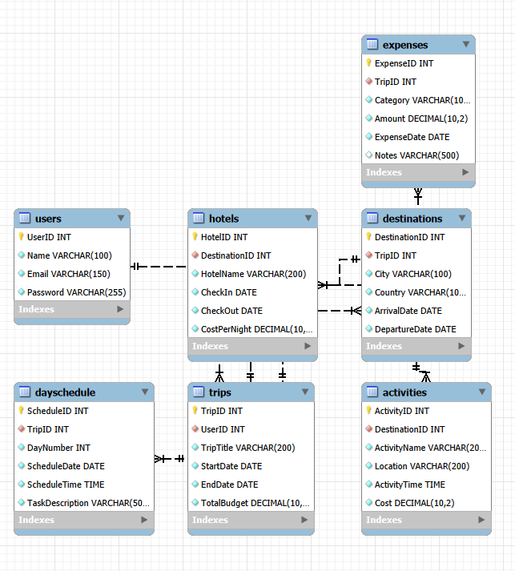
MILESTONE 5:
This milestone focuses on populating the Travel Itinerary Planner database with real data using SQL DML (Data Manipulation Language) statements, followed by validation queries to confirm data integrity
1. Data Loading (INSERT statements):
All 665 rows were loaded across 7 tables using multi-row INSERT statements in foreign-key-safe order:
Table | Rows Inserted
Users | 75
Trips | 90
Destinations | 100
Hotels | 100
Activities | 100
Expenses | 100
DaySchedule | 100
Data was sourced from preprocessed Excel files (.xltx) prepared in Milestone 3. Tables were loaded in dependency order (Users → Trips → Destinations → Hotels → Activities → Expenses → DaySchedule) to respect foreign key constraints. SET FOREIGN_KEY_CHECKS = 0 was used during the bulk load for efficiency, then re-enabled after.
2. UPDATE Operations:
Three UPDATE statements with WHERE conditions were demonstrated:
- Updated TotalBudget by 10% for all trips belonging to a specific user
- Corrected CostPerNight for a specific hotel by HotelID and name
- Added explanatory notes to high-value Food expenses (over $1000) that had no note
Before: After:
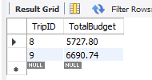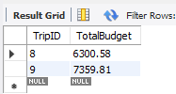

3 DELETE Operations
Two DELETE statements with WHERE conditions were demonstrated:
- Removed a specific duplicate expense record by ExpenseID
- Removed DaySchedule entries whose ScheduleDate fell before their linked trip's StartDate, using a JOIN-based subquery for data quality cleanup
Before: After:
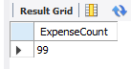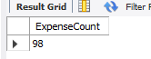
4. Validation Queries:Three categories of validation were run after loading:
Row Count Check: A single UNION query confirmed correct row counts across all 7 tables using COUNT(*).
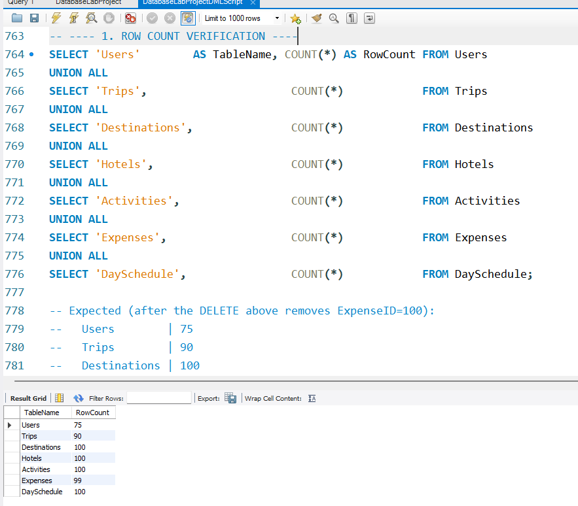

NULL Check: Every non-nullable key column in all 7 tables was checked. All returned 0 NULL values, confirming data completeness.
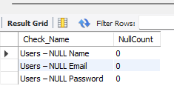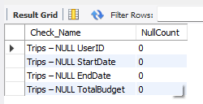
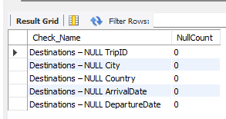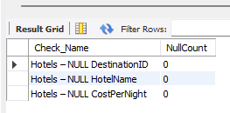

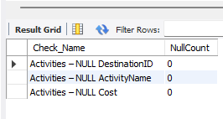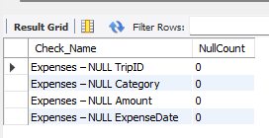

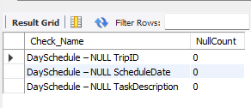

Foreign Key Integrity (JOIN-based): Six LEFT JOIN queries were run, one per foreign key relationship:
- Trips → Users
- Destinations → Trips
- Hotels → Destinations
- Activities → Destinations
- Expenses → Trips
- DaySchedule → Trips
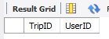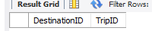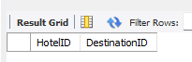

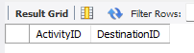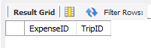
All returned 0 orphan rows, confirming referential integrity is fully intact.

Bonus Cross-table JOIN: A summary query joining all 5 main tables was included, showing traveller name, destination count, total hotel nights, total expenses, and remaining budget per trip.

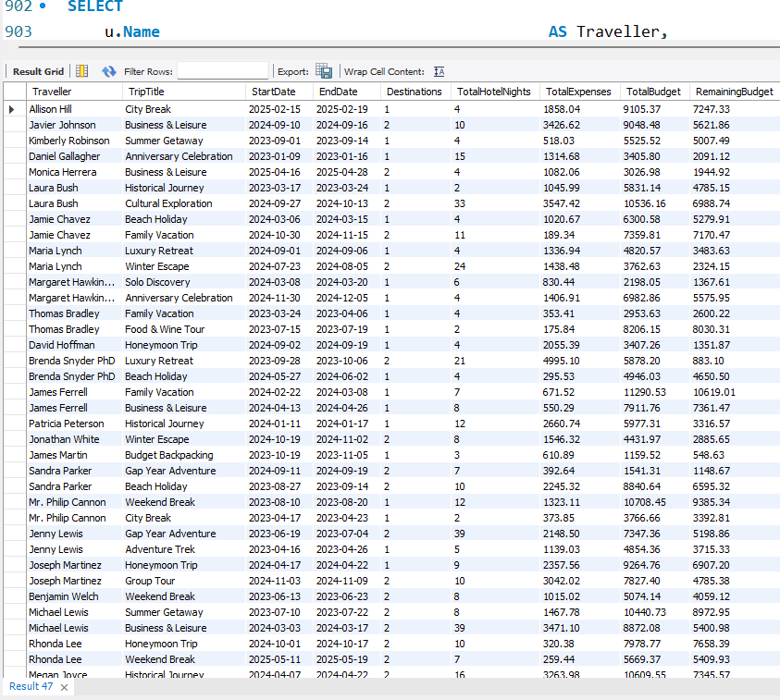

GitHub repository link:

https://github.com/ghazalk350/DatabaseLabProject

https://github.com/ghazalk350/DatabaseLabProject.git

