Matrimonial Details

Dr. Inaya Jahangeer
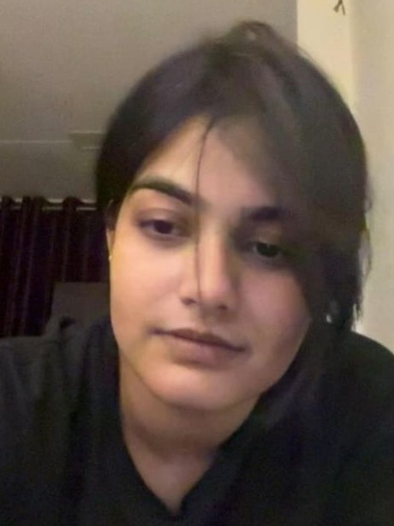
Education MBBS (2026) from Govt Medical College Kota (Result Awaited)
Aspiring to continue with Post Graduation

Year of Birth/Age 2002/24Y
Appearance Fair complexion, 5’5” high and slim

Native Place Bikaner (Rajasthan)

Hobbies/Interests Cooking, Reading

Religious Ideology Sunni Islam



About Family

Father Dr. Jahangeer, Radiologist
Mother Shabana Farooqui, LL.B., Homemaker

Father’s Message

AsSalaamuAlaikum. My daughter Inaya is our only child. She has been brought up with fully devoted care by my wife. She has good moral and religious virtues.
She also has very bright academic records. After schooling in Bikaner, she joined MBBS in Govt Medical College, Kota. Now, she is preparing for her PG entrance exam after completing MBBS this year.
We are looking for a suitable match and the boy should be MS/MD from a reputable medical college.
Dr. Jahangeer
(Mobile No. 9269935504)

