Week 2 Lab Report
Footprinting, Reconnaissance and Network Scanning
NetworkWalks Cybersecurity Internship
Batch B082 - Week 2
Project Module 4

Ghazi Smach
17 September 2026

1. Overview
This report covers two lab modules completed in Week 2. Both are reconnaissance, but they work in opposite ways.
Module | Tool | Type | Target
Footprinting and reconnaissance | theHarvester | Passive | microsoft.com
Network scanning | Zenmap / Nmap | Active | Local lab network

Passive reconnaissance collects information that is already public, without sending anything to the target. The organisation being studied has no way to know it happened. Active scanning sends packets directly to machines and can be logged by them.
This difference decides what is safe and legal to run against whom. The theHarvester module was pointed at a domain I do not own, which is acceptable because no traffic ever reached it. The Zenmap module sends real packets, so it was run only against a virtual network on my own computer.

Environment
Item | Value
Host | Windows 11, VirtualBox
Guest | Kali Linux
Kali IP address | 10.0.2.16 / 24
theHarvester version | 4.11.1
Nmap version | 7.99

2. Module PM4 - Footprinting with theHarvester

2.1 What theHarvester does
theHarvester gathers e-mail addresses, sub-domains, host names, employee names, open ports and banners from public sources such as search engines, PGP key servers and databases like SHODAN. It is written in Python and comes pre-installed in Kali Linux, so no installation was needed.
The information it collects matters because of what it becomes:
- Every e-mail address found is a possible target for phishing and password attacks.
- Every sub-domain is another way into the organisation, often one the defenders have forgotten about. Old test and staging servers are rarely kept patched to the same standard as the main website.
Because the tool only reads public data, the target never knows it is being studied. That is what makes this kind of reconnaissance powerful and very hard to detect. Defenders run the same tool against their own organisation to see what an attacker would see, and then reduce what they leak.

2.2 Starting the tool
theHarvester was launched from the Kali applications menu.
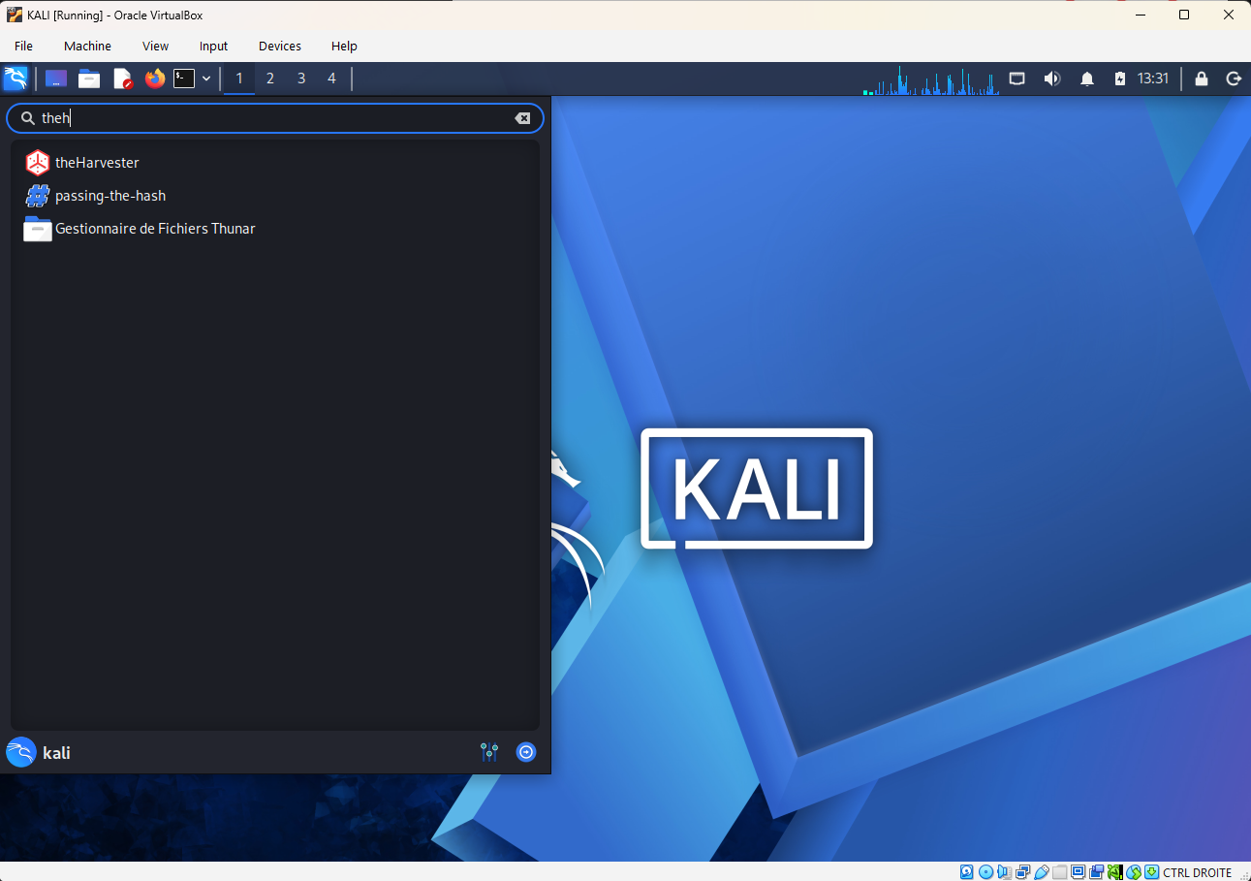
Figure 1 - theHarvester in the Kali applications menu

2.3 Task 1 - search using Baidu, limit 1000
Task: find e-mail IDs and sub-domains related to microsoft.com using Baidu, with the number of results limited to 1000.
Command used:
theHarvester -d microsoft.com -l 1000 -b baidu
The options mean:
Option | Meaning
-d | The target domain
-l | Limit on the number of results
-b | The source to search

The -b option accepts a long list of sources. The screenshot below shows the end of that list, with the Task 1 command typed underneath.
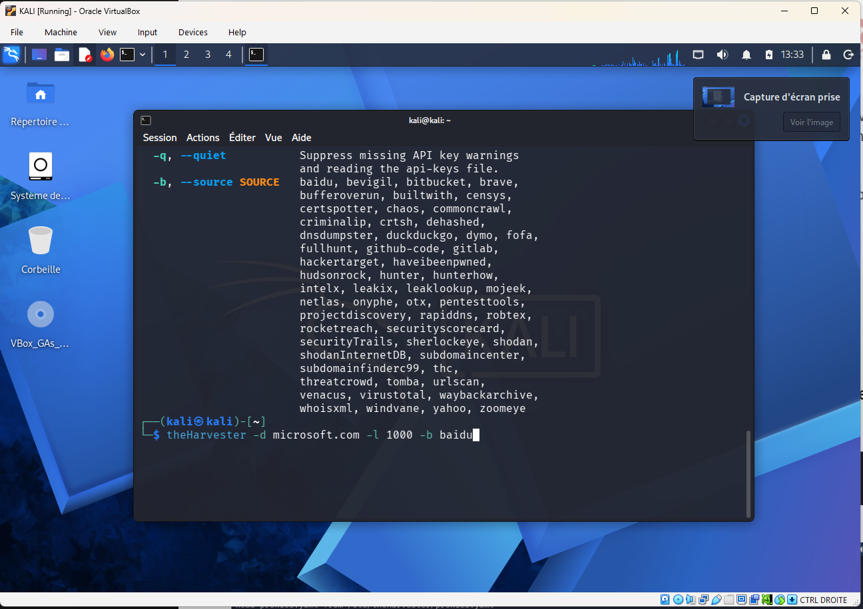
Figure 2 - Available sources and the Task 1 command
The list includes very different kinds of source, such as crtsh for certificate transparency logs, shodan, haveibeenpwned and dnsdumpster. This is why the choice of source changes the results so much.

Result
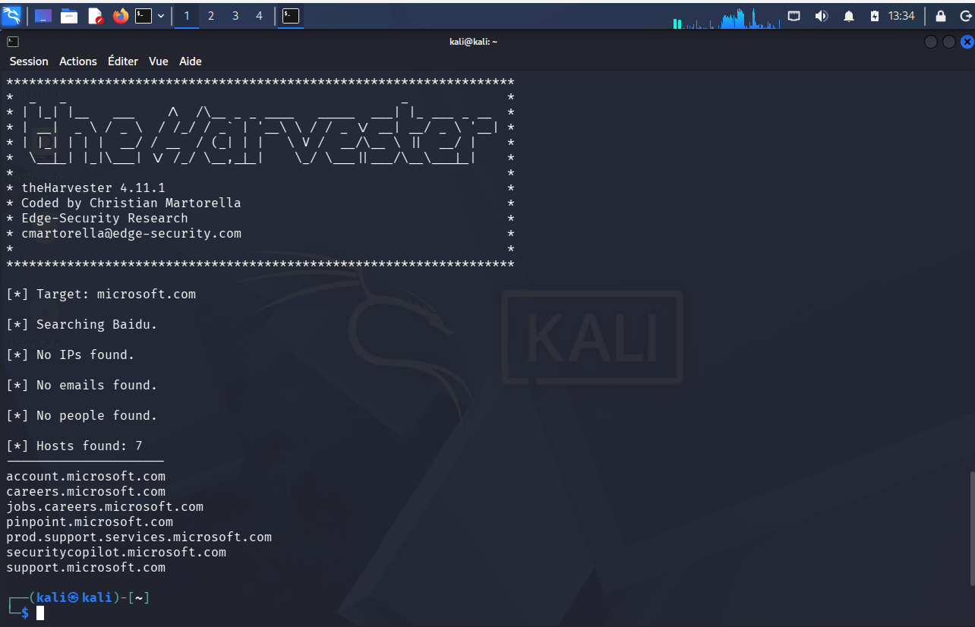
Figure 3 - Task 1 output - seven hosts found through Baidu
Output:
[*] Target: microsoft.com
[*] Searching Baidu.
[*] No IPs found.
[*] No emails found.
[*] No people found.
[*] Hosts found: 7
---------------------
account.microsoft.com
careers.microsoft.com
jobs.careers.microsoft.com
pinpoint.microsoft.com
prod.support.services.microsoft.com
securitycopilot.microsoft.com
support.microsoft.com
Seven hosts were found. No e-mail addresses, no people and no IP addresses.
The empty results are not a failure, and they are the more interesting half of the output. A limit of 1000 does not mean 1000 results exist; it only caps what the tool will accept. Baidu is a single search engine, it indexes Microsoft lightly compared with its coverage of Chinese-language sites, and search engines are a poor source for e-mail addresses in the first place. The limit was never the constraint here. The source was.
The seven sub-domains found are all public-facing and unremarkable, which is what would be expected from an organisation the size of Microsoft.

2.4 Task 2 - search using all sources, limit 50
Task: the same search against microsoft.com, but using all available sources and with the number of results limited to 50. This was run in a second terminal window.
Command used:
theHarvester -d microsoft.com -l 50 -b all
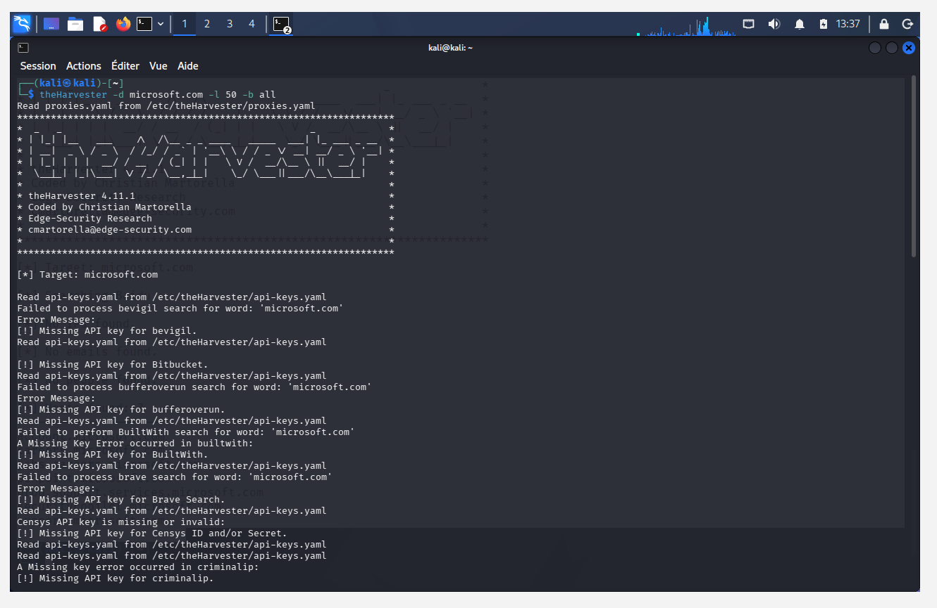
Figure 4 - Task 2 output - missing API key warnings

What happened
The run immediately filled with warnings:
Read api-keys.yaml from /etc/theHarvester/api-keys.yaml
Failed to process bevigil search for word: 'microsoft.com'
[!] Missing API key for bevigil.
[!] Missing API key for Bitbucket.
[!] Missing API key for bufferoverun.
[!] Missing API key for BuiltWith.
[!] Missing API key for Brave Search.
[!] Missing API key for Censys ID and/or Secret.
[!] Missing API key for criminalip.
This is expected on a default Kali installation and is not an error that needed fixing. The option -b all asks theHarvester to query every source it knows about, and many of those are commercial services that require a registered key in the file /etc/theHarvester/api-keys.yaml. With no keys configured, each of those sources fails and the tool moves on to the next one. Only the free sources return anything.
This means the name of the option is misleading. In practice -b all means all sources you have credentials for, and on a fresh installation that is a much smaller set. Shodan and Censys are exactly the sources that would produce the richest information, and they are exactly the ones that require a key.
Note: the screenshot was taken while the API key warnings were still scrolling past, so the final result counts for Task 2 were not captured. This needs to be run again, writing the output to a file rather than relying on the terminal scrollback.

2.5 Comparison of the two tasks
 | Task 1 | Task 2
Source | baidu | all
Limit | 1000 | 50
Hosts found | 7 | Not captured
E-mails found | 0 | Not captured
API keys required | None | Most sources

3. Module - Network Scanning with Zenmap

3.1 What Zenmap does
Zenmap is the official graphical front end for Nmap. It builds the command for you, keeps a history of scans and draws a topology map of the results. The Command box at the top of the window always shows the actual nmap command being run, so the same work can be done from the terminal.
A ping scan, also called host discovery, answers one question: which addresses on this network have something alive on them. It does not check for open ports or identify services. That comes later.
This is the first genuinely active step of the week. Every host that replies has received a packet from me and could have recorded it. Inside my own virtual network that does not matter, but it is the reason this module comes after the passive one.

3.2 Starting Zenmap
Zenmap opens on the Intense scan profile by default, which builds the command nmap -T4 -A -v.
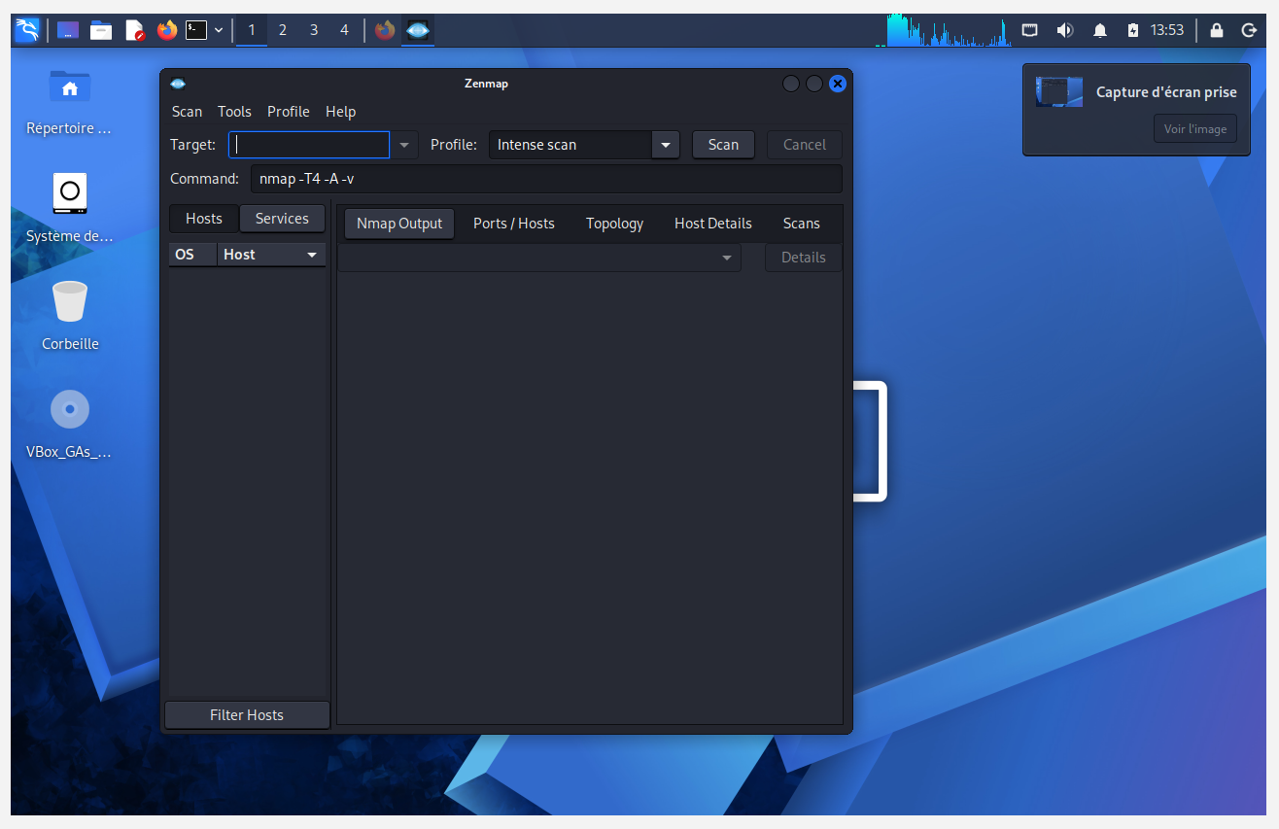
Figure 5 - Zenmap on launch, showing the default Intense scan profile
That default is worth understanding before pressing Scan. The -A option turns on operating system detection, version detection, script scanning and traceroute all at once, and -T4 speeds the scan up aggressively. It is noisy, slow against a whole subnet, and far more than is needed to answer the question of what is alive on the network. The profile was changed to Ping scan instead.

3.3 Finding the network to scan
Before scanning a network you need to know which network you are on.
ifconfig
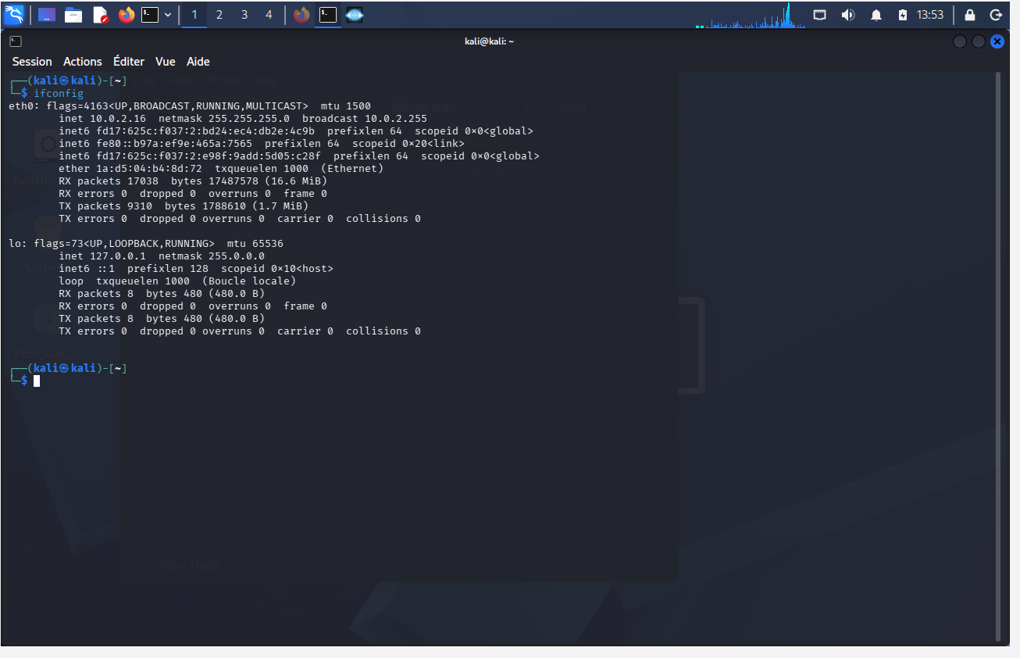
Figure 6 - ifconfig output showing eth0 on 10.0.2.16
The relevant part of the output:
eth0: flags=4163<UP,BROADCAST,RUNNING,MULTICAST> mtu 1500
inet 10.0.2.16 netmask 255.255.255.0 broadcast 10.0.2.255
ether 1a:d5:04:b4:8d:72 txqueuelen 1000 (Ethernet)
The virtual machine is on 10.0.2.16 with a netmask of 255.255.255.0, which makes the local network 10.0.2.0/24.

3.4 An unexpected finding: the address had changed
This is not the address that was configured in Week 1.
 | Week 1 | Now
Address | 10.0.0.2 | 10.0.2.16
Network | 10.0.0.0/24 | 10.0.2.0/24
Source | Static, set manually | DHCP

Two things show that the address came from DHCP rather than the static configuration set up in Week 1:
- An address ending in .16 is typical of a DHCP pool. A manually assigned host would not normally land there.
- 10.0.2.0/24 is the default network used by VirtualBox plain NAT. The NAT Network created in Week 1 was 10.0.0.0/24.
This means the network adapter is attached to plain NAT and not to the NatNetwork, so the static IP address is not in effect. The most likely cause is that the adapter was switched back to NAT at some point, which discards both the NAT Network attachment and the manual address.
This matters because it changes what the scan below actually shows. It is a scan of the default VirtualBox NAT segment, not of the isolated multi-machine lab network that Week 1 set out to build.

3.5 Running the ping scan
Target: 10.0.2.16/24. Profile: Ping scan.
nmap -sn 10.0.2.16/24
The -sn option means host discovery only, with no port scan. Giving the tool 10.0.2.16/24 rather than a single address tells it to sweep all 256 addresses in that range.
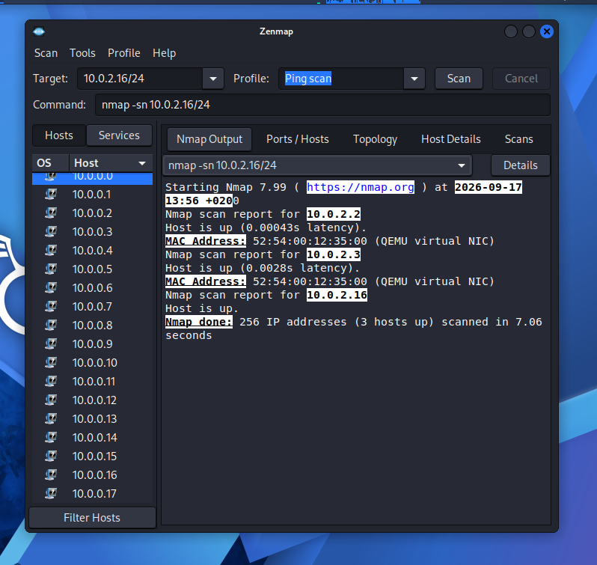
Figure 7 - Ping scan results - three hosts up out of 256
Output:
Starting Nmap 7.99 ( https://nmap.org ) at 2026-09-17 13:56 +0200
Nmap scan report for 10.0.2.2
Host is up (0.00043s latency).
MAC Address: 52:54:00:12:35:00 (QEMU virtual NIC)
Nmap scan report for 10.0.2.3
Host is up (0.0028s latency).
MAC Address: 52:54:00:12:35:00 (QEMU virtual NIC)
Nmap scan report for 10.0.2.16
Host is up.
Nmap done: 256 IP addresses (3 hosts up) scanned in 7.06 seconds

3.6 Reading the results
Three hosts were found alive out of 256 addresses, in 7 seconds.
Address | MAC address | What it is
10.0.2.2 | 52:54:00:12:35:00 | VirtualBox NAT gateway
10.0.2.3 | 52:54:00:12:35:00 | VirtualBox NAT DNS server
10.0.2.16 | None shown | The Kali virtual machine itself

Three details in this output are worth explaining.
Both gateways share the same MAC address.
10.0.2.2 and 10.0.2.3 report the identical MAC address 52:54:00:12:35:00. On real hardware that would be a misconfiguration. Here it shows that neither is a real machine: both are services provided by the same piece of the VirtualBox NAT engine, which answers on two addresses using one virtual network card.
The MAC prefix reveals the virtualisation.
The first half of a MAC address identifies the hardware manufacturer. The prefix 52:54:00 belongs to QEMU/KVM, and Nmap translates it automatically to QEMU virtual NIC using its built-in vendor table. Anyone landing on an unknown network can see immediately that these are virtual machines rather than physical ones, without any further probing.
No MAC address is shown for 10.0.2.16.
Nmap learns MAC addresses using ARP, which only works on the local network segment and only for other machines. 10.0.2.16 is the machine doing the scanning, so there is no ARP exchange and no MAC address to report. The line Host is up with no latency figure is Nmap recognising that it is scanning itself.
What is missing is also informative. No other virtual machines were found. Week 1 chose NAT Network specifically so that virtual machines could see each other, and this scan found only the gateway, the DNS server and itself. That is consistent with running on plain NAT, where each virtual machine is isolated in its own segment.

3.7 Topology map
The Topology tab draws the discovered hosts as a graph.
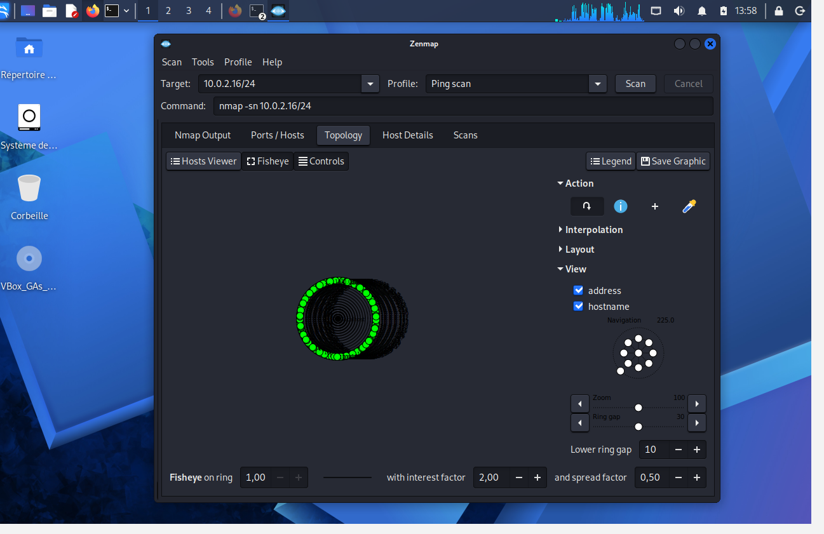
Figure 8 - Zenmap topology map of the scanned network
The map shows the scanned range as a ring of nodes around the scanning host. With only three live hosts on a flat network there is little structure to draw, because every host is one hop away. It therefore renders as a single ring rather than a branching diagram.
Topology maps are more useful on larger networks that have routers between segments, where the hop counts produce real depth in the diagram. Here it mainly confirms that the network is flat. A copy was saved using the Save Graphic button.

4. Problems encountered
theHarvester: expected e-mail addresses, found none.
The first assumption was that a limit of 1000 would produce a long list of addresses. It produced none. Search engines index web pages, and organisations stopped publishing staff e-mail addresses on web pages a long time ago. E-mail addresses come from breach databases and PGP key servers, which are different sources, and the useful ones require API keys.
theHarvester: the API key warnings looked like a broken installation.
They are not. They are the tool reporting, source by source, that it cannot authenticate. The run continues using whichever sources are free.
theHarvester: the Task 2 screenshot was taken too early.
The warnings were captured but not the summary at the end, so there are no result counts for Task 2. Writing the output to a file with the -f option is more reliable than screenshotting the terminal.
Zenmap: nearly scanned the wrong network.
The Week 1 range was about to be typed in from memory when ifconfig showed a different address. Checking the interface first is what caught it. Scanning 10.0.0.0/24 would have returned zero hosts, and the tool would probably have been blamed instead of the adapter setting.
Zenmap: the Intense scan profile was selected at first.
Running -T4 -A -v against a whole /24 network is a slow and noisy way to find out which hosts are alive. The Ping scan profile answered the same question in 7 seconds.

5. Still to do
- Re-run Task 2 of the theHarvester module and capture the final summary.
- Try the crtsh source. Certificate transparency logs are free, need no API key, and are a much better source of sub-domains than any search engine, because every TLS certificate issued is publicly logged.
- Register free API keys for one or two sources and compare the difference.
- Attach the network adapter back to NatNetwork, confirm that the static address 10.0.0.2 holds, and scan 10.0.0.0/24 again to compare.
- Add the second virtual machine planned in Week 1 and re-run the scan to confirm it appears.
- Follow the ping scan with a port scan once there is a real target machine.

6. Conclusions
The source matters more than the limit.
In Task 1 the option -l 1000 looked like the significant setting, but it was -b baidu that decided the outcome. A larger limit on a thin source returns the same thin results.
All is a claim about capability, not results.
The option -b all looked like the thorough choice but quietly reduced to the free subset of sources. It is worth checking what a tool actually did rather than what the option name implies, because the difference is invisible unless the warnings are read.
Empty output is still a finding.
Zero e-mail addresses from Baidu says something real about where that kind of data is held. It would have been easy to dismiss as the tool not working.
Check the interface before trusting the plan.
The lab was not on the network it was believed to be on, and the only reason this was noticed is that ifconfig was run before the scan. A configuration set up once in Week 1 was silently no longer in effect a week later.
MAC addresses carry information.
A repeated MAC address on two IP addresses, together with a 52:54:00 prefix, shows both that this is a single emulated device and that the environment is virtual. Neither fact required a port scan.
Host discovery is cheap and quiet.
256 addresses were checked in 7 seconds with -sn, compared with the several minutes an Intense scan would have taken. Finding out what is alive first and then scanning only those hosts is both faster and less noisy than scanning everything thoroughly.
The asymmetry of passive reconnaissance is the main lesson of the week.
Seven of Microsoft's sub-domains were collected with one command, in a few seconds, from a virtual machine on a desk, and nothing ever reached Microsoft. Whatever detection they have in place, none of it saw this, because there was nothing to see.

7. Note on responsible use
The theHarvester module sent no traffic to Microsoft. Everything it reported was read from third-party search engines and public databases that had already indexed the information.
The Zenmap module is active scanning, and it was run only against a virtual network on my own computer.
That distinction is the point of this week. Passive reconnaissance against a third party is reading public records. Active scanning against infrastructure you do not own can be an offence in itself, regardless of whether anything is exploited afterwards. These tools belong in the lab.

