**Air Quality Prediction Report**

***A Machine Learning-Based Analysis of Air Quality Index***

**1. Introduction**

Air quality is a vital indicator of environmental health, significantly impacting human well-being. Understanding the **Air Quality Index (AQI)** and its relation to key pollutants enables governments and stakeholders to manage pollution effectively and improve public health. This report outlines a machine learning approach to predict AQI and classify pollution levels using data from the Iranian Environmental Organization.

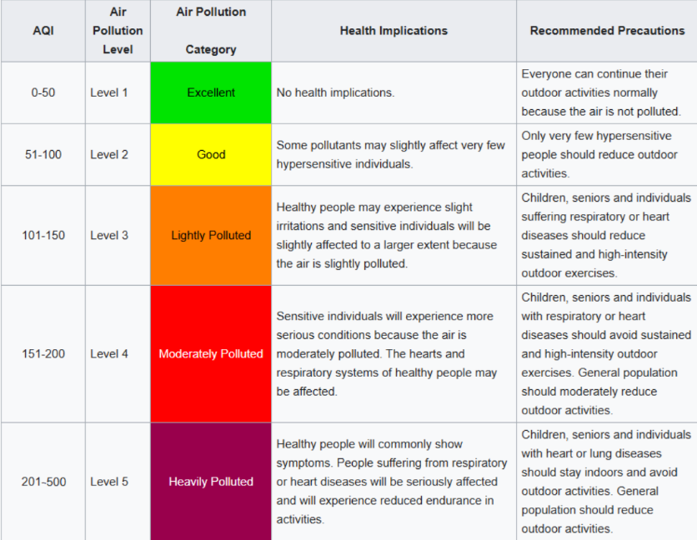

**2. Dataset Overview**

The dataset consists of:

* **2123 air pollution monitoring stations**
* Metrics included:
  + **CO** (Carbon Monoxide)
  + **O3** (Ozone)
  + **NO2** (Nitrogen Dioxide)
  + **SO2** (Sulfur Dioxide)
  + **PM10** (Particulate Matter 10)
  + **PM2.5** (Particulate Matter 2.5)

There is AQI as target.

**Data Preprocessing Steps:**

* **Missing Values:** Resolved using the median.
* **Duplicated Rows:** Removed.
* **Column Names and Contents:** Originally written in Persian; converted to English.

Two target variables were created:

1. **AQI Average**
2. **AQI Description**

**3. Regression Analysis**

**3.1 Models Used**

To predict the **AQI Average**, the following regression models were evaluated:

* Gradient Boosting
* XGBoost
* Random Forest
* KNN
* Decision Tree
* SVR
* Linear Regression, Ridge, Lasso, ElasticNet

**3.2 Evaluation Metrics**

* Mean Absolute Error (MAE)
* R² (Coefficient of Determination)

**3.3 Results**

The **best models** were:

|  |  |  |  |
| --- | --- | --- | --- |
| **Rank** | **Model** | **MAE** | **R²** |
| 1 | Gradient Boosting | 4.576557 | 0.909186 |
| 2 | Random Forest | 4.947887 | 0.905484 |
| 3 | XGBoost | 4.962615 | 0.905852 |
| 4 | KNN | 5.127256 | 0.873260 |
| 5 | Decision Tree | 5.332536 | 0.857144 |
| 6 | SVR | 6.478604 | 0.813697 |
| 7 | ElasticNet | 13.003160 | 0.693486 |
| 8 | Lasso | 13.003974 | 0.693382 |
| 9 | Linear Regression | 13.018671 | 0.691836 |
| 10 | Ridge | 13.018671 | 0.691836 |

**Best Hyperparameters:**

Gradient Boosting :

* learning_rate : 0.05
* max_depth : 10
* min_samples_split : 10
* n_estimators : 300
* subsample : 0.8

**3.4 Feature Importance**

For the **Gradient Boosting** model, feature importance was as follows:

|  |  |
| --- | --- |
| **Feature** | **Importance** |
| PM2.5 | 0.697276 |
| CO | 0.105519 |
| NO2 | 0.063716 |
| O3 | 0.053219 |
| PM10 | 0.053100 |
| SO2 | 0.027170 |

**Observation:**  
PM2.5 has the highest importance, indicating its dominant contribution to AQI prediction.

**4. Classification Analysis (AQI Description)**

**4.1 Models Used**

For classifying AQI into **"Excellent," "Good," "Lightly Polluted," "Moderately Polluted," and "Heavily Polluted"**, the following classifiers were implemented:

* KNN
* XGBoost
* Gradient Boosting
* Random Forest
* Decision Tree
* SVC
* Logistic Regression

**4.2 Evaluation Metrics**

* Accurracy
* Recall
* F1-Score
* ROC-AUC

**4.3 Results**

The **best models** was:

|  |  |  |  |  |
| --- | --- | --- | --- | --- |
| **Model** | **Accuracy** | **ROC AUC** | **F1-score** | **Recall** |
| Gradient Boosting | 0.9426 | 0.9840 | 0.7251 | 0.7222 |
| XGBoost | 0.9330 | 0.9715 | 0.7285 | 0.7266 |
| Random Forest | 0.9282 | 0.9897 | 0.7219 | 0.7103 |
| KNN | 0.9258 | 0.9444 | 0.9268 | 0.9131 |
| Decision Tree | 0.9067 | 0.8367 | 0.7081 | 0.7029 |
| SVC | 0.8612 | 0.9707 | 0.6777 | 0.6713 |
| Logistic Regression | 0.7727 | 0.8662 | 0.6108 | 0.5854 |

**Best Hyperparameters:**

Gradient Boosting :

* learning_rate: 0.1
* max_depth: 7
* n_estimators: 200
* subsample: 0.8

**4.4 Feature Importance**

|  |  |
| --- | --- |
| **Feature** | **Importance** |
| PM2.5 | 0.596267 |
| NO2 | 0.112122 |
| CO | 0.105613 |
| PM10 | 0.087409 |
| O3 | 0.055173 |
| SO2 | 0.043416 |

**5. Deep Learning (Multilayer Perceptron)**

**5.1- MLP model_Classification:**

**5.1.1-Best Hyperparameters:**

* batch_size=16,
* dropout_rate=0.4
* epochs=550
* learning_rate=0.01,
* neurons_layer1=32
* neurons_layer2=16

**5.1.2- Feature Importance:**

|  |  |
| --- | --- |
| PM2.5 | 0.5308 |
| PM10 | 0.1554 |
| NO2 | 0.1149 |
| CO | 0.0918 |
| O3 | 0.0604 |
| SO2 | 0.0467 |

**5.2- MLP model_Regression:**

**5.2.1-Best Hyperparameters:**

* batch_size: 22
* epochs: 381
* model__dropout_rate: 0.11060969310248417
* model__learning_rate: 0.0018505523167281056
* model__neurons: 122

**5.2.2- Feature Importance:**

|  |  |
| --- | --- |
| PM2.5 | 0.6051 |
| CO | 0.1024 |
| PM10 | 0.0872 |
| NO2 | 0.0818 |
| O3 | 0.0711 |
| SO2 | 0.0524 |

**6. Feature Importance and Analysis**

**6-1-Regression Analysis: Gradient Boosting and MLP Models**

1. **Gradient Boosting Regression:**
   * **PM2.5** is the most influential feature with a feature importance of **0.697**.
   * Other significant contributors include **CO (0.106)**, **NO2 (0.064)**, **O3 (0.053)**, **PM10 (0.053)**, and **SO2 (0.027)**.
   * **Observation:** The dominance of PM2.5 highlights its critical impact on AQI prediction, likely due to its direct and severe health implications.
2. **MLP Regression:**
   * **PM2.5** holds the highest normalized permutation importance of **0.6051**, followed by **CO (0.1024)**, **PM10 (0.0872)**, **NO2 (0.0818)**, **O3 (0.0711)**, and **SO2 (0.0524)**.
   * **Observation:** Both models agree on the importance of PM2.5, but slight variations in other features suggest differences in model learning.

**6-2-Classification Analysis: Gradient Boosting and MLP Models**

1. **Gradient Boosting Classification:**
   * **PM2.5** is again the leading feature with an importance score of **0.5963**.
   * Secondary contributors include **NO2 (0.1121)**, **CO (0.1056)**, **PM10 (0.0874)**, **O3 (0.0552)**, and **SO2 (0.0434)**.
   * **Observation:** Consistent importance of PM2.5 emphasizes its critical role in determining pollution levels across categories.
2. **MLP Classification:**
   * **PM2.5** leads with a feature importance of **0.5308**, followed by **PM10 (0.1554)**, **NO2 (0.1149)**, **CO (0.0918)**, **O3 (0.0604)**, and **SO2 (0.0467)**.
   * **Observation:** The MLP model assigns slightly higher importance to PM10 compared to Gradient Boosting, possibly capturing non-linear relationships.

**7. Conclusion**

**Dominance of PM2.5**: Across all models, PM2.5 consistently emerges as the most critical feature, emphasizing its direct impact on air quality and human health.

**Consistency Across Models**: Gradient Boosting and MLP models align in identifying PM2.5, CO, NO2, PM10, O3, and SO2 as key contributors, reflecting the robustness of feature importance analysis.

**Model Performance**:

* Gradient Boosting outperformed others in both regression (MAE: **4.576557**) and classification (Accuracy: **0.9426**), highlighting its suitability for AQI tasks.
* MLP models demonstrated competitive performance with flexibility in feature importance.

**8. Recommendations and Future Work**

**Target PM2.5 in Interventions**:

* Focus regulatory measures and public health campaigns on reducing PM2.5 levels, as it is the most impactful feature across all models.

**Feature Engineering**:

* Incorporate meteorological factors such as temperature, humidity, and wind speed to improve predictions. These factors often influence pollutant dispersion and concentration.

**Regionalized Models**:

* Develop separate models for specific regions to account for localized factors like traffic density, industrial activities, and seasonal trends.

**Model Combination**:

* Use ensemble approaches (e.g., stacking Gradient Boosting and MLP models) to leverage the strengths of both models for robust predictio