**CREATE CUSTOMERTABLE**

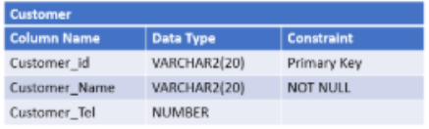

**CREATE TABLE** Customer (

Customer_Id **VARCHAR2**(20) **CONSTRAINT** pk_Customer **PRIMARYKEY**,

Customer_Name **VARCHAR2**(20) **CONSTRAINT** nn_Customer **NOTNULL**,

Customer_Tel **NUMBER**

) ;

**CREATE PRODUCTTABLE**

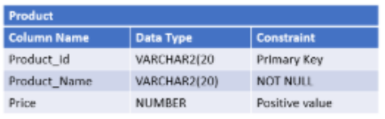

**CREATETABLE** Product (

Product_Id **VARCHAR2**(20) **CONSTRAINT** pk_Product **PRIMARYKEY**,

Product_Name **VARCHAR2**(20) **CONSTRAINT** nn_Product **NOTNULL**,

Price **NUMBERCONSTRAINT** check_price **CHECK** (Price > 0)

) ;

**CREATE ORDERS TABLE**

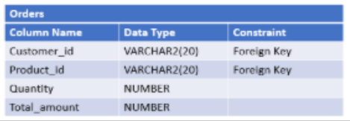

**CREATETABLE** Orders (

Quantity **NUMBER** ,

Total_amount **NUMBER**

**CONSTRAINT** fk_Orders_Customer**FOREIGNKEY** (Customer_id) **REFERENCES** Customer(Customer_id) ,

**CONSTRAINT** fk_Orders_Product **FOREIGNKEY** (Product_id) **REFERENCES** Product (Product_id)

) ;

**Add ColumnCategory to the PRODUCT table**

**ALTERTABLE**Product **ADD** Category **VARCHAR2**(20) ;

**Add Column OrderDate to the ORDERS table**

**ALTERTABLE** Orders **ADD** OrderDate **DATEDEFAULT**SYSDATE () ;