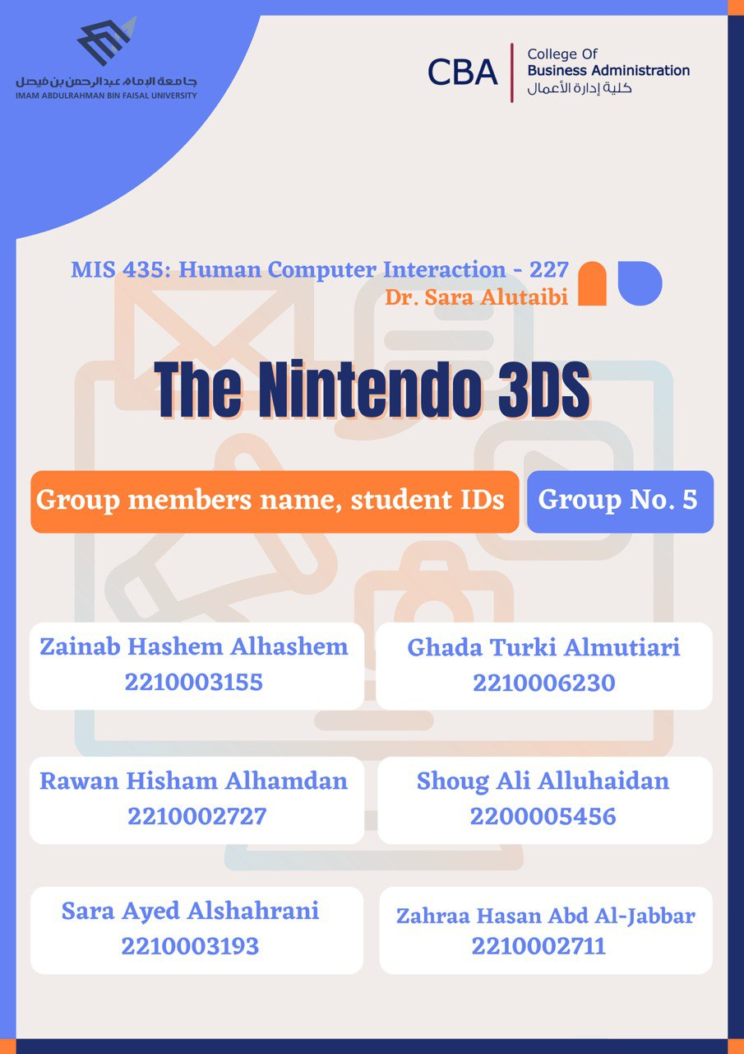

**Table of Content**

Abstract

Product Selection:

* Product: 3ds Nintendo

Current Design Analysis:

* 3DS Selection and Investigation
* Reference to Usability and User Experience Goals
* Design Principles
* Critical Analysis Based on Documenting Findings

Proposed Improvements:

* Problem Space
* Assumptions
* Claims Regarding User Interaction Challenges
* Proposed Improvements

Conceptual Model Creation

Conclusion

References

**Abstract**

This study explores the Nintendo 3DS, a portable gaming device praised for its wide range of games and innovative features like augmented reality and glasses-free 3D. Examining its current design, the study emphasizes how well it delivered a rich gaming experience and kept up an engaged community after it was discontinued. The critical analysis underscores its significance in gaming history, emphasizing effective Human-Computer Interaction (HCI) design principles. Proposed improvements identify hardware challenges and user interaction issues and introduce innovations like an OLED display, ergonomic design, and lithium-polymer battery with the goal of improving user satisfaction. If these adjustments were made, the 3DS would be in line with modern gaming standards. This study promotes the 3DS's development and guarantees its ongoing significance in the ever-changing portable gaming market.

*Keywords: Nintendo 3DS, handheld gaming console, design analysis, HCI, user interaction, hardware improvements, augmented reality, gaming community, portable gaming.*

**Data gathering (Survey):**

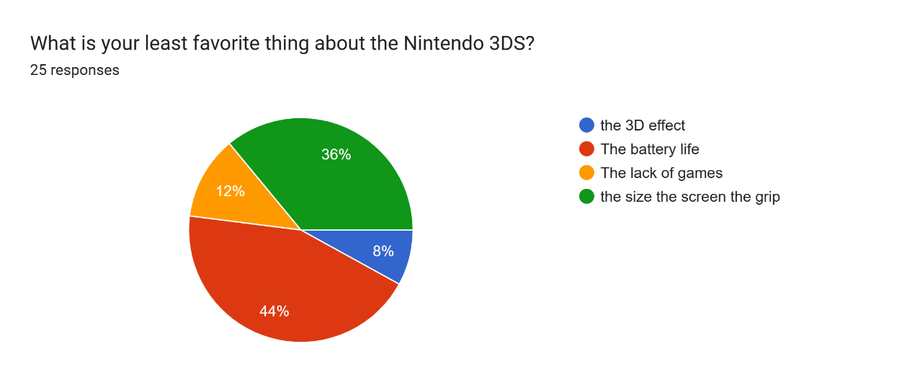



Forms response chart. Question title: How often do you use your 3DS device?
. Number of responses: 24 responses.

Forms response chart. Question title: Which features of the 3DS device do you find most appealing? (Select all that apply) 
. Number of responses: 25 responses.

Forms response chart. Question title: What are the primary reasons for using your 3DS device? (Select all that apply) 
. Number of responses: 25 responses.

Forms response chart. Question title: How satisfied are you with the overall gaming experience on the 3DS device? 
. Number of responses: 25 responses.

**Analysis:**

1. Age: This information can be used to understand the demographic distribution of the respondents and provide insights into the target audience for the Nintendo 3DS.

2. Least Favorite Thing: Analyzing these responses can help identify common pain points or issues that users have experienced with the device. This information can be valuable for identifying areas of improvement.

3. Frequency of Use: This data can help gauge the level of engagement and usage patterns among respondents.

4. Appealing Features: Analyzing these responses can help identify the key selling points and strengths of the device according to user preferences.

5. Primary Reasons for Usage: Analyzing these responses can provide insights into the various motivations and use cases of the users, which can contribute to understanding the device's versatility and appeal.

6. Satisfaction with Gaming Experience: Analyzing these responses can help assess user satisfaction and identify areas where improvements may be needed.

By analyzing these responses, Nintendo can gain valuable insights into user preferences, pain points, and satisfaction levels. This information can inform product development, marketing strategies, and customer support efforts to enhance the overall user experience and address any identified issues.

**Product Selection**

**Product: 3ds Nintendo**

The product that we have chosen is Nintendo 3DS which is a handheld game console, it was a popular device for kids after it was launched. The specific uses of 3DS to play video games, also players can take photos and videos because it contains dual front and rear cameras. Furthermore, players can connect with their friends, browse the web, and watch videos due to the ability of the device to connect to the Internet. Our purpose in selecting 3DS is to develop an existing product and to solve the problems that we will mention later. The significance of developing 3DS is to provide entertainment and Leisure for all players and to provide an interactive experience that can move players to different worlds and engage their imaginations. Our reason for selecting the product is it was popular with many players we are in the era of fast technology and the interaction between humans and technology has become multifaceted, we discussed developing this product to be suitable and keep pace with technological developments and to be suitable for children and adults (Bakalar, 2011).

**Current 3DS Design Analysis:**

**3DS Selection and Investigation**:

* **Extensive Game Library**: The 3DS boasts a vast game library with over 1,328 titles, including 390 exclusives, showcasing a diverse range of genres and high-quality games (Nintendo, 2023). This extensive collection, featuring core Nintendo franchises, has received critical acclaim, indicating the system’s success in delivering a varied and engaging gaming experience (Pessolano, G., 2019).
* **Unique Features**: The 3DS introduced groundbreaking features like glasses-free 3D, augmented reality, and StreetPass for social interactions, enhancing the gaming experience beyond traditional handheld norms. Its folding clamshell design contributed to its durability and portability. Despite being discontinued in 2020, it maintains a vibrant community, underscoring its appeal and accessibility (Nintendo, 2023).

**Reference to Usability and User Experience Goals**:

* **Active Community and Accessibility**: Despite being discontinued in 2020, the 3DS maintains an active community, with over 150,000 members on the r/3DS subreddit and enthusiast forums like GBATemp. The portability and approachable games have made it popular among kids and families, differing from modern mobile gaming focused on touch controls and microtransactions (Pessolano, G., 2019).
* **Affordability and Durability**: Used 3DS systems are still readily available at reasonable prices, and its sturdy construction ensures longevity. These factors contribute to the 3DS’s continued relevance and accessibility (Nintendo, 2023).

**Design Principles**:

* **Cognitive/Social/Emotional Aspects**: The 3DS’s design accommodates various cognitive, social, and emotional aspects. The interactive features like augmented reality and StreetPass encourage social interactions, while the extensive game library caters to diverse cognitive needs and emotional experiences.
* **Data Gathering and Analysis**: Utilizing user feedback, expert reviews, and community discussions can provide insights into the 3DS’s design and user experience, aiding in a comprehensive analysis of its impact and reception.
* **Technical Architecture**: The 3DS was designed with a focus on user interaction and experience. The console’s architecture features the ARM11 MPCore CPU, indicating a complex and sophisticated internal structure. This CPU, in both its original and upgraded ‘New’ variants, highlights Nintendo’s commitment to technological advancement and efficient system design (Nintendo 3DS Architecture | a Practical Analysis, 2023).

**Critical Analysis on the basis of Documenting Findings**:

* **Design and Hardware Analysis**: In-depth technical analysis reveals the 3DS’s use of the ARM11 MPCore CPU, featuring a two-core setup in the original variant and a four-core setup in the ‘New’ variant. The Advanced eXtensible Interface (AXI) bus connects the cores and interfaces with the external world, indicating a sophisticated internal architecture.

Therefore, the Nintendo 3DS’s design principles, focused on enhancing user experience through technological innovation, align perfectly with the project’s objectives (Nintendo 3DS Architecture | a Practical Analysis, 2023). The 3DS not only represents a significant chapter in gaming history but also serves as a case study in effective HCI design, balancing functionality, user engagement, and aesthetic appeal. The 3DS is expected to become more collectible over time, with increasing rarity of hardware and a continuous interest in its games. Its legacy as a significant handheld in gaming history is assured.

**Proposed Improvements:**

**Problem space:**

The Nintendo 3DS has hardware issues such as 3D effect fatigue, poor screen quality, limited size options, uncomfortable hand grip, and short battery lifetime. Furthermore, the device misses personalized algorithms for recommendation in the E-shop and synchronization with other gaming platforms in terms of software. Addressing these challenges with new changes aims to increase player satisfaction by offering a more adaptable, appealing, and feature-rich portable gaming experience.

**Assumptions:**

Assumptions involve the notion that customers want a more adaptable and comfortable portable gaming experience. It is assumed that the modifications would increase user satisfaction plus improve the general appeal and use of the Nintendo 3DS.

**Claims regarding user interaction challenges:**

The modifications proposed state that implementing a higher resolution display, an enhanced 3D effect, varying size possibilities, offering a comfortable hand grip, and upgraded battery technologies would solve user issues and dramatically enhance the 3DS experience. Furthermore, customized suggestion algorithms in the E-shop and enhanced integration with different gaming platforms can make the console ergonomic, user-friendly, and comply with current gaming expectations.

**Proposed improvements:**

**1-Battery:**

The short battery life of the Nintendo 3DS makes it difficult for users to play for extended periods of time. To increase the battery life, upgrading to a lithium-polymer battery, known as a kind of rechargeable battery with a lengthy lifespan, greater power density, and lightweight (Reddy & Linden, 2010). In addition, making use of OLED display technology, which consumes less power by selectively turning off pixels would make the battery life longer (Soh, Lee, & Foo, 2014).

**2-3D Effect:**

Nintendo defied market expectations when it introduced the 3D effect; it was innovative and worked without requiring 3D glasses, yet it was extremely uncomfortable to use as it required the user to maintain a certain posture and would cause fatigue and eye strain due to its instability and blurriness. The appropriate adjustments would be to include eye sensors to determine the user's gaze direction and to adjust the effect so that it is viewable from any angle to suit the user's preferences and comfort level.

**3-Screen:**

The 3DS has issues with its poor 240x400 (240p) pixel screen resolution and its 60 Hz refresh rate, which can result in ghosting—an image's shadow left on the screen. Increasing the screen resolution to 480x640 (480p) would make the image crisper, and better detailed, in addition boosting the rate of refresh to 120hz or more could enhance the motion of the image and prevent the presence of ghosting; additionally, implementing an OLED display screen would advance the screen's quality. OLED screens are renowned for their low energy use, broad view angles, quick reaction times, and excellent image quality.

**4-Hand Grip:**

The existing 3DS is not pleasant to play for extended periods of time; after a short while, the user's hands start to cramp from the awkward grip. The 3DS's hand grip should be shaped to better fit the curves of the human hand. Users might also find it easier to manage their grasp by adding a rubber material, also by rearranging the buttons the user can click them without experiencing any discomfort.

**5-Integration Platform Compatibility:**  
To address integration platform compatibility challenges, it is recommended to conduct thorough compatibility testing with widely used integration platforms, ensuring seamless functionality between the Nintendo 3DS and these platforms. Collaborating with integration platform providers is crucial to identify and resolve any conflicts or compatibility issues that may arise. Additionally, providing clear and comprehensive documentation and guidelines for integrating the Nintendo 3DS with other platforms will facilitate a smoother integration process for developers and users.

**6-Algorithmic Enhancements in the Game Store:**  
To enhance the user experience in the game store, algorithmic enhancements can be implemented. Intelligent algorithms can be introduced to offer personalized game recommendations by analyzing user preferences, play history, and social interactions. Additionally, advanced sorting and filtering options can be incorporated, allowing users to discover games based on genre, popularity, or release date. To continuously improve the recommendations, feedback from users and data analysis can be utilized to refine and enhance the algorithms, ensuring greater relevance and accuracy in suggested games.

**Enhanced 3DS Conceptual Model:**

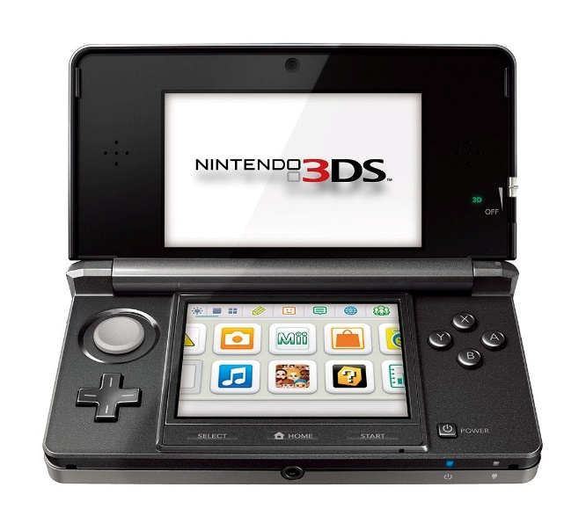

the current 3DS.

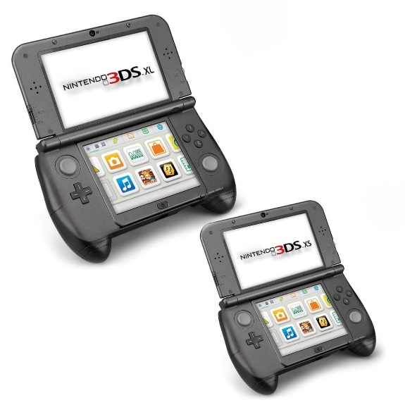

By modeling a grip that is contoured for the human hand, adding a second stick, and providing different sizes makes it appealing and user friendly.

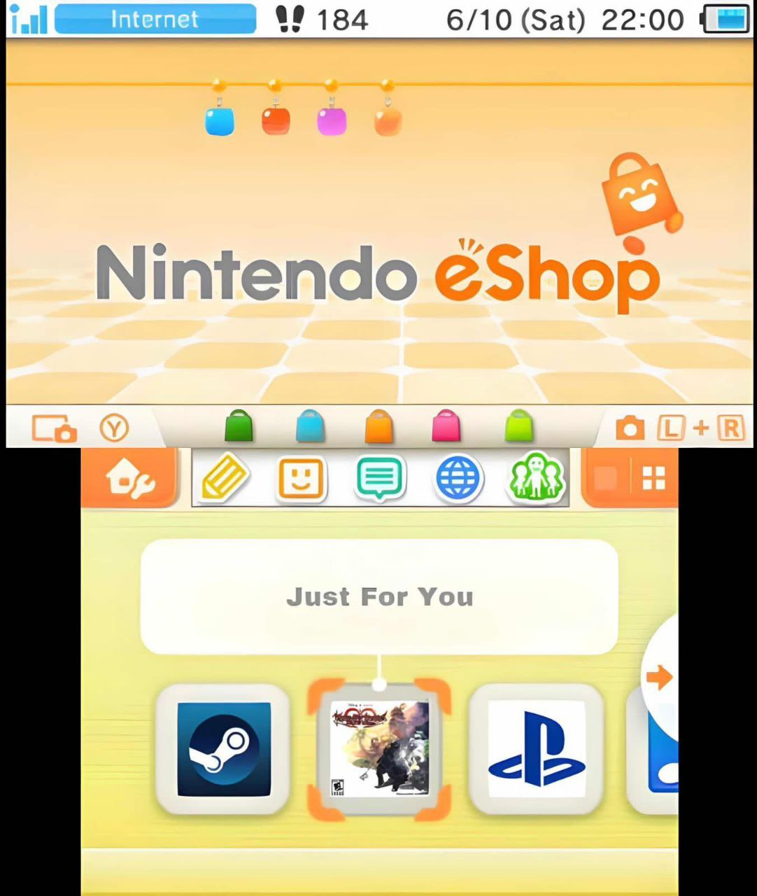

Integrating different gaming platforms such as Steam (a platform that allows individuals and gaming firms to distribute their games to consumers for gameplay and download) and PlayStation makes the 3DS versatile and attractive to all players rather than just Nintendo fans.

In addition, giving users a personalized recommendations allows gamers to find their preferred genre of games.

**Conclusion**

In conclusion, the Nintendo 3DS is a highly regarded handheld gaming device with a wide range of games and unique features. While it has been discontinued, it maintains an active and engaged gaming community. The proposed improvements, including upgrades to hardware and user interaction, have the potential to enhance the 3DS and provide a more satisfying gaming experience for users. These improvements aim to address challenges such as battery life, 3D effect, screen quality, and hand grip comfort. By aligning with modern gaming standards and incorporating personalized recommendations and integration platform compatibility, the 3DS can remain significant in the portable gaming market. The study emphasizes the importance of effective Human-Computer Interaction (HCI) design principles in creating a successful gaming device. Overall, implementing these improvements can make the Nintendo 3DS more appealing, user-friendly, and equipped to deliver a feature-rich gaming experience**.**

**References**

‌*Nintendo 3DS Architecture | A Practical Analysis*. (2023, September 16). The Copetti Site. <https://www.copetti.org/writings/consoles/nintendo-3ds/>

Nintendo. (2023). *Nintendo - about us*. Www.nintendo.com. <https://www.nintendo.com/us/about/>

Pessolano, G., Read, H. O., Sutherland, I., & Xynos, K. (2019). Forensic analysis of the nintendo 3ds nand. *Digital Investigation*, *29*, S61-S70. <https://www.sciencedirect.com/science/article/pii/S1742287619301641>

Reddy, K. N., Linden, D. (2010). *Lithium-polymer batteries*. Wiley.

.Soh, K. M. S., Lee, W. J., & Foo, D. C. S. (2014). *OLED displays: Technology, applications, and market*. Wiley.

# *Bakalar, J., 2011. Nintendo 3DS review: Nintendo 3DS. [Online] Available at: https://www.cnet.com/reviews/nintendo-3ds-review/*